**Assignment Three**

**Report**

-

09020328 Liang Wang

# **First: System Design**

**Description:**

A system designed to find out information of all students who are currently take all courses of certain department.

**E-R diagram:**

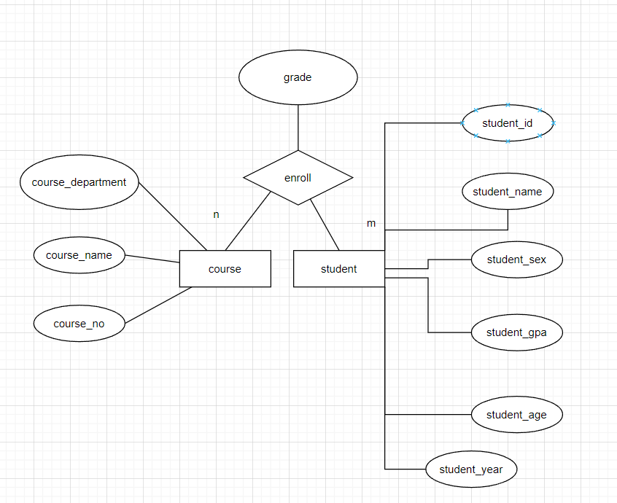

**Function design:**

A system designed to find out information (ids, names, gpas) of all students who are currently taking all courses of certain department.

**Database query:**

*SELECT* student.sid,

         student.sname,

         student.gpa

*FROM*

    (*SELECT* *sid*

*FROM*

        (*SELECT* COUNT(enroll.dname) *AS* num,

         enroll.sid

*FROM* enroll

*WHERE* dname = '*Civil Engineering*'

*GROUP BY*  enroll.sid) *AS* t

*WHERE* t.num *IN*

            (*SELECT* COUNT(course.dname)

*FROM* course

*WHERE* course.dname = '*Civil Engineering*')) *AS* m

*INNER JOIN* student

*ON* m.sid = student.sid;

Given a programming environment, the two dname followed by ‘Civil Engineering’ can be replaced by variables, so it can work in a flexible fashion accordingly to the specified department parameter in practice rather than the hard-coded style here, which is the product of compromise due to the failure in defining variables in Access.

In Access, the “Query 13” is the specified instance for the experiment.

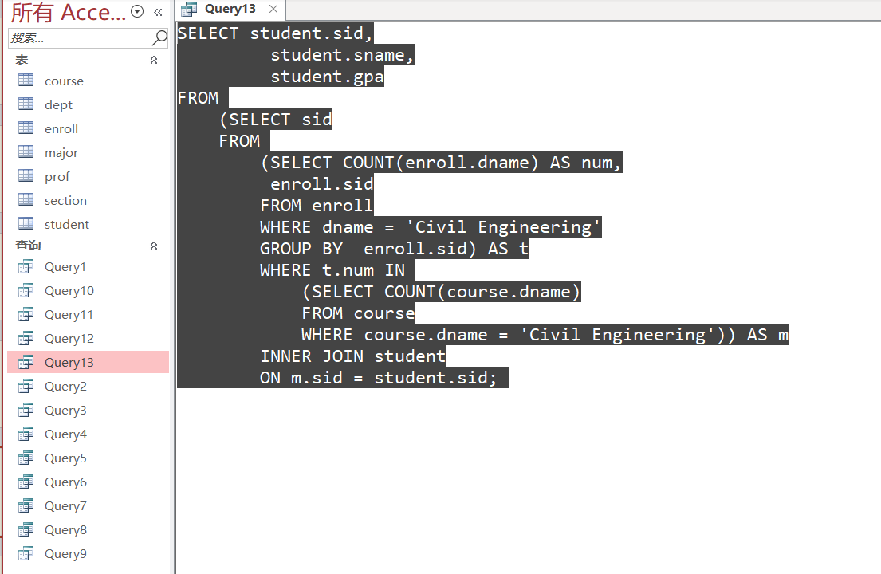

# **Conclusion**

A simple experiment with regard to practice in E-R diagram. Rudiment for a complete application with database integrated.