REPUBLIC OF CAMEROON
Peace-Work-Fatherland
REPUBLIQUE DU CAMEROON
Paix-Travail- Patrie




ONE LOVE, ONE MIND, ONE LEGACY!
LinkedIn: shaderl
Tel: 678 358 509 / 692 199 722
Site: www.shaderl.com
Email: info@shaderl.com

AFRICAN INSTITUTE OF COMPUTER SCIENCES -PAUL BIYA TECHNOLOGICAL CENTER OF EXCELLENCE
P.O. Box: 13719 Yaoundé
Tel: +237.242.729.957
Fax : 22729958
E-mail : contact@iaicameroun.com

INTERNSHIP REPORT

DESIGN AND IMPLEMENTATION OF AN ESCROW-SECURED PLATFORM FOR EVENT VISIBILITY, ATTENDANCE, AND CLIENT–SERVICE PROVIDER COLLABORATION IN EVENT MANAGEMENT"

Internship carried out from the 1st July to 31st September 2026
in view of obtaining an Engineering Diploma in Computer Sciences.
Option: Software Engineering
Written By:
DEUGOUE II KAMGOUE ALBERT CAMEL
Level III student at AICS Cameroon

Supervised By:
Academic Supervisor
Mme. Tchotouo Isabelle
Lecturer at AICS
Professional Supervisor
Mr. Yaya
Consultant at SHADERL

Academic Year: 2025 - 2026

DEDICATION

This work is dedicated to the KAMGOUE & MAGWA Family

ACKNOWLEDGEMENTS

Drafting this document would not have been possible without the contributions of several individuals who dedicated their time and efforts to ensure its completion. Our heartfelt gratitude goes to the following peoples:
- The Resident Representative of AICS Cameroon, Mr. Armand Claude ABANDA, for his unwavering support, encouraging words, and valuable advice on how to approach various situations.
- The Chief Executive Officer of SHADERL Mr. ASANE Derick, for trusting us with the opportunity to serve as interns their prestigious enterprise. Your support and guidance have been invaluable to our learning experience.
- To my Mother Mrs. Nadege, for her love, support and encouragement towards my academic success.
- Our professional supervisor Mr. Yaya, for his advice, professional expertise and commitment he showed during his supervision.
- Our academic supervisor Mme.Tchotouo for her moral support, advice and invaluable support throughout the academic year.
- Our academic teachers, Mr. MESSIO, Mr. Agbor and Mrs. TCHOUTOUO Isabelle for their guidance and assistance in the realization of this document.
- To all my teachers at AICS Cameroon, for the knowledge they imparted, which has been essential in my journey.
- To my parents, brothers, sister, uncles and aunties for their unwavering love and support they gave me through my long academic journey.
- To the countless contributors of the open-source programming community, for their invaluable resources that helped me learn essential skills and troubleshoot issues.
- Finally, to all my classmates, for their collaborative spirit and teamwork throughout the academic year.
Thank you all for your contributions and support!

SUMMARY

DEDICATION i
ACKNOWLEDGEMENTS ii
SUMMARY iii
LIST OF FIGURES iv
LIST OF TABLES v
LIST OF ABREVIATIONS vi
ABSTRACT vii
RESUME viii
GENERAL INTRODUCTION 1
PART I: INSERTION PHASE 2
PART II: THE EXISTING SYSTEM 14
PART III: SPECIFICATION BOOK 27
PART IV: ANALYSIS PHASE 42
PART V: DESIGN PHASE 82
PART VI: DEPLOYMENT PHASE 100
PARTVII: TEST OF FUNCTIONALITIES 112
PART VIII: INSTALATION AND USER GUIDE 119
PERSPECTIVE 129
GENERAL CONCLUSION 130
ANNEXES x
BIBLIOGRAPHY xi
WEBOGRAPHY xii
TABLE OF CONTENT xiii

LIST OF FIGURES

LIST OF TABLES

Table 1: SHADERL products 7
Table 2:comparative study of Devpilot and existing project management SaaS. 24
Table 3: Chronogram of activities 35
Table 4:Software resources 37
Table 5: Hardware requirements source (https://www.ubuy.cm) 38
Table 6: Human resources source (https://www.paylab.com/cm/salaryinfo/information-technology) 39
Table 7: global estimation table 40
Table 8: list of participants 42
Table 9: Differences between UML and MERISE 50
Table 10:components of a use case diagram 56
Table 11: textual description of authentication 63
Table 12: Textual description of manage roadmap (create action) 64
Table 13:Order service textual description 65
Table 14: components of a communication diagram 67
Table 15: components of a sequence diagram 72
Table 16: components of an activity diagram 77
Table 17: components of a class diagram 89
Table 18: components of a state machine diagram 93
Table 19: components of a package diagram 97
Table 20: technology stack 104
Table 21: components of a deployment diagram 107
Table 22: components of a component diagram 110

LIST OF ABREVIATIONS

ABSTRACT

The event services sector in Cameroon suffers from two intertwined problems: poor visibility into events for prospective attendees, and a lack of trust and centralized coordination between organisers and service providers. Attendees rely on scattered, informal channels with no centralized platform for real-time event visibility, while organisers depend on unverified service provider listings, risking wasted time and financial fraud from upfront payments to providers who fail to deliver. This report details the "DESIGN AND IMPLEMENTATION OF AN ESCROW-SECURED PLATFORM FOR EVENT VISIBILITY, ATTENDANCE, AND CLIENT–SERVICE PROVIDER COLLABORATION IN EVENT MANAGEMENT" addressing both problems. Every client gets immediate visibility into events and can discover, browse, and attend them via integrated ticketing, with no barriers to entry. Any client can also progress into the role of organiser, creating and managing their own events and securely engaging verified service providers — caterers, photographers, decorators — within the Cameroonian market. The platform connects clients, organisers, and service providers in one space to discover events, request organiser privileges, and book verified provider services, protected by an escrow-based payment system that holds funds until service delivery is confirmed. Key features include role progression from client to organiser, real-time event discovery, trust signals, a booking and contract workflow, escrow payments with dispute resolution, and direct messaging. This system modernizes event discovery and service coordination, reduces financial fraud, and empowers users with verified information. The project uses UML as our modelling language, coupled with 2TUP (2 Track Unified Process) as our method.

Key words
- Escrow, Event Management.
- Trust, Event Visibility.
- Ticketing.
- Digital Marketplace.

RESUME

Ce projet propose "LA CONCEPTION ET LA MISE EN ŒUVRE D'UNE PLATEFORME SECURISEE PAR SEQUESTRE (ESCROW) POUR LA VISIBILITE DES EVENEMENTS, LA PARTICIPATION, ET LA COLLABORATION ENTRE CLIENTS ET PRESTATAIRES DE SERVICES DANS LA GESTION D'EVENEMENTS. Le secteur des services événementiels au Cameroun souffre d'un manque de visibilité centralisée des événements et d'un déficit de confiance entre organisateurs et prestataires, exposant les utilisateurs à la fraude financière lors des paiements anticipés. La plateforme permet à tout client de découvrir, parcourir et assister à des événements via une billetterie intégrée, sans restriction. Tout client peut également évoluer vers le rôle d'organisateur afin de créer et gérer ses propres événements, et de collaborer avec des prestataires vérifiés (traiteurs, photographes, décorateurs). Les paiements sont protégés par un système de séquestre qui retient les fonds jusqu'à confirmation de la prestation, avec un mécanisme de résolution des litiges. Le système intègre également une messagerie directe entre organisateurs et prestataires. Ce projet a été réalisé à l'aide du langage de modélisation UML, associé à la méthode 2TUP (2 Track Unified Process).

Mots-clés
- Séquestre, Gestion d'événements.
- Prestataire de services,
- Organisateur.
- Marketplace numérique.

GENERAL INTRODUCTION

In today's digital age, technology has moved many traditionally offline processes online for greater efficiency. The Cameroonian event services market remains largely informal: prospective attendees have no centralized platform for real-time event visibility, and organisers still rely on informal networks to find service providers, often paying deposits upfront with no protection if a provider fails to deliver, leading to scams and unresolved disputes.
This project focuses on the theme "DESIGN AND IMPLEMENTATION OF AN ESCROW-SECURED PLATFORM FOR EVENT VISIBILITY, ATTENDANCE, AND CLIENT–SERVICE PROVIDER COLLABORATION IN EVENT MANAGEMENT," resulting in the platform Evenza. Evenza gives every client visibility into events and the ability to discover, browse, and attend them via integrated ticketing, while allowing any client to progress into the role of organiser — creating events and engaging verified service providers with confidence, with funds held in escrow until service delivery is confirmed. This directly addresses payment risk, lack of provider accountability, poor event discoverability, and inefficient booking communication.
This report is structured in the following parts:
- PART I: The Insertion phase
- PART II: Existing System
- PART III: The specification book
- PART IV: Analysis book
- PART V: Design phase
- PART VI: Deployment phase
- PART VII: Test of functionalities
- PART VIII: user guide

PART I: INSERTION PHASE

Preamble

This section of the report will cover details of how we were welcomed in the host company, presentation, organization and brief introduction to our project.

Content

INTRODUCTION
- WELCOME AND INSERTION
- GENERAL PRESENTATION OF THE COMPANY
- ORGANIZATION OF THE COMPANY
- GEOGRAPHICAL LOCATION
- BRIEF PRESENTATION OF PROJECT THEME
CONCLUSION

INTRODUCTION
The insertion phase in a company is a period during which we discover our working
environment, the staff of the company and other interns. Here, we will begin by discussing our first two weeks in the company, how we were welcomed and how we began adapting to our internship environment, we will proceed by exploring the history of the company, discovering its missions, learning what its major activities are, and witnessing some of its key realizations. We will also get to understand how the company is structured administratively and functionally so that it operates effectively and accomplishes its goals. Furthermore, we will look at the hardware equipment used by the company, and the software resources used in its daily operations. We will then introduce our chosen theme for the internship period, briefly elaborate on It.

WELCOME AND INSERTION
We arrived at SHADERL on Wednesday 01st July 2026, at 08:30 am. we were received by the SHADERL team who introduced us to our workspace, gave us an official welcome to the enterprise, its activities and its different rules and regulations. Also, we discussed on the enterprise’s preferred languages and frameworks, our professional supervisor encouraged us through his past working experiences in different enterprises.
The first two week we started with our internship report by configuring our MS WORD processor, reviewing key concepts like page numbering, styles, section breaks, page breaks etc. There was a talk on project ideas, we were advised to propose project ideas and we were assigned the tasks to carry out research on these ideas. The objective was that the enterprise did not want to impose some themes on us. For those who could not find a theme, the enterprise could propose an idea for them to think about.

GENERAL REPRESENTATION OF SHADERL

Background:
SHADERL is a dynamic, non-governmental tech startup founded in 2023 by ASANE Derick with a bold vision: to bridge the gap between traditional industries and the rapidly evolving digital economy. Recognizing the urgent need for digital transformation, SHADERL is committed to providing cutting-edge IT solutions while empowering the next generation of innovators.

Mission
At SHADERL, we harness the power of AI and cutting-edge technology to democratize digital transformation. Our mission is to empower individuals and businesses with intelligent tools, accessible education, and personalized mentorship bridging the gap between today’s potential and tomorrow’s opportunities. We believe AI should augment human potential, not replace it. By making AI-driven solutions practical and ethical, we equip the next generation to lead, innovate, and thrive in an era where human creativity meets machine intelligence.

Vision
At SHADERL, we envision a world where technology unites humanity, where innovation is driven by collective purpose, not just profit. By putting “People First”, we strive to build a future where:
- One Love→ Technology fosters inclusion, empathy, and global collaboration, breaking down barriers.
- One Mind→ AI and digital tools amplify human potential, creating shared knowledge and opportunity.
- One Legacy→ Every individual we empower leaves a lasting impact, shaping a smarter, kinder, and more connected world.
We don’t just adapt to the digital age; we redefine it with humanity at the core.

Activities
The activities of SHADERL range from computer sciences, engineering, and training. We can outline the following:
- Conception realization, and hosting of websites.
- Software development and maintenance.
- Training in Software related fields.
- Conception and realization of multimedia.
- IT consulting and innovation.
- AI driven solutions

Products
Table 1: SHADERL products
NO | Name | description | LOGO
1 | ShaderlStock | ShaderlStock is an application, which helps small, medium and large businesses to manage their inventory, with the help of a QR code and AI assistance for more complex queries. | 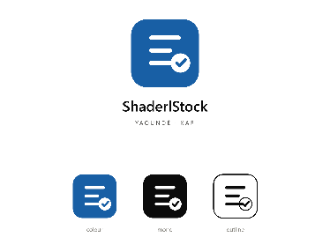
2 | ShaderlAlgorithm | It is an application, which helps individuals in the society to learn how to write algorithms and programing, despite their educational background. With the help of artificial intelligence. | 

III-ORGANISATION OF SHADERL

A- Administrative organisation
SHADERL is administratively organized as follows:

Executive Leadership
This department is responsible for:
✓ Setting the company's vision, mission, and strategic direction
✓ Making high-level decisions about investments, partnerships, and growth
✓ Representing SHADERL in key meetings with investors and government agencies
✓ Ensuring all departments align with the company's core values and objectives
✓ Overseeing the overall performance and sustainability of the organization
b. Software Engineering Department
This department is responsible for:
✓ Designing, developing, and maintaining all of SHADERL's software products
✓ Implementing AI and machine learning solutions for company offerings
✓ Ensuring software security, scalability, and optimal performance
✓ Collaborating with other departments to understand technical requirements
✓ Staying updated with emerging technologies and industry best practices

c. Human Resource Department
This department is responsible for:
✓ Recruiting and onboarding top talent that aligns with SHADERL's values
✓ Managing employee relations, welfare, and performance evaluations
✓ Developing training programs to enhance staff skills and capabilities
✓ Maintaining company culture and ensuring a positive work environment
✓ Handling compensation, benefits, and conflict resolution

d. Communication Department
This department is responsible for:
✓ Managing SHADERL's public image and brand reputation
✓ Developing and executing marketing and PR strategies
✓ Handling all internal and external communications
✓ Managing social media platforms and digital content
✓ Organizing corporate events and press engagements

e. Department of Financial Affairs
This department is responsible for:
✓ Managing all financial operations and accounting
✓ Preparing budgets and financial forecasts
✓ Handling payroll, taxes, and financial reporting
✓ Ensuring compliance with financial regulations
✓ Managing investments and financial partnerships

B- Functional organisation
The functional branch of SHADERL is organized as follows:
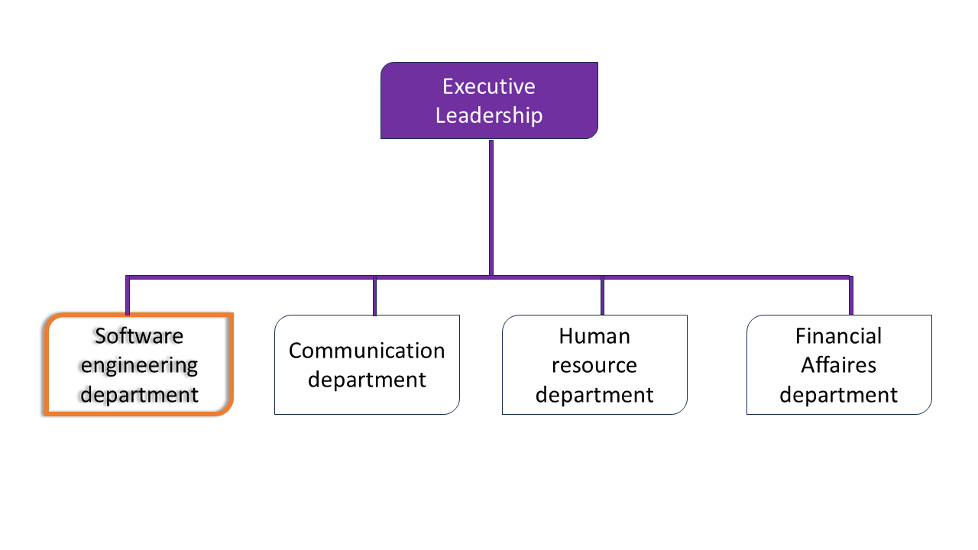

Figure 1: Functional organization of SHADERL

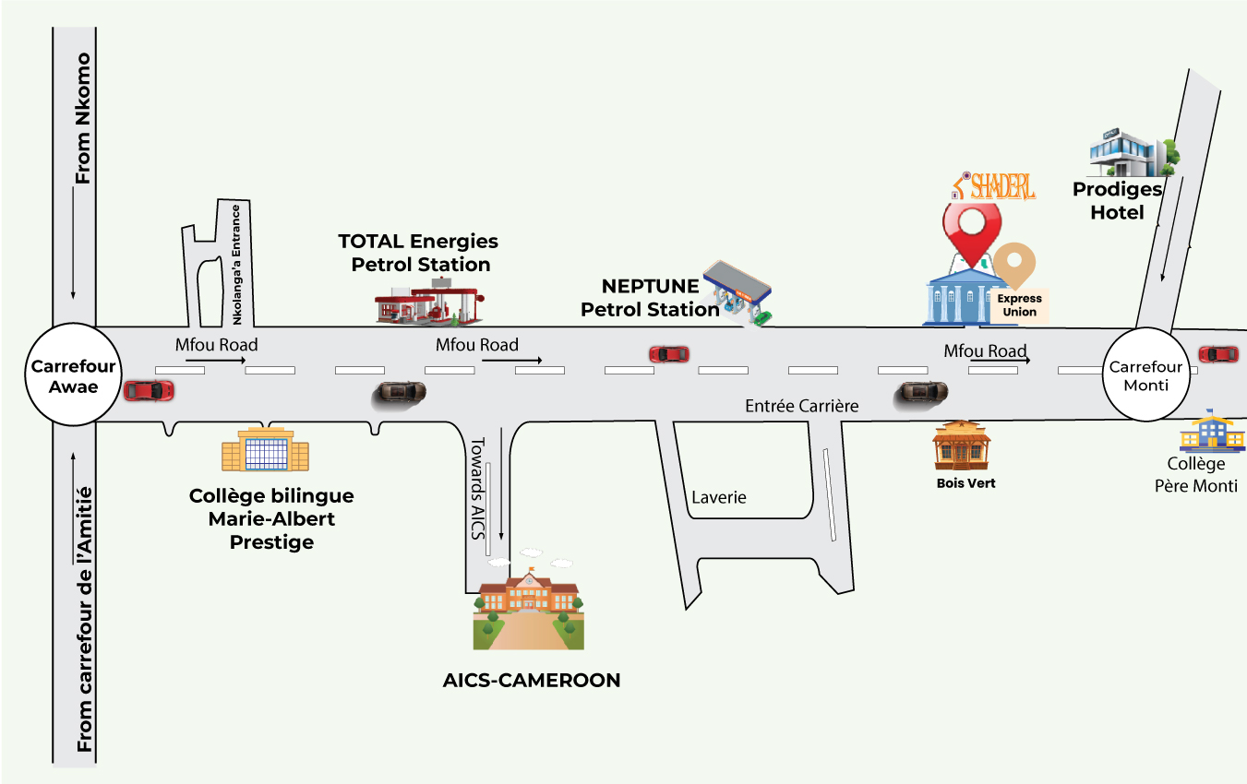
IV- GEOGRAPHICAL LOCATION

Figure 2:localization plan of SHADERL

V- BRIEF PRESENTATION OF THE PROJECT THEME
Following an in-depth analysis of the modern event management landscape and the rising demand for transparent, trustworthy client–service provider engagement, we initiated the development of a scalable escrow-secured platform. Reflecting the core software engineering mission to drive digital innovation and strengthen trust between event organizers, attendees, and service providers, we undertook the development theme "DESIGN AND IMPLEMENTATION OF AN ESCROW-SECURED PLATFORM FOR EVENT VISIBILITY, ATTENDANCE, AND CLIENT–SERVICE PROVIDER COLLABORATION IN EVENT MANAGEMENT." This web application, Evenza, is architected around a unified Administrator responsible for system governance and platform-wide moderation, Clients who discover events, purchase tickets, and — once verified — organize and manage their own events, and Service Providers who deliver the specialized offerings (catering, photography, decoration, and more) that bring those events to life. The system delivers tailored, role-based dashboards enabling event organizers, attendees, and service providers to efficiently interact, collaborate securely through escrow-protected transactions, and transparently monitor the live status of bookings, tickets, and ongoing events.

CONCLUSION
Our insertion phase at SHADERL lasted for two (2) weeks. We discovered the environment where we found ourselves in. This environment had all the necessary requirements and tools for hard work and collaboration. We learned about the company's missions and its different activities. We met other interns with whom we were doing collaborative works and finally, we were assigned the theme "DESIGN AND IMPLEMENTATION OF AN ESCROW-SECURED PLATFORM FOR EVENT VISIBILITY, ATTENDANCE, AND CLIENT–SERVICE PROVIDER COLLABORATION IN EVENT MANAGEMENT."

PART II: THE EXISTING SYSTEM

Preamble

The existing system is a document that provides a view of how the current system works, how it carries out its different activities, it equally provides a deep understanding of the system associated to the various limitations and the problems that result from it and we propose the solution.

Content

INTRODUCTION
- PRESENTATION OF THE PROJECT THEME
- STUDY OF THE EXISTING SYSTEM
- CRITICISMS OF THE EXISTING SYSTEM
- PROBLEMATICS
- PROPOSED SOLUTION
CONCLUSION

INTRODUCTON
As Engineers our role in the society is problem-solving which is targeted at making life easier for everyone and in order to bring forth a solution, we ought to ask ourselves some questions to know why the problem exist in the first place and how it is being dealt with at a time. The existing system refers to the system put in place to carry out the work done in the field on which our theme is based. Understanding this system is a great step in solving the problems that we might identify. It’s of great importance that we take into consideration this system before proposing a suitable solution that will ameliorate or replace the current one.

PRESENTATION OF THE PROJECT THEME
The African tech ecosystem has grown rapidly in recent years, with increasing demand for digital solutions tailored to local and continental market needs. However, many event organizers and service providers still face structural challenges managing event collaboration due to a lack of platforms that ensure secure payment handling, client involvement, and flexible access to trusted talent. To address this systemic issue, we propose the theme "DESIGN AND IMPLEMENTATION OF AN ESCROW-SECURED PLATFORM FOR EVENT VISIBILITY, ATTENDANCE, AND CLIENT–SERVICE PROVIDER COLLABORATION IN EVENT MANAGEMENT." This web application, Evenza, aims to provide a robust solution that enables clients to discover and attend events with transparent, real-time visibility, while giving event organizers a dynamic marketplace to safely onboard and collaborate with trusted service providers, thereby driving overall operational efficiency throughout the event production pipeline — secured end-to-end through escrow-protected payments.

DESCRIPTION OF EXISTING SYSTEM
Based on our study of the current event management landscape, we have identified significant challenges that lead to inefficiency and client dissatisfaction. While event organizers and service providers offer valuable services, they often struggle with transparent and secure collaboration.
- Limited Client Engagement: There is little to no real client involvement or visibility once a booking is placed with a service provider. This lack of collaboration can lead to misunderstandings and outcomes that don't fully meet the client's vision.
- Inadequate Workflow Transparency: Clients are often expected to pay service providers upfront with no safeguard, and service providers have no guarantee of payment for completed work. This creates a disconnection between the client's expectations and the service provider's actual delivery.
This analysis provides a strong foundation for why a platform like Evenza is needed to bridge this gap and foster a more collaborative and secure event environment, as it brings clients and service providers closer through escrow-protected, hand-in-hand collaboration.

Figure 3: Project follow up importance survey

Figure 4: project visibility level survey

Figure 5:functionality preference survey

Figure 6:frequency usage survey

Figure 7:integrated payment survey

CRITITCISMS OF THE EXIXTING SYSTEM
After research and study of popular event management and service-provider platforms such as Eventbrite, Meetup, and Thumbtack, we were able to come out with the following table which shows the gaps left by Eventbrite and Thumbtack that our application (Evenza) compensates.
Table 2:comparative study of Devpilot and existing project management SaaS.
Feature/Goal | Eventbrite/Meetup | Evenza
Primary Focus | - Event discovery & ticketing only; no service-provider layer. | Unified event visibility, attendance, and escrow-secured client–service provider collaboration.
Target audience | - General event attendees and community organizers. | Event clients (organizers & attendees) and verified event service providers, in one ecosystem.
Client Visibility | - Weak; attendees see ticket/RSVP status only, no insight into vendor or booking progress. | Native; built directly around client dashboards showing live booking, escrow, and event status.
Client–Service Provider Communication | - None; organizers must source and coordinate with vendors entirely off-platform. | Native booking chat, gated on confirmed bookings, with file/image evidence sharing.
Payment Integration | - Ticketing payments only; no support for booking or paying service providers. | Native escrow/service payment settlement (Campay MoMo, Flutterwave fallback), 5-day auto-release, dispute handling.
User Simplicity | - High learning curve to coordinate an event end-to-end, since ticketing and vendor sourcing live on separate tools. | Streamlined; tailored strictly for end-to-end event collaboration in one account.
Architecture Type | - Single-purpose ticketing/community. | Unified event visibility, ticketing & escrow-secured service marketplace platform.

PROBLEMATIC
In today's digital era, many individuals and businesses attend or organize events and need to work with independent event service providers — caterers, photographers, decorators, and more. However, these clients often face a lack of structured visibility into event progress and booking status, while service providers struggle with fragmented communication and no guarantee of secure payment when scaling their client base. This situation leads us to ask: "HOW CAN WE PROVIDE A SECURE, ESCROW-PROTECTED WEB APPLICATION THAT EMPOWERS CLIENTS WITH REAL-TIME EVENT VISIBILITY AND TRUSTED COLLABORATION WITH SERVICE PROVIDERS?"
We will try to offer solutions regarding this problem through our application.

PROPOSED SOLUTION
After analyzing and evaluating the limitations of existing systems, we propose to design an escrow-secured web application that will enable event clients, service providers, and event organizers across Cameroon and Africa to:
- Gain real-time visibility into event details, availability, and booking progress through role-based dashboards tailored to clients, service providers, and admins.
- Collaborate more effectively across the event planning process through integrated booking chat and dedicated messaging channels tied to each confirmed booking.
- Easily manage and monitor ticket purchases, bookings, and event milestones via intuitive, user-friendly dashboards tailored for non-technical stakeholders.
- Access and browse structured service provider catalogs, complete with verified badges, ratings, and completed-booking counts, to streamline the vendor selection process.
- Dynamically build trust with new service providers by securely onboarding them through an admin-reviewed access request flow before they can be booked.
- Maintain strict control over transaction security and deliverables through escrow-protected payments, immutable dispute audit logs, and a 5-day auto-release mechanism.

CONCLUSION
Having reached the end of this part, we studied the existing system by carrying out a survey that enabled us to come out with the limitations of the system that leads to the consequences and we proposed solutions to the various limitations. Finally, we proposed our solution which is "DESIGN AND IMPLEMENTATION OF AN ESCROW-SECURED PLATFORM FOR EVENT VISIBILITY, ATTENDANCE, AND CLIENT–SERVICE PROVIDER COLLABORATION IN EVENT MANAGEMENT."

PART III: SPECIFICATION BOOK

Preamble

The Specification book is a document which is been established by the customer needing a particular product and the producer (engineer) who is to create the product, which is to be respected to its fullness during the realization of the product. From this, we obtain the major importance of the specification book.

Content

INTRODUCTION
- CONTEXT AND JUSTIFICATION
- OBJECTIVES OF THE PROJECT
- EXPRESSION OF NEEDS
- PROJECT PLANNING
- ESTIMATED COST OF THE PROJECT
- PROJECT CONSTRAINTS
- DELIVERABLES
CONCLUSION

INTODUCTION
The specification book of our reports helps us provide details about our theme, to improve our understanding of it and increase the likelihood of it succeeding. To delimitate the scope of our project, we will specify the context of our theme. From the context, we will list the problems we have identified in our context and that we have decided to address throughout the project. After presenting our solution, we will talk about the objective we have set for the project. Also, we will explore the needs to which our system will respond both at the functional and non-functional level. We will then look at the estimated financial requirements for our project, and establish a plan we will follow to complete our project on time. From here we will discuss what is expected of us by the end of the project under the project deliverables.

CONTEXT AND JUSTIFICATION

CONTEXT
The digital economy has seen significant growth in recent years, marked by the widespread adoption of mobile payment technologies and an exponential increase in demand for trustworthy event collaboration. This surge has led to a boom in event organizers, independent service providers, and attendees seeking secure, transparent ways to plan and experience events. However, as the ecosystem expands, structural bottlenecks have shifted. Traditional tools built as single-purpose ticketing or discovery platforms fail to accommodate a fluid market where clients demand total visibility into their bookings and service providers must be trusted before being engaged for high-stakes events.
To address these modern structural gaps, transitioning from disconnected, single-purpose tools to a unified, escrow-secured event platform becomes essential. Such a solution allows clients to discover and attend events with confidence while securely booking and collaborating with verified service providers under a single deployment. By combining this architecture with an escrow-protected payment layer, the platform not only provides clients with real-time, transparent visibility over their bookings and investments but also empowers service providers to seamlessly build trust, deliver quality work, and consolidate their entire client pipeline under a unified, secure environment.

JUSTIFICATIONS
The development of an escrow-secured event platform focused on trust and transparency is essential due to the modern market's heavy reliance on independent service providers and the growing demand for secure event collaboration. Traditional, generic ticketing or discovery tools fail to meet specialized client expectations when it comes to tracking booking progress, safeguarding payments, and fluidly connecting clients with trusted service providers throughout the event lifecycle. This operational fragmentation inevitably leads to misunderstandings, payment disputes, and severe communication overhead between clients and service providers.
Evenza directly addresses these ecosystem-wide challenges by offering a dedicated web application that redefines how clients, service providers, and admins interact. By shifting to a secure, escrow-protected architecture, it allows clients to discover and attend events with confidence while safely booking and paying service providers under a single platform, eliminating the need for fragmented, off-platform coordination. Clients can monitor booking and event progress in real time through dedicated dashboards, while admins can seamlessly review and onboard trusted service providers into the platform. By automating client involvement and securing payment settlement through escrow, Evenza eliminates operational friction, increases trust between parties, and directly drives higher-quality event experiences across the Cameroonian and African market.

OBJECTIVES OF THE PROJECT

GENERAL OBJECTIVES
The main objective of this project is to develop a secure, multi-tenant web application that provides independent IT service agencies and startups with a unified ecosystem to manage software projects, dynamically source specialized freelance talent, and securely isolate corporate data, while enabling B2B clients to monitor development progress transparently in real time.

SPECIFIC OBJECTVES
- Implement an escrow-secured payment architecture that ensures clients and service providers can transact safely, with funds held until service delivery is confirmed.
- Provide clients with real-time visibility into event details, availability, and the status of their bookings through dedicated, role-based dashboards.
- Integrate a service provider marketplace that allows clients to securely discover, evaluate, and book verified service providers based on category, ratings, and completed-booking history.
- Simplify booking and event tracking by breaking down the collaboration process into clear stages booking confirmation, contract acceptance, service delivery, and escrow release visible to all authorized stakeholders.
- Facilitate centralized communication through booking chat, enabling clients and service providers to coordinate, share evidence, and resolve issues directly within the platform.
- Support transparent dispute management and secure evidence sharing to maintain a clear, auditable trail of bookings and transactions throughout the event lifecycle.

EXPRESSION OF NEEDS

FUNCTIONAL NEEDS
Functional needs describe what the users can do on the system. Some of which are listed below as follows:
Admin:
- Manage user accounts (approve or reject service provider access requests, manage client accounts)
Client:
- Manage event details (create, edit, and publish events once verified as an organizer)
- Book and manage service providers for event tasks (catering, photography, decoration, etc.)
- Manage his personal profile

NON FUNCTONALREQUIREMENTS
Non-functional requirements are a set of criteria that define the overall qualities, characteristics, and constraints of a software system, rather than its specific behaviors or functions. These requirements describe how the system should operate, rather than what it should do.
Performance, Reliability and Security
- Performance defines how fast a software system responds to certain user’s action under certain workload. It explains how much a user must wait before the target operation.
- Reliability and Availability: The application should have high uptime and minimal downtime, ensuring users can access the platform consistently.
  - The application should have a friendly user interface (UI) and should be easy to use.
  - The code should be clear to facilitate future development and improvement.
- Security: The application should provide a strong security mechanism to reassure user’s that they can trust it for their sensitive information. Some of the security principles include confidentiality, Integrity and Authentication.

PROJECT PLANNING

Chronogram of activities
Table 3: Chronogram of activities
PHASE | OBJECTIVE | OUTPUT | DURATION | PERIOD
INSERTION | Collecting information’s from enterprises | Insertion book | 2 weeks | 1st to 14th July 2026
EXISTING SYSTEM | Study of the existing system | Existing System | 1week | 15th to 21st July 2026
SPECIFICATION BOOK | Specification of the user needs | Specification Book | 5 days | 22nd to 26th July 2026
ANALYSIS | ANALYSIS | Capture of needs Use case and textual description Modelling | 2 weeks | 27th July to 9th August 2026
CONCEPTION | Hardware and software conception | Conception Book | 2 weeks | 10th to 23rd August 2026
REALIZATION | Realization of the system | Realization Document | 3 weeks | 24th August to 13th September 2026
DEPLOYMENT | Deployment of the system | Testing and debugging the software | 2 weeks | 14th to 27th September 2026
WRITING USER GUIDE | Instruction on how to use the software and hardware | User Guide | 3 days | 28th to 30th September 2026

Gantt Project Planning

Figure 8: Gantt project planning

ESTIMATED COST OF PROJECT

Software resources
Table 4:Software resources
RESOURCES | DESIGNATION | USAGE | QUANTITY | UNIT COST(FCFA)
Formatting | Microsoft office  2019 | Writing Report | 1 | 161000
Cloud storage | GitHub | Saving report and source code | 1 | Freemium
Web browser | Google chrome | For research and viewing the  application | 1 | Freeware
Code Editor | Visual studio Code | For writing code of the application | 1 | Freeware
UML analysis | Visual Paradigm | For drawing UML diagrams | 1 | Freemium
Project planning | Gantt Project | For building Gantt chart | 1 | Freemium
Database | PostgreSQL | To store different information’s | 1 | Freemium
TOTAL 1 |  |  |  | 161,000

Hardware resources
Table 5: Hardware requirements source (https://www.ubuy.cm)
Resources | Usage | Quantity | Unit cost (FCFA)
Laptop (LENOVO) Intel(R) Core (TM) i5-9300H CPU @ 2.40GHz (2.40 GHz) | Main resource for the accomplishment of this project; report writing, designs, analysis, coding | 1 | 375000
Printer HP | For printing the report | 1 | 172083
USB key 64GB | For installation of and sharing of software’s | 1 | 7,000
Star Link | For collaborative network Connectivity | 1 | 390000
TOTAL2 |  |  | 944,083

Human resources
Table 6: Human resources source (https://www.paylab.com/cm/salaryinfo/information-technology)
ROLES | NUMBERS OF DAYS | QUANTITY | COST PER DAY (IN FCFA) | TOTAL PRICE (IN FCFA)
Project Manager | 45 | 1 | 35,000 | 1,575,000
Analyst | 15 | 1 | 25,000 | 375,000
UI/UX Designer | 10 | 1 | 20,000 | 200,000
Programmer | 45 | 1 | 15,000 | 675,000
Tester | 12 | 02 | 10,000 | 240,000
Total 3 |  |  |  | 4,100,000

Global estimations:
Table 7: global estimation table
TOTAL1 (IN FCFA) | TOTAL2 (IN FCFA) | TOTAL3 (IN FCFA) | OVEROLL TOTAL (IN FCFA)
161,000 | 944,083 | 4,100,000 | 5 205 083
FIVE MILLION TWO HUNDRED AND FIVE THOUSAND AND EIGHTY THREE

CONSTRAINTS
- Technical constraint: For the development of our system, we have sufficiently robust tools to guarantee a minimum of security, extensibility and excellent scalability. Moreover, the programming phase will have to follow all the technical standards for a better performance in a reduced execution time, this is why the choice of the development technologies is crucial.
- Time constraint: The project will be realized in 8 weeks (2 months) starting from the beginning date, 1st July 2026.
- Cost Constraint: The project will have a minimum cost of seven million which the developer(student) may not afford
- Integration Constraints: Limitations imposed by third-party APIs or services that may have usage restrictions or performance issues.

LIST OF PARTICIPANTS AND DELIVERABLES

List of participants:
Table 8: list of participants
NAME | FUNCTION | ROLE
Mr. Yaya | Consultant at SHADERL | Professional supervisor at SHADERL
Mme. Tchotouo Isabelle | Lecturer at AICS Cameroon | Academic supervisor
DEUGOUE II KAMGOUE ALBERT CAMEL | Intern at SHADERL | Student at AICS Cameroon

List of deliverables:
In project management, any component materializing the result of a realization service is called a deliverable. In the case of our project, the deliverables are: A report composed of the following document
  - The application.
  - The user guides.

CONCLUSION
Reaching the end of this part. The list of objectives to be achieved has been enumerated and made clear. The specification book permitted us to present the different actors associated with the project as well as the requirement and the provisional planning needed for the achievement of our project. We will move directly to the next part which is the analysis phase. In the analysis phase, we will model our system with a modelling language and a unified process, do a comparative study of UML and MERISE

PART IV: ANALYSIS PHASE

Preamble

The main objective of the analysis phase is to capture the user’s need, the delimitation of the field of study and to have a clear understanding of the system in study. To achieve this, we will use UML with the 2TUP as method applied to UML to analyze the system. We will start by doing a comparison between UML and MERISE, of various unified processes and lastly, we will present the modelling of the solution we propose Devpilot.

Content

INTRODUCTION
I. METHODOLOGY
1. COMPARATIVE STUDY OF UML AND MERISE.
2. COMPARATIVE STUDY OF UNIFIED PROCESSES.
II. CHOICE OF THE ANALYSIS METHOD
3. MODELLING OF THE PROPOSED SOLUTION
CONCLUSION

INTRODUCTION
System development can be thought of as having two major components: System analysis and system design which both help in understanding the details of the existing system or the system to be designed. The analysis and design of information systems have most of the time vocation to allow the creation of databases, which must represent as closely as possible the reality of the field studied thus requiring the use of a design method. This is why our choice will be directed on the UML method as it offers much to developers seeking a user-centered approach and / or a wide scope in design. This part of the report consists of the comparative study of UML and MERISE, unified processes and finally the various diagrams that meet the functional need requirements.

METHODOLOGY
- COMPARATIVE STUDY OF MERISE AND UML

MERISE
MERISE stands for “Méthode d’Etude et de Réalisation Informatique pour des Systèmes d’Entreprise”. Although it is prescriptive to some extent, MERISE permits the participation of end users and senior management as well as data processing professionals in its decision cycle. MERISE is a method for designing, developing and carrying out IT projects. The goal of this method is to achieve the design of an information system. The MERISE method is based on the separation of data and processing to be carried out in several conceptual and physical models. The essentials of the approach lie in its three cycles: the decision cycle, the life cycle and the abstraction cycle, which cover data and process elements equally. The separation of data and processing ensures longevity in model. Indeed, the arrangement of data does not have to be often overhauled, while treatments are more frequently.

UML
UML (Unified Modelling Language) is a standard notation for the modelling of real world objects as a first step in developing an object-oriented design methodology. Its notation is derived from three object-oriented design and analysis methodologies: Grady Booch's methodology for describing a set of objects and their relationships, James Rumbaugh's Object-Modelling Technique (OMT), Ivar Jacobson's approach which includes a use case methodology. Other ideas also contributed to UML, which was the result of a work effort by Booch, Rumbaugh, Jacobson, and others to combine their ideas, working under the sponsorship of Rational Software. UML captures information about the static and dynamic view of a system. UML 2.5 comprises of 14 diagrams which represent the different views of a system. The 14 diagrams can be subdivided into two, Static or structural and Dynamic diagrams. These diagrams include;

STATIC OR STRUCTURAL DIAGRAMS
- Class Diagram;
- Object Diagram;
- Component Diagram;
- Deployment Diagram;
- Composite Structure Diagram;
- Package Diagram;
- Profile Diagram;

DYNAMIC OR BEHAVIORAL DIAGRAMS
- Use Case Diagrams;
- Activity Diagram;
- State Machine Diagram;
- Sequence Diagram;
- Communication Diagram;
- Interaction Diagram;
- Timing Diagram;

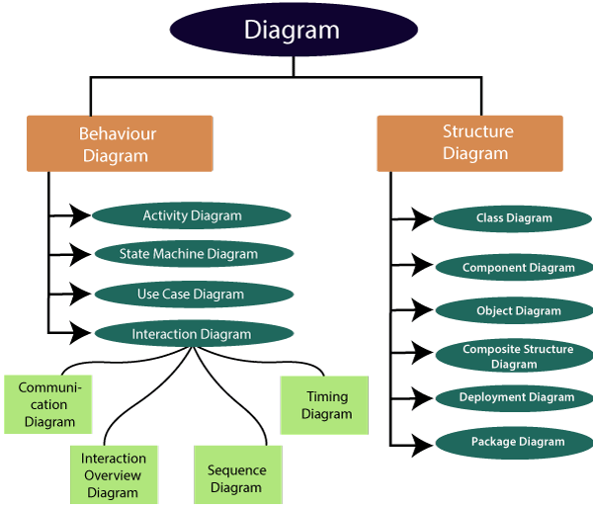

Figure 9: UML diagrams

Table 9: Differences between UML and MERISE
MERISE | UML
It stands for Méthode d'Étude et de  Réalisation Informatique pour les Systèmes d'Entreprises | Unified Modeling Language
MERISE is a systemic method of analysis and design of information systems. That is, it uses a system approach. | UML is however not a method but rather an object modeling language to which it is necessary to associate an approach to make it a method. This is the case with the 2TUP method; RUP and XP.
MERISE proposes to consider the real system from two points of view:  - A static view (data)  - A dynamic view (treatments).  That is, with the MERISE method, we have a separate study of the data and the treatments. | UML offers a different approach from that of MERISE in that it combines data and processing. Because with UML, centralizing the data of a type and the associated processing makes it possible to limit the maintenance points in the code and facilitates access to information in the event of software development.  In addition, UML describes the dynamics of the information system as a set of operations attached to the objects of the system.
Rational | Object

- COMPARATIVE STUDY OF UNIFIED PROCESS

A UNIFIED PROCESS
A Unified Process is a process of development of software constructed on UML; it is iterative, incremental, centered on architecture, driven by use cases and requirements.
Iteration is distinct sequence of activities with a basic plan and evaluation criterion that produces an internal or external output. Either the content of an iteration is improved, or the evolution of the system is evaluated by users.
An increment is the difference between two released products at the end of two iterations. Each iteration that the group is capable of integrating the technical environment in order to develop a final product and give users the possibility of having tangible results.
Centered on architecture the different models derived during the establishment of system must be reliable and coherent.
Driven by use case and requirements enables the clear definition of a users’ needs and priorities respectively thereby minimizing the risk of project failure.

THE TWO TRACK UNIFIED PROCESS
2TUP is a unified process which is built on UML and has as objective to bring solution to constraints of functional and technical changes imposed on information systems by strengthening controls on development capacities. It proposes a Y-sharped development life cycle that separates the functional aspect from the technical aspects, and the merging of these two forms the implementation aspect. 2TUP distinguishes therefore two branches: the functional and technical branches, the combination of the result of these two branches forms the third: the realization branch – where we realize our system. The diagram below illustrates the branches of 2TUP.
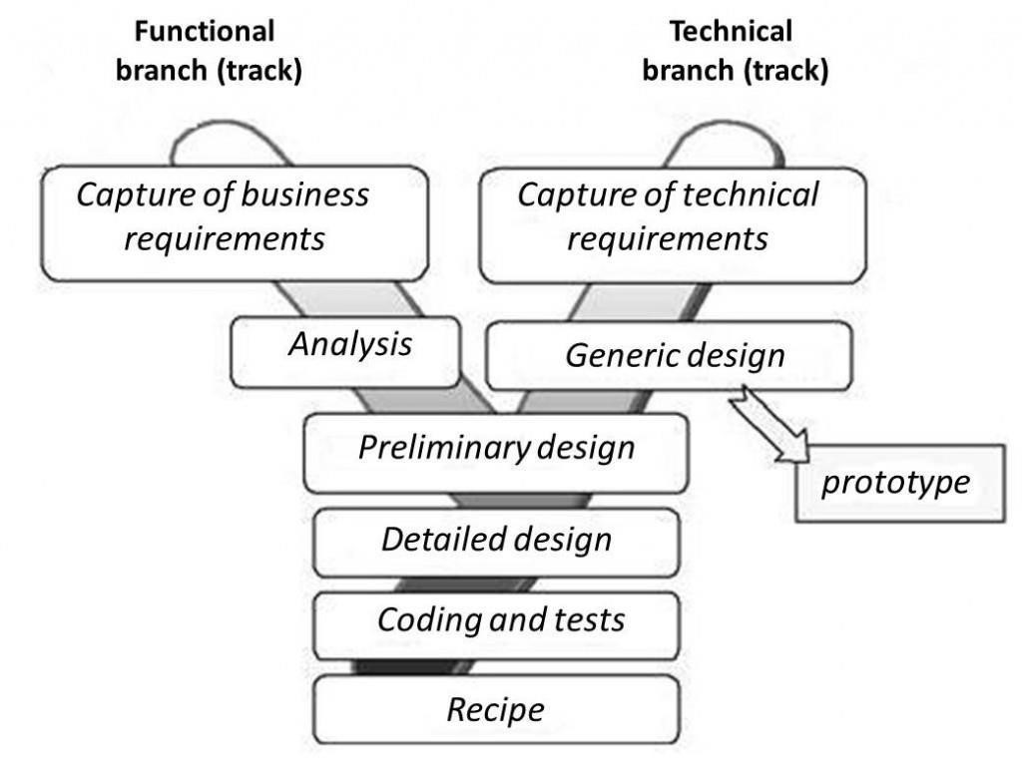

Figure 10:2TUP diagram

The left branch (FUNCTIONAL BRANCH)
It captures the functional needs of a system. This ensures the production of software that meets the needs/requirements of the user. The analysis here consists of studying precisely the functional specification in order to obtain an idea of what the system is going to realize, and its result does not depend on any technology.

The right branch (TECHNICAL BRANCH)
The technical branch enumerates the technical needs and proposes a generic design validated by a prototype. The technical needs include constraints and choices related to the conception of the system, the tools

The middle branch (REALIZATION OR IMPLEMENTATION BRANCH)
In this branch, we study the preliminary conception, detailed conception, and documentation of the system. The realization branch supports the following: Preliminary conception: This is the most sensitive step of 2TUP as it is the confluence of the functional and technical branch. It is completed when the deployment model, the operating model, the logical model, interphases and the software configuration model are defined. We have the following diagrams:
- Component Diagram;
- Deployment Diagram;
- Package Diagram;
- Composite Structure Diagram;
Detailed conception: This is the detailed design of each feature of the system. We have the following diagrams:
- Class;
- Sequence;
- State Machine;
Coding and testing: These are the phase where we program the designed features and test the coded features.
The recipe: Also known as the deliverables is the validation phase of the functions of the developed system.

CHOICE OF ANALYSIS METHOD
The reason why we chose UML modelling language and the software development process 2TUP instead of many others that exist, include:
UML is the current standard for programming in an object-oriented language. For this reason, it is widely understood and well known making it easy for a new programmer to join the project and be productive from the very first day.
UML diagrams allow teams to virtualize how a project is or will be working, and they can be used in any field, not just software engineering. The diagrams will allow teams to virtualize together how a system, or a process will work or did work. It can provide new ideas for how teams have to collaborate to achieve the goal of the workflow process.
2TUP is centered around the creation and maintenance of a model, rather than the production of mountain documents.
2TUP is user oriented as it permits the development of software that responds to the needs of the users through the study of the user needs.
2TUP is iterative and incremental, hence it enables the project team to produce refined amelioration if necessary and easily integrate it in the already existing system.
2TUP by permitting the project team identify and test the key functionalities of the system limits the risk related to building the system.

- MODELING OF THE PROPOSED SOLUTION

Capture of Functional Needs
The first step of the left (functional) branch of Two Track Unified Process (2TUP) is the capture of the functional needs. At this step, we capture the intended behavior of the system that maybe express as services, tasks or functions the system is required to perform.

USE CASE DIAGRAM

Definition:
Use case diagram shows the functionalities of a system, their interdependencies and how they relate with actors of the system. A use case is a specification of behavior. The main objectives of the use case diagram are:
- Provide a high-level view of the system.
- Identify the functions of the system.
Use case diagrams are completed with a textual description of each use case that is intended to define the use case in greater details.

Formalism:
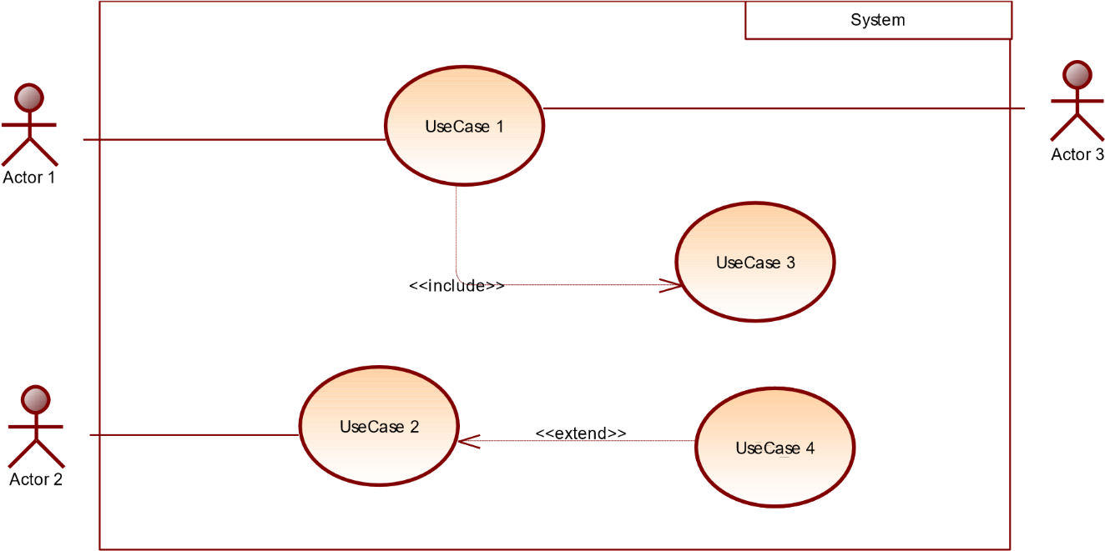

Figure 11:formalism of a use case diagram

Components of a Use Case Diagram
Table 10:components of a use case diagram
Elements | Notation |  | Description
Actors |  | 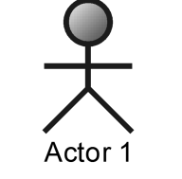 | Represents an entity that directly interacts with the system. The actor is what performs the different possible actions of the system
Use case |  | 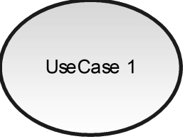 | A use case represents a functionality of the system. It is an action that can be performed by an actor.
Association |  | 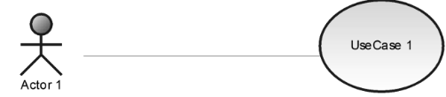 | it indicates that an actor takes part in a use Case.
Include |  | 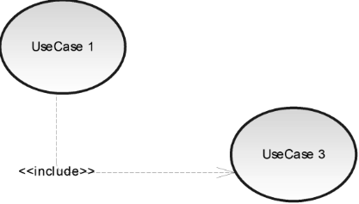 | An inclusion denotes that an included action must be performed before the including action can be performed.
Extend |  | 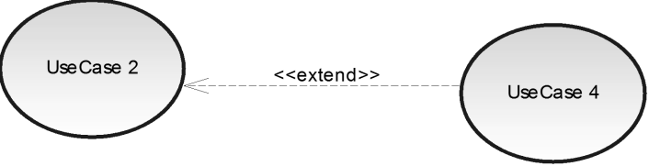 | An extension denotes that an extending action may be performed while an extended action is being performed.

Generalization | 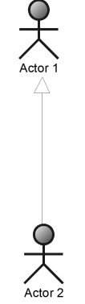  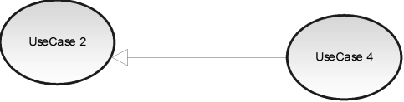 | This shows that an actor or a use case is a kind of another abstract or concrete actors can be defined and later specialized using generalization relationship.
System | 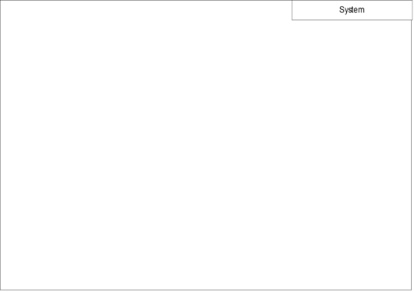 | It is a container of use cases which interact with external actors

The actors of our system
The actors of our system are listed below
- Admin
- Client
- Service Provider
- SMTP server
- Campay API
- Gemini API

General Use Case diagram

Figure 12:General use case diagram

Specific use case of manage collaborator
Figure 13: manage collaborator specific use case

Specific use case diagram of manage staff account
Figure 14:manage staff account specific use case

Specific use case of manage roadmap
Figure 15: manage roadmap specific use case

Textual description of Authenticate
Table 11: textual description of authentication
Title | Authenticate
Summary | This Use Case
Actors | Admin, Client, Service Provider
Date | July 19, 2026
Stakeholders | Evenza
Version | 2.0
Precondition | - The app is launched  - The actor has an account in the application  - The actor account is neither suspended nor banned/deleted
Trigger | The actor clicks on the Login button.
Nominal scenarios | - The system displays the login form.  - The actor fills and submits the form.  - The system verifies conformity of the forms fields.  - The system sends the data to the DBMS.  - The DBMS returns the result of the query.  - The system verifies the query results.  - The system displays a success message to the actor
Alternative scenario | - At step 3 of the nominal scenario the user enters wrong credentials or omits a character  - The system displays an error message then returns to step 2 of the nominal scenario.  - At step 6 of the nominal scenario, the DBMS result is not valid.  - The system displays an error message then returns to step 2 of the nominal scenario.
Post condition of success | The user has access to his/her dashboard
Poste condition of failure | The user does not have access to the platform
Non-functional requirement | The password should not be visible on screen

Manage event textual description
Table 12: Textual description of manage manage event (create action)
Title | Manage event
Summary | The use case describes how an event is managed, case study of event creation
Actor(s) | Client (organizer)
Date | July 19, 2026
Stakeholder | Evenza
Version | 2.0
Precondition | - The actor must be authenticated  - The actor has organizer privileges (approved by admin)  - The actor must be on his/her dashboard
Triggers | The user navigates to the event creation page and clicks "Create event".
Nominal scenario | 1. The system displays the event creation form.  2. The actor fills the form with relevant information concerning the event (title, category, date, venue, ticket details) and submits it.  3. The system verifies all fields have been filled.  4. The system sends data to the DBMS.  5. The DBMS returns the result of the query.  6. The system verifies the DBMS results.  7. The system displays a success message to the actor.
Alternative scenario | 8. At step 3 of the nominal scenario the actor forgets to fill one field.  9. The system displays an error message and returns to step 2 of the nominal scenario.
Post condition of success | The actor can view the event created
Post condition of failure | No event is created

Book service provider textual description
Table 13:Order service textual description
Title | Book service provider
summary | This use case explains how a service provider is booked for an event
Actor(s) | Client (organizer)
Date | July 19, 2026
Stake holder | Evenza
Version | 2.0
precondition | - The user must be authenticated  - The user must have organizer privileges  - The user must have access to the service provider page
Trigger(s) | The user clicks on "Book service provider"
Nominal scenario | 1. The system displays the booking form.  2. The actor fills and submits the form (event, service, date, agreed amount).  3. The system checks the form conformity.  4. The system sends the data to the DBMS.  5. The DBMS returns the result to the system.  6. The system verifies the DBMS results.  7. The system displays a success message to the user.
Alternative scenario | - At step 3 of the nominal scenario the user forgets to fill o field  - The system displays and error message and returns to step 2 of nominal scenario  - At step 6 of nominal scenario the system gets an error  - The system displays and error message and return to step 2 of nominal scenario
Precondition of success | The user successfully places a booking request
Precondition of failure | No booking is placed

COMMUNICATION DIAGRAM

Definition
Communication Diagrams models the interactions between objects in a sequence. They describe both the static structure and the dynamic behavior of a system. It is a simplified version of a Collaboration Diagram introduced in UML 2.0. A communication diagram is more focused on showing the collaboration of objects rather than the time sequence.

Formalism

Figure 16: formalism of a communication diagram

8.3:
Message_
11
Message_
8.4:
12
8.5:
Message_
13
Objet_1
Obje
t_2
Objet_3
Objet_4

Components of a communication

Table 14: components of a communication diagram
ELEMENT | NOTATION | DESCRIPTION
Message | 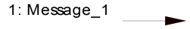 | Designs a particular communication between lifelines.
Connectors |  | It represents the relationships that exist between lifelines
Dependency | 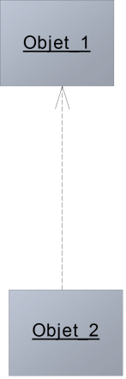 | A dependency is a relationship that signifies a single or a set of model elements for their specification
Lifeline | 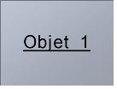 | An object represents an individual participant in the interaction conversation.

Communication diagram of Authentication
Figure 17: Communication diagram of authentication

Communication diagram of order Service
Figure 18:order service communication diagram

Communication diagram of Make payment
Figure 19: make payment communication diagram

SEQUENCE DIAGRAM

Definition
A Sequence diagram describes interactions among classes in terms of an exchange of messages over time. They are also called event diagrams. A Sequence diagram is a good way to visualize and validate various runtime scenarios. These can help to predict how a system will behave and to discover responsibilities a class may need to have in the process of modelling a new system.

Formalism

sequence diagram formalism
Objet_1
Objet_2
Objet_3
ok
not ok
alt
Message_6
Message_5
Message_4
Message_3
Message_2
Message_1

Figure 20: formalism of a sequence diagram

Components of a sequence diagram
Table 15: components of a sequence diagram
ELEMENT | NOTATION | DESCRIPTION
Life line | 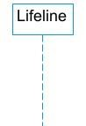 | An individual participant in a sequence diagram, it is position at the top of the diagram
Combined fragment | 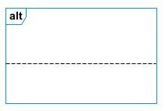 | It represents a choice of behavior in which at most one operand will be chosen.
Messages | 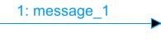  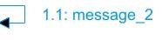  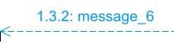 | These are arrows which shows the direction of message flow. We have the synchronous, the asynchronous and the self-messages.
Activation | 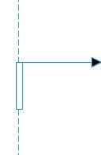 | It describes the time period in which an operation is performed by an element

Sequence diagram of Authentication
Figure 21: Authentication sequence diagram

Sequence diagram of Order service

Figure 22: Order service sequence diagram

Sequence diagram of make payment

Figure 23: make payment sequence diagram

ACTIVITY DIAGRAM

Definition
An activity diagram is a graphical representation of workflows that show the steps needed in the realization of a process; showing the details from a start point to an end point through all decisions and actions that can possible be performed. Activity diagrams are intended to model both the computational and organizational process. They flow can be sequential, branched or concurrent. Below is an activity diagram formalism.

Formalism














Figure 24: formalism of an activity diagram

Partition 1
Partition 2
Partition 3
action 1
action 3
action 2
action 4
action 5
action 7
action 8
Decision_1
Decision_2
[
ok
]
[
not ok
]
action 6
[
ok
]
[
not ok
]

Components of an activity diagram
Table 16: components of an activity diagram
Element Diagrammatic Representation |  | Description
Activity | 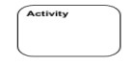 | Used to represent a set of actions.
Action | 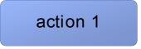 | Represent a task to be performed.
Activity edge |  | A directed connection between two activity nodes through which tokens may flow
Initial node |  | Shows the beginning of an activity or set of actions.
Final node |  | Stops all controls and object flows in an activity.
Object node | 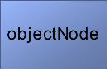 | Represents an object connected to a series of object flows.
Decision node | 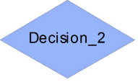 | Represents a test condition that slits an incoming activity edge into opposite outgoing activity edges.
Merge node | 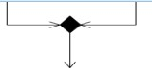 | Reunite different decision paths created using a decision node.

Fork node |  | Slits behavior into parallel or concurrent flows of activities (or actions).
Join node |  | Unites a set of parallel or concurrent flows of activities or actions.
Swimlane and partition | 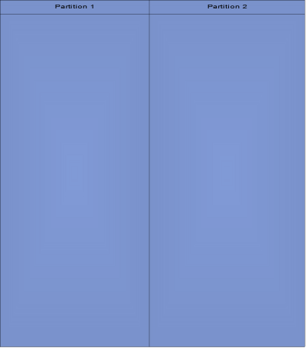 | A way of grouping activities performed by the same actor in an activity diagram or to group actions in the same thread.

Activity diagram of authentication
Figure 25:authentication activity diagram

Activity diagram of Order service

Figure 26: order service activity diagram

Activity diagram of Make payment
Figure 27: make payment activity diagram

CONCLUSION
In the analysis phase, we selected a software development process and a modeling language, after which we outlined the functional requirements of our system. We examined the use case diagram, which illustrates the relationships between the actors and the use cases (the actions the actors can perform within the system). We also explored the communication diagram, which depicts the system's architecture based on object-oriented programming principles. Additionally, we analyzed the sequence diagram, which outlines the flow of messages between elements in the system. Finally, we reviewed the activity diagram, which illustrates the workflow of our system. We will now transition to the conception phase, where we will present the technical aspects of our system along with the associated diagrams

PART V: DESIGN PHASE

Preamble

The conception phase will permit us to present in an orderly manner the components necessary for the good functioning of our software and also the architecture used for the proposed solution. It bridges the gap between the analysis phase and the realization phase.

Content

INTRODUCTION
I. TECHNICAL BRANCH
A. CAPTURE OF TECHNICAL NEEDS
B. RELATED UML DIAGRAMS
i. STATE MACHINE DIAGRAM
ii. PACKAGE DIAGRAM
CONCLUSION

INTRODUCTION
The conceptual phase will provide a detailed description of the necessary specifications, features, and operations required to meet the functional requirements of the proposed system, as outlined in the analysis phase. This stage aims to identify and consider essential components both hardware and software as well as the system's structure (including network capabilities), processes, and procedures needed to achieve its objectives. We will examine several key diagrams, including the class diagram, state machine diagram, and package diagram, to support our understanding of the system's design and functionality.

TECHNICAL BRANCH
- CAPTURES OF TECHNICAL NEEDS

Physical architecture
The design of the Evenza system is based on an n-tier architecture, which effectively partitions the entire system into related but separate modules. This modular approach allows for independent modification, alteration, or replacement of each tier as needed.
In our project, we utilize the n-tier architecture to separate the system components based on user interactions and the data managed within the database. Each layer has a well-defined communication interface, enabling independent evolution without impacting other layers. The n-tier architecture of Evenza consists of the following components:
Client Tier (Presentation Interface): This tier represents the user interface of the application, where users interact with the system. It encompasses the web application that allows clients to discover events, purchase tickets, and book service providers.
Application Tier: This tier consists of the web server that hosts the Evenza application. It handles the business logic, processes user requests, manages escrow and booking workflows, and facilitates communication between the client and data tiers.
Data Tier: This tier represents the DBMS and storage server, where all user data are stored. It manages data access, retrieval, and security, ensuring that users can securely access their information.
Email Tier: This tier contains the mail server of the organization.
.
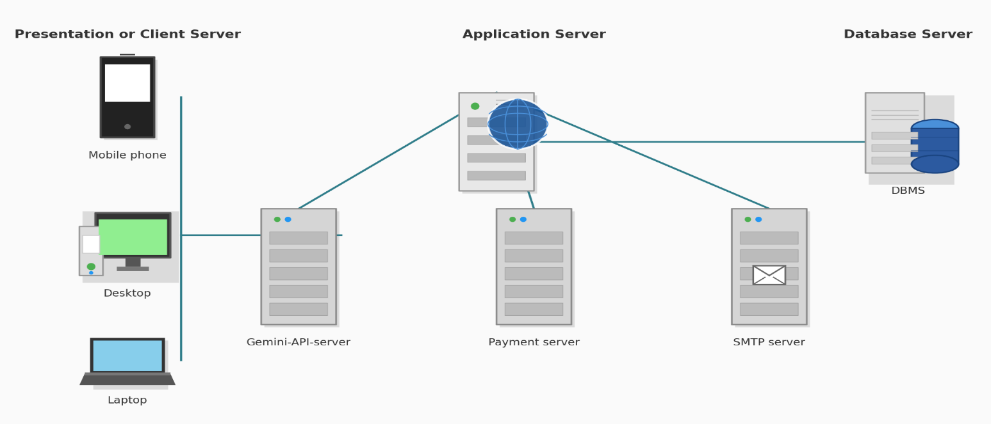

Figure 28: N-tier architecture

Logical architecture
Model-Controller-Service (MCS) architecture pattern, a decoupled variation of the traditional Model View Controller (MVC) design pattern, used in NestJS/Next.js applications. It is made up of the following:
- Model: it acts as the data layer of the application, responsible for structuring your database and handling data-related logic. It typically represents your database tables and is responsible for querying, inserting, updating, and deleting data. Evenza's models are defined via Prisma schema and backed by PostgreSQL.
- Controller: it is responsible for handling incoming requests and orchestrating responses. It receives user/client requests, delegates to the appropriate service to interact with the models, and returns the resulting data as a JSON HTTP response. In NestJS, controllers are classes decorated with route handlers that map endpoints to methods.
- Service (in place of View/Template): since the "view" is decoupled from the backend, business logic and data preparation live in the service layer, while the actual user interface rendering happens separately on the Next.js frontend, which consumes the API and renders the templates/components client-side.
The Model-Controller-Service architectural pattern is popular, particularly in NestJS-based API-first applications, due to its focus on separation of concerns, which allows developers to work on different parts of the application independently — the database (Model), request handling (Controller), business logic (Service), and user interface (Next.js frontend) — without interfering with each other.

Figure 29: MCS architecture pattern(source: www.radixweb.com)

- RELATED UML DIAGRAMS
- Class Diagram

Definition:
A class diagram is a static diagram. It represents the static view of an application. class diagram is not only used for visualizing, describing and documenting different aspect of the system but also for constructing executable code of the software application. Class diagram describes the attribute and operation of a class and constraints imposed on the system. Its purpose is to model the static view of an application.

Formalism:
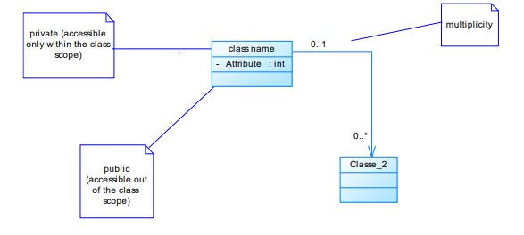
Figure 30: formalism of a class diagram

Elements of a Class Diagram

Table 17: components of a class diagram
Element | Representation | Description
Class | 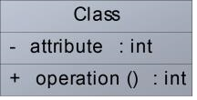 | A class is an element that defines the attributes and behaviors that an object can generate
Composition | 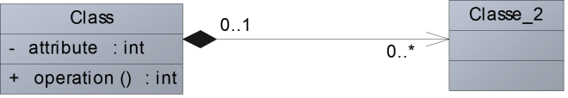 | If a parent of a composite is deleted, usually, all its parts are deleted with it.
Aggregation | 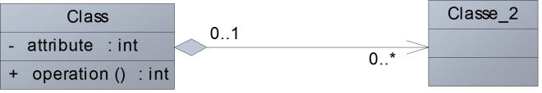 | If the parent of the aggregate is deleted, usually the children are not deleted.
Dependency | 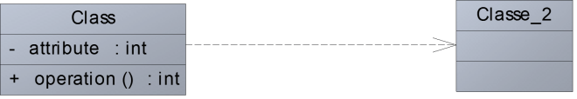 | It existed between two classes, if one changes it may cause the change in the order, but the other way around

Generalization | 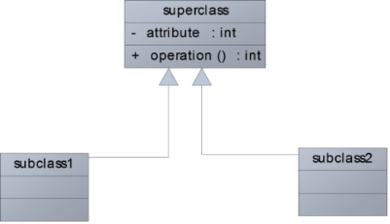 | it a relationship between a whole thing (called superclass) and a more specific thing  (Called subclass)
Association | 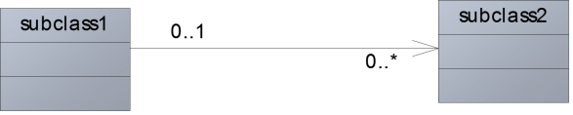 | It is a general type of relationship between elements, it may include cardinality, roles etc.

Evenza’s class Diagram

Figure 31:Application class diagram

- State Machine Diagram

Definition
A state machine diagram describes the behavior of a single object in response to a series of events in a system. Also known as the state machine diagram, it models the dynamic flow of control from the state of a particular object within a system.

Formalism:
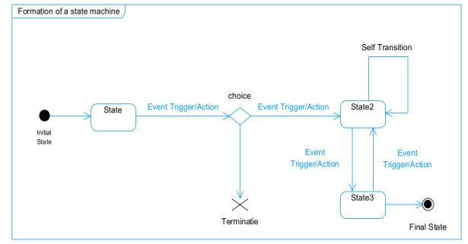
Figure 32: formalism of a state machine diagram

Components of a State Machine Diagram

Table 18: components of a state machine diagram
Element | Representation | Description
State | 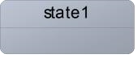 | Models a situation during which a certain invariant condition holds.
First (Initial  State) |  | It represents a default vertex, that is, a source for a single transaction to the default or composite state.
Final State |  | A state specifying that the enclosing region is complete.
Transition | 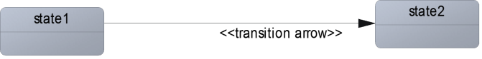 | A direction relation between a source and a target vertex.
Choice pseudo state |  | A diamond symbol that indicates a dynamic condition with branched  potential results
Terminate |  | Implies that the execution of a state by means of it context is terminated.
Diagram overview | 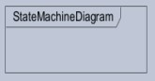 | A placeholder for the linked states in a state machine diagram.

Payment Transaction state machine diagram
Figure 33: transaction state machine diagram

booking state machine diagram
Figure 34: developer invitation state machine

- Package Diagram:

Definition:
This is a structural diagram used to show the organization and arrangement of various model elements in the form of packages. A package diagram is the grouping of related UML elements such as classes, diagrams or even other packages.

Formalism:
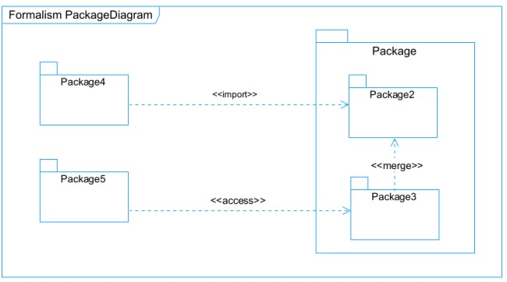
Figure 35: formalism of a package diagram

Components of a package diagram

Table 19: components of a package diagram
Element Representation |  | Description
Package | 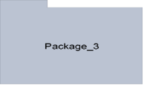 | A package is a namespace use to group related elements; it is a mechanism used to group elements into a better structure in a system.
Package import | 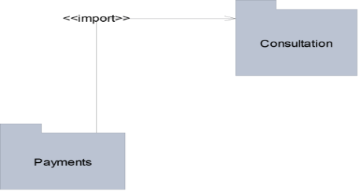 | A relationship Indicate that, functionality has been imported from one package to another.
Package access | 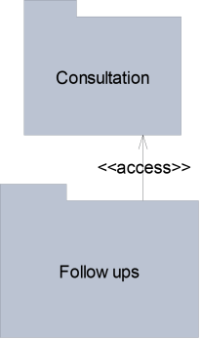 | A relationship  Indicates that one package requires assistance from the function of another package.

Package merge | 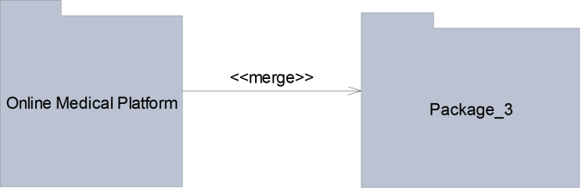 | It is a relationship  which shows that, the functionality of two packages are combines to a single function.

Evenza’s package diagram
Figure 36: application package diagram

CONCLUSION
In the conception phase, our objective was to plan the various aspects of our system, demonstrating how it will be structured and integrated within existing technical architectures. We began by addressing the technical constraints for our system, followed by identifying the components, their groupings, and the appropriate deployment targets for each. We concluded this phase by examining the interactions between the different elements and actors within our system. The next phase of our report is the realization phase, where we will focus on the implementation aspects of our system.

PART VI: DEPLOYMENT PHASE

Preamble

In this phase we will to straight forward in the implementation of our solution, we will base ourselves on the analysis and conception phases and also present the component and deployment diagrams.

Content

INTRODUCTION
- TECHNOLOGY STACK
- II. RELATED UML DIAGRAMS
A. DEPLOYMENT DIAGRAM
B. COMPONENT DIAGRAM
CONCLUSION

INTRODUCTION
The Deployment phase marks the transition from design to implementation for our digital preservation app, focusing on the selected technology stack and relevant UML diagrams, specifically the deployment and component diagrams. We will outline the technologies chosen for the frontend, backend, database, and cloud services, ensuring scalability and optimal performance. The deployment diagram will illustrate the physical architecture of the application components across servers and services, while the component diagram will detail the internal structure, highlighting key components and their interactions. This comprehensive approach aims to establish a solid foundation for development, facilitating collaboration and alignment with project goals for a successful app launch

TECHNOLOGY STACK
Table 20: technology stack
NAME | LOGO | DESCRIPTION | ADVANTAGE
Next.js |  | Next.js is a React framework with the App Router, used for building the web application. | Helps us build a fast, SEO-friendly, and scalable frontend with server and client rendering.
Tailwind CSS + shadcn/ui |  | Utility-first CSS framework paired with a pre-built accessible component library. | Helps us style and assemble web pages quickly with consistent, production-ready UI components.
NestJS |  | NestJS is a progressive Node.js framework built with TypeScript, used for backend development. | Helps us build secure, scalable, and maintainable server-side applications with a modular architecture.
TypeScript |  | TypeScript is a statically-typed superset of JavaScript that compiles to plain JavaScript. | It is primarily used across both frontend and backend for type-safe web and server-side programming.
Google Chrome |  | Google Chrome is a fast, secure, and user-friendly web browser developed by Google. Used to test our application UI | Chrome is optimized for  fast page loading and  efficient resource  management, providing a

PostgreSQL |  | It is a powerful open-source object-relational database system that reliably stores, manages, and scales complex data workloads with high integrity. | It offers full ACID compliance, advanced indexing, high concurrency, and custom extensibility to support reliable enterprise applications efficiently. .
Visual studio code |  | Visual Studio Code (VS Code) is a free, open-source, and cross-platform source code editor developed by Microsoft. | Provides a fast and efficient environment for writing and editing code, with support for syntax highlighting, intelligent code completion (IntelliSense), snippets, and code refactoring.
Chrome |  | Google Chrome is a fast, secure, and user-friendly web browser developed by Google. Used to test our application UI | Chrome is optimized for fast page loading and efficient resource management, providing a smooth browsing experience.

Visual  Paradigm |  | Visual Paradigm is a comprehensive modeling tool that supports software design and system modeling. Used to design our UML diagrams. | Supports multiple modeling languages and methodologies, making it suitable for various project requirements and enabling teams to adapt to different development processes.
Gantt Project |  | Gantt Project is a free, open-source project management tool that allows users to create Gantt charts for planning and scheduling projects | Allows users to assign tasks, set deadlines, and manage resources effectively, facilitating better project coordination and efficiency.

RELATED UML DIAGRAMS
- DEPLOYMENT DIAGRAM

Definition
Deployment diagram is a structural diagram used to visualize the topology of the physical components of a system, where the software is deployed. They consist of nodes and their relationship. It is related to the component diagram because the components are deployed using the deployment diagram. A deployment diagram consists of nodes. Nodes are nothing but physical hardware used to deploy the application.

Formalism
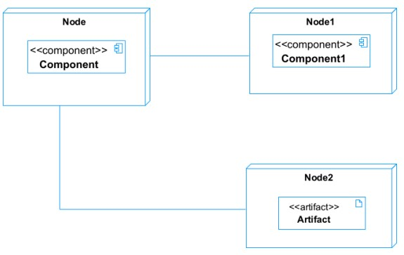
Figure 37: formalism of a deployment diagram

components of a deployment diagram
Table 21: components of a deployment diagram
Element | Representation | Description
Node | 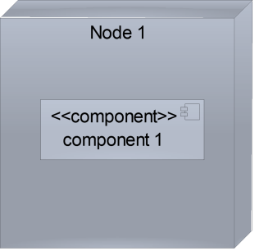 | It is a hardware used to deploy the application
Artifact | 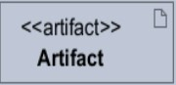 | An artifact is a major product, which is produced or used during the development of a software. E.g diagrams, data models, setup scripts
Component | 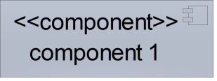 | It represents a modular part of a system that encapsulates its content and whose manifestation is replaceable within it environment.
Association | association | An association helps to connect two nodes together which permits them to communicate together

System deployment diagram

Figure 38: applications deployment diagram

- COMPONENT DIAGRAM

Definition
Component diagrams are used to model the physical aspect of a system. Now the question is what are this physical aspect? They are elements such as Executables, libraries, files, document etc. which resides in a node. The component diagram does not describe the functionality of the system, but it describes the components used to make those functionalities.

Formalism
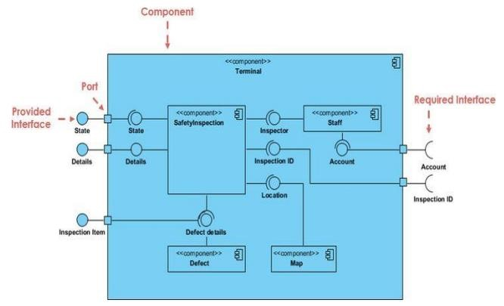
Figure 39: formalism of a component diagram
a.

Elements of a Component Diagram

Table 22: components of a component diagram
Name Representation |  | Description
A Component | 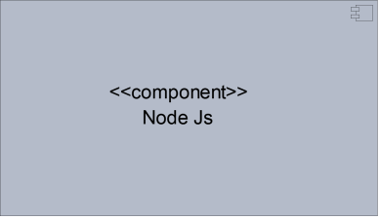 | A component is an abstract logical unit block of a system.it is represented as a rectangle with smaller rectangle in the upper right corner which saves as it icon for recognition.
Dependency | 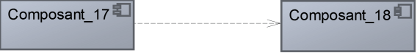 | Dependency is a directed relationship which is used to show that some components are dependent on others for their correct functioning.
Required  Interface | 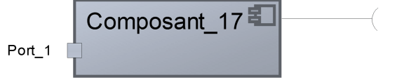 | It is a straight line from the component box with an attached half circle representing interfaces where a component requires information in order to perform its own functions.
Provided Interface | 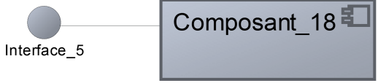 | It is a straight line from the component box with an attached circle representing interfaces where a component produces information used by required interfaces
Port | 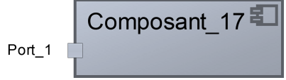 | A port (represented by a small square at the end of a required or provided interface) is used when the components delegate the interfaces to an internal class.

System component diagram
Figure 40: Application's component diagram

CONCLUSION
In conclusion, the deployment phase is a crucial step in the development of our escrow-secured event platform, where we bring our vision to life through the implementation of the selected technology stack and the creation of key UML diagrams. By leveraging technologies such as Next.js, Tailwind CSS, and NestJS, we ensure that the application is scalable, efficient, and capable of meeting user needs. The deployment and component diagrams provide valuable insights into the system architecture, facilitating better communication among team members and streamlining the development process. Following this phase, we will transition to functional testing, where we will rigorously evaluate the application to ensure all features work as intended, further enhancing its reliability and user experience before deployment.

PARTVII: TEST OF FUNCTIONALITIES

Preamble

In this phase, we will present the various functionalities of our application.

Content

INTRODUCTION
- APPLICATION FUNCTIONALITIES
- TEST SHOWCASE
CONCLUSION

INTRODUCTION
The testing phase allows us to gain deeper insights into the solution we are developing, for web platforms. This phase highlights the various functionalities or modules within our application and their benefits to users. In this context, we will explore the different functionalities present in Evenza, examining how each module contributes to enhancing user experience and meeting their needs.

APPLICATION FUNCTIONALITIES
- User Authentication: This functionality enables users to access their workspace through accounts they create themselves. The admin has the ability to suspend, reset, or activate user accounts, ensuring control over user access and security.
- User account creation: This functionality enables non-users to create client accounts in our application.
- Event creation: This functionality permits verified organizers to create and publish events.
- Service catalog management: This functionality permits service providers to add and manage the services they offer on the platform.
- Collaboration tools: This functionality gives service providers the ability to be booked for an event and gives room to coordinate via a structured booking chat system.
- User management tools: This functionality permits the admin to manage client and service provider accounts.
- Log Out: Users can securely log out to close their working session, ensuring that their accounts remain protected.
- Booking Assignment: Organizers can assign event tasks to booked service providers. This feature ensures that responsibilities are clearly defined and tracked within the app.
- Booking Status Management: Users can track the status of a booking as it moves through "pending," "confirmed," "completed," or "disputed." This functionality allows for effective booking management and ensures everyone is updated on progress.
- Reporting and Analytics: Users receive insights into their application usage, bookings, transactions, and more. This feature helps in understanding user behavior and improving the application.
- User Support and Documentation: This functionality provides help resources, including FAQs and user guides, ensuring users have access to assistance when needed.
- Personal information modification: This functionality allows users to manage their personal information, upload assets such as profile pictures.

TEST SHOWCASE
The following tests were carried out using our python built in test.py file using the configurations bellow
Figure 41:test showcase configurations
The above test configuration is executed by typing the command python manage.py test

The results of the test carried out above are as follows
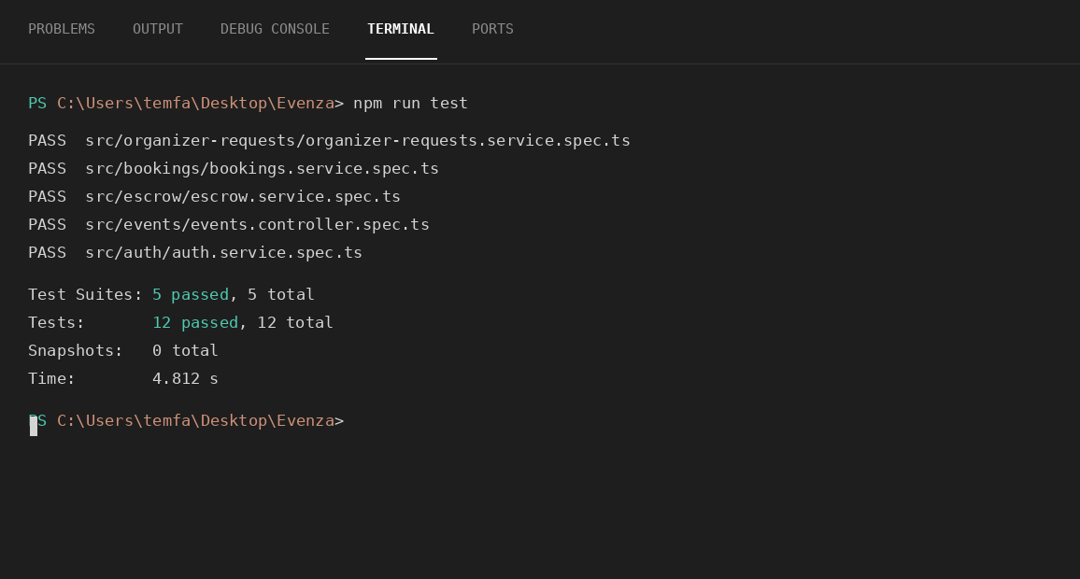
Figure 42: test showcase results

Above are the results of the test of the registration and authentication modules and we received a 200 (ok) status code from the backend hence the test was successful

CONCLUSION
In the testing phase, we outlined the different functionalities of our application and their benefits to various users, including clients and service providers. This phase is crucial for understanding how the application operates and serves its users effectively. We will now transition to the final phase, which is the installation and user guide. In this section, we will provide detailed instructions on how to install and use Evenza.

PART VIII: INSTALATION AND USER GUIDE

Preamble

The purpose of the user guide is to provide users of our platform with step-by-step instructions on how to install and use the system.

Content

INTRODUCTION
- INSTALLATION OF THE APPLICATION
- SHOWCASE
CONCLUSION

INTRODUCTION
This is the final phase of our report. In this section, we will outline the requirements for our system, detail the installation process, and explain how to access the system and its features. We will present this information in a step-by-step manner to ensure that first-time users can easily set up the platform. Following this, we will showcase our application by reviewing the different screens, highlighting the user interface and key functionalities.

INSTALLATION OF THE APPLICATION
Here we are going to give some steps in order to have the complete set up to run Evenza locally, that is on your machine.
Step 1 — Get access to the application directory:
The very first step is to get access to the repository containing the application's source code. After that, clone the repository on your computer using the command:
git clone <<repository URL>>
After doing this you are good to go to the next step.
Step 2 — Install required dependencies:
After getting access to the application source code and cloning it on your computer, the next step is to install the necessary dependencies to be able to run Evenza locally, as shown below:
Open a terminal and navigate to the location where you cloned the repository — for example, let's say you cloned it on the desktop, so we will navigate there using the command: cd Desktop
When in the location where you cloned the repository, access the two directories containing the source code of our app (backend and frontend):
cd Evenza-backend
Install the backend dependencies using the command: npm install
After that, create a .env file at the root of the backend directory with your database connection string and other required environment variables (Campay , SMTP, and Gemini keys).
Run the Prisma migrations to set up your database schema:
npx prisma migrate dev
Once the backend dependencies are installed, open another terminal, navigate to the frontend directory:
cd Evenza-frontend
Install the frontend dependencies using the command: npm install
After the installation is completed you can move to the next step.
Step 3 — Launching of servers:
After successful installation of the dependencies you need to launch the development servers so as to view the app locally.
In the backend terminal, run: npm run start:dev
In the frontend terminal, run: npm run dev
Pro tip: to facilitate this task you can run the above commands from separate terminals in Visual Studio Code.

SHOWCASE

User Registration
Here the user creates an account as a client using the registration form and is automatically logged in.
Figure 43: Client registration showcase

Figure 44: Sevice provider request access Show Case

Figure 45:create event form

Booking service builder
Here the client (organizer) creates the event, sets the event date, venue, and ticket details, and books service providers for each event task where needed.

Figure 46:Booking sevice builder show case

Event and bookings dashboard page
Here the client can view the event and bookings he created, service providers can view and update the status of bookings assigned to them, and admins can view all events and bookings on the platform.
Figure 47: Event and bookings dashboard page showcase

CONCLUSION
Once the platform is set up, it is essential to provide a manual to assist its various users. Therefore, we have outlined the different tools required for installation and detailed the installation process to ensure the application runs smoothly. Additionally, we will explain how users can effectively navigate and utilize the platform once the environment is fully configured. This manual will serve as a comprehensive guide to maximize the user experience.

PERSPECTIVE

Having reached the end of this document and considering the fact that this project can be improved to a higher extent, as perspectives we can bring some ameliorations such as:
- Mobile Application Development: Recognizing that a vast majority of event clients and on-the-move service providers rely primarily on smartphones, the development of a cross-platform mobile version of Evenza represents a critical next milestone. This will provide instantaneous push notifications for booking updates, mobile booking confirmations, and on-the-go chat communication.
- AI-Driven Event Planning & Automated Vendor Matching: Integrating an AI assistant capable of analysing raw event requirements to automatically generate a structured checklist of needed services, complete with estimated timelines and recommended service provider matches from the marketplace.
- Automated Multi-Event Reporting Analytics: Implementing a reporting engine that automatically compiles weekly or monthly progress analytics. These summaries can be auto-generated per organizer, emailed directly to clients, and include attendance trends, booking completion rates, and upcoming event milestones.
- Smart Escrow and Automated Smart Contracts: Expanding the escrow system's capabilities by implementing blockchain-based conditional payment gateways or smart contracts. This ensures that service provider payments are automatically held and securely released only when a client electronically signs off on a verified service delivery confirmation.
- Interactive Multi-Role Onboarding Overlays: To guarantee a seamless user experience across the platform, designing context-aware, interactive onboarding tutorials tailored dynamically to whether the logging-in user is an Admin, a Client, or a Service Provider.

GENERAL CONCLUSION

Having reached the conclusion of our software engineering project, we have accomplished significant milestones during this intensive development period. The experience of architecting a complex, escrow-secured platform was both challenging and rewarding, requiring us to navigate technical setbacks, optimize data workflows, and celebrate breakthrough successes. This journey proved invaluable, teaching us how to adapt to rigorous software engineering standards and design scalable, secure architectures.
For our project, we focused on the theme "DESIGN AND IMPLEMENTATION OF AN ESCROW-SECURED PLATFORM FOR EVENT VISIBILITY, ATTENDANCE, AND CLIENT–SERVICE PROVIDER COLLABORATION IN EVENT MANAGEMENT," with the primary goal of strategically connecting clients and service providers through a trusted, transparent booking pipeline while maintaining a secure, escrow-protected payment structure. We began by assessing existing event and service marketplace platforms, identifying critical ecosystem gaps, trust and payment constraints, and functional requirements. Utilizing the UML-2TUP methodology, we meticulously analysed and designed our multi-tier system architecture. We then successfully implemented these blueprints using modern web technologies, leveraging Next.js, Tailwind CSS, and TypeScript for a highly responsive frontend interface, NestJS for a secure and scalable backend engine, and PostgreSQL for handling our relational database models. Our resulting platform, Evenza, empowers clients with unprecedented, real-time visibility into events and their bookings, while simultaneously offering service providers a secure marketplace to be discovered, trusted, and paid safely through escrow.
Looking ahead, we recognize that this ecosystem can be further expanded. We envision future enhancements such as implementing cross-platform Mobile Application Development for real-time mobile booking tracking, an AI-driven event planning engine to automatically recommend needed services and matching providers, automated multi-event reporting analytics, blockchain-based smart escrow contracts for service provider payments, and interactive, multi-role onboarding overlays tailored to different user tiers. These strategic improvements aim to elevate the web application's core functionality, responsiveness, and global market readiness. This is just the beginning; we remain deeply committed to deploying continuous updates, feature enhancements, and strict security optimizations to ensure our application remains a reliable, cutting-edge solution that meets the evolving demands of the global event management economy.

ANNEXES

BIBLIOGRAPHY

- Git — Chacon, S. & Straub, B. (2024).
- PCI DSS & Escrow Payment Systems — Payment Card Industry Security Standards Council.

WEBOGRAPHY

- https://docs.nestjs.com/ NestJS documentation, June 25, 2026.
- https://www.prisma.io/docs Prisma ORM documentation — schema, migrations, and querying, August 15 2026 5:00 PM
- https://www.youtube.com/watch?v=ao1ESgIy2Ws how to draw a UML class Diagram? August 15 2026
- https://www.youtube.com/watch?v=84N1D6fI-i4 how to draw a UML package diagram? August 15 2026
- https://www.youtube.com/watch?v=_iiOOxIDrGA&t=3s how to draw a UML component Diagram? August 15 2026.
- https://youtu.be/ZfEK3WP73eY how to configure an SMTP server.
- https://www.google.com/url?sa=i&url=https%3A%2F%2Fwww.javatpoint.com%2Fumldiagrams UML diagrams. July 15 2026.
- https://www.mysciencework.com/omniscience/pervasive-mobile-healthcare-system-based-on-cloud-computing image of the 2TUP. July 15 2026.

TABLE OF CONTENT

