Cameron Thorp

CS-230 Operating Platforms

Assignment 1-5: UML Diagrams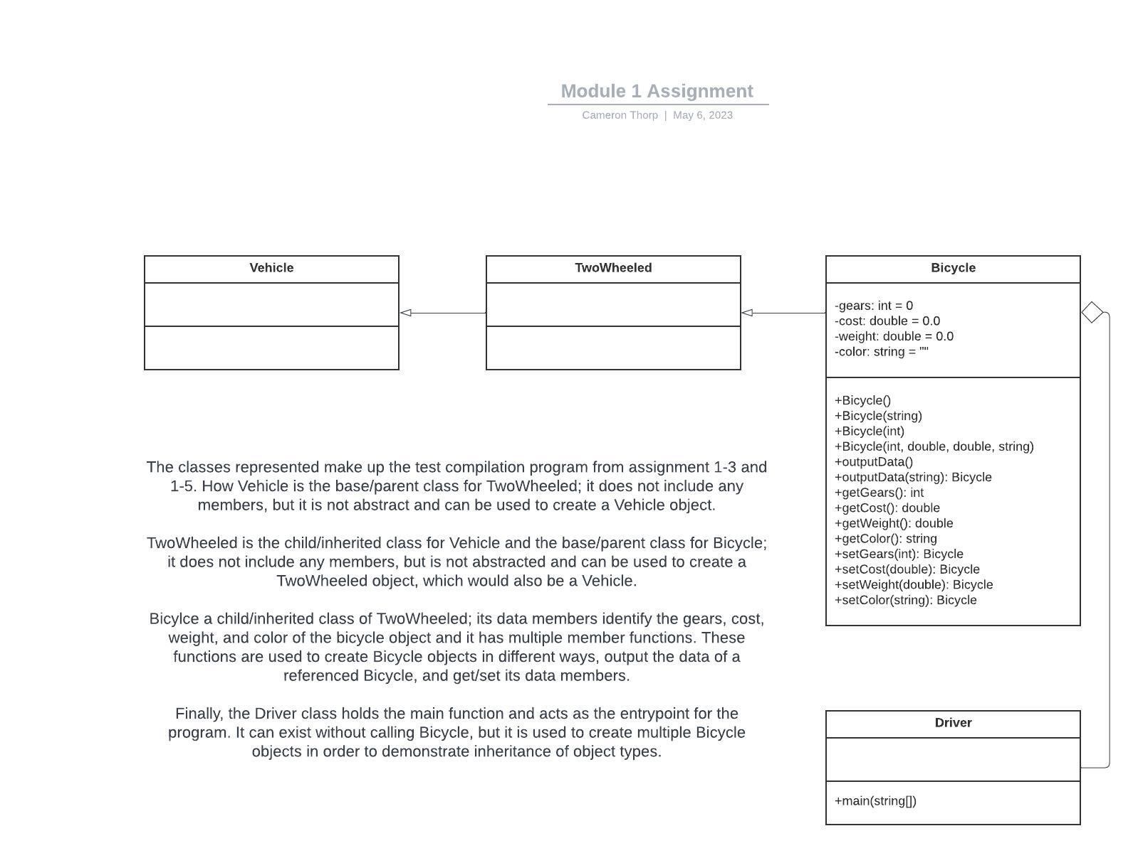

Described above in the diagram is how the classes relate and a generalized description of their purpose. The purpose of this assignment was to understand the relationship between classes that interact with each other, to include the concept of inheritance.

The principle of inheritance allows for programmers to reduce redundant code, while adding flexibility and functionality to programs that have complex software architectures. This concept, along with all the other OOPs and SOLID principles will help to create effective code during this course and afterwards.