Cameron Thorp

IT-140 Introduction to Scripting

Project 1

Overview (1):

The hero is the last of his party upon reaching the dungeon of the dracolich. He can’t turn back and has no hope of defeating this foe in single combat, so a ritual must be performed to dispel the necromantic magic keeping the dracolich alive. The hero will start in the antechamber and will have to travel around the different locations in the primary keep of the dracolich. He will need to find the required items in the surrounding rooms, to combine and perform the ritual, dispelling the evil magic.

Diagram (2):

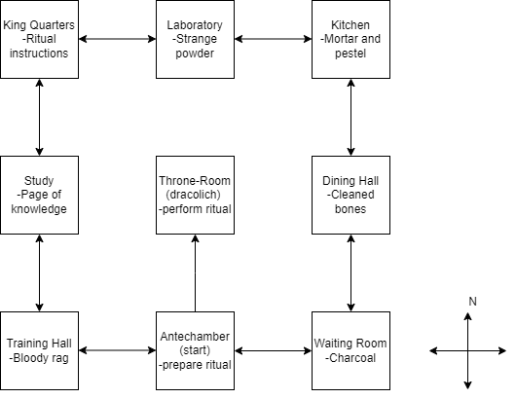

Pseudocode (4/5):

The user will be welcomed and given some rules, the backstory and then prompted if they want to begin the game.

If the user enters an affirmative response, the adventure will begin. If the response is negative, the program will exit. Otherwise the user will be informed of the response options and prompted to enter a new one.

The user will be placed into a loop which will continue as long as the game is not won or lost.

In each loop, the user will be informed which room they are in, and the available actions or movements they can take. These actions will be listed with numbers for ease of input.

Each room will be controlled by an object to dictate what options are available to the user based on their position. This will include booleans to enable the directions of movement and the presence of items.

Once the user travels and collects all objects required, they will be prompted to return to the antechamber room to complete the ritual and win the game. This state will be tracked by a variable that is checked at the end of each loop.

One of the objects they can collect will provide extra information to the user about how to win the game once all the other objects are found.

The user will then select items in order from their inventory until there are no items left. They will then be able to perform the ritual in the villain room and win the game.

If the order of the items selected is incorrect, the player will lose the game, else if the player has combined the items in the correct order, they will win the game.

Once the user wins or loses, they will be given the end of the story which corresponds with their outcome.