Assignment 2

SPICE Simulations and Circuit v1.0

Q1: Power supply subsystem

Q1.1

Figure 1.1.1

The plot above shows the input voltage which is set at 24V DC. The output voltage will be a constant 12V DC which will be sent to the Amplifier subsystems to be used in the powering of the solenoid valves. The voltage out does have a small delay time which is negligible as it is less than 1 millisecond. This is due to the internal configuration of the LTC3895 IC that will be used.

Figure 1.1.2

The figure above shows that the switching voltage regulator can provide a stable 12V DC output even if the input voltage drops to15V for example. The lowest rated voltage the switching regulator can accept is 4V although this is not recommended.

Figure 1.1.2

The figure above demonstrates that the switching voltage regulator can provide a stable 12V DC output when the input voltage exceeds the predicted input of 12V. The plot shows an input of 48V for example. The highest rated voltage the switching regulator can accept is 140V although this is not recommended.

Q1.2 & 1.3

**3  
LTC3895 IC Package**

**4  
Main GND Point**

**5  
LTSpice Simulation Command**

**2  
Output Voltage**

**1  
Input Voltage**

Figure 1.2.1

This figure shows the main circuit layout of the power sub module. At its core it uses a LTC3895 IC package provided by Analog Systems. The circuit design and simulation were done in LTSpice. The macromodel’s test configuration was used as the final configuration, as recommended by the datasheet and LTSpice. The labels on the diagram describe the following sections:

1 – The Input Voltage, in the case of figure 1.2.1, is 24V. This voltage is adjusted in the figures 1.1.2 and 1.1.3 to demonstrate the high- and low-end voltage protection due to incorrect external DC power supply rating.

2 – The Output Voltage is 12 V. The voltage drawn from the point called “OUT” is 12V for all voltage inputs in the range of 4V to 140V. The output can allow a draw of a maximum of 5A. This 5A threshold suits the project well for expansion as an individual solenoid valves draw a maximum of 710mA during operation and the combined current draw in parallel is 1.4A. This is much lower than the 5A rating and allows for future output expansion.

3 – The LTC3895 IC is a Step-Down Buck regulator providing the ability to regulate input voltages down to 12V. In its most basic configuration, as seen in the above diagram with external circuitry, it requires a number of resistors, capacitors, inductors and MOSFETs.

4 – This is the main ground pin connection of the IC package and all other ground points are relative to this same ground point.

5 – The LTSpice simulation command used was a transient DC analysis over a short duration. This circuit has numerous data points to calculate and thus the plotting of the values is determined by the calculation speed. Because of this, a short analysis period was chosen.

Originally a simple linear voltage regulator was used in our V0.1 power submodule circuit designs. This was used as it was not clear what the difference was between it and the switching voltage regulator (now implemented above). After research was completed on the topic it was found that a switching voltage regulator proves to be more efficient and does not require a heatsink as minimal heat is dissipated by the device. The figures below display the difference between the V0.1 and V1.0 KiCAD designs:

Q1.4

Yes, the circuit simulated meets the specifications for this subsystem, as follows:

Initially the system used a linear voltage regulator which was incorrect. This regulator was replaced with the correct switching regulator as specified in the instructions of the project and thus met the requirements for the subsystem.

Another subsystem requirement was a stable output of 12V which was achieved during simulations of the circuit. For added protection, we made sure to choose a switching regulator which can accept a wide range of input voltages while still producing the 12V output. This ensures that the solenoid valves cannot be damaged by severe voltage increases or incorrect external power supply connections by the user.

Lastly, the subsystem redesign allowed for a future specification to be met. This was that the size of the Pi HAT should meet the Raspberry Pi Zero standard mechanical specifications. By moving away from a linear voltage regulator (which required a heatsink about five times the size component footprint) and implementing a switching regulator (which uses small components that can be surface mounted to save space) we managed to achieve this specification.

Q2: Amplifier

Q2.1

*Running Simulations of Amplifier subsystem of Irrigation PiHAT*

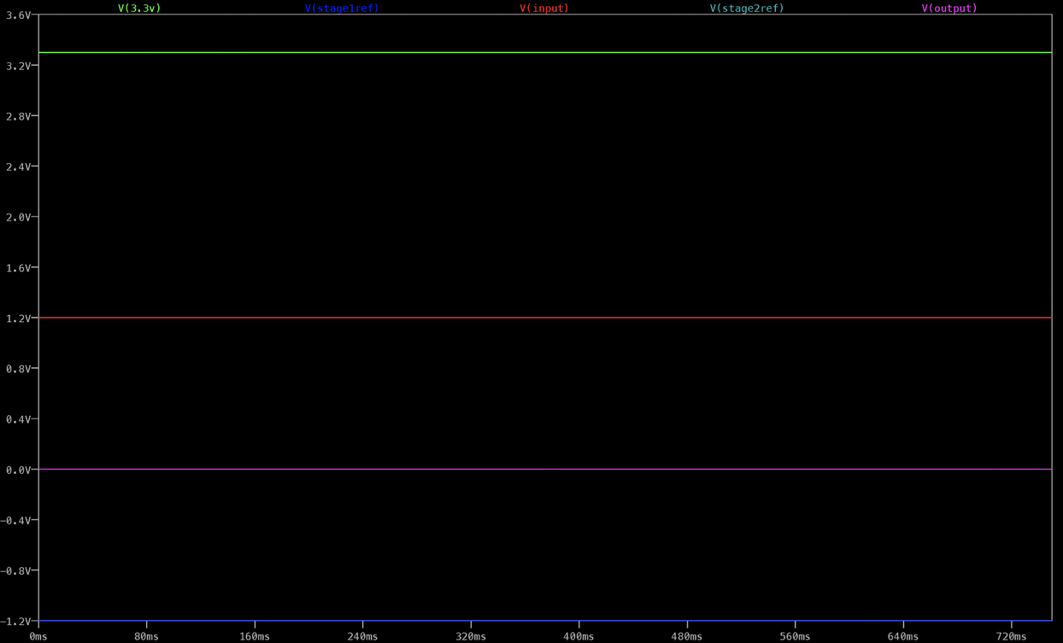

Figure 2.1.1

Amplifier circuit simulation displaying the output Voltage of the circuit yielded from a constant 1,2 V input V(input). This input provides a means for simulating the lower bound of the input voltage received from the soil moisture level sensing circuit.

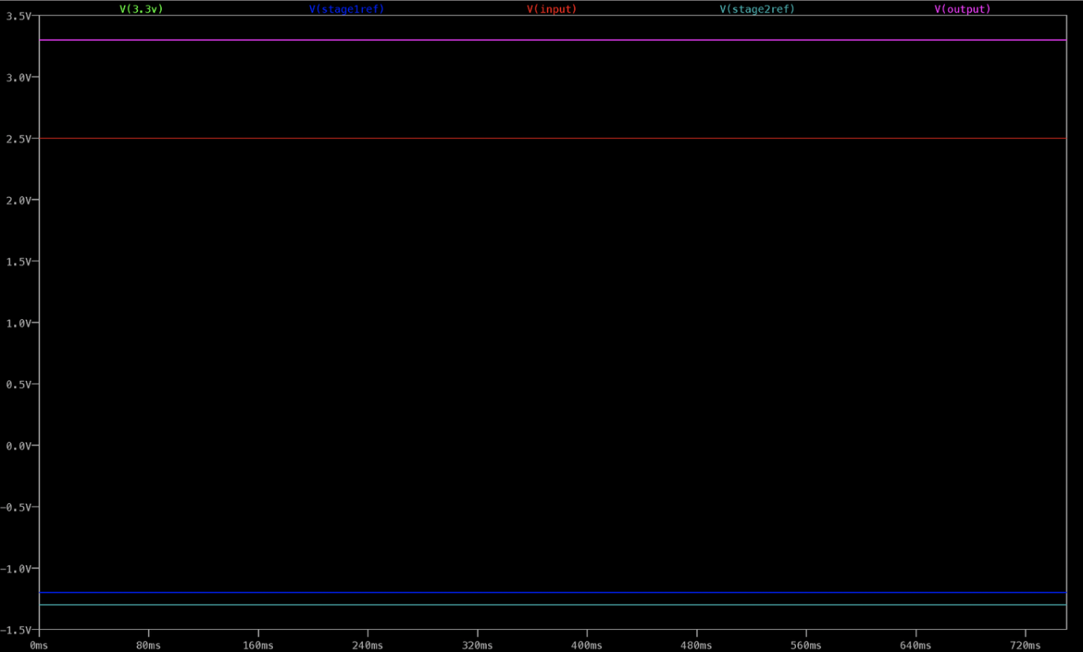

Figure 2.1.2

Amplifier circuit simulation displaying the output Voltage of the circuit yielded from a constant 2,5 V input V(input). This input provides a means for simulating the upper bound of the input voltage received from the soil moisture level sensing circuit. At this input voltage, the output of this sub-system V(out) is the maximum output of 3,3V Vout(3.3V).

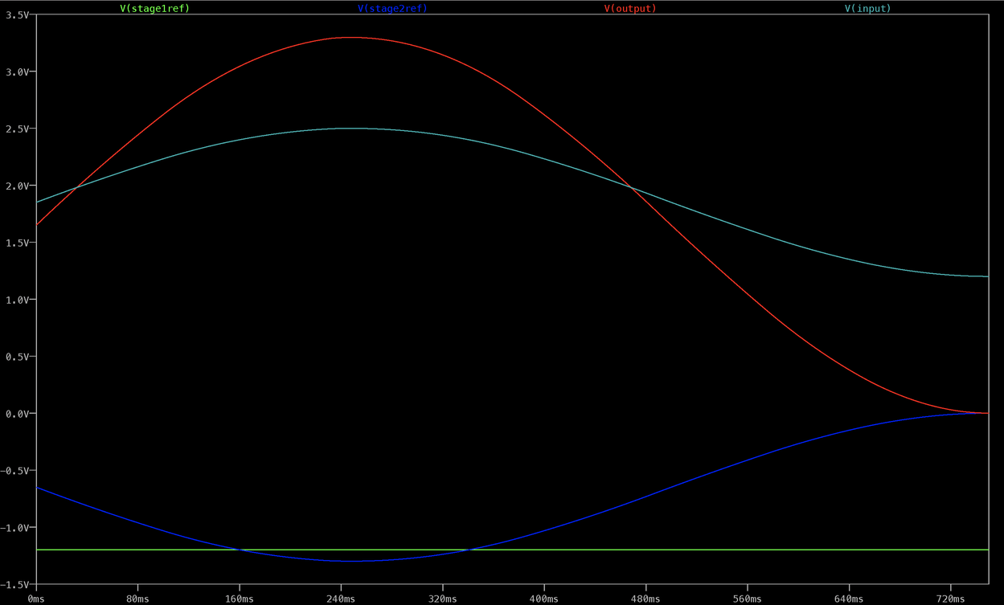

Figure 2.1.3

Amplifier circuit simulation displaying the output Voltages of the circuit yielded from a sinusoidal input V(input). This input provides a means for simulating the various voltage inputs received from the soil moisture level sensing circuit depending on the possible soil moisture levels.

Q2.2

*Circuit diagrams of Amplifier subsystem of Irrigation PiHAT*

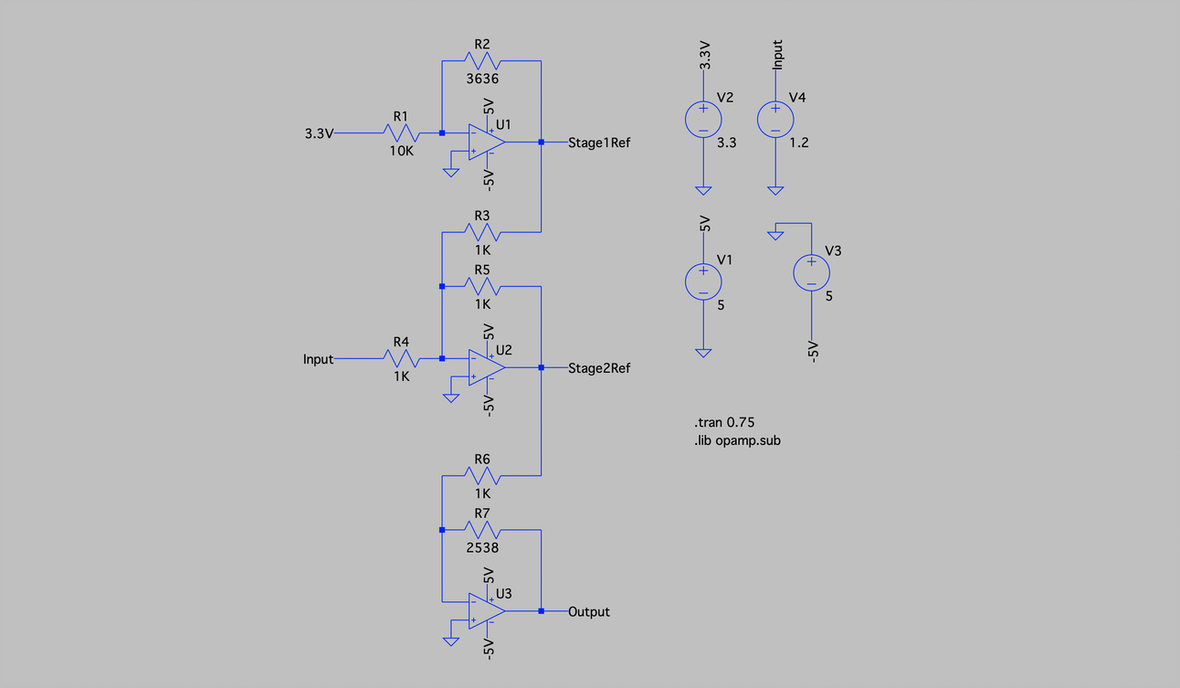

Figure 2.2.1

Amplifier circuit with an input Voltage yielded from a constant lower bound 1,2 V input V(input).

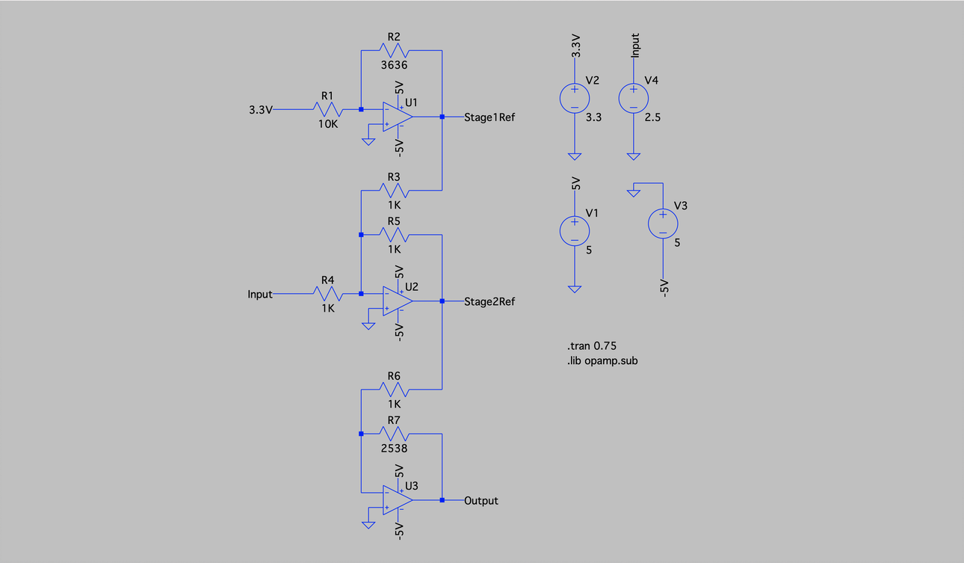

Figure 2.2.2

Amplifier circuit with an input Voltage yielded from a constant upper bound 2,5V input V(input).

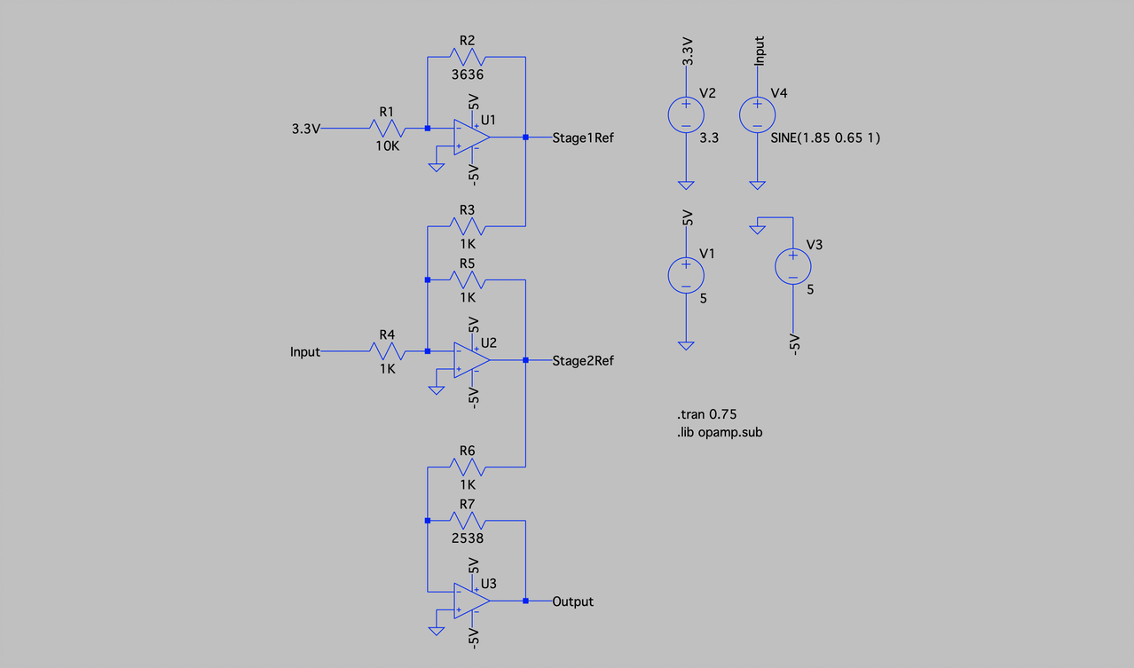

Figure 2.2.3

Amplifier circuit with an input Voltage yielded from a time-varying sinusoidal input V(input).

Q2.3

The three stages of op amps are connected to each other, with U3 providing the amplified output that will interface with the LED comparators and manual comparator subsystems. The input to the amplifier subsystem comes in the form of an analogue signal from the moisture sensors, in the range of 1.2V to 2.5V.

The output of the subsystem involves an adjusted analogue signal which is scaled to be between 0V and 3.3V to match the Raspberry Pi’s output rails.

The LM324D op amp was chosen for this circuit as it is a quad op amp, which means it is a 4-in-1 integrated circuit, and therefore is more space-efficient on a PCB. Additionally, this op amp is a Surface-Mount Device, further saving space on the PCB.

Q2.4

Yes, the circuit simulated meets the specifications for this subsystem, as follows:

***Stage 1:*** The inverting op amp U1 amplifies a 3.3V input voltage to –1.2V to be used in Stage 2.

***Stage 2:*** Consists of a summing amplifier op amp U2. The input signal of 1.2-2.5V is summed with the –1.2V to achieve a 0-1.3V output to be used in stage 3.

***Stage 3:*** The inverting op amp U3 amplifies Stage 2’s output to a value between 0V and 3.3V as required.

Q3: Status LEDs and Valve Control

Q3.1

*Running Simulations of LED and Valve Control subsystem of Irrigation PiHAT*

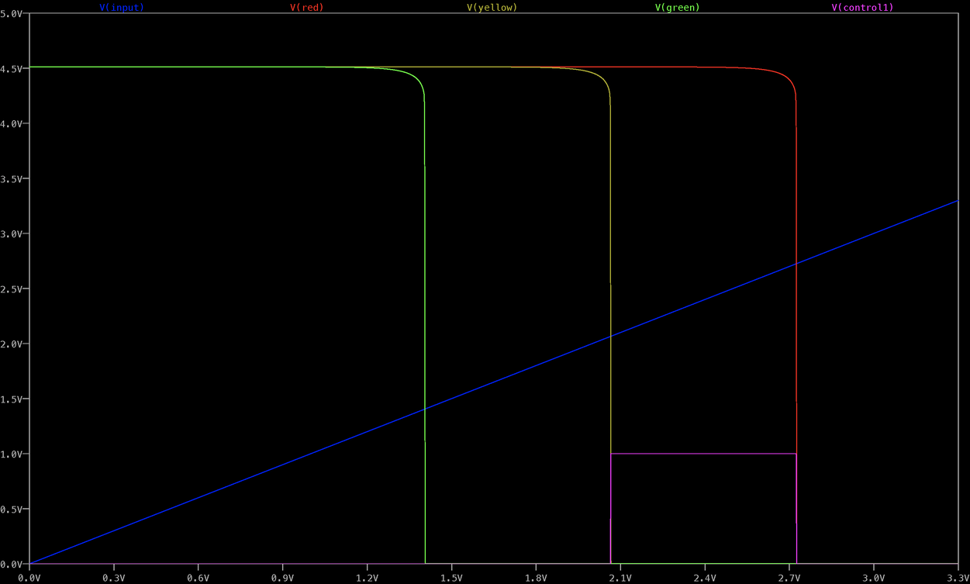

Figure 3.1.1

LED circuit simulation displaying:

1. A simulated input Voltage V(in) ranging from 0V (very moist soil) to 3,3V (very dry soil).
2. The adjustable trigger Voltages of the comparators V(red), V(yellow) and V(green) for the respective coloured LEDs, indicating at what input voltage these comparators turn on (consecutively).
3. An additional potentiometer-dependent voltage V(control) that can be adjusted by the PiHat user, to manually control the valves and bypass the soil moisture sensors.

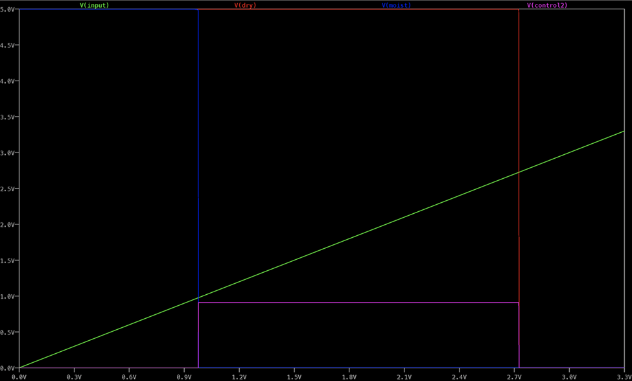

Figure 3.1.2

Valve control circuit simulation displaying:

1. A simulated input Voltage V(in) ranging from 0V (very moist soil) to 3,3V (very dry soil).
2. The adjustable trigger Voltages of the comparators V(dry) and V(moist), in the case that the user does not want to use the LED subsystem.
3. An additional potentiometer-dependent voltage V(control2) that can be adjusted by the PiHat user, to manually control the valves and bypass the soil moisture sensors.

Q3.2

*Circuit diagram of LED and Valve Control subsystem of Irrigation PiHAT*

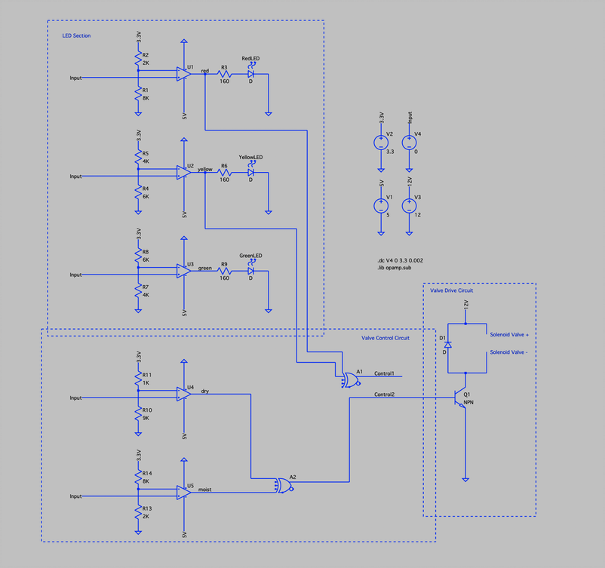

Figure 3.2.1

LED and Valve Control circuit, visually divided into the “LED Section”, “Valve Control Circuit” and “Valve Drive Circuit” circuity.

Note: Control 1 and 2 indicate the action of physical switch control, as this cannot be simulated on LTSpice. The Valve Drive Circuit demonstrates the result of triggering Control 1 and 2 (i.e. the switches).

Q3.3

The inputs to the comparator subsystems come in the range of 0V to 3.3V as an analogue input signal. This signal is received from the amplifier subsystem. When each comparator’s input voltage exceeds the set threshold voltage, the LEDs sequentially turn on.

The outputs of the comparators additionally enter the Raspberry Pi to provide optional data for users to read in. These outputs will vary between a high or low state as outputted by the Op-Amps. Essentially, the Raspberry Pi will read the LED state.

There is an override switch present between the LED and valve control circuit, as a means to manually control the valve control values. There is an internal subsystem which provides the user of the HAT to switch the output interface configuration using a pin jumper.  The output is an analogue signal and can be drawn from either the LED comparator system or by a potentiometer adjustable circuit.

The LED resistor values (160 Ohms) were determined from (5V-1,8V / 20mA), where 20mA is the operating current of the LED.

Q3.4

Yes, the circuit simulated meets the specifications for this subsystem, as follows:

1: Three comparator circuits present, with each threshold voltage controlled by a potentiometer.

2: There are two circuits present to determine the valve control system, namely two additional comparators for when the valve turns off and on, as well as logic gates to ensure the valves turn on at the required values.

Q4: Simulation as a design stage

The LED subsystem simulation results changed the circuitry of the comparators, which were originally designed with a 5V Vcc and 0V Vss, wherein the Vcc and Vss values had to be swopped for the simulation to correctly display the sequential triggering of the LEDs.

The simulation of the original voltage regulator subsystem, which used a linear voltage regulator, identified some edge cases where it would not work. By researching further into voltage regulators as well as obtaining an instructor’s advice, it was discovered that a switching voltage regulator should instead be used. This research also proved useful for thinking ahead to the PCB design as a linear voltage regulator would require a large heatsink which would exceed the mechanical dimensions of the Pi HAT.

Other subsystems confirmed that our designs were done correctly.

Q5 Simulation Files Access

Access all our Assignment 2 resources via:

* <https://github.com/ryxcam002/IrrigationPiHat/tree/master/Assignment2>

All other project files generated so far can be found at the root of the master branch:

* <https://github.com/ryxcam002/IrrigationPiHat>