Metasploit - Lab Report

Date: 29/05/2026
Difficulty: Medium
Category: Exploitation
Platform: TryHackMe

Overview

This lab gives a total overview of Metasploit and how it is used by penetration testers and attackers to scan targets, exploit targets and gain information in the post-exploitation phase. This lab has explanations about all the details to do with Metasploit as well as practical examples and challenges to show how this would be used in the real-world.

2. Toolset Used

Tool | Purpose / Function
Metasploit | Exploitation framework which supports all phases of a penetration test to gather information, scan targets, exploit targets and run post-exploitation processes using various built-in tools and techniques.

3. What I did

Introduction

Metasploit is the most used exploitation framework as it is a tool which can support all phases of a penetration test. The framework is a collection of tools that allow information gathering, scanning, exploitation and post-exploitation. Msfconsole is the main command-line interface, modules are supporting modules such as scanners, payloads and exploits, tools are used in their own way depending on the users needs.

An exploit is code that uses a vulnerability on the target system. A vulnerability is a weakness in the target system such as poor design or coding. A payload is the code that runs on the target system to carry out the attack such as reading confidential data or gaining access to the target system.
- Auxiliary – supporting modules, scanners etc can be found here
- Encoders – these allow you to encode the exploit and payload in the hope that a signature-based antivirus software will miss them as signature-based antivirus systems have a database of known threats.
- Evasion – these try there best to evade antivirus software
- Exploits – contain exploits for targets
- NOPs – No OPeration - do nothing
- Payloads – codes that run on the target system. There are different types of payloads such as adapters, singles, stagers and stages. Adapters wrap single payloads to convert them into different formats. Singles are self-contained that do not need to download an additional component to run. Stagers responsible for setting up a connection between the target and Metasploit. Stages are downloaded by the stager which allows larger payloads. Single payloads are also called inline payloads (generic/shell_reverse_tcp) whereas staged payloads look like (windows/x64/shell/reverse_tcp).
- Post – useful on the final stages of a penetration test (post-exploitation)

Msfconsole can be launched by typing msfconsole in the terminal. It supports most Linux commands but does not allow for redirection. The module to be selected can be chosen by typing the use command followed by the exploit. You can use the show options command to view the possible requirements such as RHOSTS and RPORT. Some options are required but some are not so you need to make sure that the required ones are filled out before it will work. You can use the show command for any of the module types above such as payload, exploit etc. The back command takes you back a step and the info command gives you more details such as a description and authors. Search command can be used to search the database for CVE’s or exploit names.

- RHOSTS – Remote hosts which is the IP address of the target system
- RPORT – Remote port is the port on the target system the vulnerable application is running on
- PAYLOAD – The payload you will use with the exploit
- LHOST – Local host is the attacking machines IP address
- LPORT – Local port is the port you use for the reverse shell to connect back to
- SESSION – Session ID of the connection established to the target system

Once all parameters are set, you can run the module by using the exploit command or run command. The exploit -z command runs the exploit as soon as it opens. Some modules have a check option which checks to see if the target system is vulnerable without actually exploiting it. The background command puts the session to the back and takes you to the msfconsole prompt again.

Exploitation

Metasploit has scanning modules which scan open ports on the target system and network. You can find these by using the command “search portscan”. You will need to set a few parameters such as PORTS for port range, RHOSTS for target, CONCURRENCY for number of targets to be scanned at the same time and THREADS for the number of threads to be used at the same time (the more threads, the quicker). You can also directly perform Nmap scans from the msfconsole. UDP service identification module scans UDP services and service scans such as SMB scans.

For example, to scan the target I selected the TCP module from the options and ran it against the target IP which shows 5 open ports.
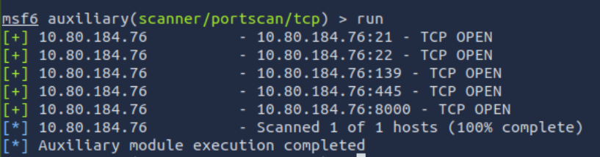

To find out the NetBios name the /scanner/netbios/nbname module was used against the target
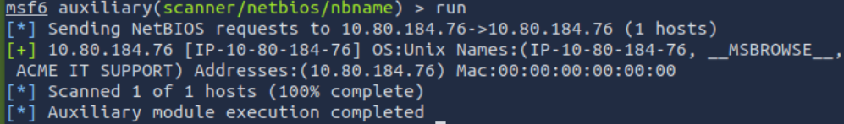

To find out what was running on port 8000, I used the /scanner/http/http_version module against the target IP and changed the RPORT from 80 to 8000
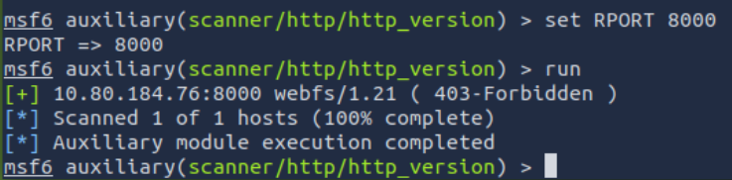

To find the SMB password for the user “Penny”. I used the /scanner/smb/smb_login module and set the RHOST to the target IP, the USERNAME to penny and the PASS_FILE to the file path to the wordlist to brute force the password.

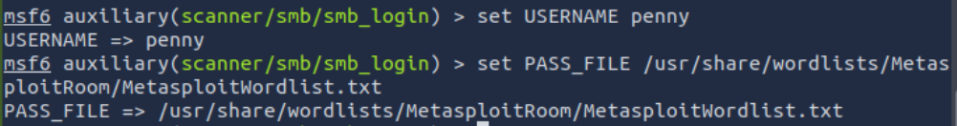

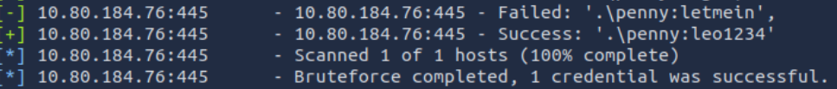

If your scans return a possible vulnerability, then you would sue the search command to look for exploits and the info command to get more information of what each exploit does. For example, you could search SMTP and find the scanner/smtp/smtp_relay module > use > info and see the creator is Campbell Murray.
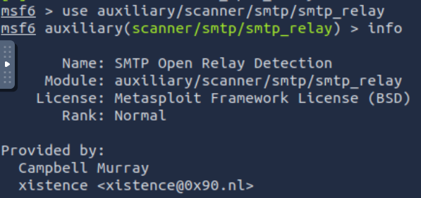

During exploitation, you can search exploits > show payloads > set payloads > show options > set parameters > run/exploit and Metasploit does the rest for you.

An example of exploitation is shown below where the ms17_010_eternalblue vulnerability is exploited using a selected payload.

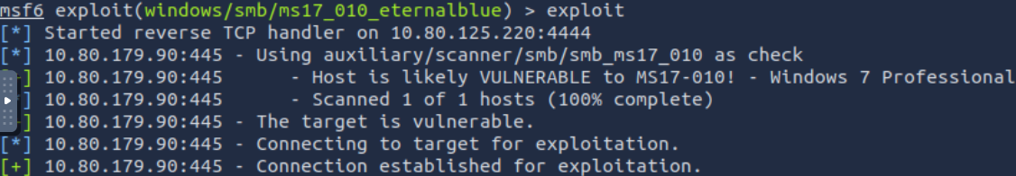

From this, we get a meterpreter session which we can then search for the flag.txt file and that returns the path to it so we can cat the file and view the flag.

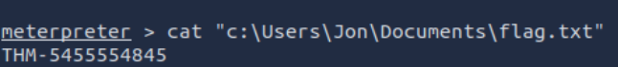

To find the NTLM hash of the user “pirate”, I use hashdump to view the hashes of each user

Msfvenom allows you to access all payloads available in the Metasploit framework and create payloads in many different formats such as PHP, elf and exe for different target systems such as Apple, Windows and Linux. Encoding can be used with the -e parameter to encode the payload. Handlers accept incoming connections generated by the Msfvenom payload. Multi Handler can be used to receive incoming connections by using the exploit/multi/handler module. This module supports all Metasploit payloads and can be used for regular shells and Meterpreter. You need to set the LHOST and LPORT and then run the handler and wait for incoming connections. Once the reverse shell is triggered, the connection is received by the multi/handler and gives us a shell.

To show Msfvenom in a practical example, I used the attack machine to create a .elf file and used wget to download it to the target machine. I then set the module to exploit/multi/handler and the payload to /linux/x86/meterpreter/reverse_tcp. I set the LHOST and LPORT to the attacker IP and PORT.

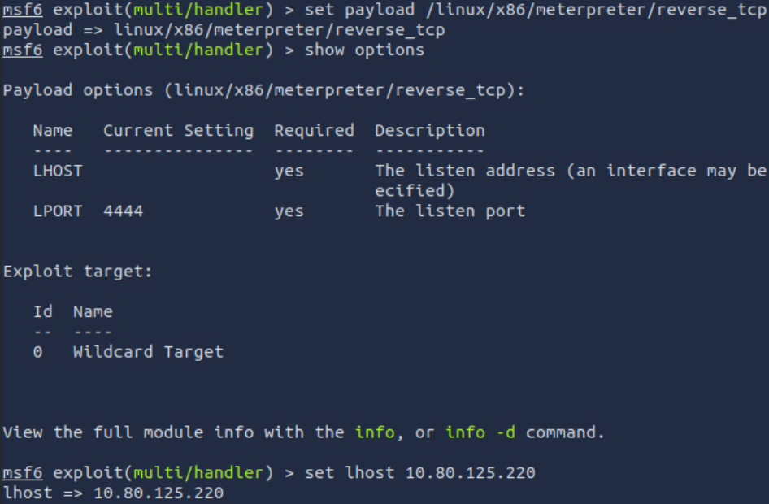

Once this was run, I executed the .elf file on the target machine and the meterpreter shell was open on the attacker’s machine. Now to find the hash of the users, I needed to use the background command and then use the post/linux/gather/hashdump module and set the session to session 2 which was the meterpreter session of the target machine.

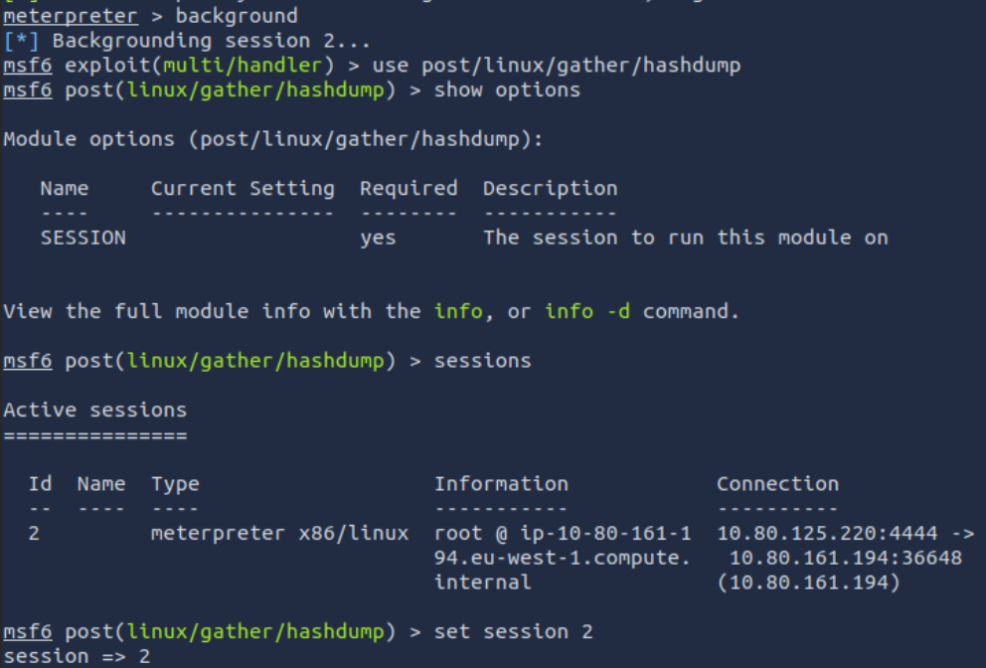

When this module was ran, the user’s hashes were available
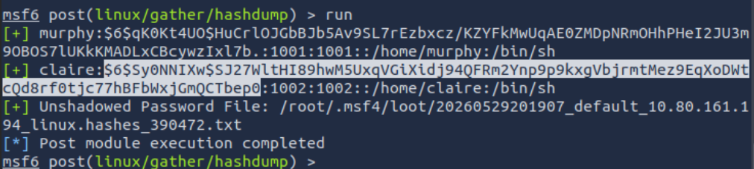

Meterpreter

Meterpreter is a Metasploit payload that supports the penetration testing process as it runs on the target system and acts as an agent to take control. It runs on the target system, but it is not installed on it, and it runs in memory (RAM) and doesn’t write to the disk of the target to avoid detection. This means that Meterpreter is viewed as a process and not a file on the targets system. It also looks to avoid detection by using encrypted communications (TLS) with the attacking machine.

Meterpreter also has inline (single) and staged payloads. The decision on what to use can be decided based on the target OS, components available on the target system (is python installed, is it a PHP website) and the network connection types (can you have HTTP reverse connections or only HTTPS ones). It has 3 primary categories of tools – built-in commands, meterpreter tools and meterpreter scripting. Commands for meterpreter post-exploitation are identified below.

- Getuid – displays the user that is currently being used
- Ps – lists the running processes
- Migrate – used to migrate to another process (migrate to word.exe and capture keystrokes)
- Hashdump – displays the content of the SAM (security account manager) database
- Search – used to locate files
- Shell – launches a regular command-line shell on the target system (CTRL+Z to go back to meterpreter shell)

A practical example of how Meterpreter can be used for post-exploitation is documented below:

To find the computer name, use the sysinfo command
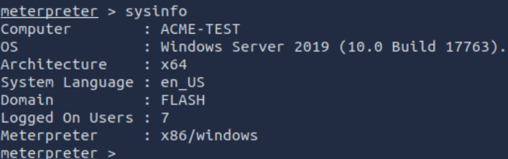

To find the target domain, use the background command and use the new module enum_domain and set the session parameter to the meterpreter one.
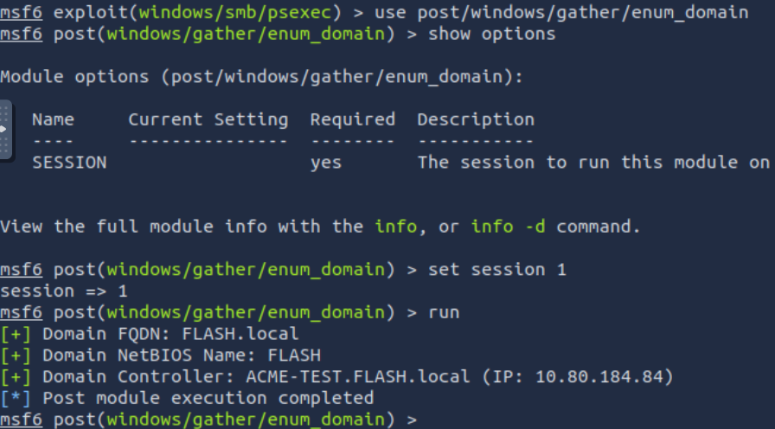

To find the name of the share, the background command was used again and then the new module enum_shares was used and the session parameter was set to 1 again.

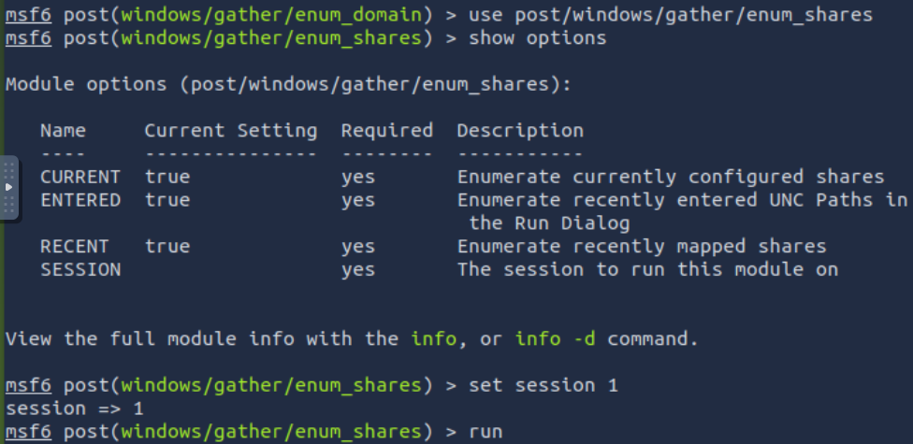
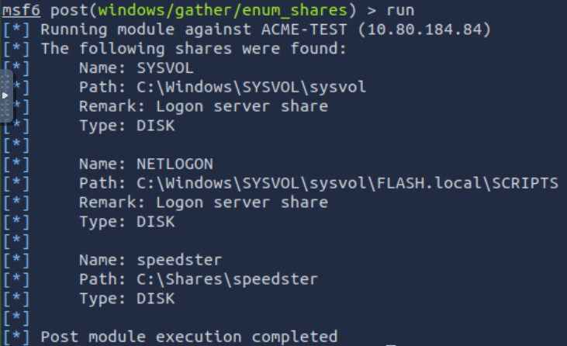

To find the NTLM hash of the user jchambers, I had to find the PID of the lsass.exe and then migrate to that PID and use the hashdump command.
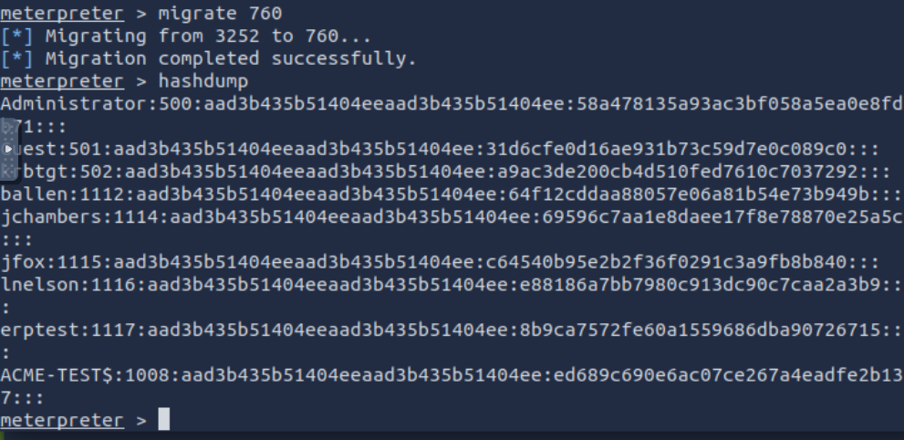

I was then able to crack that hash and reveal their password by putting the hash into crackstation.net and it cracked the hash for me.

To discover where the secrets.txt file was located, I used the search -f command which managed to find the location of this file. Inside this file, the twitter password was revealed.

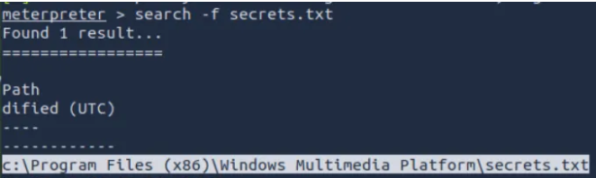

4. What I’ve learned

- The background to Metasploit
- Exploitation techniques
- Payloads
- Navigation around Metasploit and Msfvenom
- How to use Meterpreter
- Post-exploitation methods and information gathered using Meterpreter

