SQLMap - Lab Report

Date: 29/05/2026
Difficulty: Easy
Category: Offensive Security
Platform: TryHackMe

Overview

This lab introduces SQLMap which is an automated tool used for finding and exploiting SQL Injection vulnerabilities on web applications. This lab covers some fundamental knowledge needed to understand databases and how they can be exploited as well as practical examples of using SQLMap.

2. Toolset Used

Tool | Purpose / Function
SQLMap | An automated tool for detecting and exploiting SQL Injection vulnerabilities in web applications as it simplifies the process of finding the vulnerabilities.

3. What I did

A database is a collection of data which is stored, retrieved and modified from several sources and applications and stored in a structured format making it easier and efficient. Websites with features such as login portals use databases to store log in credentials and the website compares the user input with the database entries to see if there is a match or not. Databases are managed by database management systems (DBMS) such as MySQL, SQLite or Microsoft SQL Server. These use SQL language, so any application or website uses SQL queries to interact with the database.

SQL Injection is a web vulnerability that allows attackers to gain access to an application without valid credentials. When the input is not sanitized in the code, attackers can manipulate the input and write SQL queries which execute in the database. For example, if you have a username of John but you don’t know their password, you can use “’ OR 1=1 --” in the password field and this logs you in as John because the apostrophe is the password and then the 1=1 part equals true so login is granted.

SQLMap is an automated tool for detecting and exploiting SQL Injection vulnerabilities in web applications as it simplifies the process of finding the vulnerabilities. The –dbs flag extracts all the database names, -D database_name –tables finds all the tables in the database. The -cookie flag lets you include session cookies in the request to ensure that authentication is met like a normal user. An example command using SQLMap could be “sqlmap -u http://sqlmaptesting.thm/search/cat=1 -D members --tables” which extracts all tables from the members database from the vulnerable URL provided.

Practical

The vulnerable URL is http://10.81.150.119/ai/login which takes you to a login page as shown below.

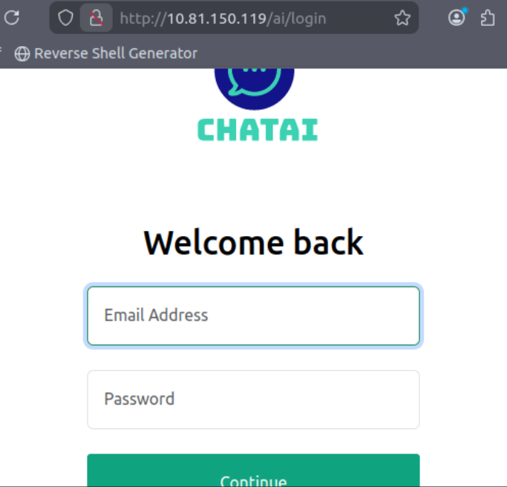

To find the URL with the GET parameters, right click > inspect > network and enter some test credentials to see the GET request.

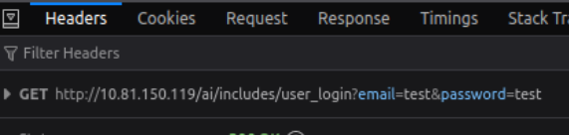

Now to use SQLMap to find the number of databases, table names and passwords. To find the number of databases, the command below was used which showed that there were 6 databases found.

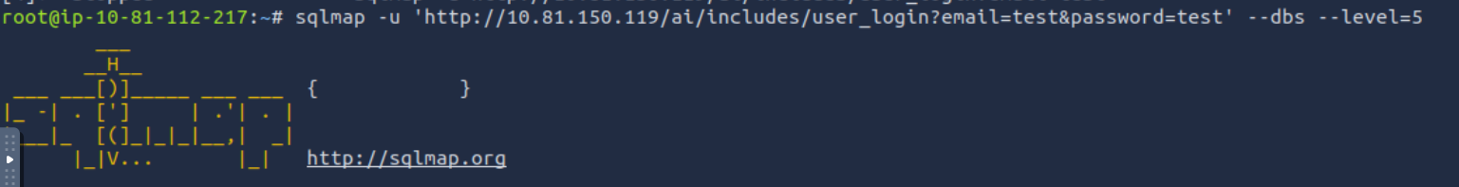

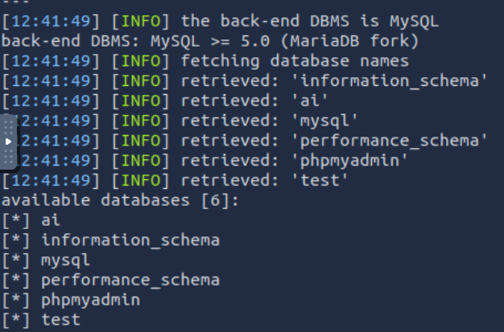

To find the name of the tables in the ai database the following command was used which returned that there is one table called user.

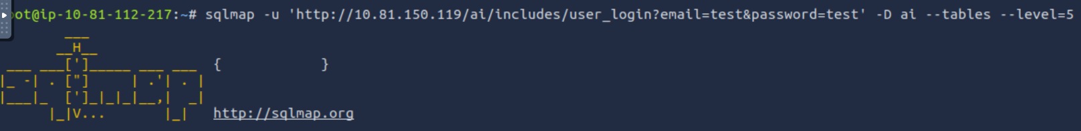

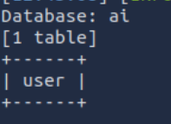

Finally, to find the password of the email test@chatai.com we need to use the following command which takes the database name and the table name and dumps the records to the screen.

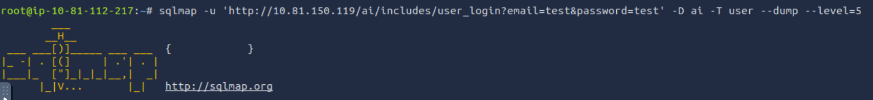

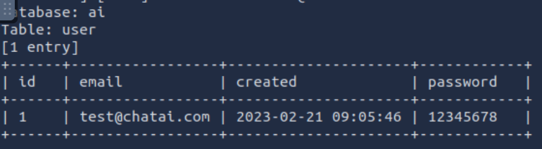

Now I can use these credentials to log in to the web application.

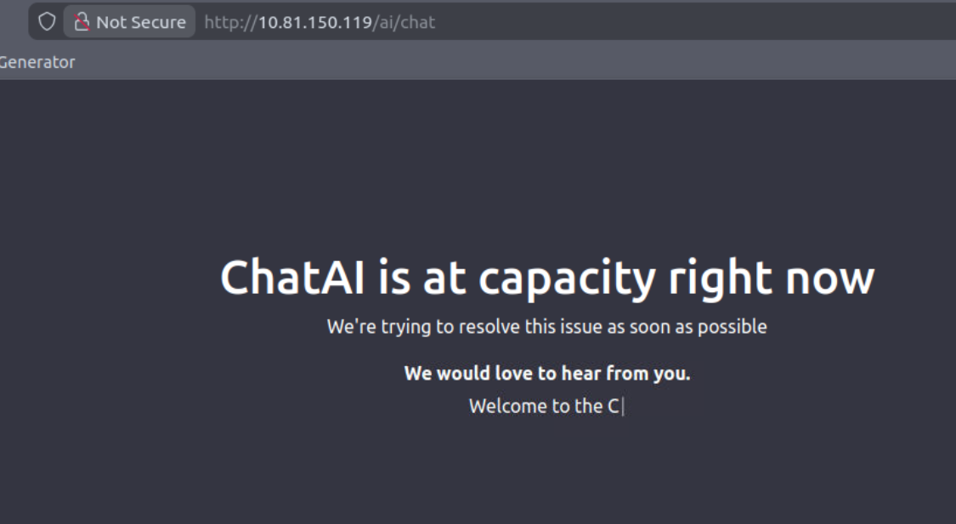

4. What I’ve learned

- Database fundamentals
- SQL Injection background information
- SQLMap tool
- Practical experience of SQLMap to see databases, tables and retrieve passwords to log in

