Gobuster - Lab Report

Date: 28/05/2026
Difficulty: Easy
Category: Offensive security
Platform: TryHackMe

Overview

This lab is an introduction to the reconnaissance and scanning tool Gobuster. This lab focuses on 3 different modes which can be used by this tool. The modes discussed and used are dir, dns and vhost. Each mode is described and has a practical use case shown.

2. Toolset Used

Tool | Purpose / Function
Gobuster | Offensive security tool used for reconnaissance and enumeration of web directories, subdomains and virtual hosts

3. What I did

Gobuster is an open-source tool written in the Golang language and it enumerates web directories, DNS subdomains, virtual hosts etc. It uses wordlists and is commonly used for penetration tests, cyber security assessments or bug bounty challenges. This tool is between the reconnaissance and scanning phases of penetration testing. Enumeration is the process of listing all the available resources, whether they are accessible or not. The wordlists are used to brute force.

Available commands + flags:

- Dir for directory enumeration mode
- Dns for DNS subdomain enumeration mode
- Vhost for Virtual hosts enumeration mode
- -t is for threads
- -w is for wordlist
- -o is to output the results to a file
- -u target URL

Example command:

gobuster dir -u "http://www.example.thm/" -w /usr/share/wordlists/dirb/small.txt -t 64

Use case for directory and file enumeration

The dir mode is used here and is useful in a pen test when you would like to see the directory structure of a website and what files are stored there. There are multiple flags that can be used as shown below.

- -c = cookies
- -x = extensions
- -H = headers
- -P = password
- -s = status codes
- -U = username

Examples:
- gobuster dir -u "http://www.example.thm" -w /path/to/wordlist
- gobuster dir -u "http://www.example.thm" -w /usr/share/wordlists/dirbuster/directory-list-2.3-medium.txt -x .php,.js

If I run the command “gobuster dir -u "http://www.offensivetool.thm" -w /usr/share/wordlists/dirbuster/directory-list-2.3-medium.txt -x .js”. The following output is shown which shows us the /secret directory which we can investigate further.

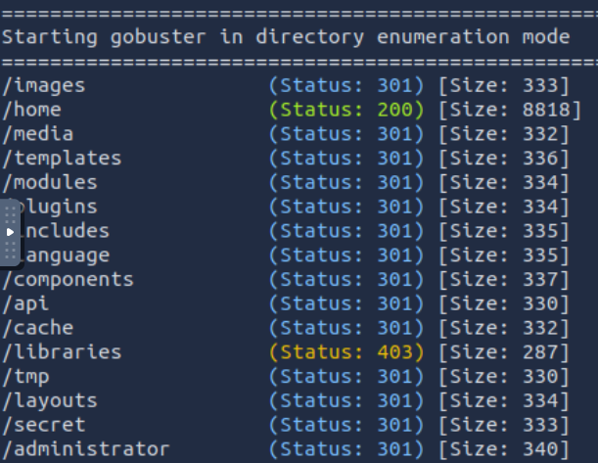
Now if I run this command – “gobuster dir -u "http://www.offensivetool.thm/secret" -w /usr/share/wordlists/dirbuster/directory-list-2.3-medium.txt -x .js”. I enumerate the secret directory and come across the flag I was looking for in flag.js.

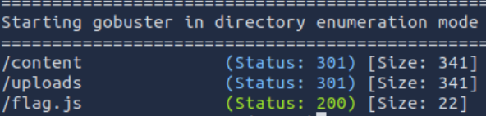

To view the file, I used curl to make a request to view the flag.js file

Use case for subdomain enumeration

This allows gobuster to brute force subdomains. During a pen test, checking the subdomains of the targets top domain is important as even if the top domain is safe, one of the subdomains may contain a vulnerability. There are flags which can be used such as:

- -c = CNAME records
- -i = show IP’s
- -r = resolving
- -d = the domain you want to enumerate

Examples

- “gobuster dns -d example.thm -w /path/to/wordlist”
- “gobuster dns -d example.thm -w /usr/share/wordlists/SecLists/Discovery/DNS/subdomains-top1million-5000.txt”

- If I run the command “gobuster dns -d offensivetools.thm -w /usr/share/wordlists/SecLists/Discovery/DNS/subdomains-top1million-5000.txt. The subdomains of the offensivetools.thm domain are shown.

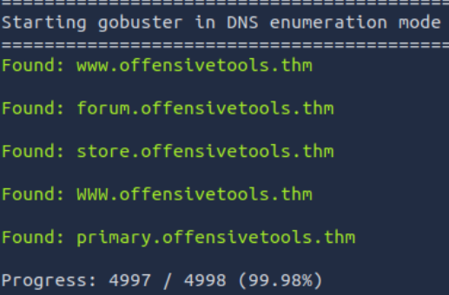
Use case for VHOST enumeration

This mode allows gobuster to brute force virtual hosts which are different websites on the same machine. Vhosts can look like subdomains, but they are scanned different. DNS mode does a DNS lookup using the domain name and a wordlist whereas VHOST navigates to the URL created by combining the HOSTNAME and the wordlist. Some flags are listed below:

- -u = URL target
- -m =method (GET or POST)
- -r = follows HTTP redirects

Examples

- “gobuster vhost -u "http://example.thm" -w /path/to/wordlist”
- “gobuster vhost -u "http://10.81.157.15" --domain example.thm -w /usr/share/wordlists/SecLists/Discovery/DNS/subdomains-top1million-5000.txt --append-domain --exclude-length 250-320”

- If I run the command “gobuster vhost -u "http://10.81.157.15" --domain offensivetools.thm -w /usr/share/wordlists/SecLists/Discovery/DNS/subdomains-top1million-5000.txt --append-domain --exclude-length 250-320”. The vhosts are displayed below.

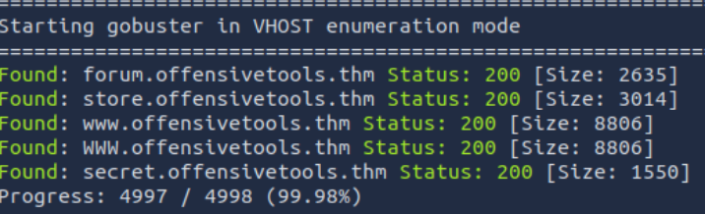

4. What I’ve learned

- What Gobuster is
- How to use Gobuster
- The different modes – dir, dns and vhost
- Practical uses for these modes

