FlareVM - Lab Report

Date: 24/06/2026
Difficulty: Easy
Category: Defensive security
Platform: TryHackMe

Overview

This lab discusses FlareVM and the collection of tools that are included with this. It highlights and discusses the tools in categories and gives a practical example of some tools such as Process Explorer, PEStudio and FLOSS.

2. What I did

FlareVM or Forensics, Logic Analysis, and Reverse Engineering is a collection of tools developed to meet the needs of forensic investigators, incident responders, pen testers and malware analysts. Below are the tools categorized into groups.

Reverse Engineering + Debugging

- Ghidra - reverse engineering
- X64dbg – debugger for binaries in x64 and x32 formats
- OllyDbg – debugger for reverse engineering at assembly level
- Radare2 – reverse engineering
- Binary Ninja – disassembling and decompiling binaries
- PEiD – packet, cryptor and compiler detection tool

Disassemblers + Decompilers

- CFF Explorer – portable executable editor
- Hopper Disassembler – debugger, disassembler and decompiler
- RetDec – Decompiler for source code

Static + Dynamic Analysis

- Process hacker – memory editor and process watcher
- PEview – portable executable file viewer for analysis
- Dependency walker – displays an executables DLL dependencies
- DIE (Detect It Easy) – a packer, compiler and cryptor detection tool

Forensics + Incident Response

- Volatility – RAM dump analysis for memory forensics
- Rekall – Memory forensics in incident response
- FTK Imager – disc image acquisition and analysis tools for forensic use

Network Analysis

- Wireshark – network protocol analyser for traffic recording and examination
- Nmap – Vulnerability detection and network mapping tool
- Netcat – Read and write data across network connections

File Analysis

- FileInsight – viewing and editing binary files
- Hex Fiend – Hex editor that is quick
- HxD – Binary file viewing and editing with a hex editor

Scripting + Automation

- Python – Mainly automation-focused on Python modules and tools
- PowerShell Empire – Framework for PowerShell post-exploitation

Sysinternals Suite

- Autoruns – shows what executable are configured to run during system boot-up
- Process Explorer – gives information about running processes
- Process Monitor – Monitors and logs real-time processes

Below is more information about some of these tools mentioned above as they are used in this lab.

Process Monitor (Procmon) is a Windows tool which records issues with the systems apps and lets you see, record and keep track of system and Windows file activity in real-time. It can be useful for tracking system activity, malware research, troubleshooting and forensic investigations.

Process Explorer (Procexp) gives insights into the active processes running on your computer and look at the inner workings of your system. It shows running processes and linked user accounts to see who is doing what.

HxD is a quick and flexible hex editor used to edit files, memory and drives. It can be used for forensic investigations, data recovery or debugging. Some important features include viewing file and memory content or editing/searching hex data.

CFF Explorer lets investigators generate file hashes for integrity checks, authenticate the source of system files and validate their validity. This is important when analysing malware as dangerous code could be hidden in altered system files.

PEStudio allows analysts to statically analyse or study executable files without running them so that their system is not at risk of the malware during execution.

FLOSS or FLARE Obfuscated String Solver automatically extracts and de-obfuscates all strings from malware programs. FLOSS includes Python scripts which can be used to load the scripts output to other programs such as Binary Ninja.

Practical

This practical part of the lab will use tools that have been discussed above to analyse different executables. A suspicious windows.exe file was downloaded and flagged as a potential threat, so my job is to analyse it and get details about it.

Firstly, I used PEStudio to gather information about this executable which shows details such as file size, hashes, file-type etc as shown below.

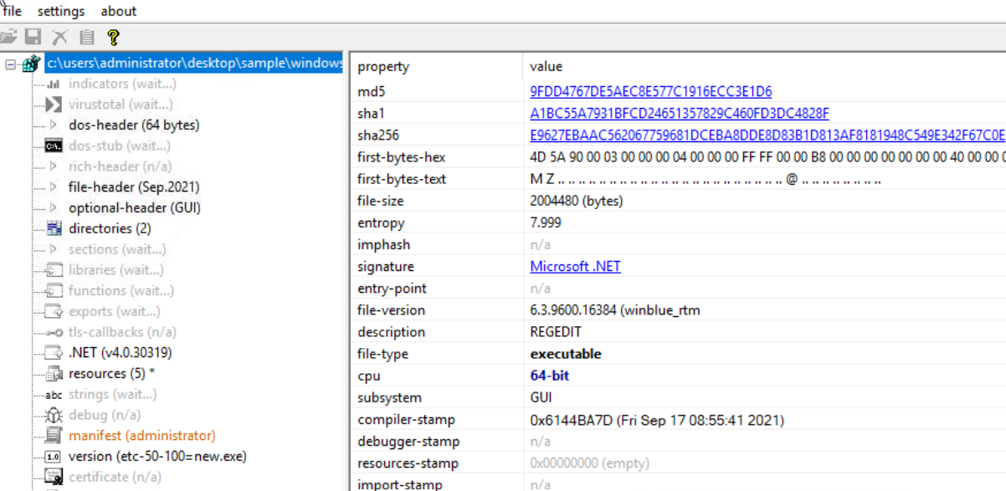

You could compare these hashes with databases such as VirusTotal to ensure that they are safe and are not known hash values. The file also claims to be connected to Windows Registry Editor (REGEDIT) but this is likely a trick to evade discovery as REGEDIT tools are usually found in Windows\System32 rather than the users download location. The absence of a rich header indicates that the file is likely packed or obfuscated to avoid detection from static analysis tools. Under the functions tab, the blacklist function “set_UseShellExecute” is detected which allows the process to use the OS shell to execute other processes which is dangerous.

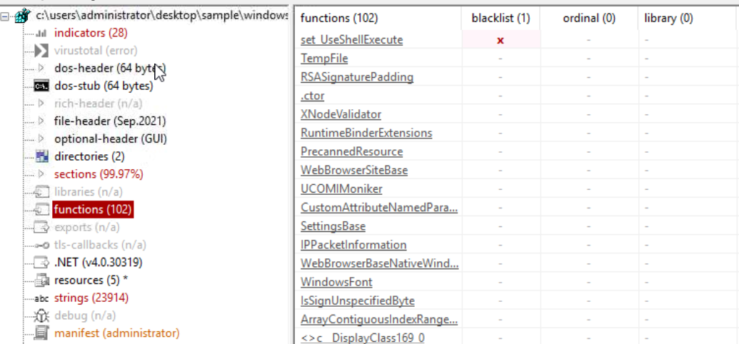

Next, I used FLOSS in PowerShell by using the command below and exporting the results to a text file.

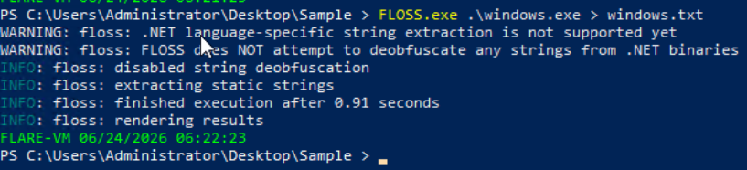

The output shows some familiar functions which were seen in the function section of the PEStudio tool.

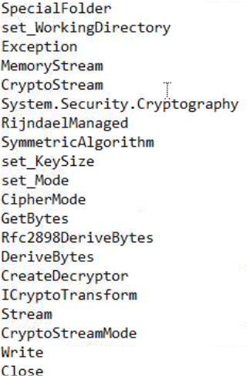

Using Process Explorer, I ran the cobaltstrike executable and found the process running under its parent process, explorer.exe.

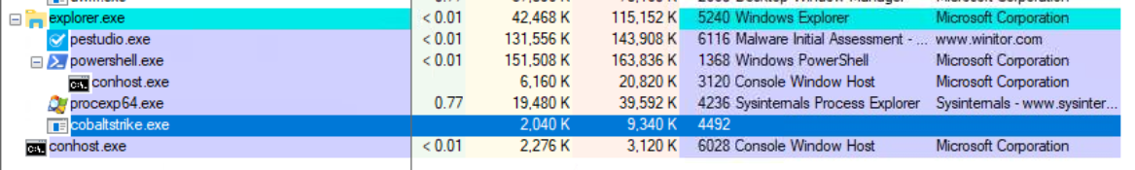

I right clicked this process and selected properties which gave me much more information and under the TCP/IP header, I was able to view the IP address it connects to and the state it sends.

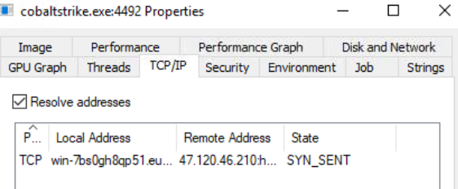

3. What I’ve learned

- What FlareVM is
- Which tools are available
- Hands on experience of some of these tools

