Hydra - Lab Report

Date: 27/05/2026
Difficulty: Easy
Category: Offensive Security
Platform: TryHackMe

Overview

This lab is an introduction to the brute force attack tool, Hydra. It includes details about the tool and how the commands are used as well as a practical example of using it to crack a user’s SSH password and use it to log in as them and find the flag.

2. Toolset Used

Tool | Purpose / Function
Hydra | A brute force online password cracking program

3. What I did

Hydra is a brute forcing tool used to run through a list and brute force authentication services. It speeds up the process of manually guessing passwords as it uses a password list and tries each password in that list against the target. It has the ability to brute force protocols such as SSH, FTP, MYSQL, SMTP, HTTPS and many more. This highlights the importance of using a strong password as if it appears in these common password lists then it is prone to being guessed.

Practical: Using Hydra

The command we use with Hydra depends on the protocol/service we are attacking. See examples below:

FTP with username = user and password list = passlist.txt you would use:
- Hydra -l user -P passlist.txt ftp://10.80.133.76

SSH with username = root and password list = passwords.txt you would use:
- Hydra -l root -P passwords.txt 10.80.133.76 -t 4 ssh

Web Forms
- Hydra -l <username> -P <wordlist> 10.80.133.76 http-post-form “<path>: <login_credentials>: <invalid_response>”
- hydra -l <username> -P <wordlist> 10.80.133.76 http-post-form "/:username=^USER^&password=^PASS^:F=incorrect" -V

if the web server is listening on a non-default port, you can specify the port number using -s <port>

To show this practically, I used Hydra to find the SSH password for user molly using the rockyou.txt password list. This returned her password as butterfly.

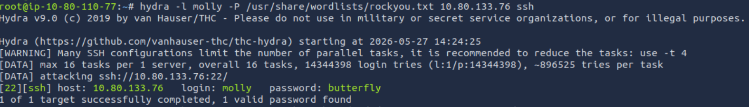

I used this password to log in as molly on SSH and access the flag
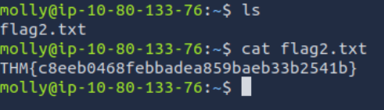

4. What I’ve learned

- The services/protocols hydra can be used to attack
- Specific hydra commands and parameters
- Hands-on example of using hydra to get SSH password and login using it

