Forecasting Sea Level Rise in the Pacific
CST184 Data Analysis and Visualisation | Project 2
Dataset: NOAA Station 732-012 Funafuti B, Tuvalu | SDG 13: Climate Action

Problem Definition and Case Study Context
Tuvalu is a small Pacific island nation with an average elevation of just two metres above sea level. It is widely regarded as one of the countries most at risk from rising seas globally, and for that reason it makes a compelling and meaningful case study for an analysis aligned with SDG 13, which calls for urgent action on climate change. The goal of this project was to take real tide gauge data from the Funafuti monitoring station and apply a range of analytical and forecasting techniques to understand how sea levels have changed over the past five decades and where they might be headed.
The dataset used is publicly available from the NOAA Tides and Currents platform under station 732-012, Funafuti B. It was selected over the broader global regional datasets because it focuses on a single at-risk location with a long, continuous record dating back to 1977, giving us 47 years of data to work with. The brief specifically named this station as an appropriate choice for the analysis, and after reviewing the data it was clear it contained everything needed to complete all twelve steps of the project. The raw file contains monthly mean sea level readings in metres, measured relative to a local datum, along with confidence interval bands and a modelled linear trend line.

Variables and Their Types
The raw CSV contained six columns after skipping the header rows. Year and Month are both integer variables that together identify the time of each reading. Monthly MSL is a continuous floating point variable representing the mean sea level in metres for that month. Linear Trend, High Confidence, and Low Confidence are also continuous variables representing the modelled trend and its uncertainty bounds.
For the analysis, a new variable called Sea Level mm was derived by subtracting the 1993 annual mean from each monthly reading and multiplying by one thousand to convert from metres to millimetres. This baselining step makes the values interpretable as change relative to the satellite era baseline year, which is the standard approach used in sea level research. Monthly values were then averaged by year to produce 47 annual data points. A Decade variable was also created by rounding each year down to the nearest ten, which was useful for visualising long-term acceleration in the bar chart.

Dataset Justification
The Funafuti B dataset was chosen primarily because it offers a long, consistent, single-location record. Alternative datasets such as the global regional trends comparison cover broader geographic areas but would have introduced the problem of comparing countries with very different land movements and local ocean dynamics. For a focused analysis of a vulnerable Pacific nation, the single-station record is more appropriate. The 1977 start date gives over four decades of pre-satellite data, which is valuable for understanding the long-term baseline before the modern acceleration period began. One limitation worth noting is that the record contains a datum shift in 1993 which NOAA corrected by applying an offset, and there are three months with missing values across the entire record, which is a very low rate of incompleteness.

Methods and Visual Techniques
The project was split across Python for the exploratory and structural steps and R for the statistical modelling and forecasting. This division made practical sense because Python tools like pandas and networkx are well suited to data wrangling, filtering, and graph visualisation, while R provides cleaner syntax for regression, Bayesian updating, and time series forecasting through packages like forecast and ggplot2.
Step 1 covered importing the CSV, skipping the six metadata header rows, renaming columns, converting to millimetres, and baselining to 1993. The result was 521 clean monthly rows with only three missing values. Annual averages were computed for use in the modelling steps.
Step 2 used Python sets to identify unique values in the dataset and defined a reusable function for filtering by country and year range. Testing this with Tuvalu between 2000 and 2020 returned 21 rows as expected.
def get_country_data(country, year_start, year_end):
return df[(df['Country']==country) & (df['Year']>=year_start) & (df['Year']<=year_end)]
Step 3 applied Boolean filtering to identify years where sea level exceeded a statistically significant threshold defined as the mean plus one standard deviation. The 2020 reading of 190.6mm was found to be above the 156.8mm threshold.
Step 4 computed descriptive statistics and estimated the empirical probability that a given year exceeds 120mm. Across all 47 years, 25.5% of observations exceeded this level, rising to 30.3% under a normal distribution model in R.
Step 5 counted unique year-country-sea level combinations, confirming that the dataset has 47 distinct annual records with no duplicates.
Step 6 used networkx to build a graph where each decade is a node and edges connect decades whose average sea levels differ by less than 50mm. This revealed that the 1970s, 80s and 90s cluster together at low levels, while the 2000s and 2010s are linked to each other, and the 2020s node stands completely isolated, reflecting how unlike any previous decade current sea levels are.
Step 7 produced three visualisations in Python. A line chart showed the full 1977 to 2023 record with a trend line, a bar chart compared decade averages, and a scatterplot showed the post-1993 acceleration coloured by magnitude.
Steps 8 to 12 were completed in R. A correlation heatmap was built by splitting the data into three time periods and comparing them using cor() and ggplot2 with geom_tile(). A distribution analysis overlaid a normal curve on the annual histogram and used pnorm() to estimate tail probabilities. Linear regression with lm() modelled sea level as a function of year. A Bayesian update used rbeta() to simulate 10,000 posterior samples and compare prior and posterior distributions. Finally auto.arima() was used to fit a time series model and forecast sea levels to 2030.

Interpretation of Findings
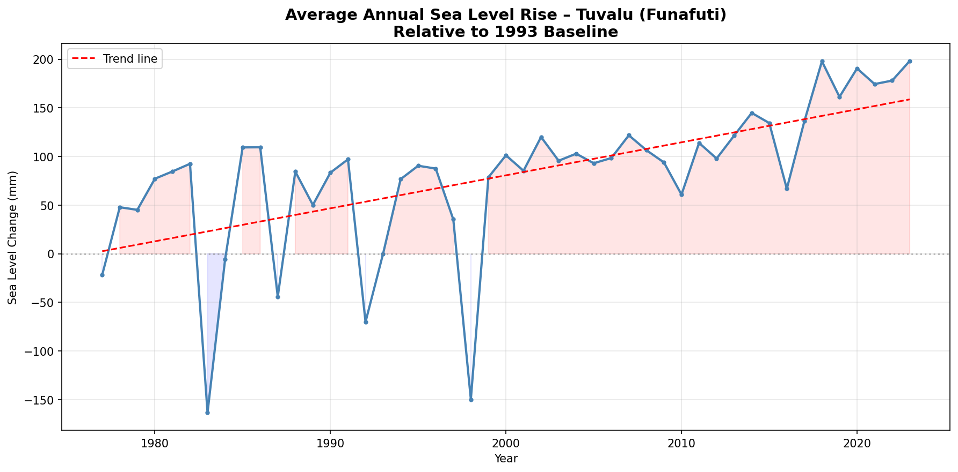
Figure 1. Average annual sea level rise at Funafuti relative to the 1993 baseline, with linear trend line.
The line chart makes the overall pattern clear. Sea levels at Funafuti have risen substantially since 1977, with the 2020s sitting around 185 to 200mm above the 1993 baseline. Two significant dips are visible around 1983 and 1998, both of which correspond to strong El Nino events that temporarily suppressed sea levels in the Pacific. Outside of those anomalies, the direction of travel has been consistently upward.
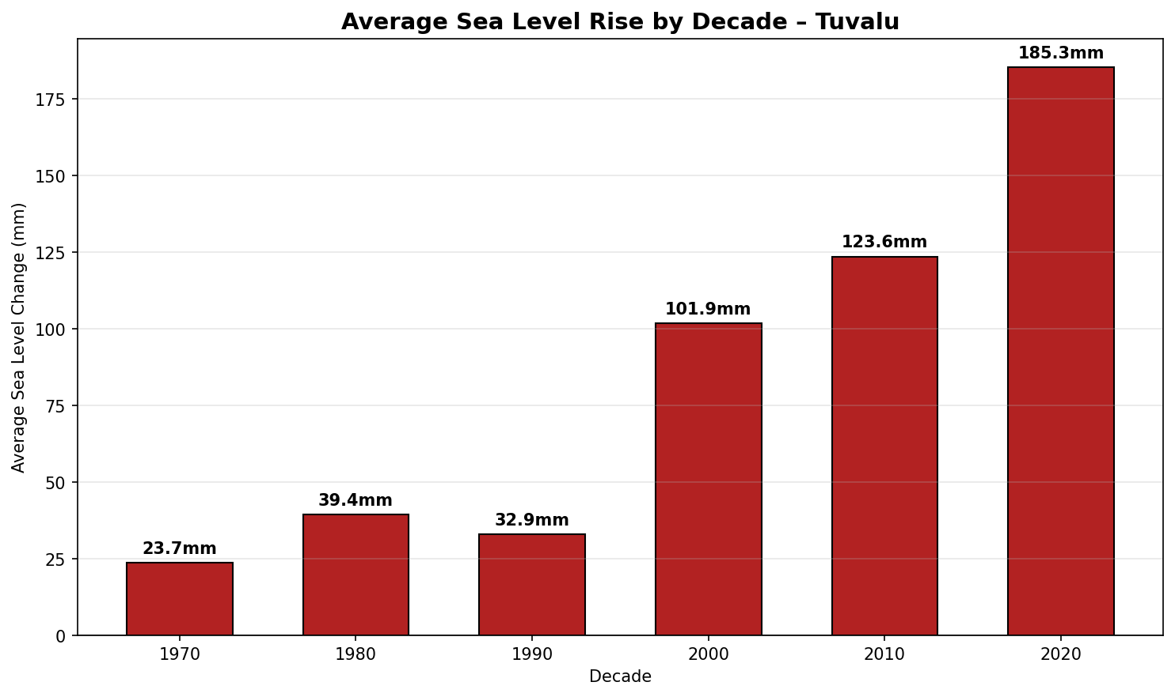
Figure 2. Decade average sea level rise in millimetres.
The decade bar chart is perhaps the most striking way to communicate the acceleration. The 1970s average was just 23.7mm, the 1990s dipped slightly to 32.9mm partly due to the 1997 to 1998 El Nino, then the 2000s jumped to 101.9mm, the 2010s reached 123.6mm, and the 2020s average so far is 185.3mm. That is nearly an eightfold increase from the 1970s in under fifty years.
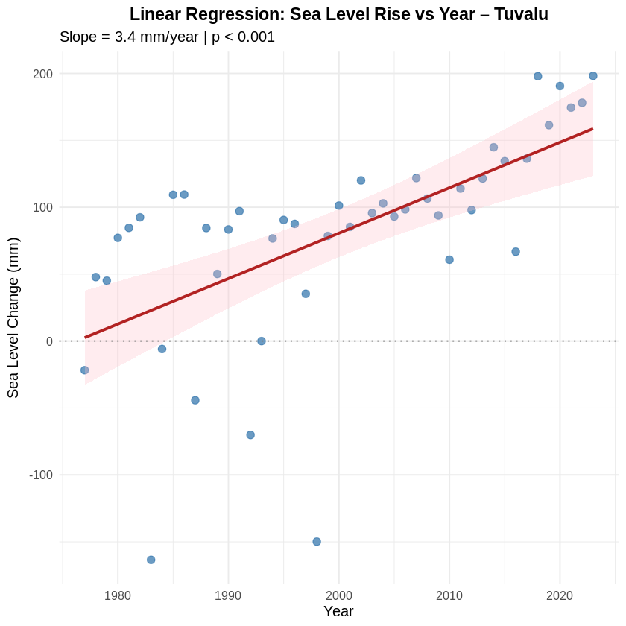
Figure 3. Linear regression of sea level rise against year for Tuvalu, with 95% confidence interval shading.
The regression analysis in R confirmed that the upward trend is statistically significant. The estimated slope is 3.4mm per year with a p-value of 5.1e-06, well below any reasonable significance threshold. The 95% confidence interval for the slope runs from 2.07 to 4.72mm per year, meaning even the lower bound represents a meaningful rise. Over the full period from 1977 to 2030 this projects a total rise of approximately 180mm. The R-squared value of 0.37 means year alone explains about 37% of the variability in sea level, which is reasonable given the natural year-to-year variation driven by El Nino and other climate patterns.
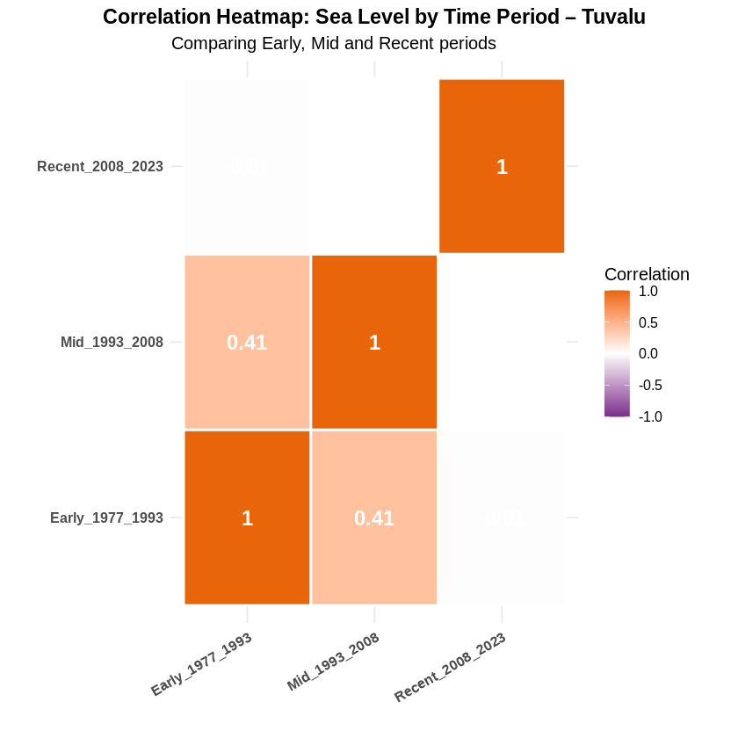
Figure 4. Correlation heatmap comparing sea level readings across three time periods.
The correlation heatmap was produced by splitting the data into an early period from 1977 to 1993, a middle period from 1993 to 2008, and a recent period from 2008 to 2023. The early and middle periods correlate at 0.41, reflecting some shared variation. Crucially, the recent period shows near-zero correlation with both earlier periods. This is a strong indication that something structurally different is happening in recent years, consistent with the accelerating rise visible in the line chart and decade bar chart.
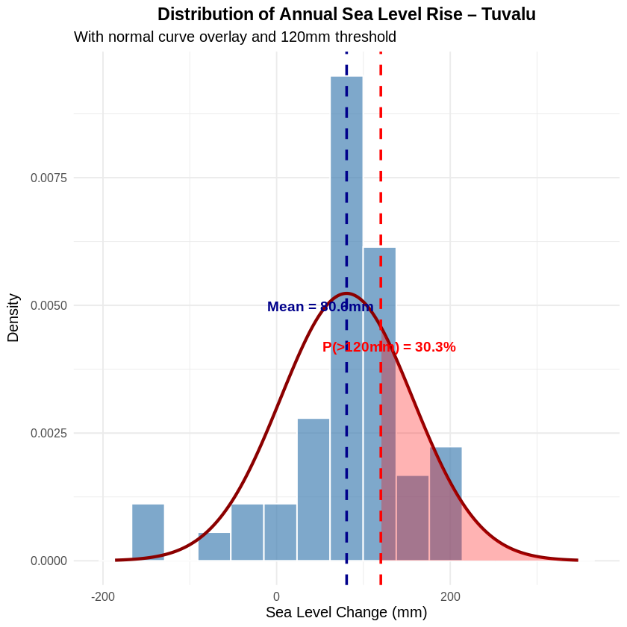
Figure 5. Distribution of annual sea level values with normal curve overlay and 120mm threshold.
The distribution analysis showed a mean annual sea level rise of 80.6mm with a standard deviation of 76.2mm. The distribution is visibly right-skewed, with a long tail to the right driven by the high values in recent years. Under a normal distribution model, the probability of exceeding 120mm in any given year is estimated at 30.3%, but given the skewness and the trend, this probability is increasing over time rather than being a fixed parameter.
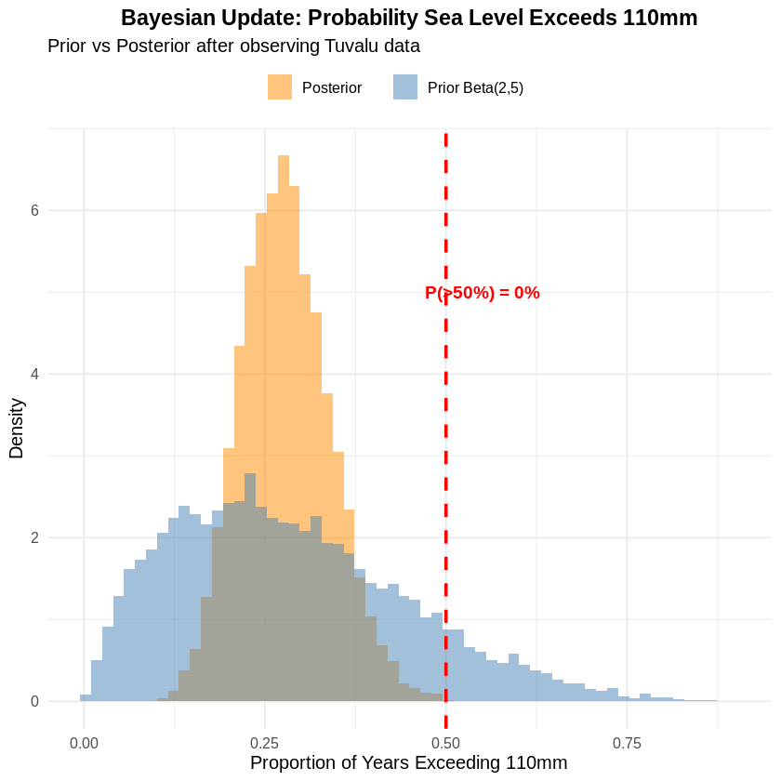
Figure 6. Bayesian prior and posterior distributions for the proportion of years exceeding 110mm.
The Bayesian update started with a Beta(2,5) prior, reflecting a slightly pessimistic belief that fewer than half of all years would exceed 110mm. After observing that 13 out of 47 years in the dataset exceeded 110mm, the posterior updated to Beta(15,39), which centres around a true proportion of about 28%. The probability that the majority of years exceed 110mm is currently estimated near zero, but as more recent high-value years accumulate that proportion is clearly trending upward. This analysis is useful for a decision-making context where policymakers need a confidence estimate rather than just a point prediction.
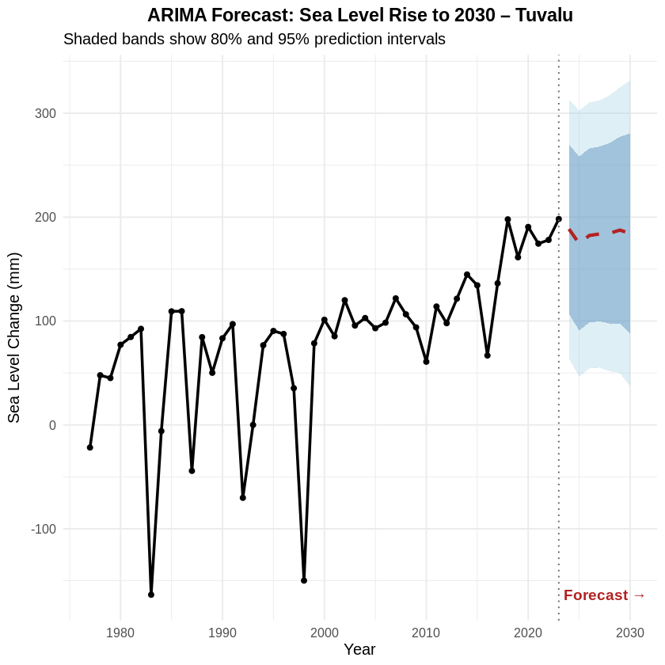
Figure 7. ARIMA(5,1,0) forecast of sea level rise to 2030 with 80% and 95% prediction intervals.
The ARIMA forecast was produced using auto.arima() in R, which selected an ARIMA(5,1,0) model based on AIC minimisation. The forecast to 2030 suggests sea levels will remain in a range of roughly 175 to 190mm, with the central estimate plateauing slightly below the 2023 peak. However the uncertainty bands widen considerably by 2030, with the 95% upper bound approaching 330mm. Even the lower bound of the 95% interval sits around 37mm above the 1993 baseline, meaning even the most optimistic forecast outcome still represents significant sea level rise. The widening uncertainty is itself an important finding and communicates the inherent difficulty in forecasting beyond a few years in a volatile climate system.

Reflection on Working in Python and R
Working across both Python and R in the same project was a genuinely useful experience for understanding what each tool is best suited to. Python with pandas felt very natural for the earlier steps involving data loading, cleaning, filtering, and exploration. Writing the get_country_data function, chaining Boolean conditions to filter the dataframe, and building the networkx graph were all tasks where Python syntax felt clean and readable. Matplotlib and seaborn gave a lot of flexibility for customising the visuals, particularly the colour-coded scatterplot and the filled area line chart.
R felt more native for the statistical modelling steps. The syntax for linear regression with lm() and summary() is very concise and the output is immediately readable. Functions like pnorm(), rbeta(), and auto.arima() are built into the R ecosystem in a way that would require more setup in Python. ggplot2 produced polished, publication-quality visuals with less manual formatting work than matplotlib required. The main frustration with R in this project was package installation time in Google Colab, particularly for the forecast package which pulled in several dependencies. Once installed it ran without issues.
If approaching this type of project again, the same split would make sense. Python handles the structural and exploratory work efficiently and networkx in particular has no straightforward R equivalent for graph visualisation. R earns its place in the modelling and forecasting stages where its statistical functions are mature, well-documented, and produce outputs that are easy to interpret and present.

Conclusion
Sea levels at Funafuti have risen approximately 200mm since the 1993 baseline and the trend is accelerating decade by decade. Every method applied in this project pointed in the same direction. Regression confirmed a statistically significant slope of 3.4mm per year. The distribution analysis showed that nearly one in three years now exceeds 120mm. The Bayesian update demonstrated that observed data shifted beliefs toward a higher proportion of above-threshold years. The ARIMA forecast projects continued elevated sea levels through 2030 with substantial uncertainty in the upper range.
For a nation like Tuvalu where average land elevation is just two metres, this analysis is not abstract. The findings directly support the urgency of SDG 13 action. A rise of 500mm, which is plausible within this century under high emissions scenarios, would threaten the habitability of the entire archipelago. The data collected at Funafuti since 1977 tells a clear story and this project has used that data to tell it as precisely and honestly as possible.

