**Project Proposal, Requirements, Stakeholders**

**Team Name:** Static void 4 **Date:** 1/31/2017

**Team Members:** Tyrone Jefferson (CS), Daja McCoy (IS), Cameron Mosley (IS), Marques Brown (CS)

**Project Name:** Intranet Newsletter for Austal USA

**Project Client Name, Organization, and contact information:**

A.J Briggs, Sr. Director Information Systems & Technology

Austal USA

100 Addsco Road, Mobile AL 36602

(251) 445-5916

AJ.Briggs@AustalUSA.com

**Brief Project Description:**

Austal USA is currently looking for an intranet page that would act like a newsletter for the employees to keep up with current events and dates that are important to employees. The active employee will be able to edit and add personal information voluntarily to the newsletter\website. The administrator will also be able edit and update the user or employee data displayed on the website.

**Describe the problem your project will solve:**

At the moment, Austal does not have an employee friendly way to share personal information such as birthdays and baby announcements besides the means of email. Austal desires to give an employee the ability to share personal information with other employees through a social flyer like newsletter. The majority of these employees feel that this will improve communication between coworkers as well as assisting in the coordination of special events.This application will allow employees access to the company newsletter website through a basic GUI after providing authentication. From this newsletter, they will be able to see other employee’s profile information such as job title, job duties, birthday, anniversary, hire date, and other various information provided by that employee as well as input their own personal information they would like to share. This will make it easier for coworkers to remember each others birthday or display the annual dates of when the employees joined the company. The site will also display other pertinent information that will be important for company employees to know about. This will connect employees more around the company.

**Identify the stakeholder and how they will benefit from and be impacted by you.**

|  |  |  |
| --- | --- | --- |
| ***Stakeholder*** | ***Impact of System*** | ***Explanation*** |
| **Administrator** | **High** | **The administrator will control what content goes in the newsletter. They will also be able to update user information such as the name of the employee, job title, job duties, birthday, anniversary, hire date, and other information that can be useful to the employees viewing the newsletter. The administrator will oversee the security of the intranet and maintain structure of the website.** |
| **Users\Employees** | **Medium** | **The users will be able to input personal information after logging into the intranet and view the content that is displayed on the newsletter. The users will be notified of other employee’s birthdays and other important dates that are posted on the newsletter.** |

***Functional Requirements of the Project:***

***Minimal functional requirements:***

* The system will require a valid username and password authentication to login to intranet website.
* The system will allow employees to enter and update personal information to their profile directly into website such as birthday and anniversary dates.
* The system will allow active employees to create a new username/password for authentication to their profiles.
* The system will store provided information in SQL Server database.
* The system will allow all and only active employees to view information on company’s intranet website.
* The system will display upcoming events and newsletter information provided voluntarily by the employees of the company on the private intranet website.
* The system will allow administrators will be able to update or edit any information displayed on the website.
* The system will allow administrators to add new users by creating usernames and temporary passwords for login authentication by employees as well as the ability to delete users from accessing the system.

***Additional desired functional requirements:***

* The system shall allow active employees to submit comments and suggestions to administrator to improve newsletter.
* The system shall allow employees to upload a profile picture as well as voluntarily add a bio section for other personal information to be displayed.

***Describe the Non-Functional Requirements of the Project:***

* **Extensibility**– the system will allow easy updates and changes through database, directly through the UI intranet site, and website source code as well as server management using Windows Server 2012.
* **Usability** - this system should require minimal learning and provide for input by active users in which will be displayed on intranet website.
* **Auditability**- changes will be logged in company database and changed by active users as well as administrators to the SQL database.
* **Security**- the system should be accessible only after proper login authentication. The intranet will be provided only to active employees by means of a LAN at the company. No outside persons should have viewing privileges.
* **Robustness** –the system should respond to errors via error codes generated by software (SQL Server 2012, Visual studio) as well as the UI output showing errors in coding.

**Technologies/skills expected and required:**

It may be required to use either, or all, of the following programming language: C#, ASP.Net, and MVC Architecture. There may be instances of HTML5/CSS3 to create the webpage for the administrator to interact with. SQL Server 2012 with Transact SQL will be used to update database information based on currently existing information from Austal’s own database. The operating system being used will be Microsoft Windows 7, and Microsoft Windows Server 2012.

**Currently known constraints:**

This system must be able to operate on the company’s current intranet to be visible only by personnel for security reasons. This presents a level of security measures that must be observed. Due to the fact this application will be implemented inside Austal’s current system, there is a pre-existing framework which must be adhered to when designing this application. This will require communication between the group and current software professionals at Austal for guidance. The system will be built under a separate VS and must be able to be incorporated into their web server pages. Administrator must be able to login and update, change, and add information to the database to be displayed on the newsletter site.

**Use Case Narrative:**

|  |  |
| --- | --- |
| **Use case:** | User enters Austal Intranet web page |
| **Actors:** | User/Employee |
| **Preconditions:** | The user must be or already been an employee of Austal with provided login authentication information from their SQL server. |
| **Postconditions:** | The user will be able to access the Intranet webpage, provide personal information to their own pages, and view other employee’s personal pages. |

**Use Case Narrative**

|  |  |
| --- | --- |
| **Use Case** | An administrator accesses the Austal Intranet page |
| **Actors** | User administrator / Employee |
| **Preconditions:** | The administrator must have been already a user and given access to become an administrator |
| **Postconditions** | The administrator will gain abilities to modify and delete user information. They will also have the ability to manage user accounts. |

**Flow of Events:**

|  |  |
| --- | --- |
| **Actor Action** | **System Response** |
| A new employee of Austal wishes to login and access the Intranet web page | The system will check the server to determine if the user’s login information exists in the database. If not, an error should be thrown that the information provided is incorrect. |
| The new employee of Austal was given the login information to finally access the Intranet web page | The system will check the server if there exist such user. If so, the user will gain access to the web page. The system welcomes the new user. |
| Administrator | The system will treat an administrator in a similar fashion like a regular user. But the administrator will gain abilities to manage user accounts. |

**Screen prototypes**

**Log-in page**

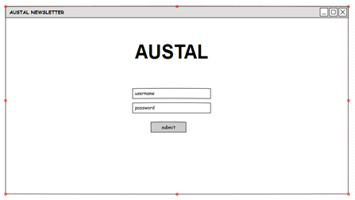

**Main page for all users**

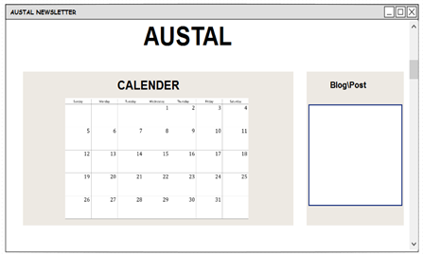

**User Newsletter page**

