2478 Words
Research & Consultancy : Assignment 1
2026
Contents
Section 1 : Employability (1098 Words) 1
Introduction 1
Career Rationale 1
Career Roadmap – Skill-Analysis & Development-Plans. 2
Undergraduate (2025-2027) 2
Masters (2027-2028) 2
Early-Career (2028-2030) 2
Mid-Career (2030-2035) 3
Section 2 : Consulting (1204 Words) 4
Introduction 4
Defining the Problem 4
Potential Benefits of Artificial Intelligence 5
Proposed Solutions & Considerations 5
Conclusion 6
Section 3 : Reflection (275 Words) 7
Consultation Process 7
Consultation Approach: Limitations and Strengths 7
Skill development and applicability to career. 7
Appendix 8
Graduate Job Examples 9
References 13

Section 1 : Employability (1098 Words)

Introduction
To achieve my career goals, I have developed a structured career plan beginning in 2025 up till 2035, corresponding to year-two of my undergraduate studies through mid-career demonstrated in Figure 4A. This plan is organised around key milestones that I have identified: earning a relevant undergraduate degree, securing a place in a Master’s program, gaining industry skills, and transitioning into medical robotics. During the process of creating this plan, I uncovered skill gaps and created actions to support my personal development. My chosen career, Robotics Engineering with a focus on medical robotics, was selected because of its emerging presence alongside Artificial Intelligence. In addition to, my personal interests in electronic hardware and motivation to make a positive impact on society further solidified this pathway.

Career Rationale
My chosen discipline is Electronic Engineering, a field that appeals to me for its proximity to Computer Science and its emphasis on analytical thinking and problem-solving. Both disciplines overlap somewhat, in areas such as Computer Architecture and Programming, which aligns with my strengths. Computer Science as an adjacent degree, will allow me to transfer into Electronic Engineering programmes for a Master’s degree.
Electrical Engineering is a broad degree, so I intend to specialise in the branch of robotics applied to medicine. This is because robotics is a rapidly emerging field closely linked to the development of Artificial Intelligence. Entering this field in its infancy will position me advantageously as the field matures. Robotics Engineers are well compensated, though not as much as some Computer Science careers. It is a less saturated field with higher career stability and better work-life balance, as demonstrated in Figure 2A and Figure 2B. Beyond financial motivations, a career has the potential to make positive contributions to society. My grandparents inspired my interest in medical robotics; my grandmother battled with Alzheimer’s towards the end of her life, with my grandfather serving as her full-time caretaker. This responsibility limited his ability to enjoy his final years. Had medical robotics been more developed to help them, potentially my grandparents would have enjoyed more independence in their final years. These personal experiences motivate me to pursue a career where I can contribute to innovations that support families in similar situations.

Career Roadmap – Skill-Analysis & Development-Plans.

Undergraduate (2025-2027)
To develop an effective career roadmap, I analysed relevant job listings for graduate roles in Robotics and Electronic Engineering in-order to create milestones to meet the expectations of an ideal candidate; educationally a standard requirement is a Masters or PhD in Electrical, Electronic or Computer Engineering; as Computer Science is a related field, I can progress directly onto a Master’s degree in any of these degrees after graduation in 2027, I am particularly interested in the MSc in Electronic and Computer Engineering provided by the University of Birmingham as seen in Figure 3A & Figure 3B; this will require me to get a 2:1 in my undergraduate study to achieve this I have analysed my current and future level 5 and 6 modules; the majority of these modules are Artificial Intelligence related, as that is the degree specialization I chose; to close the gap I have enrolled in the IBM Artificial Intelligence course to supplement my knowledge in Artificial Intelligence and general programming. Additionally, I have made a conscious effort to increase my attendance and have undertaken extracurricular roles to stand out in admissions, such as serving as a Student Academic Representative and a Committee Member of one of Winchester's many Societies. For my third year, to prepare for my capstone dissertation, I intend to read two publications from leading scientific journals such as IEEE daily. This will help me gain deeper insight into selecting my own research topic and into conducting effective research.

Masters (2027-2028)
Upon graduation, I am underprepared to begin study in Electronic and Computer Engineering at the Master's level, as I have not taken any classes in Embedded Systems, Signal Processing, or other core modules that provide foundational knowledge. To compensate for this, I have studied the content outlined in Birmingham University's Undergraduate Programme, as well as relevant industry tools and technologies, including Electronic Diagnostic Tools, such as Multimeters and Oscilloscopes, and modelling software such as LTSpice and Multisim. I have been in contact with various universities offering places of study for Computer Scientists interested in Electrical Engineering and have received relevant recommendations to help me stand out in admissions. I have also compiled a list of universities likely to be receptive to an application from someone with my background, which is displayed in Figure 1A.

Early-Career (2028-2030)
After completing a Master’s in Electronic & Computer Engineering, my goal is to secure an entry-level position in robotics or electronic engineering, such as the positions shown in Figure 2A & Figure 2B To enhance my employability, I will attend industry events to network with professionals. By this stage, I will have developed a strong theoretical knowledge. However, I recognise I will lack the practical knowledge required in the industry. To overcome this, I need to develop my interpersonal and teamwork skills to receive effective mentorship and work effectively as part of a team. As my early career will be focused more on learning, I have always struggled with this as someone who is on the autism spectrum. I have taken proactive steps to address this through my undergraduate studies; for example, serving as a Student Academic Representative and participating in societies has helped me build confidence.

Mid-Career (2030-2035)
Once I have developed sufficient experience and confidence, I expect to work more independently within my team, taking on responsibilities and making decisions without constant oversight. As I become established, I expect to gradually transition into taking on more leadership and mentor responsibilities to support junior engineers. At this point, my goal is to transition towards medical robotics, which is a more specialised field in its research stage. Because of this, I may be required to undertake a PhD and postdoctoral positions to demonstrate research competency.

Section 2 : Consulting (1204 Words)

Introduction
Artificial Intelligence (AI) is reshaping UK Higher Education (Ahmet Baytak, 2025), introducing both opportunities and challenges. This consultation for Universities UK identifies specific concerns regarding AI, such as plagiarism, and details the external pressures exerted on academic institutions to adopt this technology. The report also describes the potential benefits of AI implementation, including improved accessibility for students with learning difficulties, and assesses additional key advantages. Finally, it analyses the implementation challenges and proposes solutions to mitigate concerns while retaining the benefits of AI.

Defining the Problem
Universities in the United Kingdom are currently facing the significant rise of Artificial Intelligence. A comprehensive PESTLE Analysis identifies key concerns and external pressures, such as regulatory, economic, and technological factors, that compel Academia to adapt.
Political factors such as the government's position on Artificial Intelligence as a national priority, with both the previous Conservative government through the National AI Strategy and current Labour government through the AI Opportunities Action Plan (GOV.UK, 2022); the government has explicitly expressed desire to increase the number of graduates taught Artificial Intelligence-related skills, which are desperately needed in industry by 2030 (GOV.UK, 2025). Economically, Universities with the United Kingdom are currently plagued by a funding crisis (Shearing, 2025); AI adoption may require significant investment in staff and infrastructure which may not be feasible on the other hand; due to the increase enthusiasm in Artificial intelligence the government has committed an extra £1 billion to position Britain as an Artificial Intelligence leader (GOV.UK, 2025) this as well as other factors means securing funding for areas related to AI is easier to justify to government research councils and industry players for collaboration such as Google which provided $20 million (Piyajanaka, 2023) or meta which provided $1 million into Artificial intelligence grants (GOV.UK, 2025); Universities, not teaching AI skills risk producing graduates unlikely to participate in research intersecting AI potentially diminishing the Universities research rankings; for the industry students graduation with outdated skills can lead to unemployment, and student satisfaction (Cybericonic, 2025) which can affect institutional reputation and funding from prospective students as graduate opinions are a key metric to produce University rankings (Gilmore, n.d), which have been observed to influence enrolment numbers (‌Lazell, 2023). . There is a changing Social attitude towards Artificial Intelligence students increasingly expect Universities to teach AI-related skills (Weston, 2024). ; students without knowledge or access to AI are likely to risk falling behind their peers that do; on the other hand, there is academic resistance to Artificial Intelligence deployment in academia due to worries about plagiarism (Shata, 2025), with many journals require authors to declare AI utilisation affecting credibility; additionally Artificial intelligences ability to solve assignment questions without much critical thinking from students, can potentially produce graduates with an overreliance on Artificial Intelligence which can devalue the prestige of institutions and degrees (Weston, 2025). Technologically the rapid evolution of AI means academic policy is being outpaced, and the technology for policing academic misconduct, such as AI detection tools, is also being outpaced (Leaton, 2025). Another concern is Legality; the government has expressed that AI usage needs to be legal. Artificial intelligence has been reported to commit intellectual property theft or disregard data protection and GDPR compliance (Gomstyn and Jonker, 2024), as some models have been found to process and retain data without user permission. Finally, there are Environmental factors, such as the energy consumption of Artificial Intelligence, which can make Its Development harder, as many universities in the UK have carbon-reduction commitments (Universities UK, 2024) . The adoption of Artificial intelligence infrastructure must support these commitments.

Potential Benefits of Artificial Intelligence
Although implementing AI in higher education presents unique challenges, if properly implemented, its benefits may outweigh the costs. AI can enhance students' learning outcomes, especially for those with learning difficulties such as Autism or ADHD, making academia more accessible (Dumitru et al., 2025). AI has use cases in catching grammar or syntax errors before publication; it can also be extremely useful for finding appropriate references or existing literature for research, saving students and faculty significant time in the overall research process (Erik, et al2025). Furthermore, there is a high demand in the industry for AI-related skills (Patrick, J. 2025). As most graduates enter industry rather than academia, it makes sense to help them become more competitive than their peers at international institutions (Telfer, 2025). However, it is important to acknowledge that increased reliance on AI could diminish students' independent critical thinking ‌(Jackson, 2025) and foster overreliance on automated tools, potentially undermining the development of essential academic competencies.

Proposed Solutions & Considerations
AI is here to stay, and many students will continue to use it to gain unfair advantages that are difficult to detect (Leaton, 2025), creating inequality for students who do not use these tools. To address this, I recommend the following structured measures. First, Universities UK could collaborate to develop an academic LLM (Large Language Model) designed specifically for higher education; there is already precedent for this with the University of Edinburgh's ELM model, (The University of Edinburgh, 2024). which is available to all students and staff. Second, any academic LLM should be required to report the sources of its content so that academic work can be audited for plagiarism. Third, establishing clear standards for permissible and prohibited uses of AI in academia will require supportive legislation. I suggest universities permit AI tools for essay critique, grammar checking, and literature discovery, but prohibit their use for academic misconduct, such as generating essays or assignments from scratch. Some universities, such as the University of Birmingham, already follow this approach (University of Birmingham, 2018). Fourth, to further limit the impact of AI-generated submissions, universities could implement new grading criteria that recognize both the essay process and the final product by reviewing edit histories to verify authentic authorship (Faculty Resources for Educational Excellence, 2023). However, requiring students to submit extensive edit histories may be perceived as burdensome and could raise privacy concerns. Finally, outside of essay assignments, I recommend universities increasingly employ proctored exams (Henry, 2025), as take-home exams or questionnaires may no longer be sufficient to assess student knowledge in the era of AI.
Implementing an LLM for academia poses financial, regulatory, and environmental challenges. First, universities must address the costs of developing and maintaining secure infrastructure to comply with GDPR requirements and meet carbon-emission standards. Next, successful adoption depends on comprehensive staff training, effective student onboarding through workshops, and the creation of clear documentation and legislative guidelines, all integrated into the curriculum. These steps are critical for ensuring a smooth transition.

Conclusion
The rise of AI presents both significant challenges and valuable opportunities for higher education. As outlined in this consultation, coordinated action is essential; otherwise, institutions may fall behind in research, funding, and graduate outcomes, while perpetuating inequalities between students with and without access to AI. Evidence presented in the report, such as the University of Edinburgh's ELM model and government and industry funding commitments, demonstrates that developing academic AI models and establishing consistent institutional policies can improve accessibility for neurodiverse students, enhance graduate skills competitiveness, and increase academic efficiency. These examples support the recommendation that implementing structured AI integration enables universities to realize AI's benefits while safeguarding academic integrity.

Section 3 : Reflection (275 Words)

Consultation Process
Before this report, I was unaware of the skills and research required to produce a high-quality consultation. Consultancy is not about blind recommendations; it requires using academic frameworks and techniques, such as PESTLE, to identify otherwise unconsidered factors, such as the legal and environmental ramifications of implementing Artificial Intelligence in Higher Education. These ideas must then be supported by relevant literature to substantiate claims and develop practical recommendations.

Consultation Approach: Limitations and Strengths
Although I focused on maintaining an unbiased perspective, as a student, my stance may unconsciously reflect my personal interests rather than the organisation I am consulting for. Although much of my referenced literature is peer-reviewed, a reasonable amount was grey literature, which is less reliable. As a student operating within a limited timeframe with only brief knowledge of consultancy and the topic, I may produce fewer insights than seasoned professionals. Despite the limitations of my approach, the consultation maintained an appropriate tone throughout, utilising academic frameworks such as PESTLE to consider unidentified factors, with consistently evidenced claims and suggestions.

Skill development and applicability to career.
Although I’m unlikely to pursue a career in consultancy; I believe the skills developed during this assessment such as academic theory, and evidenced-based insights, and critical-analysis will be beneficial anywhere; especially later in my career where I will be expected to investigate and contribute to key decisions for a team or company; possibly through reports before this assignment I had a strictly academic style of writing which is polar to the consultative style I have developed; this style of writing is likely to be much more practical for industry.

Appendix
Figure 1A
University of Leeds (Electronic & Electrical Engineering) | BSc in Computer Science are accepted at 2:1
University of Birmingham (Electronic & Computer Engineering | BSc in Computer Science accepted on case-by-case basis. (Refer to Figure 3A)
University of Essex (Computer Engineering) | BSc in Computer Science accepted at 2:2
University of Essex (Electronic Engineering) | BSc in Computer Science accepted at 2:2 with specific module requirements
University of Cambridge (Electrical and Electronic Engineering) | BSc in Computer Science accepted at 1st
University of Durham (Electrical Engineering) | Accepts Relevant Degrees BSc Computer Science is likely a case-by-case basis.
University of Warwick (Electrical & Electronic Engineering) | Does not accept BSc Computer Science
University of Sheffield (Electronic and Electrical Engineering) | Does not accept BSc Computer Science
University of Queen Mary (Electronic and Electrical Engineering) | BSc in Computer Science accepted at 2:1
University of Glasgow (Electronics & Electrical Engineering) | BSc in Computer Science accepted at 2:2
University of Surrey (Electronic Engineering) | BSc in Computer Science accepted at 2:2
University of Lancaster (Electronic & Electrical Engineering) | Does not accept BSc Computer Science
University of Leicester (Electrical & Electronic Engineering) | BSc in Computer Science accepted on case-by-case basis.

Graduate Job Examples
Figure 2A
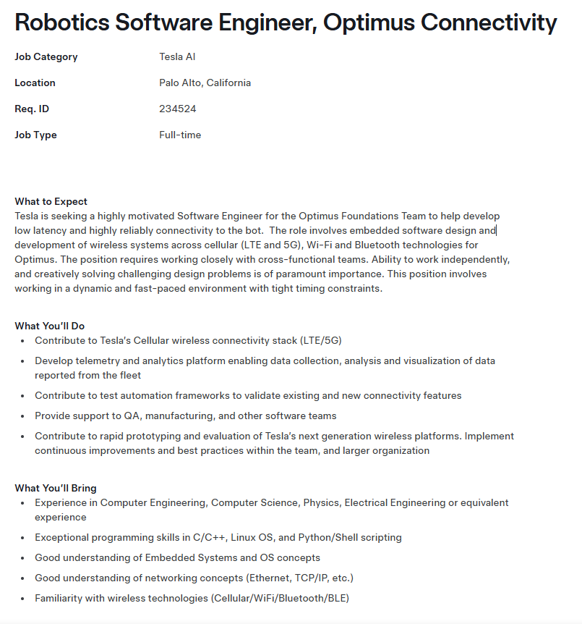

Figure 2B
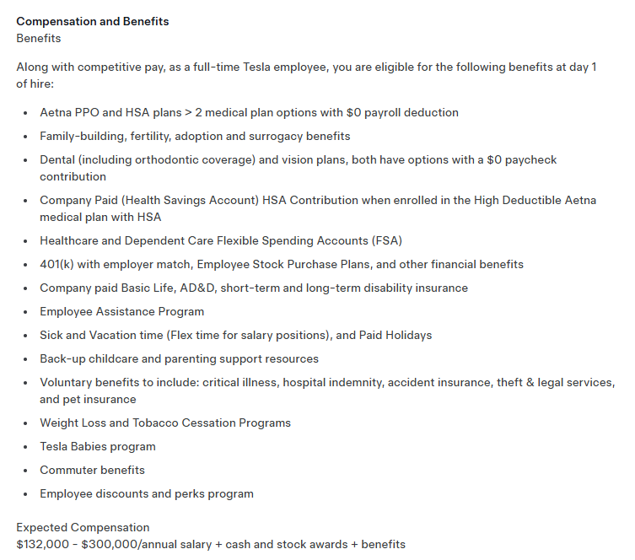

https://www.tesla.com/careers/search/job/robotics-software-engineer-optimus-connectivity-234524

Figure 3A
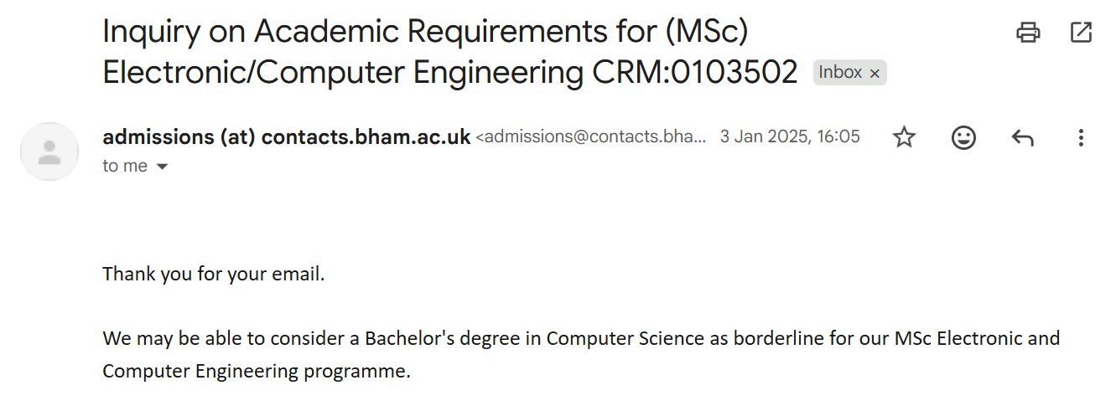
Figure 3B
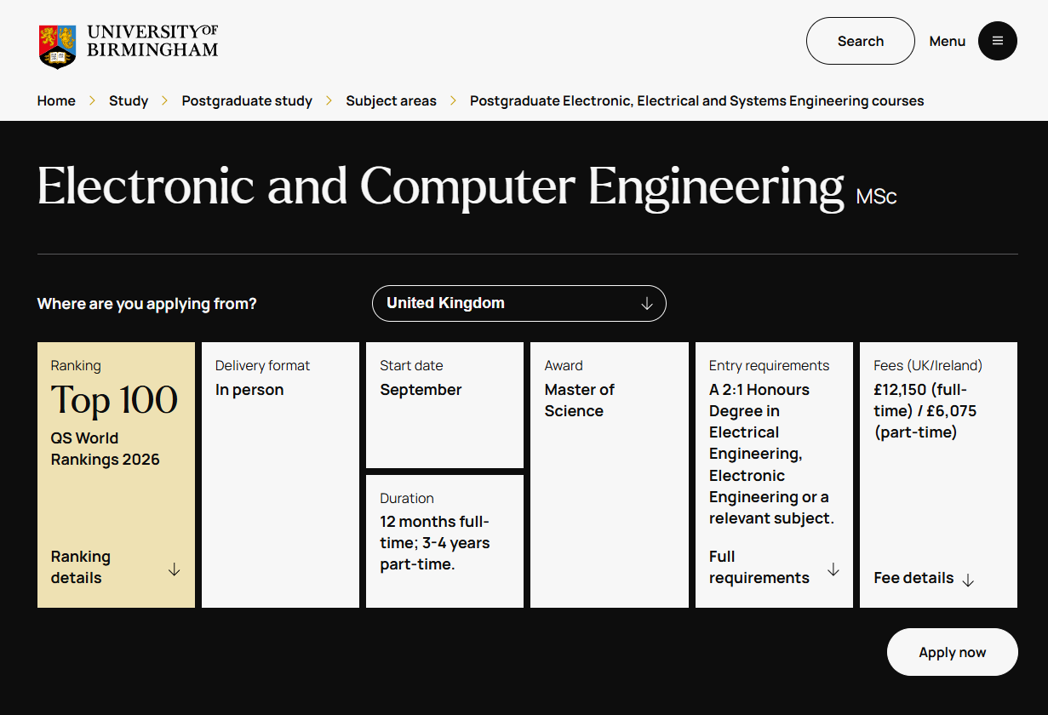

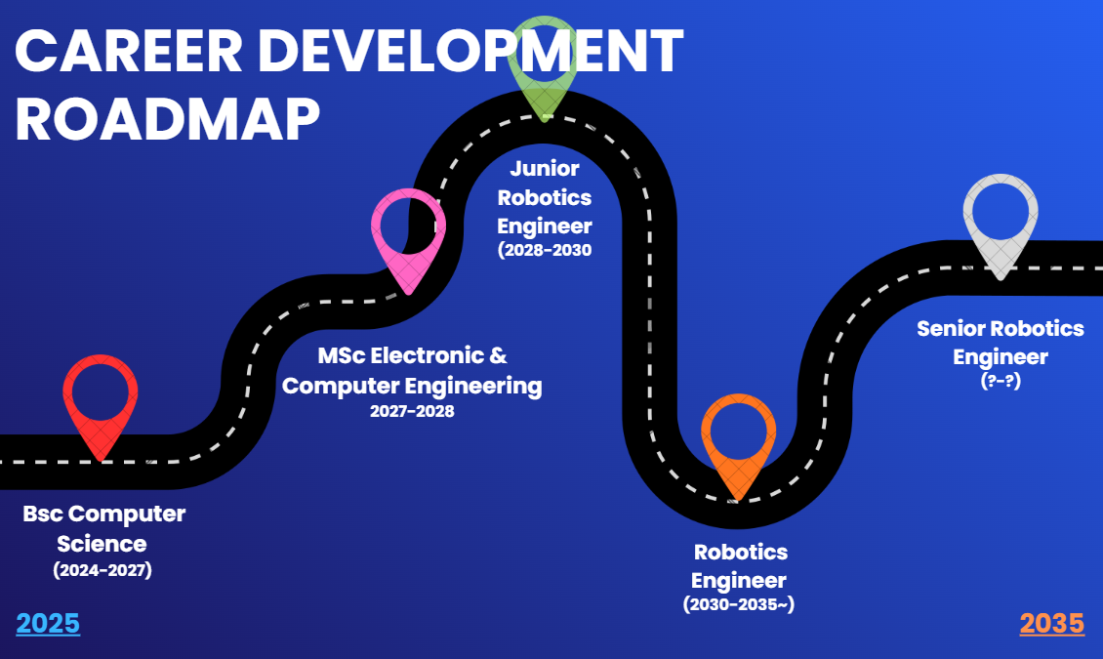
Figure 4A

References
Baytak, A., 2025, September. Reshaping higher education in the unavoidable era of AI. In Proceedings of London International Conferences (No. 14, pp. 22-30). At Reshaping higher education in the unavoidable era of AI | Proceedings of London International Conferences [Accessed 05/01/2026
Cybericonic. (2025). Students Without AI Literacy Face Growing Academic Disadvantage. [online] Available at: https://cybericonic.com/2025/08/23/students-without-ai-literacy-face-growing-academic-disadvantage/?utm_source=copilot.com [Accessed 5 Jan. 2026].
Dumitru, C., Muttashar, G., Khalaf, I. and Bennour, K. (2025). Integrating artificial intelligence in supporting students with disabilities in higher education: An integrative review. Technology and Disability. Integrating artificial intelligence in supporting students with disabilities in higher education: An integrative review [Accessed 05/01/2026]
Erik, K., Li, D., Raymond, L. (2025) Generative AI at Work. Available at: Generative AI at Work* | The Quarterly Journal of Economics | Oxford Academic [Accessed 05/01/2026]
Faculty Resources for Educational Excellence. (2023). Using Google Docs to Detect Students’ AI Usage - Faculty Resources for Educational Excellence. [online] Available at: https://www.eastcentral.edu/free/ai-faculty-resources/using-google-docs-to-detect-ai/?utm_source=copilot.com [Accessed 5 Jan. 2026].
‌GOV.UK (2025). AI Opportunities Action Plan. [online] GOV.UK. Available at: https://www.gov.uk/government/publications/ai-opportunities-action-plan/ai-opportunities-action-plan?utm_source=copilot.com [Accessed 05/01/2026]
GOV.UK (2022). National AI Strategy. [online] GOV.UK. Available at: https://www.gov.uk/government/publications/national-ai-strategy/national-ai-strategy-html-version. [Accessed 05/01/2026]
GOV.UK (2025). UK’s best AI engineers can apply now to build tech for public services in $1 million fellowship. [online] GOV.UK. Available at: https://www.gov.uk/government/news/uks-best-ai-engineers-can-apply-now-to-build-tech-for-public-services-in-1-million-fellowship?utm_source=copilot.com. [Accesed 05/01/2026
Gomstyn, A. and Jonker, A. (2024). AI privacy. [online] Ibm.com. Available at: https://www.ibm.com/think/insights/ai-privacy?utm_source=copilot.com[Accessed 5 Jan. 2026].
‌Gilmore, J. (2023). Talking about reputation - QS Insights Magazine 18. [online] Available at: https://magazine.qs.com/qs-insights-magazine-18/talking-about-reputation?utm_source=copilot.com [Accessed 05/01/2026]
Henry, J. (2025). The academics taking on ‘cheating’ students using AI to write their essays. [online] The Telegraph. Available at: https://www.telegraph.co.uk/news/2025/07/22/cheating-students-using-ai-universities/?utm_source=copilot.com [Accessed 5 Jan. 2026].
‌Jackson, J. (2025). Increased AI use linked to eroding critical thinking skills. [online] Phys.org. Available at: https://phys.org/news/2025-01-ai-linked-eroding-critical-skills.html?utm_source=copilot.com [Accessed 5 Jan. 2026].
‌Lazell, K. (2023). The impact of UK university league tables on student decision-making. [online] Thecompleteuniversityguide.co.uk. Available at: https://www.thecompleteuniversityguide.co.uk/student-advice/where-to-study/impact-of-uk-university-league-tables-on-student-decisions?utm_source=copilot.com#Positive%20impact%20on%20decision-making [Accessed 05/01/2026]
‌Leaton Gray, S., Edsall, D. and Parapadakis, D. (2025). AI-Based Digital Cheating At University, and the Case for New Ethical Pedagogies. Journal of Academic Ethics. AI-Based Digital Cheating At University, and the Case for New Ethical Pedagogies | Journal of Academic Ethics [Accessed 05/01/2026
Piyajanaka, A. (2023). Google’s $20M AI Investment: Fueling Innovation in Think Tanks and Academia. [online] Medium. Available at: https://medium.com/@asiripiyajanaka/googles-20m-ai-investment-fueling-innovation-in-think-tanks-and-academia-f95acbe7d484 [Accessed 05/01/2026]
Shearing, H,. Jeffrey, B. (2025). Four in 10 universities face financial challenges. BBC News. [online] 8 May. Available at: https://www.bbc.co.uk/news/articles/c8dgdlrdnrgo. [Accessed 5 Jan. 2026].
Shata, A. (2025). ‘Opting Out of AI’: exploring perceptions, reasons, and concerns behind faculty resistance to generative AI. Frontiers in Communication, 10. Frontiers | “Opting Out of AI”: exploring perceptions, reasons, and concerns behind faculty resistance to generative AI [Accessed 05/01/2026]
Song, N. (2024). Higher education crisis: Academic misconduct with generative AI. Journal of Contingencies and Crisis Management, 32(1). Higher education crisis: Academic misconduct with generative AI - Song - 2024 - Journal of Contingencies and Crisis Management - Wiley Online Library [Accessed 05/01/2026]
Patrick, J. (2025). Universities meeting fraction of demand for AI skills training. [online] Available at: https://www.timeshighereducation.com/news/universities-meeting-fraction-demand-ai-skills-training?utm_source=copilot.com [Accessed 5 Jan. 2026].
Telfer, R. (2025). Universities risk falling behind without a clear AI strategy. [online] TechRadar. Available at: https://www.techradar.com/pro/universities-risk-falling-behind-without-a-clear-ai-strategy?utm_source=copilot.com [Accessed 5 Jan. 2026].
‌ The University of Edinburgh. (2024). Introduction to ELM. [online] Available at: https://information-services.ed.ac.uk/computing/comms-and-collab/elm/elm-competence-centre/introduction-to-elm. [Accessed 05/01/2026]
‌University of Birmingham. (2018). Student and PGR guidance on using GenAI tools ethically for work. [online] Available at: https://intranet.birmingham.ac.uk/student/libraries/asc/student-guidance-gai.aspx?utm_source=copilot.com [Accessed 5 Jan. 2026].
Universities UK. (2024). Climate crisis: what progress have universities made? [online] Available at: https://www.universitiesuk.ac.uk/latest/insights-and-analysis/climate-crisis-what-progress-have?utm_source=copilot.com [Accessed 5 Jan. 2026].‌
Weston, S. (2024). UK university student AI use doubles between 2024 and 2025; educator confidence wanes – Intelligent Edu.tech. [online] Available at: https://www.intelligentedu.tech/2025/12/10/uk-university-student-ai-use-doubles-between-2024-and-2025-educator-confidence-wanes/ [Accessed 5 Jan. 2026].

‌

‌

‌

‌

