**Balance does not increase correctly when a player wins a game**

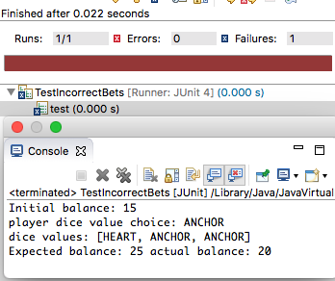

**Hypothesis 1**

The bug exists in the ‘Game’ class when ‘playRound’ method is called at line 49

**Test**

Check the values of the parameters

**Prediction**

Player == Fred, pick == ‘A value’, bet == 5

**Result**

Parameters are all sane, hypothesis confirmed

When we step over the ‘playRound’ method call, if there was 1 match, the balance wasn’t changed, if there were 2 matches the balance was increased by the bet, and if there were no matches the balance is reduced by the bet.

**Hypothesis 2**

The bug exists in the ‘Player’ class when the ‘receive winnings’ method is called from the ‘Game’ class

**Test**

Check the number of winnings compared to the (bet * matches) and then check the value of the balance after the player.receiveWinnings is called.

**Prediction**

* If the there were no matches, the winnings should be 0, if there was one match the winnings will be 5, if there were two matches the winnings will be 10 and if there were three matches, the winnings will be 15.
* After each round, before the ‘player.receiveWinnings’ method is called, the balance has been reduced by the bet 5.

**Result**

* The balance is reduced to 95 before the ‘player.receiveWinnings’ method is called
* If there was a single match the balance is brought back to 100
* If there were two matches, the balance was 105
* When there were three matches, the balance was increased by 15 to 115.

**Hypothesis 3**

Within the ‘player.receiveWinnings’ method (line 39), the program only adds the winnings to the balance (line 41); it does not restore the bet along with the winnings to the balance if the player has at least one match. We need to add the bet back to the balance if the player has at least one match

**Test**

Check to see if the bet is added to the balance when the player gets a match.

**Prediction**

* The bet that was taken is not added back to the balance when the player has one or more matches.
* That the calculation of the winnings is correct
  + Bet = 5
  + 1 match – winnings = 5
  + 2 matches – winnings = 10
  + 3 matches – winnings = 15

**Result**

The bet is not added back to the balance when the player has one or more matches.

Hypothesis 4

The bet is not added back into the balance when the player as one or more matches

Test

Add the bet to the balance equation at line 41

Prediction

The bug will be fixed once we add the bet at line 41 in the ‘Player’ Class.

Result

The balance received is the same as the expected balance

The bug is resolved

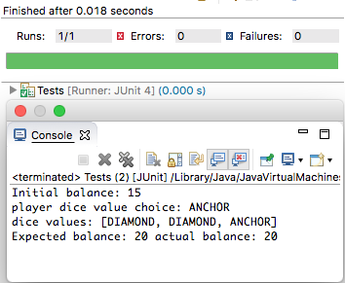

* Player cannot reach betting limit
* Odds in the game are not correct
* The value of the dice do not change after every roll
* Not giving the correct win/lost decisions.