AUTOENCODER VS PCA VS SVD REPORT
Context:
The features being compressed in the Autoencoder are only the raw sensor features, and cyclic features (such as month_cos, month_sin etc.). The total compression is from 36 → latent dim. We observed if we trained the LSTM model with all features compressed into the Autoencoder, our model performance downgraded severely, predicting only the mean once again. We learned from the validation team that the lag aqi and other lag features are important predictors for the aqi, so we removed them from compression and combined them back with the latent representation of selected features to train the LSTM.

1) MinMaxScaler – Training Loss Curves
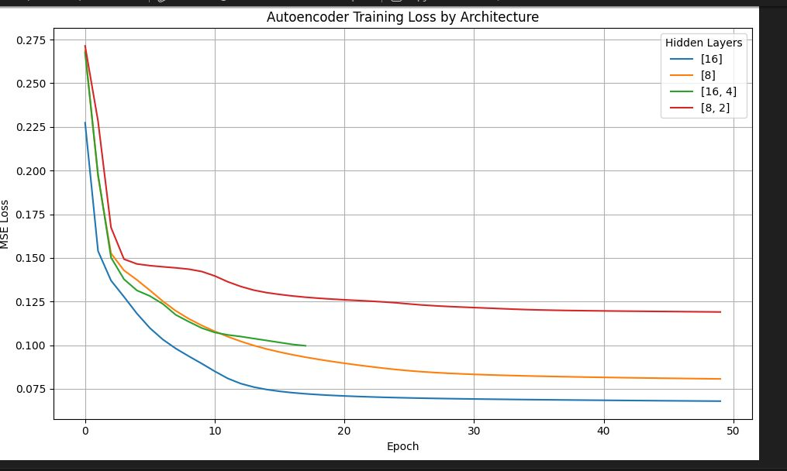
All architectures converge smoothly, indicating stable training. The [16] architecture (single wide layer) achieves the lowest loss (~0.07), followed by [8] (~0.08). Deeper architectures ([16,4], [8,2]) plateau at higher loss (~0.10–0.12). This shows that increasing depth does not improve performance.

Conclusion:
Capacity (width) is more important than depth. Deeper bottlenecks likely over-compress information.

2) MinMaxScaler – Reconstruction MSE (AE vs PCA vs SVD)
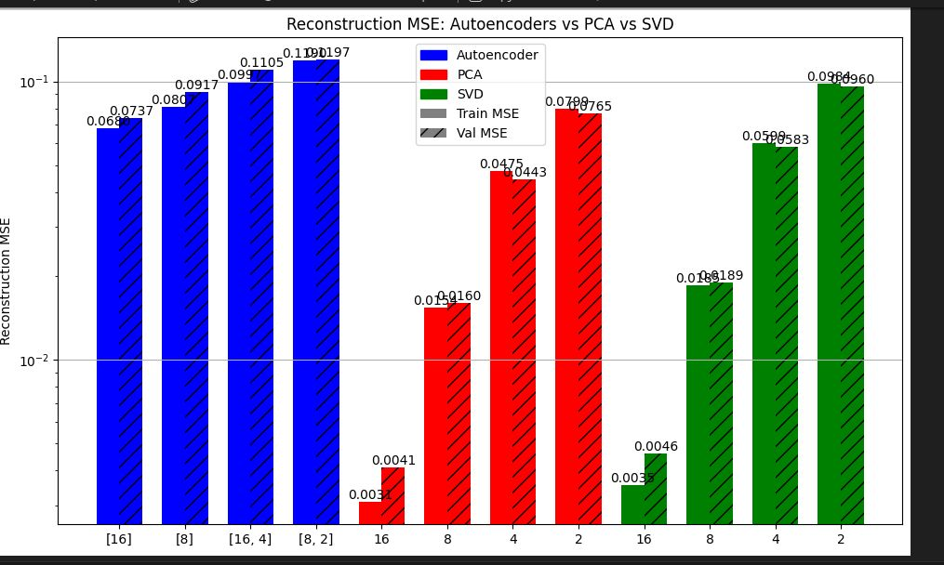
Autoencoder performs best at latent size 16 (~0.068 train / ~0.073 val). PCA achieves very low error at high dimension but degrades quickly at lower dimensions. SVD follows a similar trend but is slightly worse.

Conclusion:
Autoencoders outperform PCA/SVD at low dimensions indicating some features are nonlinear, which suggests a nonlinear Autoencoder is necessary for compression. PCA and SVD perform better at higher dimensions.

3) MinMaxScaler – Training Time + Validation Loss
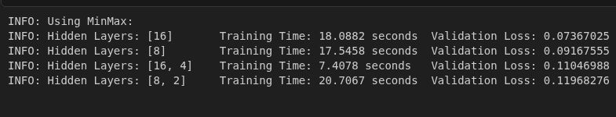
[16] is both fastest (~18s) and best (~0.073). Deeper models are slower and perform worse.

Conclusion:
Best tradeoff is the [16] architecture, which is the latent dimension we chose to train the LSTM model.

4) StandardScaler – Training Loss Curves
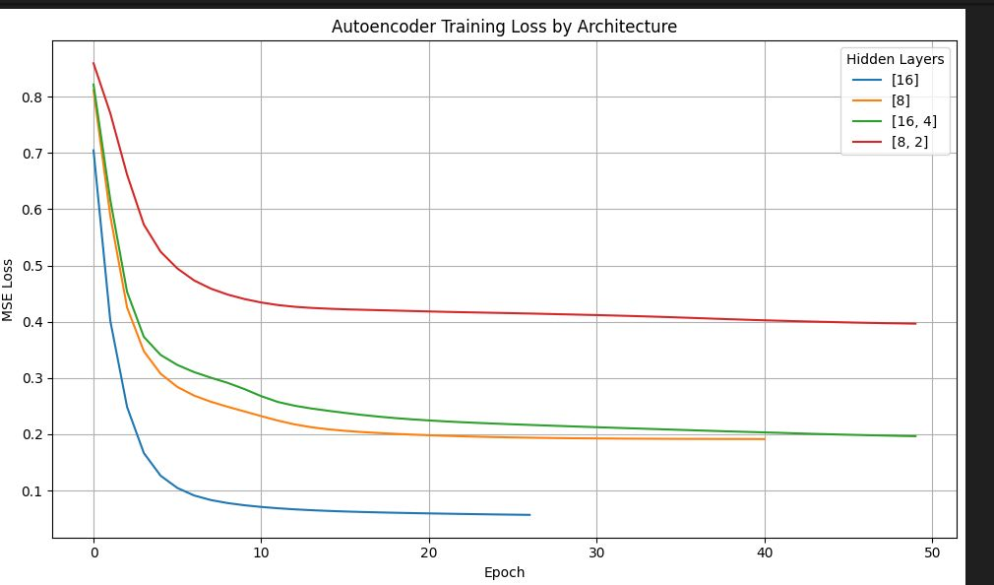
Convergence behavior is similar, but loss values are higher overall. The [16] model remains best. Deeper models perform worse.

Conclusion:
StandardScaler increases reconstruction difficulty but does not change relative performance.

5) StandardScaler – Reconstruction MSE
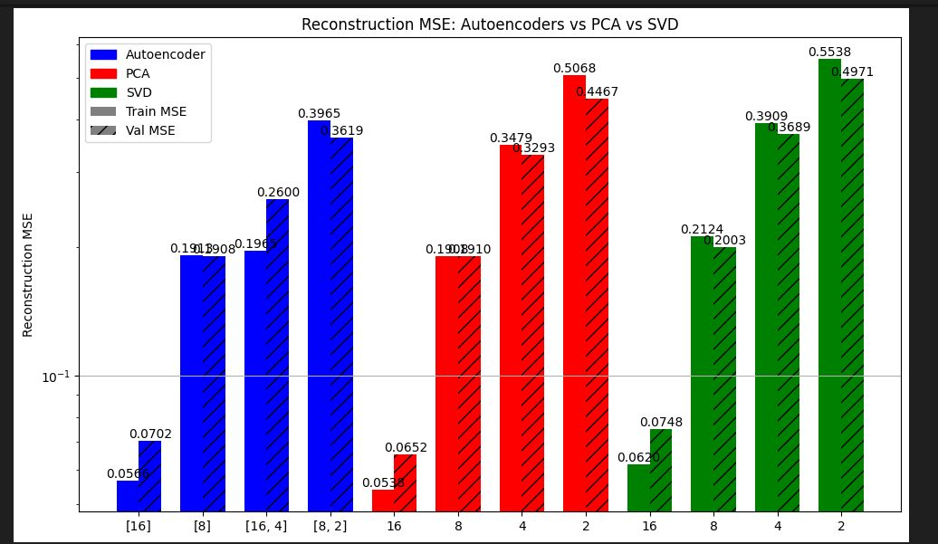
Autoencoder again performs best at latent size 16 (~0.056 train / ~0.070 val). PCA remains strong at high dimensions. SVD performs worst overall.

Conclusion:
Same trend as MinMaxScaler. Autoencoder excels at low dimensions, PCA at high dimensions.

6) StandardScaler – Training Time + Validation Loss
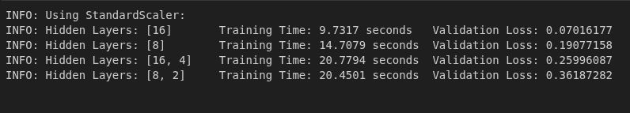
[16] is fastest (~9.7s) and best (~0.070). Deeper architectures perform significantly worse.

Conclusion:
Deeper architectures over-compress standardized data more severely.

OVERALL CONCLUSIONS

1. Architecture:
Shallow, wide autoencoders outperform deeper ones. Best model is a single hidden layer with 16 units.

2. Autoencoder vs PCA/SVD:
At high dimensions, PCA is competitive. At low dimensions, Autoencoders outperform due to nonlinear feature learning.

3. Scaling:
MinMax yields lower reconstruction loss values; however, this does not suggest down stream performance when training the LSTM. The low reconstruction loss is likely due to the constraint on the range [0,1] for each feature, and since the last layer in the decoder passes the final output through a sigmoid activation function. This also bounds the output range from [0,1], which leads to less error compared to the range when using StandardScaler (-infinity, infinity). In addition, the data being very homogeneous with few outliers can also be another reason why MinMax had lower loss. After switching to StandardScaler, our model performance improved (LSTM performance). This suggests that although the reconstruction error is, generally, lower when using MinMax, using StandardScaler might compress the features into a more meaningful representation.

4. Feature Insight:
Sensor and cyclic features contain nonlinear structure, as shown by Autoencoder performance.

5. Practical Takeaway:
Use autoencoders (latent 8–16) for nonlinear compression. Use PCA for simpler, high-dimensional linear reconstruction.

