LSTM Training

Iteration 1
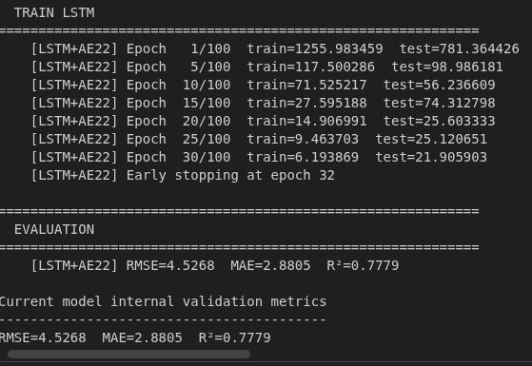
Configuration Summary:
- Autoencoder input: MinMax scaled (cyclic + raw sensor + binary features)
- Latent dimension: 22
- Lag features: 24-hour lags for 6 features (144 dimensions)
- Lag scaling: not scaled
- Final LSTM input size: 166 features (144 lag + 22 latent)

Key Observations:

1) Feature Space Composition:
The majority of the input space (144 out of 166 features, ~87%) is composed of lag features, while the latent representation contributes only ~13%. This indicates that the model is dominated by temporal lag signals rather than learned representations.

2) Scaling Mismatch:
The autoencoder output is MinMax scaled (0–1 range), while lag features remain unscaled. This creates a feature imbalance, causing the LSTM to prioritize higher-magnitude lag inputs and reducing the influence of latent features.

3) Latent Representation Usage:
Although the autoencoder learns compressed nonlinear structure from sensor and cyclic features, its contribution is diluted when concatenated with the much larger lag feature space. The latent space acts more as an auxiliary input rather than a primary signal.

4) Model Behavior Implication:
The LSTM is likely prioritizing short-term temporal correlations from lag features instead of leveraging cross-feature nonlinear structure from the latent representation.

Conclusion:
The architecture is dominated by lag features, and the benefit of the our autoencoder is not seen. The lack of scaling for lag features introduces distribution mismatch, reducing model effectiveness.

Iteration 2
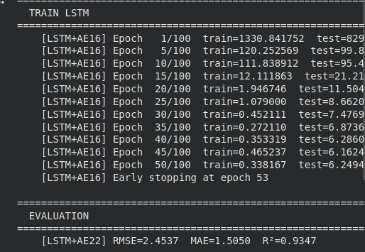

Configuration Changes:
- Autoencoder input: StandardScaler
- Input features: raw sensor + cyclic only (36 → 16 latent)
- Latent dimension: reduced from 22 → 16
- Lag features: reduced from 6 → 4 (removed wind_direction sin/cos)
- Lag scaling: scaled using the same scaler as AE input
- Final LSTM input size: 113 features (latent + lag + binary)

Key Improvements:

1) Scaling Consistency:
All major feature groups (latent + lag) now share the same distribution. This eliminates magnitude imbalance from Iteration 1 and ensures the LSTM treats features comparably.

2) Dimensionality Reduction:
Latent space reduced (22 → 16). Lag space also reduced due to fewer features. The overall input is more compact, less noisy, and reduces risk of overfitting. Reduced from 166 → 113 from iteration 1.

3) Feature Selection (Lag Reduction):
Removing wind direction (sin/cos) likely eliminates low-contribution or redundant signals, improving signal-to-noise ratio.

4) Balanced Feature Contribution:
Compared to Iteration 1, latent features now have greater relative influence, and lag features no longer dominate due to scale or dimensionality.

Model Behavior Implication:
The LSTM now operates on a well-conditioned input space with a balanced mix of temporal dependencies (lags) and nonlinear feature abstraction (autoencoder). This improves generalization, stabilizes training, and allows better use of latent features.

Conclusion:
Consistent scaling, reduced dimensionality, and feature pruning improve model efficiency and effectiveness. The latent representation is now meaningfully incorporated.

Iteration 3
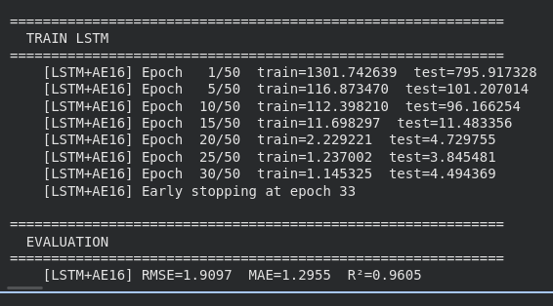

Configuration Changes:
- Same base as Iteration 2 (StandardScaler, latent = 16)
- Removed wind speed lag feature entirely
- Reduced lag windows:
- PM2.5 and Ozone → 8-hour lag
- AQI → full 24-hour lag (retained)
- Final LSTM input size: 57 features

Key Improvements:

1) Targeted Lag Reduction:
Not all features require equal temporal depth. Shortening PM2.5 and Ozone to 8 hours removes redundant long-range dependencies and focuses on the most relevant recent signals. Keeping AQI at 24 hours preserves long-term temporal structure for the target variable.

2) Feature Elimination:
Wind speed lag was removed, indicating low predictive contribution and potential noise. This improved signal clarity and reduced unnecessary complexity.

3) Significant Dimensionality Reduction:
Input reduced from 166 → 113 → 57. This lowers model complexity, speeds up training, reduces overfitting risk, and improves optimization efficiency.

4) Improved Feature Efficiency:
Remaining features are more purposeful and informative. The model input is compact, information-dense, and better conditioned.

Model Behavior Implication:
The LSTM now learns from selective temporal signals (long-term AQI, short-term others) combined with nonlinear compressed representations from the autoencoder. This improves generalization and reduces sensitivity to noise.

Conclusion:
The final iteration achieves the most effective structure by removing weak features, applying variable-specific lag windows, and preserving key signals.

Final iteration
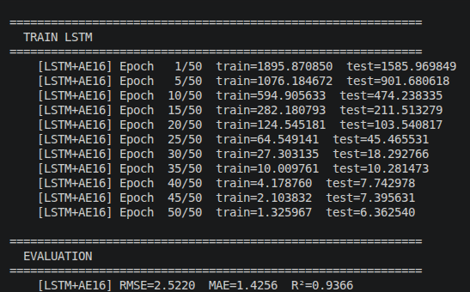
Configuration Changes:
- Removed cyclic columns from AE compression
- Removed columns based on exploration and validation teams feedback
- Reduced size of LSTM model from 512 hidden size and 3 layers → 96 hidden size and 1 layer
- AE compression is only on sensor data + lat/long (21 → 8 dimension)
- Changed AE activation function to LeakyReLU

Unchanged Configuration:
- Lag features remain the same as iteration 3
- Scaled using StandardScaler
- LSTM input dimension = 57 (40 lag + 8 latent + 8 cyclic + 1 binary)

Key Improvements:

1) Cyclic removal from AE compression
The cyclic columns are engineered to have a meaningful representation, and are bound in a range from [-1,1]. Since they capture the periodic pattern of traffic/weather and are already scaled, we decided to remove from AE

2) Column removal
Implementing the feedback from our data exploration and validation teams, we removed columns that were not significant indicators for the AQI prediction, highly correlated, and columns that had low variability to reduce our dimensionality.

3) AE changes
As an exploratory experimentation, we changed the activation function of the AE to see if the reconstruction results were any different, and reconstruction was slightly more accurate. We believe this to be because we used StandardScaler, which ranges from (-infinity, infinity), we could have had some dead neurons during training. LeakyReLU helps fight against this problem. In addition, with the cyclic columns removed, we aimed for a smaller latent space representation (8). Our AE performed better than SVD and PCA at this dimension, which would indicate some nonlinearity in the sensor features.

4) Reduced size of LSTM model
With our features and AE being honed in, we wanted to experiment with smaller models. After multiple tests, we concluded only 1 layer and a hidden size of 96 was sufficient for an accurate prediction. Although, the larger sizes were a bit more accurate on both the training and validation data, we were facing problems with overfitting, so we decided on the smaller model.

