INCIDENT REPORT

Scareware Pop-up Attack & System Remediation
Report Date: | September 3, 2026
Incident Date: | September 3, 2026
Severity: | Medium (Scareware - No Malware Detected)

EXECUTIVE SUMMARY
Multiple fake security alert pop-ups were encountered during normal web browsing. The alerts impersonated Norton and McAfee antivirus software, attempting to trick the user into clicking malicious buttons. User followed proper security protocol by closing the alerts without clicking any buttons. Subsequent system scans and cleanup procedures revealed no actual malware infection.

INCIDENT DETAILS
Type of Incident:
Scareware (Fake Security Alert Pop-ups)
Description:
While browsing the internet, multiple pop-up windows appeared displaying fake security alerts claiming the system was infected with viruses. This incident occurred after mistyping a website URL, which resulted in landing on a typo-squatted malicious domain hosting the scareware pop-ups.The alerts impersonated legitimate antivirus companies (Norton, McAfee) with bright red warning colors and urgent messaging.
Malicious Domain Identified:
dac79p9s66ac73adjlm0.rehit.co.in
Fake Alerts Displayed:
• Norton "Your Norton Is No Longer Active" with "RENEW NORTON" button
• McAfee "Critical Virus Alert" with "Delete Viruses" and "Open Antivirus" buttons
• Multiple overlapping alerts designed to create panic and confusion

INCIDENT TIMELINE
10:43 AM – User mistyped website URL(tutorialspoint.com), accidentally landing on typo-squatted malicious domain
10:45 AM - Fake security pop-ups first encountered during web browsing
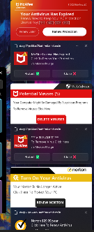
~10:46 AM - User closed browser tab without clicking any pop-up buttons (correct action)
~10:47 AM - Initiated Windows Defender Full System Scan
~11:21 AM - Windows Defender scan completed: No threats detected
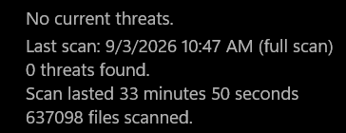

~11:22 AM - Cleared browser cache, cookies, and site settings
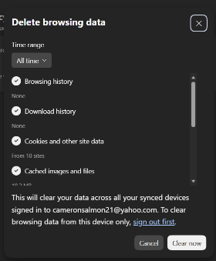
~11:23 AM - Checked browser extensions for malicious additions (found none)
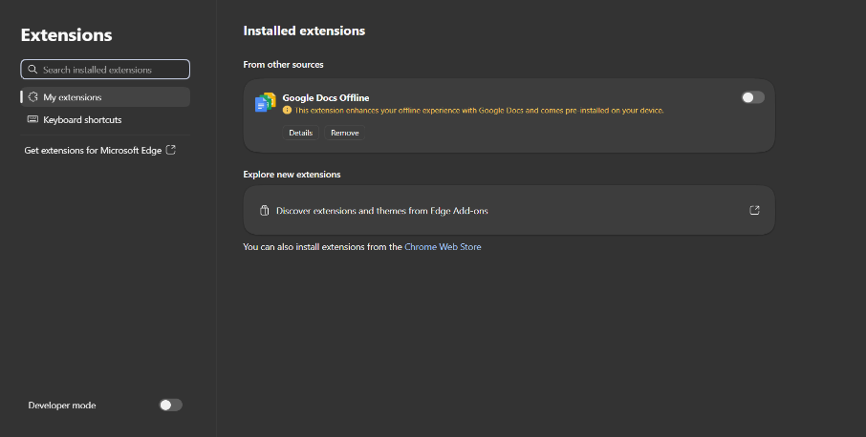
~11:25 AM - Initiated System File Checker: sfc /scannow
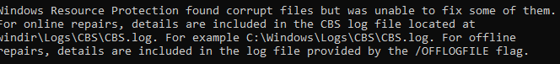
~11:30 AM - Initiated DISM repair: dism.exe /online /cleanup-image /restorehealth
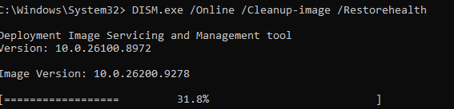
~12:15 PM - All system repairs completed successfully

ACTIONS TAKEN
Step 1: Immediate Response
✓ Closed browser tab containing malicious pop-ups without clicking any buttons ✓ Did NOT click "Delete Viruses," "Protect," or "Renew" buttons ✓ Used task manager to safely close the tab
Step 2: System Scan
✓ Opened Windows Security (Settings > Update & Security > Windows Security) ✓ Ran "Full scan" option in Virus & threat protection ✓ Scan completed with result: NO THREATS DETECTED
Step 3: Browser Cleanup
✓ Pressed Ctrl + Shift + Delete to open Clear Browsing Data ✓ Cleared: Cookies and site data, Cached images and files, Site settings ✓ Set time range to "All time" ✓ Reviewed and removed suspicious browser extensions (found none)
Step 4: System File Repair - SFC Scan
✓ Opened Command Prompt as Administrator ✓ Ran command: sfc /scannow ✓ Purpose: System File Checker scans for corrupted Windows system files ✓ Result: Windows Resource Protection found corrupt files but was unable to fix some of them (normal after scareware exposure)
Step 5: Deep System Repair - DISM Cleanup
✓ Ran command: dism.exe /online /cleanup-image /restorehealth ✓ Purpose: Deployment Image Servicing and Management tool performs deeper Windows system repair ✓ Parameters used: - /online: Works on currently running Windows system - /cleanup-image: Cleans up Windows installation files - /restorehealth: Restores and repairs Windows system health ✓ Result: Successfully completed verification and repairs (started at 63.3% and completed at ~1:15 PM)

TECHNICAL DETAILS
System Repair Commands Used:
Command 1: sfc /scannow
• Tool: System File Checker (built-in Windows utility) • Function: Scans Windows system files for corruption • Action: Attempts to automatically repair corrupted files • Runtime: Approximately 15-30 minutes • Result in this incident: Found corrupt files, repaired what could be fixed
Command 2: dism.exe /online /cleanup-image /restorehealth
• Tool: Deployment Image Servicing and Management (built-in Windows utility) • Function: Performs deeper system image repair than SFC • Parameters: /online - Operates on the currently running Windows installation /cleanup-image - Cleans up the Windows installation image /restorehealth - Repairs Windows system components and health • Runtime: Can take 30+ minutes • Result in this incident: Successfully restored system health
Command Sequence Rationale:
These two commands are commonly run together as a comprehensive system repair process. SFC /scannow handles system files, while DISM /online /cleanup-image /restorehealth provides a deeper level of system restoration. Running them in sequence ensures thorough remediation of any system-level damage caused by malware or scareware exposure.

FINDINGS & RESULTS
Malware Status: CLEAN
✓ Windows Defender Full Scan: No threats detected ✓ No malicious files found on system ✓ No unwanted browser extensions installed
Browser Status: CLEANED
✓ Cache and cookies cleared ✓ Site settings reset ✓ Browser running optimally ✓ Pop-ups stopped after browser cleanup
System Status: REPAIRED
✓ SFC /scannow scan completed with file repairs ✓ DISM /online /cleanup-image /restorehealth completed successfully ✓ System files restored and verified ✓ No pop-ups reappeared after cleanup

LESSONS LEARNED
1. Scareware Identification
• Recognize urgent, panic-inducing language as a red flag • Real security alerts don't use bright red emergency styling with multiple overlapping warnings • Legitimate antivirus vendors won't use random domain names (like .rehit.co.in)
2. Proper Response Protocol
• Closing the tab/browser without clicking suspicious buttons prevented any actual infection • Proper incident response requires both immediate action and follow-up verification • Never click buttons on unsolicited security alerts
3. System Repair Tools
• SFC /scannow and DISM /online /cleanup-image /restorehealth are powerful built-in Windows tools • These commands are safe and designed for system remediation after malware exposure • Both must be run from Command Prompt as Administrator • Running them together provides comprehensive system repair
4. Typo Squatting Risk
Mistyping a single character in a URL can land you on a malicious typo-squatted domain. Attackers register similar domain names to real websites and host malware/ scareware. Always double check URLs before pressing enter, especially for sensitive sites like banks or email.

RECOMMENDATIONS
1. Install a pop-up blocker browser extension (uBlock Origin, Adblock Plus)
2. Enable browser pop-up blocking in settings
3. Keep Windows Defender up-to-date and schedule regular full scans
4. Avoid clicking on suspicious websites or unknown links
5. Remember: Real security alerts will never pop up from websites—they come from Windows Security or installed antivirus software
6. Monitor for unusual system behavior and investigate immediately
7. Bookmark proper system repair procedures (SFC and DISM commands) for future reference

CONCLUSION
The scareware incident was successfully contained and remediated. By following proper security protocol (not clicking suspicious alerts), performing comprehensive system scans with Windows Defender, running Windows repair tools (sfc /scannow and dism.exe /online /cleanup-image /restorehealth), and executing browser cleanup procedures, the system was restored to a clean and healthy state. The root cause was identified as a typo-squatted domain encountered through a mistyped URL, which highlights the importance of URL verification and careful typing when navigating the web. The incident demonstrates the importance of user awareness, proper response procedures, and knowledge of built-in system repair tools in preventing and recovering from malware infections.
Incident Status: RESOLVED

