Closed Loop Disturbance Recovery Comparison of Twin Only and Tail Assisted Vectored VTOL Configurations
Cameron Thomas
Department of Aerospace Engineering

Abstract
This report compares two vectored-thrust VTOL configurations under pitch-rate disturbances and a commanded longitudinal translation. The twin-only vehicle uses two independently thrust-controlled, two-axis-gimballed main propulsors. The tail-assisted vehicle retains the two main propulsors and adds an aft propulsor intended to produce pitch moment through a longitudinal lever arm. Existing controllers and gains were retained for both cases. The twin-only proof-of-concept response shows a weak pitch axis: a 4 rad/s initial pitch-rate disturbance approaches a 90 degree attitude excursion and drives the lateral gimbals to their plus or minus 35 degree limits. The tail-assisted response reaches approximately 17.5 degrees under the same isolated disturbance while tail thrust remains below its 10 N limit. A separately logged combined 4 rad/s pitch-rate and plus 1 m x-step simulation shows that the tail-assisted case meets the stated attitude, altitude, and settling gate, whereas the twin-only case does not. The result supports a dedicated pitch-control channel for further development, subject to a full nonlinear 6-DOF validation with actuator dynamics and CAD-derived properties.

Nomenclature
Symbol | Definition
F_x, F_y, F_z | Body-axis force components
M_x, M_y, M_z | Body-axis moment components
q | Body pitch rate
T_i | Thrust of propulsor i
T_3 | Tail-propulsor thrust
alpha | Main-propulsor fore/aft gimbal angle
beta | Main-propulsor lateral gimbal angle
theta | Pitch angle
l_t | Tail moment arm

I. Introduction
The purpose of this study is to determine whether a two-main-propulsor vectored-thrust VTOL can retain practical attitude and position control once its thrust and gimbal limits are applied. A local rank calculation alone is insufficient because a vehicle may be mathematically controllable near hover but unable to generate a required wrench after saturation.
Two architectures were evaluated. The twin-only reference vehicle uses two two-axis-gimballed main propulsors. The tail-assisted vehicle adds a third aft propulsor. The study asks whether the tail propulsor provides a useful allocation path for pitch recovery while allowing the main propulsors to maintain translational and altitude-control capability.

II. Simulation Method

A. Coordinate System and Main Propulsor Geometry
The body frame uses aerospace axes: x_b forward, y_b right, and z_b down. The main-propulsor thrust direction is modeled as
n(alpha, beta) = [sin alpha, cos alpha sin beta, -cos alpha cos beta]^T | (1)
Common fore/aft gimbal deflection alpha primarily produces F_x. Differential lateral gimbal deflection beta produces lateral force and the weak reaction-torque pitch moment M_y. The architecture therefore does not have a literal first-order F_x-versus-M_y demand on one identical gimbal coordinate. Coupling occurs when finite gimbal travel, finite thrust, and the need to preserve the vertical thrust component are considered together.

B. Test Cases and Evidence Traceability
Test | Purpose | Pitch rate input | Position command
Isolated proof of concept | Compare axis authority and actuator response | 2 rad/s; selected 4 rad/s pitch case | Separate +1 m x step
Combined closed-loop maneuver | Test constrained recovery and translation | 4 rad/s | Simultaneous +1 m x step

The same controller structure and gains were retained for the combined test; neither vehicle was retuned for this case. The proof-of-concept figures document isolated disturbances and x steps. The numerical combined-maneuver metrics are reproduced from separately logged simulation data in the referenced analysis artifacts. The isolated x-step plots must not be interpreted as direct evidence of simultaneous-maneuver performance.
The engineering screening gate was |theta| < 45 degrees, |z| < 0.5 m, and settling time < 6 s.

III. Results and Discussion

A. Isolated Disturbance Recovery Results
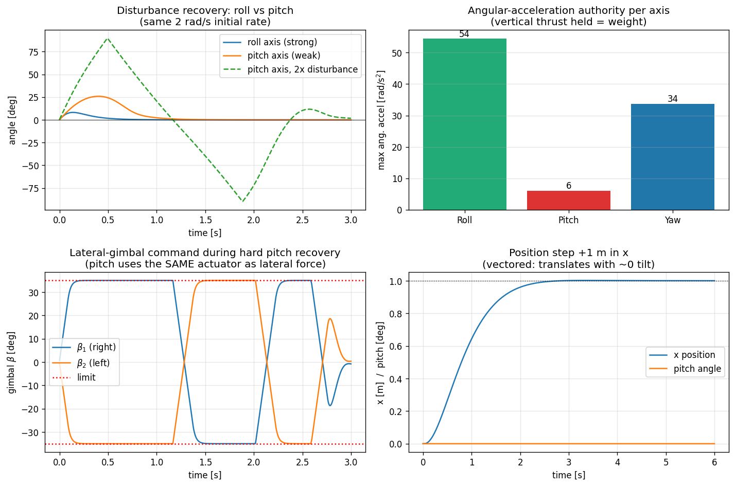
Fig. 1 Twin-only disturbance recovery, angular authority, gimbal command, and isolated x-step response.

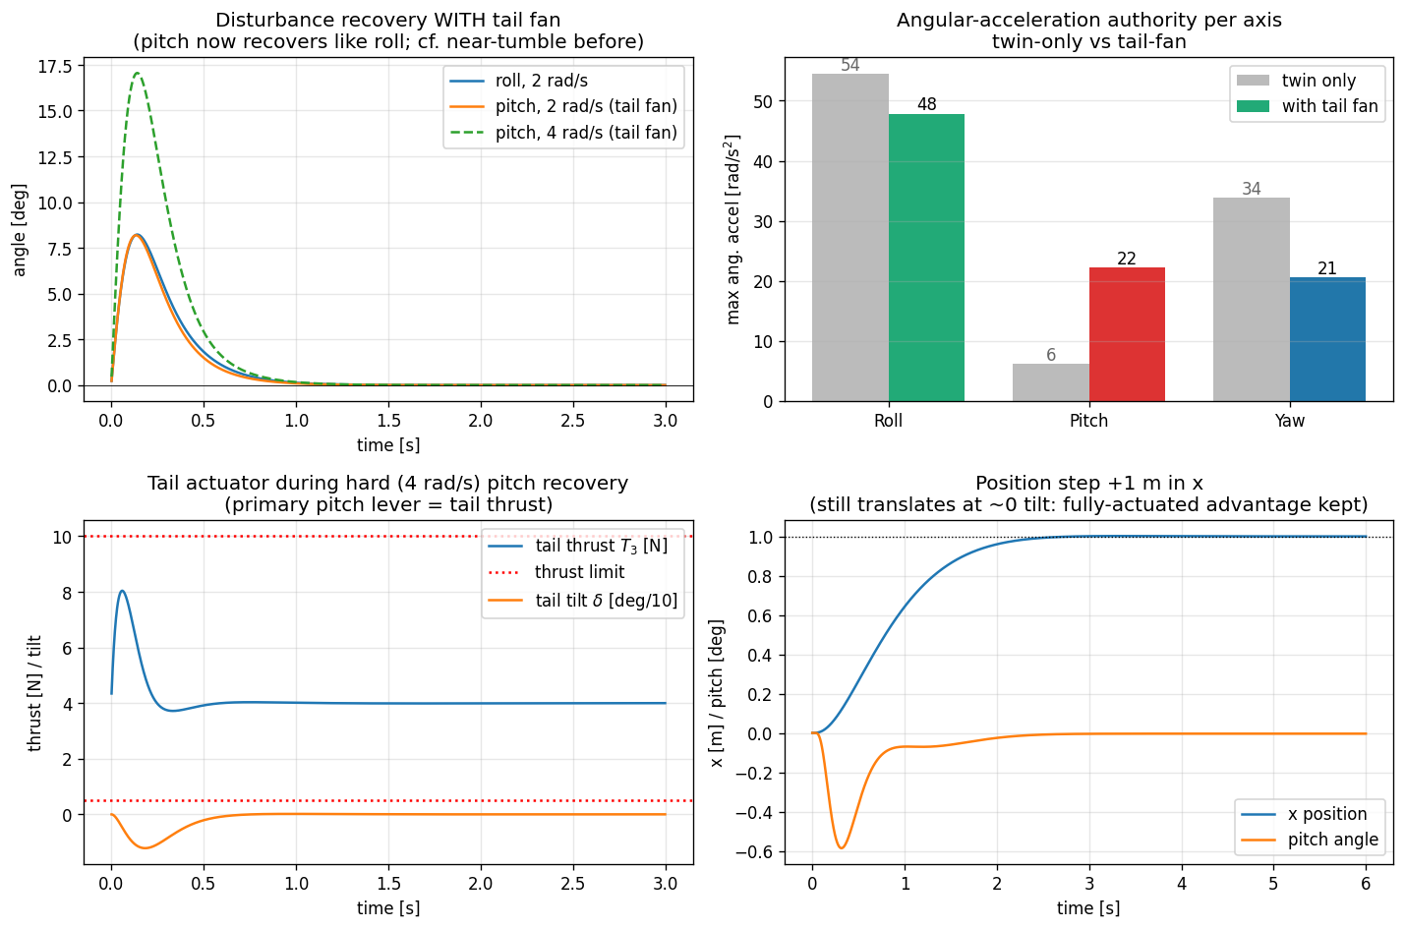
Fig. 2 Tail-assisted disturbance recovery, angular authority, tail-actuator response, and isolated x-step response.
Table 2 summarizes the angular-authority values shown in Figs. 1 and 2. The models hold vertical thrust approximately equal to weight for this comparison.
Architecture | Roll authority | Pitch authority | Yaw authority
Twin-only | 54 rad/s^2 | 6 rad/s^2 | 34 rad/s^2
Tail-assisted | 48 rad/s^2 | 22 rad/s^2 | 21 rad/s^2

The twin-only vehicle recovers a 2 rad/s roll disturbance with a small angular excursion, whereas the same initial pitch-rate disturbance creates a substantially larger pitch response. At 4 rad/s, the simplified twin-only pitch trace approaches plus or minus 90 degrees, indicating loss of useful attitude margin. The lateral gimbals spend extended intervals at their plus or minus 35 degree position limits during this recovery.
The tail-assisted 4 rad/s isolated pitch case reaches approximately 17.5 degrees before recovering. Its tail-thrust trace peaks near 8 N against the plotted 10 N maximum, indicating remaining positive thrust margin for that specific case. The additional pitch authority is consistent with a force applied at the tail moment arm rather than with a change in controller tuning.

B. Combined Disturbance and Translation Result
The combined simulation imposed q(0) = 4 rad/s, theta(0) = 0, zero initial translational velocity, zero roll/yaw rate, and a simultaneous +1 m x-position command. The logged results are listed in Table 3.
Metric | Twin-only | Tail-assisted
Peak pitch angle | 89.93 degrees | 17.52 degrees
Time to arrest initial pitch rate | 2.312 s | 0.148 s
Pitch settling time | 2.732 s | 0.510 s
x settling time | 5.272 s | 2.248 s
x overshoot | 19.58 percent | 0.218 percent
RMS x-position error | 0.780 m | 0.329 m
Maximum altitude deviation | 26.337 m | 0.114 m

The twin-only simulation eventually trends toward the commanded state, but it violates the attitude and altitude limits in the screening gate. This is not an acceptable practical recovery. The tail-assisted vehicle remains inside the screening gate, arrests the pitch rate rapidly, preserves altitude, and settles the x step more quickly.
A preliminary disturbance sweep with the +1 m x command retained found approximate recoverable initial pitch-rate limits of 2.25 rad/s for the twin-only vehicle and 7.60 rad/s for the tail-assisted vehicle. These values are screening results for the present model, not certified flight-envelope boundaries.

C. Actuator Level Interpretation
When main gimbals are tilted, the available vertical force is reduced according to
F_z is proportional to -T cos alpha cos beta | (2)
In the twin-only system, the pitch disturbance consumes beta authority and vertical-force margin, while the x command consumes alpha authority and further reduces the vertical thrust component. The resulting attitude deviation also couples gravity into the horizontal force balance. Thus, attitude recovery and translation become practically coupled once limits are reached.
Near hover, the tail-assisted configuration produces pitch moment approximately as
M_y is approximately -l_t T_3 | (3)
Tail thrust therefore carries much of the pitch-recovery demand while main gimbals remain more available for force generation. The result is primarily an allocation and moment-arm improvement; the tail case also has greater total installed thrust, so a future matched-mass and matched-thrust study is required to isolate the two contributions quantitatively.

IV. Conclusions
The twin-only reference vehicle is locally controllable near hover but is not robustly controllable under the 4 rad/s pitch-disturbance and +1 m translation test. Its main-propulsor gimbals saturate, vertical-force margin collapses, and the available reaction-torque pitch moment is insufficient for a practical recovery.
The tail-assisted vehicle passes the same simulation gate and provides substantially improved disturbance rejection, translation tracking, and altitude retention. The evidence supports retaining a dedicated pitch-control channel in the next design iteration. The next technical gate is to repeat the combined maneuver using the nonlinear constrained allocator inside the full 6-DOF model with motor/gimbal dynamics, CAD-derived mass properties, aerodynamic forces, and experimentally measured propulsor data.

References
1. models/twin_vtol_poc.py, Twin Only Vectored VTOL Proof of Concept Model, project source code.
2. models/twin_vtol_tail_poc.py, Tail Assisted Vectored VTOL Proof of Concept Model, project source code.
3. models/combined_vtol_analysis.py and results/combined_metrics.csv, Combined Pitch Disturbance and x Step Simulation Results, project analysis artifacts.

