Hover Constrained Nonlinear Wrench Authority and Control Allocation for Twin Only and Tail Assisted VTOL Architectures
Cameron Thomas
Department of Aerospace Engineering
Simplified AIAA Style Technical Report

Abstract
This report evaluates the instantaneous nonlinear actuator-to-wrench authority of twin-only and tail-assisted vectored-thrust VTOL architectures while maintaining hover. Each main propulsor has independently commanded thrust and two gimbal angles. The tail-assisted configuration additionally includes an aft propulsor. An exact nonlinear wrench model, bounded weighted least-squares allocator, scaled Jacobian analysis, and hover-constrained force/moment maps were used. Both architectures are locally rank six over the sampled gimbal grid. However, the twin-only vehicle has a weak pitch-control direction: its feasible pitch-moment range is approximately plus or minus 0.15 N m and its smallest scaled singular value near hover is approximately 0.02. The tail-assisted architecture expands the central pitch-moment envelope to approximately -2.6 to +1.6 N m and increases the smallest scaled singular value to approximately 0.25. The results demonstrate that rank alone is not a sufficient measure of practical controllability. The tail provides its main benefit through a direct longitudinal thrust-moment lever and improved constrained allocation, although a matched mass/inertia/thrust study is required to quantify the contribution independently of increased installed thrust.

Nomenclature
Symbol | Definition
alpha, beta | Main-propulsor fore/aft and lateral gimbal angles
delta | Tail-propulsor tilt angle
F_i | Thrust force vector of propulsor i
M_i | Moment vector of propulsor i about the CG
r_i | Propulsor position relative to the CG
W | Body wrench [F_x, F_y, F_z, M_x, M_y, M_z]^T
J | Nonlinear wrench Jacobian, dW/du
J_s | Dimensionless scaled wrench Jacobian
kappa | Reaction-torque arm, 0.0144 m
l_t | Tail longitudinal moment arm, 0.350 m
u_max | Largest normalized actuator utilization

I. Introduction
The closed-loop proof-of-concept simulations showed a pronounced difference between twin-only and tail-assisted pitch-disturbance recovery. This report examines the actuator geometry and constrained authority behind that dynamic behavior. The objective is to determine whether a requested force/moment vector is physically achievable after thrust and gimbal limits are applied, rather than only determining whether an unconstrained controller can command it.
The study is quasi-static and hover constrained. It includes nonlinear thrust-vector geometry, reaction torque, actuator position limits, and allocation residuals. It does not include motor/gimbal bandwidth, structural flexibility, aerodynamics, or 6-DOF trajectory dynamics; those effects must be included in the next validation step.

II. Nonlinear Wrench and Allocation Formulation

A. Propulsor Wrench Model
Body axes follow the aerospace convention: x_b forward, y_b right, and z_b down. For each main propulsor,
n(alpha, beta) = [sin alpha, cos alpha sin beta, -cos alpha cos beta]^T; F_i = T_i n_i | (1)
Reaction torque and propulsor moment are modeled as
Q_i = -sigma_i kappa F_i; M_i = r_i x F_i + Q_i | (2)
The exact nonlinear body wrench is
W(u) = [sum(F_i), sum(M_i)]^T | (3)
For the twin-only reference geometry, r_1 = [0, +d, 0]^T and r_2 = [0, -d, 0]^T, where d = 0.300 m. The resulting pitch moment is
M_y = -kappa F_y1 + kappa F_y2 | (4)
Thus, common alpha primarily generates F_x, common beta primarily generates F_y, and differential beta generates the weak reaction-torque pitch moment. The direct trade is F_y versus M_y, not a literal F_x versus M_y demand on a single gimbal coordinate.
For the tail-assisted vehicle, F_3 = T_3[-sin delta, 0, -cos delta]^T and r_3 = [-l_t, 0, 0]^T. The tail pitch contribution is
M_y3 = -l_t T_3 cos delta | (5)
At trim, delta = 0, so dM_y3/dT_3 = -l_t = -0.350 N m/N and dM_y3/delta = 0. Tail thrust modulation, rather than tail tilt, is the first-order pitch-control mechanism in this geometry.

B. Constrained Allocation and Scaled Jacobian
For requested wrench W_des, the allocator minimizes a weighted wrench-tracking residual and a command-change penalty, subject to thrust and gimbal position limits. Moment components receive greater priority than translation when the entire wrench cannot be achieved. Each map point maintains the hover condition F_z approximately equal to -mg.
minimize ||S_W[W(u) - W_des]||^2 + lambda_u ||S_u(u - u_prev)||^2 | (6)
Because actuator coordinates mix newtons and radians, raw Jacobian conditioning is not meaningful. The dimensionless scaled Jacobian uses wrench scales of mg and mgL_ref and actuator scales equal to half of the physical actuator travel.
J_s = diag(1/W_scale) J diag(u_half-range) | (7)
A value of u_max = 1 indicates that at least one actuator is at a position bound.

III. Results and Discussion

A. Force and Moment Envelopes
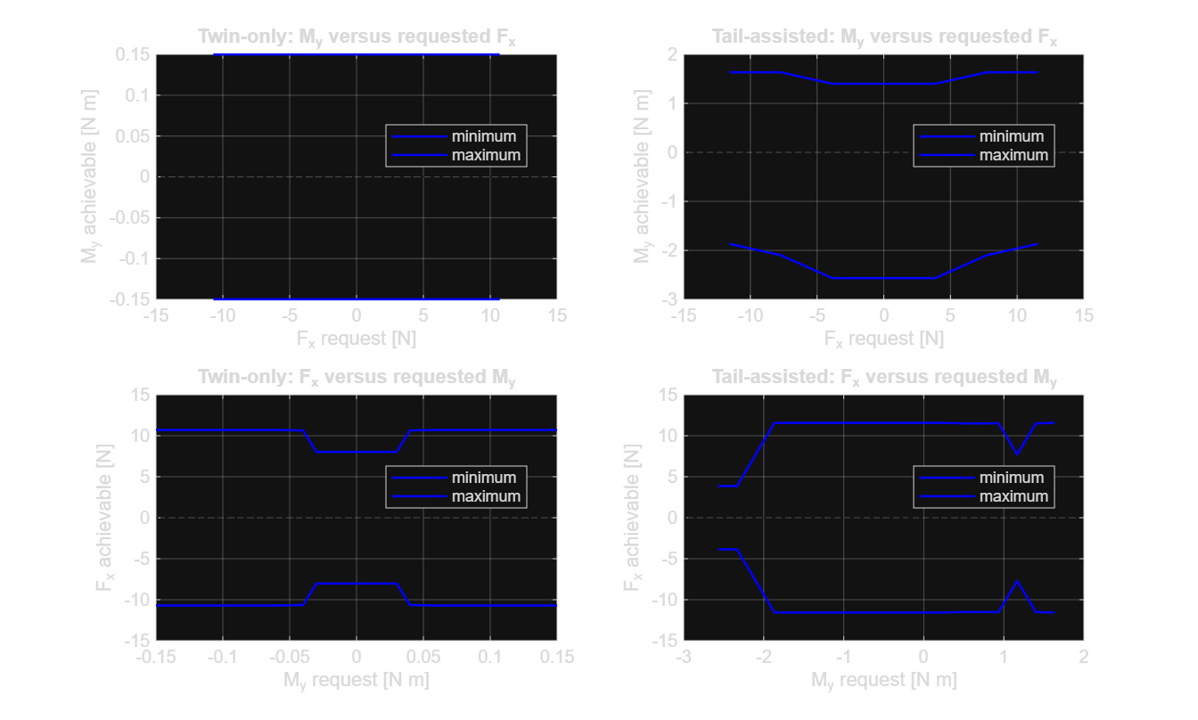
Fig. 1 Achievable longitudinal force and pitch moment while maintaining hover.
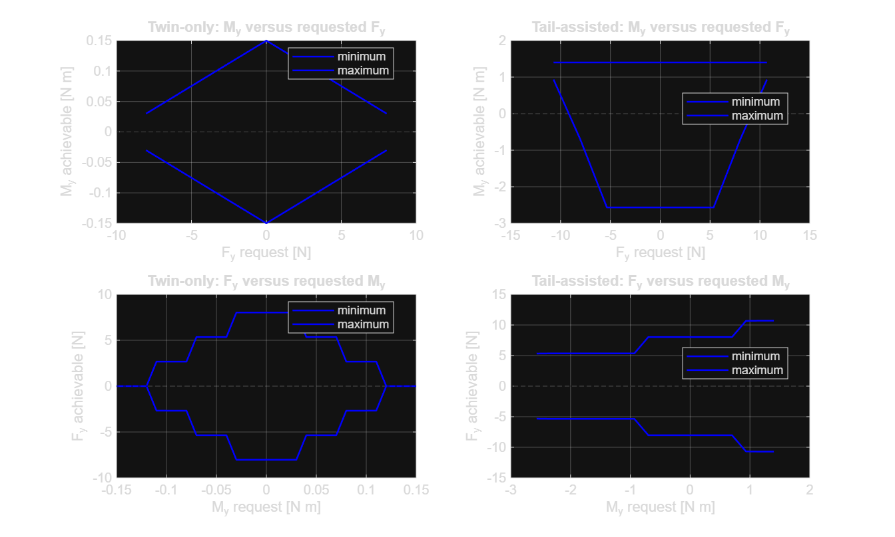
Fig. 2 Achievable lateral force and pitch moment while maintaining hover.
At nominal twin-only trim and beta = plus or minus 35 degrees, the differential-beta model predicts approximately plus or minus 0.122 N m of pitch moment, equivalent to approximately 6.1 rad/s^2 for I_yy = 0.020 kg m^2. The maps show a similarly narrow twin-only pitch-moment envelope, approximately plus or minus 0.15 N m.
The tail-assisted map expands the central pitch-moment range to approximately -2.6 to +1.6 N m. The range is asymmetric because the tail propulsor trims near 4 N and has unequal thrust-increase and thrust-decrease reserve within its 0.5 to 10 N bounds. The F_y/M_y map demonstrates the direct twin-only trade: lateral-force demand consumes the same finite beta authority required for reaction-torque pitch control. The tail-assisted configuration preserves considerably more pitch moment throughout the lateral-force sweep.
The F_x/M_y maps show indirect rather than direct coupling. Main alpha provides the primary F_x channel, whereas beta provides the twin primary M_y channel. Their ability to coexist decreases when gimbal travel, thrust limits, and the vertical-force constraint are simultaneously active.

B. Allocation Residual and Actuator Utilization
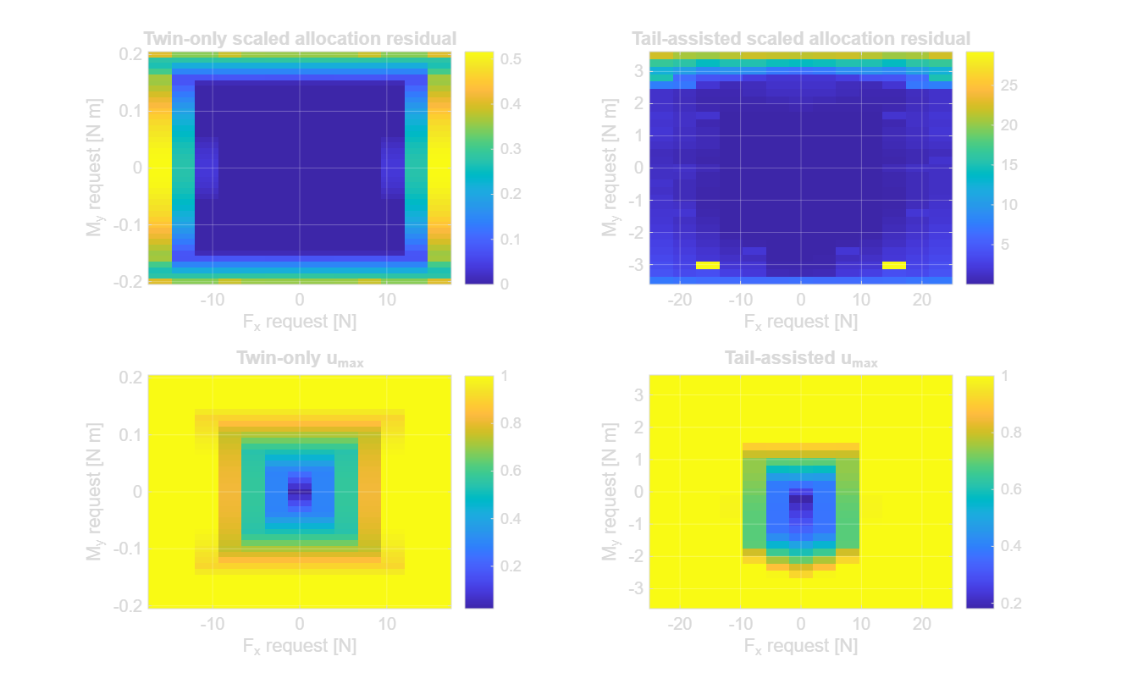
Fig. 3 Allocation residual and maximum normalized actuator utilization, u_max.
The twin-only maps contain a relatively small central region of accurately achievable hover-compatible F_x/M_y requests. Near the boundary, u_max reaches one and the scaled wrench residual increases. Saturation alone is not a numerical failure; it is a limit of physical authority. It becomes a flight-control problem when the required attitude moment cannot be generated while the controller also needs translation and vertical force.
The tail-assisted map covers a much broader pitch-moment request range. Its outer boundary also saturates, as expected for a finite actuator set, but the attitude-priority feasible region is farther from nominal hover. The two residual maps use different requested-wrench and color-bar ranges, so their colors should not be treated as a direct point-by-point numerical comparison.

C. Local Controllability and Conditioning
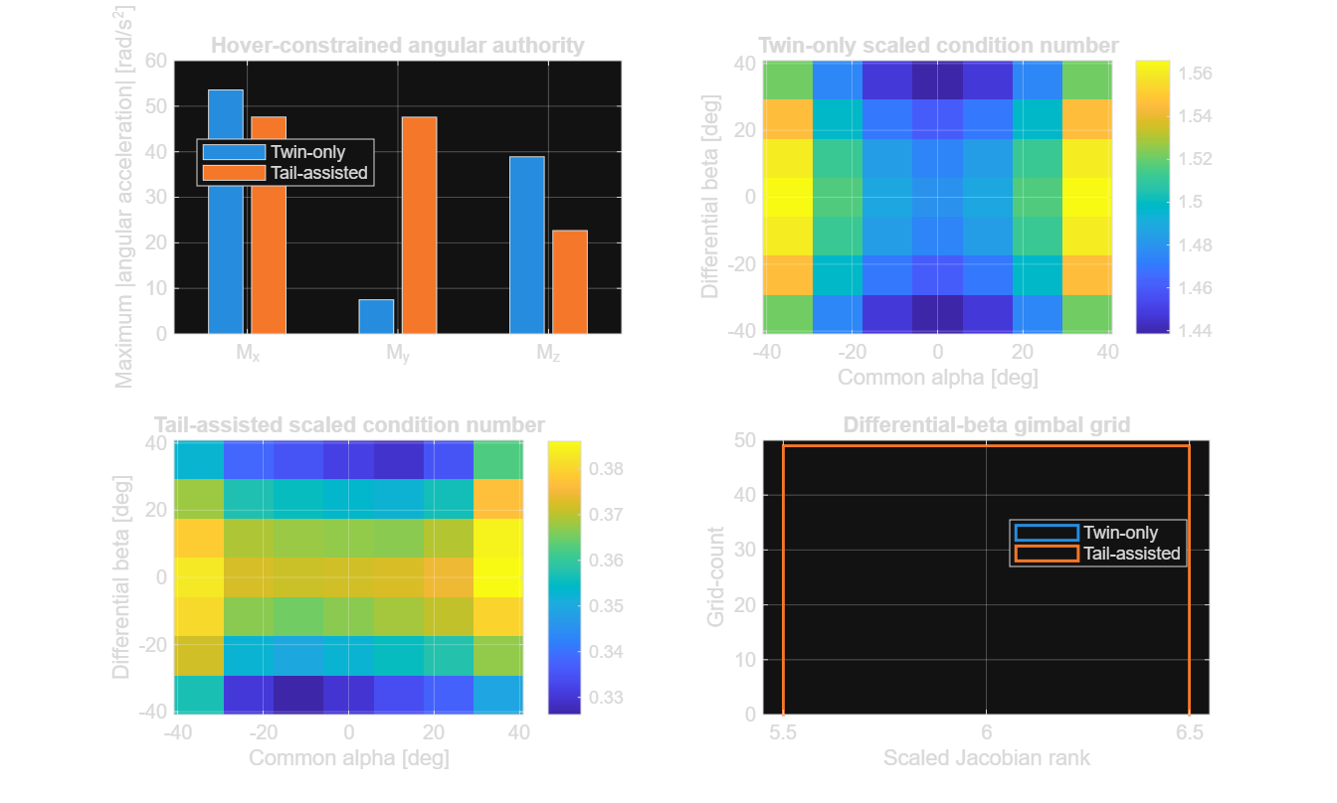
Fig. 4 Hover-constrained angular authority and scaled-Jacobian conditioning across the sampled gimbal grid.
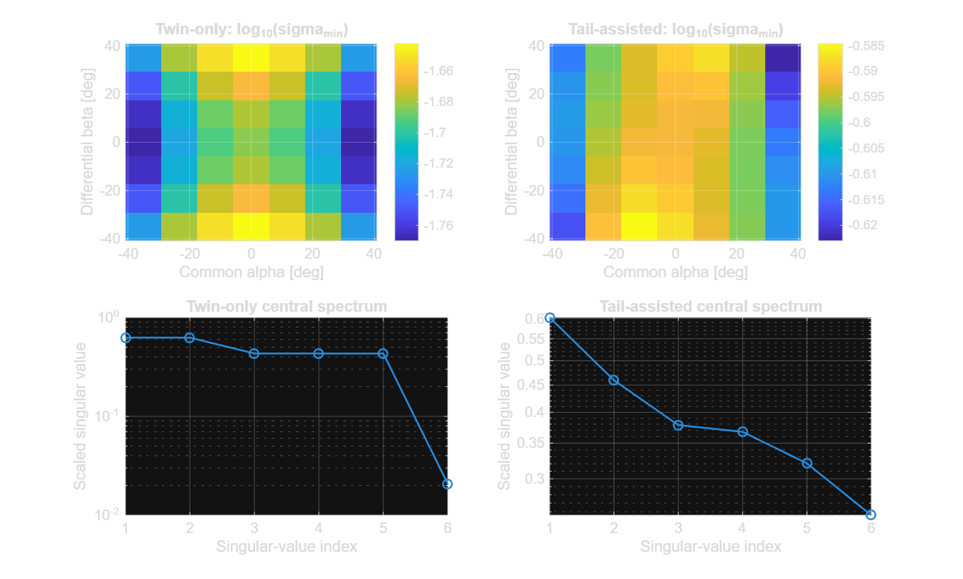
Fig. 5 Minimum scaled singular value across the grid and central scaled-Jacobian spectrum.
Both sampled grids remain rank six, which confirms local mathematical controllability of the instantaneous map. Rank alone is misleading, however. Near the central operating condition, the twin-only minimum scaled singular value is approximately 0.02, compared with approximately 0.25 for the tail-assisted configuration. The twin-only vehicle therefore has a much weaker normalized wrench direction and is more sensitive to saturation, modeling uncertainty, and command scaling.
The hover-constrained pitch angular acceleration rises from roughly 7 rad/s^2 in the twin-only map to roughly 47 rad/s^2 in the tail-assisted map. Roll and yaw authority change because the supplied tail model differs in mass, inertia, and geometry; those axes are not a mass-normalized architecture comparison.
The conditioning heat maps display log10[kappa(J_s)], even though their abbreviated titles state scaled condition number. The logarithmic labeling must be retained or corrected before publication because a conventional condition number cannot be below one.

IV. Engineering Implications
The results qualify the original architecture hypothesis. The twin-only model is locally full rank but lacks robust pitch authority under its stated limits. Its direct F_y/M_y coupling and weak reaction-torque pitch path lead to saturation before the full attitude-priority wrench can be sustained.
The tail-assisted model does not eliminate saturation, but it creates a direct pitch-control lever and improves the weakest allocation direction by roughly an order of magnitude. This preserves more main-propulsor gimbal capacity for force generation. The benefit is not solely attributable to the tail: the two reference vehicles differ in mass, inertia, geometry, and total installed thrust. A fair ablation should retain identical mass properties and main-propulsor limits while adding only the tail pitch channel.

V. Conclusions
The nonlinear model does not reject the twin-only vehicle on rank alone; it remains rank six over the sampled static grid. It does show that the twin-only vehicle has a narrow practical pitch-moment envelope and poor margin in its weakest scaled direction. The tail-assisted vehicle materially increases pitch authority and improves constrained allocation by using aft thrust as a moment arm.
The next validation gate is a full 6-DOF combined simulation using this exact nonlinear allocator. It should log F_x,cmd versus F_x,actual, M_y,cmd versus M_y,actual, individual actuator commands, and u_max(t). This will separate instantaneous allocation loss from motor/gimbal lag, rate limits, altitude coupling, and nonlinear attitude dynamics.

References
1. matlab/vtolWrench.m, matlab/vtolWrenchJacobian.m, and matlab/vtolDefaultParams.m, Nonlinear VTOL Wrench Model, project source code.
2. matlab/vtolConstrainedAllocate.m and matlab/vtolFeasibleWrenchMap.m, Constrained Allocation and Hover-Constrained Authority Mapping, project source code.
3. matlab/run_vtol_wrench_analysis.m and results/nonlinear_wrench_analysis.mat, Nonlinear Wrench Analysis Results, project analysis artifacts.
4. Closed Loop Disturbance Recovery Comparison of Twin Only and Tail Assisted Vectored VTOL Configurations, project technical report.

