**CS1181 Programming Assignment 11**

**Temperature Converter App**

The purpose of this assignment is to get a taste of Android application programming and using the Android Studio editor, as well as using widgets/views and events to produce an interactive graphical application.

**Assignment Description:**

The following screen shot shows the basic setup of an Android app that does temperature conversion from any of three input scales to any of three output scales.

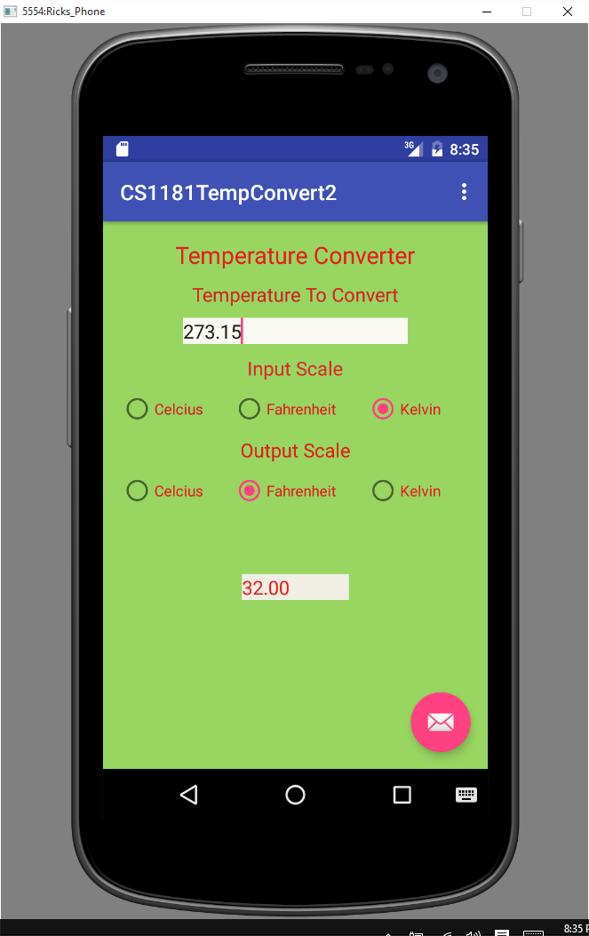**Requirements for the Application**

1. You must use radio buttons to allow the user to select the input scale and the output scale.
2. The input widget must only allow numbers to be entered.
3. If there is no number in the input widget, your program should display a **Toast** indicating that there was no number to convert and the program should NOT stop working.
4. Clicking on any of the 6 radio buttons causes the output area to be updated with the conversion specified by the currently selected input button and output button.
5. All 6 possible conversions should produce correct values.
6. The converted output must be displayed to 2 decimal digit accuracy.
7. The layout can be as shown or can be some other arrangement. However, the appearance of the app must be well organized and easy for any user to comprehend.
8. Make sure that you use 273.15 in your Kelvin formulas and 5.0/9.0 or 9.0/5.0 in your Celcius and Fahrenheit formulas where needed.

**The project must compile and load onto an emulator in order to get any credit. Your Java source code must be loaded into a separate text file and uploaded into the drop box. Your project will not be graded without this. Your entire Android project must be loaded into a ZIP file and that single ZIP file must be uploaded into the drop box.**

**Rubric (60 pts)**

* **GUI is well organized. It includes 6 radio buttons, input and output scale designations, an obvious place for a user to enter a value, an obvious place where the converted value will be displayed. (18 pts)**
* **The input widget only allows numbers to be entered. (3 pt)**
* **Clicking on a radio button with no input number present causes a Toast to appear telling the user what is wrong. (6 pts)**
* **Each time any radio button is clicked the new conversion is calculated and the output is updated. (12 pts)**
* **The converted value is accurate for all 6 conversions and is displayed to 2 digit accuracy. (15 pts)**
* **Code follows style standards and code is commented. (6 pts)**