62. Translate the following sentences into NNF:

* 1. David is friends with Alice.

IsFriendsWith(david, alice)

* 1. Everyone who studies logics is cool

Ɐx∃y(~studies(x, y) v ~logics(y) v Cool(x))

* 1. Everyone with cool friends is also cool.

Ɐx∃y (~IsFriendsWith(x, y) v ~Cool(y) v Cool(x))

* 1. Everybody who is friends with a bunny is nuts.

Ɐx (~IsFriendsWith(bunny, x) v Nuts(x))

* 1. Alice is friends with some bunny.

∃x (bunny(x) ^ IsFriendsWith(alice, x))

* 1. Friendship is a transitive and symmetric relationship!

ⱯxⱯy (~isFriendsWith(x,y) v ~isFriendsWith(y,z)) v isFriendsWith(x,z))

ⱯxⱯy (isFriendsWith(x,y) -> isFriendsWith(y,x))

* 1. Everybody who eats ramen is either homeless or a grad student.  
      Ɐx∃y(~eats(x,y) v ~ramen(y) v homeless(x) v gradStudent(x))
  2. David eats ramen, is not homeless and studies logics  
      ∃x∃y [eats(david,x) ^ ramen(x) ^ ~homeless(david) ^ logics(y) ^ studies(david,y))]

63.

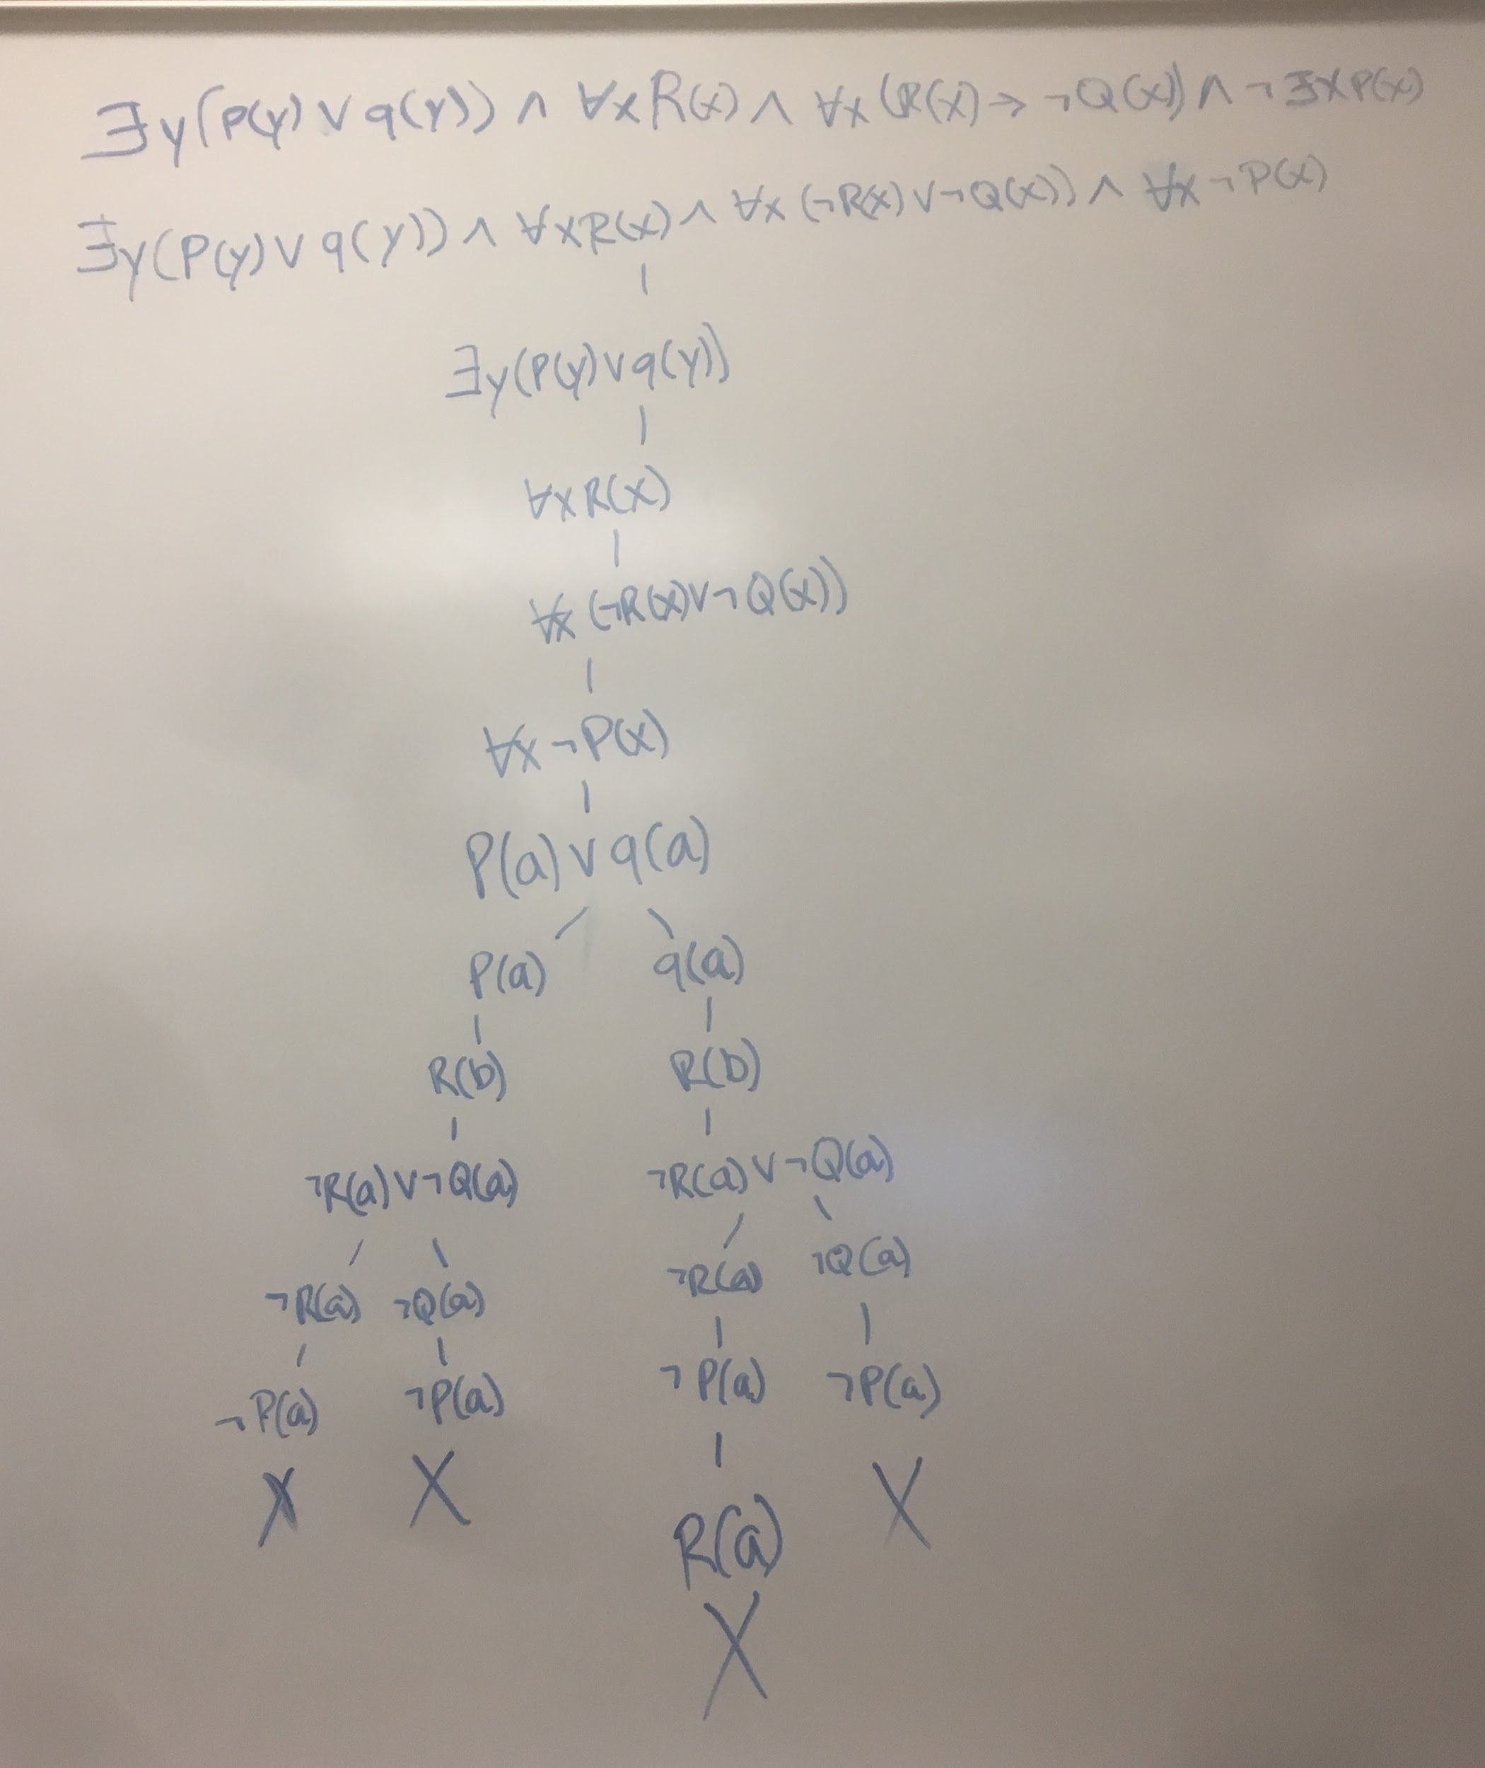

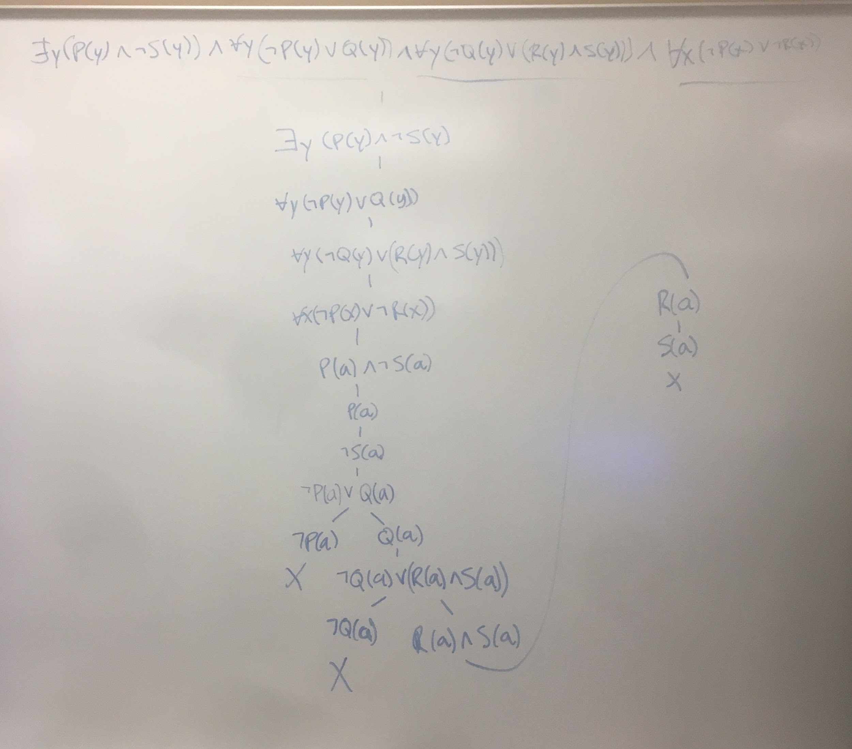

64.

65.

