CS 1180 Lab Assignment 12
Due: The due date for this lab is found in the course’s Pilot drop box.

POINTS: 20

PURPOSE: The purpose of this lab is to demonstrate the ability to use basic JavaFX nodes.

ASSIGNMENT [10 pts] You are to write a program that uses JavaFX to produce a side view of a stick character similar to that shown in Figure 1. Show your program to your TA.

ASSIGNMENT [10 pts] (1) Modify your program so that your stick character is created touching the left side of the window and then begins moving to the right side of the window. When the stick figure touches the right side of the window, the figure should reverse its direction of travel. When the figure reaches the left side, it should once again reverse direction. The figure should be entirely visible from start to finish and should not distort– it should look the same going from one side to the other and back. IT should continue moving endlessly. Set the speed of travel so that it takes at least two seconds, but less than ten seconds for the stick figure to cross a window that is 800 pixels wide.

Figure 1
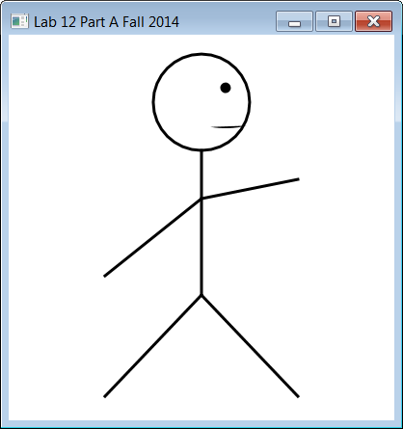

Save your lab code by creating a zip file of the entire project. Upload your zip project to Pilot.
You are to also copy your main method into a notepad file (.txt) and also upload the notepad file to Pilot.

If your program does not compile OR you do NOT upload a separate text file containing your source code you will receive a 0.

Rubric:

Part 1: 10 pts
- You have a Java FX application that displays some of the shapes above, but it does not look much like this figure (5pts)
- The figure your program displays looks a lot like the figure shown above, including the use of an arc for the mouth (5pts)
Part 2: 10 pts
- Your figure starts at the left side and moves to the right side but may not properly reverse direction (3 pts)
- It takes between 2 and 10 seconds for your figure to travel to the other edge (2pts)
- Movement across the window should appear to be continuous motion and not jerky (2 pts)
- Your figure properly reverses direction when reaching either edge of the pane (3 pts)

