CS 1180 Lab Assignment 4
Due: The due date for this lab is found in the course’s Pilot drop box.

POINTS: 20

PURPOSE: The purpose of this laboratory assignment is to familiarize students with the mechanics of constructing a program from an algorithm presented in pseudo-code or flowchart form. This lab also introduces basic concepts in iteration.

This laboratory assumes introductory familiarity with the concepts of:
• Semantics, Syntax, and Style
• Program construction/decomposition
• Variables
• Arithmetic and Relational Operators and Assignments
• Simple flow control with if and while statements
• Input using the Scanner class
• Output using System.out.println() and System.out.printf()

ASSIGNMENT: [10 pts.] Constructing code from an algorithm
Consider the following problem, algorithm, and implementation (as a Java program)

Initial Problem: Calculate the weekly gross pay for an hourly employee. Overtime rates (for hours worked over 40 per week) are x1.5 standard rate. Allow for multiple calculations.

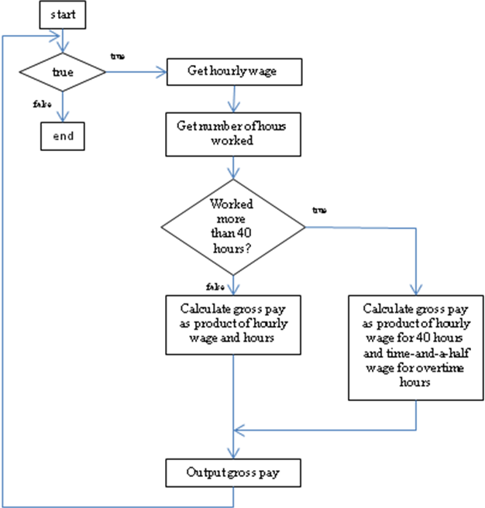
Figure 1: Algorithm as a flow chart

WageCalculator
1 While (forever)
2 Input hourly wage
3 Input number of hours worked
4 Determine gross pay
5 if number of hours worked does not exceed 40
6 then calculate gross pay with no overtime
7 if number of hours worked exceeds 40
8 then calculate gross pay with overtime
9 Output gross pay
10 end-While
Figure 2: Algorithm as pseudo-code

import java.util.Scanner;

public class WageCalculator {

public static void main (String[] args) {

Scanner keyboard = new Scanner (System.in);
double hourlyWage = 0.0;
double hoursWorked = 0.0;
double grossPay = 0.0;

while (true) {
// Get hourly wage
System.out.println("Enter hourly rate of pay: ");
hourlyWage = keyboard.nextDouble();

// Get number of hours worked
System.out.println("Enter number of hours worked: ");
hoursWorked = keyboard.nextDouble ();

// Determine gross pay
if (hoursWorked <= 40) {
grossPay = hoursWorked * hourlyWage;
} // end if no overtime

if (hoursWorked > 40) {
grossPay = 1.5 * hourlyWage * (hoursWorked - 40)
+ hourlyWage * 40;
} // end if overtime

// Output gross pay
System.out.printf("Gross pay is: $%.2f\n", grossPay);

} // end while

} // end method main

} // end class WageCalculator
Figure 3: An implementation of the algorithm in Java

Modifying existing code: Often, in practice, program specifications change over time. In this case, let us assume that after using the program, we now determine a need to separately list normal pay, overtime pay (if any), and total pay (the sum of normal pay and overtime pay). Also, let us say that instead of running forever, we would like to ask the user after we complete the wage for each employee if they would like to calculate the wage for another employee. The user is to answer ‘y’ (for yes, process another employee) or ‘n’ (for no, exit the program).

- [5 pts] Construct a flowchart and pseudo-code for the modified problem. Ask your TA to check your work before moving forward.
- [5 pts] Implement the modified algorithm in Java. Demonstrate your implementation to your TA.

ASSIGNMENT: [10 pts.] Sum of series calculator
The goal of this assignment is to develop an algorithm and implement code to calculate the series sum of reciprocals S(n) = (1/1 + 1/2 + 1/3 + 1/4 + … + 1/n) for a user specified value of n. Note: a second part of this assignment is explained below.

Enter n (the number of terms): 3
The series sum of reciprocals is: 1.8333333333333333
Example I/O (for reference: your input/output should look similar to this!)

- [1 pts] Create a flowchart OR pseudocode for your implementation to this problem. Ideally, you should show (and get feedback on) your flow chart OR pseudocode to your TA before the end of the second lab period. If you do not, then you must include your flowchart OR pseudocode as part of your assignment upload (however is appropriate: scanned, printed as PDF, as a powerpoint, etc).
- [3 pts] Correctness of sum of series calculator for various values of n. Ideally, you should demonstrate your implementation to your TA before the end of the second lab period.
- [1 pts] Documentation, style (refer to style guidelines!), clarity of program

Second part:
- [1 pt] Create a flowchart or pseudocode for a second (related) problem. This problem is to ask the user to enter a positive decimal value (for example, 1.5 or 5.0) and then have your program calculate the smallest number n for which the series sum of reciprocals S(n) EQUALS OR EXCEEDS the entered the value. If the user enters 1.5 (for example), your program should return the value n=2 (since 1/1 + 1/2 equals 1.5).
- [3 pt] Copy your original sum of series calculator program and modify the new program so that instead of taking the value n from the user, it uses a loop to compute the lowest integer value n for which the series sum of reciprocals equals or exceeds the user provided value.
- [1 pts] Documentation, style (refer to style guidelines!), clarity of program

Save your lab 4 assignment by creating a zip file. Show you lab assignments to your TA. Upload your lab assignments to the Pilot drop box before the lab due date. Ask your TA for help if you have any questions.

