BIMR Future Materials Innovators Program Application
FUTURE MATERIALS
INNOVATORS PROGRAM
APPLICATION FORM

Program Details

- This program is open to graduate students only.

- Call for proposals goes out January 8, 2025. Notice of Intent is due February 7, 2025. Proposals are due March 14, 2025. Decisions will be made by early April 2025.

- Must include collaboration between at least 2 different research groups. Preference for collaboration between different departments/faculties, but 2 different research groups within the same department will be accepted.
Must be a topic relevant to Materials Research.
Projects must be new (existing collaborative projects are not eligible)

- Funds can be used for materials, supplies, consumables, instrument time (small equipment will require justification)

- Students must begin work during summer of 2025. Will have one year to complete the project.
  - Students must present progress updates in Fall 2025.
  - Student groups will present research outcomes in BIMR seminar program in spring of 2026, prior to next round of competition.

- Any unspent funds at the end of 1 year will be recovered by BIMR unless project extension is granted (students can request extension of up to 6 months).

Section 1 – Applicant Details – Open to graduate students only

1. Please complete the information below for the principal applicant and co-applicants (maximum of 2 co-applicants):

Principal Applicant Name: Cameron Gurwell | Principal Applicant Email: gurwellc@mcmaster.ca
Student ID: | Home Department:
Research Supervisor Name: | Research Supervisor Email

Co-Applicant Name: Uriel Garcilazo Cruz | Co-Applicant Email: garcilau@mcmaster.ca
Student ID: 400655357 | Home Department: CSE
Research Supervisor Name: Dr. Rodrigo Alejandro Vargas Hernandez | Research Supervisor Email  vargashr@mcmaster.ca

Co-Applicant Name: | Co-Applicant Email:
Student ID: | Home Department:
Research Supervisor Name: | Research Supervisor Email

2. Please list the names of additional research team members who will participate in the research, if any:

Name | Email | Student ID | Department | Supervisor

Please confirm that all team members are aware of the proposal ☒

Please confirm that all research supervisors have agreed to this proposal submission ☒

Additional Requirements:
a) Letters of support from each research supervisor indicating that they are aware of this proposal and support time spent on achieving the goals of the proposal by all students involved.

b) Video Pitch – please prepare a short video (3 minutes max) that explains the main ideas of the proposal and why it should be funded. Please upload the video on Vimeo and add link below, as well as password if you want your submission to be password protected on Vimeo:

Video Link:

Section 2 – Proposal Details

- Proposal Title:
Optimising the conductivity of solid-state batteries by doping optimization via genetic algorithms.

- Provide a brief summary of your proposal idea (300 words max).
Solid-state batteries have seen increasing attention due to their increased energy density and inherent safety considerations when compared to traditional liquid electrolyte batteries. The efficiency of solid-state batteries depends, among other factors, on the concentration of chemical dopants and its density in the battery relative to lithium. Herein, we use a crystallography information file (CIF) to represent the molecular structure of a lithium solid-state electrolyte. We propose the use of genetic algorithms in combination with LLMs as a heuristic approach for the optimization problem of finding the best configurations and ratios of dopant relative to lithium. Along with the doping density, we also incorporate into the analysis the temperature, …

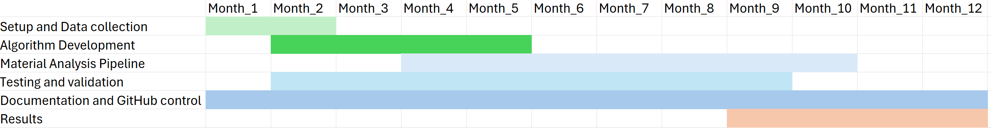
- Please describe the details of your proposal below (3 pages max, including figures). Clearly identify the hypothesis, describe the experimental work to be accomplished, and provide a Gantt chart listing milestones to be achieved over 12 months of the project.

Fig. 1. Gantt chart listing milestones to be achieved over a 12 month period
Hypothesis: The use of a heuristic approach via genetic algorithms will generate an improved type of lithium battery that offers higher conductivity and lower heat release.

Experimental work: We begin by the gathering of crystallography data and the selection of a single molecular structure that makes the lithium battery cell, represented as a .cif file. Such file will then be processed using custom Python scripting to obtain the current configuration of hyperparameters that include doping density, temperature and conductivity.

The dataset will serve as the input of an innovative codebase on genetic algorithms that introduce variation in a population of candidate configurations, assisted by an LLM. We refer to such candidates as units (u see Table 1) because of their role as fundamental elements subject to selective pressure, where their “genes” are suggested values of doping density, temperature, conductivity, and parameters related to the geometry of the chemical structure.

A population of units, known as founder population, is initialized with random attributes and
evaluated using an optimality criterion (Oc, ref. Table 1) to provide a fitness score for each unit in the population, allowing the creation of a sorted list with the best-performing units at the top. The first k units will be taken as seed to generate the next population. We will insert “mutations” to each child unit using a random value taken from a Gaussian probability distribution with mean 0 and standard deviation 1.

The unique sequence of generations, started by a founder population and iterated over an arbitrary number of generations is called a path. The model will integrate multiple paths to improve exploration of the high dimensional space with the scope of avoiding local optima and obtaining better parameter configurations.
The program integrates two main theoretical models, detailing the recursive nature of the genetic algorithm and the evaluation step that defines the stopping condition:
Theoretical model for recursive genetic algorithm (ThM1):
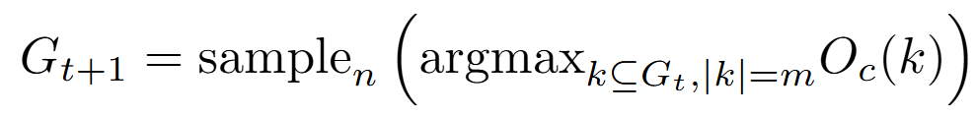
Where:
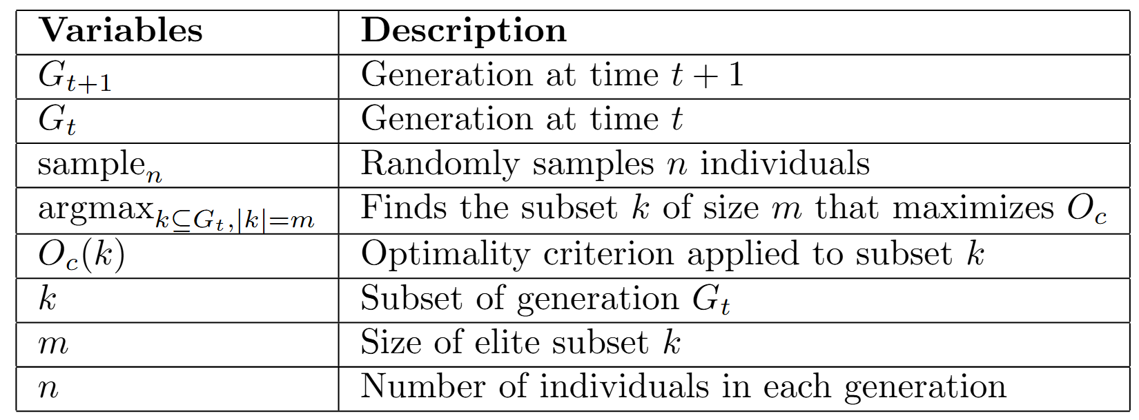

Theoretical model for stopping condition (ThM2):
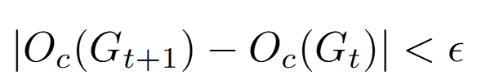
Where:
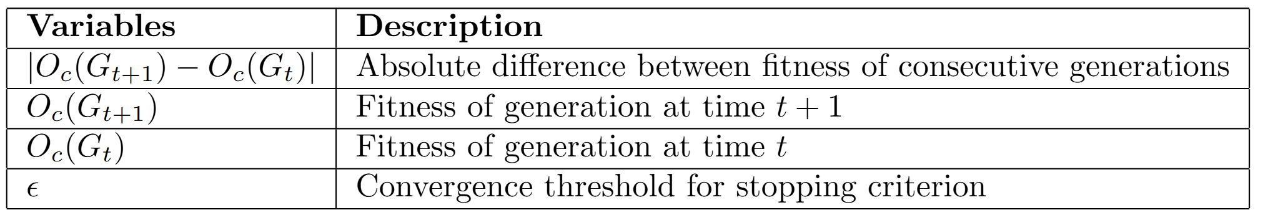

Given a founder population of size n at time t=0, and an optimality criterion Oc:
- Simulate a new population at time t+1by randomly sampling among the top k units with the highest fitness in population t (ThM1).
- Evaluate convergence in the model by calculating the difference in the average population fitness of populations t+1 and t, stopping the model if the difference is under a threshold epsilon (ThM2).
Symbol | Unit | Description
u | unit | Collection of parameters subject to selection
s | selective pressure | Force imposed by optimality criterion to  discriminate fitness among units in the population
Oc | optimality criterion | Set of evaluation rules and metrics resting on theoretical  models which enable evaluating units in a population
f | fitness | The "intrinsic" capacity of a unit to perform well in a given environment, given the Oc

Table 1. Glossary of technical terms used throughout the document

[Proposal details – page 3]

- Please explain the collaborative nature of this project. Explain why this work can’t be done without the combined expertise of the collaborating groups (500 words max).
The project is a good opportunity to ensure collaboration between computer science, biology and chemistry at McMaster, particularly focused towards the development of new materials and engineering using genetic algorithms coupled with large language models. The theoretical models and data definitions of our project require a high level of specialization in particular subdomain of chemistry, with a thorough understanding of crystallography, density functional theory, and molecular databases. It requires specialization in computational engineering due to the systematic development and scalability of the algorithms used to ensure verifiability and correctness in the final model. Moreover, the implementation of genetic algorithms demands an understanding on a very specific family of models that rely in Evolutionary theory.

Section 3 – Budget Justification

Use of Funds: Available funding can be used to purchase chemicals, supplies, and consumables. It can also be used to pay for instrument time in facilities. Small equipment specifically required for the project must be clearly justified (applicants are strongly encouraged to use existing equipment within McMaster facilities and research groups). Personnel salaries are not an eligible use of funds.

Justification: Please provide a detailed budget for the proposed project. This should include categories such as “consumables”, “chemicals”, or “microscopy” with expected costs for each category (i.e., number of samples measured × cost per sample).
The use of genetic models requires a considerable investment in computational time, given the

