BIMR Future Materials Innovators Program Application
FUTURE MATERIALS
INNOVATORS PROGRAM
APPLICATION FORM

Program Details

- This program is open to graduate students only.

- Call for proposals goes out January 8, 2025. Notice of Intent is due February 7, 2025. Proposals are due March 14, 2025. Decisions will be made by early April 2025.

- Must include collaboration between at least 2 different research groups. Preference for collaboration between different departments/faculties, but 2 different research groups within the same department will be accepted.
Must be a topic relevant to Materials Research.
Projects must be new (existing collaborative projects are not eligible)

- Funds can be used for materials, supplies, consumables, instrument time (small equipment will require justification)

- Students must begin work during summer of 2025. Will have one year to complete the project.
  - Students must present progress updates in Fall 2025.
  - Student groups will present research outcomes in BIMR seminar program in spring of 2026, prior to next round of competition.

- Any unspent funds at the end of 1 year will be recovered by BIMR unless project extension is granted (students can request extension of up to 6 months).

Section 1 – Applicant Details – Open to graduate students only

1. Please complete the information below for the principal applicant and co-applicants (maximum of 2 co-applicants):

Principal Applicant Name: Cameron Gurwell | Principal Applicant Email: gurwellc@mcmaster.ca
Student ID: 400365714 | Home Department: CCB
Research Supervisor Name: Dr. Gillian R. Goward | Research Supervisor Email: goward@mcmaster.ca

Co-Applicant Name: Uriel Garcilazo Cruz | Co-Applicant Email: garcilau@mcmaster.ca
Student ID: 400655357 | Home Department: CSE
Research Supervisor Name: Dr. Rodrigo Alejandro Vargas Hernandez | Research Supervisor Email  vargashr@mcmaster.ca

Co-Applicant Name: | Co-Applicant Email:
Student ID: | Home Department:
Research Supervisor Name: | Research Supervisor Email

2. Please list the names of additional research team members who will participate in the research, if any:

Name | Email | Student ID | Department | Supervisor

Please confirm that all team members are aware of the proposal ☒

Please confirm that all research supervisors have agreed to this proposal submission ☒

Additional Requirements:
a) Letters of support from each research supervisor indicating that they are aware of this proposal and support time spent on achieving the goals of the proposal by all students involved.

b) Video Pitch – please prepare a short video (3 minutes max) that explains the main ideas of the proposal and why it should be funded. Please upload the video on Vimeo and add link below, as well as password if you want your submission to be password protected on Vimeo:

Video Link:

Section 2 – Proposal Details

- Proposal Title:
Optimising conductivity via genetic algorithms using simulated doping for solid-state batteries

- Provide a brief summary of your proposal idea (300 words max).
Solid-state batteries have seen increasing attention due to their increased energy density and inherent safety considerations when compared to traditional liquid electrolyte batteries. The efficiency of solid-state batteries depends, among other factors, on the concentration of chemical dopants and its density in the battery relative to lithium. Herein, we use a crystallography information file (CIF) to represent the molecular structure of a lithium solid-state electrolyte. We use genetic algorithms to propose a heuristic approach to finding the best configurations and ratios of dopant relative to lithium. We seek to optimize the doping density for various solid-state electrolytes by investigating the temperature and pressure dependence of out doped systems computationally and feeding that information back into the prediction algorithms.

- Please describe the details of your proposal below (3 pages max, including figures). Clearly identify the hypothesis, describe the experimental work to be accomplished, and provide a Gantt chart listing milestones to be achieved over 12 months of the project.
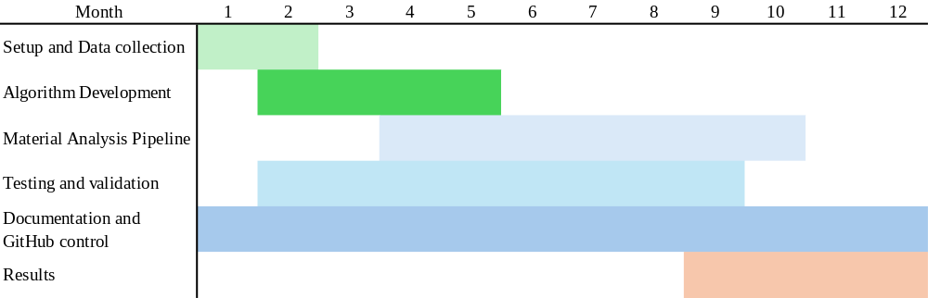
Fig. 1. Gantt chart listing milestones to be achieved over a 12-month period
Hypothesis
The use of a heuristic approach via genetic algorithms will generate an improved doped phase for solid-state lithium battery electrolytes that offers higher conductivity.

Experimental work
We will begin by gathering crystallography data from the Materials Project/ICSD and selecting a single crystal structure to build the doped phase, represented as a CIF file. The file will then be processed using custom Python scripting to obtain the current configuration of hyperparameters, including but not limited to, temperature and conductivity.

The crystallography data will serve as the input of the codebase on genetic algorithms that introduce variation in a population of candidate configurations, assisted by a large-language model. We refer to such candidates as units because of their role as fundamental elements subject to selective pressure, where their “genes” are suggested values of doping density, temperature, conductivity, and parameters related to the geometry of the chemical structure.

A population of units, known as the founder population, is initialized with perturbed attributes (random changes in the original values of genes) and evaluated using an optimality criterion to provide a fitness score for each unit in the population, allowing the creation of a sorted list k with the best-performing units at the top. The units in k will be taken as seed to generate the next population (see ThM1). We will insert “mutations” to each child unit using random values taken from a Gaussian probability distribution with mean 0 and standard deviation 1. The use of this model as an iterative process produces refinement in the population’s average fitness, with parameter configurations that promote higher conductivity.

The unique evolutionary history of a population produced by a founder population and iterated over a certain number of generations is called a path. The project will integrate multiple paths to improve exploration of the high dimensional space with the aim of avoiding local optima and obtaining better parameter configurations.
The program integrates two main theoretical models, detailing the recursive nature of the genetic algorithm and the evaluation step that defines the stopping condition:
Theoretical model for recursive genetic algorithm (ThM1):
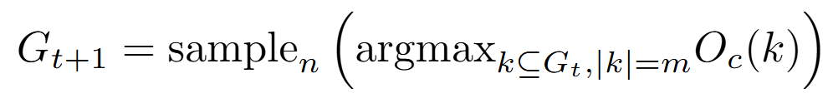
Where:
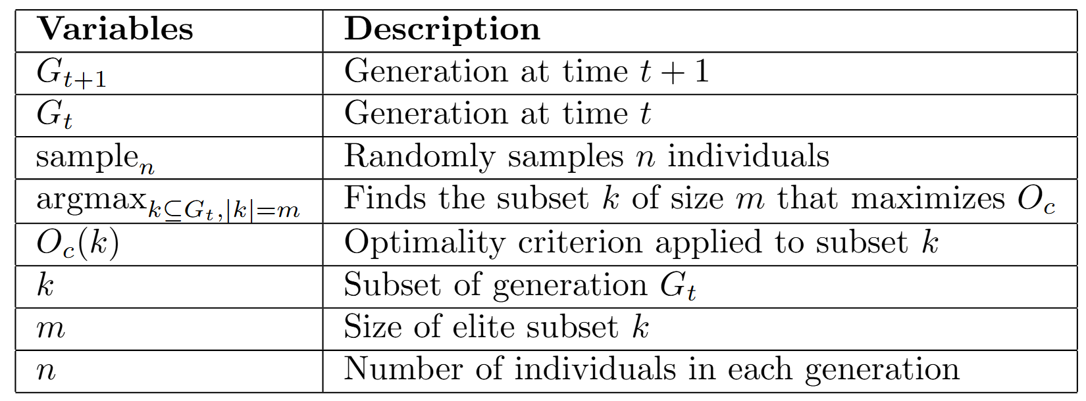

Theoretical model for stopping condition (ThM2):
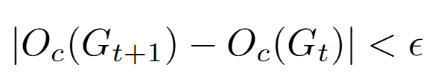
Where:
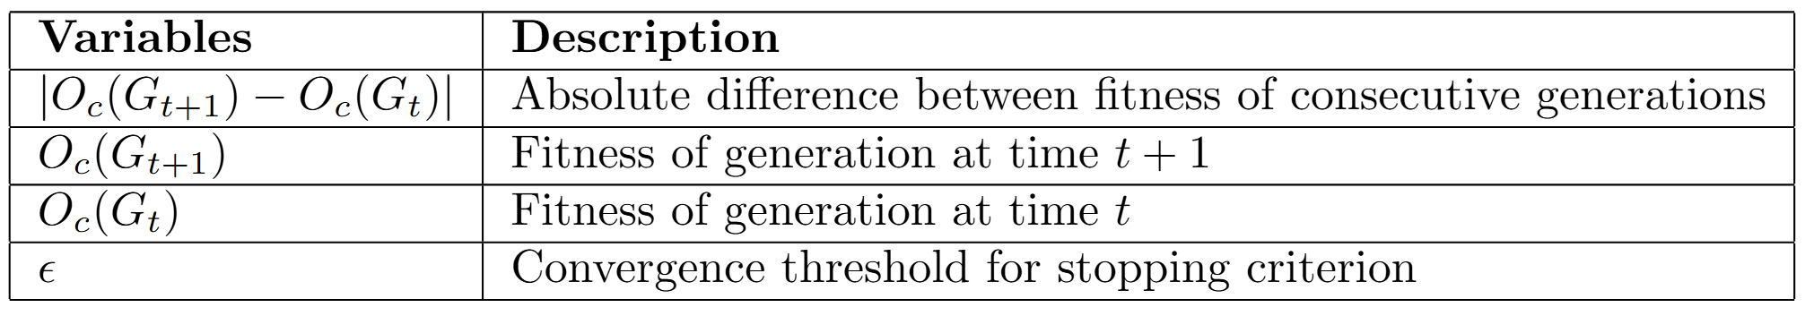

Algorithm
Given a founder population of size n at time t=0, and an optimality criterion Oc:
- Simulate a new population at time t+1by randomly sampling among the top k units with the highest fitness in population t (ThM1).
- Evaluate convergence in the model by calculating the difference in the average population fitness of populations t+1 and t, stopping the model if the difference is under a threshold epsilon (ThM2).
- Please explain the collaborative nature of this project. Explain why this work can’t be done without the combined expertise of the collaborating groups (500 words max).
This project is a good opportunity to ensure collaboration across different specializations at McMaster, which include chemistry, materials development, and computer science. The implementation of the theoretical models and definitions that compose our project require a thorough understanding of crystallography, solid-state battery materials, and density functional theory. Moreover, the implementation of genetic algorithms demands a comprehensive understanding of a very specific family of models that rely in Evolutionary theory.

Section 3 – Budget Justification

Use of Funds: Available funding can be used to purchase chemicals, supplies, and consumables. It can also be used to pay for instrument time in facilities. Small equipment specifically required for the project must be clearly justified (applicants are strongly encouraged to use existing equipment within McMaster facilities and research groups). Personnel salaries are not an eligible use of funds.

Justification: Please provide a detailed budget for the proposed project. This should include categories such as “consumables”, “chemicals”, or “microscopy” with expected costs for each category (i.e., number of samples measured × cost per sample).
The estimated computational time for our proposed genetic algorithm is given by the big O notation: 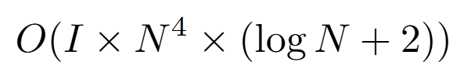
Where N is the population size and I the number of iterations that take for our program to converge. This fourth-degree polynomial showcases the rapid consumption of hardware resources that make the program impossible to run with modest computational resources, with population sizes as small as 100 units. To overcome this limitation, we decided to destine our entire resources to computation, using GPU optimization to run the large language models that will help us find the patterns in the crystallography data required to introduce variability to the populations. Our budget is as follows:

