*Great Job! 100/100*

*Using your textbook and notes complete the following Hands-On Test. Use Bootstrap v5 to implement all of the requirements below.*

*HandsOnTests/BOOTRAP_HOT1 directory in your local repository.*

*Suggestion: It is usually best to keep the nav order the same on each page, so it does not jump around every time you click a link. That way it does not distract the user.*

**Create a small 3-page website for a fictional business.**

**Home Page (index.html)**

* **The home page includes the following sections: header, main, footer.**
* The **header** contains the **name of the company and the navbar. - 15pts**
  + Use the Bootstrap's **responsive** [navbar](https://getbootstrap.com/docs/5.3/components/navbar/) component, to implement a navbar that is expanded on **medium** **or** **larger** devices, and **collapsed** on **smaller** devices.
  + The navbar has links to each page: **Home, Products, Team**
  + The **Home** page link has the **active class.**
* The **main** area contains a [jumbotron](https://getbootstrap.com/docs/5.3/examples/jumbotron/) and three columns of information about the company.
  + **Include the company name, a tag line, and contact information on the jumbotron. - 12pts**
    - Use a suitable **background image** for the jumbotron.
    - Use **CSS text-shadow** to make the text in the jumbotron more readable.
    - Use **Bootstrap padding/margin** **classes** to adjust spacing.
    - Use the correct semantic tags! (generally just divs)
  + **Include three sections of information about the company. This can be whatever you choose. - 12pts**
    - Each section **must have** a heading and **at least one paragraph** of text.
    - Layout the sections responsively using a [Bootstrap Grid](https://getbootstrap.com/docs/5.3/layout/grid/#example).
    - The columns must be **⅓** of the container width on **large** screens, and 100% of the container width on smaller screens.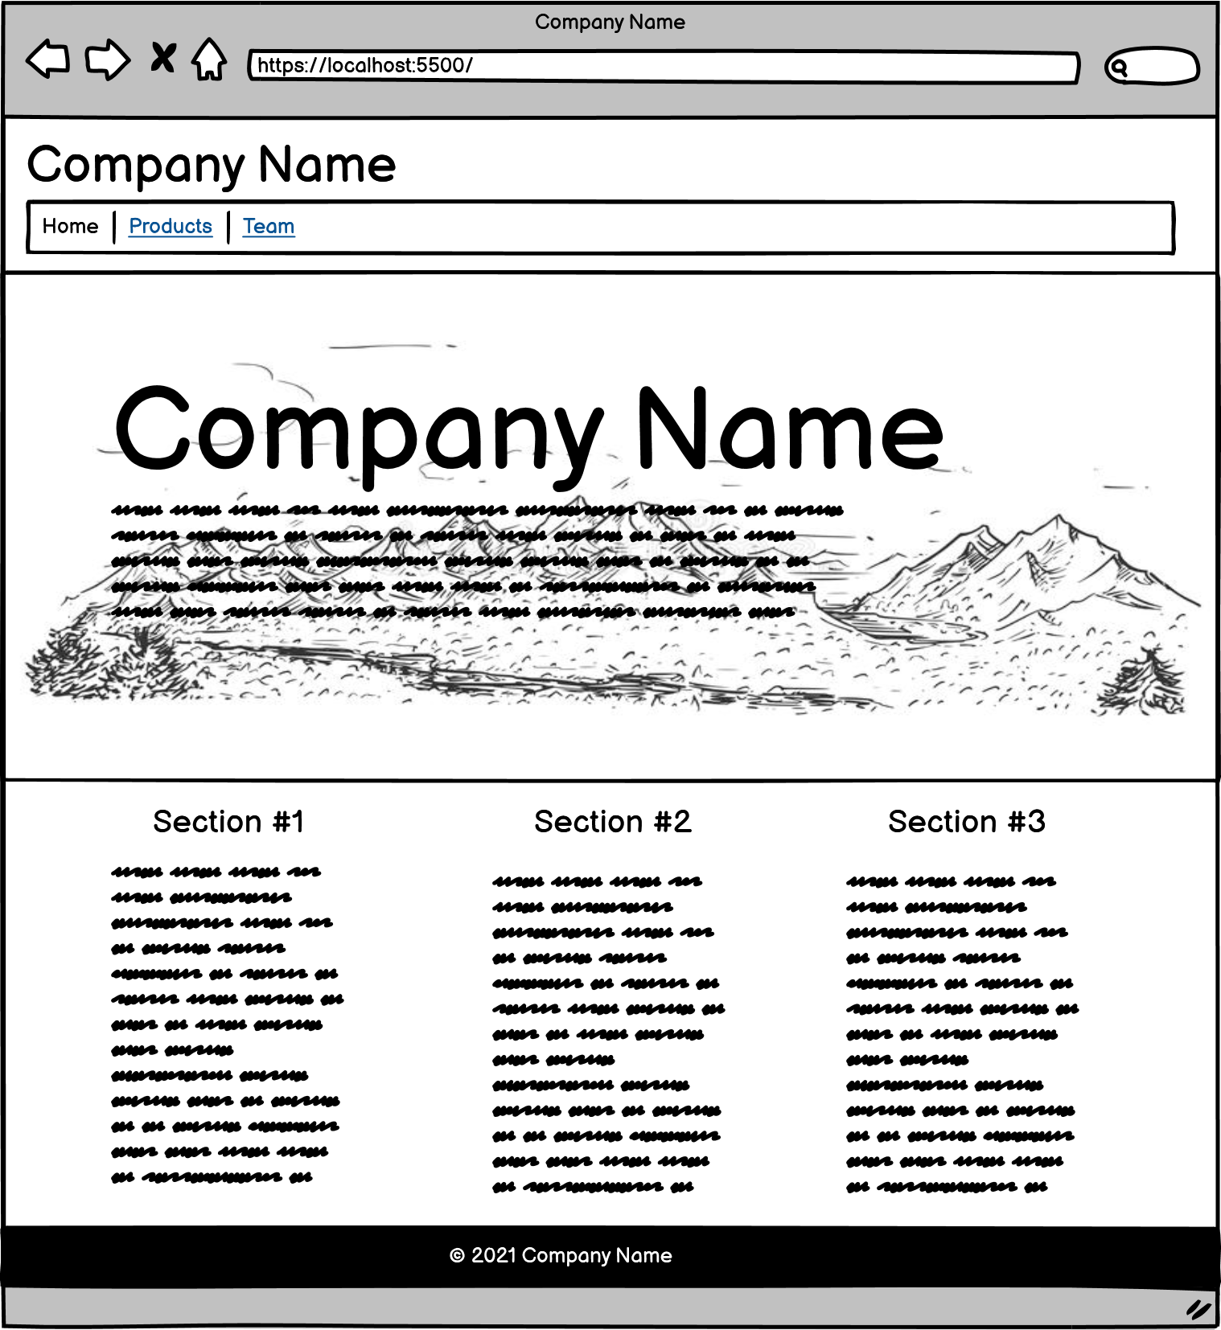
* The **footer** contains the copyright line. Such as "© 2021 Company Name" **- 5pts**
  + Center the text using **Bootstrap's** **text utilities**.
  + Give the footer a dark background color and white text using **Bootstrap's color utilities**.

**Products Page (products.html)**

* The products page includes the following sections: header, main, footer.
* The **header** is the same as the home page. Except that:
  + The **Products** **page** link has the **active class.** **- 5pts**
* The **main** area contains a jumbotron and a small selection of products.
  + **The** [**jumbotron**](https://getbootstrap.com/docs/5.3/examples/jumbotron/) **provides information about a current sale. - 12pts**
    - Use a suitable background image for the jumbotron.
    - Use **CSS text-shadow** to make the text in the jumbotron more readable.
    - Use **Bootstrap padding/margin classe**s to adjust spacing.
    - Use the correct semantic tags! (generally just divs)
  + **Include information and images for at least 4 products. - 12pts**
    - Layout the products responsively using a [**Bootstrap Grid.**](https://getbootstrap.com/docs/5.3/layout/grid/)This layout must show **4 items per row for large or greater screen size**, **2 items per row on a smaller screen size**, and 1 item per row at the smallest screen size. (You can pick the actual breakpoints to fit your content, but use Bootstrap's column classes to implement this.) Implement each product as a [**Bootstrap Card**](https://getbootstrap.com/docs/5.3/components/card/#about)**.** This card must include the following classes: **card, card-img-top, card-body, card-title, card-text**
      * Each product includes an image.
      * Each product includes a name
      * Each product includes a link to view more information.
      * Each product includes a short description. (1 sentence)
* The **footer** is the same as the home page. **- 5pts**

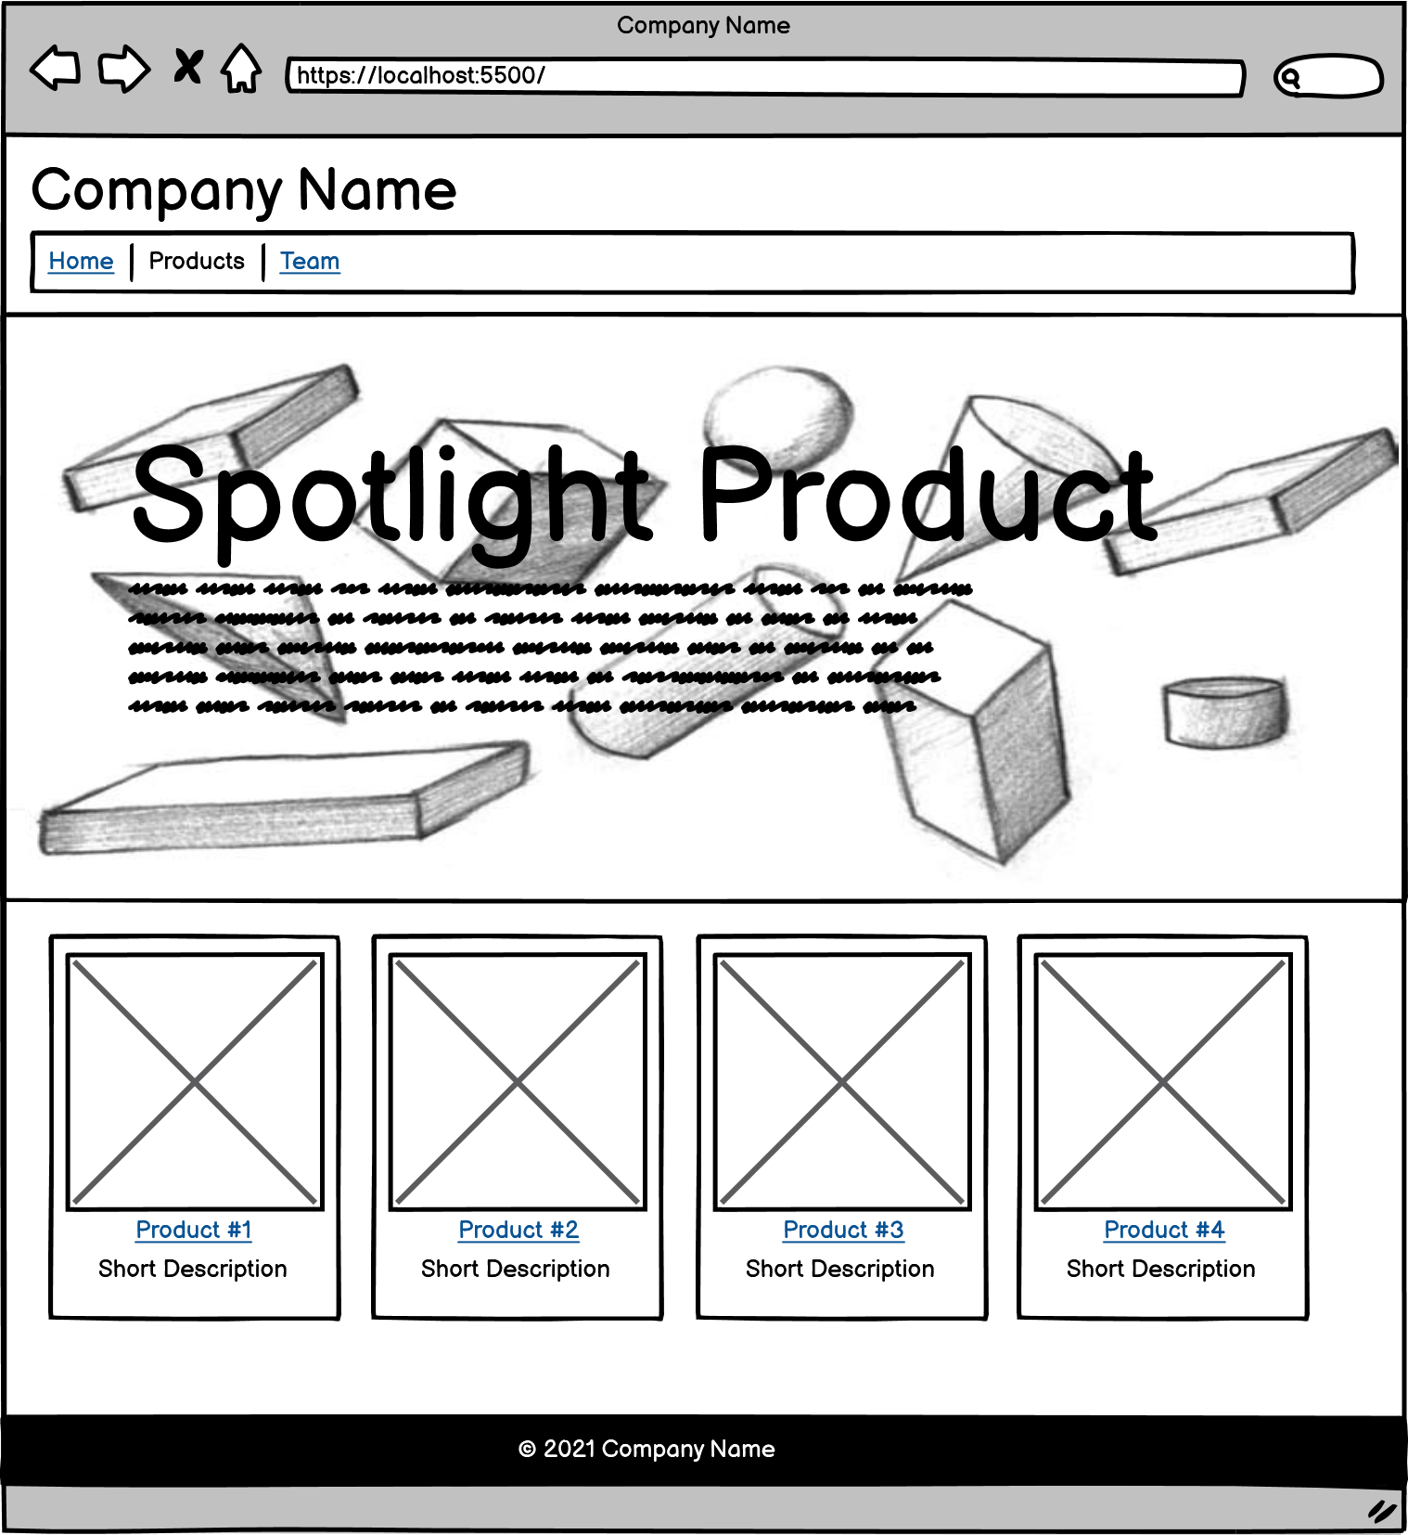

**Team Page (team.html)**

* The team page includes the following sections: header, main, footer.
* The **header** is the same as the home page. Except that:
  + The **Team** page link has the **active class**. **- 5pts**
* **The main area contains information about at least 2 employees. - 12pts**
  + Layout the products responsively using a **Bootstrap Grid.** This layout must show **2 items per row at the large or greater screen size**, and **1 item per row at the smallest screen size**. (You can pick the actual breakpoints to fit your content, but use Bootstrap's column classes to implement this.)
  + Implement each product as a **Bootstrap Card.** This card must include the following classes: **card, card-img-top, card-body, card-title, card-text**
  + Each employee includes an image.
  + Each employee includes a name.
  + Each employee includes a short bio. (1-2 paragraphs)
* The **footer** is the same as the home page. **- 5pts**

