AirlinkToDot

AirlinkToDot is a utility program designed for converting bui files into network diagrams. The program converts the TRNFlow Multizone Airflow Network data in the bui file to the DOT language for GraphViz, an open source graph visualization software. (see <https://www.graphviz.org/> )

The converted DOT is automatically saved to a file with the extension '. GV'. Also, the diagram generated from DOT is automatically saved in PNG file.

Both files are saved with the filename of the original 'BUI file name' + '_ ariflownetwork'.

For example, When 'Restaurant.bui' is converted, 'Restaurant_airflownetwork.gv' and 'Restaurant_airflownetwork.png' are generated.

# Software environment

The operation of this utility has been confirmed on the following environments.

* Windows10 Pro(64bit, 1803)
* TRNSYS18.00.0019(64bit)

# Installation

* 1. Installing AirlinkToDot

Firstly, download the installer from the following URL and unzip it.

<https://github.com/TRNSYSJP/TRNSYS.JP/tree/master/Tools/AirlinkToDot>

Next, Run the Setup.exe and complete the installation according to the message displayed by the installer.

* 1. Installing Graphviz

Please download GraphViz from the official website and install it.

<https://www.graphviz.org/>

After installation, copy all files in 'C: \Program Files (x86) \ Graphviz 2.38 \ bin' to 'C: \ Program Files (x86) \ TRNSYS.JP \ AirlinkToDot \ GraphViz' folder.

# Using AirlinkToDot

* 1. Launch AirlinkToDot from the start menu

To start the program, select [TRNSYS.JP] - [AirlinkToDot] from the start menu.

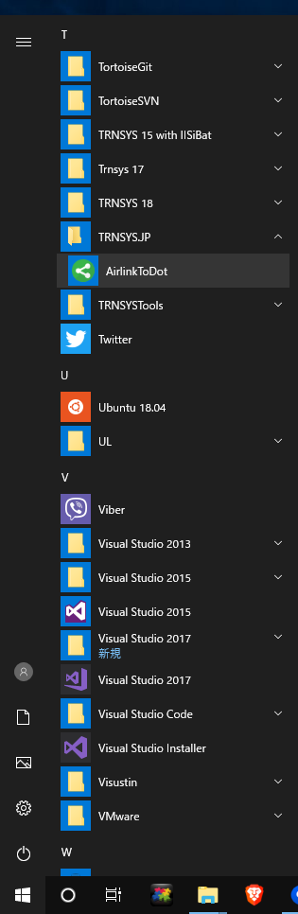

Click the [Load Bui] button or drop a Bui file from Explorer into the AirlinkToDot window.

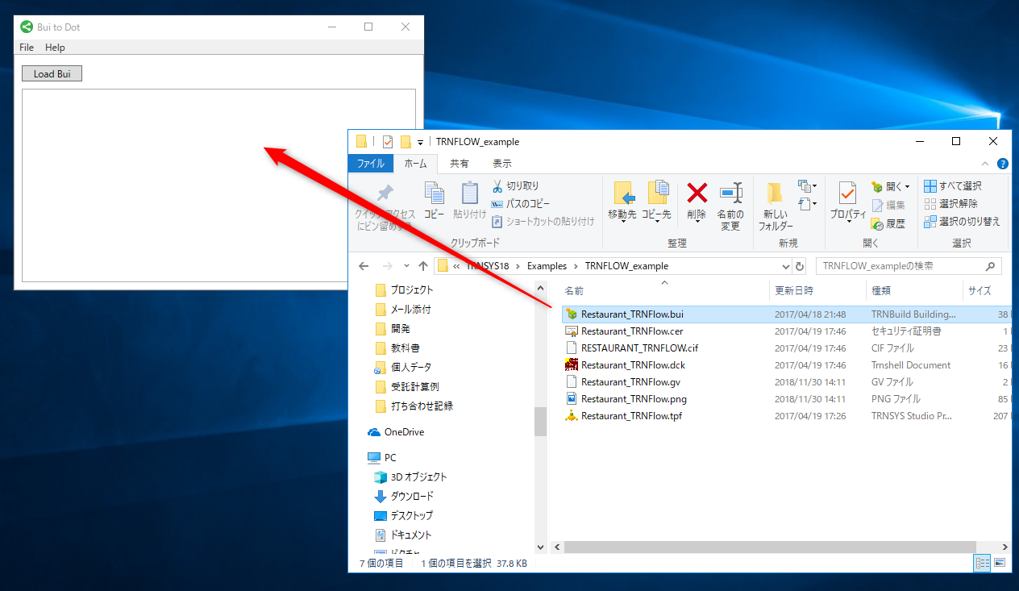

The Bui file is converted to Graphviz format (*. gv) and the generated diagram is displayed.

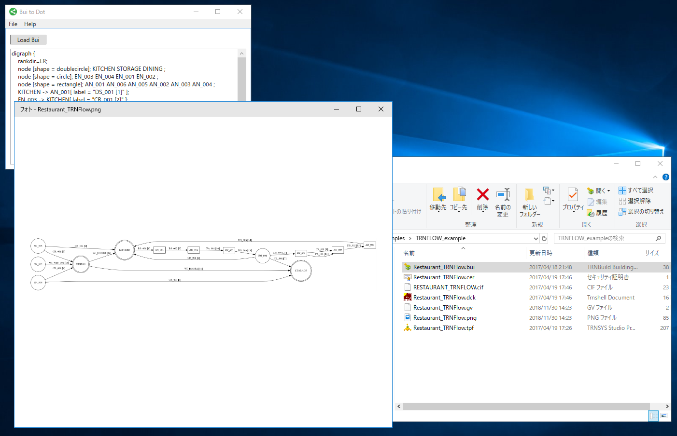

Airlinks and nodes are displayed as shown below.

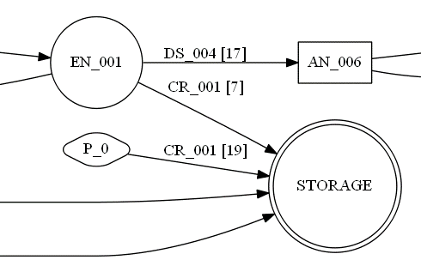

ID

External node

Type Name

To-Node

From-Node

Thermal airnode

Auxiliary node

Const. Pressure node

◎　Thermal airnode

○　External node

□　Auxiliary node

◇　Constant Pressure Node

←　Airlink(Window,Door,Crack,Duct)

* 1. Using AirlinkToDot in batch job mode

You can run AirlinkToDot in batch job mode by adding a bui file and “/n” option to the command line.

e.g.

"C:\Program Files (x86)\TRNSYS.JP\AirlinkToDot\AirlinkToDot.exe" "C:\TRNSYS18\Examples\TRNFLOW_example\Restaurant_TRNFlow.bui" **/n**

When the program is started with the "/n" option, the program automatically exits after converting the specified BUI file.

# Author

Yuichi Yasuda

quattro corporate design Co., Ltd.

A TRNSYS Official Distributor

<https://qcd.co.jp/>

# License

This program is licensed under [MIT license](https://github.com/Microsoft/nni/blob/master/LICENSE)