Final Business Analytics Project Report
Marketing Report
Camila Campbell
CAI 3801-001

Fall 2025

Business Problem and Objectives
This project falls within Marketing domain, focusing on customer behavior, sales performance, and growth. The core business problem in this project is understanding what factors the main contributors are and which ones are restricting sales performance growth. This project aims to answer the following marketing questions: What products are contributing the most in sales? What factors are influencing sales over time? How can the company boost customer engagement to increase overall sales? This matters because sales performance impacts the profits of a company, through this customer behavior can be seen and resources can be allocated efficiently, in the constantly changing market.

Data Source and Preparation
The dataset “Store Dataset” includes transactional data with 9,994 rows and 27 columns. Key fields include Total Sales, Total Profit, Total Costs, Sub-Category, and Region. Through the revision of the dataset, the following assumptions were made prices and quantities are recorded correctly with no system errors and competitor activity, or economic shifts are not included in the dataset and are assumed to not significantly distort trends. Upon inspection, the dataset was already well-structured and free of null values, formatting inconsistencies, or duplicate entries.

Part 3: Descriptive, Diagnostic, Predictive & Prescriptive Analytics

A. Descriptive/Diagnostic Analysis

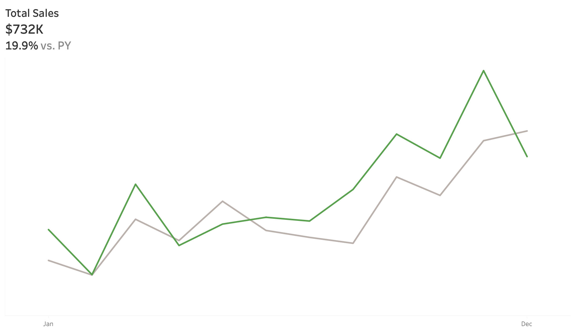
Chart 1: Total Sales KPI
This visualization shows the monthly total sales throughout a specific year as well as those of the previous year. The insight is important because it highlights the growth or decline that the company has gone through, and it shows patterns regarding which periods through the year get higher sales than others. From business perspective, this suggest that the company should allocate their resources towards the time periods that have the higher sales performance.

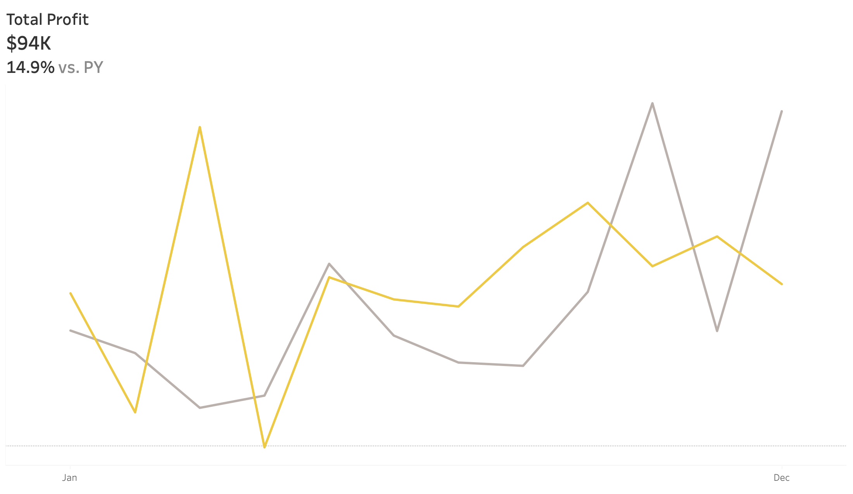
Chart 2: Total Profit KPI
This visualization shows the monthly total profit throughout a selected year as well as those of the previous year. The insight is important because it highlights the growth or decline of how much the company makes. From a business perspective, this suggest that the company should allocate their money accordingly to their demand so that their expenses would be lower to that of their revenue.

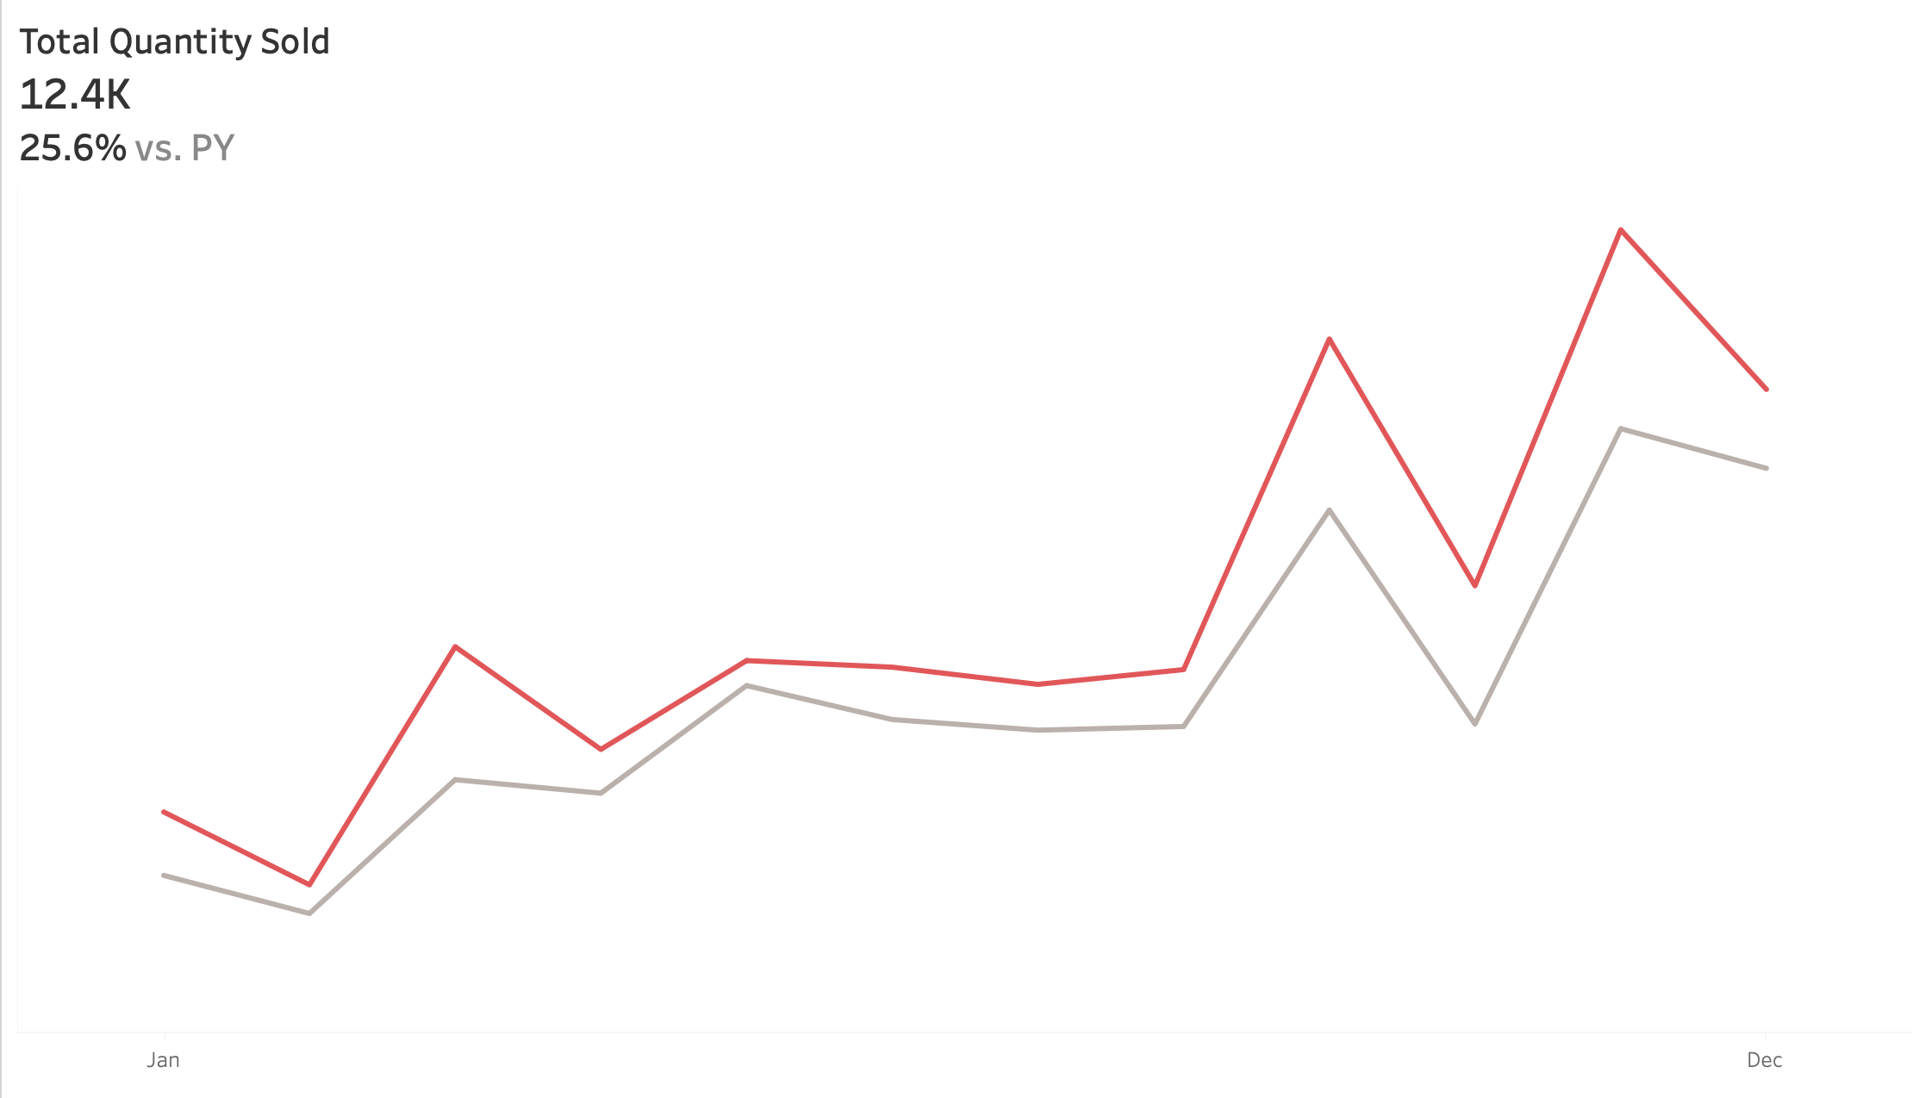
Chart 3: Total Quantity Sold KPI
This visualization shows the monthly total quantity sold of items throughout a selected year with the addition of the previous year’s monthly quantity sold. The insight is important because it highlights the number of items sold through the year. From a business perspective, this would help in allocating the resources and planning for inventory priorly to when the demand increases for some of the products.

Chart 4: Drill-Down
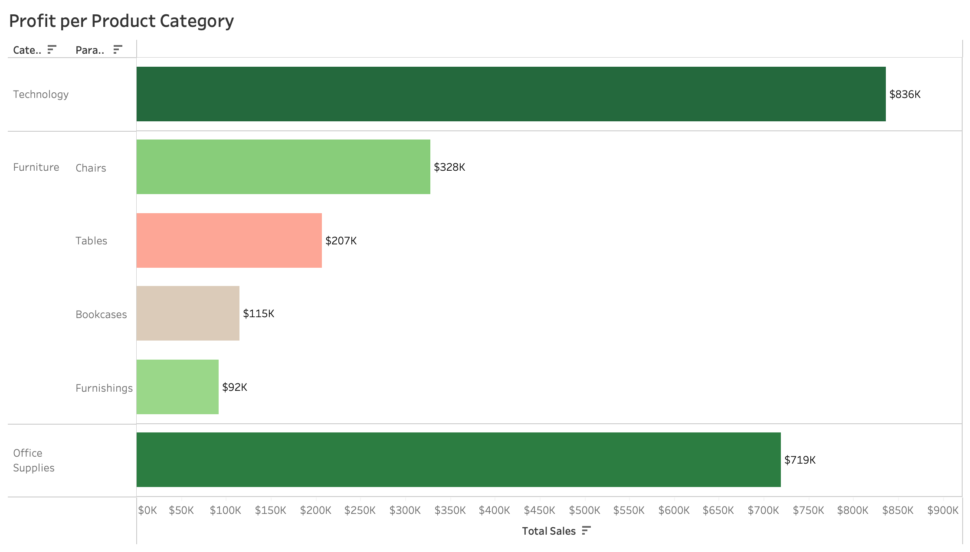
This visualization demonstrates that “Furniture” is the category that provides the least amount of profit. From this category, “Tables” give the most loses. This means that reassessing the strategy used for the Furniture category needs to go through revision, it could be done by implement the strategies used with the other categories.

Chart 5: Pareto Chart
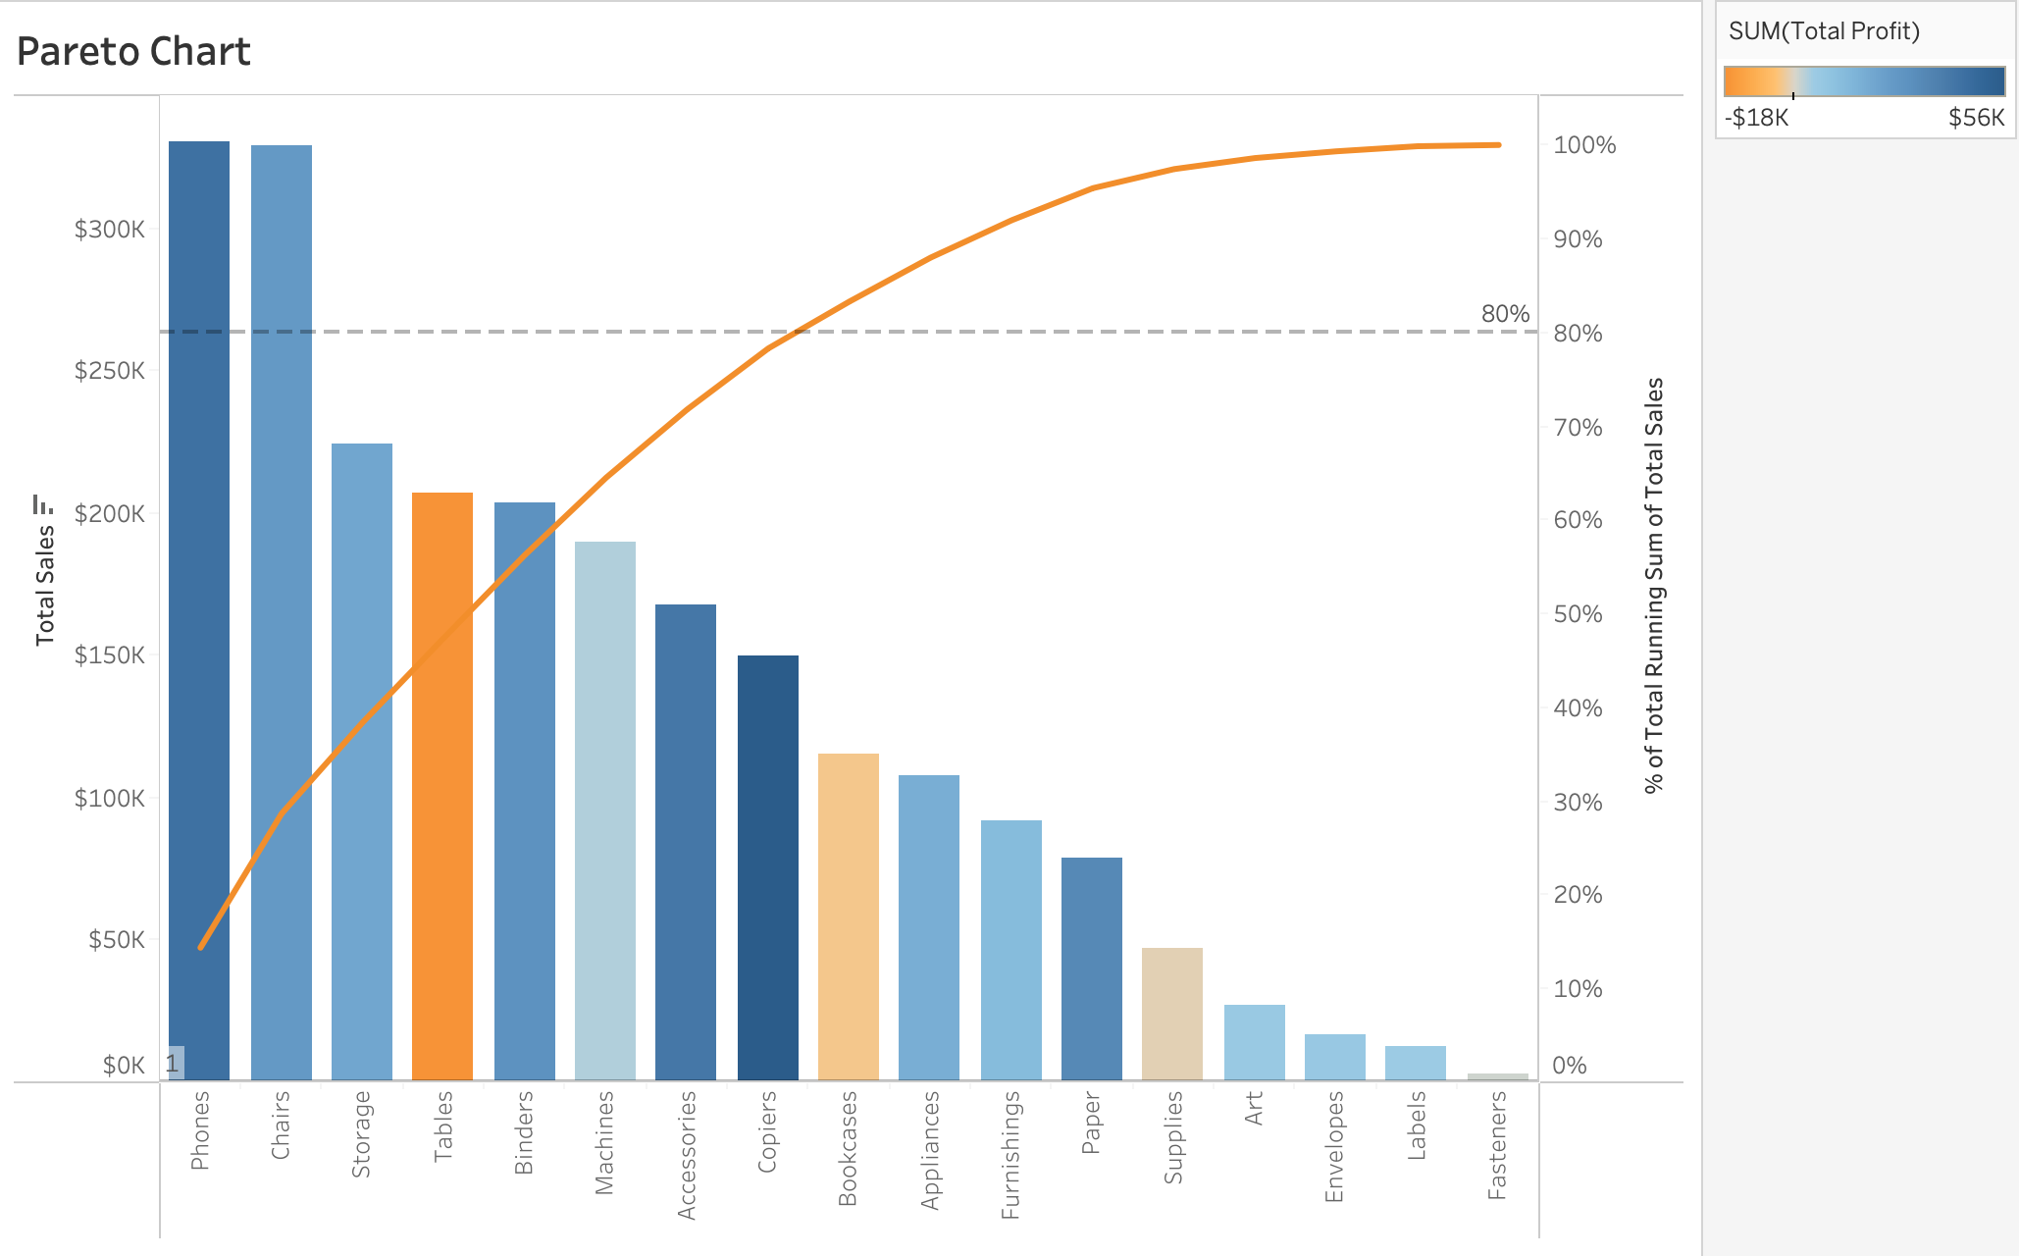
This visualization displays the contribution of each category to the total amount of sales, sorted from highest to lowest. This chart matters because it highlights the categories that have the largest impact based on 80/20 rule, where roughly 80% of an outcome is influenced by about 20% of the inputs. From a business perspective, that the top-performing categories, to the left of the chart, need to be prioritized, since they contribute the most overall sales. Implementing more marketing or operational strategies will increase returns.

Chart 6: Tree Map of States
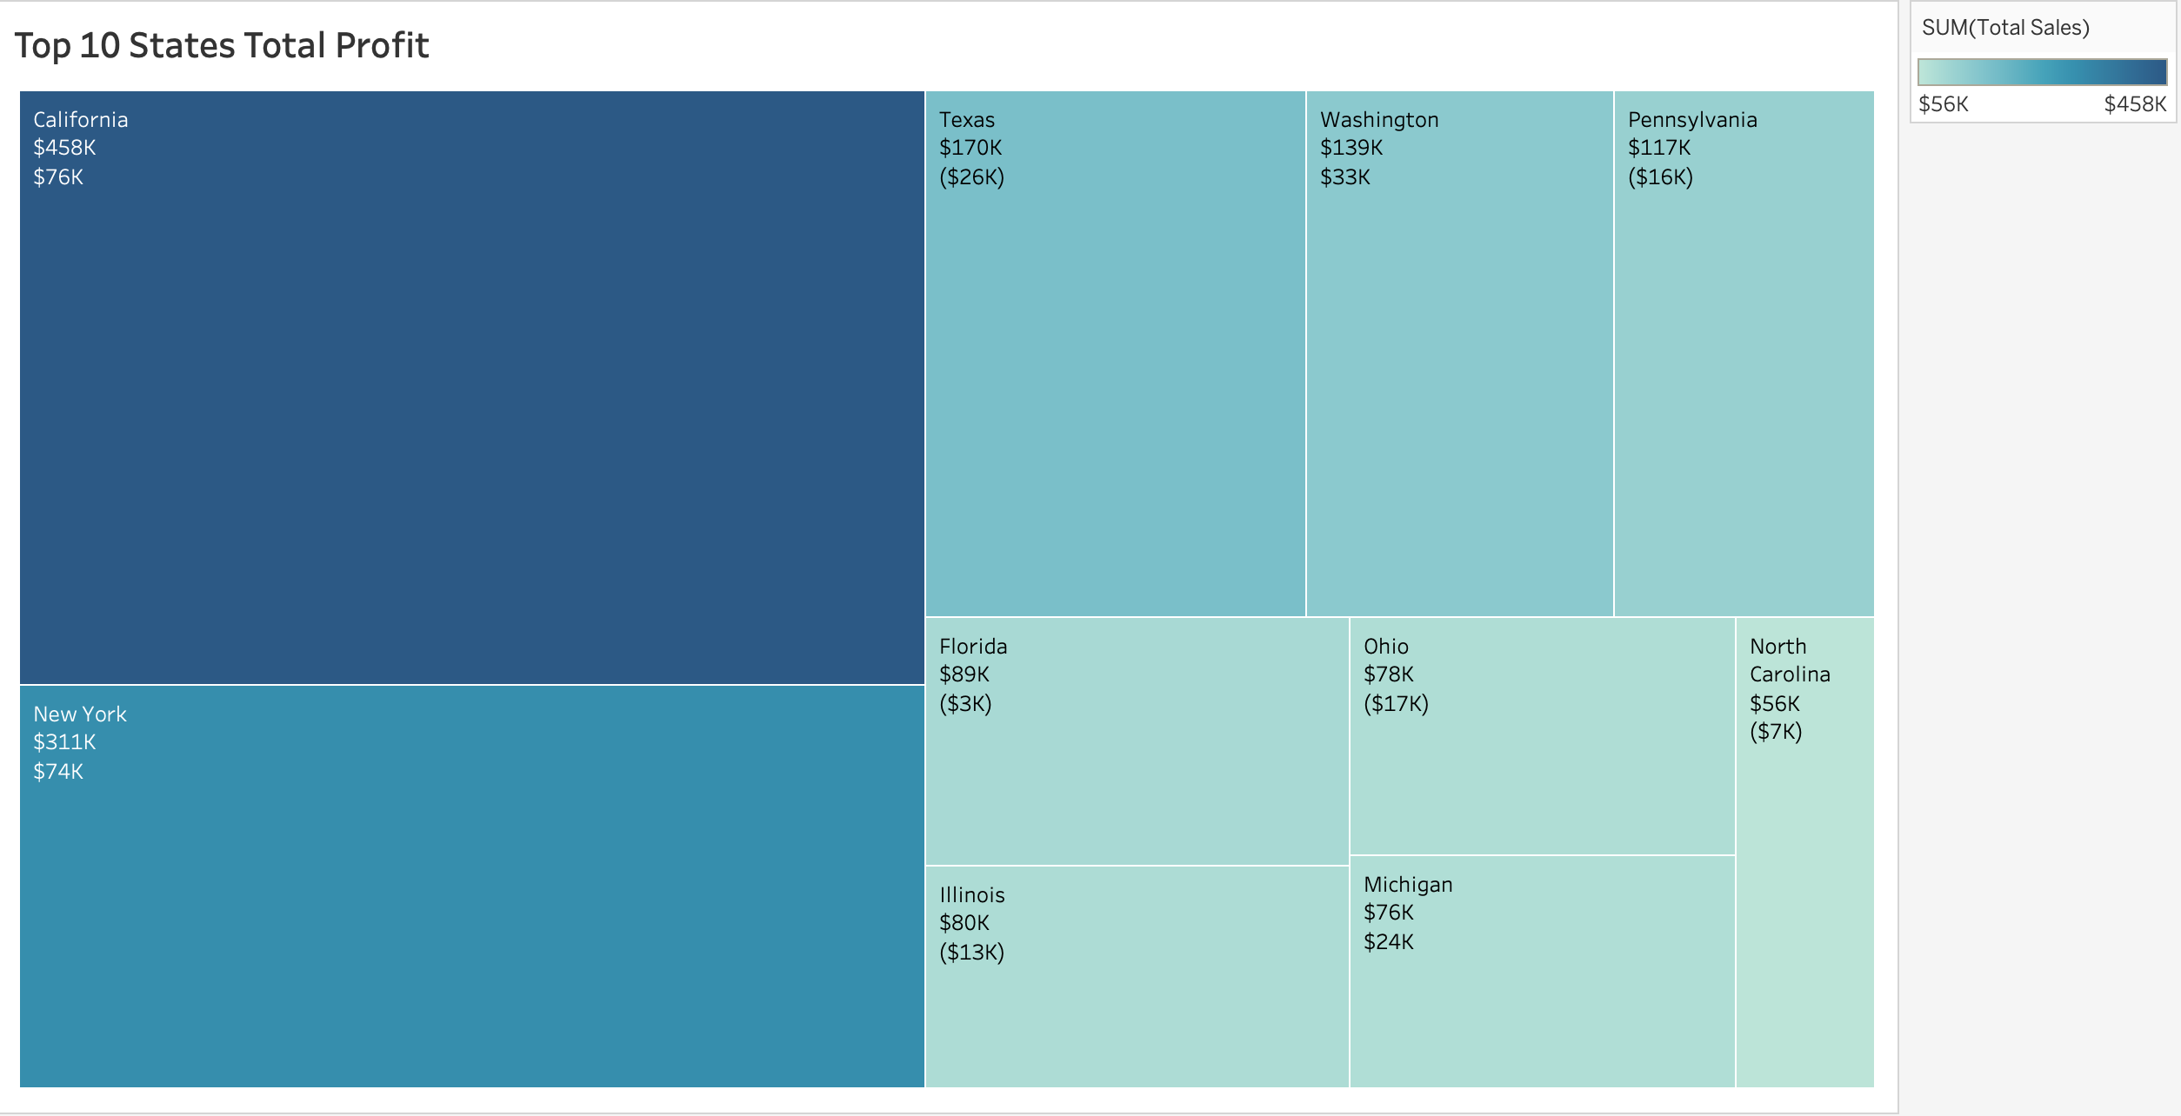
This visualization displays the top 10 most profitable states for the company. This chart matters because it shows the states which products have higher sales. From a business perspective, this chart allows for the company to know where to allocate their resources as well to where they need to prioritize some of their marketing and operations to increase the sales in each state.

Chart 7: Top 5 Loss Drivers
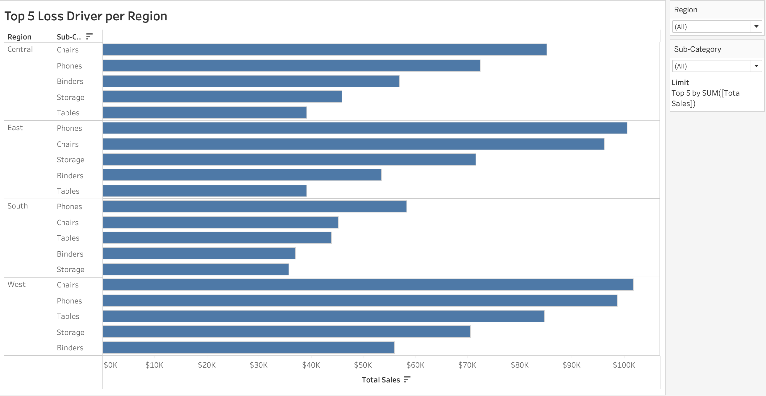
This visualization displays the top loss drives segmented by region to show how losses are distributed geographically. This chart highlights which loss drivers contribute the most overall, while also revealing patterns. This matters because it allows a business to identify the highest-impact loss categories but also where the losses are occurring. From a business perspective, this helps guide decision-making around where to focus risk reduction strategies, allocate resources, and investigate root causes. Addressing the largest and most regionally concentrated loss drivers will likely produce the greatest improvement in performance and cost control.

B. Predictive Analysis

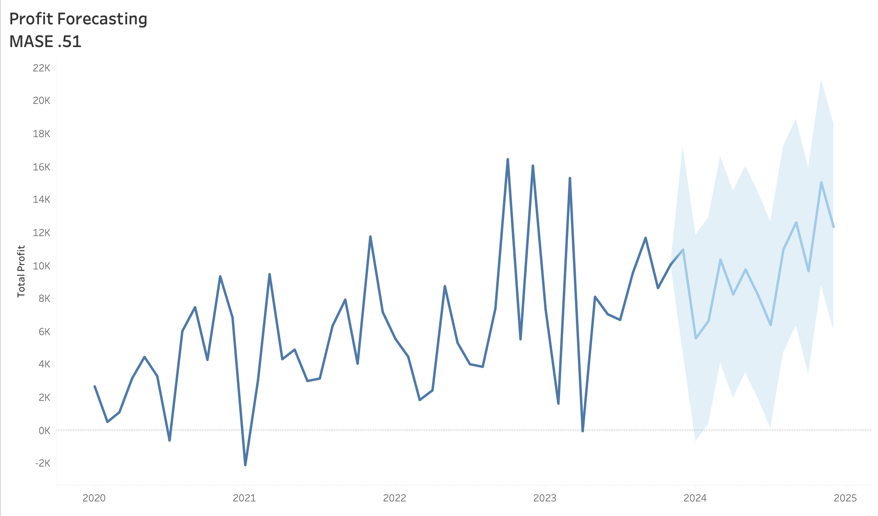
Chart 1: Forecasting
The forecasting analysis predicts future profits over the next year based on historical trends in the dataset. This forecast is important because it allows management to anticipate fluctuations in profitability, plan cost controls, and optimize pricing or promotional strategies. From a business perspective, these insights inform strategic decision-making, resource allocation, and investment priorities, ensuring the company can maximize profits while mitigating financial risks.

Chart 2: What-If Scenario Analysis (Discount)
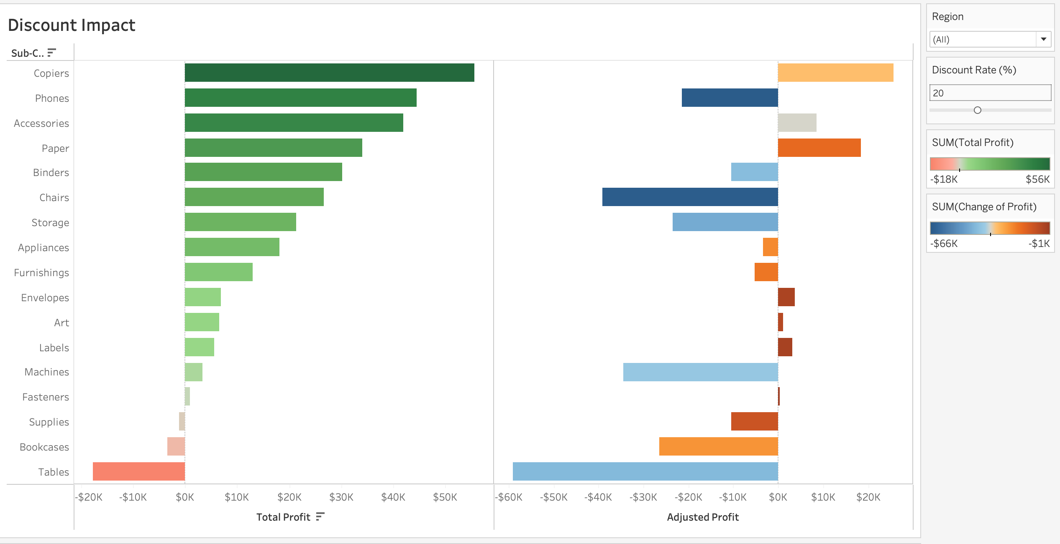
The what-if analysis explores how changes in discount rates impact profit, allowing the business to see adjusted profit level under different scenarios. By modifying the discount parameter, the analysis shows the resulting effect on profit, helping management evaluate trade-offs between driving sales volume and maintaining profitability. This insight is important because it enables data-driven decisions on pricing strategies and promotional campaigns. From a business perspective, these insights guide strategic planning, ensuring that discounts maximize revenue without reducing overall profitability.

Dashboard Overview
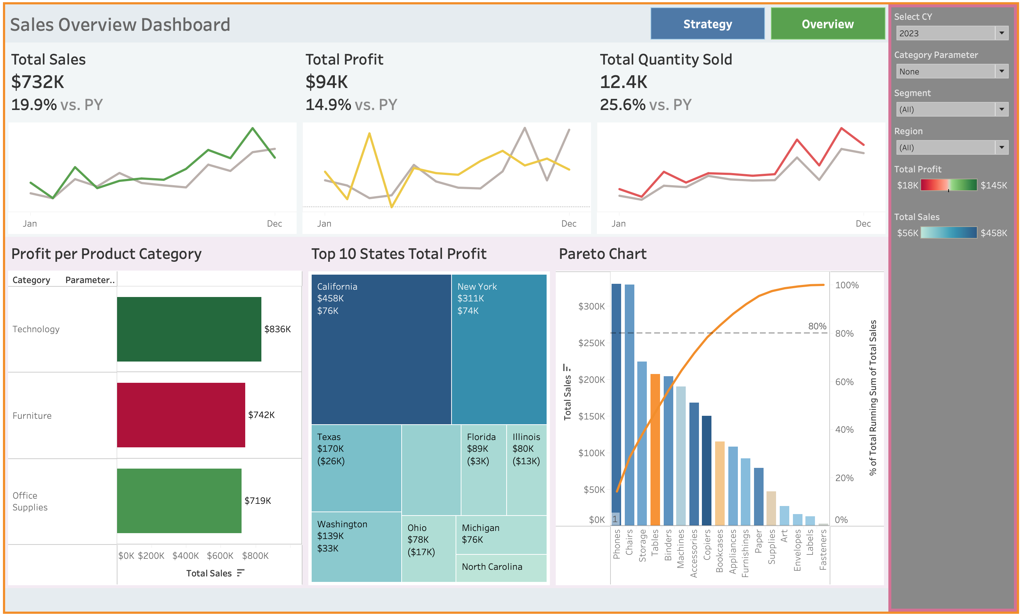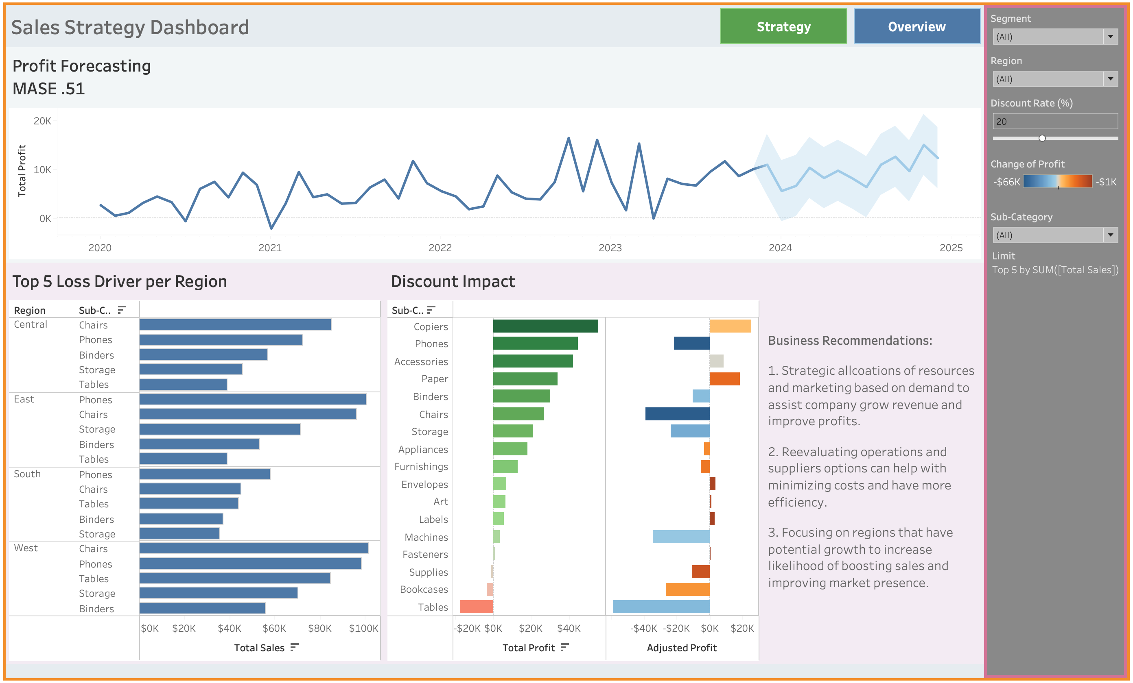
These dashboards conclude the project visualization and are designed for intuitive navigation. Users can move between the two pages by clicking the blue navigation button. The first page, Sales Overview, features KPI cards for total sales, total profit, and total quantity sold, chosen because they clearly reflect trend in company performance and customer demand over time. The second page, Strategic Overview, focuses on deeper insights, including customer segmentation and what-if scenario analysis. A consistent storytelling approach guiding the user, dashboard tiles use a bolder color at the top, KPI cards and forecasting charts are highlighted with lighter shades, and the charts themselves use a light purple background. Filters, placed on a dark grey background on the outermost left side, provide interactivity between the charts, allowing users to view performance by region, segment, product category, and year. To the bottom right of the filter, a recommendation box offers actionable insights based on the displayed data. Overall, the layout balances high-level summaries with actionable insights, making complex information easily digestible for executives.

Part 5: Project Conclusions

A. Key Findings
The analysis of sales data and forecasting results revealed several actionable business insights. Strategic allocation of resources and marketing efforts can drive revenue growth and improve overall profitability. Evaluating operational processes can help optimize costs and enhance efficiency. Targeted regional strategies and promotions have the potential to increase market share in areas with growth opportunities. Monitoring product performance and adjusting inventory based on forecasted demand also helps prevent overstocking and minimizes losses. Overall, utilizing insights from sales trends, predictive analysis, and what-if scenarios allows more informed, strategic business decisions.

B. Reflection
The project provided hands-on experience in turning raw data into actionable business strategies, helping me develop technical and strategic skills. A significant challenge that I faced was creating dashboards that displayed the insights harmoniously for clear and concise for the user to easily interpret. Through this process, I strengthened technical skills such as creating interactive visualizations and applying calculations, while improving my ability to interpret trends and communicate insights clearly. Working through this also improved my attention to detail skills and confidence in making data-driven recommendations. These experiences have not only improved my technical and analytical skills but also prepared me to tackle future projects and professional challenges with a data-driven mindset.

