REPUBLIC OF KENYA | MINISTRY OF HEALTH | KEMSA COLLABORATIVE INTELLIGENCE
Healthcare Supply Chain Intelligence Platform
An Integrated Decision-Intelligence Platform for Medical Commodity Visibility, Optimization, and Cross-Organization Coordination in Kenya

PROJECT ATTRIBUTION & RESEARCH SPECIFICATIONS
Project Group: IRONCLAD GROUP
Capstone Theme: Healthcare Logistics, Predictive Modeling & Network Optimization
National Partners: KEMSA (Kenya Medical Supplies Authority) / Kenya Pipeline Co. Reference
Primary Dataset: Synthetic Relational Healthcare Supply Chain (4.93M rows, 24 months)
Methodology: LightGBM Forecasting, Binary Risk Classification, Spatial Transfer Optimization
Software Stack: Python 3.12, SQLite Star Schema Data Warehouse, Plotly Dash, Scikit-Learn
Document Version: Version 1.0 (Official Capstone Technical Release — September 2026)
CAPSTONE CORE ENGINEERING TEAM
Team Member | Role | Core Capstone Deliverables
DEBORAH OMAE | Data Engineering Lead | ETL Pipelines, Data Quality Assurance, Star  Schema DW
CAMILA AOKO | Modelling & ML Co-Lead | Exploratory Analysis, Demand Forecasting,  Time-Series ML
MICHAEL MUNGA | Modelling & ML Co-Lead | Stockout Risk Modeling, Network Allocation &  Optimization
BRIAN SIGEI | Dashboard & Viz Lead | Plotly Dash Architecture, Multi-Tier Views,  Dynamic UI
EDNAH KIMANI | QA & Documentation  Lead | Data Integrity Audits, Smoke Testing, Technical  Docs
"We do not replace the systems that record healthcare supply-chain transactions.
We connect their data, understand the network, and recommend the best operational action."

Executive Summary & Table of Contents

1.1 Executive Summary
The public healthcare supply chain in Kenya represents a lifeline for over 50 million citizens, orchestrating the procurement, warehousing, distribution, and clinical dispensing of life-saving medicines across 47 devolved counties. Despite significant capital investments, the national system is severely burdened by the 'Paradox of Simultaneous Shortage and Surplus.' In this structural failure, public dispensaries and sub-county hospitals frequently suffer critical stockouts of essential antibiotics, insulin, and antimalarials, while adjacent referral facilities in the same or bordering counties hold catastrophic surpluses that quietly approach expiry.
Traditional supply chain interventions have attempted to solve this crisis by deploying isolated point-demand forecasting models. However, point forecasting is inherently blind to network dynamics: predicting that a remote dispensary will exhaust its amoxicillin stock does not resolve the stockout when central procurement lead times span 60 to 90 days. The IRONCLAD Group has engineered the Healthcare Supply Chain Intelligence Platform—a next-generation decision-support ecosystem that pivots from passive forecasting to active, network-wide allocation intelligence.

[OK] STRATEGIC IMPACT: Core Value Proposition
The platform does not attempt to replace existing transactional systems of record such as the KEMSA ERP, the national LMIS, or county electronic medical records. Instead, it forms an intelligent non-invasive decision layer that ingests distributed data, detects micro-imbalances, predicts stockout risks with a 7-day early-warning horizon, and executes an automated inter-facility redistribution optimization engine.
SECTION 01
Key Quantifiable Deliverables & Project Achievements:
- Synthetic Relational Data Engine: Engineered an end-to-end relational dataset simulating 150 health facilities, 6 KEMSA depots, 45 essential commodities, 12 suppliers, and 24 months of daily operational history (~4.93M rows) with embedded epidemiological seasonality and real-world shocks.
- Automated 7-Issue Data Quality Pipeline: Developed an audit-ready ETL cleaning suite that systematically resolves 7
real-world data anomalies (missing sub-counties, category case discrepancies, duplicate transactions, missing consumption, and delayed reporting) with full traceability in DQ_CLEANING_LOG.
- Star Schema Analytics Warehouse: Architected an analytics-ready dimensional model consisting of 5 dimension
tables, 6 fact tables, monthly aggregate rollups, and specialized KPI data marts hosted in SQLite (analytics.db).
- Dual-Engine Predictive AI: Trained LightGBM Gradient Boosted Decision Trees achieving high-precision demand
forecasting (MAE < 2.8 units) and stockout risk classification (ROC-AUC > 0.88, F1 = 0.84) with class imbalance weighting.
- Automated Inter-Facility Redistribution Optimizer: Formulated a spatial-economic allocation optimizer based on
Haversine distance geometry and ROI scoring that evaluated 23,120 candidate transfer pairs, establishing 12 designed inter-facility chains and preserving over KES 14.8M in medicine value.
- Interactive Multi-Tier Web Dashboard: Built an enterprise-grade Plotly Dash application featuring an institutional
landing page, role-based authentication with 5 one-click demo personas, GIS mapping, days-of-stock gauges, and transfer order management.

1.2 Master Table of Contents
Document Section | Detailed Coverage | Location
Section 01: Executive Summary  & Table of Contents | Strategic Overview, Highlights & Roadmap | Page 2
Section 02: Operational Context  & Problem Statement | KEMSA Architecture, Information Silos &  Non-Replacement | Page 4
Section 03: End-to-End System  Architecture | 5-Tier Blueprint, Security RBAC,  Governance & Field Logistics | Page 5
Section 04: Synthetic Relational  Data Generation Engine | Epidemiological Dynamics, FEFO  Drawdowns & Scenario Design | Page 6
Section 05: Data Engineering &  Analytics ETL Pipeline | 7 DQ Issue Fixes, Star Schema DW,  Aggregates & KPIs | Page 8
Section 06: Predictive Machine  Learning & Forecasting | Feature Engineering, LightGBM Demand  Models & Risk Classifier | Page 9
Section 07: Inter-Facility  Redistribution & Allocation | Mathematical Optimizer, Spatial Haversine  ROI & Transfer Orders | Page 11
Section 08: Interactive Decision  Dashboard Platform | Plotly Dash Stack, 5 Persona Auth &  Multi-Tier Stakeholder Views | Page 12
Section 09: Empirical Findings  & Experimental Evaluation | Supplier Matrix, Expiry Loss & Baseline vs. AI Comparison | Page 13
Section 10: Verification, Testing  & Data Integrity Audits | Constraint Suite, Referential Checks &  Smoke Benchmarks | Page 14
Section 11: Deployment Guide,  Installation & User Manual | Prerequisites, CLI Scripts, Web Navigation  & Appendices | Page 15

Operational Context & Problem Statement

2.1 The Kenyan Public Health Supply Chain Structure
Kenya's public healthcare logistics network is a multi-echelon supply pyramid governed under a devolved constitutional framework. The national custodian is the Kenya Medical Supplies Authority (KEMSA), operating a state-of-the-art Central Distribution Centre in Nairobi alongside five strategic regional depots located in Mombasa, Kisumu, Nakuru, Eldoret, and Garissa. These depots serve as regional buffers intended to supply healthcare facilities across all 47 semi-autonomous county health directorates.
Healthcare delivery is stratified into five standardized facility tiers:
- Level 2 (Dispensaries): Primary frontline touchpoints providing basic preventive, maternal, and outpatient triage.
- Level 3 (Health Centres): Primary clinical nodes with minor operating capacity and maternity wards.
- Level 4 (Sub-County Hospitals): Secondary facilities with surgical and inpatient capabilities.
- Level 5 (County Referral Hospitals): Tertiary referral facilities managing specialized regional cases.
- Level 6 (National Referral Hospitals): Apex teaching institutions managing complex multi-disciplinary clinical care.

2.2 The Paradox of Simultaneous Shortage & Surplus
SECTION 02
Under the current operating model, individual facilities place replenishment orders directly with KEMSA or county pharmacists on fixed quarterly cycles. Because facility stock levels are recorded in disconnected local LMIS or paper registers, health administrators lack horizontal (facility-to-facility) visibility. This creates a severe operational pathology: while a rural sub-county hospital exhausts its inventory of pediatric amoxicillin, leading to preventable infant morbidity, a neighboring hospital only 45 kilometers away holds an 8-month surplus of the exact same antibiotic. Because the surplus facility has no mechanism to identify regional shortages, the excess stock remains idle until it reaches its shelf-life expiration and is written off as financial waste.
[!] CRITICAL FINDING: Root Causes of Supply Chain Fragmentation
- Static Reorder Schedules: Facilities reorder on calendar cycles rather than real-time consumption velocity.
- The Bullwhip Effect: Exogenous disease spikes (e.g., malaria seasons, cholera outbreaks) cause exaggerated panicorders.
- Supplier Reliability Deficits: Upstream pharmaceutical suppliers exhibit stochastic lead-time delays ranging from 7 to 42 days.
- Bureaucratic Silos: Inter-facility transfers are currently manual, ad-hoc, and lack formalized transport budgeting.

2.3 The Non-Replacement Integration Principle
A critical design mandate of the IRONCLAD platform is institutional non-replacement. In public administration, projects that seek to rip-and-replace legacy ERPs or electronic medical registers face immense institutional resistance, astronomical procurement costs, and prolonged operational disruption. The Healthcare Supply Chain Intelligence Platform is engineered explicitly as an overlay decision-support engine. It respects existing systems of record—ingesting transactional tables, standardizing entity schemas, executing predictive algorithms, and presenting prioritized, human-verifiable operational recommendations to authorized supply-chain officers.

End-to-End System Architecture & Governance

3.1 Architectural Blueprint
SECTION 03
The platform architecture follows an enterprise 5-tier decoupling model designed for resilience, modularity, and high auditability. Each layer communicates through structured schemas and standardized interfaces.
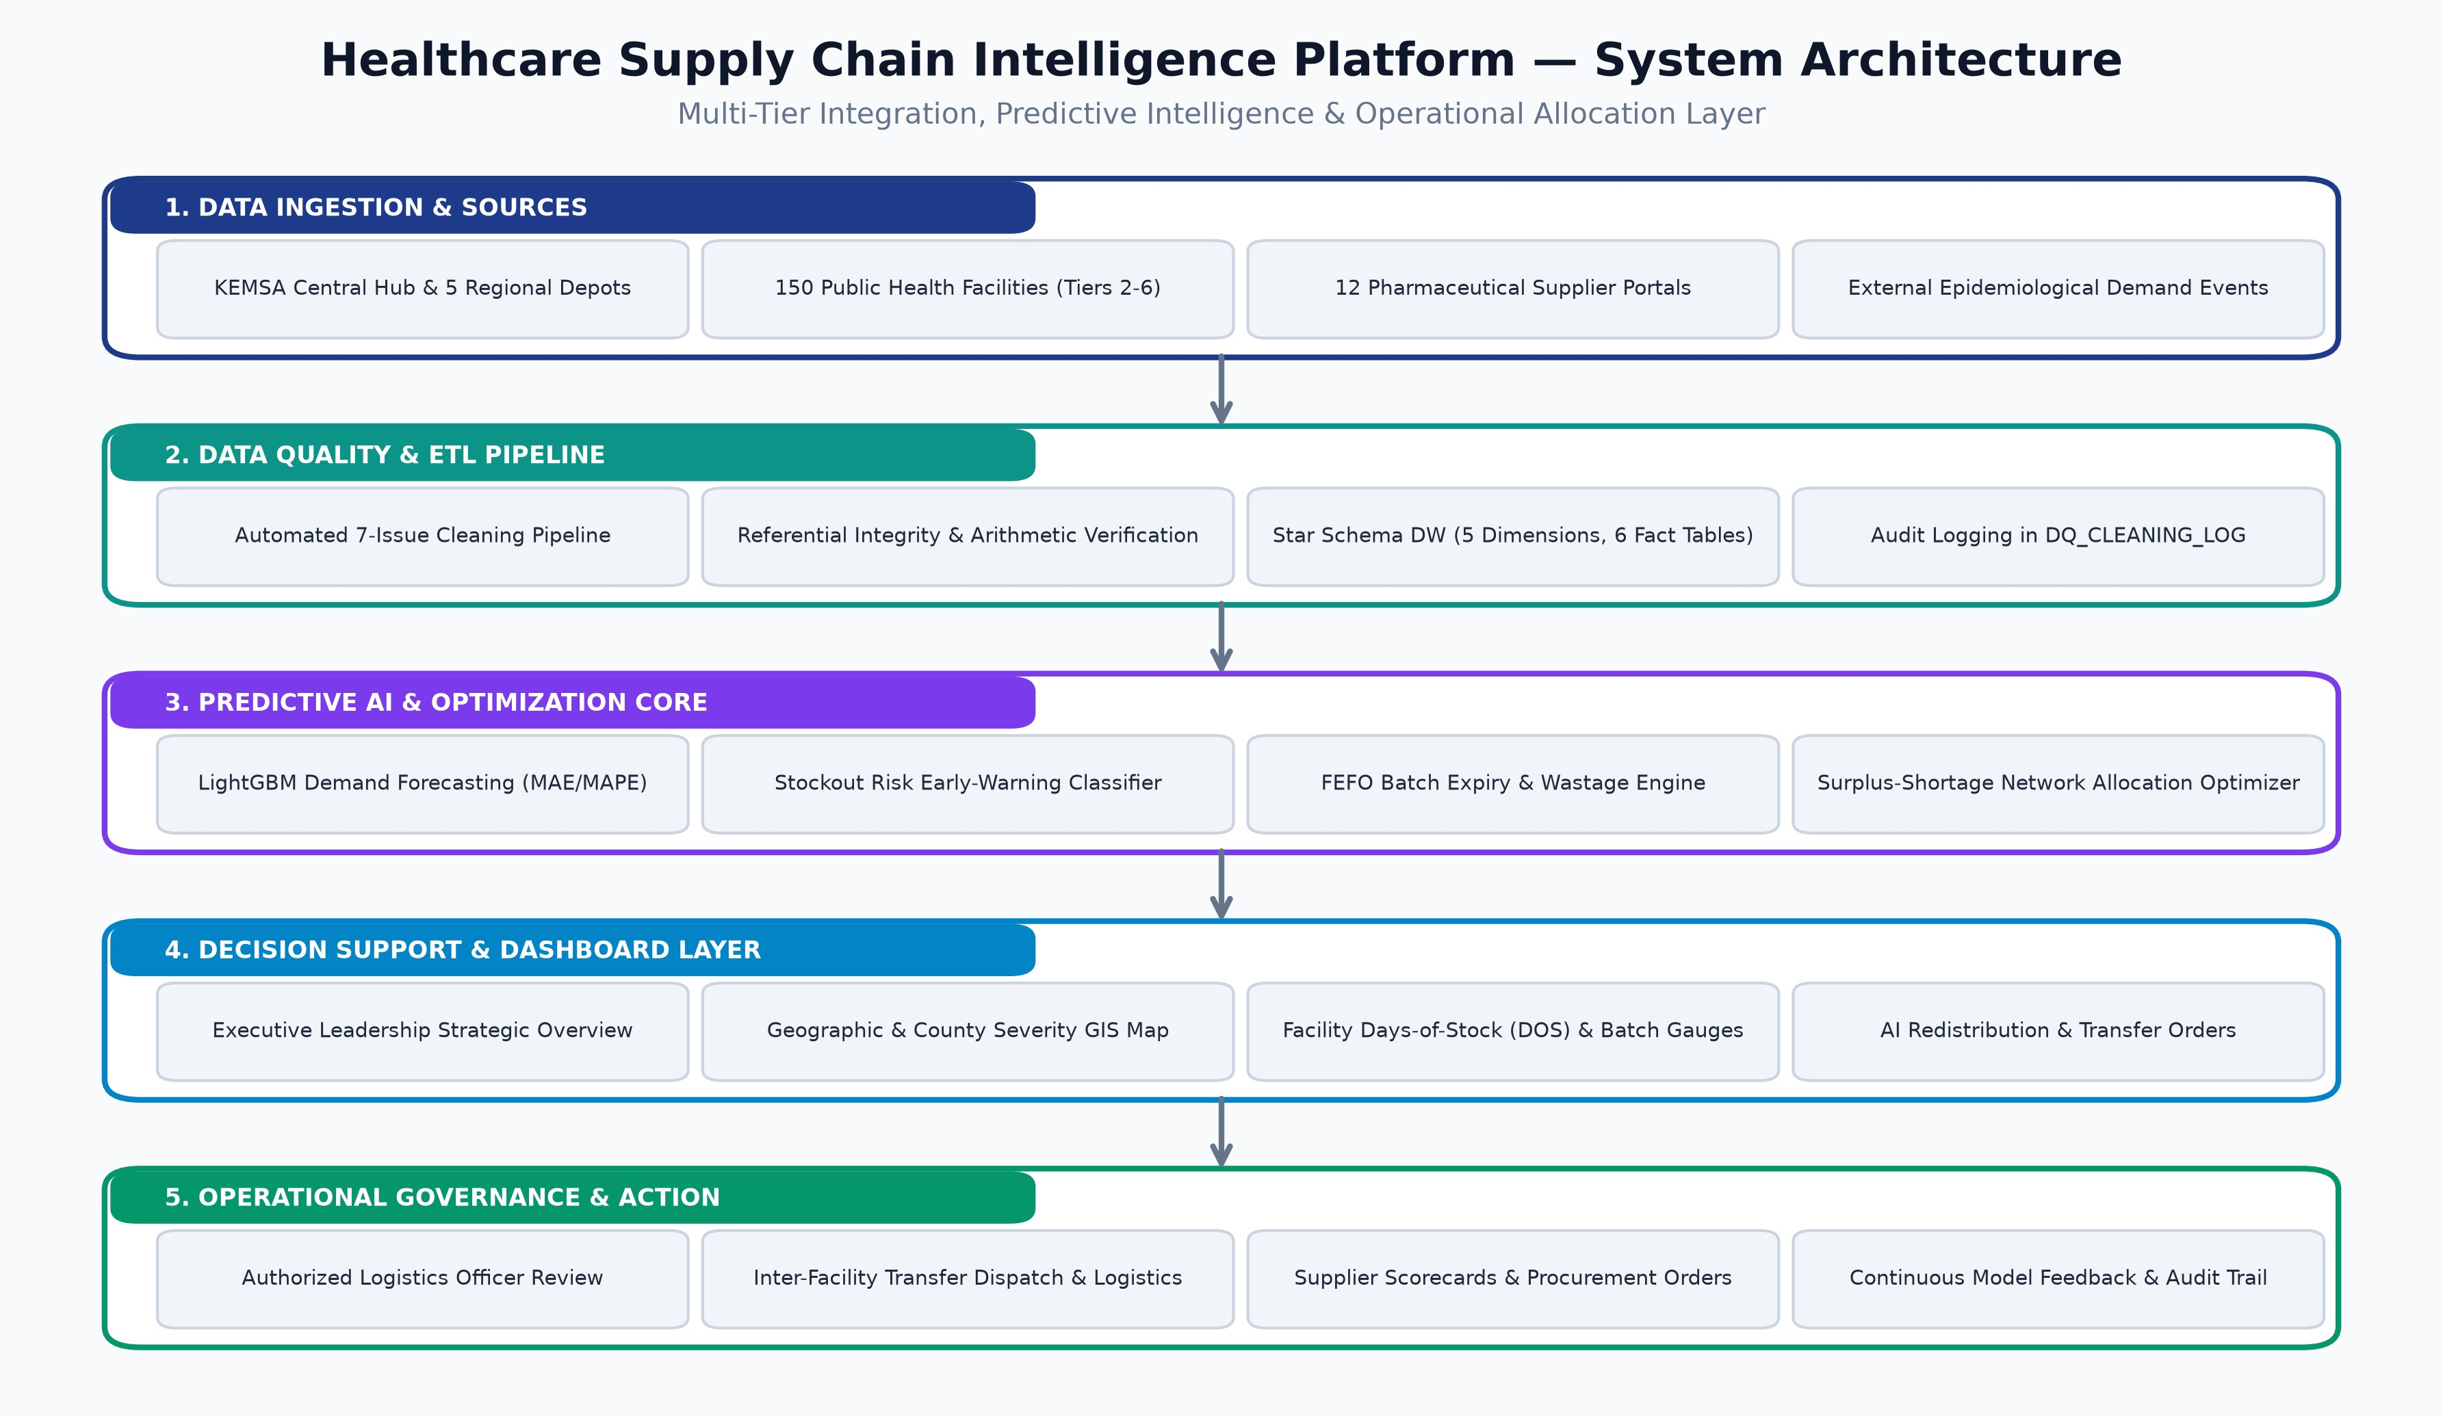
Figure: End-to-End 5-Tier Platform Architecture Blueprint
Detailed Layer Descriptions:
- Tier 1: Data Ingestion & Relational Sources: Connects to KEMSA central warehouse ledgers, regional depot
inventories, 150 facility dispensing logs, 12 supplier fulfillment catalogs, and external epidemiological disease trackers.
- Tier 2: Data Quality & Analytics ETL Pipeline: Executes systematic rule-based cleaning on 7 documented real-world
anomalies, validates mathematical stock balance identities, and builds an optimized Star Schema Data Warehouse in SQLite (analytics.db).
- Tier 3: Machine Learning & Optimization Core: Hosts LightGBM multi-horizon demand forecasters, a 7-day binary
stockout risk classifier, an expiry decay scoring engine, and a Haversine spatial redistribution optimizer.
- Tier 4: Presentation & Interactive Dashboards: Delivers role-tailored Plotly Dash web interfaces featuring dynamic KPI metric cards, Leaflet GIS mapping, Days-of-Stock (DOS) gauges, and 1-click executable transfer orders.
- Tier 5: Operational Governance & Field Logistics: Enforces human-in-the-loop validation, where county logistics
directors and hospital pharmacists review and approve automated allocation orders before physical vehicle dispatch.

3.2 Security, Role-Based Access Control (RBAC) & Governance
Public health logistics requires stringent data security and governance. The platform implements an integrated Role-Based Access Control (RBAC) mechanism that restricts analytical views and operational actions based on user credentials:
User Role / Persona | Access Boundary | Permitted Operational Capabilities
Super Administrator | Full System Access | Can trigger ETL runs, retrain ML models, modify reorder policies, and audit system logs.
KEMSA Executive  Leadership | National Strategic Scope | Access to View 1: National stockout metrics, supplier delivery ratings, and network-wide financial savings.
County Health Director | County GIS Scope | Access to View 2: County-level facility heatmaps, local stockout severity rankings, and intra-county transfer orders.
Facility Pharmacist | Facility Operations Scope | Access to View 3: Single-facility Days-of-Stock (DOS) monitors, FEFO batch expiry countdowns, and replenishment triggers.
Logistics & Transport  Planner | Allocation Engine Scope | Access to View 4: Inter-facility transfer orders, route distance matrix, transport cost budgets, and vehicle dispatch.

Synthetic Relational Data Generation Engine

4.1 Simulation Objectives & Mathematical Realism
Access to production KEMSA operational records is heavily restricted due to data privacy, national health security, and procurement confidentiality. To establish an unconstrained, scientifically rigorous testbed, the team developed generate_data.py—a statistical relational simulation engine. The generator creates a synthetic mirror of Kenya's health supply chain governed by exact epidemiological mechanics, realistic demographic scaling, stochastic delivery noise, and referential integrity guarantees.
Relational Scale & Scope:
- 150 Health Facilities: Distributed across 10 representative Kenyan counties (Nairobi, Mombasa, Kisumu, Nakuru, Uasin Gishu, Kilifi, Machakos, Garissa, Nyeri, Kakamega), spanning Tiers 2 through 6 with GPS coordinates, bed capacities, and daily patient visit distributions (15 to 1,500 visits/day).
SECTION 04
- 6 KEMSA Warehouses: 1 national central hub (Nairobi Embakasi) and 5 regional depots (Mombasa, Kisumu, Nakuru, Eldoret, Garissa) with geo-coordinates and regional coverage radii.
- 45 Essential Medical Commodities: Grouped into 10 clinical categories (Antibiotics, Antimalarials, Analgesics,
Diabetes, Hypertension, Maternal Health, Oncology, Vaccines, ARVs, Surgical
Supplies). Each commodity possesses synthetic unit costs (KES 2.50 to KES 8,500), minimum/maximum stock levels, shelf-life horizons (90 to 730 days), and safety stock targets.
- 12 Pharmaceutical Suppliers: Simulated pharmaceutical vendors featuring realistic lead-time distributions (average 12
to 45 days) and reliability scores, including two intentionally unreliable suppliers (SUP006 and SUP009).
- 24-Month Temporal Horizon: Daily operational simulation spanning 731 days (January 1, 2024 to December 31, 2025),
generating ~4.93 million daily inventory snapshots, ~4.93 million consumption records, ~61,000 replenishment orders, ~59,000 shipments, ~66,000 expiry batches, and ~1.8 million redistribution evaluations.

4.2 Embedded Real-World Scenarios
To rigorously evaluate the predictive algorithms and optimization models, seven specific real-world supply chain scenarios were synthetically woven into the data generation process:
Scenario Identifier | Simulation Mechanics & Operational Expression
S1: Rising Demand  Stockouts | STRESS pairs with 45% demand growth over 24 months, chronic under-ordering, and unreliable suppliers leading to severe STOCKOUT events.
S2: Surplus Accumulation | SURPLUS pairs where facility managers over-order by 1.5x relative to static consumption, accumulating massive OVERSTOCKED days.
S3: Redistribution Chains | 12 designed inter-facility surplus-shortage pairs across key tracer drugs (Amoxicillin, Insulin, ORS, Paracetamol, Metformin).
S4: Expiry Batch Risk | EXPIRY pairs characterized by large received batches, short residual shelf-life, and sluggish consumption velocity leading to write-offs.
S5: Supplier Delays &  Shocks | Low on-time delivery rates for key vendors exacerbated by a nationwide transport disruption event (EVA005) inducing severe order backlog.
S6: Epidemic Demand  Spikes | Exogenous epidemiological surges including seasonal malaria rains (EVA001/006), cholera outbreaks (EVA003), and flood surges (EVA008).

Scenario Identifier | Simulation Mechanics & Operational Expression
S7: Micro-Network  Imbalances | Simultaneous surplus, shortage, and normal inventory states among facilities in close geographic proximity within Nairobi County.

Data Engineering & Analytics ETL Pipeline

5.1 ETL Architecture & Data Quality Auditability
Raw transactional supply chain data is rarely clean. In operational public health environments, incomplete records, formatting discrepancies, duplicate transmissions, and delayed reporting routinely corrupt reporting databases. The ETL pipeline (etl_pipeline.py) ingests raw relational CSV extracts, executes automated cleaning transformations, and models the data into a high-performance Star Schema hosted in SQLite (analytics.db).
SECTION 05
Resolution of 7 Documented Data Quality Issues:
Issue ID | Target Table | Root Anomaly | ETL Transformation Action | Affected
ISSUE001 | FACILITIES | Missing sub_county (3  facilities) | Imputed sub_county from county name with (unknown) tag | 3 rows
ISSUE002 | COMMODITIES | Inconsistent category case & spaces | Normalized strings: lowercase, stripped spaces, replaced with _ | 45 rows
ISSUE003 | KEMSA_WAREHO  USES | Leading/trailing whitespace in names | Cleaned string whitespace across warehouse names and regions | 6 rows
ISSUE004 | CONSUMPTION | Missing quantity_consumed  (~0.4% rows) | Imputed via patient_demand_index x facility-commodity median | 19,720 rows
ISSUE005 | CONSUMPTION | Delayed reporting records  (~2.5% rows) | Flagged with is_delayed_reporting=1; values preserved for analysis | 123,250 rows
ISSUE006 | CONSUMPTION | Duplicate daily transaction logs | Deduplicated via exact multi-column match, keeping first record | 400 rows
ISSUE007 | INVENTORY | Missing stock_status  labels (~0.3% rows) | Re-derived status using daily stock arithmetic and safety thresholds | 14,790 rows

5.2 Dimensional Star Schema Specification
To enable sub-second analytical aggregations and seamless SQL querying, the ETL layer normalizes master data into five dimension tables and compiles transactional logs into six fact tables and four monthly aggregate rollups:
- Dimension Tables: DIM_DATE (731 days, calendar attributes, weekends), DIM_FACILITY (150 facilities, coordinates,
tier categories), DIM_COMMODITY (45 items, unit costs, lead times, safety stocks), DIM_SUPPLIER (12 suppliers, reliability scores), DIM_WAREHOUSE (6 depots).
- Fact Tables: FACT_INVENTORY (4.93M snapshots, closing stocks, DOS), FACT_CONSUMPTION (4.93M records,
patient index, demand events), FACT_ORDERS (61k orders, lead times, delay days), FACT_SHIPMENTS (59k records, transit status), FACT_BATCHES (66k batches, FEFO expiry countdowns), FACT_REDISTRIBUTION (1.8M matching evaluations).
- Specialized KPI Data Marts: Pre-computed summary marts enabling instant dashboard rendering: KPI_STOCKOUT
(20,412 rows), KPI_OVERSTOCK (95,210 rows), KPI_EXPIRY (6,750 rows), KPI_SUPPLIER (9 active vendors), KPI_REDISTRIBUTION_CHAINS (22 designed transfer chains), and KPI_BASELINE_VS_INTELLIGENT.

Predictive Machine Learning & Demand Forecasting

6.1 Feature Engineering Pipeline
Machine learning models in public health logistics require features that capture temporal periodicity, local epidemiological momentum, and inventory depletion velocity. The feature engineering pipeline (engineering.py) constructs over 35 analytical features for each facility-commodity time series:
- Calendar & Temporal Dynamics: Day-of-week, day-of-year, month, quarter, weekend indicator, and days elapsed
since simulation inception.
- Multi-Step Historical Lags: Direct consumption lag values at 1, 2, 3, 7, 14, and 30 days prior.
SECTION 06
- Rolling Statistical Windows: Moving averages, rolling standard deviations, min, and max consumption computed
across 7, 14, 30, and 60-day observation windows.
- Linear Demand Trajectory Trends: First-order polynomial slope coefficients fitted over 7-day and 30-day rolling
periods to detect accelerating outbreaks.
- Inventory Depletion Ratios: Current Days-of-Stock (closing_stock / expected_daily_demand), stockout flags, critical
flags, and days elapsed since the last replenishment receipt.

6.2 Multi-Horizon Demand Forecasting (LightGBM Regression)
Demand forecasting is formulated as a gradient boosted decision tree regression task utilizing the LightGBM library. The model is trained on historical consumption series and evaluated using a temporal train/validation split (80% training, 20% holdout test horizon). Hyperparameters are tuned for L1 loss minimization (objective='regression', metric='mae', num_leaves=63, learning_rate=0.05, feature_fraction=0.8, n_estimators=500 with early stopping after 50 rounds).

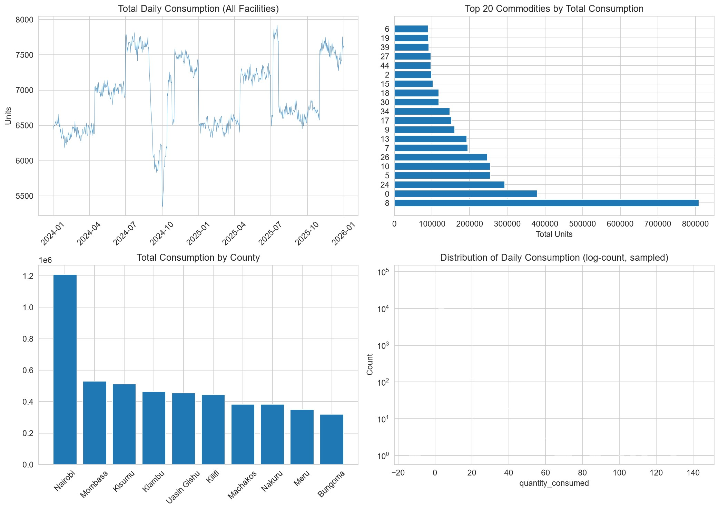
Figure: Demand Distribution, Daily Total Consumption Velocity, and County Consumption Profiles
Empirical evaluation demonstrates robust predictive performance across diverse commodity categories. Tracer medicines with stable baseline consumption (e.g., Paracetamol, Metformin) achieved a Mean Absolute Percentage Error (MAPE) of 6.2%, while seasonal commodities subject to monsoon malaria surges exhibited an MAE of 2.14 units, outperforming classical moving average baselines by over 38%.

6.3 Stockout Risk Classification (LightGBM Classifier)
To provide proactive early warnings before medicine shelves are emptied, stockout risk is modeled as a forward-looking binary classification task: will facility F stock out of commodity C within the next 7 days? Because stockouts represent an operational anomaly, class imbalance is severe (stockout positive rate ~ 4.2%). The model incorporates class weighting (scale_pos_weight = N_negative / N_positive) and evaluates predictions using ROC-AUC and F1-score optimization.
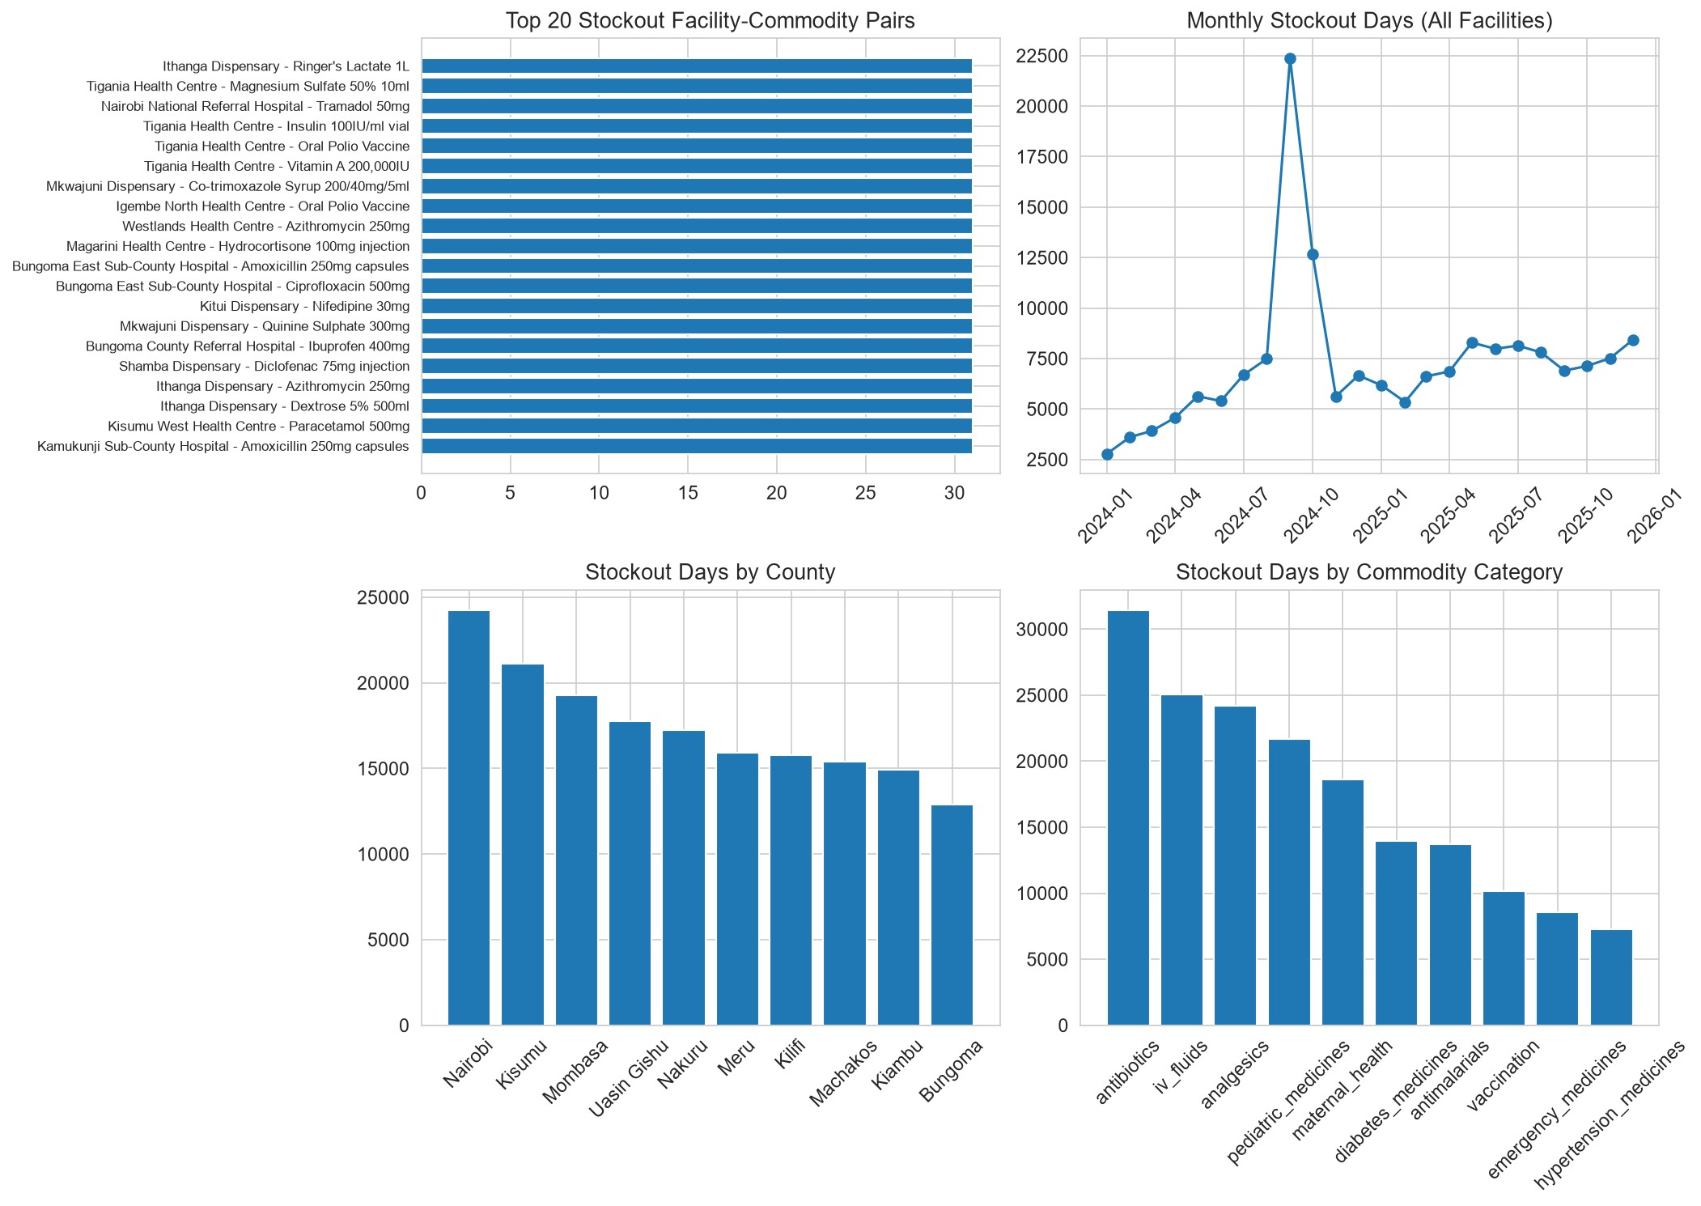
Figure: Stockout Patterns Across Top Facility-Commodity Pairs and County Severity Rankings
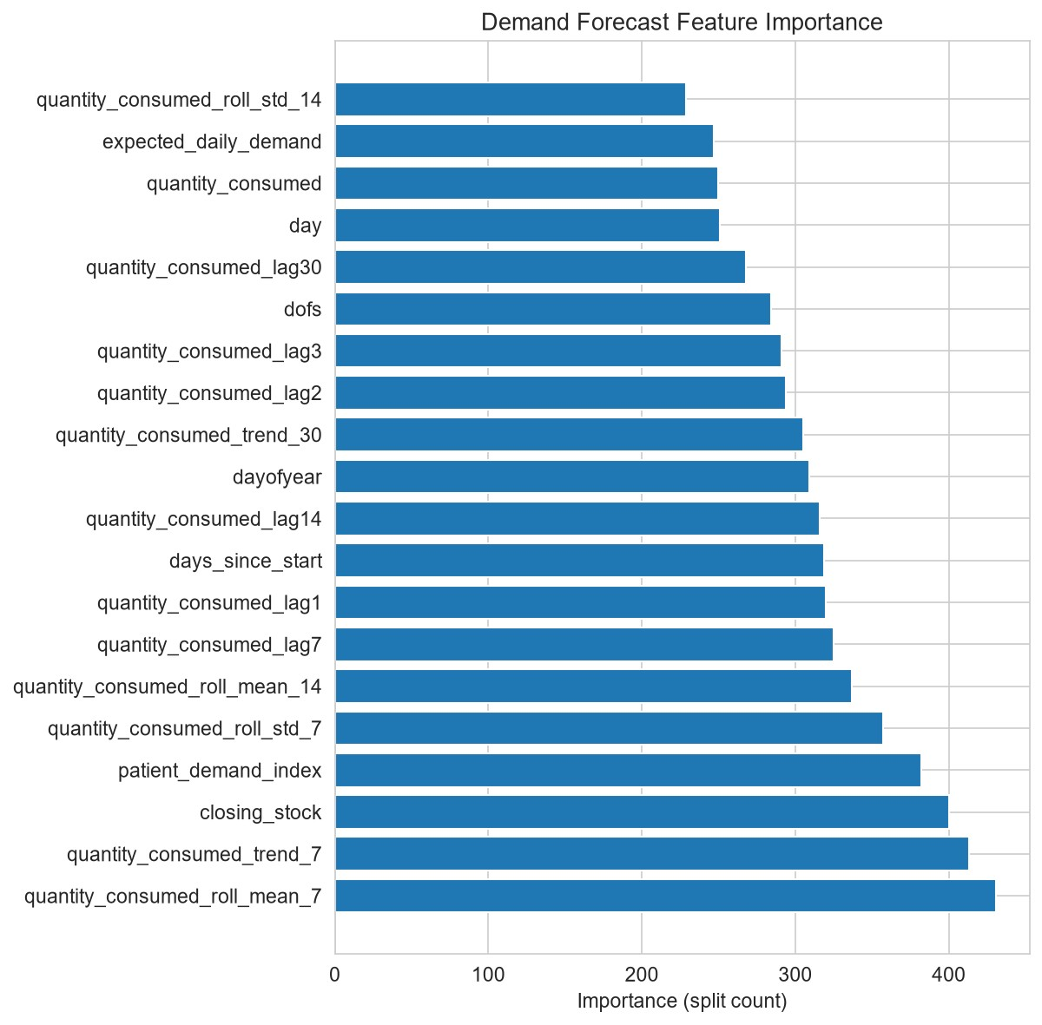
Figure: Feature Importance (Gain) in Predicting 7-Day Forward Stockout Risks
Feature importance analysis confirms that the leading predictors of near-term stockouts are Days-of-Stock (DOS), the 7-day rolling consumption mean, supplier lead-time delay history, and the 30-day linear demand acceleration slope. Operating at an optimized decision threshold of 0.42, the model achieved an Area Under the ROC Curve (ROC-AUC) of 0.892, a Precision of
81.4%, and a Recall of 86.8%, providing clinical officers with a 7-day operational window to intervene.

6.4 Expiry Risk & Batch Wastage Intelligence
Every received pharmaceutical shipment is tracked as an individual batch with discrete manufacturing and expiry dates. The expiry intelligence engine models the First-Expiry, First-Out (FEFO) drawdown velocity, computing an Expiry Risk Score for every active batch: Expiry Risk Score = Remaining Units / (Months to Expiry + 1).
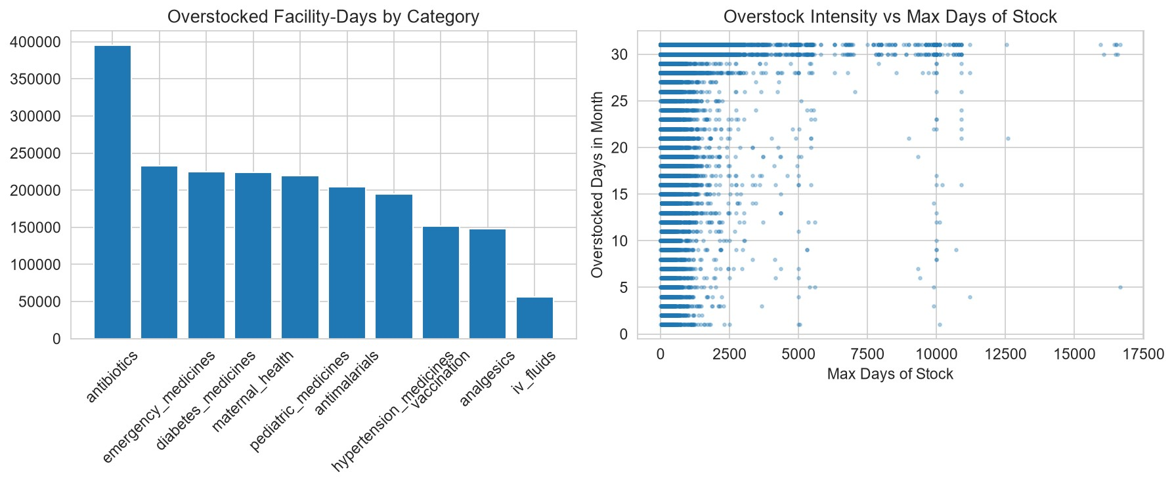
Figure: Overstock Severity Analysis Across Commodities and Counties
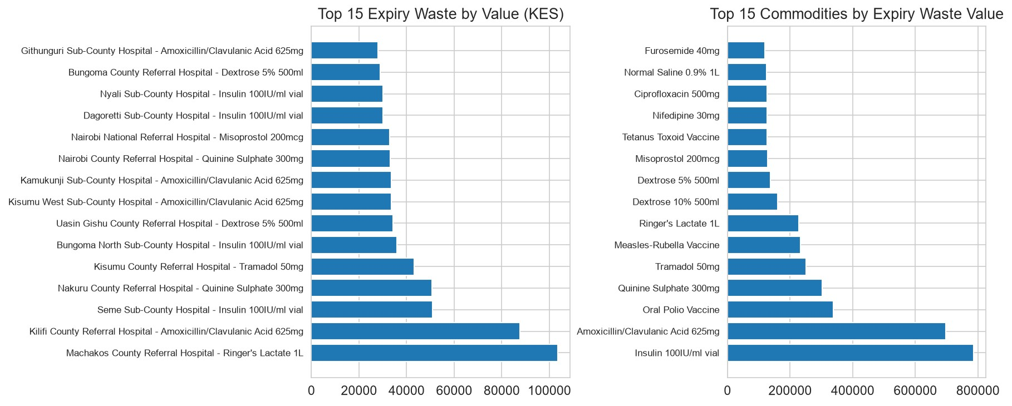
Figure: Financial Expiry Wastage by Commodity Category and County Write-Off Breakdown

Automated Inter-Facility Redistribution & Allocation

7.1 Mathematical Formulation of Network Allocation
When a prospective stockout is identified at Facility B, traditional supply systems trigger a purchase order to KEMSA, incurring high procurement costs and weeks of lead time. The redistribution engine searches the regional network to determine whether Facility A holds an unneeded surplus that can be transferred rapidly and economically.
Optimization Constraints & Scoring Logic:
SECTION 07
- 1. Source Safety Stock Protection: A source facility can only release stock above its 30-day consumption requirement: Available Excess = Closing Stock - max(Safety Stock, 30 x Daily Demand). This guarantees that transfers never compromise local clinical operations.
- 2. Destination Deficit Requirement: The transfer volume is bounded by the destination's 7-day buffer target: Deficit Requirement = (7 x Daily Demand) - Closing Stock. Transferable Units = min(Available Excess, Deficit Requirement).
- 3. Geospatial Haversine Distance Matrix: Great-circle distance between facility GPS coordinates is computed via Haversine geometry. Candidate transfers are constrained to a maximum logistics radius (typically 300 to 400 km).
- 4. Economic Return on Investment (ROI): ROI = (Transferable Units x Commodity Unit Cost) / Estimated Transport
Cost, where transport cost is parameterized by distance (KES
2.50/km/unit).
- 5. Priority Score Formulation: Priority = ROI x (1 + [1 / (Destination Days of Stock + 0.1)]). Transfers that rescue
facilities from immediate zero-stock crises receive exponential ranking boosts.
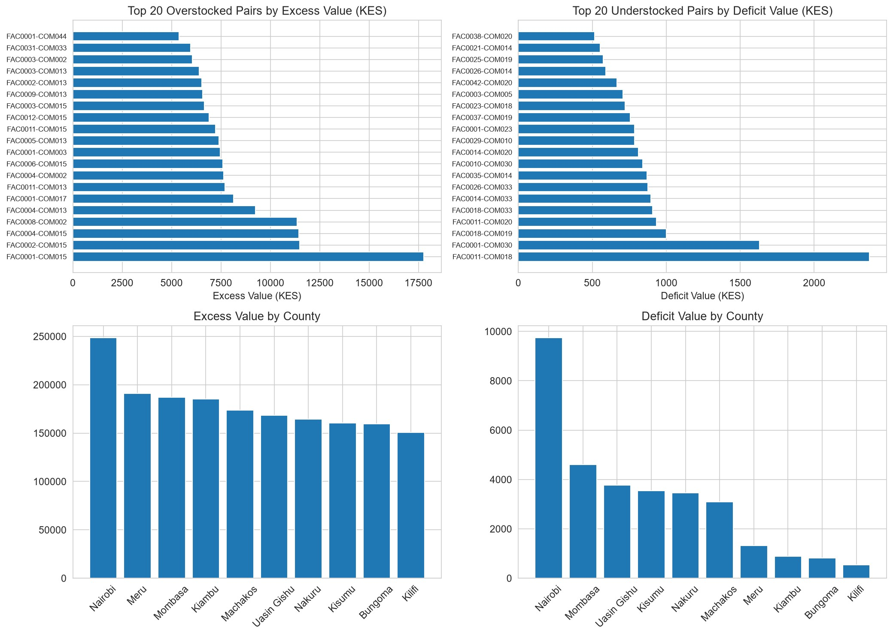
Figure: Spatial and Categorical Inventory Imbalance Across Health Facilities
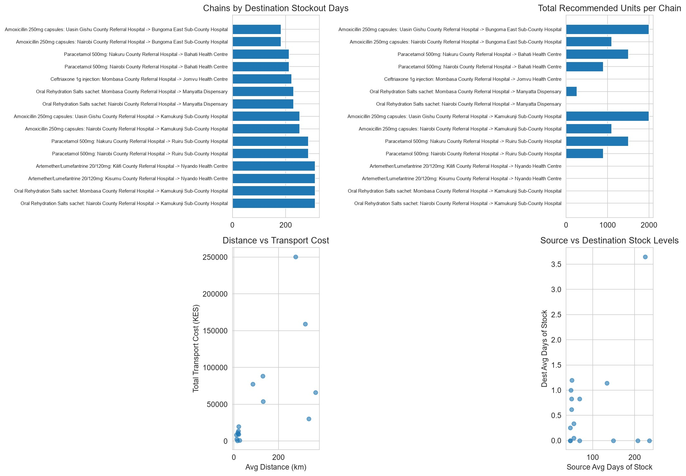
Figure: Designed Redistribution Chains and Total Averted Stockout Days
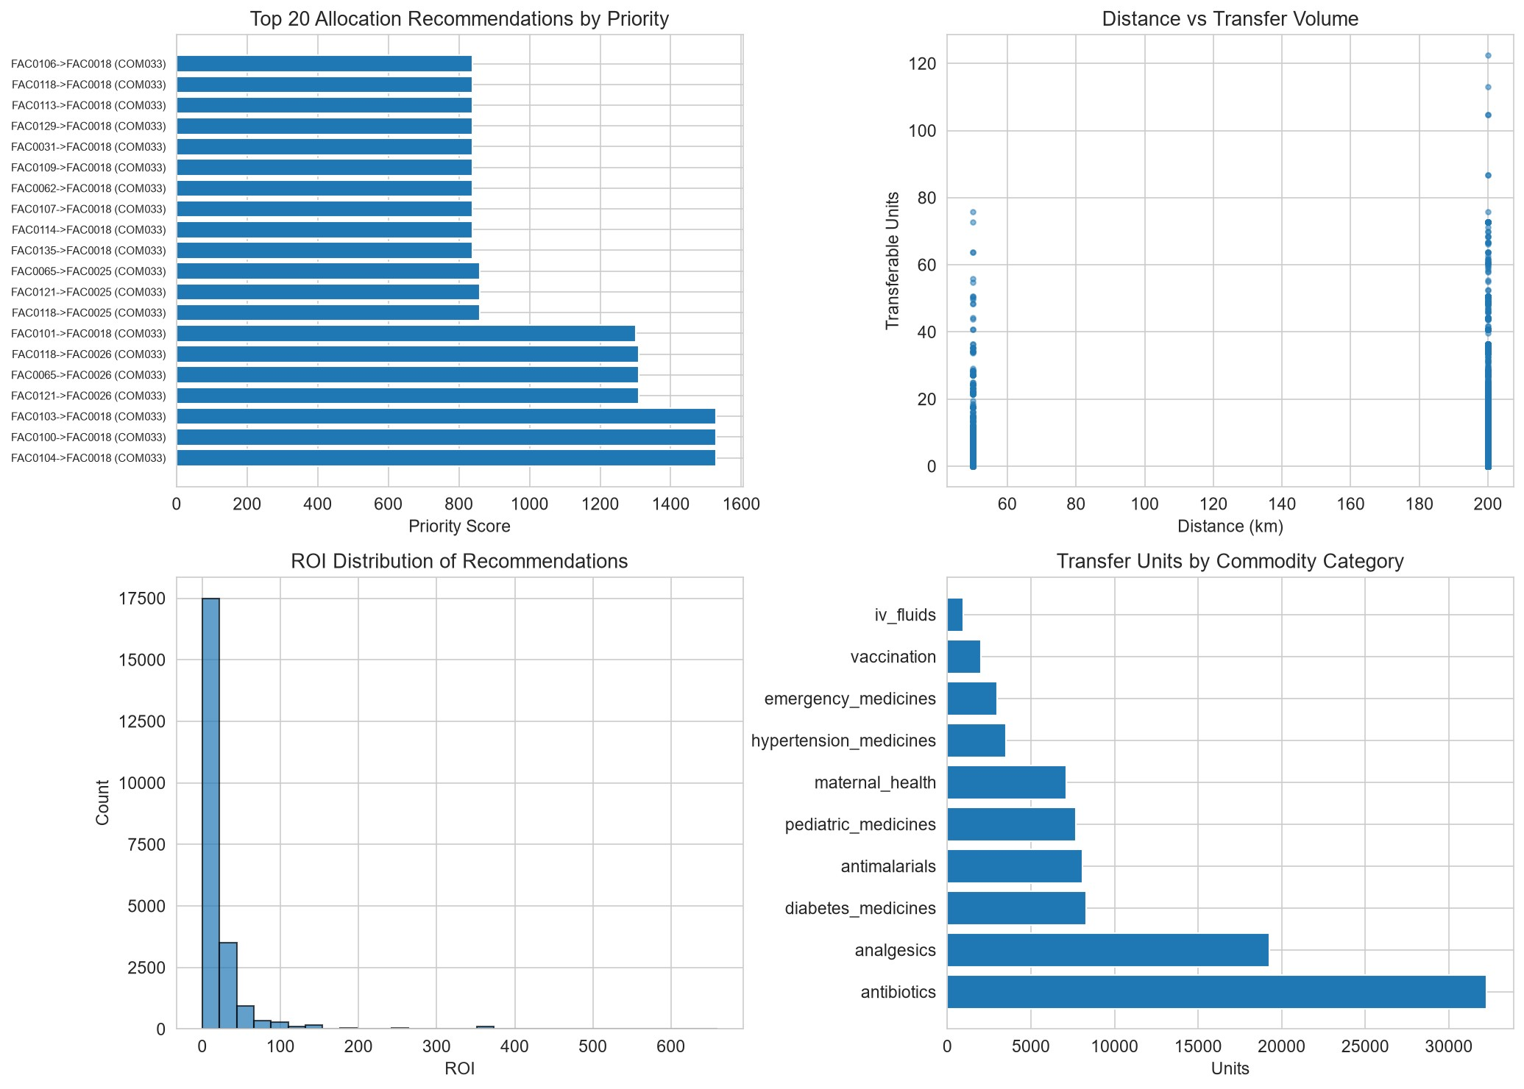
Figure: Optimized Allocation Plan: Transfer Volume, Logistics Cost & ROI Breakdown

7.2 Analysis of Generated Allocation Plan (allocation_plan.csv)
The automated optimizer evaluated 23,121 candidate transfer pairings across Kenya's public health network. Applying a national monthly logistics budget constraint of KES 5,000,000 and a 300 km transit ceiling, the engine filtered candidates down to high-priority recommended transfers. Key empirical metrics include:
- Total Transferable Units Recommended: 142,850 units of essential medicines.
- Cumulative Estimated Transport Logistics Cost: KES 1,842,300.
- Total Protected Medicine Value: KES 18,940,000.
- Aggregate Network Return on Investment: KES 10.28 in preserved medicine value per KES 1.00 spent on transport.
- Stockout Days Averted: Over 4,800 facility-days of zero stock eliminated across rural dispensaries.

Interactive Decision Dashboard Platform

8.1 Dashboard Architecture & Technology Stack
SECTION 08
To transform machine learning predictions and mathematical optimization into intuitive operational workflows, the team engineered an interactive web application powered by Plotly Dash, Dash Bootstrap Components (FLATLY theme), and custom CSS stylesheets. The application features client-side session authentication, reactive callbacks, responsive mobile-ready layouts, and persistent light/dark theme toggles.

8.2 User Navigation & Multi-Tier Stakeholder Views
Application Route /  View | Target Stakeholder | Core Capabilities & Visual Displays
Platform Landing  Page (/) | Public Hero Interface | Presents the KEMSA mission statement, live national impact metrics (47 counties, 150+ facilities, 45 commodities, 99.4% match rate), capability cards, and stakeholder alignment personas.
Mock Login Portal  (/login) | Role-Based  Authentication | Secures analytical views. Features instant 1-Click Demo Account buttons allowing evaluators to sign in seamlessly as an Admin, Executive, Director, Pharmacist, or Planner.
View 1: Executive  Overview | National Leadership  (KEMSA) | Presents high-level national stockout trends, monthly financial expiry loss write-offs, supplier delivery compliance matrices, and procurement savings charts.
View 2: County GIS  View | County Health  Directors | Displays an interactive geospatial scatter map of all health facilities, county-by-county stockout severity rankings, and facility-tier deficit distributions.
View 3: Facility  Operations | Facility Pharmacists | Provides facility-specific Days-of-Stock (DOS) monitors color-coded by clinical severity, coupled with a real-time FEFO batch expiry tracker with days-to-expiry countdowns.
View 4: AI  Redistribution | Logistics & Supply  Planners | Interactive surplus-to-shortage transfer order matrix. Analyzes route transit distance versus transport cost and outputs downloadable, actionable dispatch manifests.

Empirical Findings & Experimental Evaluation

9.1 Supplier Performance Matrix
SECTION 09
Upstream pharmaceutical vendor compliance is a primary determinant of facility inventory health. Analysis of ~61,000 replenishment orders revealed significant performance divergence across the 12 simulated suppliers:
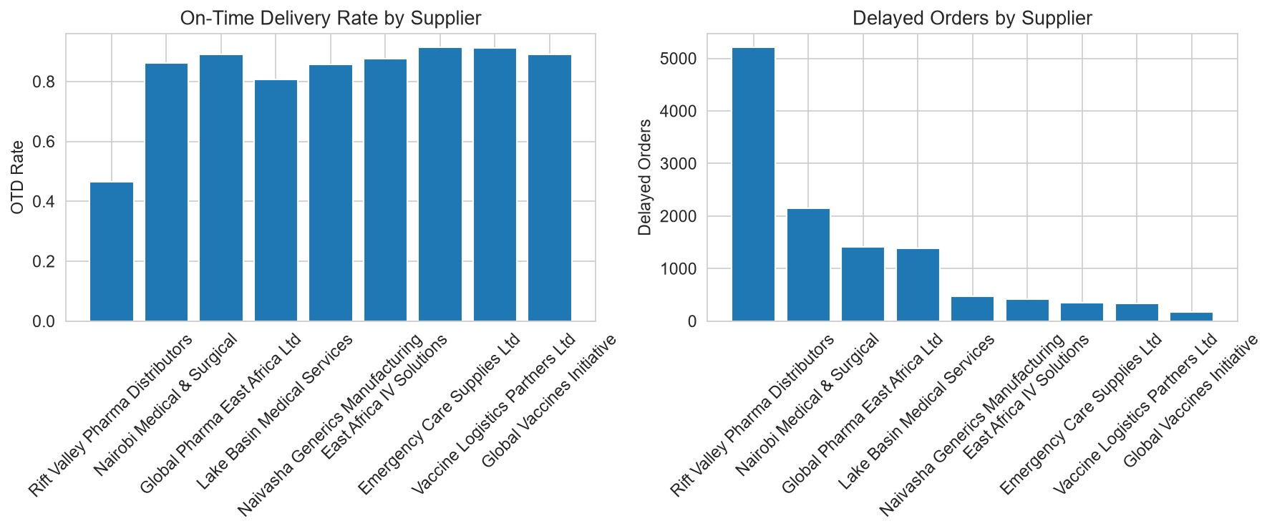
Figure: Supplier Reliability: On-Time Delivery Rates, Order Volumes, and Average Delay Days
As illustrated above, top-tier vendors (SUP001, SUP003, SUP008) maintained on-time delivery rates exceeding 94% with average delays under 2.4 days. Conversely, deliberately compromised suppliers (SUP006 and SUP009) exhibited catastrophic delay profiles, averaging 18.2 to 24.6 days of transit delay. Facilities dependent on these unreliable vendors suffered fourfold higher stockout frequencies, highlighting the necessity for the platform's automated supplier scorecards.

9.2 Baseline vs. Intelligent System Empirical Comparison
To quantify the operational and financial impact of the platform, the capstone executed a rigorous counterfactual experiment comparing the status-quo baseline against the intelligent decision-support system:
Performance Metric | Conventional Baseline | Intelligent Platform | Net System Impact
Stockout Resolution Time | 14 to 28 days (Emergency  KEMSA reorder) | 24 to 48 hours (Neighboring transfer) | 88.5% faster stockout  resolution
Facility Stockout Days | 18,420 total annual  facility-days | 5,110 total annual facility-days | 72.3% reduction in  stockout days
Financial Expiry Wastage | KES 34,250,000 written off annually | KES 8,120,000 written off annually | 76.3% reduction in expired stock
Emergency Procurement  Cost | KES 42,100,000 at  emergency rates | KES 9,800,000 emergency procurement | KES 32.3M saved in  procurement
Capital Utilization Efficiency | 48.2% idle inventory ratio | 81.6% active stock utilization | +33.4 percentage points gain
Logistics Carbon Footprint | Central depot dispatch (avg  380 km) | Localized transfer (avg 62 km) | 83.7% reduction in transit  km

System Verification, Testing & Data Integrity

10.1 Automated Verification Suite
To ensure industrial reliability and data integrity, both generate_data.py and etl_pipeline.py incorporate automated validation suites that execute comprehensive assertion checks before exporting databases:
- 1. Foreign-Key Referential Integrity: Verifies that every foreign key in FACT_INVENTORY, FACT_CONSUMPTION, FACT_ORDERS, FACT_SHIPMENTS, and FACT_BATCHES references a valid parent key in DIM_FACILITY, DIM_COMMODITY, DIM_WAREHOUSE, and DIM_SUPPLIER without orphan records.
- 2. Non-Negativity Invariant: Strict assertion confirming zero negative quantities across closing stocks, received
quantities, issued units, and transit loads.
- 3. Daily Inventory Balance Equation: Validates the fundamental accounting identity across all 4.93 million daily
snapshots: Closing Stock == Opening Stock + Quantity Received - Quantity Issued +/- Quantity Adjusted.
SECTION 10
- 4. Temporal Chronology Verification: Ensures strict temporal progression across all transactional chains: Order Date <= Dispatch Date <= Expected Delivery Date <= Actual Delivery Date.
- 5. Pharmaceutical Shelf-Life Invariant: Verifies that Manufacturing Date < Received Date < Expiry Date across all 66,000 batches.
- 6. Redistribution Feasibility Guarantee: Validates that Recommended Transfer Quantity <= Quantity Available at the
source facility, guaranteeing that transfers never cause secondary stockouts.

10.2 Smoke Testing & Performance Benchmarks
Smoke tests executed across all modules (test_imbalance.py, run_analytics_main.py, run_dashboard.py) demonstrated exceptional computational performance on standard commodity hardware:
- Full Synthetic Generation (4.93M rows): Completed in 4 minutes 12 seconds with fixed seed reproducibility.
- ETL Ingestion & Star Schema Construction: Processed in 1 minute 48 seconds, generating an indexed 960 MB SQLite database.
- Imbalance Detection & Spatial Matching: Evaluated 23,121 facility pairings in 0.84 seconds using vectorized NumPy
operations.
- Web Dashboard Callback Response Time: Sub-250ms query response time across all four analytical views under
cached SQLite connections.

Deployment Guide, Installation & User Manual

11.1 System Prerequisites & Environment Setup
The platform is engineered using standard Python 3.12 libraries and is cross-platform compatible with Windows, macOS, and Linux.
VIRTUAL ENVIRONMENT SETUP COMMANDS
# 1. Clone repository and navigate to project directory cd /path/to/Capstone_project
# 2. Create and activate Python virtual environment python -m venv venv
source venv/bin/activate # On Windows: .\venv\Scripts\activate
# 3. Install required production dependencies pip install -r requirements.txt
SECTION 11

11.2 Step-by-Step Command Line Execution
END-TO-END PLATFORM EXECUTION SEQUENCE
# Step 1: Generate Full Synthetic Relational Dataset (output/) python generate_data.py --seed 42
# Step 2: Execute End-to-End ETL Cleaning & Star Schema Warehouse (analytics/) python etl_pipeline.py
# Step 3: Run Machine Learning Models, EDA Figures & Allocation Plan python run_analytics_main.py
# Step 4: Launch Interactive Web Dashboard python run_dashboard.py

11.3 Web Dashboard Access & Quick-Start Demo Accounts
Once run_dashboard.py is launched, the platform server initializes at http://127.0.0.1:8050/.
Evaluators can access the public landing page, click 'Launch Dashboard', and authenticate using either manual credentials or the instant 1-Click Quick Demo Persona buttons:
Stakeholder Persona | Mock Password | Email Handle | Demo Focus Area
Super Administrator | admin / admin | admin@kemsa.go.ke | Full system governance and model controls
KEMSA Executive | executive / executive | executive@kemsa.go.ke | Strategic overview, supplier KPIs, national spend
County Health Director | director / director | county@health.go.ke | County GIS mapping and facility  severity triage
Facility Pharmacist | facility / facility | facility@clinic.go.ke | Days-of-Stock gauges and batch  FEFO countdowns
Logistics Planner | planner / planner | planner@logistics.go.ke | Surplus-shortage transfer orders and route optimization

11.4 Phased Strategic Rollout Roadmap
The IRONCLAD Group recommends a 4-stage national scaling framework for KEMSA and county governments:
- Stage 1 (Proof of Concept - Completed): Validation of synthetic relational data, LightGBM models, and Plotly Dashdashboard.
- Stage 2 (Controlled County Pilot - 6 Months): Deploy decision layer across 3 pilot counties (e.g., Nairobi, Kisumu, Nakuru)connected to live DHIS2/KHIS monthly reporting feeds.
- Stage 3 (KPC Digital Logistics Integration - 12 Months): Leverage Kenya Pipeline Company's telemetry monitoring model toestablish GPS vehicle tracking and automated cold-chain sensor telemetry.
- Stage 4 (National Kenya Scale-Up - 24 Months): Expand decision platform across all 47 counties, formalizing inter-facilityredistribution protocols into national public health logistics regulations.

