
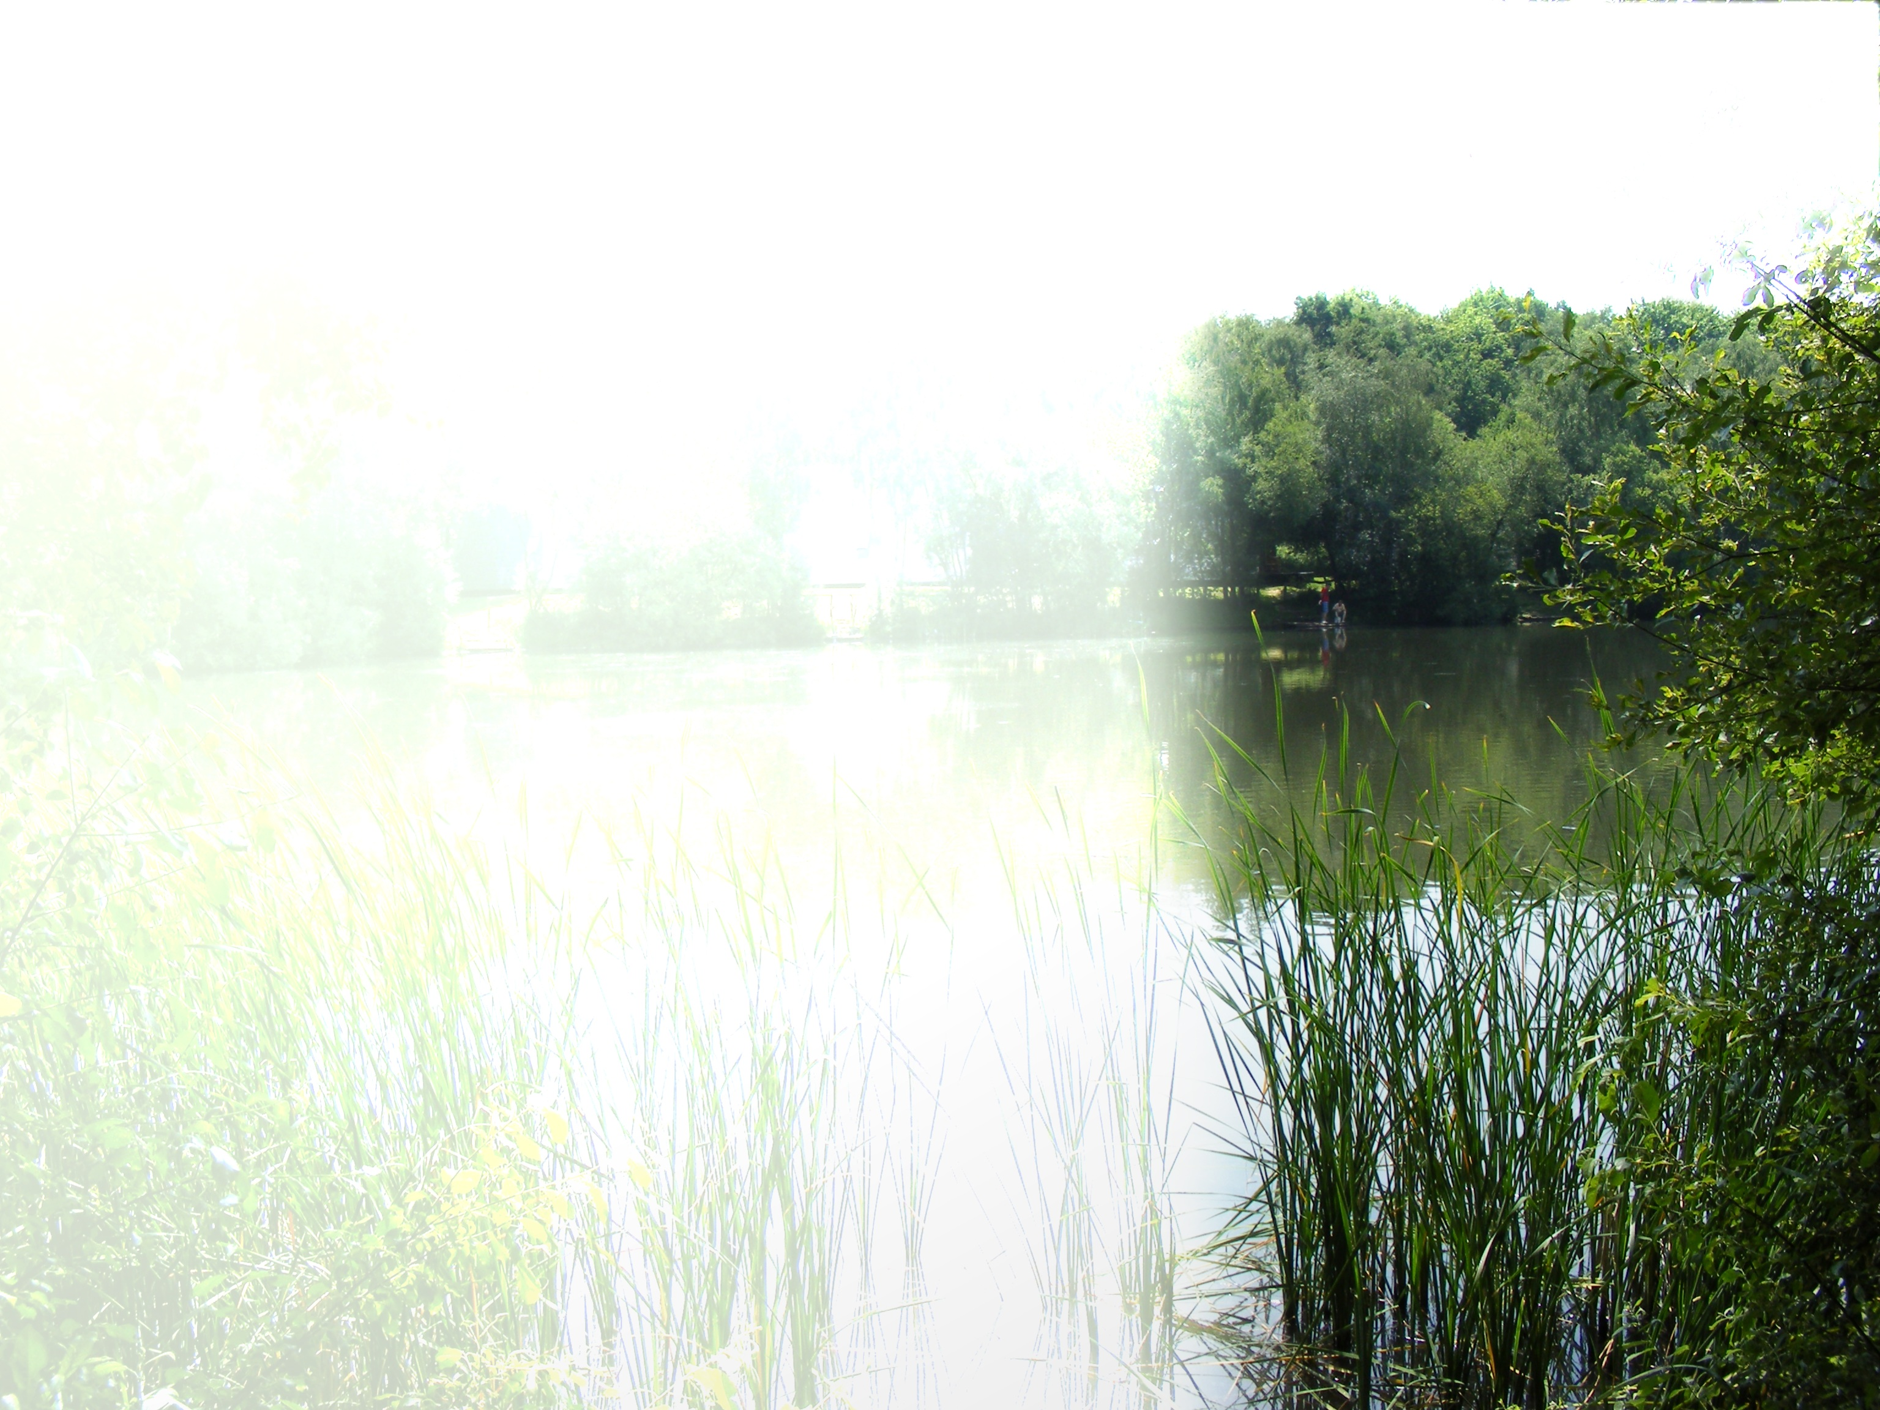
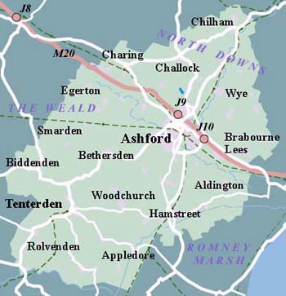
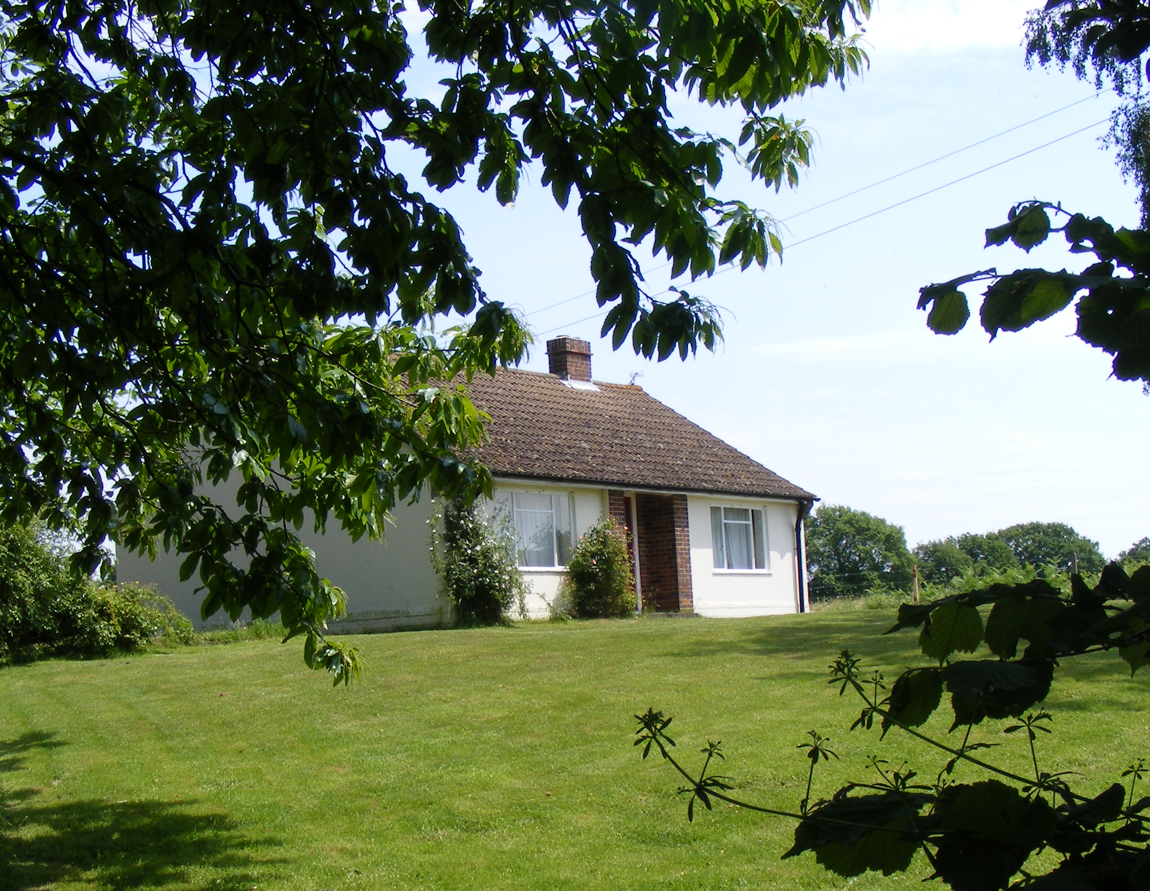
Contact us

At Ashby Farms, it's our priority to make your holiday as easy and enjoyable as possible.

Website: www.ashbyfarms.com
Email: info@ashbyfarms.com
Phone: 01233 733332
Address: Ashby Farms Ltd
Kenardington
Ashford
Kent, TN26 2LZ
At Ashby Farms we have been providing quality self-catering accommodation for over 25 years. We offer country cottages and detached pine lodges set in bluebell woods overlooking 4 acres of water with a panoramic view of fields, woods and nearby unspoilt village. We are flexible and tailor your stay to your needs: form a relaxing weekend break to long lets (ideal for those in the process of moving homes.)

Fishing is available year-round in our two beautiful lakes which contain Bream, Gudgeon, Roach, Rudd, Tench(up to 5lb.), Common and Mirror Carp (up to 31lb.), Perch (up to 5 3/4 lb). Rough Shooting (Rabbits, Pigeons, etc.) is also available on our farmland.

Ashford, with it's fast train line to London and Eurostar service is less than 10 miles away. In the surrounding area there is lots to see and do: the unspoilt beaches of Camber Sands are nearby as are many charming and historic towns such as Tenterden and Rye which offer many excellent restaurants and traditional pubs. The Rare Breeds Centre and Port Lympe Animal Park are within easy reach and well worth a visit, particularly for those with children to entertain.
Ashby Farms Holiday Cottages

Self catering accommodation in the British countryside
Roughlands
A country bungalow with its own large garden, set well back from the quiet country road between Appledore and Woodchurch with Roughlands Wood and our fishing lakes in the woods on the North side and open fields on the others.

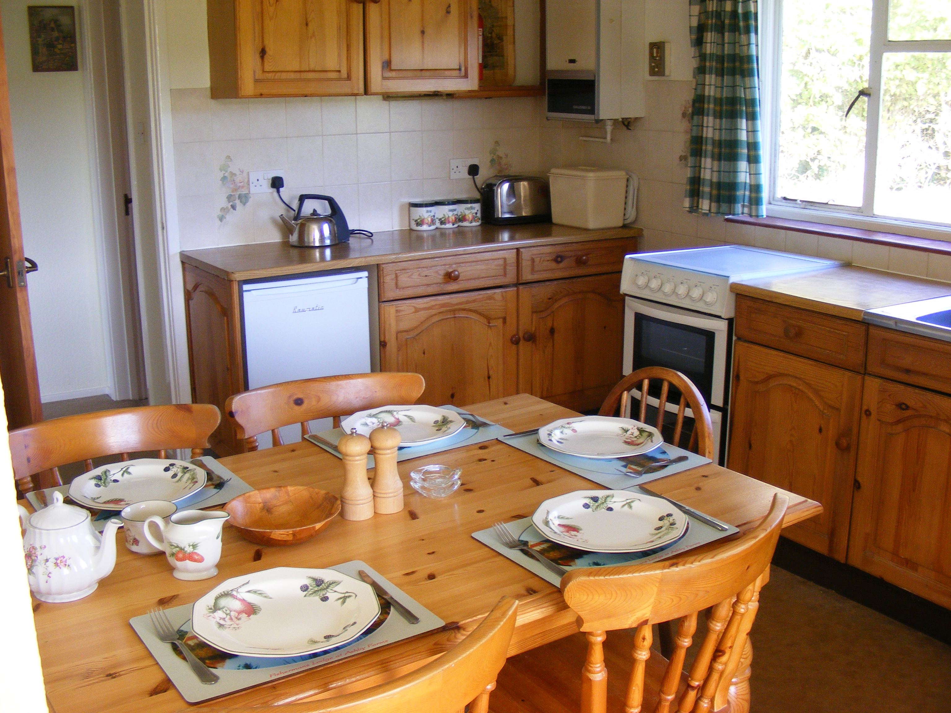
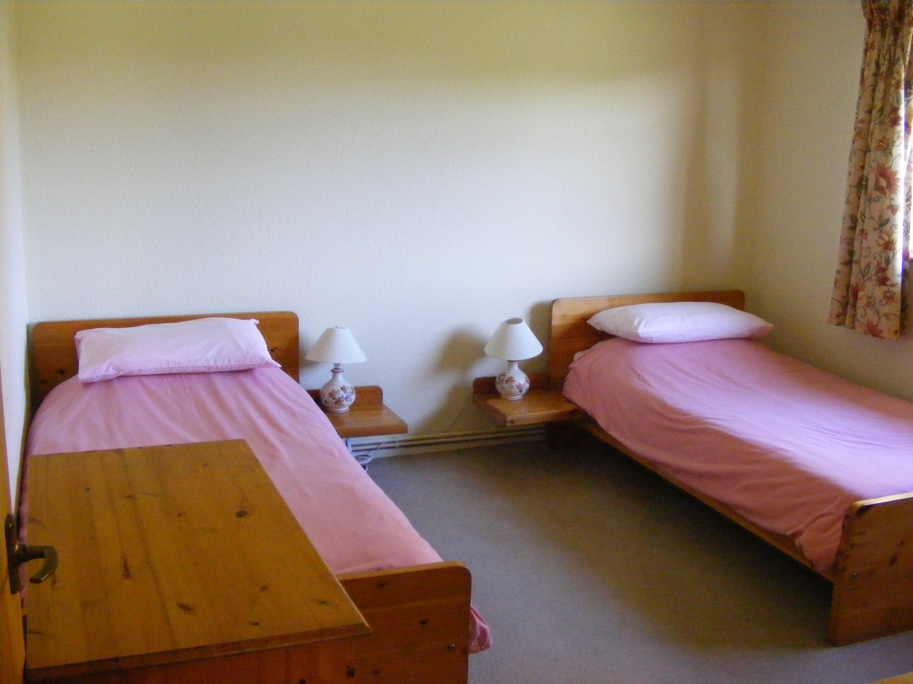
* Accommodates 5 people
* Fully equipped kitchen/diner
* Two bedrooms: one with a double & single bed and one twin
* Detached with large garden
* Off road Car parking

Fisherman's Lodges
Eight detached pine lodges beautifully situated by the water's edge, with a view across the water to the village of Woodchurch a mile or so away.

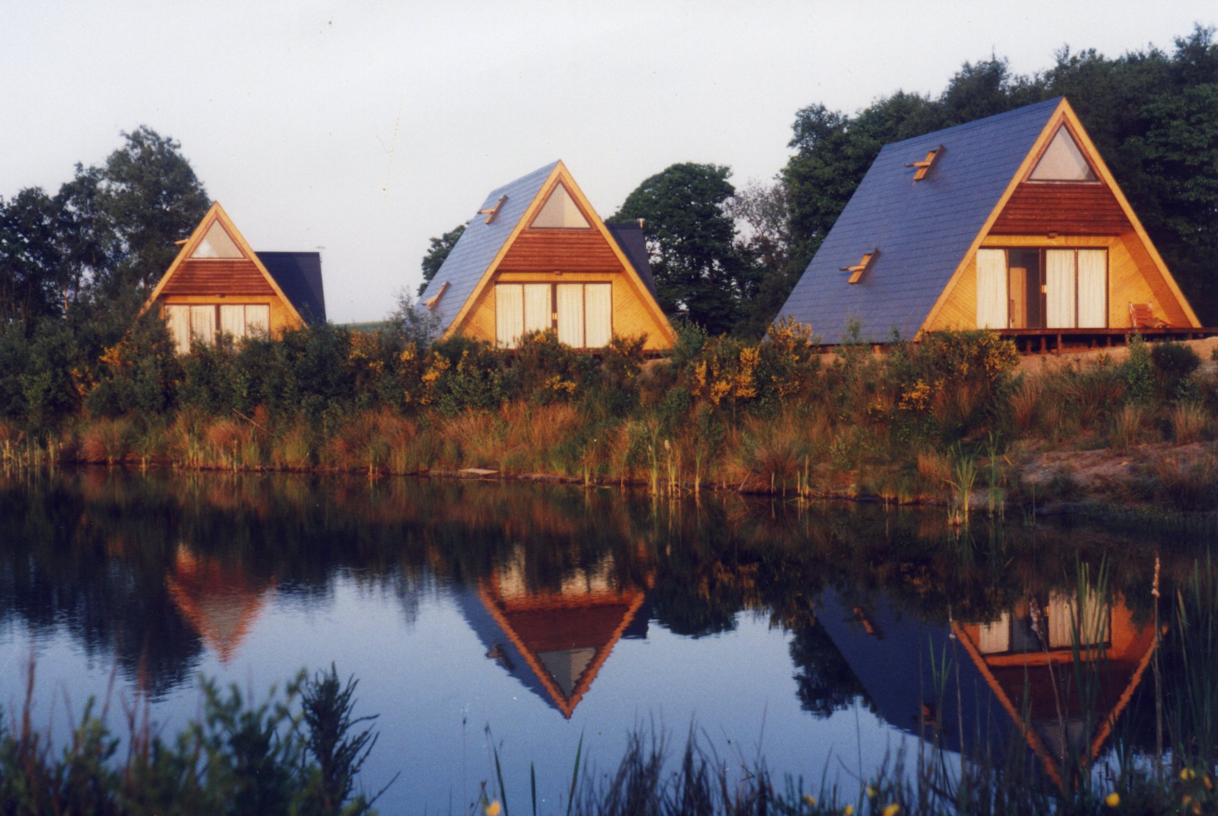
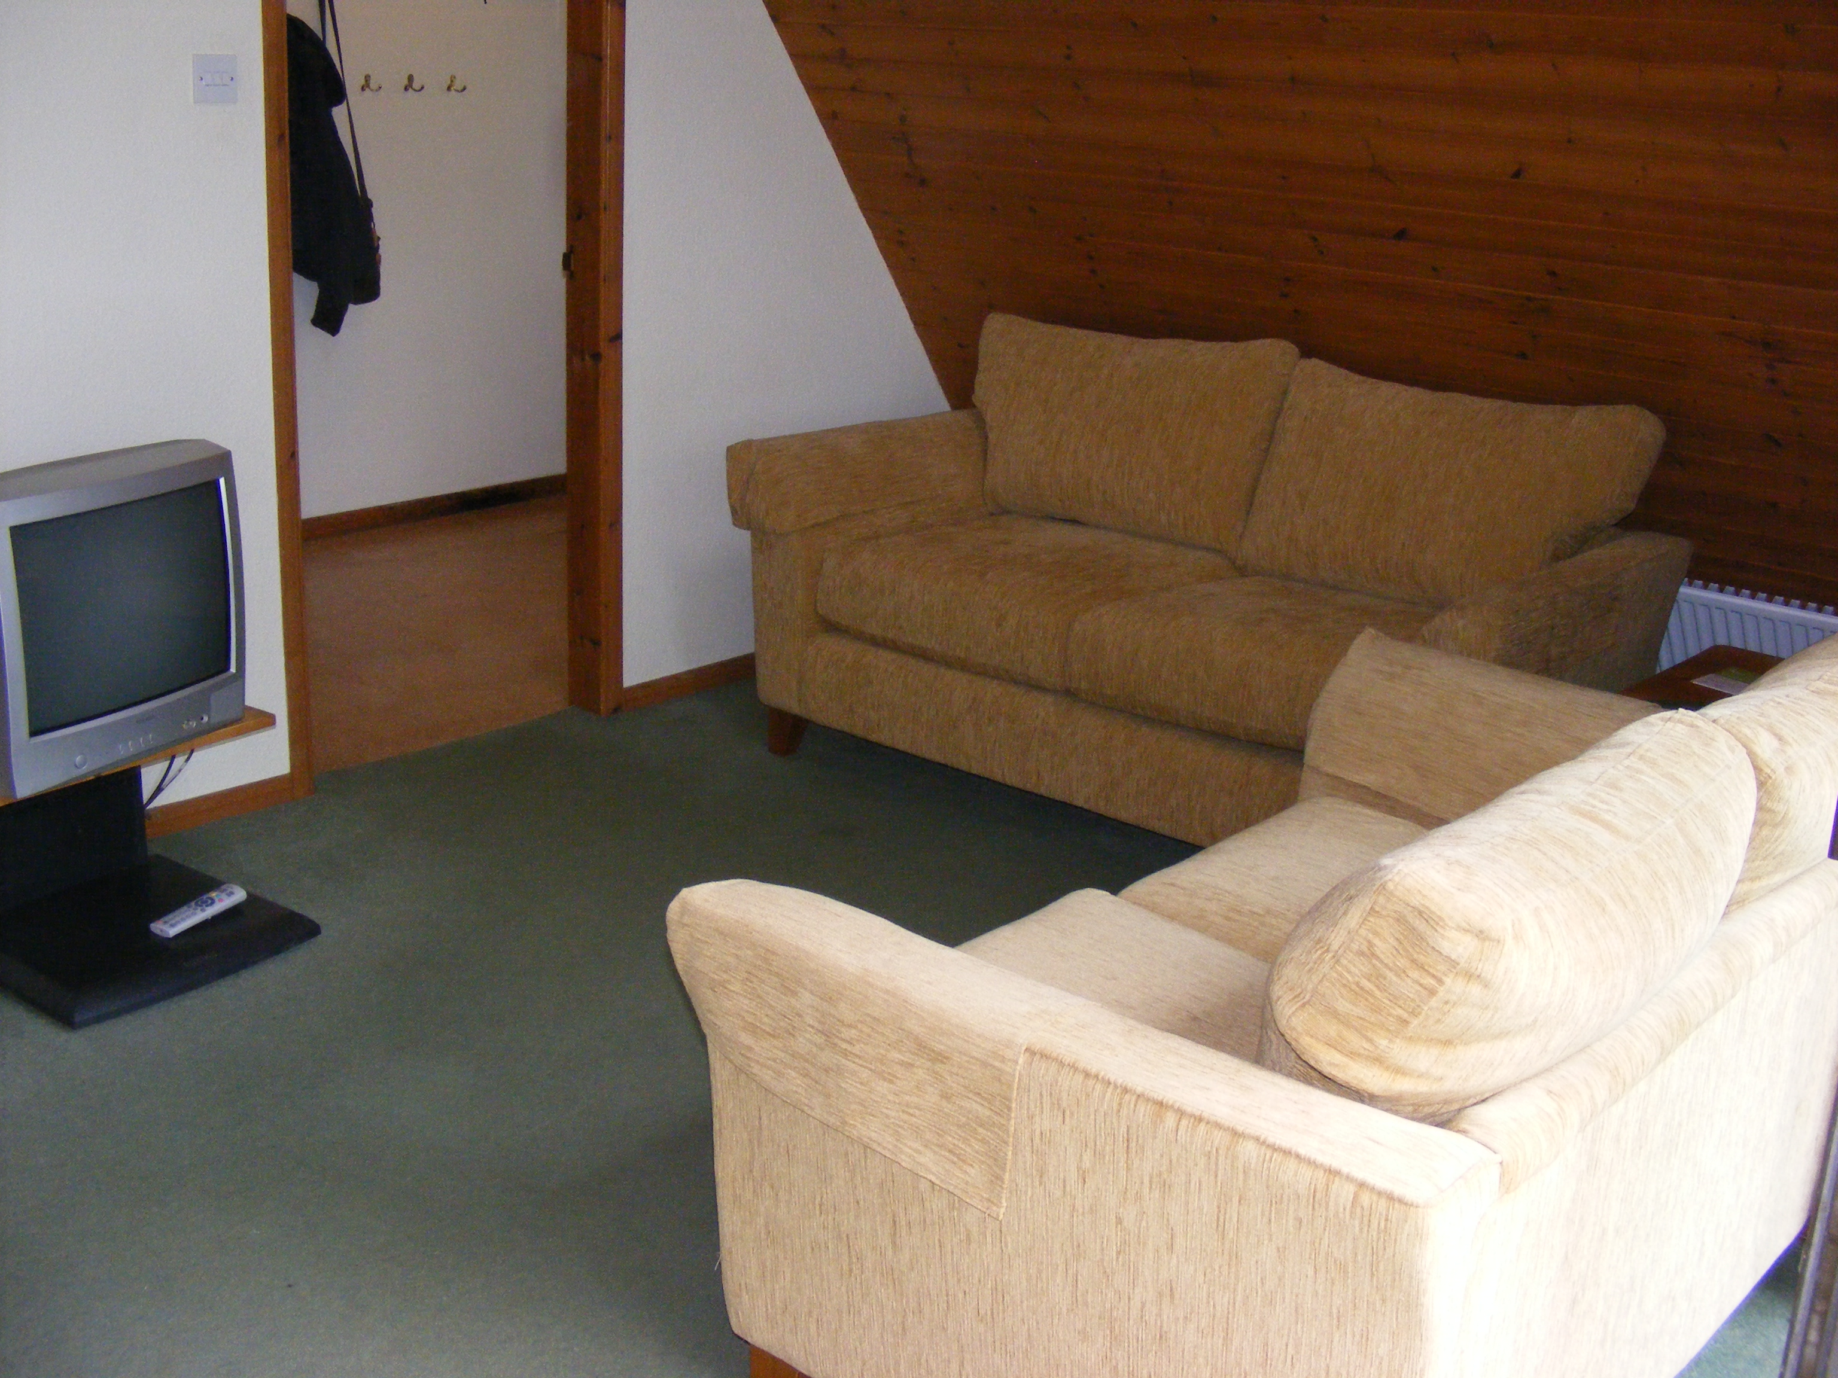
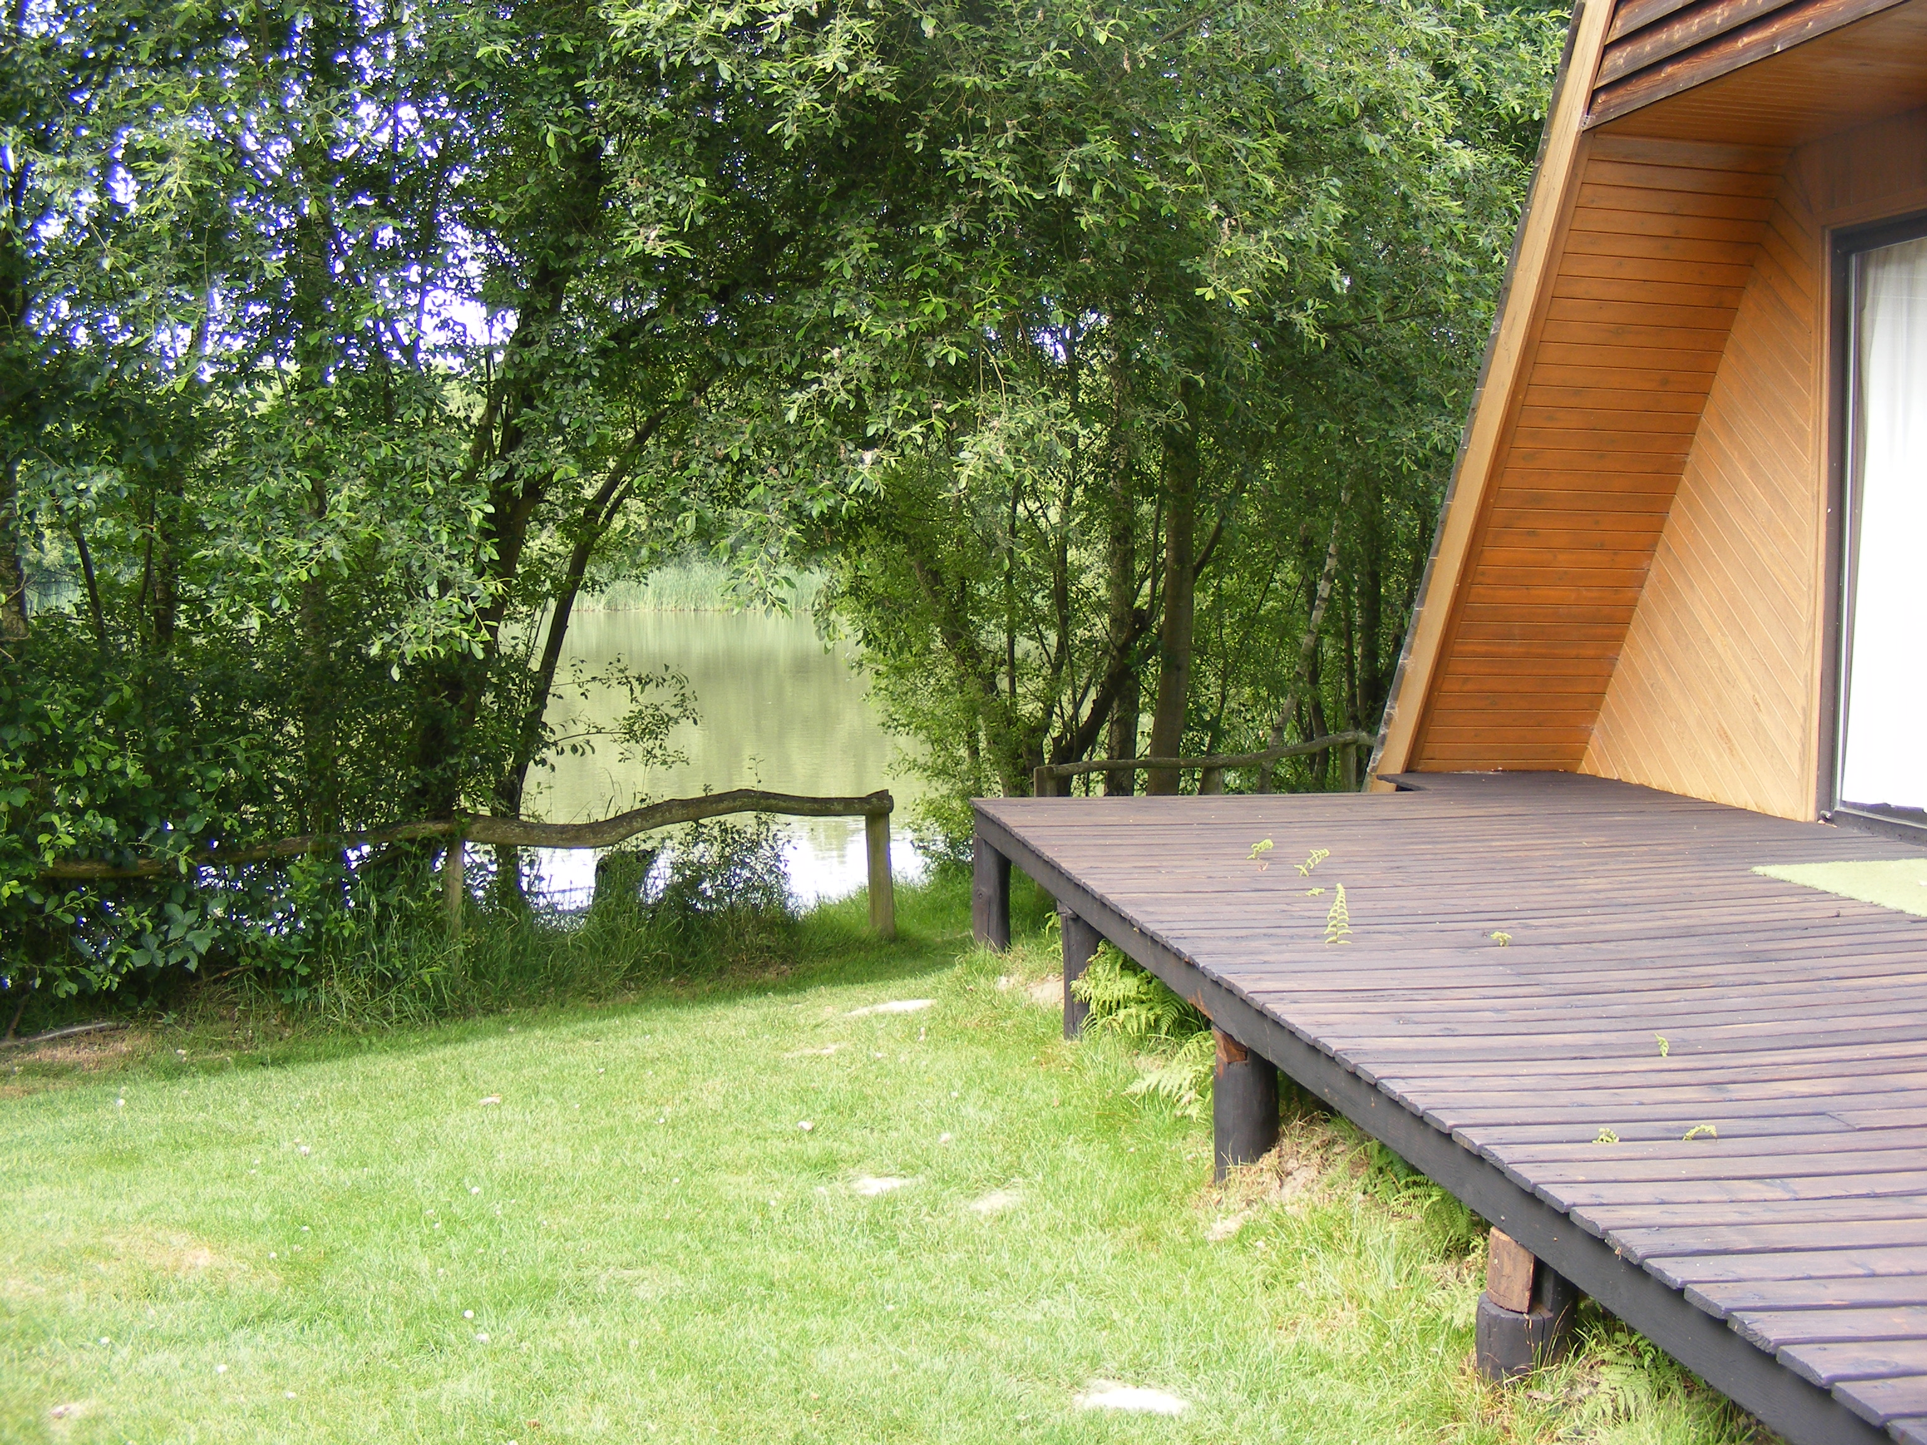
* Accommodates 6 people
* Attractive living/dining area
* Lakeside terrace sun deck
* Fully equipped pine kitchen
* One double bedroom
* Two twin bedrooms
* One bathroom

Spring Cottages
Three terraced Cottages with views to Kenardington Church. The large rear garden backs onto farmland.

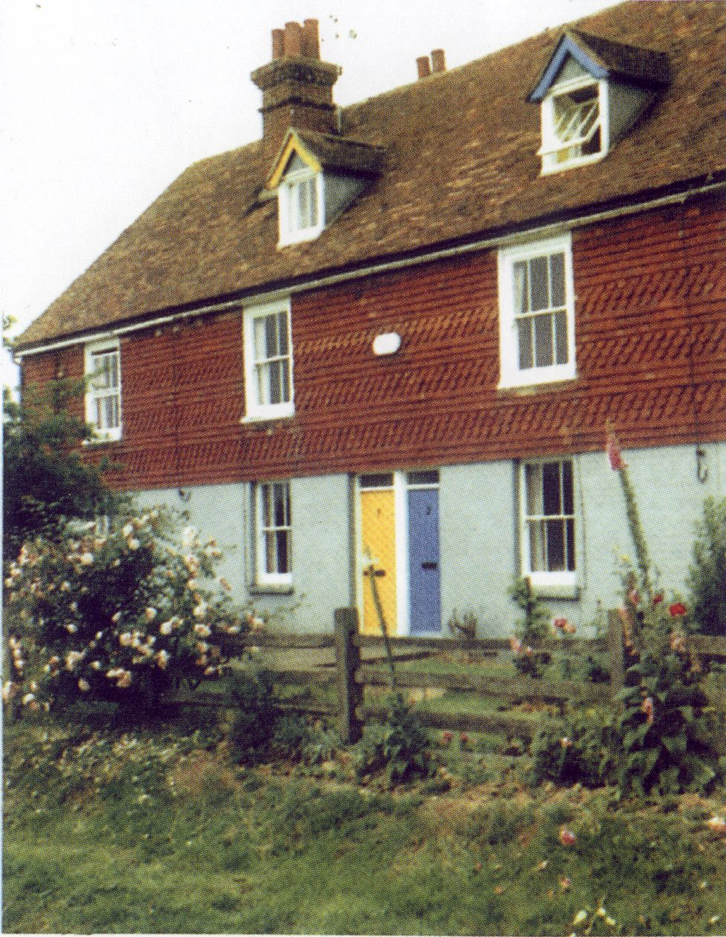
* Accommodates 5 people
* Attractive kitchen/dining area
*Fully equipped kitchen
* One double bedroom
* One twin bedroom
* One single bedroom
* Off road car parking
65 the Street
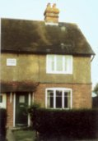
A semi-detached cottage in the centre of the picturesque village of Appledore in an area of outstanding natural beauty. The property enjoys extensive views across farmland.
* Accommodates 5 people
* Attractive kitchen/dining area
*Fully equipped kitchen
* One double bedroom
* One twin bedroom
* One single bedroom
* Off road car parking

