Briefing for C19AG: Comparison of doubling times

NOT FOR DISTRIBUTION

COVID-19 Epidemic Response Unit, University of Edinburgh

06/04/2020

# Key points summary

We compare the size and rate of increase of the COVID-19 epidemic for Scotland, London and the rest of the UK except for London (rUKxL).

**The epidemic in Scotland is ~7 days behind London and is now growing at a faster rate but may be slowing.**

Based on deaths:

* The current doubling time for deaths in Scotland is 2.9 days (95% confidence interval: 2.5 - 3.3 days) (Figure 1).
* This is not significantly different from doubling time for previous 7 days (2.4 days; 95%CI: 1.6-3.7 days).

Based on case counts per 10,000 population available as of 05/04/2020:

* The epidemic in Scotland is 6.8 days behind London and 1 days ahead of rUKxL (Figure 2, Figure 3).
* The current 7-day doubling time in Scotland is 4.9 days (95%CI: 4.7 - 5.1 days).
* This is slower than the doubling time for previous 7 days (4.0 days; 95%CI: 3.8 - 4.3 days).
* The current doubling time in Scotland is significantly faster than London (6.9 days, 95%CI: 6.8 - 7.1 days) and is not significantly different to rUKxL (5.0 days, 95%CI: 4.9 - 5.1 days) over the same time period.
* Across Health Boards in Scotland there is variation in cumulative case incidence (3.0 to 11.3 per 10,000 population, Figures 4, 5) and doubling time (3.3 to 6.0 days, Figure 6).

# Results

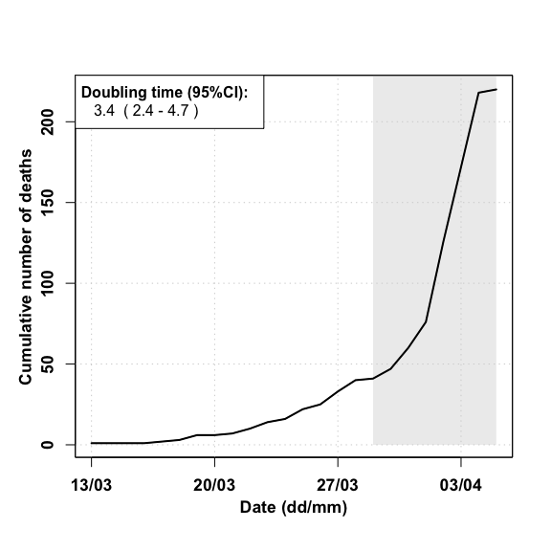 **Figure 1. Epidemic curve for Scotland based on deaths over time up to 05/04/2020.** Doubling time estimated over the past 7 days is 2.9 days (95%CI: 2.5-3.3 days).

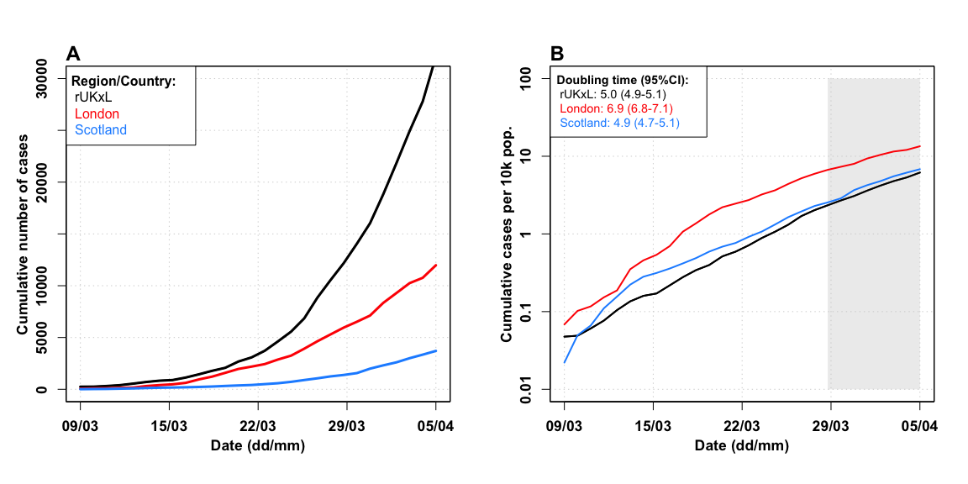

**Figure 2. Comparison of epidemic curves for Scotland, London and rUKxL up to 05/04/2020**. **A)** Cumulative reported cases. **B)** Cumulative cases per 10,000 population on a log10 scale. Inset shows corresponding doubling times (in days) over the past 7 days (with 95% confidence intervals).

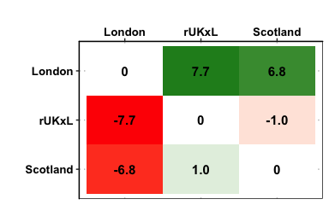

**Figure 3. Pairwise epidemic progression comparison**. The reported numbers are the numbers of days ahead (positive numbers, green) or behind (negative numbers, red) the regions in horizontal entries are relative to the regions in vertical entires.

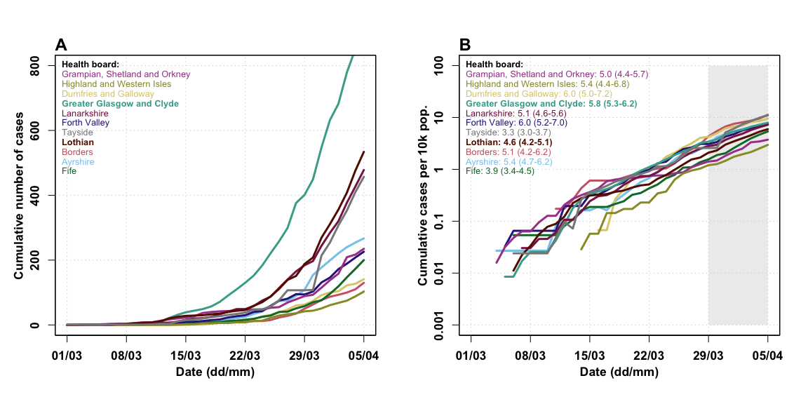

**Figure 4. Comparison of epidemic curves for all Scottish Health Boards up to 05/04/2020**. **A)** Cumulative reported cases. **B)** Cumulative cases per 10,000 population on log10 scale. Inset shows corresponding doubling times (in days) estimated over the past 7 days with 95% confidence intervals.

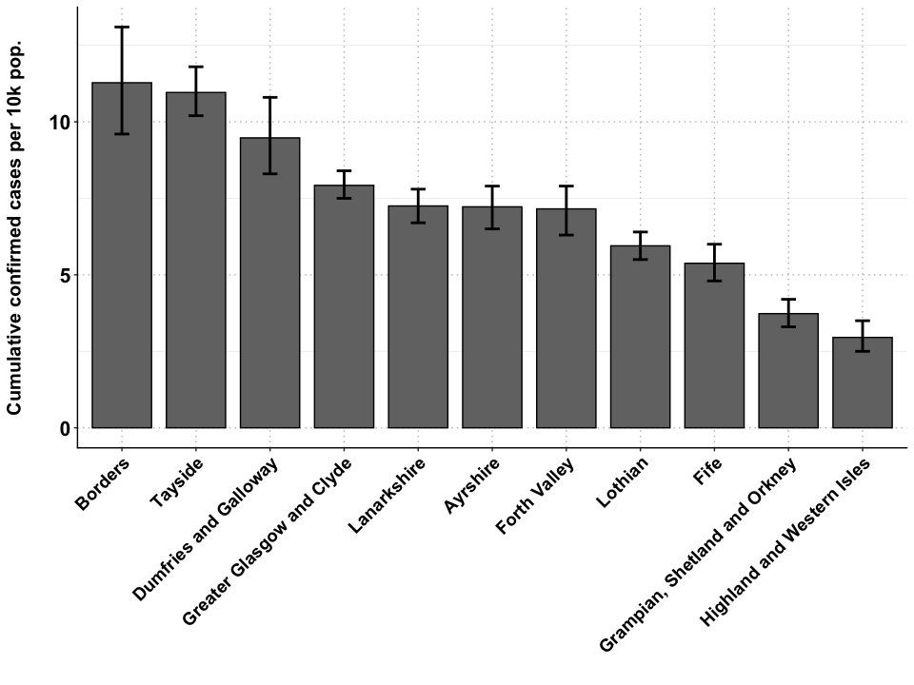

**Figure 5. Cumulative incidence for all Scottish Health Boards up to 05/04/2020**. The error bars show the 95%CI of the cumulative incidence per 10,000 population reached at last time point over the bootstrapped simulated datasets with Poisson error structure.

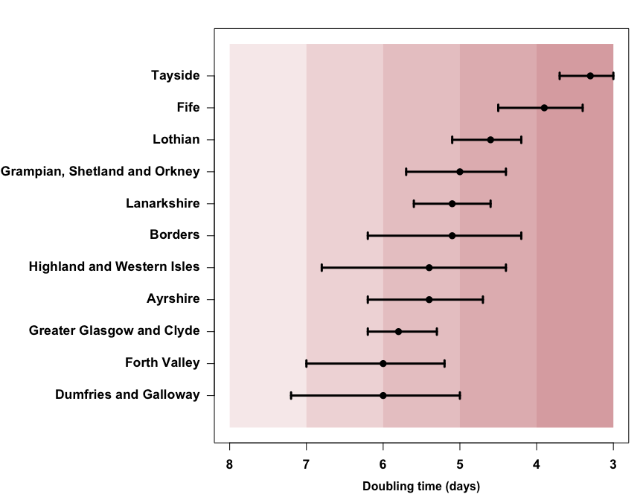

**Figure 6. Doubling time of cases**. Doubling times are calculated over a 7 day period up to 05/04/2020. Error bars indicate 95%CI.

|  |  |  |  |  |
| --- | --- | --- | --- | --- |
| Region/Health board | Measure | Doubling time | 95%CI lower | 95%CI upper |
| Scotland | death | 2.9 | 2.5 | 3.3 |
| London | cases | 6.9 | 6.8 | 7.1 |
| Scotland | cases | 4.9 | 4.7 | 5.1 |
| Rest of UK | cases | 5.0 | 4.9 | 5.1 |
| Ayrshire | cases | 5.4 | 4.7 | 6.2 |
| Borders | cases | 5.1 | 4.2 | 6.2 |
| Dumfries and Galloway | cases | 6.0 | 5.0 | 7.2 |
| Fife | cases | 3.9 | 3.4 | 4.5 |
| Forth Valley | cases | 6.0 | 5.2 | 7.0 |
| Grampian Shetland and Orkney | cases | 5.0 | 4.4 | 5.7 |
| Greater Glasgow and Clyde | cases | 5.8 | 5.3 | 6.2 |
| Highland and Western Isles | cases | 5.4 | 4.4 | 6.8 |
| Lanarkshire | cases | 5.1 | 4.6 | 5.6 |
| Lothian | cases | 4.6 | 4.2 | 5.1 |
| Tayside | cases | 3.3 | 3.0 | 3.7 |
|  |  |  |  |  |

**Table 1. Summary of all doubling times and their 95%CI reported in the above figures.**.

# Data

* Case counts for Scotland and for Scottish HBs from <https://www.gov.scot/coronavirus-covid-19/> (accessed 1400 05/04/2020).
* Case counts for London and rUK except London from <https://www.arcgis.com/apps/opsdashboard/index.html#/f94c3c90da5b4e9f9a0b19484dd4bb14> (accessed 2000 05/04/2020).
* Death count for Scotland from <https://www.gov.scot/coronavirus-covid-19/> (accessed 1400 05/04/2020).
* Population counts from the Office of National Statistics (mid-year 2018).
  + UK: <https://www.ons.gov.uk/peoplepopulationandcommunity/populationandmigration/populationestimates/datasets/populationestimatesforukenglandandwalesscotlandandnorthernireland>, Mid-2018, spreadsheet ‘MYE2-all’ (accessed 1140 26/03/20)
  + Scotland Health Board Areas: <https://statistics.gov.scot/atlas/resource?uri=http://statistics.gov.scot/id/statistical-geography/S92000003> (accessed 1200 11/03/20).

# Doubling time calculations:

Calculated over prior 7 days using method described by *E. Vynnycky & R. White (2010) An Introduction to Infectious Disease Modelling*, page 74.

Confidence intervals calculated using bootstrapping of a simulated dataset with Poisson error structure, using method published here: <https://doi.org/10.1101/2020.02.05.20020750>.

# Caveats

* Case count data are affected by any changes in testing strategy or testing effort over time and/or any variation in testing strategy or testing effort between regions.
* Case count data are likely a substantial under-representation of the true number of COVID-19 infections.
* Death data are considered more reliable but may lag behind case data by as much as 3 weeks.
* However, death data for London and rUKxL cannot be disaggregated. Nor can death data for Scottish Health Boards. Therefore more detailed analyses using death data are not currently possible.