Briefing for C19AG: Comparison of doubling times

NOT FOR DISTRIBUTION

COVID-19 Epidemic Response Unit, University of Edinburgh

09/04/2020

# Key points summary

We compare the size and rate of increase of the COVID-19 epidemic for Scotland, London and the rest of the UK except for London (rUKxL).

**The epidemic in Scotland is ~8 days behind London and is now growing at a XXXXXXX rate XXXXXX.**

**Based on deaths**:

* The current 7-day doubling time for deaths in Scotland is 3.0 days (95% confidence interval (CI): 2.7 - 3.4 days) (Figure 1).
* This is **XXXXXX** than the doubling time for previous 7 days (4.8 days; 95%CI: 3.7 - 6.5 days).

**Based on case counts** per 10,000 population available as of 08/04/2020:

* The epidemic in Scotland is 7.7 days behind London and 0.6 days ahead of rUKxL (Figure 2, Figure 3).
* The current 7-day doubling time in Scotland is 7.1 days (95%CI: 6.9 - 7.4 days).
* This is **XXXXXX** than the doubling time for previous 7 days (4.2 days; 95%CI: 4.0 - 4.3 days).
* The current doubling time in Scotland is **XXXXXX** than London (8.9 days, 95%CI: 8.7 - 9.1 days) and is **XXXXXX** to rUKxL (6.1 days, 95%CI: 6.0 - 6.1 days) over the same time period (Figure 2).
* Across Health Boards in Scotland there is variation in cumulative case incidence (3.6 to 14.1 per 10,000 population, Figures 4, 5) and doubling time (10.8 to 8.2 days, Table 1).

# Results

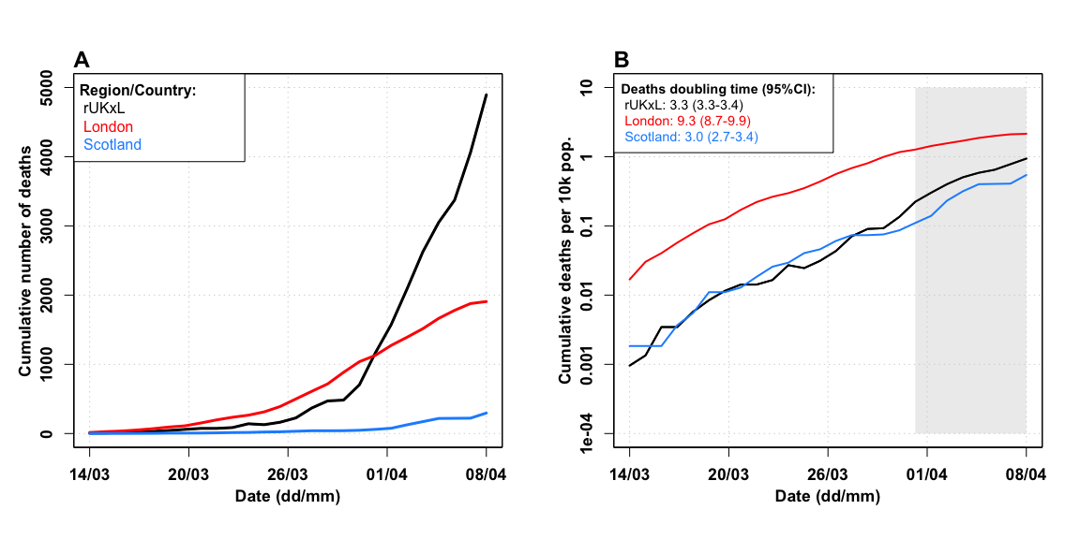 **Figure 1. Comparison of epidemic curves for Scotland, London and rUKxL based on deaths over time up to 08/04/2020**. **A)** Cumulative reported deaths **B)** Cumulative deaths per 10,000 population on a log10 scale. Inset shows corresponding doubling times (in days) over the past 7 days (with 95% CIs).

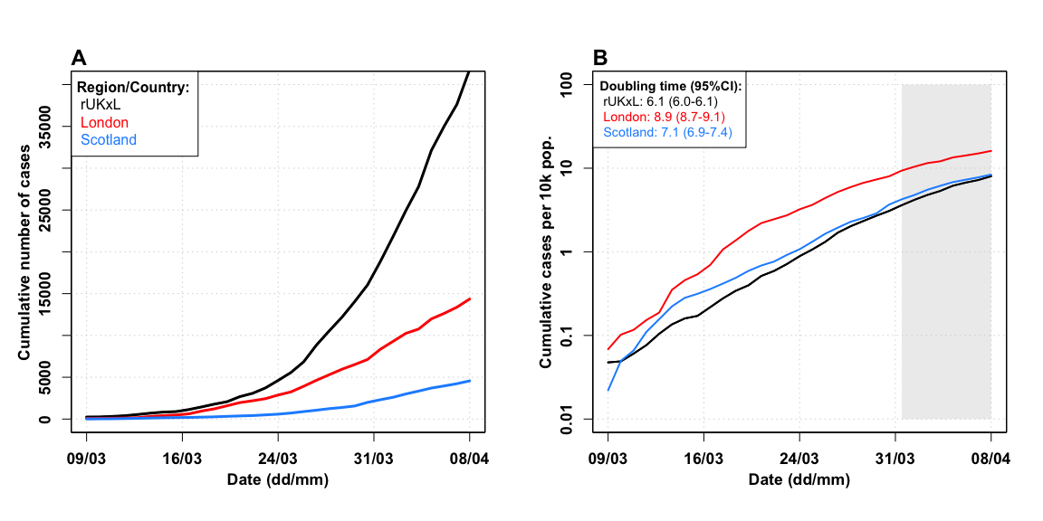

**Figure 2. Comparison of epidemic curves for Scotland, London and rUKxL up to 08/04/2020**. **A)** Cumulative reported cases. **B)** Cumulative cases per 10,000 population on a log10 scale. Inset shows corresponding doubling times (in days) over the past 7 days (with 95% CIs).

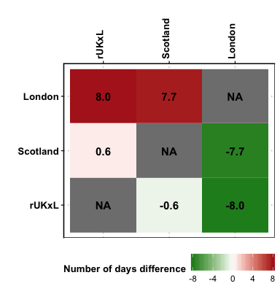

**Figure 3. Pairwise epidemic progression comparison**. The reported numbers are the numbers of days ahead (positive numbers, red) or behind (negative numbers, green) the regions in horizontal entries are relative to the regions in vertical entries. Horizontal entries are arrange from most ahead to least ahead.

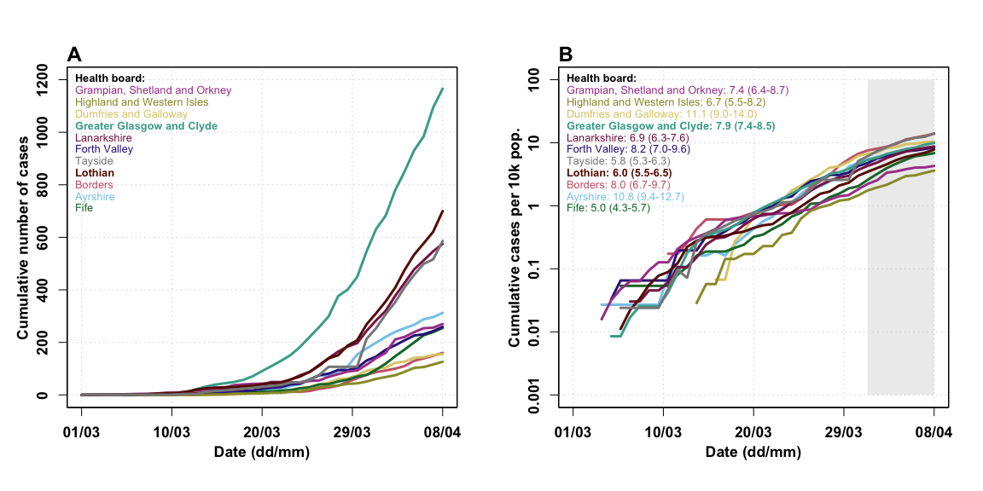

**Figure 4. Comparison of epidemic curves for all Scottish Health Boards up to 08/04/2020**. **A)** Cumulative reported cases. **B)** Cumulative cases per 10,000 population on log10 scale. Inset shows corresponding doubling times (in days) estimated over the past 7 days with 95% CIs.

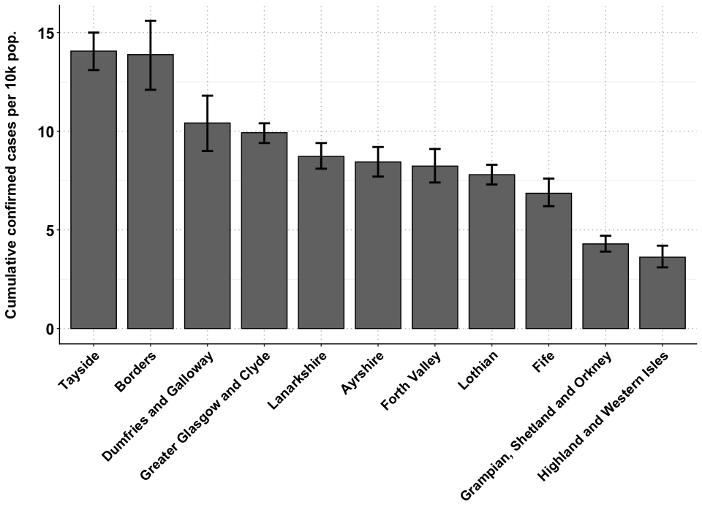

**Figure 5. Cumulative incidence for all Scottish Health Boards up to 08/04/2020**. The error bars show the 95%CI of the cumulative incidence per 10,000 population reached at last time point over the bootstrapped simulated datasets with Poisson error structure.

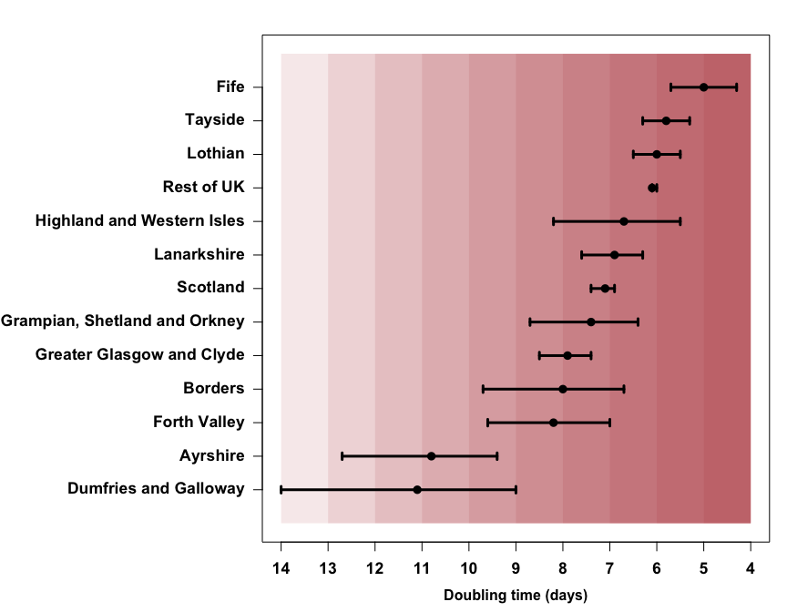

**Figure 6. Doubling time of cases**. Doubling times are calculated over a 7 day period up to 08/04/2020. Error bars indicate 95% CIs.

|  |  |  |  |  |
| --- | --- | --- | --- | --- |
| Region/Health board | Measure | Doubling time | 95%CI lower | 95%CI upper |
| London | eaths | 9.3 | 8.7 | 9.9 |
| Scotland | eaths | 3.0 | 2.7 | 3.4 |
| Rest of UK | eaths | 3.3 | 3.3 | 3.4 |
| London | cases | 8.9 | 8.7 | 9.1 |
| Scotland | cases | 7.1 | 6.9 | 7.4 |
| Rest of UK | cases | 6.1 | 6.0 | 6.1 |
| Ayrshire | cases | 10.8 | 9.4 | 12.7 |
| Fife | cases | 5.0 | 4.3 | 5.7 |
| Forth Valley | cases | 8.2 | 7.0 | 9.6 |
| Grampian Shetland and Orkney | cases | 7.4 | 6.4 | 8.7 |
| Greater Glasgow and Clyde | cases | 7.9 | 7.4 | 8.5 |
| Lanarkshire | cases | 6.9 | 6.3 | 7.6 |
| Lothian | cases | 6.0 | 5.5 | 6.5 |
| Tayside | cases | 5.8 | 5.3 | 6.3 |
| Borders | cases | 8.0 | 6.7 | 9.7 |
| Highland and Western Isles | cases | 6.7 | 5.5 | 8.2 |
| Dumfries and Galloway | cases | 11.1 | 9.0 | 14.0 |
|  |  |  |  |  |

**Table 1. Summary of all doubling times and their 95% CIs reported in the above figures.**

# Data

* Case counts for Scotland and for Scottish HBs from <https://www.gov.scot/coronavirus-covid-19/> (accessed 1400 08/04/2020).
* Case counts for London and rUKxL from <https://www.arcgis.com/apps/opsdashboard/index.html#/f94c3c90da5b4e9f9a0b19484dd4bb14> (accessed 2000 08/04/2020).
* Death count for Scotland from <https://www.gov.scot/coronavirus-covid-19/> (accessed 1400 08/04/2020).
* Population counts from the Office of National Statistics (mid-year 2018).
  + UK: <https://www.ons.gov.uk/peoplepopulationandcommunity/populationandmigration/populationestimates/datasets/populationestimatesforukenglandandwalesscotlandandnorthernireland>, Mid-2018, spreadsheet ‘MYE2-all’ (accessed 1140 26/03/20)
  + Scotland Health Board Areas: <https://statistics.gov.scot/atlas/resource?uri=http://statistics.gov.scot/id/statistical-geography/S92000003> (accessed 1200 11/03/20).

# Doubling time calculations:

Calculated over prior 7 days using method described by *E. Vynnycky & R. White (2010) An Introduction to Infectious Disease Modelling*, page 74.

Confidence intervals calculated using bootstrapping of a simulated dataset with Poisson error structure, using method published here: <https://doi.org/10.1101/2020.02.05.20020750>.

# Caveats

* Case count data are affected by any changes in testing strategy or testing effort over time and/or any variation in testing strategy or testing effort between regions.
* Case count data are likely a substantial under-representation of the true number of COVID-19 infections.
* Death data are considered more reliable but may lag behind case data by as much as 3 weeks.
* However, death data for London and rUKxL cannot be disaggregated. Nor can death data for Scottish Health Boards. Therefore more detailed analyses using death data are not currently possible.