Run HMSC for plants with traits

2023-04-03

### Model inputs :

## Loading required package: coda

# Crozet

colnames(Y_cro)

## [1] "Acaena magellanica" "Azorella selago"   
## [3] "Callitriche antarctica" "Crassula moschata"   
## [5] "Juncus scheuchzerioides" "Leptinella plumosa"   
## [7] "Montia fontana" "Poa cookii"   
## [9] "Pringlea antiscorbutica" "Ranunculus biternatus"   
## [11] "Uncinia compacta"

TrData_cro

## taxon height_m SLA  
## Acaena magellanica Acaena magellanica 0.09000000 11.968600  
## Azorella selago Azorella selago 0.13933333 8.714400  
## Callitriche antarctica Callitriche antarctica 0.09500000 37.899000  
## Crassula moschata Crassula moschata 0.03833333 22.334500  
## Juncus scheuchzerioides Juncus scheuchzerioides 0.03157143 14.478000  
## Leptinella plumosa Leptinella plumosa 0.06433333 18.350000  
## Montia fontana Montia fontana 0.15942105 40.043500  
## Poa cookii Poa cookii 0.33187500 10.485444  
## Pringlea antiscorbutica Pringlea antiscorbutica 0.18818182 6.759625  
## Ranunculus biternatus Ranunculus biternatus 0.02425000 15.023571  
## Uncinia compacta Uncinia compacta 0.08214286 9.940400

ape::plot.phylo(phyloTree_cro)

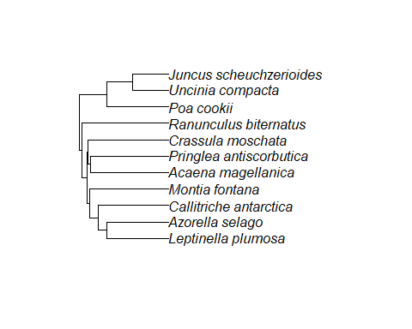

# Kerguelen

colnames(Y_ker)

## [1] "Acaena magellanica" "Azorella selago"   
## [3] "Callitriche antarctica" "Crassula moschata"   
## [5] "Juncus scheuchzerioides" "Leptinella plumosa"   
## [7] "Montia fontana" "Poa cookii"   
## [9] "Pringlea antiscorbutica" "Ranunculus biternatus"   
## [11] "Uncinia compacta"

TrData_ker

## taxon height_m SLA  
## Acaena magellanica Acaena magellanica 0.09000000 11.968600  
## Azorella selago Azorella selago 0.13933333 8.714400  
## Callitriche antarctica Callitriche antarctica 0.09500000 37.899000  
## Crassula moschata Crassula moschata 0.03833333 22.334500  
## Juncus scheuchzerioides Juncus scheuchzerioides 0.03157143 14.478000  
## Leptinella plumosa Leptinella plumosa 0.06433333 18.350000  
## Montia fontana Montia fontana 0.15942105 40.043500  
## Poa cookii Poa cookii 0.33187500 10.485444  
## Pringlea antiscorbutica Pringlea antiscorbutica 0.18818182 6.759625  
## Ranunculus biternatus Ranunculus biternatus 0.02425000 15.023571  
## Uncinia compacta Uncinia compacta 0.08214286 9.940400

ape::plot.phylo(phyloTree_ker)



# model structure:  
m = Hmsc(Y=Y, XData = XData, XFormula = XFormula,  
 TrData = TrData, TrFormula = TrFormula,  
 phyloTree = phylo_cro,  
 distr="probit",  
 studyDesign = studyDesign, ranLevels=list(site=rL.site, id=rL.id))

Variance partition for Crozet 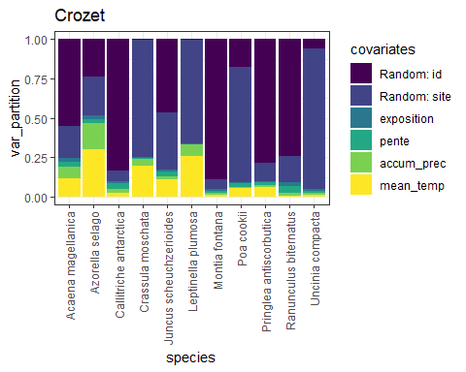

Variance partition for Kerguelen 