|  |
| --- |
| **Project “Effects of temperature and DBO on lake and river trophic networks”** |

* Fish size distribution – all sampling years pooled

|  |  |  |  |  |  |  |
| --- | --- | --- | --- | --- | --- | --- |
|  | **Fish length (mm)** | | | | | |
|  | ***n*** | ***Mean*** | ***Std. Dev.*** | ***Median*** | ***Min.*** | ***Max.*** |
| **Lake** | 654194 | 113.721 | 67.225 | 92 | 5 | 1541 |
| **Stream** | 1366166 | 82.212 | 63.088 | 65 | 1 | 1450 |

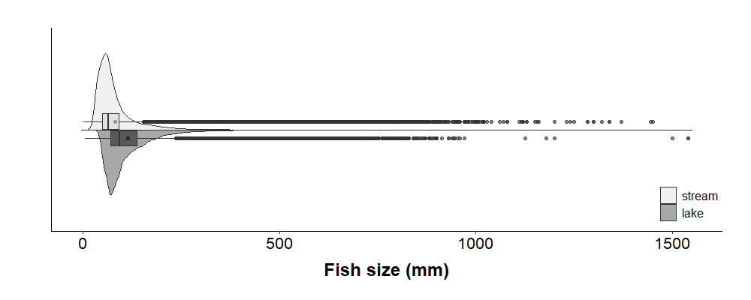

* Fish size distribution – by sampling year

|  |  |  |  |  |  |  |  |
| --- | --- | --- | --- | --- | --- | --- | --- |
|  | **Fish length (mm)** | | | | | | |
|  | ***Sampling***  ***Year*** | ***n*** | ***Mean*** | ***Std. Dev.*** | ***Median*** | ***Min.*** | ***Max.*** |
| **Lake** | 2005 | 11475 | 132.991 | 75.438 | 117 | 16 | 945 |
|  | 2006 | 15857 | 130.770 | 69.121 | 112 | 9 | 1200 |
|  | 2007 | 17144 | 132.612 | 70.676 | 115 | 31 | 830 |
|  | 2008 | 80865 | 113.459 | 68.538 | 91 | 10 | 870 |
|  | 2009 | 84156 | 113.626 | 70.742 | 92 | 11 | 940 |
|  | 2010 | 67328 | 116.658 | 65.833 | 95 | 5 | 1541 |
|  | 2011 | 63791 | 119.696 | 66.181 | 100 | 5 | 1500 |
|  | 2012 | 44869 | 111.477 | 69.080 | 85 | 15 | 930 |
|  | 2013 | 50207 | 114.704 | 67.372 | 90 | 8 | 850 |
|  | 2014 | 48158 | 102.700 | 60.827 | 84 | 16 | 1540 |
|  | 2015 | 47530 | 115.022 | 66.456 | 91 | 30 | 930 |
|  | 2016 | 75014 | 99.706 | 59.609 | 80 | 19 | 954 |
|  | 2017 | 47800 | 118.039 | 68.031 | 100 | 26 | 890 |
| **Stream** | 2005 | 199384 | 81.433 | 56.362 | 65 | 7 | 977 |
|  | 2006 | 178331 | 82.319 | 59.177 | 65 | 12 | 1000 |
|  | 2007 | 98374 | 86.461 | 66.759 | 66 | 13 | 1020 |
|  | 2008 | 72051 | 87.529 | 72.452 | 67 | 13 | 1370 |
|  | 2009 | 90637 | 84.430 | 66.448 | 65 | 1 | 910 |
|  | 2010 | 94751 | 78.500 | 61.178 | 63 | 10 | 1285 |
|  | 2011 | 90773 | 85.017 | 66.035 | 65 | 5 | 1300 |
|  | 2012 | 83497 | 82.493 | 63.773 | 65 | 11 | 1200 |
|  | 2013 | 79970 | 84.005 | 70.414 | 64 | 3 | 1340 |
|  | 2014 | 87428 | 80.254 | 62.710 | 63 | 11 | 1115 |
|  | 2015 | 102170 | 80.018 | 64.190 | 63 | 9 | 1230 |
|  | 2016 | 82425 | 81.823 | 63.447 | 65 | 4 | 1445 |
|  | 2017 | 106375 | 77.439 | 58.958 | 62 | 10 | 1450 |

