|  |
| --- |
| **Project “Effects of temperature and dbo on lake and river trophic networks”** |

**I. FISH SIZE DISTRIBUTION**

* All sampling years pooled

|  |  |  |  |  |  |  |
| --- | --- | --- | --- | --- | --- | --- |
|  | **Fish length (mm)** | | | | | |
|  | ***Nind*** | ***Mean*** | ***Std. Dev.*** | ***Median*** | ***Min.*** | ***Max.*** |
| **Lake** | 654194 | 113.721 | 67.225 | 92 | 5 | 1541 |
| **Stream** | 1366166 | 82.212 | 63.088 | 65 | 1 | 1450 |

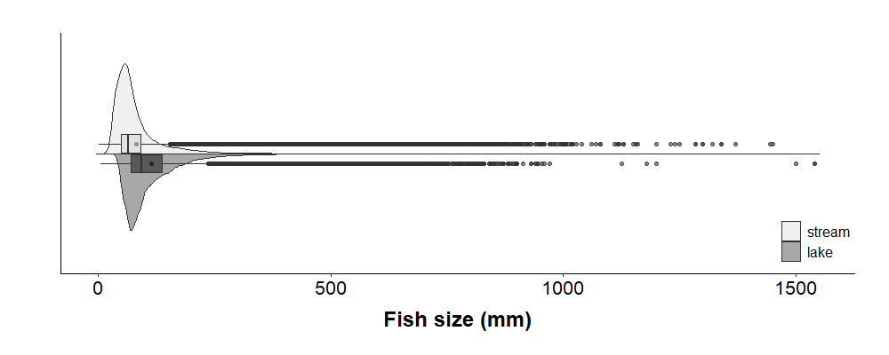

* By sampling year

|  |  |  |  |  |  |  |  |
| --- | --- | --- | --- | --- | --- | --- | --- |
|  | **Fish length (mm)** | | | | | | |
|  | ***Sampling***  ***Year*** | ***Nind*** | ***Mean*** | ***Std. Dev.*** | ***Median*** | ***Min.*** | ***Max.*** |
| **Lake** | 2005 | 11475 | 132.991 | 75.438 | 117 | 16 | 945 |
|  | 2006 | 15857 | 130.770 | 69.121 | 112 | 9 | 1200 |
|  | 2007 | 17144 | 132.612 | 70.676 | 115 | 31 | 830 |
|  | 2008 | 80865 | 113.459 | 68.538 | 91 | 10 | 870 |
|  | 2009 | 84156 | 113.626 | 70.742 | 92 | 11 | 940 |
|  | 2010 | 67328 | 116.658 | 65.833 | 95 | 5 | 1541 |
|  | 2011 | 63791 | 119.696 | 66.181 | 100 | 5 | 1500 |
|  | 2012 | 44869 | 111.477 | 69.080 | 85 | 15 | 930 |
|  | 2013 | 50207 | 114.704 | 67.372 | 90 | 8 | 850 |
|  | 2014 | 48158 | 102.700 | 60.827 | 84 | 16 | 1540 |
|  | 2015 | 47530 | 115.022 | 66.456 | 91 | 30 | 930 |
|  | 2016 | 75014 | 99.706 | 59.609 | 80 | 19 | 954 |
|  | 2017 | 47800 | 118.039 | 68.031 | 100 | 26 | 890 |
| **Stream** | 2005 | 199384 | 81.433 | 56.362 | 65 | 7 | 977 |
|  | 2006 | 178331 | 82.319 | 59.177 | 65 | 12 | 1000 |
|  | 2007 | 98374 | 86.461 | 66.759 | 66 | 13 | 1020 |
|  | 2008 | 72051 | 87.529 | 72.452 | 67 | 13 | 1370 |
|  | 2009 | 90637 | 84.430 | 66.448 | 65 | 1 | 910 |
|  | 2010 | 94751 | 78.500 | 61.178 | 63 | 10 | 1285 |
|  | 2011 | 90773 | 85.017 | 66.035 | 65 | 5 | 1300 |
|  | 2012 | 83497 | 82.493 | 63.773 | 65 | 11 | 1200 |
|  | 2013 | 79970 | 84.005 | 70.414 | 64 | 3 | 1340 |
|  | 2014 | 87428 | 80.254 | 62.710 | 63 | 11 | 1115 |
|  | 2015 | 102170 | 80.018 | 64.190 | 63 | 9 | 1230 |
|  | 2016 | 82425 | 81.823 | 63.447 | 65 | 4 | 1445 |
|  | 2017 | 106375 | 77.439 | 58.958 | 62 | 10 | 1450 |

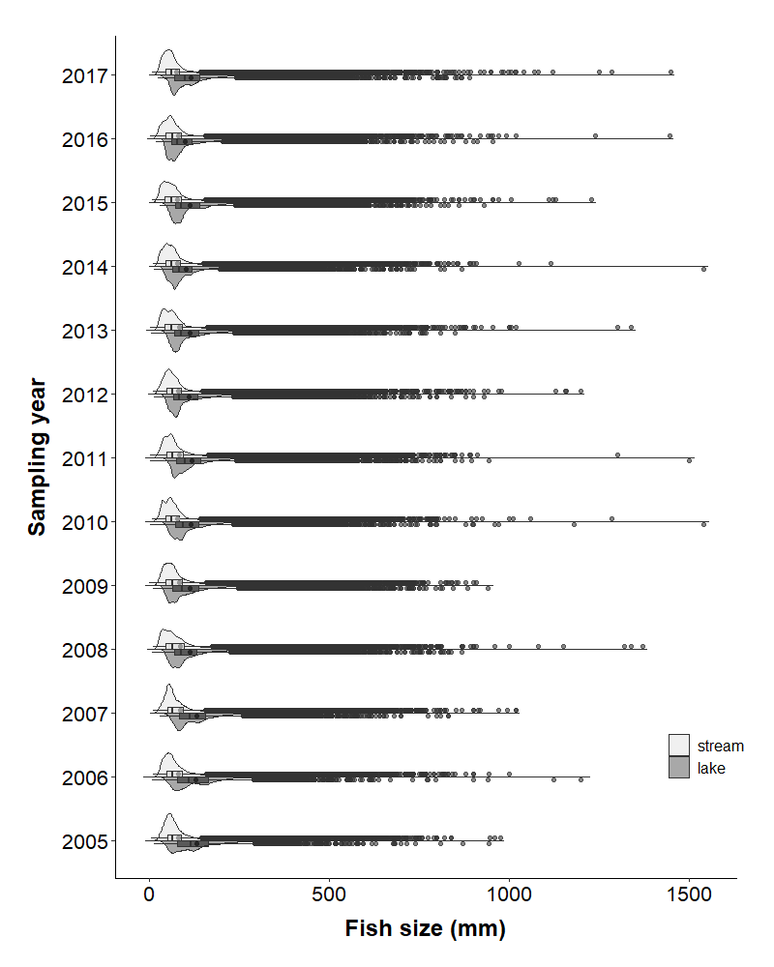

**II. PISCIVORY**

* All sampling years pooled

|  |  |  |  |  |  |  |
| --- | --- | --- | --- | --- | --- | --- |
|  | **Proportion of piscivores individuals in networks** | | | | | |
|  | ***Nsite*** | ***Mean*** | ***Std. Dev.*** | ***Median*** | ***Min.*** | ***Max.*** |
| **Lake** | 397 | 0.270 | 0.010 | 0.216 | 0 | 0.984 |
| **Stream** | 2791 | 0.188 | 0.004 | 0.114 | 0 | 0.990 |

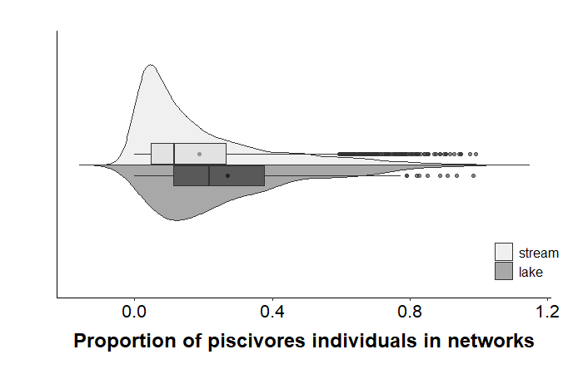

* By sampling year

|  |  |  |  |  |  |  |  |
| --- | --- | --- | --- | --- | --- | --- | --- |
|  | **Proportion of piscivores individuals in networks** | | | | | | |
|  | ***Sampling***  ***Year*** | ***Nsite*** | ***Mean*** | ***Std. Dev.*** | ***Median*** | ***Min.*** | ***Max.*** |
| **Lake** | 2005 | 15 | 0.291 | 0.291 | 0.204 | 0.000 | 0.910 |
|  | 2006 | 13 | 0.222 | 0.152 | 0.172 | 0.011 | 0.592 |
|  | 2007 | 16 | 0.313 | 0.207 | 0.264 | 0.043 | 0.645 |
|  | 2008 | 51 | 0.242 | 0.211 | 0.154 | 0.012 | 0.984 |
|  | 2009 | 47 | 0.251 | 0.191 | 0.195 | 0.002 | 0.774 |
|  | 2010 | 47 | 0.276 | 0.226 | 0.234 | 0.011 | 0.852 |
|  | 2011 | 43 | 0.337 | 0.231 | 0.261 | 0.032 | 0.791 |
|  | 2012 | 29 | 0.277 | 0.244 | 0.220 | 0.014 | 0.935 |
|  | 2013 | 27 | 0.271 | 0.161 | 0.259 | 0.072 | 0.603 |
|  | 2014 | 20 | 0.212 | 0.185 | 0.149 | 0.001 | 0.589 |
|  | 2015 | 26 | 0.281 | 0.195 | 0.204 | 0.068 | 0.742 |
|  | 2016 | 34 | 0.235 | 0.184 | 0.204 | 0.018 | 0.743 |
|  | 2017 | 29 | 0.297 | 0.184 | 0.268 | 0.048 | 0.713 |
| **Stream** | 2005 | 309 | 0.151 | 0.173 | 0.088 | 0.000 | 0.784 |
|  | 2006 | 304 | 0.163 | 0.174 | 0.081 | 0.000 | 0.783 |
|  | 2007 | 216 | 0.209 | 0.205 | 0.127 | 0.000 | 0.974 |
|  | 2008 | 181 | 0.214 | 0.208 | 0.142 | 0.004 | 0.887 |
|  | 2009 | 215 | 0.185 | 0.165 | 0.140 | 0.000 | 0.904 |
|  | 2010 | 178 | 0.181 | 0.201 | 0.102 | 0.000 | 0.806 |
|  | 2011 | 212 | 0.185 | 0.177 | 0.122 | 0.000 | 0.851 |
|  | 2012 | 179 | 0.200 | 0.211 | 0.120 | 0.000 | 0.947 |
|  | 2013 | 196 | 0.239 | 0.219 | 0.163 | 0.000 | 0.942 |
|  | 2014 | 191 | 0.199 | 0.201 | 0.126 | 0.000 | 0.916 |
|  | 2015 | 209 | 0.189 | 0.183 | 0.127 | 0.000 | 0.888 |
|  | 2016 | 199 | 0.206 | 0.205 | 0.128 | 0.000 | 0.871 |
|  | 2017 | 202 | 0.161 | 0.179 | 0.101 | 0.000 | 0.990 |

