**Name: Christine R. Loon Date: June 28, 2019**

**Section: A** **Rating:**

**Instructions:** Copy or take a picture of the Vision and Mission of the school you are assigned to observe and make a short analysis of the important points found.

**Vision**

We dream of Filipinos who passionately love their country and whose competencies and values enable them to realize their full potential and contribute meaningfully to building the nation. As a learner-centered public institution. The Department of Education continuously improves itself to better serve its stakeholders.

**Mission**

To protect and promote the right of every Filipino to quality, equitable, culture-based, and complete basic education where: Students learn in a child friendly, gender-sensitive, safe and motivating environment Teachers facilitate learning and constantly nurture every learner. Administrators and Staff, as stewards of the institution, ensure an enabling and supportive environment for effective learning to happen. Family, community, and other stakeholders are actively engaged and share responsibility for developing life-long learners.

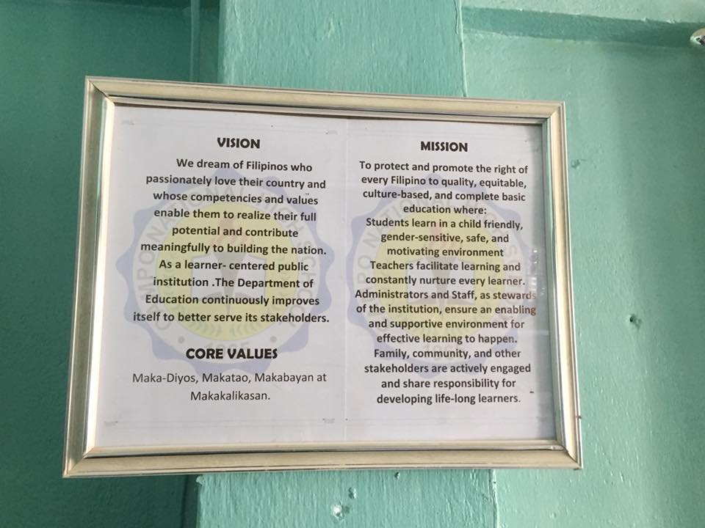

**Analysis:**

Developing the school’s vision and mission are very significant in a certain institution because it can help a school community reflect on its core educational values, operational objectives, and hoped-for results for students. By creating s “shared mission” or “shared vision” that is developing the public commitments with the involvement of teachers, staff, students, parents, and community members.

The mission describe whom do to seek to serve which is the right of every Filipinos, students and teachers. Focus to quality, equitable, culture-based, and complete basic education. A school can increase general of what it hopes to accomplish, why it matters, and what may need to change to realize a stronger academic program.

**EPISODE ONE**

**School Environment Interaction**

**Instructions:** Describe briefly your observations on the following: (*If possible attached some pictures to support your observation*)

**Student-to-Student Interaction Patterns**

Interaction between students-to- student in the classroom is a vital role in any course experience. During my observation in class, there are students who are interacting with each other, they talk with their seatmates, played, and doing some non-sense things. They also listen to each other’s comments. But when the teacher asked questions they actively participated in class discussions.

**Student-to-Teacher Interaction Patterns**

Student-to-Teacher Interaction is influenced strongly by the teaching perspective embraced by the teacher. In my observation I can conclude that the students is actively participating with their teacher. The interaction between the two is present during class discussion. They can answer also what is being asked and participated the activities being given to them with the guidance of their teacher.

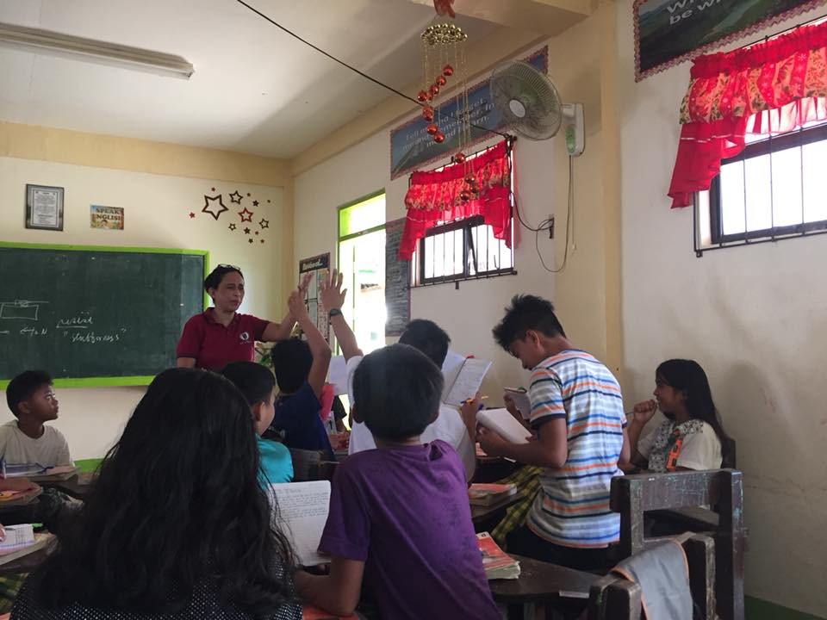

Interaction between Teacher and student

**Teacher-to-Student Interaction Patterns**

In my observation the my resource teacher in Campo National High School is very approachable and very friendly just what she did in her class. She considered her students to be her own child and give concerned to their needs. She give love and also respect their individual differences. Students also may do so they respect their teacher and follow rules inside the class. However there are instances that the student tend to misbehave inside the class but the teacher are manageable enough to give some strategies to those students who are misbehaving and by that the student are also following what is being instructed by them .

**Student-to-Non-Teaching Personnel Interaction Patterns**

The interaction between students to non-teaching personnel is they tend to have not so much respect just like what they did for their teachers. They can talk with them casually and not all students will greet them like good morning/good afternoon.

**Teacher-to-Teacher interaction Patterns**

The interaction teacher-to-teacher is very much important in a certain institution. Teacher interactions are professional in nature. Positive relationship building with your colleagues can make a world of difference when it comes to improving our own practice and making our school a better, more effective environment for our students. As what I observed in Campo National High School the teachers there are collaborating with each other, they give respect and they are all friendly when it comes in handling visitors. They emphasizes professionalism and friendly environment.

**Questions to ponder:** Answer the questions concisely.

Why is a classroom a miniature of a greater society?

The classroom is considered a miniature of a greater society because in a classroom like a greater society has various kinds of individuals with different attitudes and personalities and like a greater society, these individuals work together for the attainment of a certain goals which are necessary for their living and survival. The students represents the people of the society and the teacher represents as the leader of the society.

What are found in the classrooms that are similar to what can be observed in society?

As I observed, the similarity of a classroom with the society is the there is also rules and regulations that the student and teachers should follow just like in the society for the harmonious relationship. The interaction between the teacher and students, if you get told to listen then you are followed. In the classroom we can see the teacher and the different kinds of students corresponding to the leader and the different kinds of people in the society. Also in the classroom, there is presider; the teacher, of the different groups formed with officers in each group; like the society, there is the president governing the different groups and communities of people. In the classroom we can also observe that some students are study hard as others just normal, like in the society others work hard, others just letting it be following the flow.

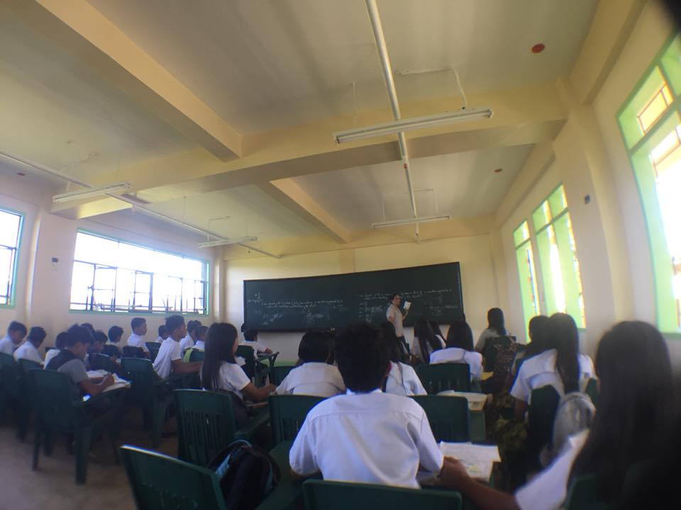

**EPISODE TWO**

**Inside the Classroom**

**Instructions:** Select and narrate briefly the best topic discussion done by the teacher while you were doing your observation. (*If possible attached some pictures to support your observation*)

**Narration of the classroom discussion**

Classroom discussion in CNHs is different from other school. The teacher is introducing first her objectives in the topic they were discussing in that day. In the discussion proper the students actively participating with their teacher and collaborative. My resource teacher promotes better learning process to have a productive classroom environment. The activities also makes the student cooperate with their classmates and shared their knowledge to gain new ideas.

**State your personal assessment and reflections**

In order to be an effective teacher, you must be able to effectively and efficiently use classroom management. Great classroom management don’t come overnight, they are something that must be learned and practiced over a period of time. And that’s how my resource teacher possessed. She have the ability to manage time, build a relationship with her students, and structure their learning environment so that it’s equal for all. They need to be prioritize so their classroom will run smoothly. She also build a genuine relationship with students and set their minds to become a good person in the future .

**Questions to ponder:** Answer the questions concisely.

How important are dialogue and substantive conversation in the classroom in terms of students’ learning?

Dialogue and substantive conversation in classroom is very important in terms of student’s learning because it empowers students to feel more invested in the course material and makes them more able to apply it to real-world situations. It enables also the teacher to see whether the students are capable of analyzing and synthesizing material. It also built the atmosphere and help in learning fast. In that manner the student and teacher can communicate well which lead to be more productive and in the sake of students learning.

What learning benefits could teachers and students draw from intentional classroom dialogue?

The learning benefits could teachers and students draw from intentional dialogue are their thoughts they can express it freely with their ideas toward others. Having a dialogue has a great chance to improve their own listening skills and more attentive in dealing with it. It develops self-confidence especially for the students to overcome their fear in communicating with others and most especially in answering questions. It can help them mold their critical thinking skills to enhance and to be more effective .

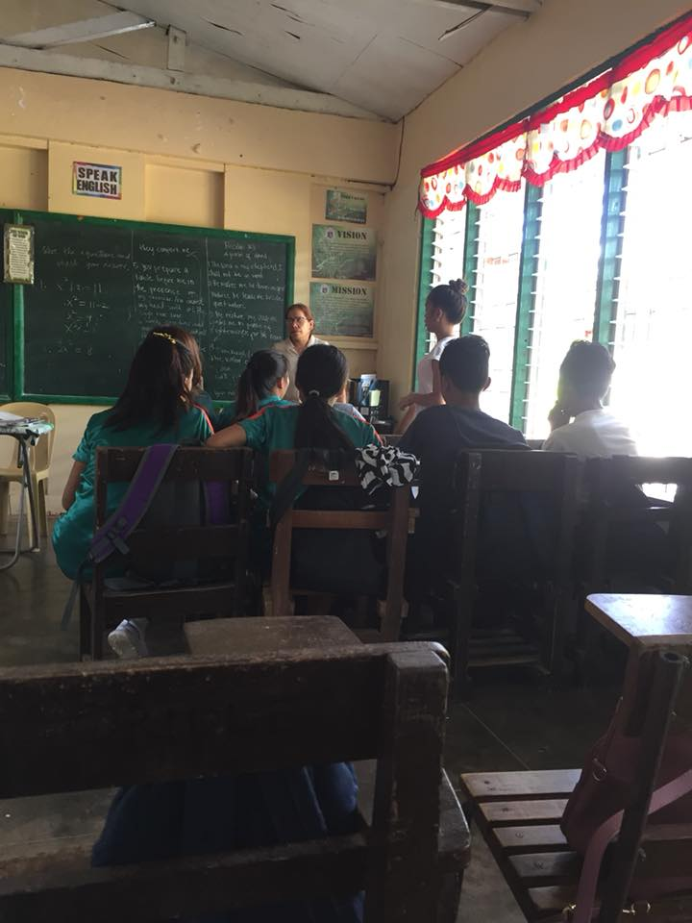

Grade 9 - Dove

**EPISODE THREE**

**Curriculum Implementation**

**Instructions:** Describe briefly your observations on the following: (*If possible attached some pictures to support your observation*)

**Classroom environment**

The ideal classroom environment will be conducive to learning. The teacher who manages the classroom must have a good well-being. A well-ventilated, well-lighted, well-decorated, and well-arranged classroom is conducive to learning. A classroom built beautifully and of strong foundation is conducive to learning, too. It is said to be conducive if it is equipped with instructional and learning materials. Having a warm atmosphere of friendship among teachers and students alike and where students can exercise their freedom of expression without the fear of being judged and discriminated are my ideas of a conducive classroom environment. It is also conducive I the campus itself promotes better learning to the students and other people who has a great factor on the school.

**School Facilities**

School Facilities are one of the basic educational requirements, and it is necessary to maintain safe and high-quality school facilities from the perspective of maintaining and improving educational levels in line with the developmental stage. For me, computer laboratory and the library are the best school facilities because this facilities will improve the keen knowledge of every student. They can be effecient and build-up skills.

**Arrangement of the Subject Matter**

Subject matter should be arranged according to the curriculum design. Ensure that your lessons are all related to your objectives. Subject matter also can be arranged according to the needs and interest of the students.

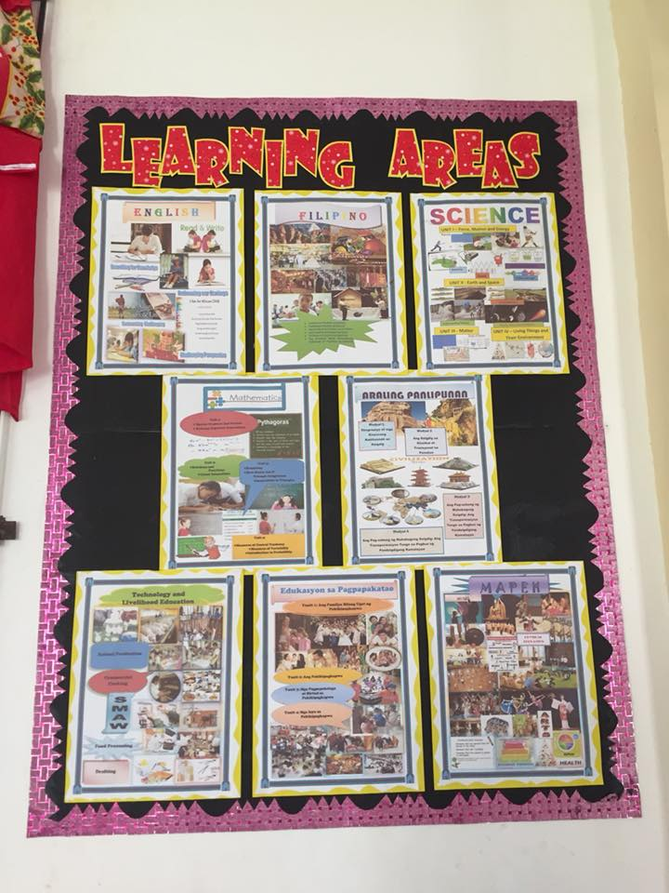

**Questions to ponder:** Answer the questions concisely.

Why should teachers know about curriculum design?

The teachers should know about curriculum design because teacher is the ones who are part of the instruction, therefore they are the ones who are first to know about the design of the curriculum that a school is to be implemented. When a teacher is aware of the design of a certain curriculum, therefore they know how to settle things in a classroom. And for them to cater properly the needs of the learners. With their knowledge, experiences, and competencies, teachers are central to any curriculum development.

What do most principles and theories of curriculum development have in common? How is the commonality expressed or spelled out in the curriculum of the class you have observed?

Most principles and theories of curriculum development have in common. In my observation, I can say that one of the target of the teacher is the behavior of the learners, and to make the principles and theories have in common is the curriculum they are being implemented in school. It made for the learners individual growth become productive for them to be better in the future.

**EPISODE FOUR**

**Curriculum Stakeholders**

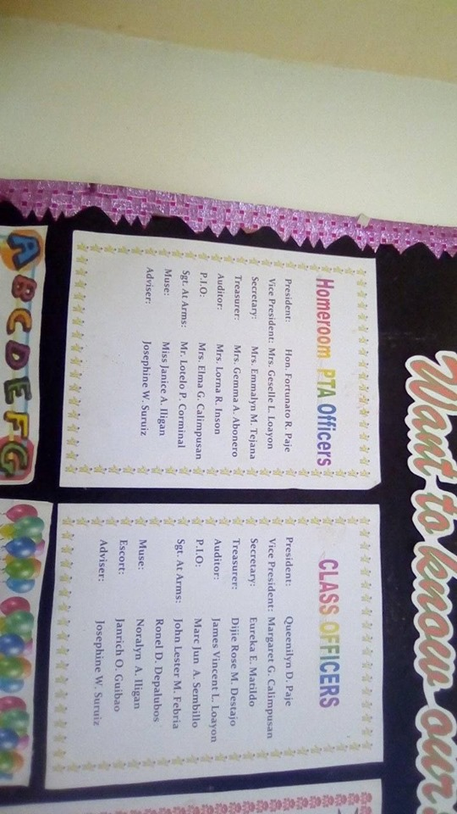

**Instructions:** Copy or take a picture of the Classroom Parents Teachers Association (PTA) list of officers of the class you are assigned to observe.

**Questions to ponder: Answer the questions concisely.**

How important is involvement of all stakeholders of the school in the school’s programs and activities?

The involvement of all stakeholders of the school in the schools programs and activities has a great impact in the institution. Parents, teachers, school heads, administrators and school board are the one who associated with the welfare and success of a school and its students. They have their big responsibilities in school and impart it for the development of the institution.

What specific principle of curriculum development justifies the importance of cooperation and collaboration among all stakeholders of the school?

The importance of cooperation and collaboration among all stakeholders of the school is the principle of mutual aid. Cooperation and collaboration can bind them to achieve the desired goals. Each of them will be participating especially if there is activities in school, and with proper guidance they can contribute a big impact for the betterment of the school.

**EPISODE FIVE**

**Curriculum design**

**Instructions:** Describe briefly the curriculum type (*Subject Centered, Experience/ Learner and Society/Culture Based)* observed in the class. Write a brief explanation to support your observation(s).

As what I have observed in Campo National High school the curriculum type they have used is student-centered curriculum because they focus primarily on the individual student’s learning. My resource teacher is only facilitating the interest and needs of the students as guide for her meaningful instruction. First, she is introducing her objectives of what the learners can be achieved in the end of the discussion then she give a little overview of the topic and after that her students will be the one who facilitates in the activity she give, and by her guidance the student will be able to performed it well.

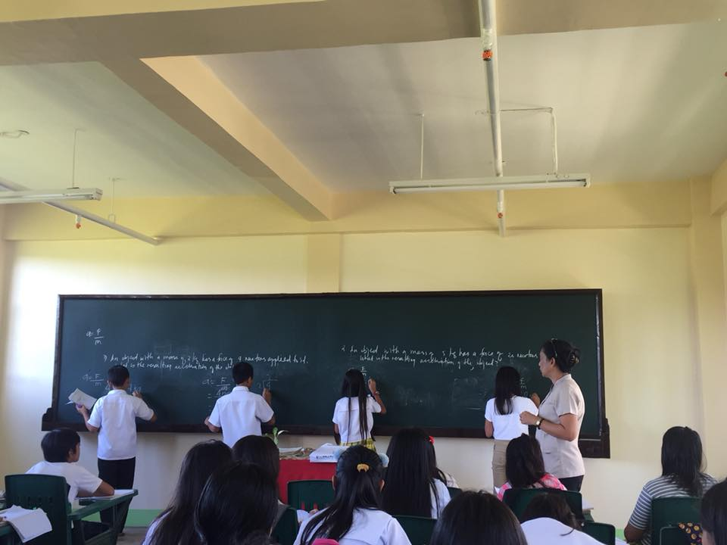

**Questions to ponder: Answer the questions concisely.**

How important is it for teachers and curriculum planners to anchor their curricular plans to specific theories and principles of curriculum development?

It is important for teachers and curriculum planners to anchor their curriculum plans to specific theories and principles of curriculum by construct a curriculum appropriate to the student’s needs. Theories is differ from practice. Plans will be designed based on the strength of the group of teachers to teach excellent lessons. Theories is best but if the teachers unable to teach from the theories and effectively utilize them the theories mean nothing.

Aside from the teachers, who else should be involved in the curriculum planning? Expound your thoughts.

Aside from the teachers, a number of people can be involved. Students, Parents, administrators, staffs, and even the community bodies can also be involved in the curriculum planning. These different stakeholders played a vital role in an institution in order that the curriculum will be relevant and will be functioning and useful tool in attaining the success of the society through educating individual students.

**EPISODE SIX**

**Curriculum experience**

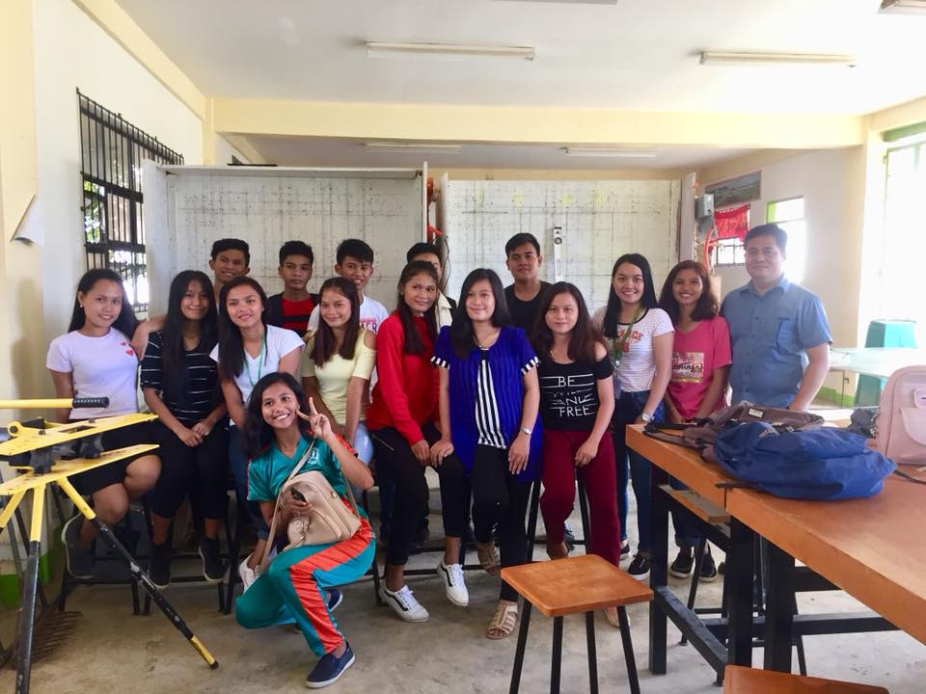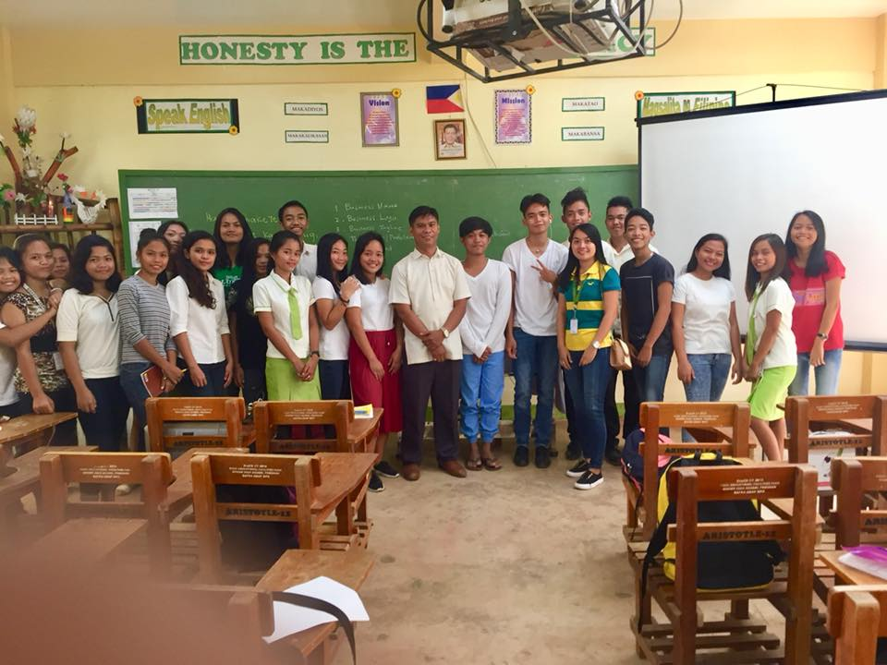**Instructions:** attached pictures of the class (*teacher and students*) you observed. Write short captions of every picture.

Grade 12 – Aristotle

Having their lecture about Nature of Business

Grade 12 EIM

With Mr. Diosdedit Ranullo

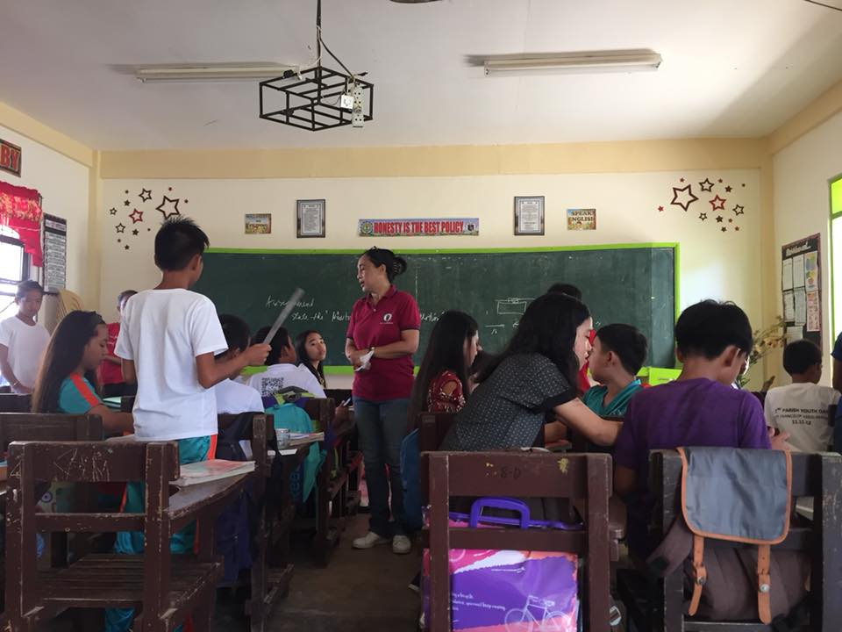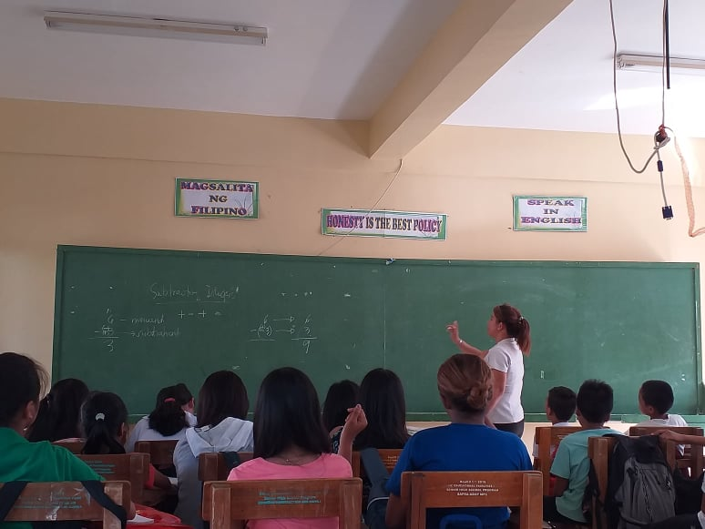

Grade 7 – Dahlia

Miss. Sajulga conducting a lecture about Subtracting Integers

Grade 8 – Ruby

Mrs. Suruiz conducting a lecture about Newton’s Law of Motion

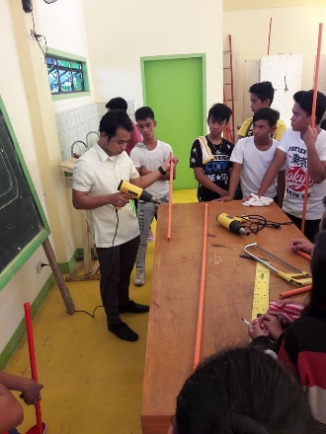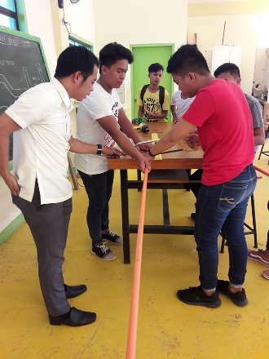

Grade 12 EIM

With Mr. Francia having their activity regarding PVC pipe.

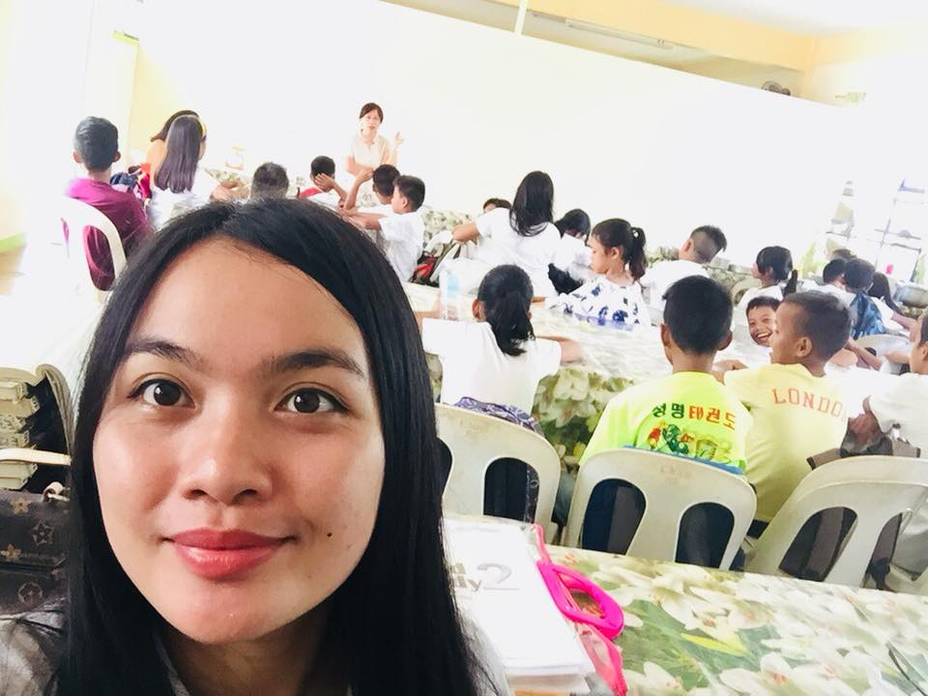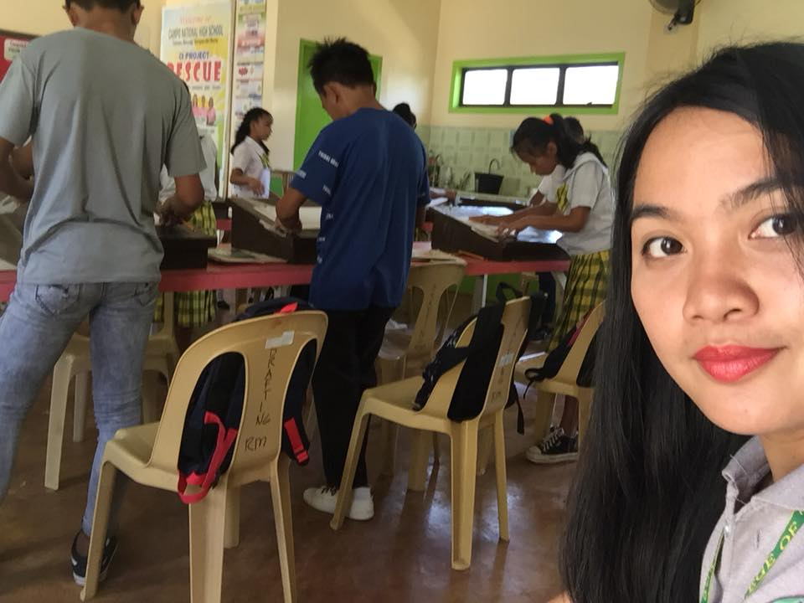

Grade 7 (Drafting)

Having an activity

Grade 7 (Culinary Arts)

Familiarizing Kitchen Utensils

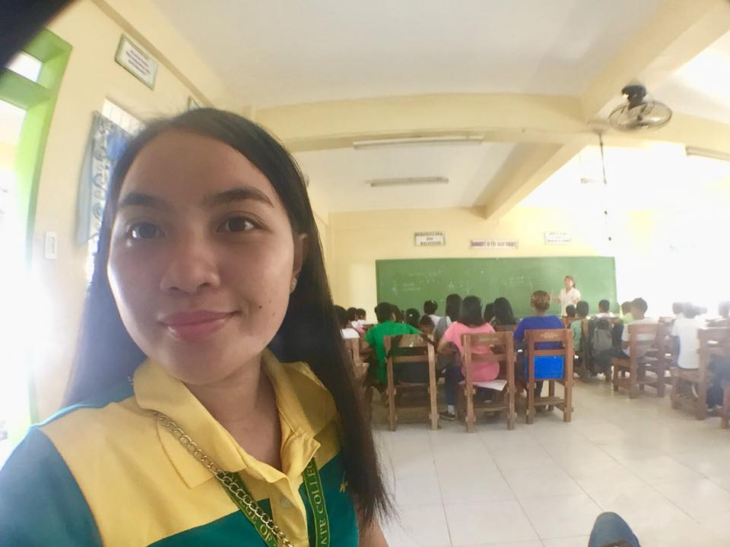

Grade 10 – Mango

Topic: Geometric Sequence

**Questions to ponder: Answer the questions concisely.**

How do you find teaching profession after your class observation?

I found teaching profession after my class observation, is that teaching profession plays a vital role of every learner’s intellectual capacity. It is not easy to be a teacher because a teacher shares the knowledge to build a better person. A teacher sacrifices his/her time just for the sake and benefits of a student especially to those students who stuck with some problems. It is a profession and it is a profession of giving what you have as what my resource teacher did. She act like their second parent in class, and she give her best to accommodate what was the need of her students And I want to be like her when God permits me to become a license teacher someday. I want to follow her footsteps especially in dealing classes, her strategies, her dedication to teach and most especially her passion. It is not easy to be a second parent of not only one but more than two. But if you love to teach, God will provide.

