**LABO-04 CAMILO RAUL BENITEZ SIGUENZA 00083223**

**HECHO CON Apache**

sudo apt install apache2

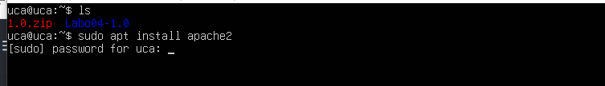

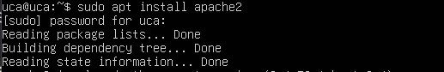

sudo ufw enable



sudo ufw allow 'Apache'

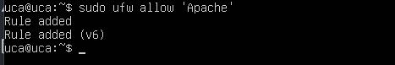

sudo mkdir -p /var/www/your_doman

sudo mv directorio_01 /var/www/your_doman



sudo chown -R $USER:$USER /var/www/your_doman/directorio_01

sudo chmod -R 755 /var/www/your_domain

sudo nano /etc/apache2/sites-available/your_domain.cof

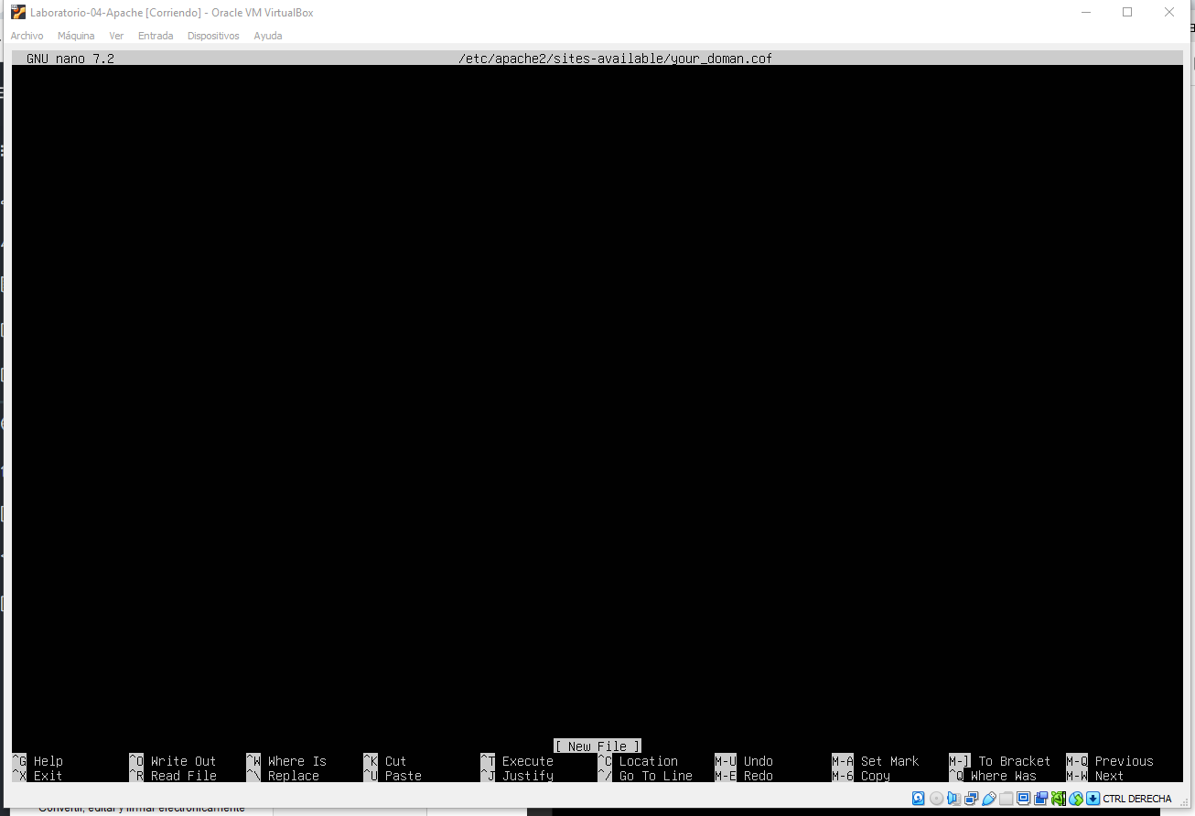

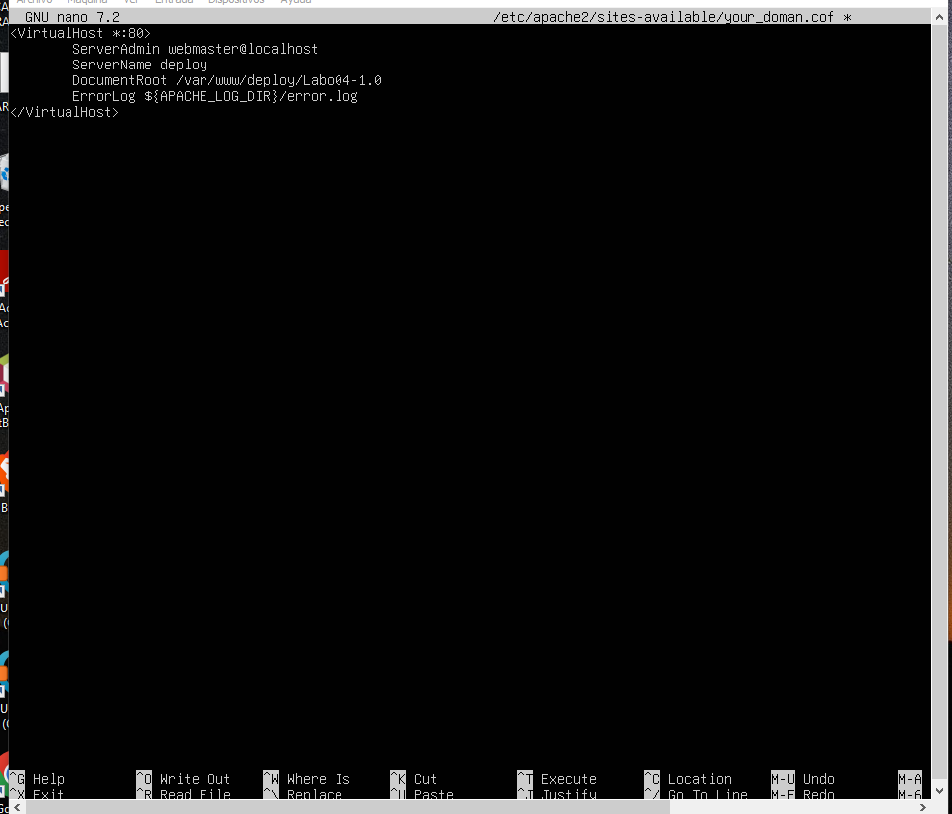

**Manejo de Nginx**