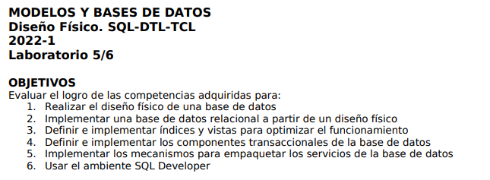

**MILTON ANDRES GUTIERREZ LOPEZ**

**CAMILO NICOLAS MURCIA ESPINOZA**

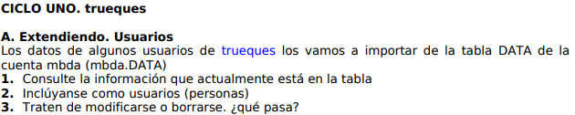

SELECT * FROM MBDA.DATA;

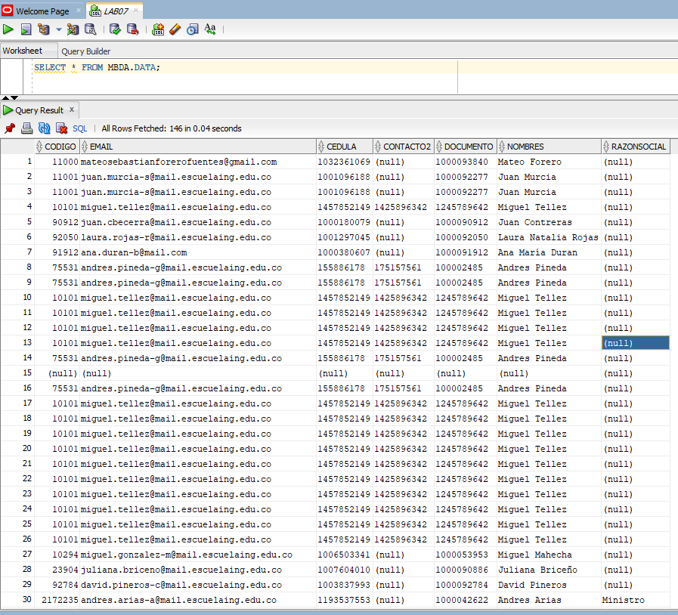



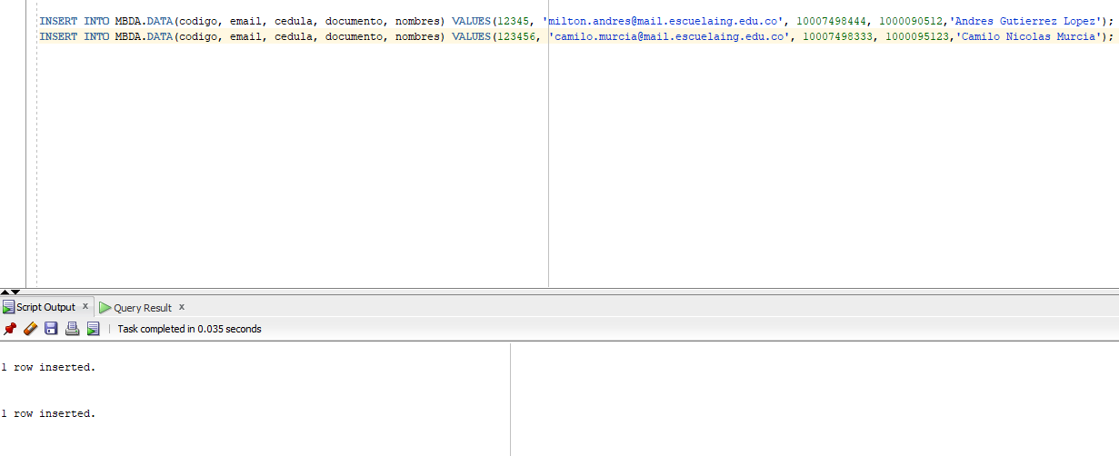

INSERT INTO MBDA.DATA(codigo, email, cedula, documento, nombres) VALUES(12345, 'milton.andres@mail.escuelaing.edu.co', 10007498444, 1000090512,'Andres Gutierrez Lopez');

INSERT INTO MBDA.DATA(codigo, email, cedula, documento, nombres) VALUES(123456, 'camilo.murcia@mail.escuelaing.edu.co', 10007498333, 1000095123,'Camilo Nicolas Murcia');



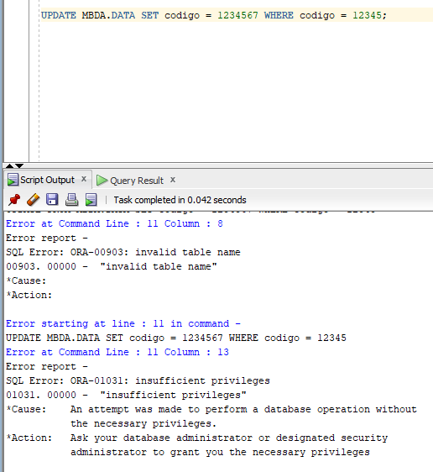

No poseemos los permisos para poder modificar la tabla.

UPDATE MBDA.DATA SET codigo = 1234567 WHERE codigo = 12345;

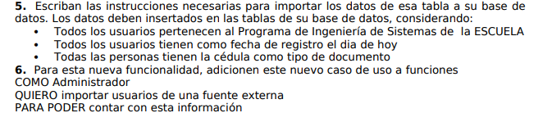

INSERT INTO USUARIO(codigo, tid, nid, nombre, correo,registro, nsuspensiones, universidad_codigo, programa) (SELECT DISTINCT codigo, 'CC', cedula, nombres, email, SYSDATE, 0, 'ECI', 'ING. SISTEMAS' FROM MBDA.DATA WHERE RAZONSOCIAL IS NULL AND NOMBRES IS NOT NULL AND CODIGO IS NOT NULL);

