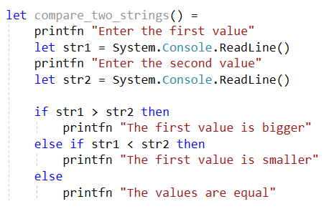

I/O

I/O

I/O

I/O

Decision/O

Decision/O

Decision/O

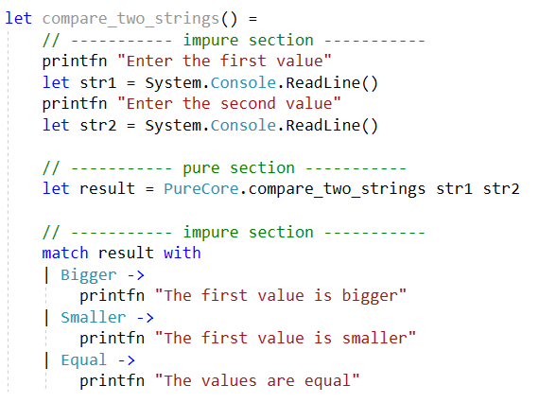

I/O

I/O

Decision/O

Decisions

I/O

I/O

Pure code

Impure code

Impure code

Unit tests

Integration tests

Deterministic

Non-deterministic

Non-deterministic

Decisions

I/O

I/O

Decisions

I/O

compareTwoStrings

comparison

Three parameters

str1

str2

compareTwoStrings

comparison

str1

str2

Two parameters

After partial application

Step 1

Injected  
service

Step 2

Injected  
service

Step 3

Injected  
service

ILogger

Dependency first

str2

str1

Dependency last

ComparisonResult

ILogger

str2

str1

ComparisonResult

ILogger

str2

str1

ComparisonResult

ILogger

str2

str1

ComparisonResult

Give this a name: Reader

returns

returns

returns

returns

Instruction

interpreter

Input to interpreter

Next instruction

Output of interpreter

interpreter

Next instruction

Instruction

interpreter

Input to interpreter

Next instruction

interpreter

Next instruction

A "program"

Output of interpreter