**Project 1.5-Page GDD**

*Third Person Horror camera hack’n slash meets Ortographic war strategy.*

*A Barbarian primal rampage thought the enslaved society clamming the feudalistic regime and blind to see the war against their own aristocracy.*

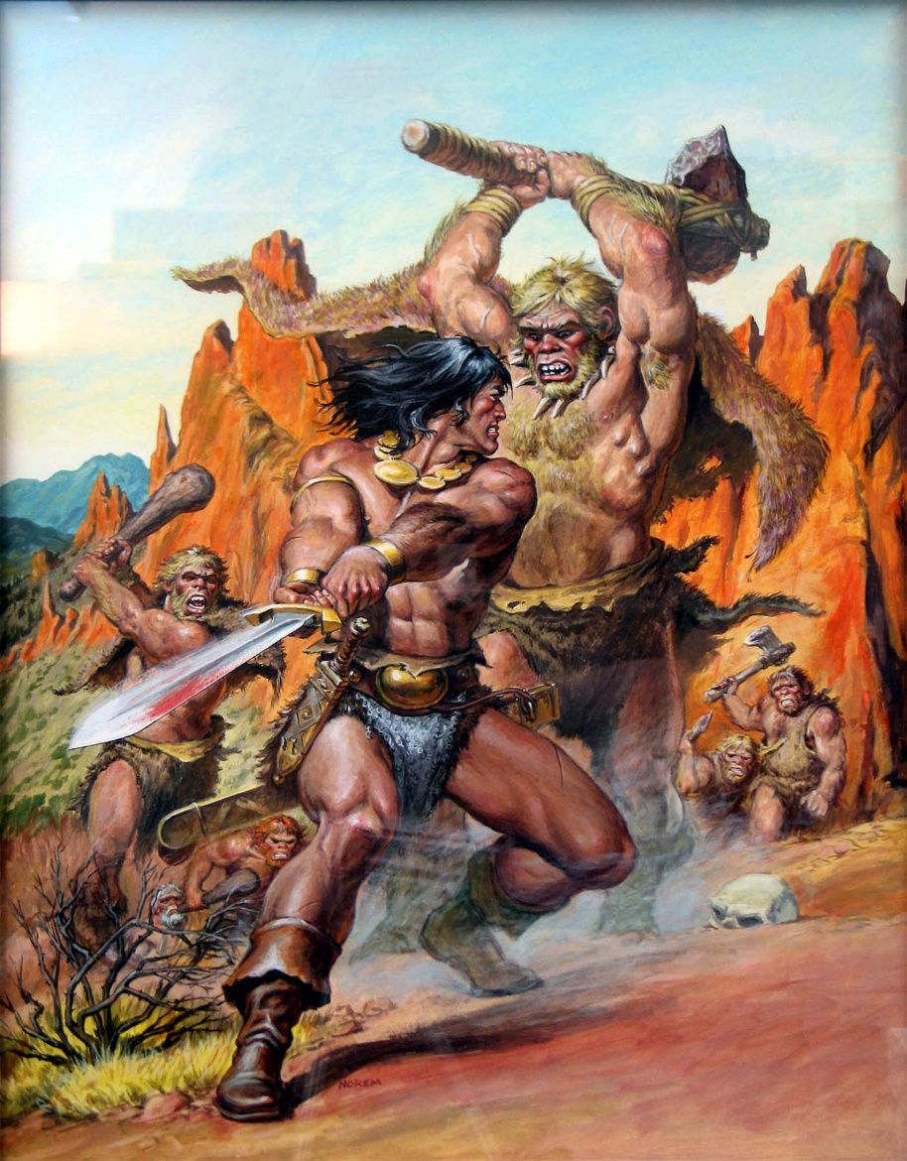

“What do I know of cultured ways, the gilt, the craft and the lie? I, who was born in a naked land and bred in the open sky. The subtle tongue, the sophist guile, they fail when the broadswords sing; Rush in and die, dogs – I was a man before I was king…” – Conan.

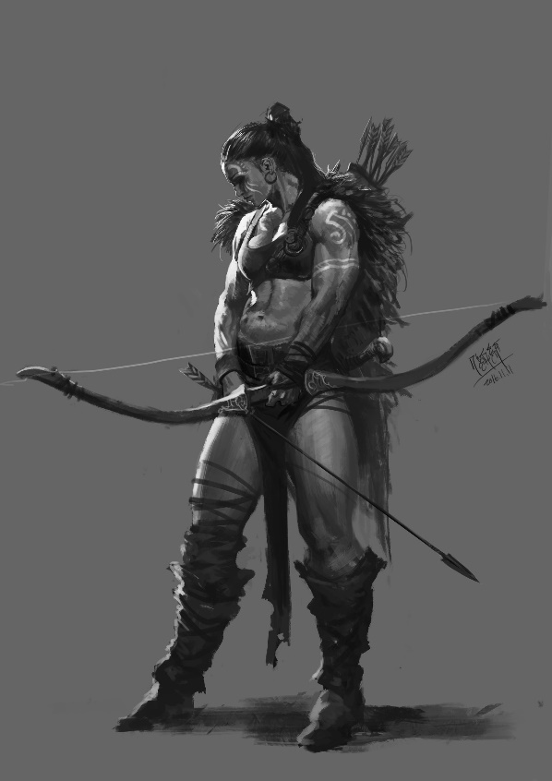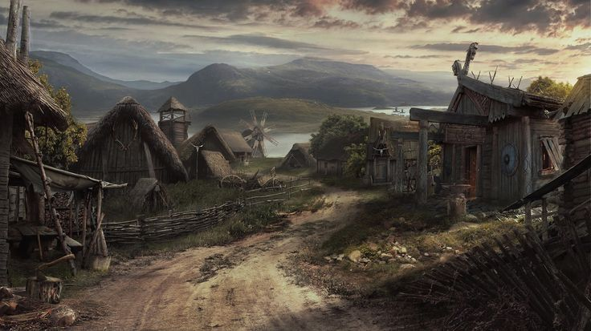

**Genre:** 3rd Person action RPG, single player, orthographic camera, strategy crossed third Person Horror camera hack’s slash.  
**Target Audience:** 16+ (fans of dark fantasy and barbarians)

**Controls:**  Mouse and Keyboard

**Thematic Setting:**  Native Brazil / Medieval Europe / Dark Fantasy / Knights, Swords, Templars, Horror, Sec XII/XIII.

A Barbarian primal rampage thought the enslaved society clamming the feudalistic regime and blind to see the war against their own aristocracy.

**Tech Stack:** Unity, Asset Store

**Platform(s):** Steam

**Anticipated Alpha Game Moment:** 2 Minutes of simple linear level flow with basic combat against 3 or 4 enemies

**Game Summary:** Tumbling, shuffling figures emerge from the sierras rupestres to conquer the native tribe. Mentally injured people suffering horrors were set loose slaving, murderers and rape on these locals. In this adventure, the powerful barbarian can form a group to stop a deranged ganacious emperors work, the darkness responsible for the slaving and abuse. In this ***Isometric tatical point&click/perspective tp hacking slash*** style adventure designed for starting the Barbarian saga, the player will be a barbarian trying to put an end to an feudalistic regime that is eradicating his people. He will hunt the powerfull emperors and crush them, until nothing remain, not their memories or their names.

**Core Player Experience:**Hostile / Discovering a dark art

**Central Story Theme:** Anti-Hero –

**Design Pillar:**  The game has no expectations

about player character survival. not every battle is winnable.

**Remarkability:** The world is dangerous / Absurd(for today's pattern) gore horror moments

**Anticipated Alpha Launch date:** January 2021

**Anticipated Steam Early Access Launch date:** January 2022

**Feature Development Priorities:**

Real-Time combat with tons of different enemies to smash

RPG's abilities and stats

Lvl building

Game progression

**Feature Development Nice to have:**

Branching Dialogue system

Inventory, loot, usable items

**Reference Games:**

Diablo 4, Dark Souls, Shadow of the Demon Lord

**Momento Design:**

1. **One sentence:**  
     
   A few hours after sunset, a slave barbarian handcuffed in chains being whipped and tortured emerges through his pain. his tortures bowl down covered in fetal position claiming for their lives. In labor camps, other workers and slaves are being punished by their persecutors. The persecutors spread out singly or in groups of two and attack the local workers and slaves that are carrying and lapidating rocks.    
     
   If Player saves slaves some of them will join the barbarian to kill persecutors and vice versa.   
     
   For each creature the PCs kill, the allied folk kill two of them. The PCs should not fight more than 1 enemy at a time.
2. **Where**:  
   A pyramid construction per feudal community, close to Serra da Capivara - Piauí. Quite small, home to a few dozen workers and slaves who beg to help them with something to eat or drink to travelers passing through, which are growing less and less common. Sierras full of rock inscriptions surrounds the community for miles.
3. **Trying to do:**Defeat the enemies, stay alive, accumulate good karma to advance to a good ending.
4. **Meaningful choice:**Attack all creatures at once or lure individuals away / Start a massacre or help the townsfolks to cease their torment.
5. **Conclusion:**  
     
    **Just a massacre:**  
     
   Barbarian reaches the pyramid and screams like a primitive monkey. The darkness fades gazing at the pyramid that holds the feudalistic leader symbol. The tower of stone.   
     
     
     
    **On Karma system:**  
     
    The last workers reach the top of the pyramid carrying on his shoulders the remaining stone from it.   
     
    Reaching the top his legs start to shake and the stone fall above him, making the pyramid starts to cry blood through its pores.   
     
   In a morbid scene, the screen fades in an overwhelming light with an orgy scenario, offering all the knowledge and the power that he needs to conquer, the path to the absolute glory that only the strongest can find.  
     
     
     
   **Bad/No Karma (Destined to be a puppet):**   
     
    He joins the light. Fades slowly into it.   
     
     
     
   **God Karma (Free the slaves and workers, kill the tormentors):**  
     
    He breaks the light with one single punch, telling him he's real.   
     
    An afraid nobleman reveals himself behind the illusion, falling.   
     
    The barbarian tells he's nothing more than any other man.   
     
    Enjoy punishing the emperor's scene.