**Project “Urquitar” 1.5-Page GDD**

*The Barbarians village meets Conan and Lovecraft*

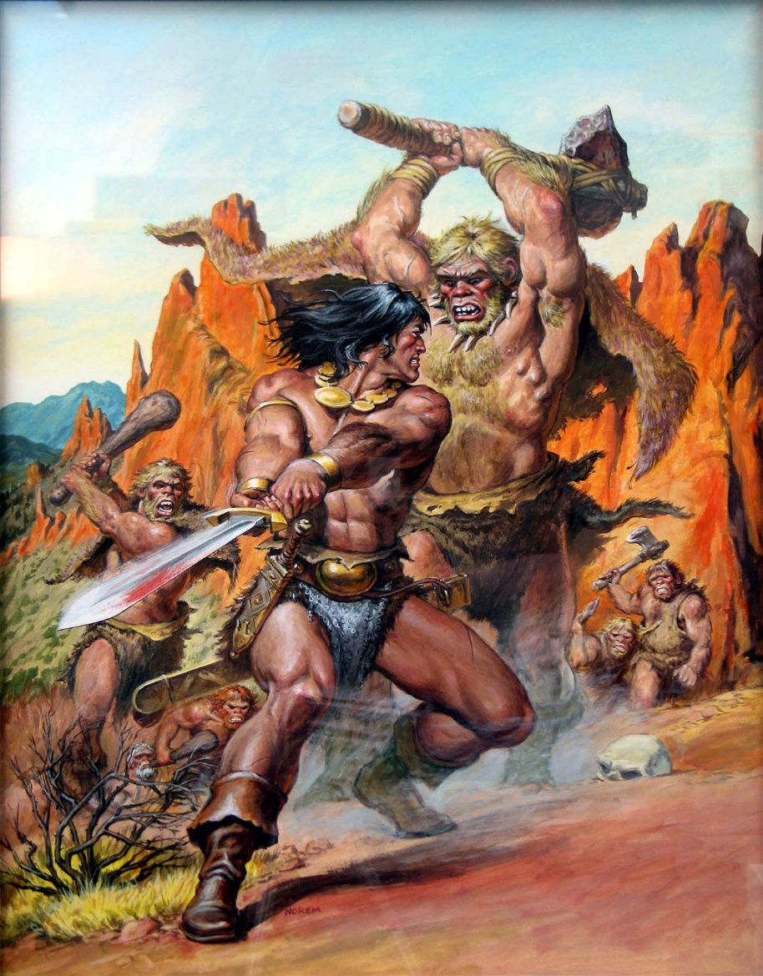

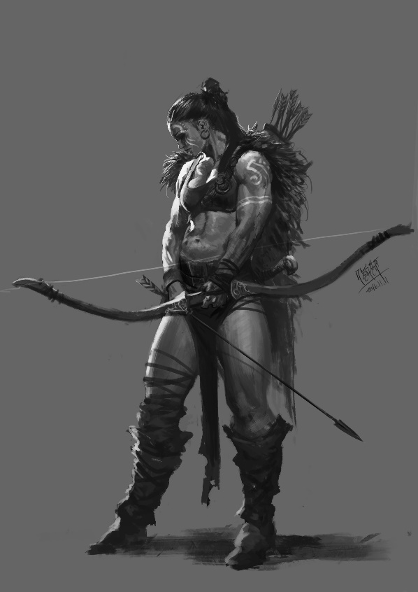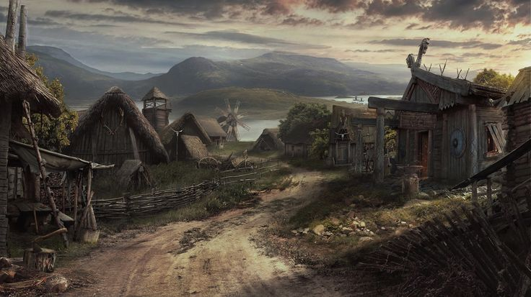

**Genre:** 3rd Person action RPG, single player, fixed-camera  
**Target Audience:** 16+ (fans of dark fantasy and barbarian stuffs)

**Controls:**  Mouse and Keyboard

**Thematic Setting:**  Medieval Europe / Dark Fantasy / Knights, Swords, Templarys, Horror

**Tech Stack:** Unity, Asset Store

**Platform(s):** Steam

**MVP Game Moment:** 2 Minuttes of simple linear level flow with basic combat agains 3 or 4

**Game Summary:** Tumbling, shuffling figures emerge from the wheat fields to attack the people of Urtigueira. Mentally injured souls, these horrors were set loose on the community, but by whom and why? In this adventure, the powerful barbarian form a group to stop a deranged cultist work, the darkness responsible for the souls. In this Diablo 4 style adventure designed for starting the Urquitar saga, the player will be a barbarian trying to put an end to a bad omen that will eradicate his people until nothing remains, not their memories or names.

**Core Player Experience:**Hostile / Discovering a dark art

**Central Story Theme:** Anti-Hero

**Design Pillar:**  The game has no expectations

about player character survival. not every battle is winnable.

**Remarkability:** The world is dangerous / Absurd humor moments

**Anticipated Alpha Launch date:** January 2021

**Anticipated Steam Early Access Launch date:** January 2022

**Feature Development Priorities:**

Real-Time combat with tons of different enemies to smash

All RPG abilities and stats

Lvl building and game progression

Branching Dialogue system

Inventory, loot, usable items

**Reference Games:**

Diablo 4, Dark Souls, Shadow of the Demon Lord

**Design a First Moment:**

1. One sentence:

A few hours after sunset, a band of 8 hollow souls emerges from the fields. They spread out singly or in groups of two and attack the locals. Not long after the fighting begins, a fire starts in one of the houses and unless put out, it will spread through the town. For each hollow soul the PCs kill, the townsfolk kill two of them. The PCs should not fight more than 1 hollow soul at a time. Give Fortune to the first character who takes action to protect the community.

1. Where:  
   A farm community, close to Urtigueira. Quite small, home to a few dozen people who make their living tending to travelers passing through, who are growing less and less common. Wheat fields surround the community for miles.
2. Trying to do:  
   Defeat the hollow souls, stay alive, save town from fire
3. Meaningful choice:  
   Attack all Hollow souls at once or lure individuals away / Let the city burn or help the townfolks to cease the fire

