**Checkfront API Data Migration**

Checkfront is a booking platform that aims to streamline reservations for both businesses and customers, supporting reservations in areas such as tours, activities, rentals, and accommodations.

This project aims to encourage clients of Checkfront’s booking platform to migrate their existing data to the latest version 4 software. By migrating, clients receive access to the latest features and allow Checkfront to better focus their efforts on maintaining their latest software. Thus, Checkfront has tasked team G11 with a data migration application that would take in customer data from Checkfront’s version 3 API and convert it into a format compatible with their version 4 API.

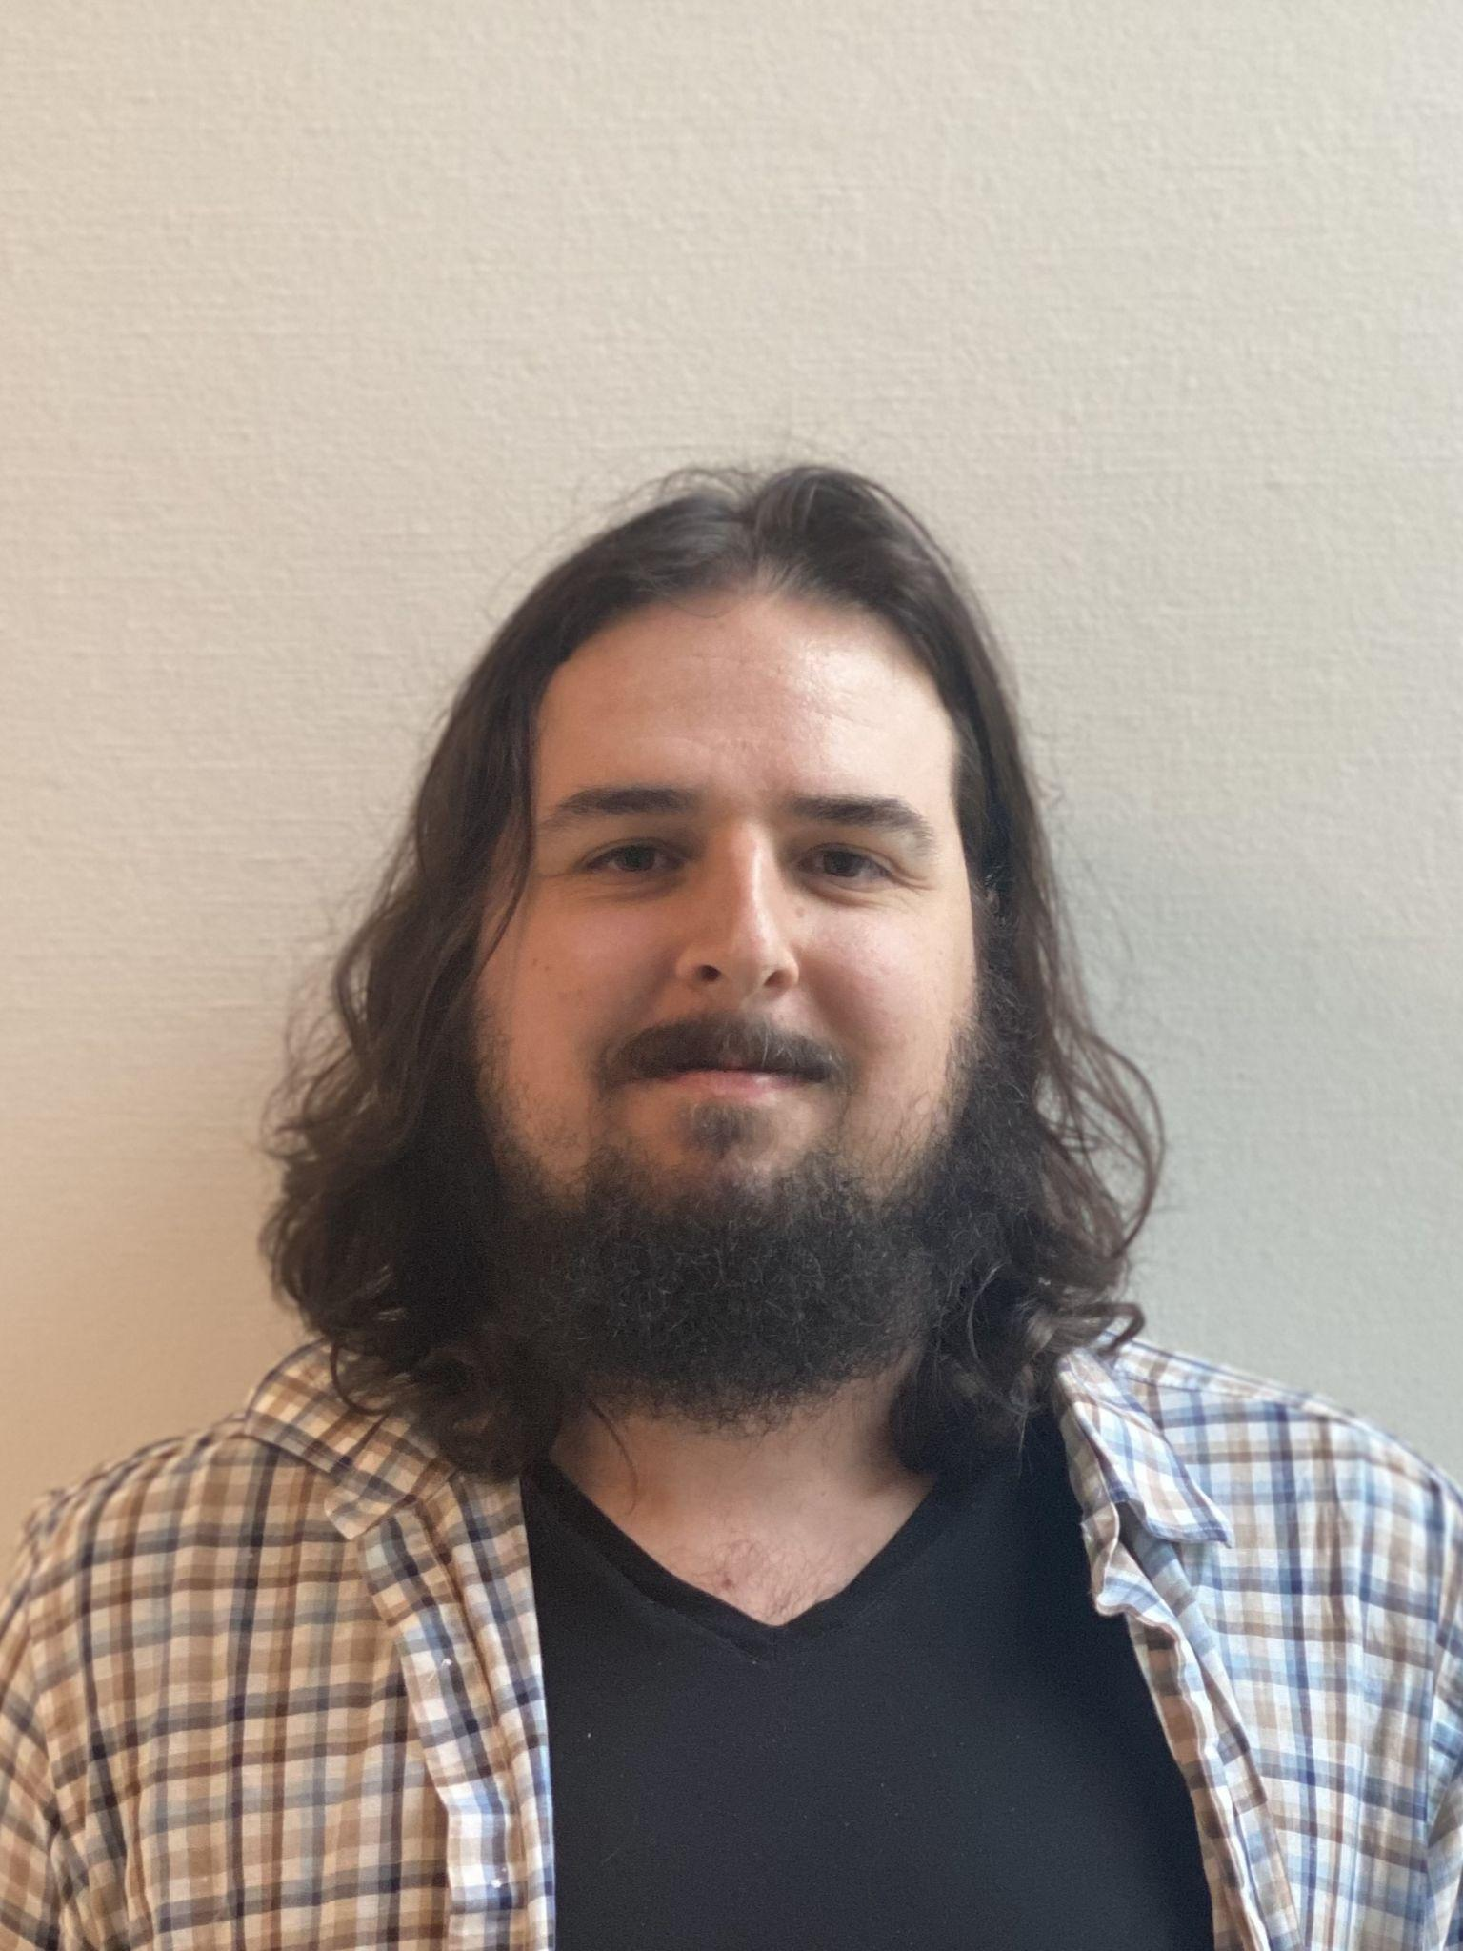

**James Green**

James is a second-year ICS student, eager to graduate from Camosun and begin his life in the computer technology field. He immigrated from England when he was 13 years old and has lived in Victoria, BC ever since then. James’ computer skills lie in DevOps and database management, making him a strong web developer. In his spare time, James enjoys almost anything Star Wars related and participates actively in marathon running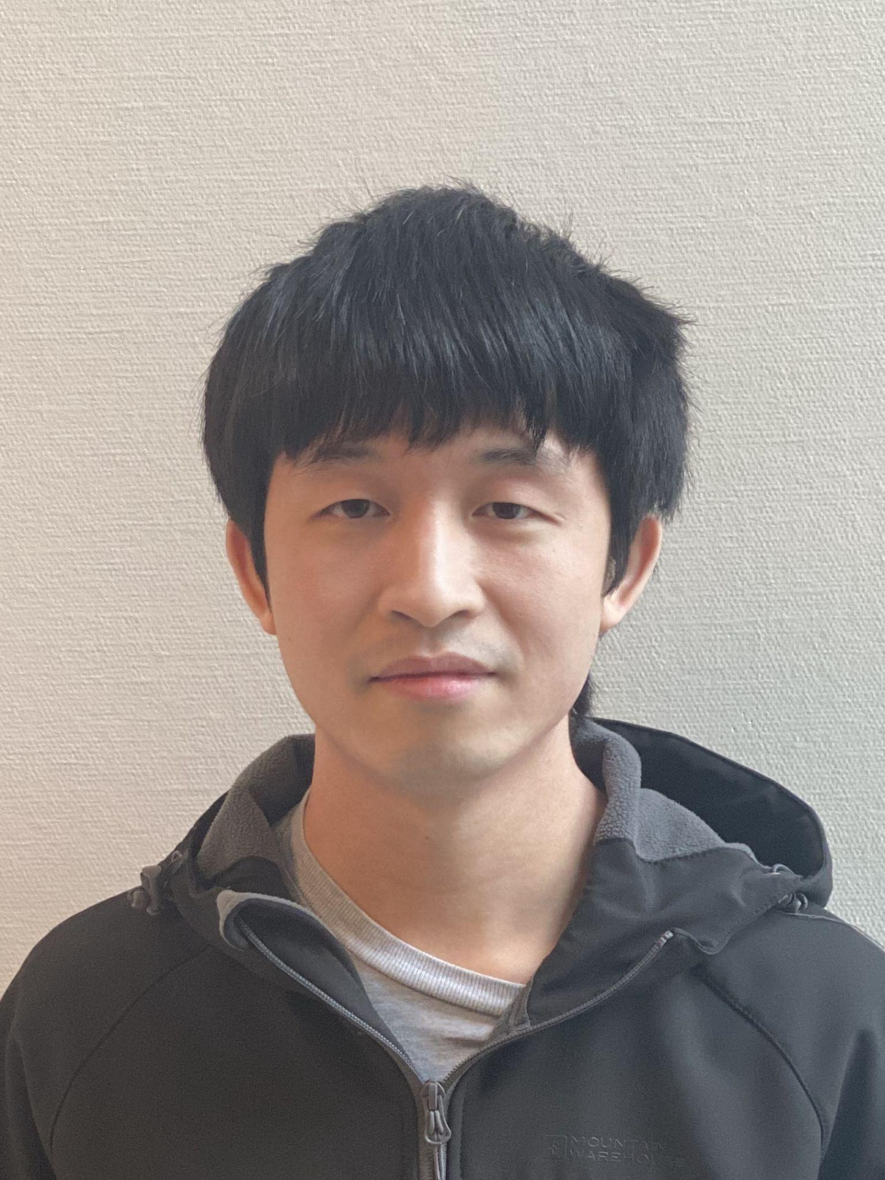

**Joseph O’Young**

Joseph O’Young grew up surrounded by technology and developed an interest in it early on. After a formal introduction in computer science during high school, he is now pursuing a career in IT. His areas of interest are artificial intelligence, machine learning, and systems design. After graduation, he hopes to work as a back-end database developer or a web developer

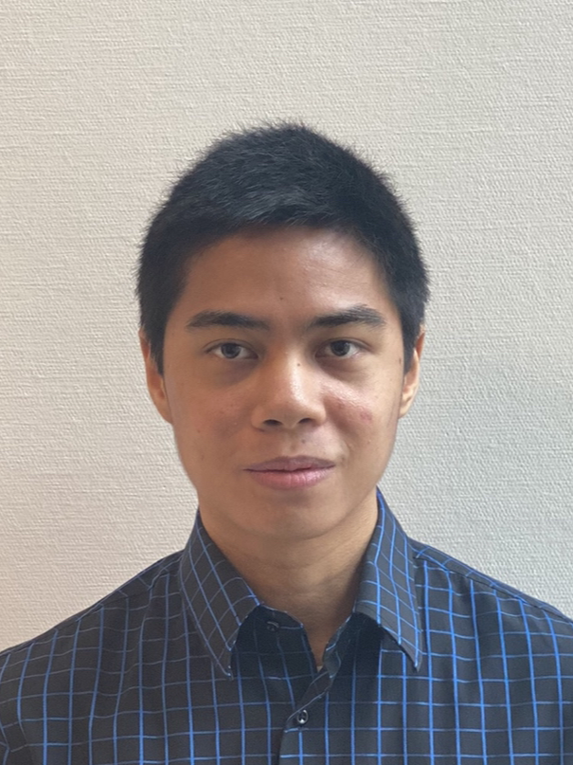

**Gabriel Iturralde**

Born in the Philippines and now living in Canada, Gabriel is a second-year Camosun college IMD (Interactive Media Development) student. Gabriel’s areas of interests lie in front-end web development and UI/UX design, with a casual hobby in 3D modelling. Once graduated, Gabriel wishes to pursue a career in web development.

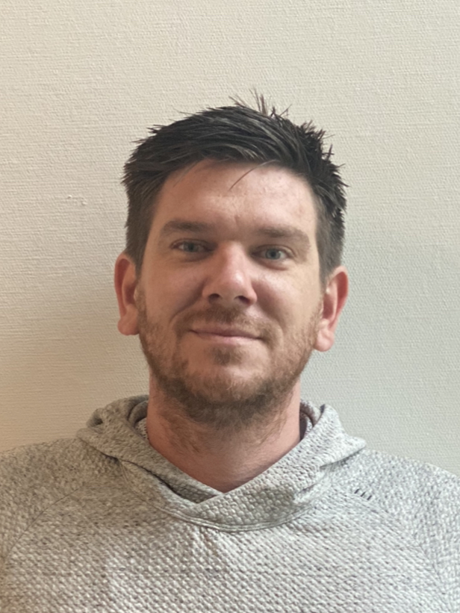

**Chris Walsh**

Chris has lived the majority of his life on Vancouver Island, spending most of his spare time enjoying the mountains and beaches that come with the luxury of living in British Columbia. Chris decided to change career paths after a decade in the construction industry and pursue his interest in technology. Through his program at Camosun, Chris was introduced to and developed skills in many areas of computer systems with a particular interest in security and mobile app development.

Team G11 would like to thank our former and current capstone sponsors Mike Gano and Ryan Launchbury, as well as Saryta Schaerer, Jonas Bambi, and Katie Tanigawa for encouraging us to do our best and providing guidance to our project.