**2020年北京市西城区高三一模英语试卷**

**第一部分：知识运用（共两节，45分）**

第一节 语法填空（共10小题；每小题1.5分，共15分）

阅读下列短文，根据短文内容填空。在未给提示词的空白处仅填写1个适当的单词，在给出提示词的空白处用括号内所给词的正确形式填空。

**A**

The International Day of Families, which was started by the United Nations in 1993, (1) ______ (hold) on May 15 every year. The day celebrates the (2) ______(important) of families. It aims to deepen people’s understanding of issues (3) ______ are related to families. With a different theme each year, the day is observed with a wide range of events that are organized at local, national and international (4) ______ (level).

**B**

For thousands of years, people have been trying to predict the weather. In China during the Shang Dynasty, people (5) ______ (record) weather forecasts on animal bones and tortoise shells. Centuries later, (6) ______ Greece, the philosopher, Aristotle wrote his theories about how weather conditions formed. Weather forecasting advanced over time, with more and more instruments used to measure temperature, humidity and air pressure. Today, satellite data and computer technology help scientists predict the weather more (7) ______ (precise).

**C**

Last year, China started testing 5G mobile networks in several cities. The Hongkou District of Shanghai was the first to operate a 5G network. To test the network, Wu Qing, vice mayor of Shanghai, made a phone call (8) ______ (use) a Huawei MateX, Huawei’s first 5G smartphone. According to The Telegraph, “5G is the innovation that (9) ______ (shape) all our lives for years to come.” It is (10) ______ (fast) and more stable than 4G, the previous generation of cellular (蜂窝状的) network technology.

第二节 完形填空（共20小题；每小题1.5分，共30分）

阅读下面短文，掌握其大意，从每题所给的A、B、C、D四个选项中，选出最佳选项，并在答题卡上将该项涂黑。

It was late, about 10:15 p.m., when Janice Esposito arrived at the Bellport train station; she jumped into her Honda Odyssey and began the 20-minute drive home to her husband and seven-year-old son. She’d just returned from visiting her mother and had traveled the route many times before. She practically ______ (11) on autopilot: a left onto Station Road, then a left on Montauk Highway, and then—wham! Out of nowhere a car T-boned Esposito’s minivan, ______ (12) her to move backward some 100 feet onto the railroad tracks. She______ (13) in the minivan, bruised (撞伤) but mostly just knocked out by the ______ (14) and the airbags.

As it happened, Pete DiPinto was getting ready for ______ (15). He’d just closed his book and was getting under the covers when he heard the sound of metal on metal and breaking glass coming from not far outside his bedroom window. A volunteer ______ (16) and retired teacher, DiPinto, 64, never ______ (17) to think. He grabbed a flashlight and, still dressed in his pajamas (睡衣), ran out the door. “Any firefighter would have done what I did,” he told *Newsday*. “We’re always on ______ (18).”

The first car he came upon, 2,000 feet from his front yard, was the one that had ______ (19) Esposito. Once DiPinto concluded the driver was OK, he looked around and ______ (20) Esposito’s minivan positioned on the the railroad tracks. And then he heard a terrible sound: the bells signaling an oncoming _____ (21).

“The gates were starting to come down,” he told *Newsday.* “I see the headlight of the train.” DiPinto ran quickly to Esposito’s minivan and knocked on the driver’s side window. She ______ (22) looked at him, her eyes unfocused. “I don’t know where I am,” she said. She seemed unhurt. “Honey, you’re on the railroad ______ (23),” DiPinto shouted. “We have to get you off right now!” He pulled hard on the ______ (24), but the door was crashed in and ______ (25). The heavy diesel train, traveling at 65 miles per hour, was moving fast toward them. DiPinto ran to the passenger side and threw open the ______ (26). “Please, don’t let her be ______ (27),” he thought. He pushed aside the deflating (瘪了的) airbags, grabbed Esposito’s arms, and ______ (28) her toward him across the passenger seat until he could help her out and quickly get her to ______ (29) behind a signal box a few feet away. Within six seconds, he estimated, the train crashed into the minivan. “It was like a Hollywood movie,” DiPinto told reporters the next day.

But this one had a twist. “Last night,” South Country Ambulance chief Greg Miglino told *CBS New York*, “the ______ (30) arrived in pajamas, not in a fire truck.”

11. A. drove B. walked C. rode D. hiked

12. A. allowing B. forcing C. ordering D. reminding

13. A. sat B. stood C. hid D. waited

14. A. action B. noise C. impact D. bomb

15. A. class B. work C. dinner D. bed

16. A. doctor B. driver C. firefighter D. engineer

17. A. stopped B. troubled C. intended D. wanted

18. A. duty B. time C. target D. schedule

19. A. warned B. caught C. hit D. followed

20. A. observed B. spotted C. realized D. predicted

21. A. train B. truck C. car D. ambulance

22. A. yet B. just C. still D. even

23. A. yards B. stations C. bridges D. tracks

24. A. belt B. key C. bell D. handle

25. A. unlocked B. jammed C. open D. gone

26. A. bag B. door C. book D. box

27. A. scared B. ignored C. trapped D. defeated

28. A. carried B. rushed C. guided D. pulled

29. A. return B. work C. safety D. life

30. A. police B. actor C. reporter D. hero

**第二部分：阅读理解（共两节，40分）**

第一节 （共15小题；每小题2分，共30分）

阅读下列短文，从每题所给的A、B、C、D四个选项中，选出最佳选项，并在答题卡上将该项涂黑。

**A**

**What it does**

The self-cleaning door handle is combining with advanced photocatalytic (光催化) and blacklight technology. A light source activates the door’s handle coating, telling it to start cleaning. It can minimize the risk of infection by contact and improve the cleanliness of a space.

**How it works**

The working principle of the product is that a thin advanced photocatalytic coating can effectively decompose bacteria (细菌) on the surface of a substance. A consistent UV light source—inside a transparent glass door handle—is required to activate the door’s handle coating on the outer surface for disinfection, so a generator is used to provide electricity to light up a UV LED lamp by the motion of an opening and closing door. Then, the door handle can clean by itself.  
**Design process**

We made the first version by using stainless steel. However, it caused the door handle to be heavier. Then, we tried aluminum, which made it light and easy to fix. We also improved the generator output which effectively turned energy from door movement into a light source.  
**How it is different**

Our innovative design is simple, effective, and attractive. It has an elegant smooth shape, and its minimalist appearance stands out in today’s world of inventions. Nowadays, people use chemical cleaning materials to clean up public areas but it harms the human body. Our design can be used for a long time and is effective. It can self-clean after each use. In the door lock and door handle market, it is a unique design because there are no similar products.  
**Future plans**

In the future, we will commercialize the product and hope that it can compete on the market with similar products. We are going to connect with public properties, for example, shopping malls, hotels, hospitals and public restrooms, where the risk of spreading infection is higher.

**Awards**

In addition to winning the James Dyson Award, it has also received the Gold Award, and in 2016, it was featured in the 44th International Geneva Inventions Exhibition.

31. How does the self-cleaning door handle function?

A. It controls the door movement automatically.

B. It minimizes the risk of infection by less contact.

C. Chemical cleaning materials are used to clean it up.

D. The light source tells the door handle coating to clean itself.

32. Compared with the first version of the product, the present one is ________.

A. safer and cheaper

B. cleaner and easier

C. less heavy and more effective

D. more attractive and expensive

33. What do we know about the new invention according to the passage?

A. It has been widely used in public areas.

B. It has received recognition for its innovation.

C. It is quite competitive among similar products.

D. It will replace traditional chemical cleaning materials.

**B**

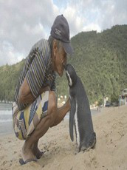This little South American Magellanic penguin swims 5,000 miles, to a beach in Brazil, every year in order to be reunited with the man who saved its life. It sounds like something out of a fairy tale, but it’s true!

71-year-old retired brick worker Joao, who lives in an island village just outside Rio de Janeiro, Brazil, found the small Magellanic penguin lying on rocks at his local beach in 2011. The penguin was covered in oil and running out of time fast. Joao rescued the penguin, naming it Din, cleaned the oil off its feathers and fed him a daily diet of fish to rebuild its strength. After a week of recovery, Joao attempted to release the penguin back into the wild. However, Din had already formed a family bond with his rescuer and wouldn’t leave.

“He stayed with me for 11 months and then, just after he changed his coat with new feathers, he disappeared,” Joao recalls. “I love the penguin like it’s my own child and I believe the penguin loves me,” Joao told Globo TV. “No one else is allowed to touch him. He pecks (啄) them if they do. He lies on my lap, lets me give him showers, and allows me to feed him.”

Professor Krajewski, a biologist who interviewed the fisherman for Globo TV, told The Independent: “I have never seen anything like this before. I think the penguin believes Joao is part of his family and probably a penguin as well.”

However, environmentalists warn that, while hundreds of the Magellanic species are known to naturally migrate (迁徙) thousands of miles north in search of food, there has been a worrying rise in the phenomenon of oceanic creatures washing up on Brazil’s beaches. Professor David Zee from Rio de Janeiro’s State University, said the increase is due in part to global climatic changes. Professor Zee added that sea animals face increased danger from leaked tanker oil.

Luckily the ending for Joao and Din has been a happy one, even though it is illegal in Brazil to keep wild animals as pets.

Professor Krajewski said: “Professionals who work with animals try to avoid relationships like this occurring so they are able to reintroduce the animal into the wild. But in this single case the authorities allowed Din to stay with Joao because of his kindness.”

34. Every year Din swims a long distance to a beach in Brazil to ______.

A. avoid being killed

B. meet his rescuer

C. escape from ocean currents

D. find much more fish

35. When Din was found in 2011, ______.

A. he was dying

B. he was running on the beach

C. he was resting on a rock

D. he was cleaning oil off his feathers

36. What can we learn about Joao from the passage?

A. He is not allowed to keep the penguin as a pet by the authorities.

B. He overprotects the penguin by keeping him away from others.

C. His contact with the penguin is encouraged by professionals.

D. His kindness wins the penguin’s trust.

37. The story in the passage mainly shows ______.

A. the environmental impact on wildlife

B. the love between humans and wildlife

C. the tendency of wildlife to bond with humans

D. the protection of threatened wildlife by mankind

**C**

Store owners have been inventing new tricks to get consumers into their stores and purchasing their goods. Even as we find new strategies to resist, neuroscientists (神经科学家) are employed at marketing agencies across the country to best figure out what is going through a consumer’s brain at each point in the decision process.

We consumers overspend due to the fact that we have a fear of missing the really good deal or having to pay more for the same thing and lose money. Normally, the prefrontal cortex (前额皮层) controls our emotional reactions to things, and keeps us from acting unreasonably by calming down our fears. But an advertiser can disturb our prefrontal cortex just by displaying flashy deal signs, encouraging it to do math on how much money we might save now by buying more of something we don’t actually need yet.

Nostalgia, that regretful affection for past events, is another strong influencer during the holiday season, and it’s shaped by emotion. Emotion—whether good or bad—enhances the formation of memories, engaging more parts of the brain. So hearing a nephew singing a carol, for instance, might reawaken memories associated with that particular song in a much more powerful way than hearing that same nephew sing another song. These kinds of memories are brought back even more easily by sensory input. This might be why we are often greeted by a sensory reminder everywhere we go in a month.

Wherever you purchase gifts, there are social influences on what you buy as well. The holidays are a time when we are especially conditioned to pay more for the label because we’re buying gifts. Receiving a brand-name gift sends the message that “this person has spent more on me, so he or she must value me more.” And it makes sense. If two things seem pretty much the same, how do I know which to choose? Humans have survived as a social species, and we have to rely on each other. So when our brains are trying to make decisions, one of the shortcuts is to assume that if a lot of other people prefer something (and higher cost is often a predictor of that), then there must be a reason.

Much of our holiday spending is driven by unplanned purchases. Plan ahead, resist the urge to purchase in the moment, make notes for comparison shopping, and if the deal is actually good, then it will hold up to inspection and you’ll feel good about your purchases later. Before you blow your budget this season, remember that your brain might be fooling you into that next purchase.

38. From Paragraph 2, we learn that .

A. the prefrontal cortex is the calculation center

B. the common consumers always act unreasonably

C. the sight of flashy deal signs may fill consumers with fear

D. the advertisers make consumers pay more for the same thing

39. According to Paragraph 3, which of the following can work on consumers?

A. Creating a festival atmosphere.

B. Following the current fashion.

C. Preparing more free samples.

D. Offering a bigger discount.

40. Why do we buy brand-name gifts during the holiday?

A. They are more reliable.

B. They are a sign of social status.

C. They make people feel valued.

D. They are favored by most people.

41. To avoid overspending, the author suggests we .

A. buy in the moment

B. reduce our budget

C. return unnecessary products

D. make a plan in advance

**D**

The Impossible Burger is entirely free of meat. But it looks, smells, feels and—most importantly—tastes so much like real hamburger beef. In fact, plant-based burger alternatives have set off a strong resistance from the beef industry. The Center for Consumer Freedom, a nonprofit that advocates on behalf of the fast food and meat industries has launched an “informational” campaign targeting plant-based meats. The campaign has included TV and online ads, as well as print ads in newspapers. The ads seem to imply that not only is an artificial burger too processed, but that it might be even less healthy than the average beef burger.

While it’s true that a plant-based meat alternative is processed and it’s true that eating one is not as healthy as a pile of raw vegetables, it’s best to take the ads with a generous pinch of salt.

For instance, the additives and preservatives in plant-based meat highlighted in one ad sure sound scary. Who wants something called titanium dioxide（二 氧 化 钛）in their meal? But the truth is that additives such as those listed in the ads are regularly used in all sorts of packaged foods. And if methylcellulose, a food thickener, sounds unpleasant, it’s really nothing compared with salmonella（沙门菌）poisoning you can get from regular meat.

Also, the ad campaign misses the bigger point. Choosing an Impossible or Beyond burger isn’t just about eating healthy. Burgers, whether they are made from processed pea protein or processed meat, will never be as healthy as organic raw vegetables.

What’s appealing is the prospect of enjoying a juicy burger without the bitter aftertaste of guilt.

Let’s face it, there are huge environmental costs to eating cows. Cattle raising is contributing to climate change, and not just because methane（甲烷）from cows and cattle is responsible for about 14.5% of greenhouse gas. More broadly, our global food production system releases more than a third of the world’s greenhouse gases. Yet we can’t seem to control our meat appetite even knowing that large areas of the Amazon forest have been ruined, and continue to be cut down to make room for more cattle to feed the growing demand for beef. Humans also know full well that many animals live short, cruel lives in awful conditions for the purpose of becoming foods for humans to enjoy at dinner.

A plant-based meat that satisfies meat desires and delivers protein but with a smaller climate footprint is a potential environmental game changer and the reason Impossible Foods was one of those receiving the U.N. Global Climate Action Award in 2019. No wonder the meat industry is on guard.

42. What does the underlined sentence in Paragraph 2 most probably mean?

A. These ads deserve little consideration.

B. We should spread the message of these ads.

C. We’d better be cautious when reading these ads.

D. These ads tell people a lot about plant-based burgers.

43. What do we know about additives and preservatives in plant-based burgers?

A. They are likely to cause poisoning.

B. Their use is within the normal range.

C. Some have not been used in hamburgers.

D. They are used to ensure burgers taste good.

44. What is the author’s attitude towards plant-based burgers?

A. Supportive.

B. Neutral.

C. Disapproving.

D. Doubtful.

45. Which of the following shows the development of ideas in the passage?

B. 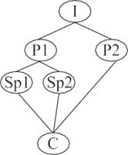

第二节 （共5小题；每小题2分，共10分）

根据短文内容，从短文后的七个选项中选出能填入空白处的最佳选项。选项中有两项为多余选项。

**Fashion and Identity**

For hundreds of years people have put some message in the type of clothing they wore. Long ago people started wanting to stand out from the “crowd” and be different from other people by means of changing their clothing. Some examples of these “standing out” became very popular and were followed by more people. ______ (46) Nowadays, fashion has become a necessary part of one’s self-realization and clothing is basically a covering designed to be worn on a person’s body. This covering is a “necessity”, which brings a lot of variety into the lives of people and makes their image more complete.

The type of clothing completely depends on the person wearing it and becomes a reflection of personal identity. Lately, a lot is being heard about its meaning in the life of every single person on the planet. The choice of clothing is as important as identification through the color of hair, skin and gender. As every piece of clothing carries a strong message about its owner, every owner “nests” a certain value in it depending on his mindset or today’s mood. Therefore, the clothing of a person is a means of communication with the outside world. ______ (47)

Clothes have a significant impact on the understanding of the people nearby as well as the person wearing them. For instance, a suit can make a person feel more confident and organized, which would eventually change even the gestures of the person. ______ (48) Sometimes, fashion may play a vital role in a person’s life, especially when the person is applying for the job he wants. Fashion also creates a message that is required by a situation the person finds himself in. This can be simply proved by analyzing one’s reaction on people wearing different types of clothing. ______ (49) Thus, even the smallest companies make wearing a suit one of the requirements for their employees.

______ (50) Fashion, with all its symbolism and features, form an outstanding base for personal and cultural identification. It is a part of the self-realization that is required for finding a place in life and has become a tool for achieving harmony with the inner world. The more diverse the society around us, the more fashion-trend will appear and surprise us.

A. Fashion helps us realize our dreams.

B. This was the moment when fashion appeared.

C. Fashion and identity are inseparable companions.

D. Clothing was designed to serve people in their daily life.

E. The preference is always given to people dressed in “business style”.

F. It is the way of telling people about the “state” and the “status” of its owner.

G. Wearing jeans after a suit may change the conduct of a person to a very casual one.

**第三部分：书面表达（共两节，35分）**

第一节 （15分）

假设你是红星中学高三学生李华。你的英国好友Jim在做关于“中学生做家务”的调查，想了解你做家务的情况。请你给他回复邮件，内容包括：

1）你平时做哪些家务；

2）你对中学生做家务的看法。

注意：1. 词数不少于50；

2. 开头和结尾已给出，不计入总词数。

*Dear Jim,*

______________________________________________________________________________________________________________________________________________________________________________________________________________________________________________________________________________

*Yours,*

*Li Hua*

**（请务必将作文写在答题卡指定区域内）**

第二节 （20分）

假设你是红星中学高三学生李华。上周,你们班参加了学校的“爱科学月”板报展活动。请根据以下四幅图的先后顺序，写一篇英文周记，记述整个过程。

注意：词数不少于60。

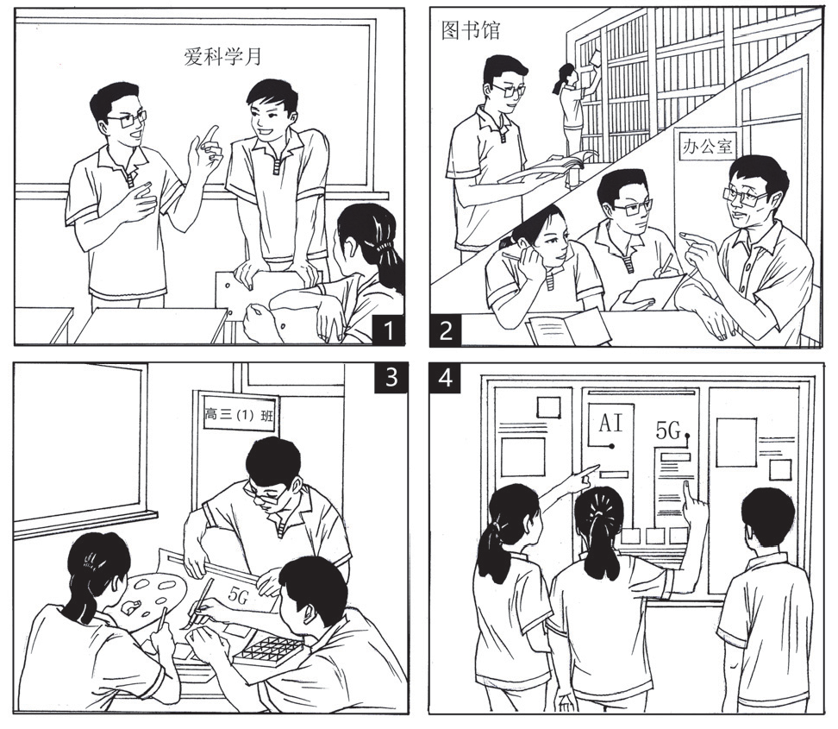

**（请务必将作文写在答题卡指定区域内）**

**2020年北京市西城区高三一模英语试卷**

**英 语**

**参考答案及评分标准**

**第一部分：知识运用（共两节，45分）**

第一节 语法填空（共10小题；每小题1.5分，共15分）

1. is held 2. importance

3. that/which 4. levels

5. recorded 6. in

7.precisely 8. using

9. will shape 10. faster

第二节 完形填空（共20小题；每小题1.5分，共30分）

11. A 12. B 13. A 14. C 15. D

16. C 17. A 18. A 19. C 20. B

21. A 22. B 23. D 24. D 25. B

26. B 27. C 28. D 29. C 30. D

**第二部分：阅读理解（共两节，40分）**

第一节 （共15小题；每小题2分，共30分）

31. D 32. C 33. B 34. B 35. A

36. D 37. B 38. C 39. A 40. C

41. D 42. C 43. B 44. A 45. D

第二节 （共5小题；每小题2分，共10分）

46. B 47. F 48. G 49. E 50. C

**第三部分：书面表达（共两节，35分）**

第一节（15分）

**One Possible Version**

*Dear Jim,*

Knowing you are conducting a survey of the housework that high school students do at home, I’m writing to tell you about what I do.

Although my school schedule is rather tight, I still manage to help with the housework from time to time. I will clean up after dinner. I also help with other things like sweeping and dusting. Every once in a while, I will cook something for my family. So far, my spaghetti has been the most delicious dish.

I think high school students should do some housework. For one thing, by doing housework we learn to take responsibility at home, and in the longer term, in society. For another, I find the time spent doing housework with my parents really fun and rewarding; we chat with each other and sometimes even sing together. Doing housework can be a great break from my busy school work.

Good luck with your survey.

*Yours,  
Li Hua*

第二节（20分）

**One Possible Version**

Last month, our class participated in the school poster exhibition with the topic “We Love Science”. We had a memorable experience working together.

Having been informed of the activity, we put forward ideas as to the contents of the poster. After a brief discussion, we agreed on the subjects of AI and 5G, since they are the hottest topics of the advanced technologies.

No time was wasted in our preparation. We first went to the school library to research the history and development of the two fields. When realizing that the library couldn’t provide us with enough information about cutting-edge technologies, we turned to our teacher for help, who proved to be a valuable resource and gave us lots of practical advice.

With the material collected, we got down to making our poster. Each of us had been assigned different tasks, to which we devoted all our efforts. We designed, wrote and painted. I even framed the poster to make it more eye-catching.

On the day of the exhibition, our elaborately designed poster attracted much attention. The students gathered in front of our poster, appreciating our work. Filled with pride, we are looking forward to the next activity.