GELBOX: OPEN-SOURCE SOFTWARE TO IMPROVE RIGOR AND REPRODUCIBILITY WHEN ANALYZING GELS AND IMMUNOBLOTS

Utku Gulbulak1, Thomas Kampourakis1, Kenneth S. Campbell1,2, *

1 Division of Cardiovascular Medicine, University of Kentucky, Lexington, KY, USA

2 Department of Physiology, University of Kentucky, Lexington, KY, USA

* Corresponding author

ABSTRACT

INTRODUCTION

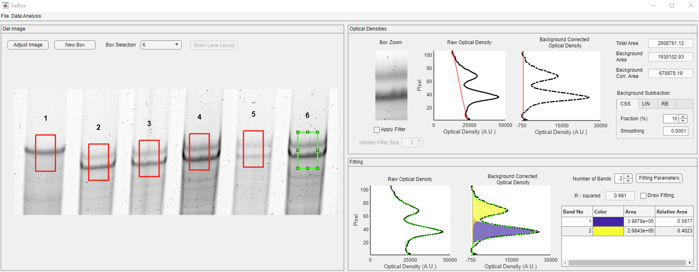

Figure 1. GelBox user interface. GelBox user interface, the green box shows the selected ROI and the resulting density profiles, and curve fits are automatically calculated. A.U. stands for arbitrary units. The illustrative image shows a 1% agarose gel stained with Oriole fluorescent stain (Bio-Rad Laboratories, Hercules, CA). Lane 1 shows a rat soleus sample with the most prominent band corresponding to the N2A isoform of titin. The other lanes show the N2B and N2BA isoforms of titin in samples prepared from human ventricular myocardium.

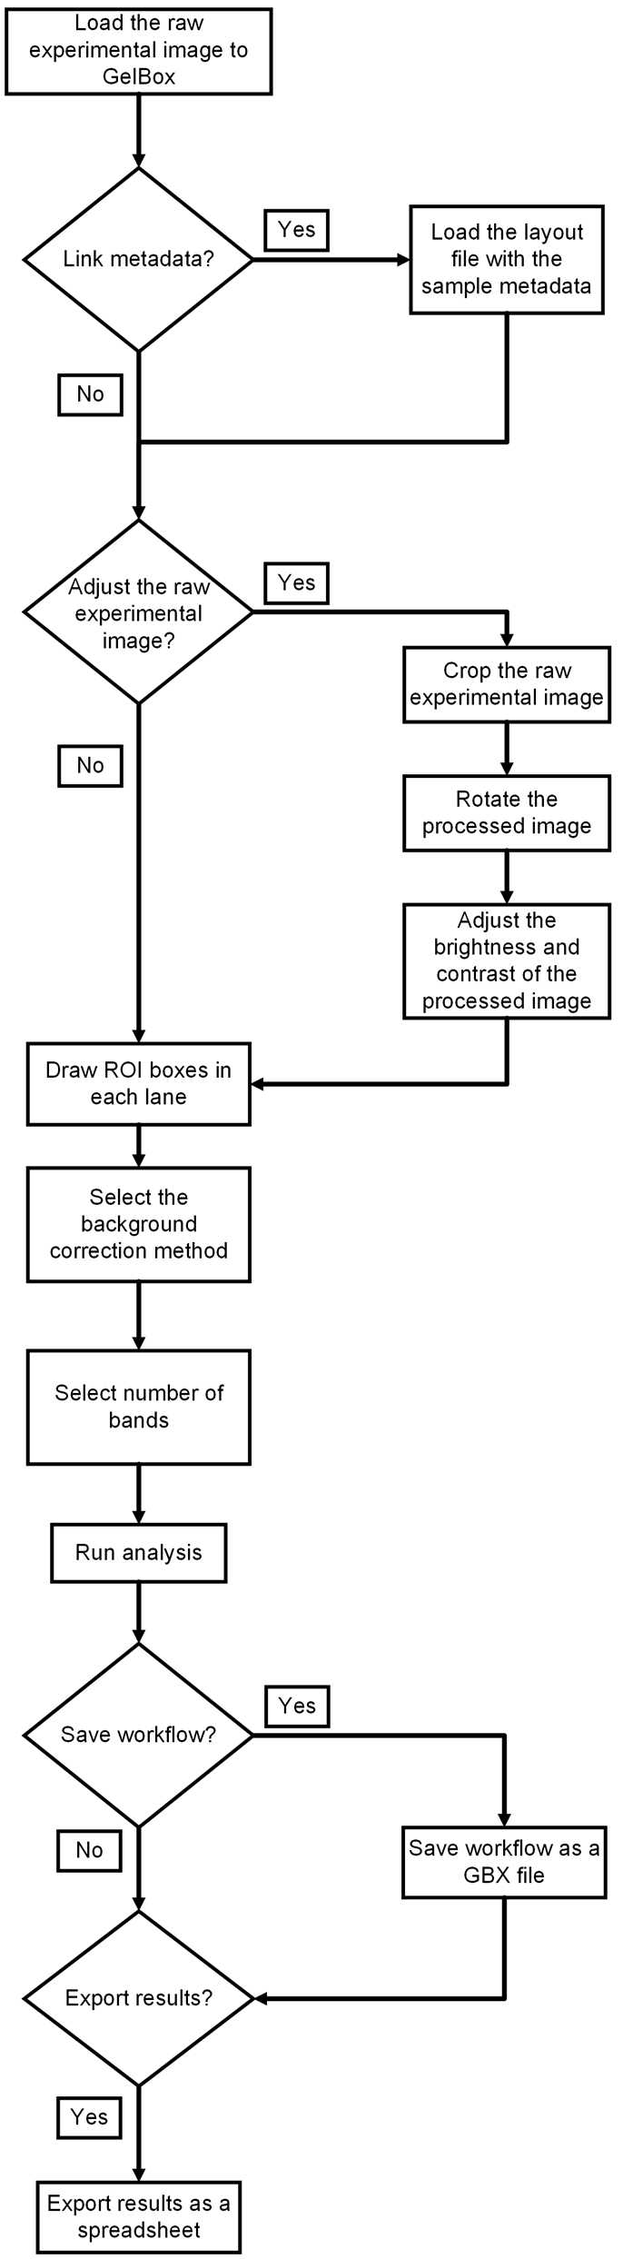

Figure 2. Analysis workflow.

Human tissue samples

All the gels and blots shown here are data generated by our lab using human myocardium samples collected from the explanted hearts of donors and transplant recipients. The University of Kentucky Institutional Review Board approved the collection procedure (IRB 46103). The patients gave informed consent for the use of their samples. The collection and storage protocol of the specimens were explained elsewhere (4).
Biochemical assays

Cardiac titin isoform, N2B, and N2BA separation was performed using a protocol from Greaser and Warren (5). Briefly, previously frozen 10 mg of human left ventricular tissue samples stored at -80ºC were pulverized with a liquid nitrogen cooled glass tissue grinder (Kimble Kontes, Vineland, New Jersey) until a fine powder was left. The pulverized tissue was tempered on ice for 20 minutes and then resuspended in 8M urea buffer and 50% glycerol buffer. Samples were mixed within the glass tissue grinder for 1 minute and then immediately incubated at 73ºC for 12 minutes. After incubation, samples were plunged 10 times using a syringe with a 21-gauge needle and spun at 15,000g for 5 minutes. About 800 µg of protein was loaded into each lane of a 1% vertical sodium dodecyl sulfate (SDS)-agarose resolving gel containing 30% glycerol. The first lane of the gel was loaded with a rat soleus sample as a loading control since it prominently expresses the N2A isoform of titin. Gel was run for 3.5 hours at 30 mA in a 4°C fridge. For isoform analysis, gels were stained with Oriole fluorescent gel stain (Bio-Rad Laboratories, Hercules, CA) and scanned on a ChemiDoc imaging system (Bio-Rad Laboratories, Hercules, CA). The images were saved in a 16-bit raw TIF format.

For the blots probing the phosphorylation of cardiac Myosin Binding Protein-C (cMyBP-C) at Ser302, samples of human left ventricular myocardium were submerged into 4M urea extraction buffer with phosphatase and protease inhibitors, homogenized in a bead homogenizer, and subsequently boiled for 5 minutes to solubilize the proteins. Approximately 10 ug of each sample was loaded into each lane of an 8% acrylamide gel that consisted of 0.5% (v/v) Tri-chloroethanol (TCE) to allow for stain-free total protein quantification (6). Each lane was loaded with samples from different patients. In addition, each gel had negative and positive control lanes containing samples treated with Lambda Protein Phosphatase (P0753S, New England BioLabs) and PKA (539576, Sigma), respectively. Gels were run for 3 hours at 160 V, imaged for total protein, then transferred to a PVDF membrane and probe with a custom phosphorylation specific antibody targeting cMyBP-C’s Ser302 site (ProSci Incorporated, 1:10,000 dilution) overnight (7). Then, a goat anti-rabbit IgG (H&L) secondary antibody (32460, ThermoFisher, 1:10,000 dilution) was used with a 1 minute rinse in SignalFire ECL Reagent (6883S, Cell Signaling Technology) prior to imaging. Blots were scanned on a ChemiDoc Imaging System (Bio-Rad Laboratories, Hercules, CA), and the images were saved in 16-bit raw TIF format.

Metadata

Gels and immunoblots have several different types of metadata. One type describes the image itself (for example, file size, image format). This is stored in the GelBox data file and can be exported to a text file when useful. Another type of metadata describes the samples (for example, species, sex, protein concentration) and must be provided by the user. GelBox allows the user to upload this lane-level information from a spreadsheet at which point it can be merged with the results of the band analyses. There is no practical limit to the amount of sample information that can be added. Users can include as many fields as the spreadsheet format will accommodate.

Image files and adjustments

GelBox allows users to load images in any format that MATLAB can open. This includes most of the commonly used formats in this area of science including TIF (Tagged Image File Format), PNG (Portable Network Graphics), BMP (Windows Bitmap), GIF (Graphics Interchange Format), JPEG (Joint Photographic Experts Group), JPEG 200 (Joint Photographic Experts Group 2000), and PGM (Portable Graymap). The resolution of the imported images is a crucial factor in the analysis process. Low resolution images provide less information and may compromise the results. Users can crop their images to a desired size, rotate the image if necessary, and then adjust the brightness and contrast as needed. Additionally, users can invert their image if needed. GelBox does not allow users to perform gamma correction as this adjustment can change the relative intensity of bands.

Regions of interest

Users define a region of interest (ROI) on each lane they want to analyze by drawing a rectangular box on the image. The ROI must be at least one pixel wide and cannot exceed the size of the image but it is otherwise unrestricted. If multiple boxes are drawn, GelBox ensures they all have the same size. If the user changes the size of a box, the other boxes resize automatically. If metadata have been provided, each ROI is linked to the appropriate information.

Analysis

Many investigators want to quantify the intensities of bands in their images. Two factors that complicate this task are background correction and potential overlap between band profiles. GelBox provides tools that handle these issues with reproducible data-driven approaches.

Background correction

GelBox allows the user to remove trends in the background data using one of three methods: cubic smoothing spline, straight line, and rolling ball (Figure 3). The cubic smoothing spline method marks portions at the ends of the density profile and interpolates a cubic spline between these segments. The straight-line method follows a similar approach, where the sampled points are used to fit a straight line. Lastly, in the rolling ball method, a circular element is ”rolled” under the density profile. The route tracked by the center of the element is used to define the background intensity (8). GelBox has default values for cubic spline (fraction and smoothing), straight line (fraction), and rolling ball (ball size) parameters. Users can change these parameters to modify the estimated background through the user interface.

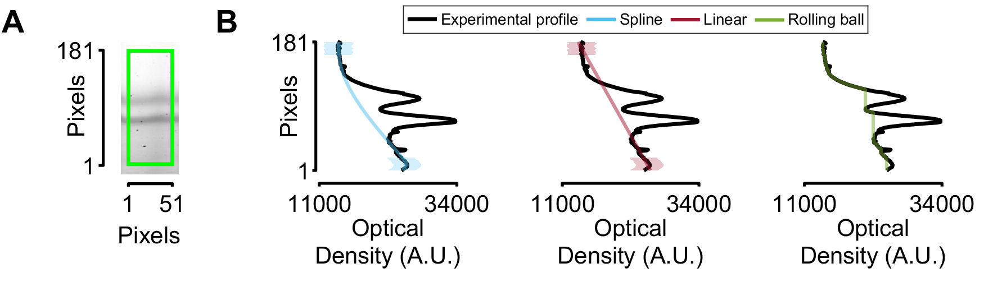

Figure 3. Background correction methods. (A) Region of interest from a gel showing isoforms of cardiac titin. (B) Density profile and estimated background profiles with three methods. The shaded colored areas highlight the portions at the ends of the profile that are used to estimate the background with the cubic smoothing spline and linear approaches.

Band quantification

GelBox quantifies the total density associated with each band by fitting mathematical functions to the profile of the region of interest. Our lab has already published a variant of this method (9) and showed that it provides more accurate quantification than splitting density profiles with straight lines when band profiles overlap. GelBox’s implementation extends on the prior method by allowing analysis of more than 2 bands simultaneously. Specifically, GelBox fits the sum of n (potentially asymmetric) Gaussians to the band profile with a mathematical function defined as

(1)

where x is the vertical position in the ROI, n is the number of bands, A_{i} and x_{i} are the peak amplitude and center of each band, α_{i} determines the width, and ϕ_{i} is a skew parameter.
The fit is performed by using the simplex search method (10) to minimize Equation 2

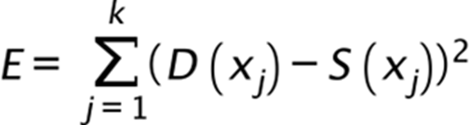
(2)

where k is the height of the ROI in pixels, and D(x) and S(x) are the density and fitted profiles, respectively.
GelBox initializes the parameters for peak amplitude and its location, width, and skew at the beginning of the optimization process. These parameters are updated, as Equation 2 is minimized. Users can review the initial and final parameters through the GelBox interface. The optimization scheme allows users to constrain or change the initial values of the parameters if required. The area associated with each band is calculated by integrating the area under each Gaussian function (11).

Workflow traceability

GelBox provides an option to combine the raw image, the user-supplied metadata, each step in the workflow, and the band data in a single GBX (short for GelBox) file. GBX files are compressed files written in MAT-format (12) and can be re-opened in GelBox to revisit analyses. This is important for rigor, reproducibility, and traceability.

Data export

Users can also export a summary of each analysis in Excel format. The first sheet in each file combines the available metadata, the position of each region of interest, calculated densities, and the background correction method. Additional sheets provide the raw and fitted density profiles for each lane. Users can perform subsequent analysis, such as comparing densities across lanes or normalization by controls, using their preferred tool with the exported spreadsheets. GelBox can also generate summary figures that show the density profiles and quantification along with the raw and adjusted image.

Availability of software

GelBox is available at no cost to academic users from https://campbell-muscle-lab.github.io/GelBox/.

The installation instructions are provided on the website. Users can access the source code through the GitHub repository (https://github.com/Campbell-Muscle-Lab/GelBox).

RESULTS

Software validation

GelBox was validated by comparing its output to results obtained using Image Lab (Bio-Rad Laboratories, Hercules, CA) and ImageJ. The raw data were blots probing the phosphorylation of cMyBP-C at Ser302.

Image Lab analyses were performed as described in the software’s user guide (13) The analysis with ImageJ was conducted as explained by Stael et al. (14), with the uncalibrated OD option unchecked to keep the analyzed bit-depth consistent among tools. Subsequent analysis was performed using MATLAB (Natwick, MA) and SAS (SAS Institute Inc., Cary, NC)

Each lane’s area result was normalized with the corresponding control samples in the blots (Figure 4A). The band areas were determined differently by each tool, as illustrated in the Figure 4B. As described earlier, GelBox fits Gaussian functions to the band profiles. In contrast, Image Lab cuts off a portion of the enclosed area, while ImageJ reports the area enclosed by the profile and the manually drawn baseline. GelBox estimates were in good agreement with those obtained with Image Lab; however, they differed slightly from those obtained with ImageJ (Figure 4C). Additionally, one-way linear mixed model analysis showed that the ImageJ results differed from those obtained by Image Lab (Figure 4D). These differences resulted from the variation in area calculation methods.

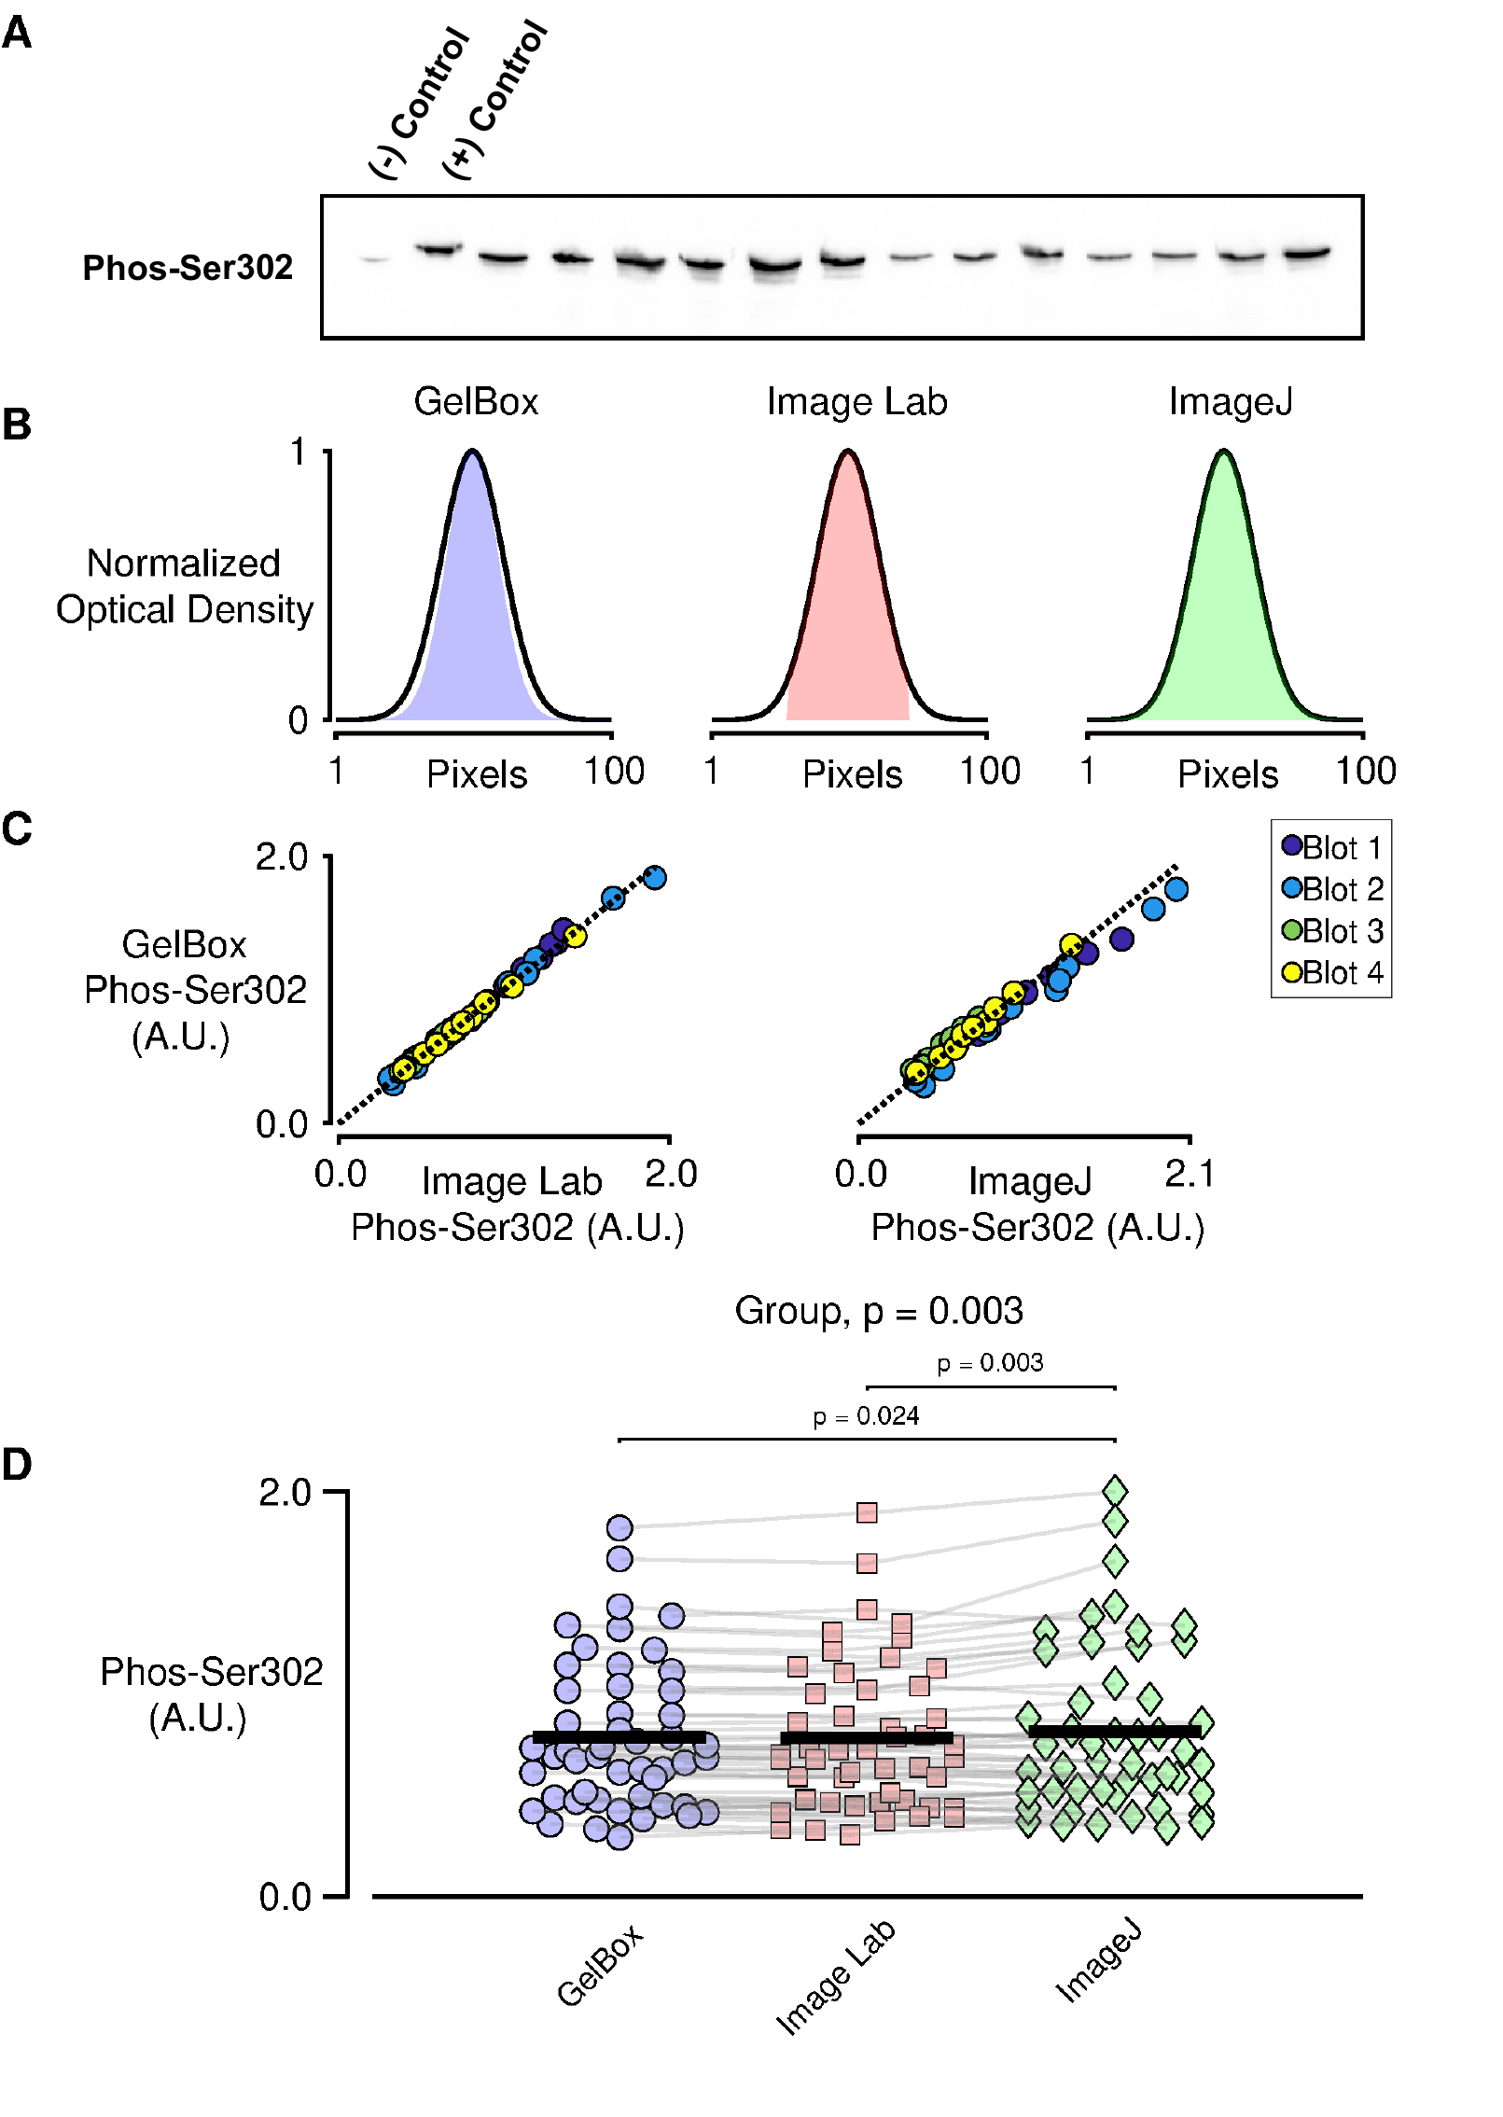
Figure 4. Software validation. (A) Representative immunoblot probed for Ser302 phosphorylation (B) Schematic band quantification by GelBox, Image Lab, and ImageJ. (C) Comparison of Ser302 phosphorylation obtained with GelBox against Image Lab (left-side panel) and ImageJ (right-side panel). (D) Collated data analyzed with one-way linear mixed model.

Comparison of background correction methods

Background correction can impact the quantification of bands on gels and immunoblots. This was investigated by analyzing computer-generated images with known band intensities superposed on mathematically-defined backgrounds. Specifically, 100 images were generated by adding a single Gaussian function to a profile defined by a third-order polynomial. The Gaussian and polynomial parameters were selected from pseudo-random distributions, yielding a wide range of qualitative image types. Speckle noise was added to each image to mimic experimental artifacts.
Each image was then analyzed using the cubic smoothing spline, linear fit, and rolling ball background correction methods (Figure 5A - B). The ratios of the calculated to actual band densities were determined (Figure 5D). One-sample t-tests showed that the linear and rolling ball correction methods led to underestimates of the true band density. Both approaches removed a portion of the true band during the correction procedure. These tests suggest that background correction via cubic smoothing splines may be more robust than linear or rolling ball methods when analyzing gels and immunoblots.
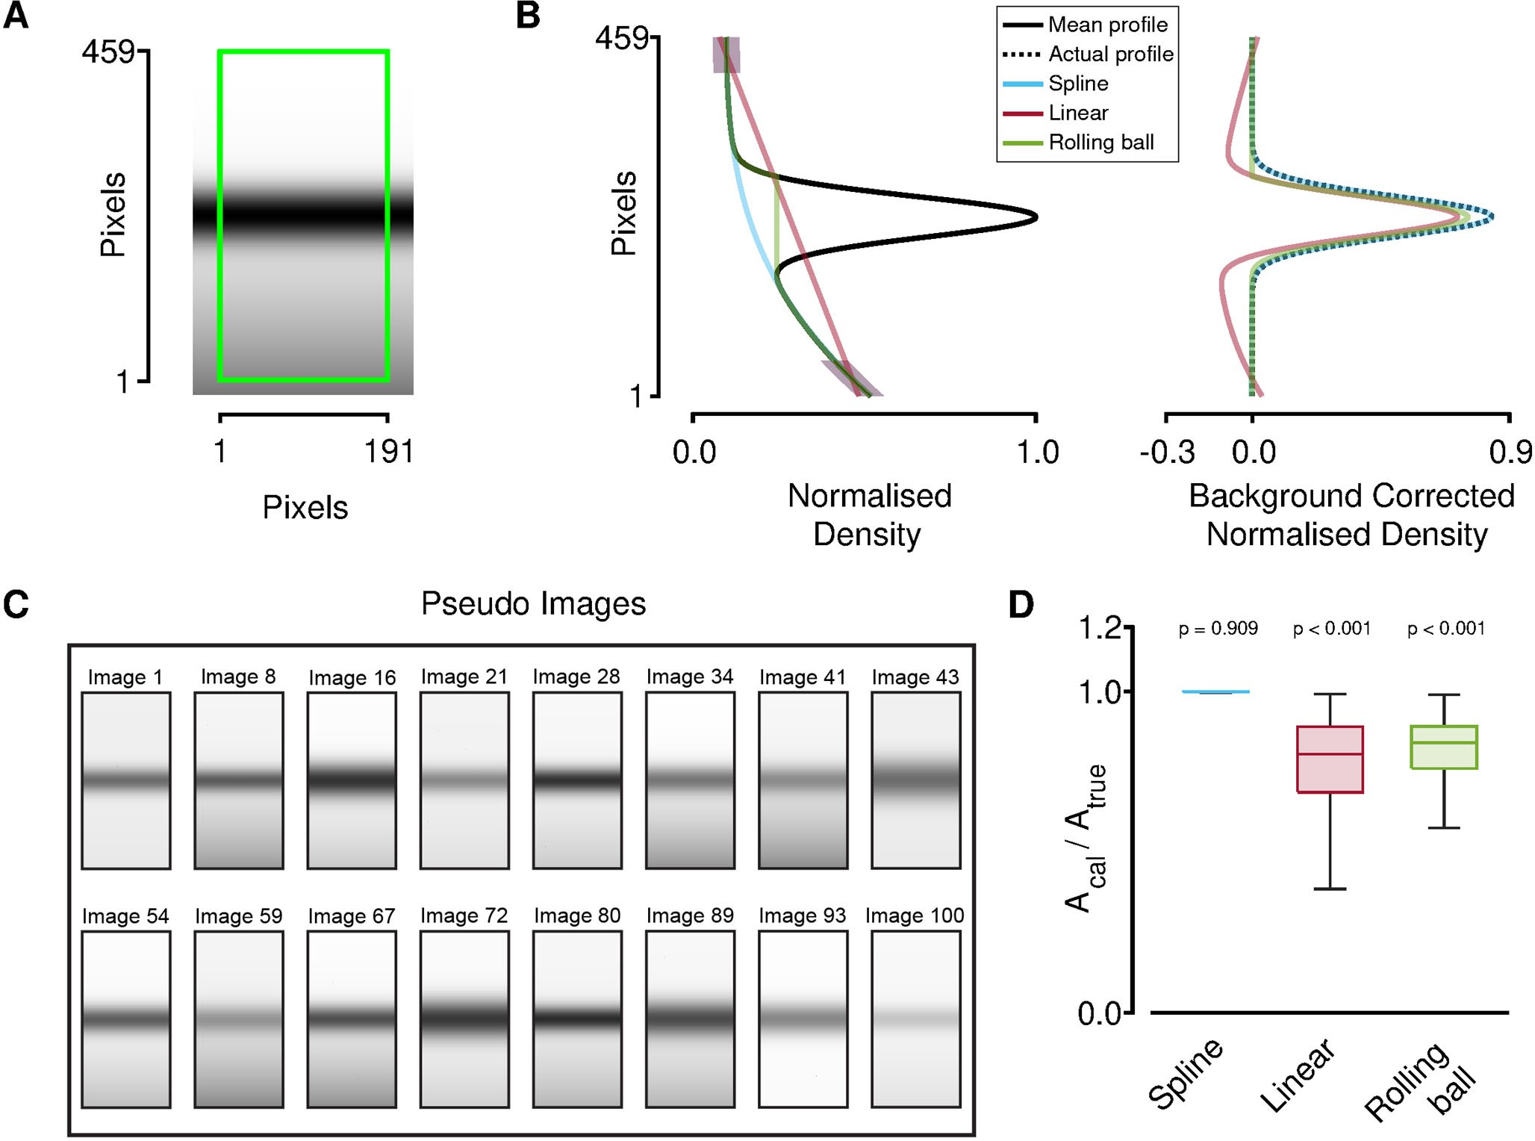

Figure 5. Comparison of background correction methods. (A) Computer-generated pseudo image. The ROI is highlighted with the green rectangle (B) Left-hand panel: the mean density profile and the estimated backgrounds. The right-hand panel: superposed traces of corrected and the actual profile. (C) Examples of pseudo images. (D) The ratios of the calculated areas to actual areas from 100 pseudo images. p-values show the results of one-sample t-tests that compare the ratios calculated by each method to unity. The linear and rolling ball methods significantly underestimated the true intensity of the simulated bands. Plots show extremes (end-caps), quartlles (box), and median (central bar).

Representative analysis using GelBox

The gel shown in Figure 6A was generated by our lab following the aforementioned experimental protocol for samples of human left ventricular myocardium.

Figure 6B - D show the representative analysis of alpha actinin (~103 kDa), beta tropomyosin (~36 kDa), alpha tropomyosin (~34 kDa), troponin I (~24 kDa), and cleaved troponin I (~23 kDa). The protein band under the alpha actinin is not known to the best of our knowledge (Figure 6B). Following the background correction, fitted Gaussian functions were used to calculate the area of each band. Troponin I had the largest area among the analyzed proteins.

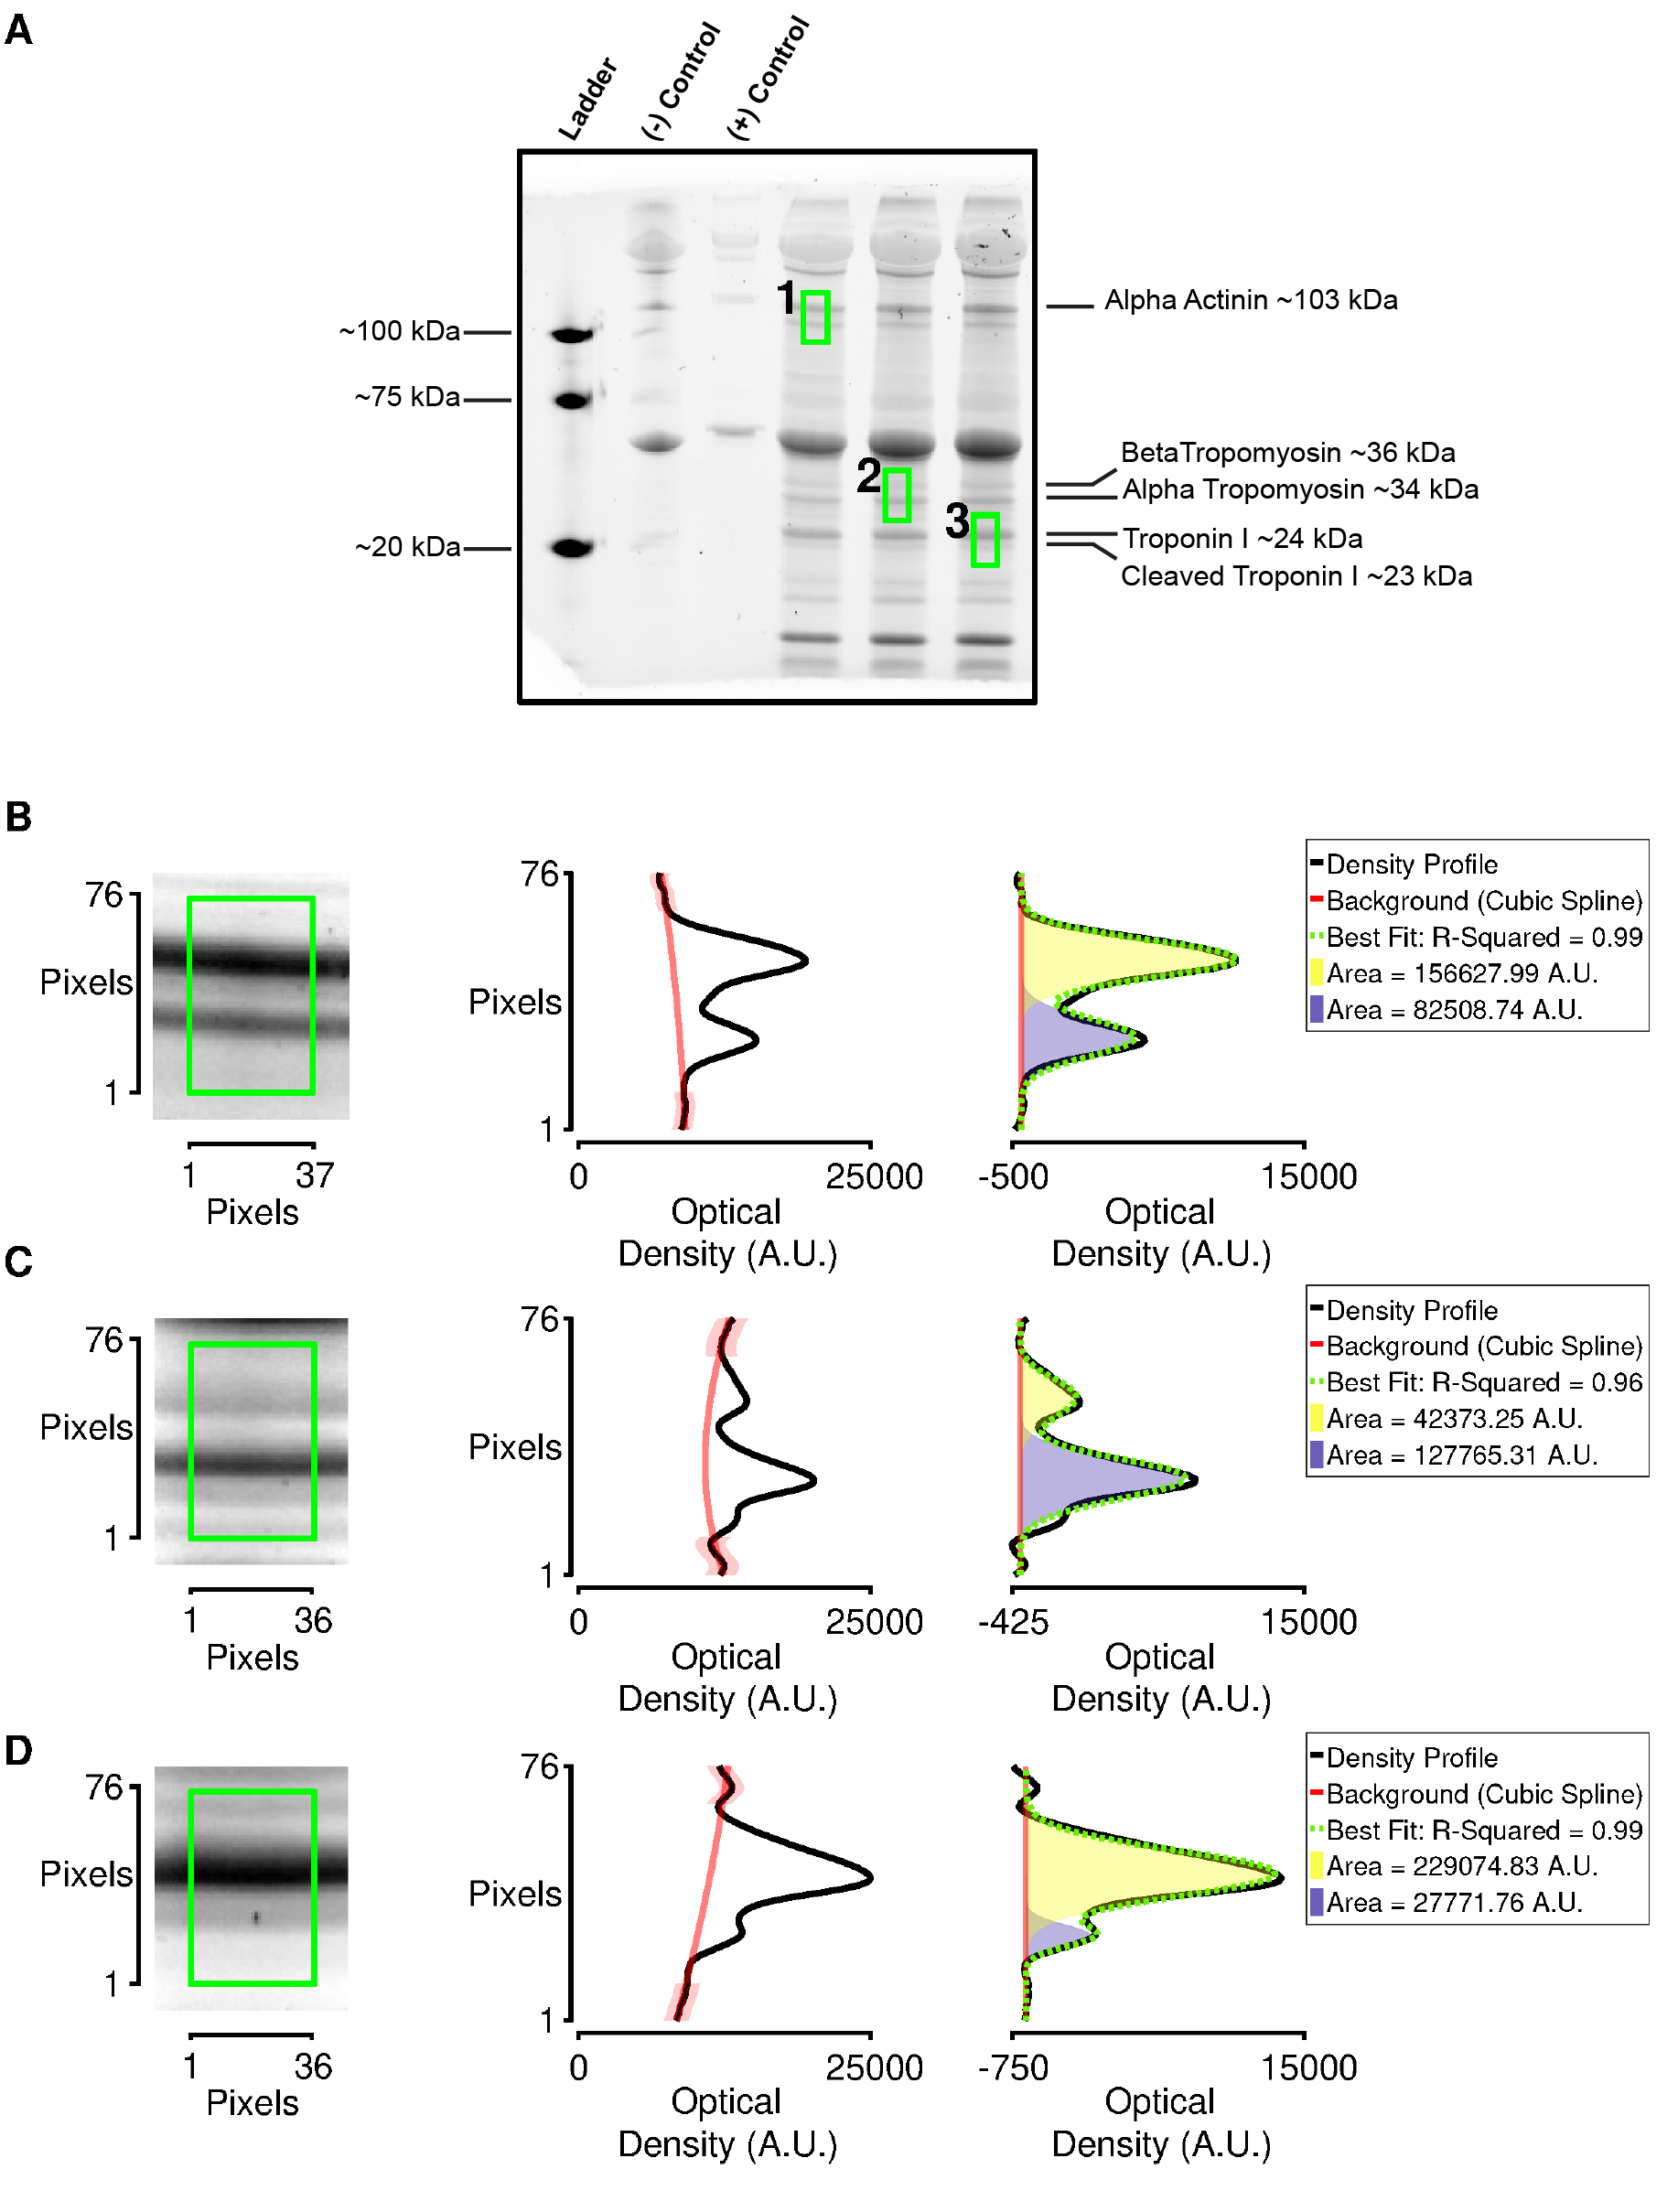

Figure 6 Representative analysis. (A) A representative gel image showing housekeeping lanes and resolved proteins from samples of the human left ventricular myocardium. (B-D) The insets of the ROI boxes one to three. The shaded areas show the Gaussian profiles fitted to the extracted density profiles. A.U. stands for arbitrary units

DISCUSSION

GelBox is a computer program tailored to help researchers analyze gels and immunoblots. It allows the user to complete their analysis workflow in a single package and saves the raw data, user-defined metadata, and all workflow steps in a single file. This can enhance rigor, reproducibility, and traceability.
Another strength is the use of curve-fitting to determine band densities. As previously explained (9), this is particularly advantageous when the band profiles overlap. The fitting procedures reduce unintended bias and add experimental rigor. GelBox analysis was compared to Image Lab and ImageJ using a dataset collated with left ventricular samples from patients with dilated cardiomyopathy and organ donors. Further analysis with a two-way linear mixed model showed that all the tools resulted in the same significant difference between heart failure and organ donor groups (data not shown). Although lane to lane comparisons slightly differed, the interpretation of the data agreed among GelBox, Image Lab, and ImageJ. Three different background correction methods are provided. The linear and rolling ball approaches are implemented in many other packages; therefore, GelBox offers them to serve as familiar options for users. However, our mathematical analysis suggests that they may lead to underestimates of band intensities (Figure 5). Cubic smoothing splines may provide a better alternative.
A limitation of GelBox is that it is written in the MATLAB language. Although the code is open source, MATLAB is a commercial product. Many universities have site licenses, so academics can use and potentially adapt the software for their own use without financial cost. Users can also install a standalone pre-compiled version of GelBox. This approach would allow them to use GelBox without installing the main MATLAB package, but it requires installing MATLAB runtime prerequisites.
Although free, these are cumbersome to install and complicated to maintain.

The website for the software provides comprehensive tutorials that explain how to analyze images with GelBox. The site also provides a troubleshooting guide that describes how to mitigate commonly encountered issues.
GelBox simplifies the analysis of gel and immunoblot data, but it cannot compensate for a poorly conducted experiment. The quality of the raw data is critical. In addition, users need to have a clear understanding of how GelBox works to analyze their data appropriately.

ACKNOWLEDGMENTS

The authors would like to thank Nicholas S. LaFave (University of Massachusetts, Lowell) and Peter Omondi Awinda (Washington State University) for providing feedback on an early version of GelBox.
This work was supported by NIH grants HL149164 and HL148785.

REFERENCES

1. Schneider CA, Rasband WS, and Eliceiri KW. NIH Image to ImageJ: 25 years of image analysis. Nature Methods 9: 671-675, 2012.
2. Schindelin J, Arganda-Carreras I, Frise E, Kaynig V, Longair M, Pietzsch T, Preibisch S, Rueden C, Saalfeld S, Schmid B, Tinevez J-Y, White DJ, Hartenstein V, Eliceiri K, Tomancak P, and Cardona A. Fiji: an open-source platform for biological-image analysis. Nature Methods 9: 676-682, 2012.
3. Kütt J, Margus G, Kask L, Rätsepso T, Soodla K, Bernasconi R, Birkedal R, Järv P, Laasmaa M, and Vendelin M. Simple analysis of gel images with IOCBIO Gel. BMC Biology 21: 2023.
4. Blair CA, Haynes P, Campbell SG, Chung C, Mitov MI, Dennis D, Bonnell MR, Hoopes CW, Guglin M, and Campbell KS. A Protocol for Collecting Human Cardiac Tissue for Research. VAD J 2: 2016.
5. Greaser ML, and Warren CM. Electrophoretic Separation of Very Large Molecular Weight Proteins in SDS Agarose. Methods Mol Biol 1855: 203-210, 2019.
6. Ladner CL, Yang J, Turner RJ, and Edwards RA. Visible fluorescent detection of proteins in polyacrylamide gels without staining. Analytical Biochemistry 326: 13-20, 2004.
7. Kampourakis T, Ponnam S, Campbell KS, Wellette-Hunsucker A, and Koch D. Cardiac myosin binding protein-C phosphorylation as a function of multiple protein kinase and phosphatase activities. Nature Communications 15: 2024.
8. Sternberg SR. Grayscale morphology. Computer Vision, Graphics, and Image Processing 35: 333-355, 1986.
9. Mitov MI, Greaser ML, and Campbell KS. GelBandFitter--a computer program for analysis of closely spaced electrophoretic and immunoblotted bands. Electrophoresis 30: 848-851, 2009.
10. Lagarias JC, Reeds JA, Wright MH, and Wright PE. Convergence Properties of the Nelder--Mead Simplex Method in Low Dimensions. SIAM Journal on Optimization 9: 112-147, 1998.
11. Recktenwald GW. Numerical Methods with MATLAB : Implementations and Applications. Pearson, 2000.
12. MAT-File Versions MATLAB. https://www.mathworks.com/help/matlab/import_export/mat-file-versions.html. [1 March, 2024].
13. Image Lab Software https://www.bio-rad.com/en-us/product/image-lab-software?ID=KRE6P5E8Z. [25 April, 2024].
14. Stael S, Miller LP, Fernández-Fernández Á D, and Van Breusegem F. Detection of Damage-Activated Metacaspase Activity by Western Blot in Plants. Methods Mol Biol 2447: 127-137, 2022.

