Overview

This page should help you run simple linear mixed model comparisons using a SAS template. After mastering this information, several subpages have additional information about SAS and the procedures used in the template.

(We assume that you have SAS installed. If you haven't already done so, you can get SAS from the downloads.uky.edu site. Be warned that its large and takes time to load.)

This page assumes you know a bit about mixed models. This page/protocol analyzes an early version of the human transmural-HF study using the "Lab Template". The data has 2 "fixed" categorical groups- the transmural layers and heart failure status. (Transmural layers have 3 subgroups- Epi, Mid, and Endo, while heart failure status has 2- failing (HF) and non failing (NF).) It also has a random variable, the subject/patient (tag). In the data file, compiled_data.xlsx, in the prep worksheet you'll see columns for the dependent variable (power_uW_per_mg), the random variable (tag), and the two fixed variables, the transmural layers (layer), and the heart failure status (condition). (A fifth column, describing the experiment reference is left in the file but ignored for this template.)

For this test, we will study whether power is different between individual layers, conditions, or a both (mixed) layer*condition.

This is equivalent to saying, how is the dependent variable related to the fixed effects and their interaction.

Additional resources

Need more help?

Check the resources, and then see Ken

Main content

**Part 1:**

1. **Download the attached files**

There are 3 files attached to this page that will help you learn how to run a linear mixed model in SAS.  Once you have figured it out, the only essential component for all your mixed model needs is the template (cschung LMM template 20130305.sas).  Make sure you remember where you put them.  I suggest you create a subfolder called SAS in your c:\lab\yourname folder.

1. **Ready?  Start by openning SAS**

There are a lot of options and programs that are installed under SAS, but this set of instructions relies on the "SAS 9.3 (English)" program.

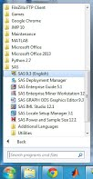

That will bring you to a window that looks like this.

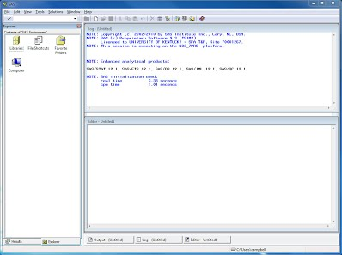

(if it does not look like this, close the program and try again)

*A quick orientation to this screen:*

* The top right is a **log**.  If you have any problems or don't see a complete output, then you should check the log for brown or maroon colored text --those are the warnings.  (Blue or black is usually fine.)
* The bottom left is the **Editor**.  This is where the code or Program (in SAS speak) will show up.
* The Right is an Explorer or Results tab.

1. **Then open the Template**

Using CTRL-o or File>Open Program, find and open the 'cschung LMM template 20130305.sas' file that you downloaded.

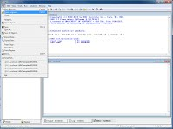

After that you will see that a program has been loaded into the editor screen in the right bottom window:

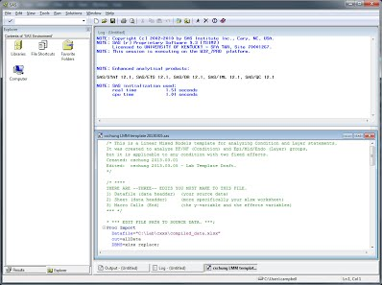

1. **Update the template to find the source file and then read and analyze your variables correctly**

The green at the top are comments that help describe this file.  One of these comments in the template tells you exactly what you need to change in the program.

/* ****  
THERE ARE --THREE-- EDITS YOU MUST MAKE TO THIS FILE.  
1) Datafile (in the data header)        (your source data)  
2) Sheet (in the data header)           (more specifically your xlsx worksheet)  
3) Macro Calls (at the end of the file) (define the variables)  
*** */

Make sure you make the THREE changes:

1) The first change you must make is the file path to the data file.

* *** EDIT FILE PATH TO SOURCE DATA. ***;

Proc Import

  Datafile="C:\Lab\xxx\complied.xlsx"

For example, if Charles' stored this data in a subfolder called SAS, then the datafile should look like this:

  Datafile="C:\Lab\charles\SAS\complied_data.xlsx"

Don't forget to check that you have the right filename.

2) Then Make sure you have the right worksheet sheet.  This is just a few lines below where it says EDIT WORKSHEET.

* *** EDIT FILE PATH TO SOURCE DATA. ***;

Proc Import

  Datafile="C:\Lab\charles\SAS\compiled_data.xlsx"

  out=allData

  DBMS=xlsx replace;

* *** EDIT WORKSHEET *** ;

  sheet='Sheet1';

run;

If you look at the compiled_data.xlsx Excel file, you'll notice there are 2 sheets.  This example uses the 'prep' worksheet.  So your file header should now look similar to this:

* *** EDIT FILE PATH TO SOURCE DATA. ***;

Proc Import

  Datafile="C:\Lab\charles\SAS\compiled_data.xlsx"

  out=allData

  DBMS=xlsx replace;

* *** EDIT WORKSHEET *** ;

  sheet='prep';

run;

3) Scroll to the bottom and edit the variable calls.

/*   
The Linear Mixed Model w Tukey correction Macro (LMM_w_Tukey) requires 5 tags to function.  
1) the variable name (column name from excel)  
2) the variable name in single quotes to display on the output  
3) the random variable (animal, human, etc)  
4) fixed effect #1 (column name from excel)  
5) fixed effect #2 (it doesn't matter which order you put the effects in.  
  
You can call the macro as many times as you want in the same run.  
*/  
  
* *** EDIT THE VARIABLES *** ;  
  
%***LMM_w_Tukey***(DependentVar, 'DepVarName', RandomVar, Effect1, Effect2);

This might look complex, but its that way to let you test any set of variables

* DependentVar is just the dependent variable; replace it with power_uW_per_mg.
* DepVarName is an alias or nickname for the data.  It will show up on your graph titles and such so you can identify the variable.  You can either replace it with the full dependent variable again, something shorter.  For example here we will just use power.
* RandomVar is the random variable, in this case replace it with tag, because that is the column name identifying the patient.
* Effect1 and Effect2 are the fixed effects.  You can replace them with layer and condition.  (Note: I don't think the order matters here.

Your file should now look something like this:

* *** EDIT THE VARIABLES *** ;  
  
%***LMM_w_Tukey***(power_uW_per_mg, 'power', tag, layer, condition);

1. **Run your Linear Mixed Model**

That's it!  You are now ready to run your first Linear Mixed Model!

In SAS you “submit the Program”; so in the menu you can go to Run>Submit

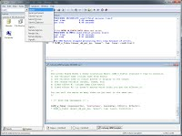

…or use your mouse and right click on the editor window and click on submit all.

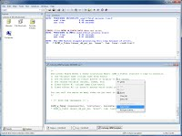

I all went well, your screen will now look like this:

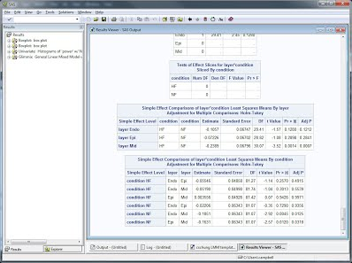

The right side of the screen now has a results viewer window covering the log and editor windows. You’ll also notice at the left the explorer window has been swapped with a results viewer.

(If you don't see the results, maybe scroll down to section 8 below before going on to the next section...)

1. **Reading your results**

The output file has four parts.

* The first 2 are boxplots.  They have the same data but are grouped so you can visualize the two effects independently.
* The third is a set of histograms for each subgroup.  This will be most helpful for large datasets.
* The last is your statistics.  There's a lot of statistical mumbo-jumbo in there.  But keep reading and you'll see what the important data is.

To  look through your data, you can either scroll up and down on the Results Viewer, or you can check out some of the results by going through the results viewer.  The example below shows looking at a boxplot output that shows how each layer is effected by the failure condition.

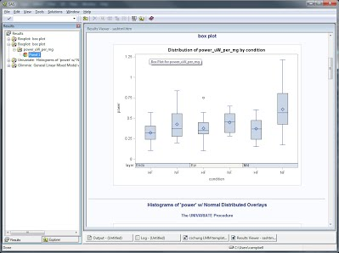

These comparisons help you figure out which of the sub effects are different.  For example in the Non Failing condition, both the Endo and Epi are different from the Mid myocardial layer (the last two lines).  (Do you see anything else significant?)

Note:  You can use the **Pr>|t|**value to look at significance (Fisher Least Significant Difference t test), but this template, outputs the Tukey correction for the multiple comparisons test (post hoc test).  The **Adj P**value is a Tukey corrected value and one that you should most commonly report.

1. **Make sure you save your results**

You can save the Results Viewer to look up your results later; first make sure that your Results Viewer window is the active window.  I prefer to choose File>Save as, then change the Save as Type to  Webpage, complete(*.htm; *.html).

However, you can also use File>Print (or CTRL-p) and select the Adobe PDF printer; this is how I saved the comparison output page.

Also save your Editor window.  Make sure that the Editor is the active window then use File>Save As.  Make sure to give your files descriptive file names.

1. **Troubles?**

If you had trouble, the most likely thing is that you didn't get a results window, or maybe didn't get some part of a results window.  To find out what is wrong, start scrolling up through your log file.  Look for something that says **ERROR**.  Often it will be a maroon color.  There are two likely errors:

1) If you get this error:

**ERROR: File WORK.ALLDATA.DATA does not exist.**

There is a problem with the spreadsheet.  If you keep scrolling up, you'll probably see:

**ERROR: XLSX file does not exist -> C:\Lab\xxx\compiled_data.xlsx**

...which means that you didn't give it the right path, or that the file is already open on your computer, or:

**ERROR: Couldn't find sheet in spreadsheet**

...which means you didn't define the right worksheet.  Make sure you have the correct filepath and worksheet.

2) If you get an error that looks like this:

**ERROR: Variable EFFECT1 not found**

It means that you didn't update the variables correctly.  (This goes for any variable name that might be in your *.xlsx worksheet.)  Make sure your variables are complete in the macro calls at the end of the program.

If you have other problems, such as your P values don't match the sample output file, your problem is outside the scope of this initial protocol.  I suggest you start over from a fresh copy of the template then talk to the others in the lab to find out why it is not working.

1. **Did you succeed?  Try it with your own data!**

You can try this with ANY *.xlsx file with any number of columns and variables.  Note that if you want your fixed effects to have some order, I recommend you number them.  You'll notice on the output file of this data that HF comes before NF, and Endo comes before Epi and Mid.  You can change that by saying 1NF and 2HF for condition and 1Epi, 2Mid, 3Endo for layer in your excel file.

So when you are ready, get your new data file, and go through these steps again with the new file path!

BTW, you can also have any number of macro calls at the same time!  Lets say that the example file had power, pCa50 and Vmax all on the same file.  Your macro call will look something like this:

* *** EDIT THE VARIABLES *** ;  
  
%***LMM_w_Tukey***(power_uW_per_mg, 'power', tag, layer, condition);  
%***LMM_w_Tukey***(pCa50, 'pCa50', tag, layer, condition);  
%***LMM_w_Tukey***(Vmax_fv, 'Vmax', tag, layer, condition);

Oh- and you do not have to worry about the column order.  Just make sure your column names are correct!

1. **Wanna know more?**

Hopefully you understand the mixed model that you used.  Make sure you discuss the experiment and results with the lab to make sure you have it right.  You can stop here, but if you are interested in learning more about SAS and the functions used in these files, browse the subpages.