Sassy & Sweet Boutique

Project Phase II

Camperina

ID# XXXXXX

Email: XXXXXX

Table of Contents

1. Introduction 4

1.1 Problems 4

1.2 Proposed Solution 5

2. Project Charter 6

2.1 Project Name 6

2.2 Project Overview 6

2.3 Project Objectives 6

2.4 Key Assumptions 7

2.5 Diagrams 7

2.5.1 Context Diagram 8

2.5.2 Level-0 Diagram 8

2.5.3 Level-1 Diagram 9

2.5.4 Use-Case Diagram 10

2.5.5 Sequence Diagram 11

2.5.6 Activity Diagram 12

2.5.7 Entity Relationship Diagram (ERD) 13

3. Baseline Project Plan Report 13

3.1 Introduction 13

3.1.1 Project Overview 13

3.1.2 Recommendation 13

3.2 System Description 14

3.2.1 Alternatives 14

3.2.2 System Description 14

3.3 Feasibility Assessment 15

3.3.1 Economic Analysis 15

3.3.2 Technical Analysis 15

3.3.3 Operational Analysis 16

3.3.4 Legal and Contractual Analysis 17

3.3.5 Political Analysis 17

3.3.6 Schedules, Timeline, and Resource Analysis 17

3.4 Management Issues 17

3.4.1 Team Configuration and Management 17

3.4.2 Communication Plan 17

3.4.3 Project Standards and Procedures 18

3.4.4 Other Project-Specific Topics 18

4. Financial Assessment 18

5. Summary 20

# 1. Introduction

Brooklyn is a former cheerleader who has opened a little shop in town catering to cheerleaders in her community. She sells bows, t-shirts, and a few other items at her store and does presale events on Facebook. Her store has become very popular and she is becoming overwhelmed with keeping track of orders and inventory manually. Brooklyn talks to her stepmom, a systems analyst, about this at lunch one day. Her stepmom suggests a computer system for her to use at her store which will allow her to keep records online. This new system could also have a customer facing website to display items currently in stock as well as presale items she is currently advertising on Facebook.

## 1.1 Problems

Currently, customers are coming into the store to shop and place orders for presale items. They are also ordering items by commenting on Facebook. Brooklyn admits presales are causing problems because she has ordered the items before people are paying for them only to be stuck with the extra merchandise once the shipment arrives. She is writing down all the order information and storing it in a folder until the order is fulfilled. She makes two copies of the order form and two copies of the receipt. She gives the originals to the customer when the order is picked up or shipped. The copies get filed in a customer folder and a sales folder. The following problems were discussed and documented regarding the current process:

* It is easy to overlook a Facebook comment requesting to order an item.
* When customers order on Facebook, it is difficult to keep up with who has paid.
* It is difficult to locate a specific customer order when shipments arrive or if a customer has an order question.
* If a shipment is delayed, she must sort through all pending orders to attempt to find everyone she needs to contact.
* Paperwork gets lost.
* The current method makes it difficult to manage inventory and keep up with monthly sales.
* She would like to begin a loyalty program but is unsure how to do so using their current method of bookkeeping.

## 1.2 Proposed Solution

The proposal is to implement an automated database that would streamline the ordering process and make record keeping easier for employees. The problems mentioned will be handled by the new system and the store will appear more professional by using current technology.

* All presale orders would be in the automated system.
* Each customer would have their own customer profile where order history could be viewed.
* Loyalty rewards will be earned and automatically tabulated for each customer. The rewards would be viewable on the customer profile.
* Presale orders would not be submitted until payment is received.
* Emails could be automatically generated for customers who have unpaid items in their cart prior to the presale date closing and to notify them of order status changes.
* Emails could be generated to notify a customer when they have earned enough loyalty points to earn a reward.
* Reports can be generated to assist with managing inventory and sales.
* Tracking information will be available for orders that are shipped to the customer.

# 2. Project Charter

## 2.1 Project Name

Sassy & Sweet Boutique

## 2.2 Project Overview

This project is to automate the ordering system for the boutique. By automating the process, employees will save time searching for orders, be more efficient at their jobs, and reduce confusion due to misplaced order forms.

## 2.3 Project Objectives

* Eliminate unpaid orders.
* Better order management.
* Improved customer experience.
* Create a customer website.
* Enhanced inventory tracking.
* Create a customer loyalty program.

Table 1.0 below describes the data flows which will address the problems detailed by the boutique owner. The description further defines the objectives mentioned above.

***Table 1.0 Data Flow Descriptions***



## 2.4 Key Assumptions

* System design will be outsourced.
* System will be easy to use.
* Will have a customer-facing website.
* System support and training will be provided.
* Web hosting will be provided.

## 2.5 Diagrams

The following diagrams allow one to visualize the flow of items in the proposed system. Multiple diagrams are presented to provide a clear understanding from many points-of-view to assist the boutique owner in making a well informed decision about the proposed system. The diagrams will also provide the developers with a clear understanding of the system expectations.

### 2.5.1 Context Diagram

The context diagram is a high-level overview of what the new web-system will provide to the boutique.

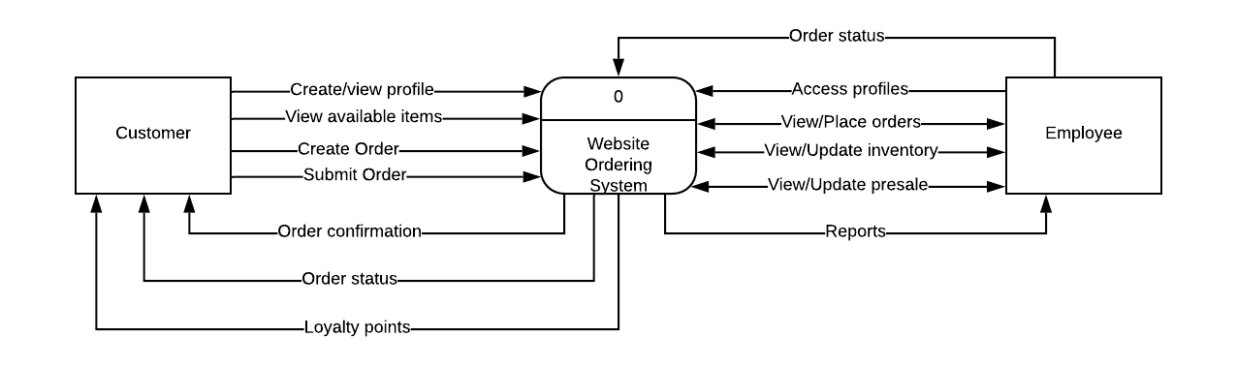

### 2.5.2 Level-0 Diagram

The level-0 diagram goes into more detail about what functionality the system will provide. It shows the flow of an order from the time it is placed until it is delivered to the customer. It also shows how the inventory is adjusted, how presale items are tracked, and the various reports that can be viewed by store employees.

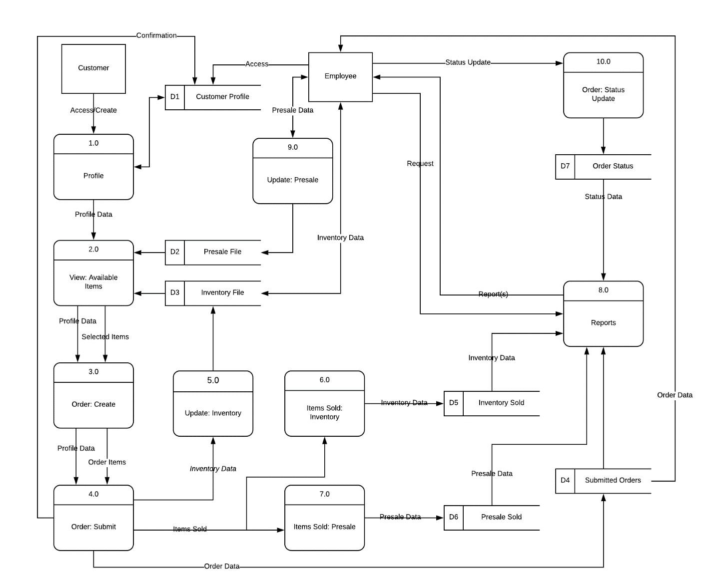

### 2.5.3 Level-1 Diagram

The level-1 diagram for process 8 goes into a detailed explanation of the reporting process in the proposed system. It shows which information is used to gather report data and the steps it goes through before becoming a report.

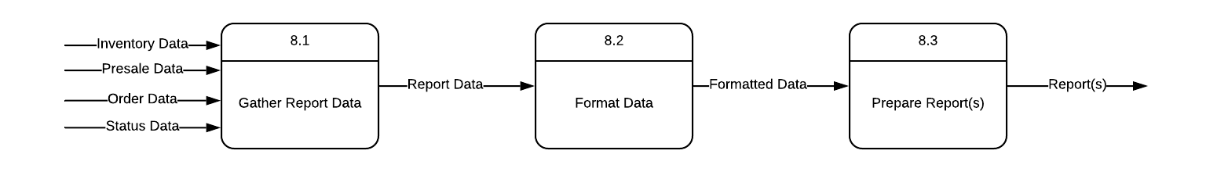

### 2.5.4 Use-Case Diagram

The use-case diagram and textual representation detail how the customer and employee will interact with the proposed system.

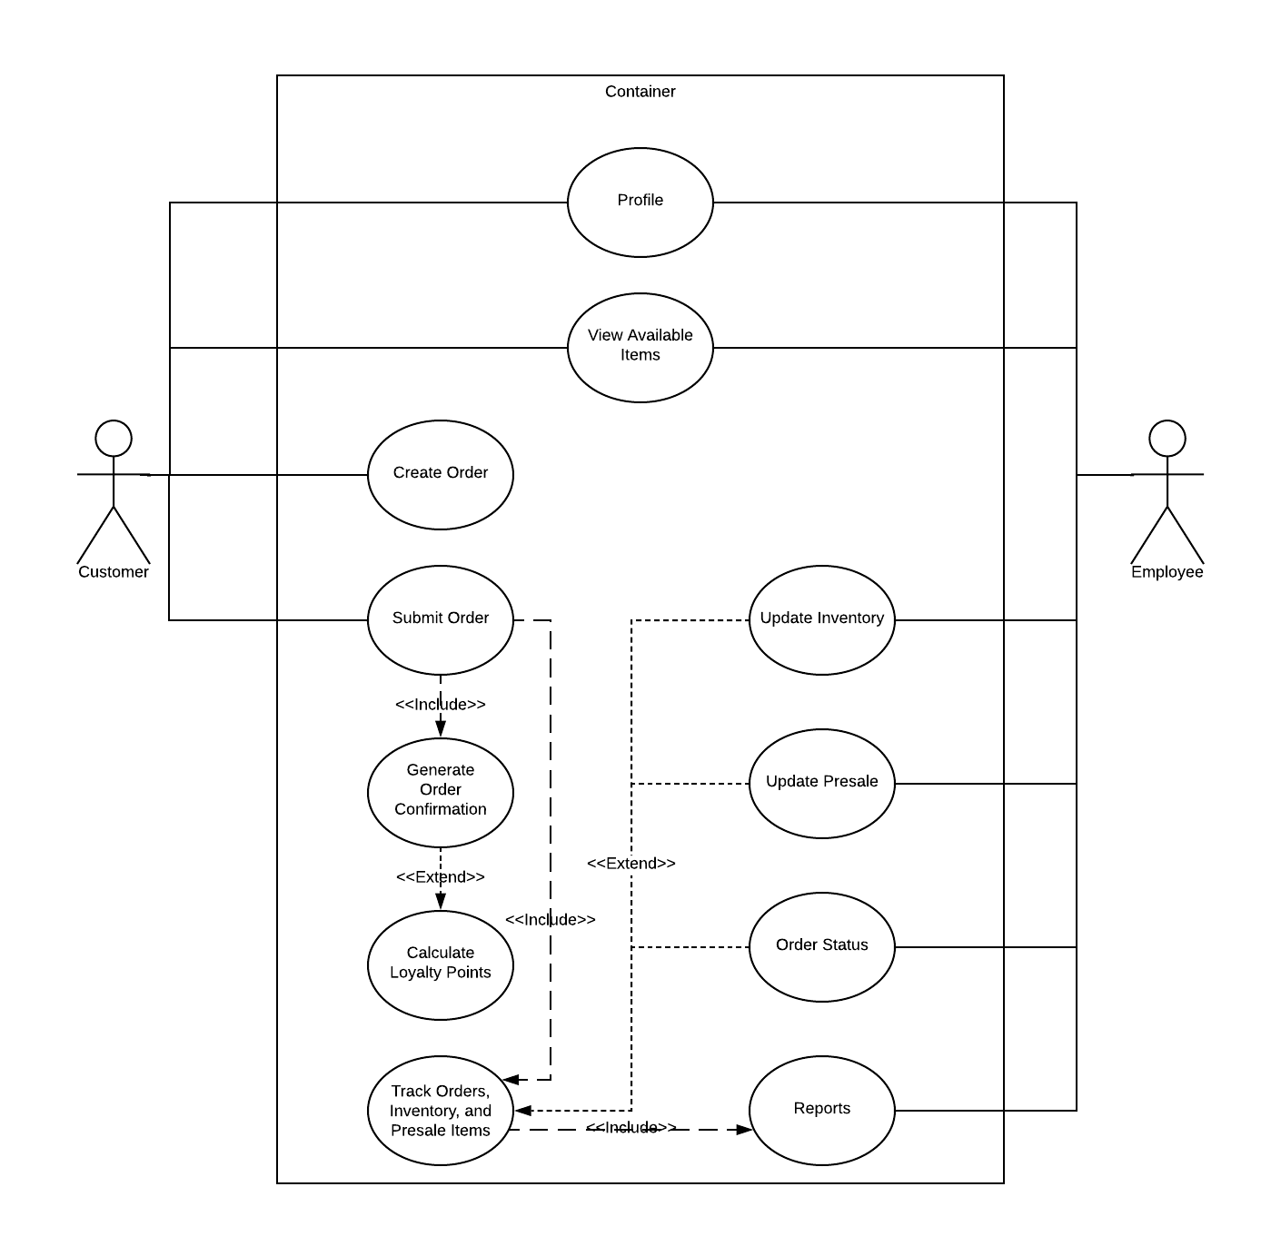

|  |  |
| --- | --- |
| Use Case Title: | Place Online Order |
| Primary Actor: | Customer |
| Level: | Kite |
| Stakeholders: | Store manager, employees, customers |
| Precondition: | Customer has a profile |
| Minimal Guarantee: | Orders can be submitted online |
| Success Guarantee: | Order is placed, paid, and tracked online. |
| Trigger: | Customer submitting an order. |
| Main Success Scenario: | Customer accesses their profile, places and pays for an order online. The order is tracked and updated via the system. |
| Extensions: | Place order with employee in person or over the phone. |

### 2.5.5 Sequence Diagram

The sequence diagram allows one to visualize how the operations are carried out in the order in which they would happen.

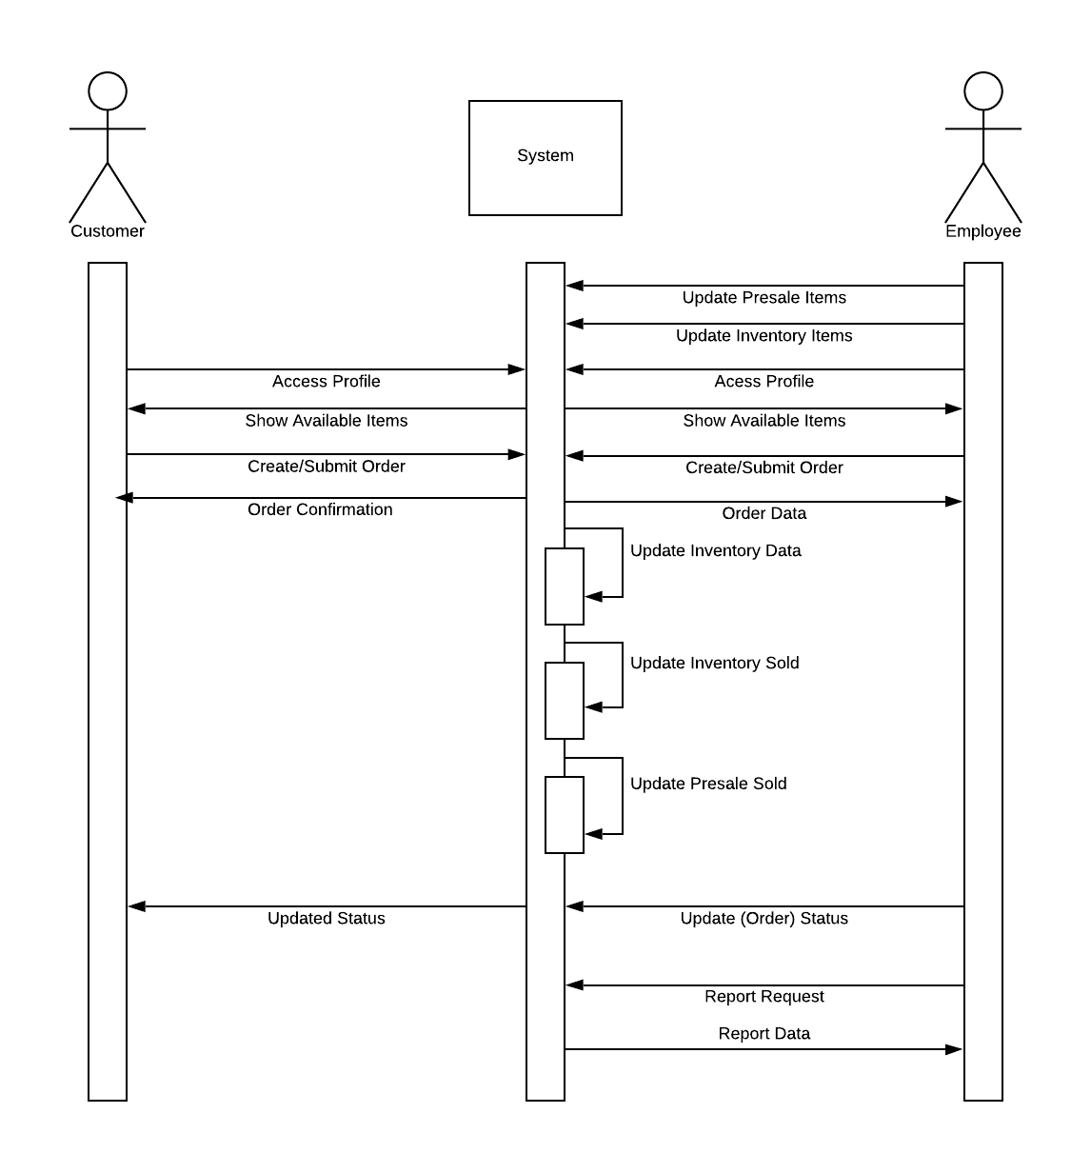

### 2.5.6 Activity Diagram

The activity diagram is a graphical representation of the workflows in the proposed system. 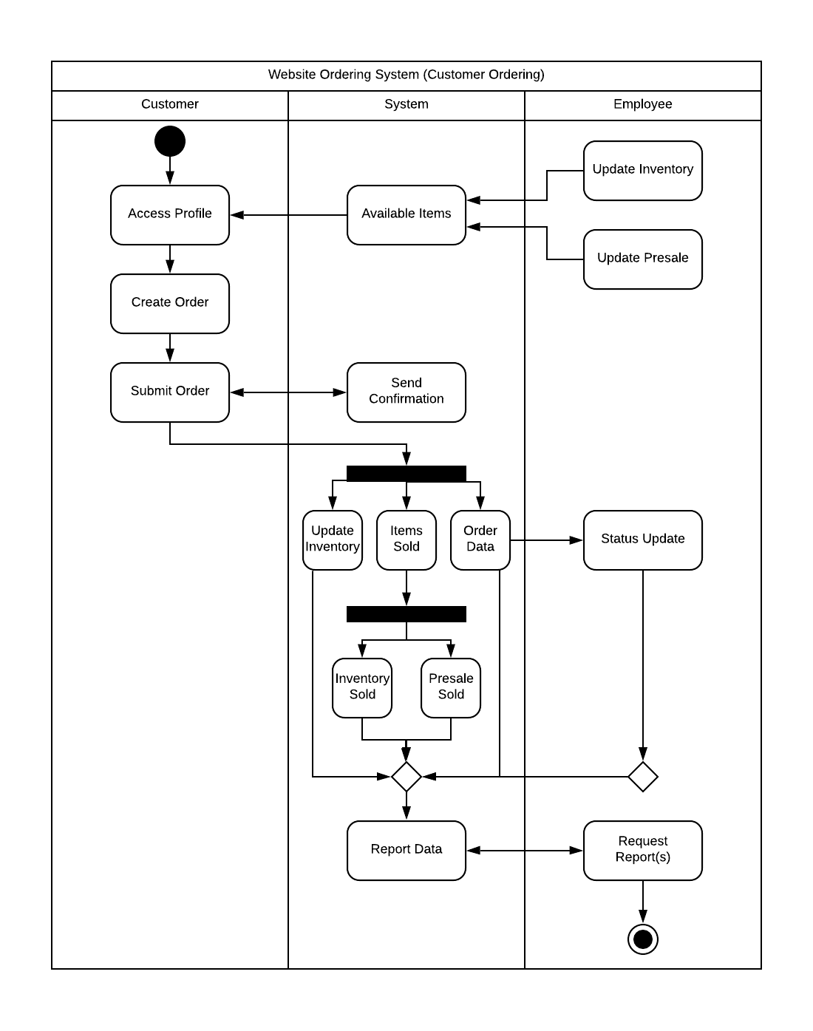

### 2.5.7 Entity Relationship Diagram (ERD)

The ERD shows the entities that make up the system. It details how each of the entities are related to each other and what makes up the entity itself.

# 

# 3. Baseline Project Plan Report

## 3.1 Introduction

### 3.1.1 Project Overview

This project is to automate the ordering system for the boutique. By automating the process, employees will save time searching for orders, be more efficient at their jobs, and reduce confusion due to misplaced order forms.

### 3.1.2 Recommendation

During the planning process, it was discovered that orders were frequently misplaced or lost. At times, items were ordered before payment was collected. It was also difficult for them to manage inventory using a paper and pen process. The recommendation is to create a system that will take all the order information and store it electronically. Allowing the boutique to focus on growing their business and servicing their customers in a timely and order manner. A loyalty program can also be implemented with the new system to thank customers for their business and to encourage them to purchase more or shop at the boutique again in the future.

## 3.2 System Description

### 3.2.1 Alternatives

The current design has 3 areas: Customer, Inventory, and Reports. However, the design of this system allows other areas to be added as needed. Other possibilities include an area for marketing, returns, employee time keeping, and the ability to connect with suppliers to place orders via the system. There is an option to add alerts which can be set by the business. These alerts would send emails to designated employees when certain events happen such a minimum or maximum value being met, shipment delays from the vendor, or other items as determined by management. Additional reports can be added as requested by the boutique.

Optional ideas for the website include automatic suggestions based on previous items viewed/ordered, the ability to contact a store representative via web chat, the ability to initiate a return, and links to other suppliers.

### 3.2.2 System Description

The proposed system would be a web-based design used for order processing. The system would have 3 areas: Customer, Inventory, and Reports. There would also be a customer facing website.

Each customer would have a “profile” which would include their name, contact information, orders placed, order statuses, payment information, and a note field to enter comments that can only be seen by employees. Customers would have access to the “customer” section when they access their account via website.

A subtab of the customer section would be the loyalty tab where the customer can see how many reward points they have earned. They will also be able to see how many reward points have been earned, available rewards, and redeemed awards.

The website will allow customers to view current inventory and presale items. They can search for items via categories (t-shirts, bows, etc.) or by size. Once signed into their account (profile), the customer can place an order, see past orders, and update their account information.

The inventory section will keep a real-time inventory count based off store and internet sales. It would also keep a running total of presale items that have been requested.

The report section will allow employees to print reports at anytime to assist with ordering inventory, notifying customers when presale items have arrived, and calculating total sales.

## 3.3 Feasibility Assessment

### 3.3.1 Economic Analysis

This project does not reach the break-even point within the first 5 years.

### 3.3.2 Technical Analysis

The system analyst has worked with the key stakeholder to create a process flow. This will be provided to the system designer and tested by the designated point-of-contact prior to implementing the system. The boutique will be required to maintain an internet connection to use the system.

System requirements for the loyalty program:

* Give the customer 1 loyalty point for each $20 spent (pre-tax) per order.
* Once 10 loyalty points have been earned, the system will notify the customer by email and on their profile that they have a reward available for redemption.
* The system will allow the customer to redeem a loyalty reward during the check-out process.
* The system will track points earned and used.

System constraints for the loyalty program:

* Rewards will not be added a customer account until the order has been paid for and shipped or picked up by the customer.
* Customers will only be allowed to use one reward or coupon per order.
* The rewards can only be applied toward regularly priced items.
* Once a reward is redeemed, it cannot be added back to the account even if purchased items are returned.

### 3.3.3 Operational Analysis

The system will solve the problem of lost or misplaced orders by keeping them stored electronically. Orders will not be processed until payment has been made. Customers will earn reward points on qualifying orders. Employees will be able to generate reports to assist them with inventory and order management.

### 3.3.4 Legal and Contractual Analysis

Customer information will be encrypted to keep their data safe.

### 3.3.5 Political Analysis

Each stakeholder will be required to sign-off on the system design prior to the programmer beginning the project.

### 3.3.6 Schedules, Timeline, and Resource Analysis

The projected timeline to complete this project is 6 months. There will be two designated programmers and the systems analyst working on this project 5 days a week until completion. The business owner will need to be available at least one evening a week to receive project updates from the analyst.

## 3.4 Management Issues

### 3.4.1 Team Configuration and Management

Developer 1 – responsible for developing the system used by the employees.

Developer 2 – responsible for developing the website.

Systems Analyst – Will also serve as the project manager. Developers will report to the analyst.

Business Owner – Will work with analyst to make key decisions that come up during the design process and to test the system as it is completed.

### 3.4.2 Communication Plan

The analyst will be available to developers and business owner via email and phone during normal business hours. The analyst will meet developers for a working lunch on Tuesdays and Fridays to get an update on the project and work through any issues or concerns. The analyst will meet with the business owner on Mondays to provide project updates. Other meetings will be scheduled as needed. The developers and business owner will not communicate directly with one another. All communication between the developers and business owner will go through the analyst.

### 3.4.3 Project Standards and Procedures

As pieces of the project are completed, the analyst will meet with the business owner to review and test the feature. Any issues or concerns will be brought to the attention of the developers by the analyst. There will be a tracking tool that can be accessed by the business owner at any time to see the status of issues found during testing. Once the business owner is satisfied with the product, a physical signature will be captured on the project document.

### 3.4.4 Other Project-Specific Topics

Not applicable.

# 4. Financial Assessment

An economic feasibility analysis has been completed and shows the new system would be beneficial to the company. On the next page are the details showing the breakdown over a 6-year period. The break-even point occurs after the first 5 years which could potentially be a risk for the boutique.

|  |  |  |  |  |  |  |  |
| --- | --- | --- | --- | --- | --- | --- | --- |
| ***Sassy & Sweet Boutique*** | | |  |  |  |  |  |
| ***Economic Feasibility Analysis*** | | |  |  |  |  |  |
| ***System Design Project*** | |  |  |  |  |  |  |
|  |  |  |  |  |  |  |  |
|  |  |  | Year of Project | |  |  |  |
|  | *Year 0* | *Year 1* | *Year 2* | *Year 3* | *Year 4* | *Year 5* | *TOTALS* |
| Net economic benefit | $0 | $40,000 | $50,000 | $60,000 | $70,000 | $80,000 |  |
| Discount Rate (10%) | 1.0000 | 0.9091 | 0.8264 | 0.7513 | 0.6830 | 0.6209 |  |
| PV of Benefits | $0 | $36,364 | $41,320 | $45,078 | $47,810 | $49,672 |  |
|  |  |  |  |  |  |  |  |
| *NPV of all BENEFITS* | $0 | $36,364 | $77,684 | $122,762 | $170,572 | $220,244 | **$220,244** |
|  |  |  |  |  |  |  |  |
| One-time COSTS | ($80,000) |  |  |  |  |  |  |
|  |  |  |  |  |  |  |  |
| Recurring Costs | $0 | ($45,000) | ($45,000) | ($45,000) | ($45,000) | ($45,000) |  |
| Discount Rate (10%) | 1.0000 | 0.9091 | 0.8264 | 0.7513 | 0.6830 | 0.6209 |  |
| PV of Recurring Costs | $0 | ($40,910) | ($37,188) | ($33,809) | ($30,735) | ($27,941) |  |
|  |  |  |  |  |  |  |  |
| NPV of ALL COSTS | ($80,000) | ($120,910) | ($158,098) | ($191,906) | ($222,641) | ($250,582) | **($250,582)** |
|  |  |  |  |  |  |  |  |
|  |  |  |  |  |  |  |  |
| Overall NPV |  |  |  |  |  |  | **-$30,338** |
|  |  |  |  |  |  |  |  |
|  |  |  |  |  |  |  |  |
| Overall ROI - (Overall NPV/NPV of All COSTS) | | |  |  |  |  | **0.12106839** |
|  |  |  |  |  |  |  |  |
|  |  |  |  |  |  |  |  |
| *Break-Even Analysis* |  |  |  |  |  |  |  |
| Yearly NPV Cash Flow | ($80,000) | ($4,546) | $4,132 | $11,270 | $17,075 | $21,732 |  |
| Overall NPV Cash Flow | ($80,000) | ($84,546) | ($80,414) | ($69,144) | ($52,069) | ($30,338) |  |
|  |  |  |  |  |  |  |  |
| Project break-even does not occur within the first 5 years. | | | | |  |  |  |
| Use first year of positive cash flow to calculate the break-even fraction - unknown. | | | | | | |  |
| ***Actual break-even occurs at unknown.*** | | |  |  |  |  |  |

The following formulas were used to determine the calculations:

Y = dollars n = years i = discount rate

* Discount rate = 1/(1+i)^n
* PV = Y * (1/(1+i)^n))
* NPV = Sum of PV from one year to the next
* Overall NPV = NPV Benefits – NPV Costs
* Yearly Cash Flow = PV Benefits – PV Costs
* Overall Cash Flow = Sum of yearly cash flow from one year to the next

# 5. Summary

Sassy & Sweet Boutique is a locally owned, small-town business in need of technical upgrades to keep up with their growing customer base. Currently, the business is manually recording all transactions. With the increasing sales volume and customer base, they are experiencing a need for an improved method of doing business in order to accurately record transactions and meet customer demands. The proposed system will address their current problems and give them the tools they need to manage their growing business today and in years to come.