Let’s dive into palmerpinguins !

C. Dervieux

05/10/2021

## About the data

**palmerpinguins** (<https://allisonhorst.github.io/palmerpenguins>) is an R package to provide a great dataset for data exploration & visualization, as an alternative to iris.

Let’s look into it !

library(palmerpenguins)  
library(dplyr)  
library(ggplot2)

## Interesting Metrics

We can get some interesting mean metrics for each species:

mean_metric <- penguins %>%  
 group_by(species) %>%  
 select(-year) %>%  
 summarize(across(where(is.numeric), mean, na.rm = TRUE))  
knitr::kable(mean_metric)

| species | bill_length_mm | bill_depth_mm | flipper_length_mm | body_mass_g |
| --- | --- | --- | --- | --- |
| Adelie | 38.79139 | 18.34636 | 189.9536 | 3700.662 |
| Chinstrap | 48.83382 | 18.42059 | 195.8235 | 3733.088 |
| Gentoo | 47.50488 | 14.98211 | 217.1870 | 5076.016 |

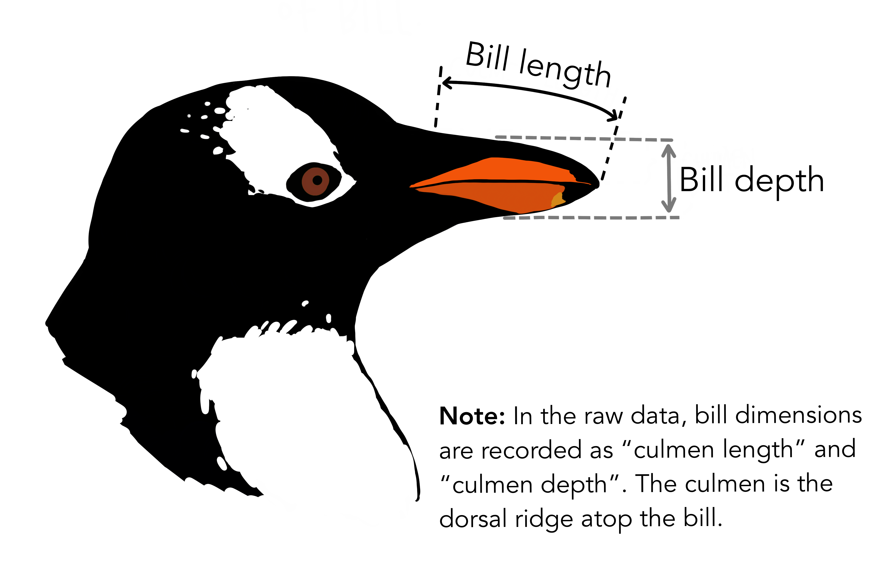

The **Gentoo** specie is heavier than other !

## Where do they live ?

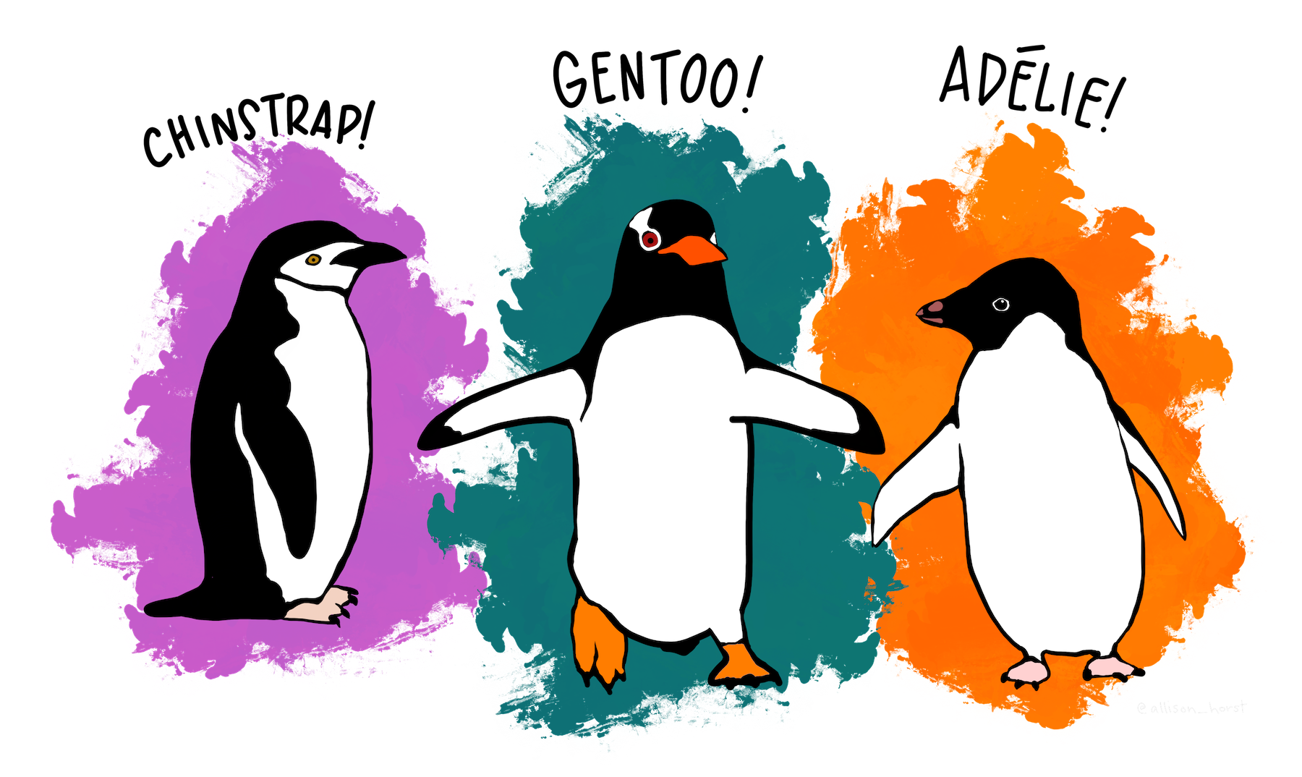

ggplot(penguins, aes(x = island, fill = species)) +  
 geom_bar(alpha = 0.8) +  
 scale_fill_manual(values = c("darkorange","purple","cyan4"),  
 guide = FALSE) +  
 theme_minimal() +  
 facet_wrap(~species, ncol = 1) +  
 coord_flip()

## Warning: It is deprecated to specify `guide = FALSE` to remove a guide. Please  
## use `guide = "none"` instead.

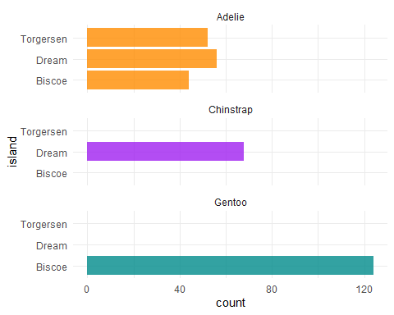

One of the species lives on all islands and the others are specific to one island only.