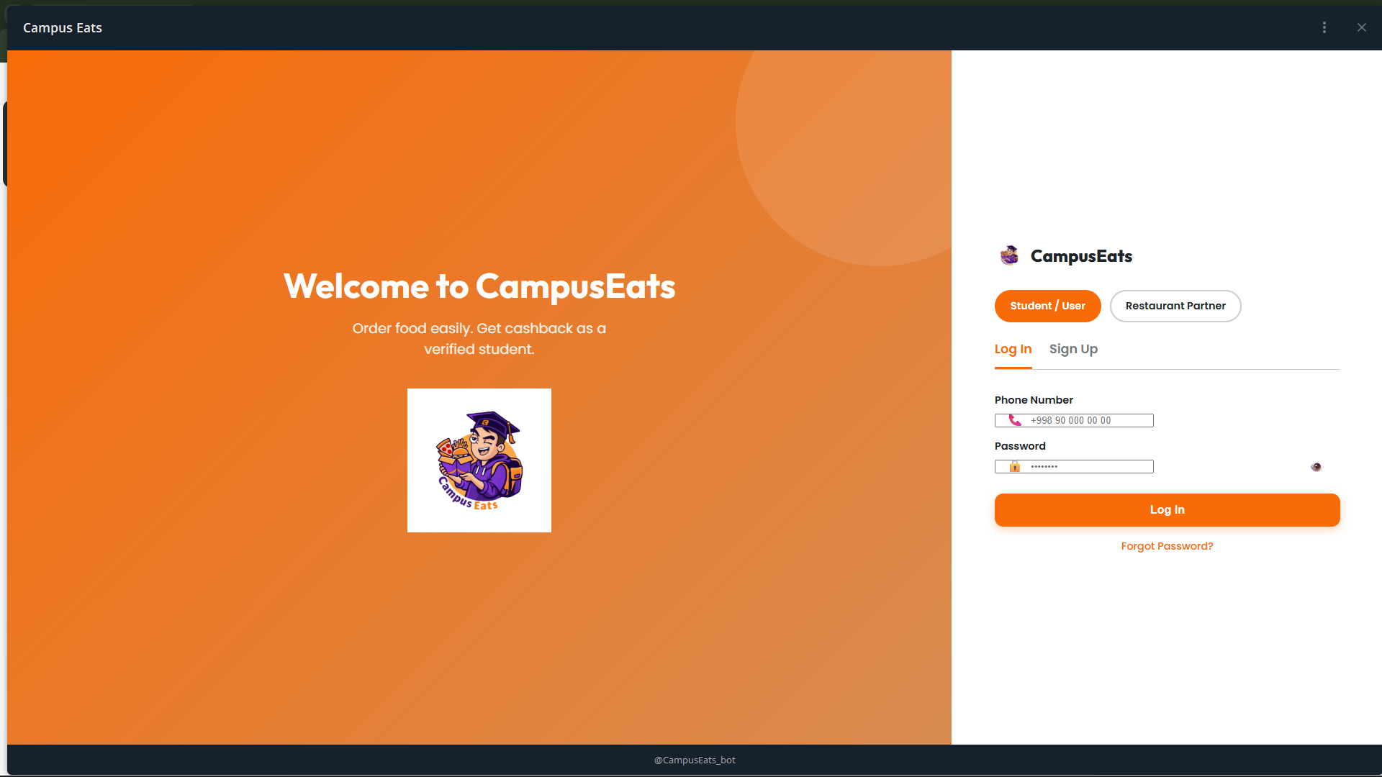
Old design to redesign
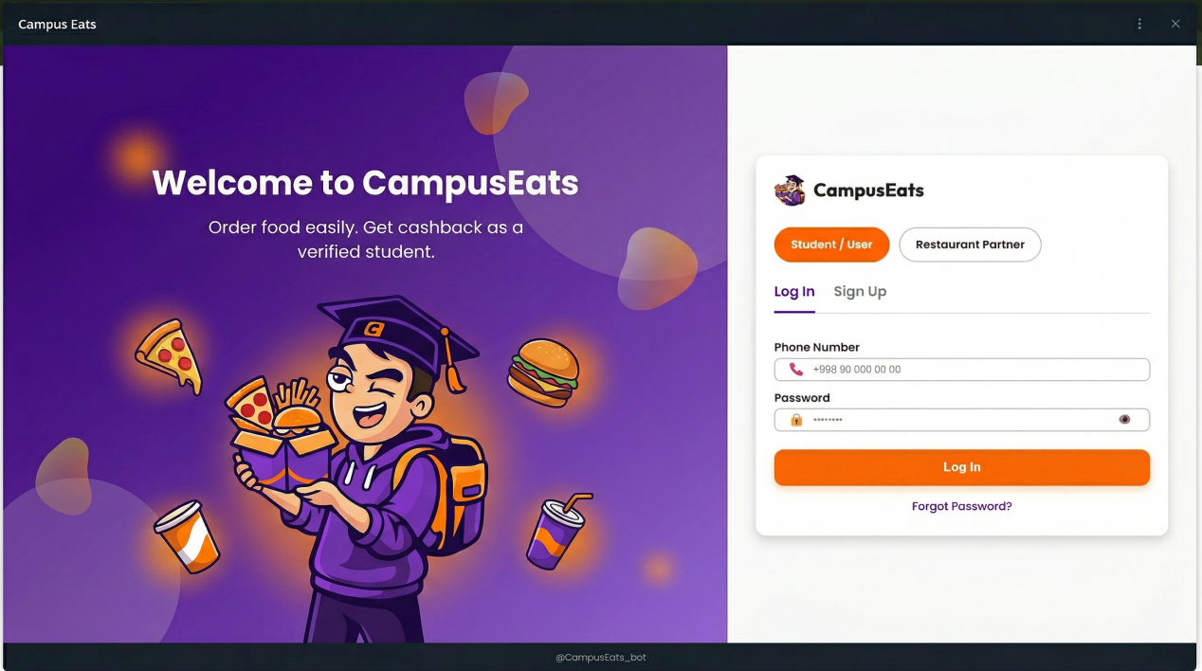
Desktop version
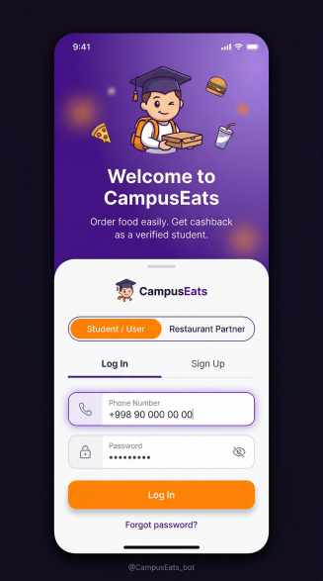 mobile version
LOGIN PAGE REDESIGN — FRONTEND IMPLEMENTATION NOTES

1. Layout Structure:
* Use split layout:
display: flex;
min-height: 100vh;
* Left (hero): 50–55%
* Right (form): 45–50%
* Mobile:
flex-direction: column;
hero → top, form → bottom

2. Container & Alignment:
* Form wrapper:
max-width: 440–480px;
width: 100%;
margin: auto;
* Vertically center using:
display: flex;
align-items: center;
justify-content: center;

3. Color Tokens:
:root {
--color-primary: #6A0DAD;
--color-accent: #FF8C00;
--color-bg: #F8F8F8;
--color-text: #1A1A1A;
--color-border: #E5E5E5;
}

4. Left Section (Hero):
* Background:
background: linear-gradient(135deg, #6A0DAD, #9D4EDD);
* Add decorative element:
radial gradient or blurred circle (pseudo element)
position: absolute;
* Content:
flex column
gap: 16px–24px
* Mascot image:
max-width: 280–320px

5. Form Card:
* Background: #FFFFFF
* Border-radius: 20px
* Padding: 32px
* Box-shadow:
0 10px 30px rgba(0,0,0,0.08)

6. Segmented Control (User Type):
* Wrapper:
display: flex;
background: #F1F1F1;
border-radius: 999px;
padding: 4px;
* Button:
flex: 1;
border-radius: 999px;
padding: 10px;
* Active:
background: var(--color-accent);
color: white;
* Inactive:
color: #666;

7. Tabs (Login / Signup):
* Use underline indicator:
position: relative;
* Active tab:
color: var(--color-primary);
* Underline:
height: 2px;
background: var(--color-accent);

8. Inputs:
* Style:
height: 48px;
border-radius: 12px;
border: 1px solid var(--color-border);
padding: 0 16px;
font-size: 16px;
* Focus:
border-color: var(--color-primary);
box-shadow: 0 0 0 3px rgba(106,13,173,0.1);
outline: none;
* Password:
add toggle icon (position: absolute; right: 12px;)

9. Buttons:
* Primary (Login):
height: 48px;
border-radius: 14px;
background: var(--color-accent);
color: white;
font-weight: 600;
* Hover:
transform: translateY(-2px);
box-shadow: 0 8px 20px rgba(255,140,0,0.25);
transition: all 0.2s ease;

10. Typography:
* Font-family: "Poppins", sans-serif;
* Heading:
font-size: 28–32px;
font-weight: 700;
* Labels:
font-size: 14px;
font-weight: 500;
* Body:
font-size: 14–16px;

11. Spacing System:

* Section gap: 24px
* Input gap: 12–16px
* Button margin-top: 16–20px

12. Micro Interactions:
* Add transition globally:
transition: all 0.2s ease;
* Button hover
* Input focus animation
* Tab switch smooth underline

13. Responsive:
* Tablet:
split → 60/40
* Mobile:
hero hidden OR reduced height (200–300px)
form full width
padding: 16–20px

14. Accessibility:
* Label must be linked with input (for/id)
* Focus states visible
* Button contrast sufficient
15. Optional Enhancements:
* Add glass effect:
backdrop-filter: blur(10px);
* Add subtle animation to mascot (floating)
RESULT:
Page becomes structured, scalable, and visually consistent. Components are reusable and ready for integration into a design system.
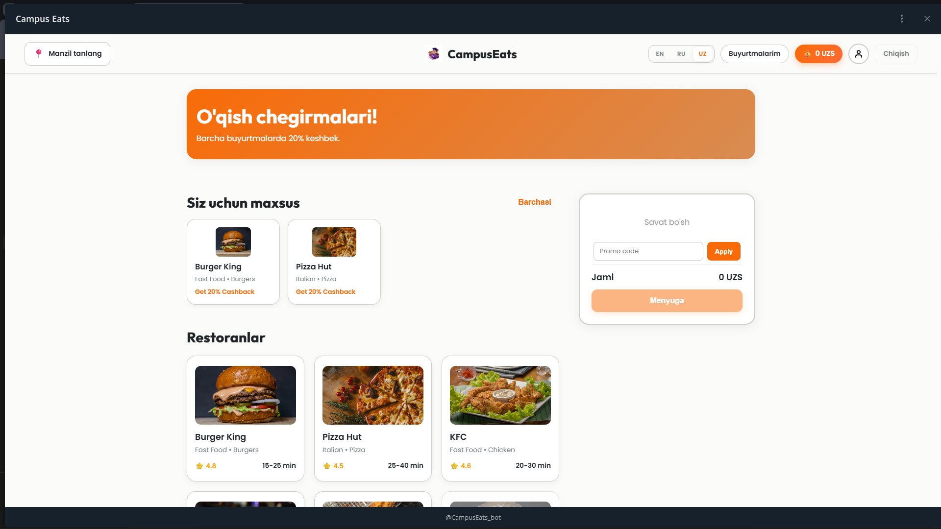
old design to redesign
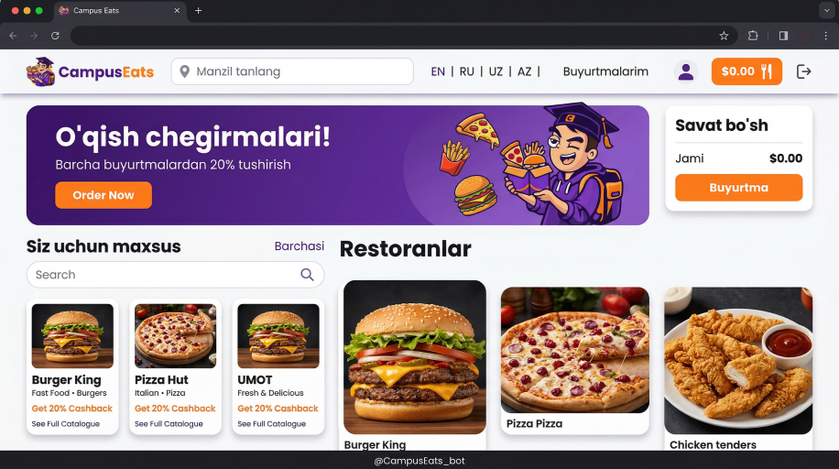desktop version
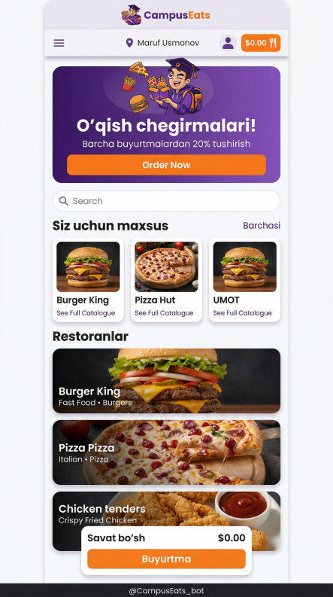 mobile version
UI redesign davomida sahifaning struktura, stil va komponent darajasida quyidagi o‘zgarishlar kiritildi:

1. Layout & Grid:
* Sahifa umumiy grid tizimga o‘tkazildi (12-column yoki responsive flex/grid).
* Sectionlar orasidagi spacing standartlashtirildi (24px / 32px / 48px).
* Container max-width qo‘llanildi (masalan: 1200px–1280px).
* Right-side cart panel sticky qilib qo‘yildi (position: sticky; top: 24px).

2. Color System:
* Ranglar design token sifatida ajratildi:
--color-primary: #6A0DAD (purple)
--color-accent: #FF8C00 (orange)
--color-bg: #F8F8F8
--color-text: #1A1A1A
* Orange faqat CTA va active elementlarda ishlatiladi.
* Purple asosiy UI elementlar (navbar, headings) uchun ishlatiladi.

3. Typography:
* Font-family: "Poppins", sans-serif
* Heading:
font-weight: 600–700
line-height: 120%
* Body:
font-weight: 400
line-height: 150%
* Font-size scale:
h1: 32–40px
h2: 24–28px
body: 14–16px

4. Navbar:
* Height: ~72px
* Flex layout (justify-content: space-between)
* Active state uchun underline yoki color change
* CTA button (cart/order) highlight (orange background)

5. Hero Section:
* Background: linear-gradient (purple → lighter purple)
* Padding: 48–64px
* Flex yoki grid (2 column layout)
* CTA button:
background: var(--color-accent)
border-radius: 12px
padding: 12px 24px

6. Cards (Restaurant / Category):
* Border-radius: 16–20px
* Box-shadow:
0 8px 24px rgba(0,0,0,0.08)
* Padding: 16–20px
* Hover:
transform: scale(1.03)
box-shadow: 0 12px 32px rgba(0,0,0,0.12)
transition: all 0.3s ease
* Image:
width: 100%
height: fixed (150–180px)
object-fit: cover
….……..
Natija:
UI komponentlarga ajratildi, reusable va scalable bo‘ldi. Styling tizimlashtirildi va frontend implementatsiya qilish osonlashdi.

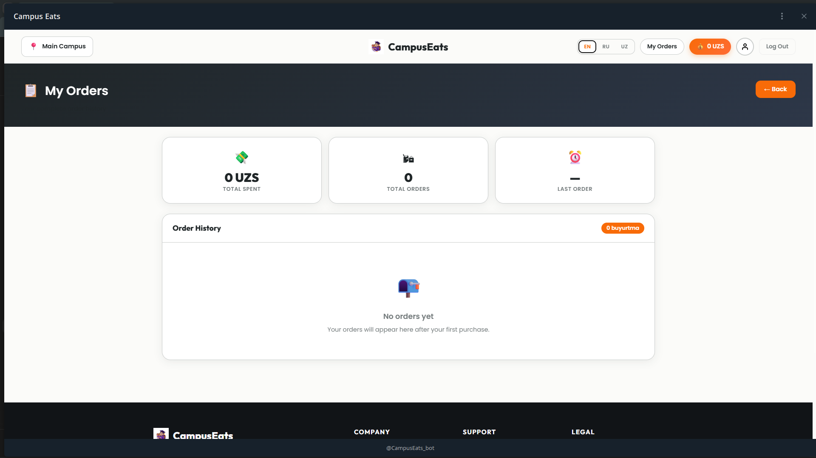
Old to redesign
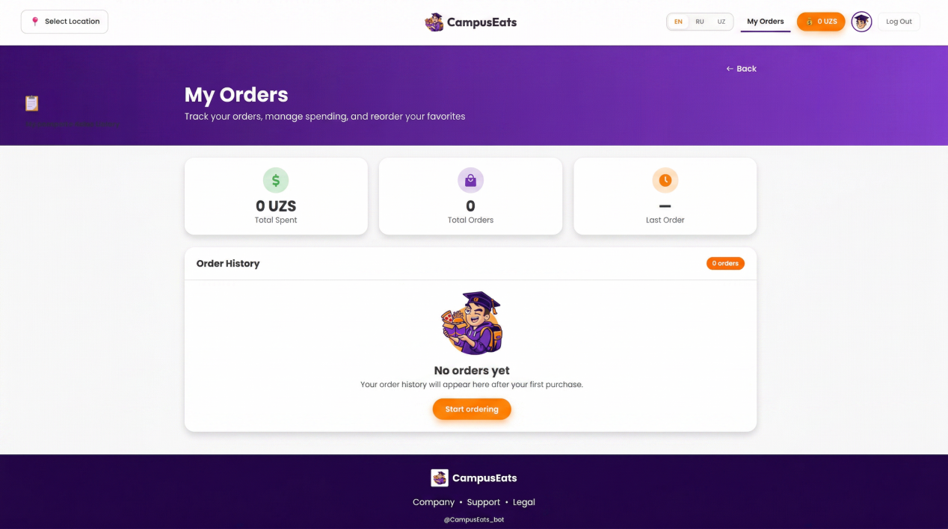
Dektop version
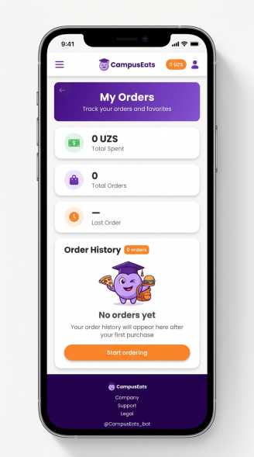 mobile version
My Orders page’da quyidagi o‘zgarishlar kiritildi:
- Sahifaning umumiy tuzilmasi tartibga solindi va vizual hierarchy kuchaytirildi.
- Header qismi CampusEats brendiga mos ravishda tozalandi va navigatsiya aniqroq qilindi.
- Hero banner qayta ishlanib, sahifaning asosiy sarlavhasi va tavsifi kuchliroq ko‘rsatildi.
- Statistika bloklari yangilanib, ko‘rinishi soddaroq va tushunarliroq qilindi.
- Order History bo‘limi asosiy fokus nuqta sifatida qayta joylashtirildi.
- Empty state holati yaxshilanib, foydalanuvchini keyingi harakatga undaydigan CTA qo‘shildi.
- Mascot va brend elementlari qo‘shilib, sahifaga jonliroq va do‘stona ko‘rinish berildi.
- Ranglar tizimi CampusEats identity’ga moslashtirildi: purple asosiy rang, orange esa action elementlar uchun ishlatildi.
- Kartalar, tugmalar va bloklarda yagona stil saqlanib, umumiy dizayn bir xil ko‘rinishga keltirildi.
- Sahifa responsive holat uchun ham moslashtirilib, mobil va tablet versiyada qulay ishlashi hisobga olindi.
Natijada, My Orders page oddiy statistik sahifadan ko‘ra, foydalanuvchini buyurtma qilishga qaytaradigan, aniqroq, zamonaviyroq va brendga mos product page ko‘rinishiga keltirildi.

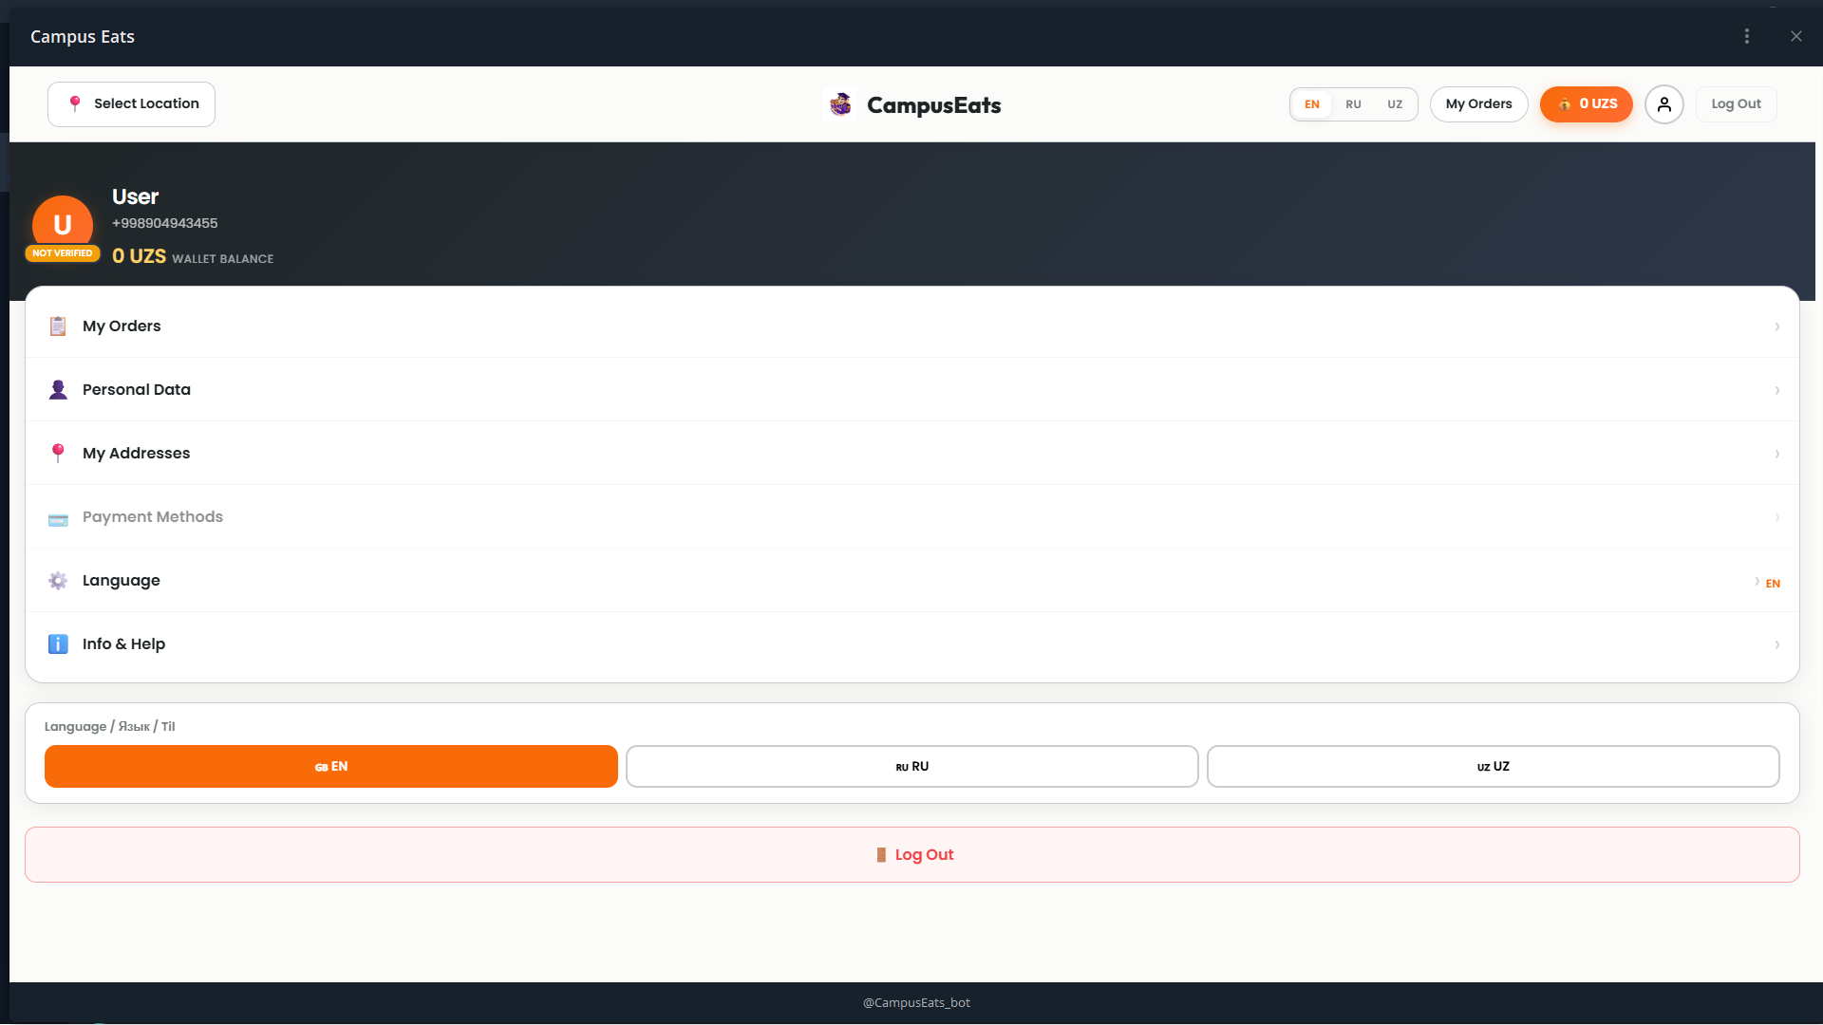
Old to redesign
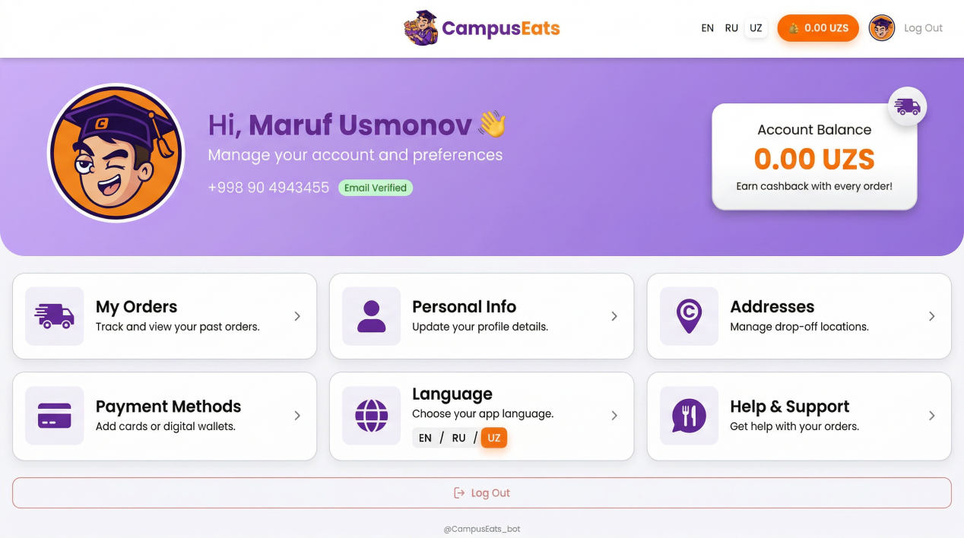
Desktop version

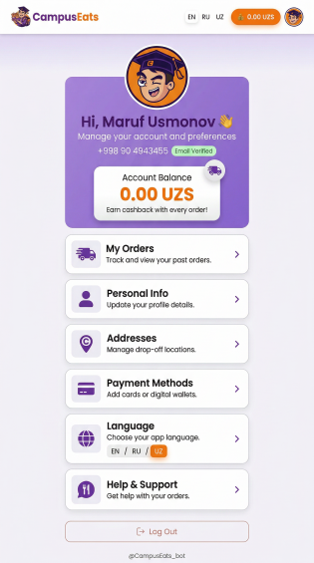mobile version
My Profile page’da quyidagi o‘zgarishlar kiritildi:
- Sahifaning umumiy tuzilmasi qayta tartiblanib, oddiy settings listdan ko‘ra product sahifaga aylantirildi.
- Profil header yangilanib, foydalanuvchi haqida ma’lumotlar aniqroq va do‘stona ko‘rinishda berildi.
- Qorong‘i fon o‘rniga yengilroq va brendga mos ranglar ishlatilib, sahifa yanada qulayroq qilindi.
- Oddiy list elementlari card-style ko‘rinishga o‘tkazilib, interaktivlik oshirildi.
- Har bir bo‘limga qisqa tushuntiruvchi matn qo‘shilib, foydalanuvchi uchun navigatsiya osonlashtirildi.
- Language tanlash qismi ixchamlashtirilib, ortiqcha joy egallashining oldi olindi.
- Logout tugmasi asosiy elementlardan ajratilib, secondary action sifatida qayta dizayn qilindi.
- Ranglar tizimi CampusEats brendiga moslashtirildi (purple — asosiy, orange — action).
- Sahifaga yumshoq animatsiyalar va hover effektlar qo‘shilib, UI yanada jonli qilindi.
- Responsive dizayn yaxshilanib, mobil va tablet qurilmalarda qulay ishlash ta’minlandi.
Natijada, My Profile page oddiy sozlamalar sahifasidan chiqib, foydalanuvchi uchun qulay, tushunarli va brendga mos zamonaviy account sahifaga aylantirildi.

