Students Campus Laundry Booking and Management System
Requirements Specification
Functional and non-functional requirements, business rules and data requirements, with the crow's-foot entity relationship diagram (ERD) and data dictionary.
Version 1.0.0 · 4 October 2026
Asemahle Sokaba (223172243) · Avuziwe Mcata (222106697)

Contents

1. Introduction 4
1.1 Purpose of this document 4
1.2 Background 4
1.3 Problem statement 4
1.4 Purpose and objectives of the system 4
1.5 Scope 4
1.6 Definitions 5
2. Stakeholders and users 6
2.1 Project team 6
3. Functional requirements 7
3.1 User management 7
3.2 Machine booking and scheduling 7
3.3 Notifications 7
3.4 Laundry tips 8
3.5 Feedback system 8
3.6 Management and administration 8
4. Non-functional requirements 9
5. Business rules 10
5.1 Assumptions and constraints 10
6. Data requirements and ERD 11
6.1 Crow's-foot notation 11
6.2 Conceptual ERD 11
6.3 Physical ERD 12
6.4 Relationships 13
6.5 Unique keys 13
6.6 Validation rules (CHECK constraints) 14
7. Data dictionary 15
7.1 users 15
7.2 laundry_rooms 15
7.3 machines 15
7.4 bookings 16
7.5 notifications 16
7.6 waitlist_entries 17
7.7 machine_outages 17
7.8 laundry_tips 17
7.9 feedback 18
8. Requirements traceability 19

1. Introduction

1.1 Purpose of this document
This document states what the Campus Laundry system must do (functional requirements), how well it must do it (non-functional requirements), the rules it follows and the data it stores. It combines the problem and objectives from Phase 1 with the requirement analysis from Phase 2, and shows the database design that meets them as a crow's-foot ERD.

1.2 Background
Laundry facilities on campus are shared among many students, which often leads to overcrowding, long waiting times and poor management of machines. Students usually rely on a first-come, first-served system, which causes inconvenience and conflicts. Students also often lack knowledge about proper laundry practices such as separating clothes, choosing the correct detergent and caring for different fabric types.

1.3 Problem statement
Problem | Addressed by
Long queues and waiting times | FR-06 – FR-12 (booking and waiting list)
Poor scheduling of machines | FR-07 – FR-10, FR-23 – FR-25
No notification when laundry is done | FR-13 – FR-17
Limited knowledge of proper laundry practices | FR-18 – FR-19
No platform to give feedback on the service | FR-20 – FR-22, FR-28

1.4 Purpose and objectives of the system
The system provides a digital platform where students book laundry machines, receive notifications, read laundry tips and give feedback. Its objectives are:
- To allow students to book machines online.
- To send notifications when laundry is complete.
- To provide helpful laundry tips.
- To allow students to give feedback.
- To improve the overall management of the laundry.

1.5 Scope
In scope | Out of scope
Student registration and login; administrator accounts | Payment for laundry or detergent
Several laundry rooms with washers and dryers | Connecting to the machines themselves (students tap Start and Collected)
Booking, rescheduling, cancelling, waiting list | SMS, email or push notifications (notifications are in the app)
In-app notifications, laundry tips, feedback | A native mobile app (the web pages work on phones)
Machine and room management, booking history, usage reports

1.6 Definitions
Term | Meaning
Slot | A fixed block of time (e.g. 60 minutes) in which one machine can be booked
Cycle | The washing or drying time of a machine, started by the student with Start cycle
No-show | A booking whose cycle was not started within 15 minutes of the slot start
Waiting list | Students waiting for a washer or dryer in a room on a day, in order of joining
Out of order | A machine with an open outage; it cannot be booked
Core table | A table that comes straight from the requirements (black heading in the ERD)
Extension table | A table added in design to meet the requirements well (grey heading in the ERD)

2. Stakeholders and users
Stakeholder | Role in the system | Main needs
Student | Main user | Book a machine without queuing; know when laundry is done; learn good laundry practice; report problems
Laundry administrator | Manages the system | Manage rooms and machines; see usage and history; handle feedback; manage accounts
Residence / campus management | Indirect | Fair, well-used facilities; reports on use and problems
Maintenance technician | Indirect | Clear reports of faulty machines (issues and outages)

2.1 Project team
Role | Responsibilities
System Analyst | Identifies user needs; analyses the system requirements
Database Designer | Designs the tables and relationships; creates the ERD
Developer | Builds the system; connects the database
Presenter | Prepares the slides; presents the project
Group members: Asemahle Sokaba (223172243) and Avuziwe Mcata (222106697).

3. Functional requirements
Priority: Must = from the Phase 2 requirement analysis and needed for the system to be accepted; Should = added in design to make the requirement work well in practice.

3.1 User management
ID | Requirement | Priority | How the system meets it
FR-01 | Students register with their full name, student number, email and a password. | Must | Registration page. Student number 8–10 digits, password at least 8 characters; optional home laundry room and phone.
FR-02 | Users log in securely. | Must | Log in with email or student number. Passwords stored only as bcrypt hashes; session cookie (http-only, 8 hours).
FR-03 | The system supports the roles Student and Admin. | Must | Role stored per user and checked on every request; each role sees only its own menu and pages.
FR-04 | Users manage their own profile. | Should | Change name, email, home room, phone and password; students can delete their own account.
FR-05 | The administrator manages accounts. | Should | People page: make another admin, deactivate/reactivate, reset a password (temporary password that must be changed), delete.

3.2 Machine booking and scheduling
ID | Requirement | Priority | How the system meets it
FR-06 | Students view available laundry machines in real time. | Must | Booking grid per laundry room and day (today and the next 7 days): free, taken, own and out-of-order slots.
FR-07 | Students book a machine for a specific date and time slot. | Must | Fixed time slots per room (slot length set by the admin); click a free slot and confirm.
FR-08 | Double bookings of the same machine are prevented. | Must | Unique key on (machine, date, slot) in the database; a student also cannot hold two machines at the same time.
FR-09 | Students cancel or reschedule a booking. | Must | My laundry → Cancel or Reschedule, until the slot starts. The freed slot goes to the waiting list.
FR-10 | Fair use of machines. | Should | At most 3 open bookings per student; a booking not started within 15 minutes becomes a no-show and the machine is released.
FR-11 | Students record the start and end of their laundry. | Must | Start cycle (from 5 minutes before to 15 minutes after the slot starts) and Collected; the cycle time comes from the machine.
FR-12 | Students join a waiting list when a room is fully booked. | Should | Waiting list per room, day and machine type; the first student in line is told when a slot frees up.

3.3 Notifications
ID | Requirement | Priority | How the system meets it
FR-13 | Send a reminder when the booking time is approaching. | Must | In-app reminder 30 minutes before the slot, sent by a background scheduler.
FR-14 | Notify the user when their laundry cycle is done. | Must | "Your laundry is done" when the machine's cycle time has passed after Start cycle.
FR-15 | Notify the next user when a machine becomes free. | Must | After Collected, the student with the next booking on that machine today is told; freed slots go to the waiting list.
FR-16 | Users see and manage their notifications. | Should | Bell with unread count on every page; notifications page with Open, Mark read, Mark all as read, Delete.
FR-17 | Users are told about changes made by the administrator. | Should | Notifications when a booking is cancelled (e.g. machine out of order), a slot is missed, or feedback is answered.

3.4 Laundry tips
ID | Requirement | Priority | How the system meets it
FR-18 | Provide guidelines on sorting clothes, choosing detergents, washing fabric types and machine maintenance. | Must | Laundry tips page with the four categories and a filter; 8 tips included at installation.
FR-19 | The administrator maintains the tips. | Should | Add, edit, delete and publish/unpublish tips (drafts are hidden from students).

3.5 Feedback system
ID | Requirement | Priority | How the system meets it
FR-20 | Students rate the service or a machine's condition. | Must | Rating of 1 to 5 stars for a laundry room or a single machine.
FR-21 | Students submit comments or report issues. | Must | Comment and issue forms; an issue needs a room and a description.
FR-22 | The administrator views and manages feedback. | Must | Feedback page (open first): reply, set status New / Being looked at / Resolved / Closed; the student is notified. Closing needs a reply.

3.6 Management and administration
ID | Requirement | Priority | How the system meets it
FR-23 | The administrator adds, edits and removes machines. | Must | Machines page. A machine that was used is retired (kept for history) instead of deleted.
FR-24 | The administrator manages laundry rooms. | Should | Rooms with opening hours and slot length; hours can only change when no bookings are upcoming.
FR-25 | The administrator marks machines out of order. | Should | Reason recorded; the machine can't be booked, its upcoming bookings are cancelled and the students notified; outage history kept.
FR-26 | The administrator views booking history. | Must | Bookings page with filters (student, dates, room, status); the admin can cancel an upcoming booking.
FR-27 | The administrator views usage reports. | Must | Dashboard: today's activity and, for 7/30/90 days, bookings, loads, cancellations, no-show rate, average rating, use per day, hour, machine and room.
FR-28 | The administrator monitors feedback and takes action. | Must | Open issues on the dashboard; an issue about a machine can take it out of order in one step.

4. Non-functional requirements
ID | Quality | Requirement | How it is met and verified
NFR-01 | Usability | The interface is simple, mobile-friendly and easy for students to use. | Plain-language pages with a menu (a tab bar on phones). Verified: browser tests at 1280 px and on a 375 px phone screen (no sideways scrolling).
NFR-02 | Performance | The system loads quickly and handles many users booking at the same time. | Targets: availability grid under 300 ms for 95% of requests; 30 students opening "My laundry" at once answered within 2 s; a page in under 200 ms. Verified by the load tests.
NFR-03 | Reliability | Booking data and notifications are accurate and consistent. | Database constraints (unique keys, CHECK rules, foreign keys); transactions with row locks; each notification sent at most once. Verified: 30 simultaneous bookings of one slot → exactly one succeeds.
NFR-04 | Security | User data and passwords are stored securely. | bcrypt password hashes; http-only session cookie; parameterised SQL; role and account status re-checked on every request; temporary passwords must be changed.
NFR-05 | Compatibility | Works in web browsers and on mobile devices. | Standard HTML/CSS/JavaScript; works in current Edge, Chrome and Firefox and on phones on the same network.
NFR-06 | Maintainability | The database can be changed without losing data. | Versioned migrations (db/migrations) recorded in schema_migrations; a full creation script (db/schema.sql) checked against the live database.
NFR-07 | Availability of data | History is kept when people leave or machines are removed. | Deleting an account keeps its bookings and feedback ("former student"); used machines are retired, not deleted.

5. Business rules
ID | Rule
BR-01 | A booking is for one machine, one day and one slot of the room's fixed slot length (30–240 minutes).
BR-02 | Bookings can be made for today and up to 7 days ahead, only inside the room's opening hours and never in the past.
BR-03 | A student has at most 3 open bookings and cannot book two machines for the same time.
BR-04 | A machine's cycle time (10–240 minutes) must fit inside one slot.
BR-05 | Start cycle is possible from 5 minutes before the slot until 15 minutes after it starts; after that the booking is a no-show.
BR-06 | Booking status flow: Booked → Washing/drying → Done → Collected, or Cancelled / No-show.
BR-07 | A machine has at most one open outage; while it is out of order it cannot be booked.
BR-08 | Feedback of kind "rating" has 1–5 stars; comments and issues have a description of at least 5 characters.
BR-09 | Each booking gets each kind of notification at most once.
BR-10 | Only students have a student number, and every student has one.

5.1 Assumptions and constraints
- The system runs on one computer in the residence or laundry office (Node.js and MySQL 8.4); students use it in a web browser on the same network.
- Students record the start and the collection of their laundry in the app; the system does not read the machines.
- Each laundry room has fixed opening hours and one slot length for all its machines.
- Notifications are shown in the app; they are not sent by SMS or email.

6. Data requirements and ERD
The database has 9 tables. Six come straight from the requirements (users, machines, bookings, notifications, laundry_tips, feedback). Three were added in design: laundry_rooms (the campus has several laundry rooms with their own hours), waitlist_entries (the waiting list that lets the system "notify the next user when a machine becomes free") and machine_outages (machines out of order, with their history).

6.1 Crow's-foot notation
Symbol at the end of a line | Meaning
Two bars ( || ) | Exactly one
Bar and circle ( |○ ) | Zero or one (the link is optional)
Crow's foot and circle ( ○< ) | Zero or many
Each line is read from the parent (top) to the child (bottom) with its verb, e.g. "a laundry room contains zero or many machines; a machine is in exactly one laundry room".

6.2 Conceptual ERD
The entities and how they are related.
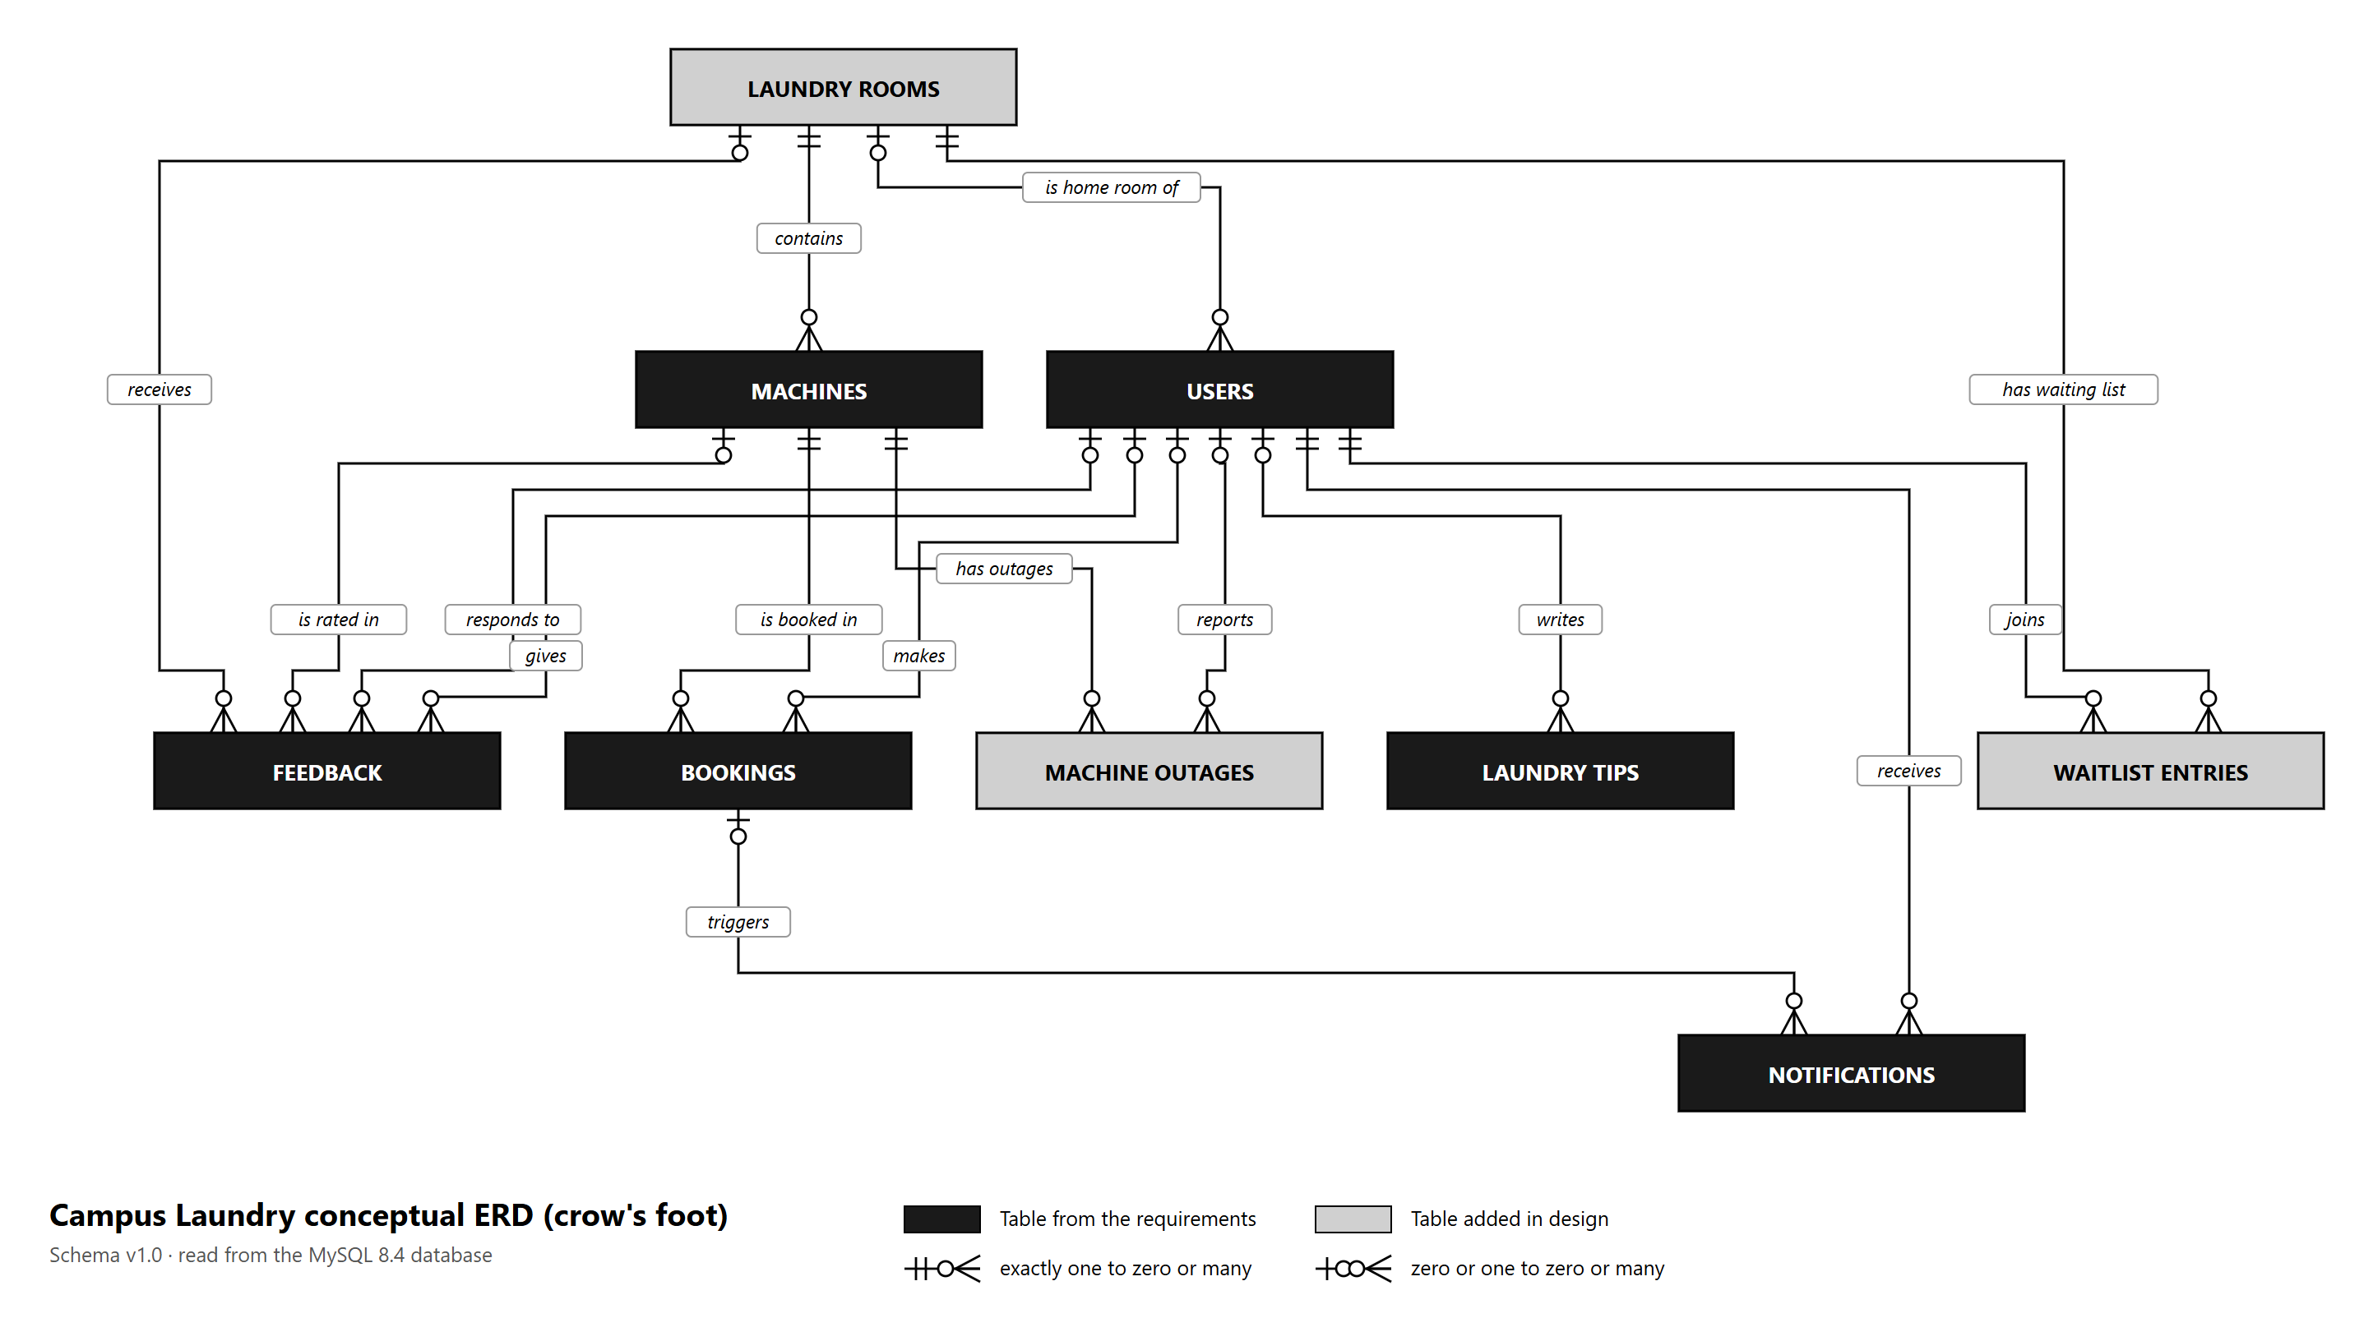
Figure 1: Conceptual ERD (crow's foot)

6.3 Physical ERD
Every table with its columns, data types and keys, as built in MySQL 8.4. The diagram is a vector image: zoom in to read it in detail.
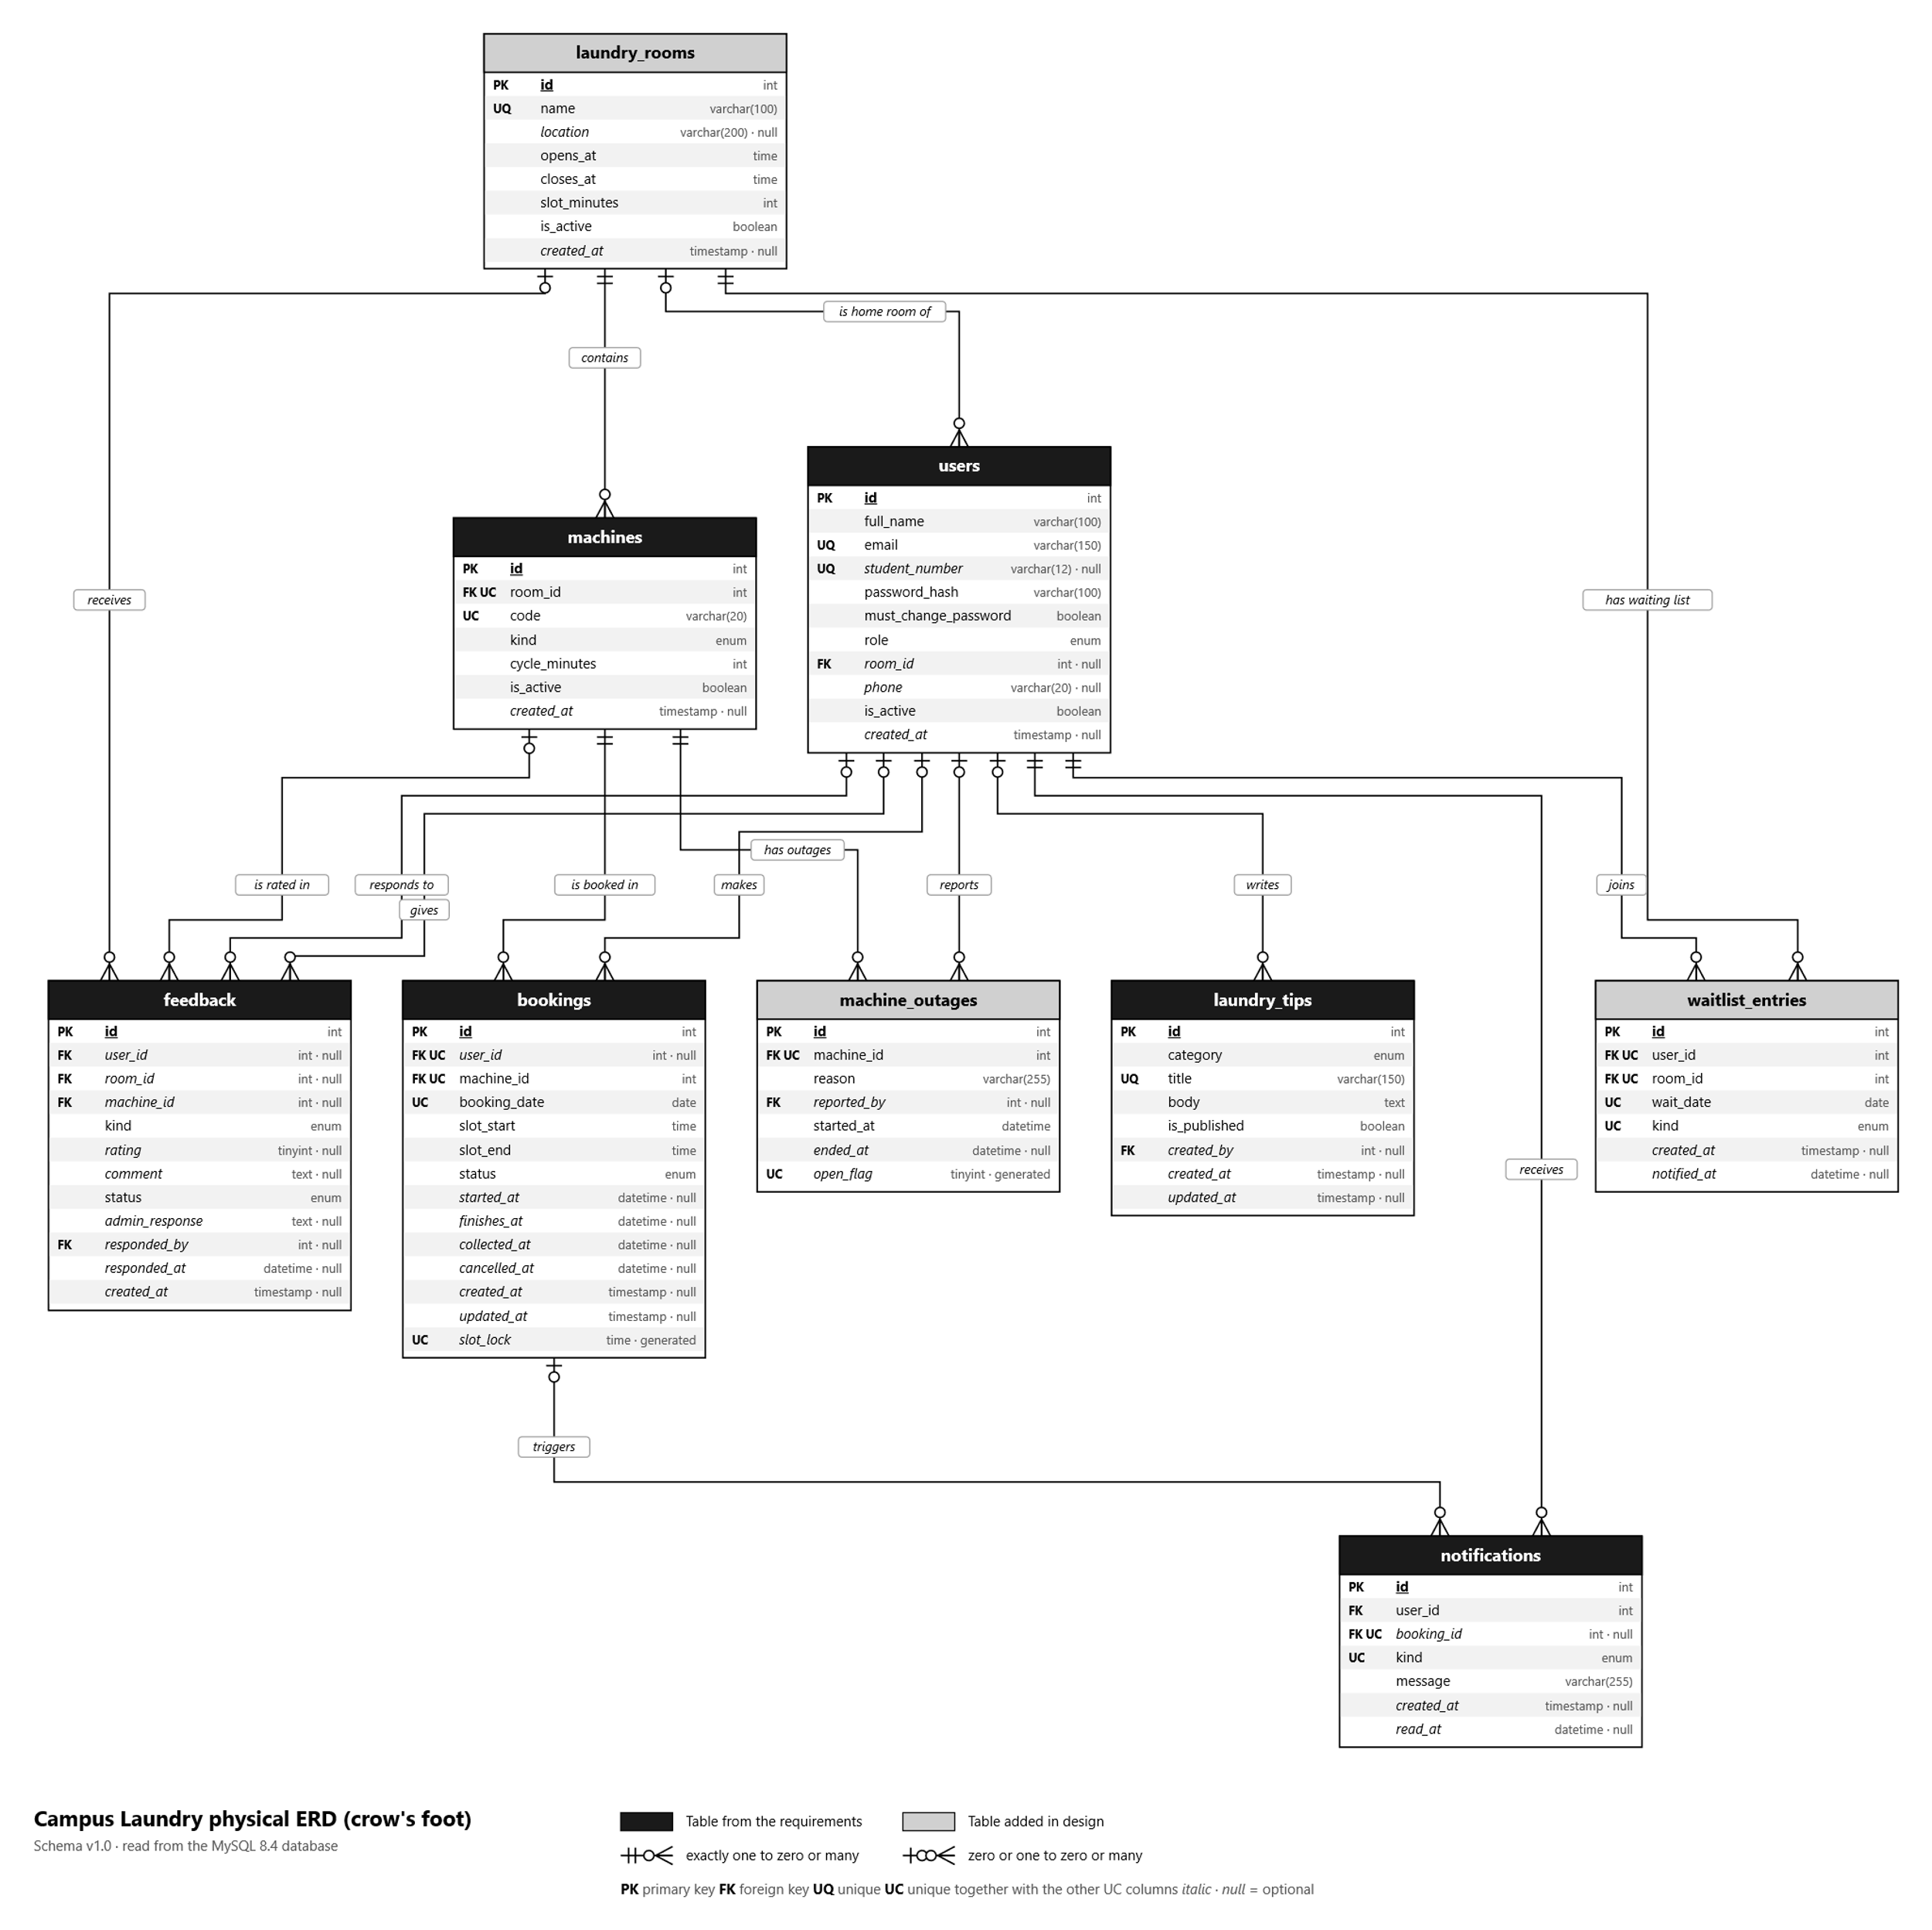
Figure 2: Physical ERD (crow's foot) with columns and keys

6.4 Relationships
Parent | Verb | Child | Cardinality | Foreign key | When the parent is deleted
machines | is booked in | bookings | 1 to 0..many | bookings.machine_id | Not allowed while children exist
users | makes | bookings | 0..1 to 0..many | bookings.user_id | Children are kept; the link becomes empty
machines | is rated in | feedback | 0..1 to 0..many | feedback.machine_id | Children are kept; the link becomes empty
users | responds to | feedback | 0..1 to 0..many | feedback.responded_by | Children are kept; the link becomes empty
laundry_rooms | receives | feedback | 0..1 to 0..many | feedback.room_id | Children are kept; the link becomes empty
users | gives | feedback | 0..1 to 0..many | feedback.user_id | Children are kept; the link becomes empty
users | writes | laundry_tips | 0..1 to 0..many | laundry_tips.created_by | Children are kept; the link becomes empty
machines | has outages | machine_outages | 1 to 0..many | machine_outages.machine_id | Children are deleted too
users | reports | machine_outages | 0..1 to 0..many | machine_outages.reported_by | Children are kept; the link becomes empty
laundry_rooms | contains | machines | 1 to 0..many | machines.room_id | Not allowed while children exist
bookings | triggers | notifications | 0..1 to 0..many | notifications.booking_id | Children are deleted too
users | receives | notifications | 1 to 0..many | notifications.user_id | Children are deleted too
laundry_rooms | is home room of | users | 0..1 to 0..many | users.room_id | Children are kept; the link becomes empty
laundry_rooms | has waiting list | waitlist_entries | 1 to 0..many | waitlist_entries.room_id | Children are deleted too
users | joins | waitlist_entries | 1 to 0..many | waitlist_entries.user_id | Children are deleted too

6.5 Unique keys
Table | Unique key | Columns | Meaning
bookings | uq_bookings_machine_slot | machine_id, booking_date, slot_lock | A machine can't be booked twice for the same slot (ignores cancelled and missed bookings)
bookings | uq_bookings_user_slot | user_id, booking_date, slot_lock | A student can't hold two machines at the same time
laundry_rooms | uq_laundry_rooms_name | name | Room names are unique
laundry_tips | uq_laundry_tips_title | title | Tip titles are unique
machine_outages | uq_machine_outages_machine_open | machine_id, open_flag | At most one open outage per machine
machines | uq_machines_room_code | room_id, code | Machine codes are unique within a room
notifications | uq_notifications_booking_kind | booking_id, kind | Each kind of notification is sent once per booking
users | uq_users_email | email | One account per email
users | uq_users_student_number | student_number | One account per student number
waitlist_entries | uq_waitlist_entries_user_room_date_kind | user_id, room_id, wait_date, kind | A student joins a waiting list once

6.6 Validation rules (CHECK constraints)
These rules are enforced by MySQL itself, so invalid data is refused even if it does not come through the web pages.
Table | Rule | Meaning
bookings | chk_bookings_cancelled | A cancellation time exists exactly when the status is cancelled
bookings | chk_bookings_collected | A collection time exists exactly when the status is collected
bookings | chk_bookings_finishes | Start and finish times come together, and the finish is after the start
bookings | chk_bookings_started | A start time exists exactly when the status is in progress, done or collected
bookings | chk_bookings_times | Slot end is after slot start
feedback | chk_feedback_comment | Comments and issues have a description of at least 5 characters
feedback | chk_feedback_rating | Rating is 1–5
feedback | chk_feedback_rating_kind | A rating exists exactly when the kind is "rating"
feedback | chk_feedback_response | A reply and its time come together
laundry_rooms | chk_laundry_rooms_hours | Closing time is after opening time
laundry_rooms | chk_laundry_rooms_name | Room name has at least 2 characters
laundry_rooms | chk_laundry_rooms_slot | Slot length is 30–240 minutes
laundry_tips | chk_laundry_tips_body | Tip text has at least 20 characters
laundry_tips | chk_laundry_tips_title | Tip title has at least 5 characters
machine_outages | chk_machine_outages_period | An outage ends after it starts
machine_outages | chk_machine_outages_reason | Reason has at least 5 characters
machines | chk_machines_code | Machine code is not empty
machines | chk_machines_cycle | Cycle time is 10–240 minutes
notifications | chk_notifications_message | Message has at least 5 characters
users | chk_users_email | Email looks like name@domain.tld
users | chk_users_full_name | Full name has at least 2 characters
users | chk_users_phone | Phone has 7–20 digits, spaces, +, - or brackets
users | chk_users_student_has_number | Every student has a student number
users | chk_users_student_number | Student number is 8–10 digits

7. Data dictionary
PK = primary key, FK = foreign key (→ the table it refers to), UQ = part of a unique key. "Null: Yes" means the value is optional.

7.1 users
Everyone who can log in: students and administrators. (Source: requirements.)
Column | Type | Null | Key | Description
id | int | No | PK | Unique number of the user
full_name | varchar(100) | No |  | Full name (at least 2 characters)
email | varchar(150) | No | UQ | Email address, used to log in
student_number | varchar(12) | Yes | UQ | Student number, 8–10 digits (students only); also used to log in
password_hash | varchar(100) | No |  | bcrypt hash of the password (the password itself is never stored)
must_change_password | boolean | No |  | True after a reset: the user must choose a new password first
role | enum | No |  | student or admin
room_id | int | Yes | FK → laundry_rooms | Home laundry room, opened first when booking
phone | varchar(20) | Yes |  | Phone number (optional)
is_active | boolean | No |  | False when the administrator deactivated the account
created_at | timestamp | Yes |  | When the account was created

7.2 laundry_rooms
A laundry room with its opening hours and slot length. (Source: design: several laundry rooms.)
Column | Type | Null | Key | Description
id | int | No | PK | Unique number of the room
name | varchar(100) | No | UQ | Name, e.g. "Residence A Laundry"
location | varchar(200) | Yes |  | Where it is (optional)
opens_at | time | No |  | Opening time
closes_at | time | No |  | Closing time (after opening time)
slot_minutes | int | No |  | Length of one booking slot, 30–240 minutes
is_active | boolean | No |  | False when the room is closed for bookings
created_at | timestamp | Yes |  | When the room was added

7.3 machines
A washer or dryer in a laundry room. (Source: requirements.)
Column | Type | Null | Key | Description
id | int | No | PK | Unique number of the machine
room_id | int | No | FK → laundry_rooms, UQ | Room the machine is in
code | varchar(20) | No | UQ | Short code written on the machine, e.g. W1 (unique in its room)
kind | enum | No |  | washer or dryer
cycle_minutes | int | No |  | Length of one cycle, 10–240 minutes
is_active | boolean | No |  | False when the machine is retired
created_at | timestamp | Yes |  | When the machine was added

7.4 bookings
A student's booking of one machine for one slot, and what happened to it. (Source: requirements.)
Column | Type | Null | Key | Description
id | int | No | PK | Unique number of the booking
user_id | int | Yes | FK → users, UQ | Student who booked (empty if the account was deleted)
machine_id | int | No | FK → machines, UQ | Machine booked
booking_date | date | No | UQ | Day of the booking
slot_start | time | No |  | Start of the slot
slot_end | time | No |  | End of the slot (after the start)
status | enum | No |  | booked, in_progress, done, collected, cancelled or no_show
started_at | datetime | Yes |  | When Start cycle was tapped
finishes_at | datetime | Yes |  | When the cycle finishes (start + cycle time)
collected_at | datetime | Yes |  | When Collected was tapped
cancelled_at | datetime | Yes |  | When the booking was cancelled
created_at | timestamp | Yes |  | When the booking was made
updated_at | timestamp | Yes |  | When the booking last changed
slot_lock | time | Yes | UQ | Generated: the slot start for a live booking, empty when cancelled or missed (makes double bookings impossible)

7.5 notifications
A message to one user (reminder, cycle done, machine free …). (Source: requirements.)
Column | Type | Null | Key | Description
id | int | No | PK | Unique number of the notification
user_id | int | No | FK → users | Who receives it
booking_id | int | Yes | FK → bookings, UQ | Booking it is about (optional)
kind | enum | No | UQ | reminder, cycle_done, machine_free, booking_cancelled, no_show or feedback_reply
message | varchar(255) | No |  | Text shown to the user
created_at | timestamp | Yes |  | When it was sent
read_at | datetime | Yes |  | When it was read (empty = unread)

7.6 waitlist_entries
A student waiting for a washer or dryer in a room on a day. (Source: design: waiting list.)
Column | Type | Null | Key | Description
id | int | No | PK | Unique number of the entry
user_id | int | No | FK → users, UQ | Student waiting
room_id | int | No | FK → laundry_rooms, UQ | Room
wait_date | date | No | UQ | Day
kind | enum | No | UQ | washer or dryer
created_at | timestamp | Yes |  | When the student joined (decides the order)
notified_at | datetime | Yes |  | When the student was told a machine is free

7.7 machine_outages
A period during which a machine is out of order. (Source: design: out-of-order machines.)
Column | Type | Null | Key | Description
id | int | No | PK | Unique number of the outage
machine_id | int | No | FK → machines, UQ | Machine that is out of order
reason | varchar(255) | No |  | Why (at least 5 characters)
reported_by | int | Yes | FK → users | Administrator who recorded it
started_at | datetime | No |  | When it went out of order
ended_at | datetime | Yes |  | When it was back in service (empty = still out of order)
open_flag | tinyint | Yes | UQ | Generated: 1 while the outage is open (allows only one open outage per machine)

7.8 laundry_tips
A laundry tip in one of the four categories. (Source: requirements.)
Column | Type | Null | Key | Description
id | int | No | PK | Unique number of the tip
category | enum | No |  | sorting, detergents, fabrics or maintenance
title | varchar(150) | No | UQ | Title (unique)
body | text | No |  | The tip (at least 20 characters)
is_published | boolean | No |  | False for a draft that students don't see
created_by | int | Yes | FK → users | Administrator who wrote it
created_at | timestamp | Yes |  | When it was written
updated_at | timestamp | Yes |  | When it was last changed

7.9 feedback
A rating, comment or issue from a student, and the administrator's reply. (Source: requirements.)
Column | Type | Null | Key | Description
id | int | No | PK | Unique number of the feedback
user_id | int | Yes | FK → users | Student who sent it
room_id | int | Yes | FK → laundry_rooms | Laundry room it is about
machine_id | int | Yes | FK → machines | Machine it is about (optional)
kind | enum | No |  | rating, comment or issue
rating | tinyint | Yes |  | 1–5 stars (ratings only)
comment | text | Yes |  | Comment or description of the issue
status | enum | No |  | new, in_progress, resolved or dismissed
admin_response | text | Yes |  | The administrator's reply
responded_by | int | Yes | FK → users | Administrator who replied
responded_at | datetime | Yes |  | When the reply was sent
created_at | timestamp | Yes |  | When the feedback was sent

8. Requirements traceability
Where each group of requirements is stored and which pages provide it.
Requirements | Tables | Pages
FR-01 – FR-05 | users | Register / Log in, Profile, People
FR-06 – FR-11 | laundry_rooms, machines, bookings | Book a machine, My laundry
FR-12 | waitlist_entries | Book a machine, My laundry
FR-13 – FR-17 | notifications | Bell, Notifications
FR-18 – FR-19 | laundry_tips | Laundry tips
FR-20 – FR-22 | feedback | Feedback
FR-23 – FR-25 | machines, laundry_rooms, machine_outages | Machines & rooms
FR-26 – FR-28 | bookings, feedback (read) | Dashboard, Bookings, Feedback
All requirements are verified by automated tests: database constraint tests, end-to-end API tests, browser tests and concurrency/performance tests (see the Test Report).

