Campus Laundry
Students Campus Laundry Booking and Management System
Installation and User Manual
How to install and run the system on a computer, and how students and administrators use it.
Version 1.0.0 · 4 October 2026 · Asemahle Sokaba · Avuziwe Mcata

Contents
1. About the system 4
How a laundry booking works 4
Part A · Installation 5
2. What you need 6
2.1 Computer 6
2.2 Software to install 6
2.3 What is in the project folder 6
3. Installation steps 7
Step 1: Copy the project folder 7
Step 2: Install Node.js 7
Step 3: Install and configure MySQL Server 7
Step 4: Open a terminal in the project folder 8
Step 5: Create the settings file (.env) 8
Step 6: Install the project's packages 8
Step 7: Create the database 8
Step 8: Create the first administrator 8
Step 9: Start the system 8
Step 10 (optional): Check the installation 9
4. First-time setup (administrator) 10
Part B · Student guide 11
5. Getting started 11
5.1 Register 11
5.2 Log in 11
5.3 The menu and the bell 12
5.4 Your profile 12
6. Booking a machine 14
6.1 Booking rules 15
6.2 Reschedule or cancel 15
7. Doing your laundry 16
8. The waiting list 17
9. Notifications 18
10. Laundry tips 19
11. Feedback 20
Part C · Administrator guide 21
12. Dashboard 21
13. Machines and rooms 22
14. Feedback and issues 23
15. Booking history 24
16. People 25
17. Laundry tips (administrator) 26
18. Everyday use 27
18.1 Starting and stopping 27
18.2 Using it from phones 27
18.3 Backing up 27
18.4 Demonstration data 27
19. Moving existing data to another computer 28
20. Troubleshooting 29
Appendix A: Command reference 30
Appendix B: macOS and Linux 31

1. About the system
Campus Laundry lets students book a washer or dryer for a time slot instead of queuing. Students get a reminder before their slot and a notification when their laundry is done, can join a waiting list when everything is booked, read laundry tips and send feedback. The laundry administrator manages the laundry rooms and machines, answers feedback and sees booking history and usage reports.
Who | Uses the system to | Read
Student | Book, start and collect laundry; waiting list; notifications; tips; feedback | Part B (Sections 5–11)
Administrator | Set up rooms and machines; mark machines out of order; reply to feedback; reports; manage accounts | Part C (Sections 12–17)
Whoever installs it | Install and run the system on a computer | Part A (Sections 2–4) and Section 18

How a laundry booking works
- Book a washer or dryer for a slot (today or up to 7 days ahead).
- 30 minutes before the slot you get a reminder (🔔).
- At the laundry room, load the machine and tap Start cycle (from 5 minutes before your slot until 15 minutes after it starts).
- When the machine's cycle time has passed you get "your laundry is done".
- Take your laundry out and tap Collected. The next student booked on that machine is told it is free.
Important: If you don't start the cycle within 15 minutes of your slot starting, the booking is marked as missed and the machine is released for others.

Part A · Installation
The system runs on one computer (for example the residence office computer). That computer runs MySQL (the database) and the Campus Laundry server (Node.js). Students and staff use it in a web browser: on the same computer at http://localhost:3003, or from phones and laptops on the same Wi-Fi (Section 18.2).
Step | Task | Time
1 | Copy the project folder to the computer | 5 min
2 | Install Node.js | 5 min
3 | Install and configure MySQL Server | 10–15 min
4 | Open a terminal in the project folder | 1 min
5 | Create the settings file (.env) | 5 min
6 | Install the project's packages | 1–3 min
7 | Create the database | 1 min
8 | Create the first administrator | 1 min
9 | Start the system and log in | 2 min
10 | (Optional) Check the installation | 5 min
Tip: You need an internet connection while installing (steps 2, 3 and 6). After that, the system works without internet.

2. What you need

2.1 Computer
- Windows 10 or 11 (64-bit). macOS and Linux also work; see Appendix B.
- At least 4 GB of RAM and 1 GB of free disk space.
- An account that is allowed to install software (administrator rights).

2.2 Software to install
Software | Version | What it is for | Where to get it
Node.js (includes npm) | 24 LTS (tested with 24.19.0) | Runs the server; npm installs its packages | https://nodejs.org (choose "LTS")
MySQL Community Server | 8.4 LTS (tested with 8.4.9) | The database | https://dev.mysql.com/downloads/mysql/ (choose 8.4 LTS)
A web browser | Any current version | Using the system | Microsoft Edge, Google Chrome or Firefox
Microsoft Edge, Word (optional) | Current | Only for the browser tests and rebuilding the documents | Not needed to run the system

2.3 What is in the project folder
Item | What it is | Copy it?
server.js, routes/, lib/, public/ | The application | Yes
db/ | Database creation script and migrations | Yes
tools/ | Admin commands, tests and sample data | Yes
docs/ | This manual, the test report and screenshots | Yes
package.json, package-lock.json | The list of packages needed | Yes
.env.example | Template for the settings file | Yes
.env | Settings for the OLD computer (database password, secret key) | No: create a new one (step 5)
node_modules/ | Downloaded packages (large) | No: re-created in step 6
.claude/ | Editor settings from development | No
Important: The database is not inside the project folder: accounts and bookings live in MySQL. A new installation starts with an empty database. To bring existing data across, see Section 19.

3. Installation steps

Step 1: Copy the project folder
- Copy the whole laundry folder, apart from node_modules, .claude and .env, using a USB drive, a zip file or a cloud drive.
- On the new computer, put it somewhere simple, for example C:\CampusLaundry\laundry.
Tip: Avoid keeping the folder in OneDrive, Dropbox or Google Drive on the new computer. Syncing thousands of package files makes installing and starting much slower.

Step 2: Install Node.js
Option A: installer (easiest). Go to https://nodejs.org, download the LTS Windows installer (.msi), run it and keep all the default options.
Option B: command. In Windows Terminal or PowerShell:
winget install --id OpenJS.NodeJS.LTS
Check it worked. Close every terminal window, open a new one, and run:
node -v
npm -v
Important: If you see "npm is not recognized", the terminal was opened before Node.js was installed. Close all terminal windows (and editors such as VS Code) and open a new one.

Step 3: Install and configure MySQL Server
Option A: installer. Go to https://dev.mysql.com/downloads/mysql/, choose 8.4 LTS, and download the Windows (x86, 64-bit), MSI Installer ("No thanks, just start my download"). Run it and choose Typical.
Option B: command.
winget install --id Oracle.MySQL
Configure the server. When installation finishes, MySQL Configurator opens. If it doesn't, search the Start menu for "MySQL Configurator".
- Config type: Development Computer. Port: 3306 (keep the default).
- Set a root password and write it down; you need it in step 5.
- Keep Configure MySQL Server as a Windows Service and Start the MySQL Server at System Startup ticked. The service is usually called MySQL84.
- Click Next through the remaining pages, then Execute, then Finish.
Check it is running: open the Services app and look for MySQL84 with status Running, or in PowerShell:
Get-Service MySQL84
Tip: If this computer already runs another project with MySQL 8.4, skip this step: they can share the same MySQL server because each uses its own database.

Step 4: Open a terminal in the project folder
In File Explorer, open the laundry folder, right-click an empty area and choose Open in Terminal, or type:
cd "C:\CampusLaundry\laundry"

Step 5: Create the settings file (.env)
copy .env.example .env
notepad .env
Setting | What to put
DB_HOST, DB_PORT, DB_USER | Leave as localhost, 3306, root
DB_PASSWORD | The MySQL root password from step 3
DB_NAME | Leave as campus_laundry
PORT | Leave as 3003 (change only if another program uses it)
SESSION_SECRET | A long random text that keeps logins secure. Create one with the command below and paste it in.
node -e "console.log(require('crypto').randomBytes(32).toString('hex'))"
Important: .env contains passwords. Do not share it or copy it to other computers.

Step 6: Install the project's packages
npm install --omit=dev
This downloads what the system needs into a new node_modules folder and ends with a line such as "added 80 packages".
Tip: --omit=dev skips the tools that are only used for browser tests, sample data and rebuilding the documents. To include them, run npm install instead.

Step 7: Create the database
npm run db:setup
You should see:
Applying migration 001_initial_schema…
Database "campus_laundry" is up to date.
There is no administrator yet. Create one with: npm run admin:create -- "Full Name" email@example.com
This creates an empty database with all 9 tables and 8 starting laundry tips. It is safe to run again at any time: it never deletes data.

Step 8: Create the first administrator
npm run admin:create -- "Your Name" you@example.com
It prints a temporary password. Write it down; you will choose your own password when you log in.

Step 9: Start the system
npm start
When you see Campus Laundry running at http://localhost:3003, open a browser and go to:
http://localhost:3003
Log in with the administrator email and temporary password, then choose your own password. Keep the terminal window open while the system is in use: it also sends the reminders and "laundry done" notifications. Press Ctrl + C in it to stop.

Step 10 (optional): Check the installation
These checks create their own temporary test data and remove it again, so they are safe on a real installation.
npm run db:check
Expect "MATCH" and "43/43 integrity rules enforced". Then, while the system is running, open a second terminal in the project folder and run:
npm run test:api
Expect "84/84 API tests passed. All test accounts and data were removed." With the full npm install, npm test also runs the browser and load tests (see the Test Report).

4. First-time setup (administrator)
- Go to Machines & rooms → Laundry rooms and add each laundry room: its name, location, opening and closing times and the slot length (for example 60 minutes). Students book one slot at a time.
- Go to Machines and add every washer and dryer: the room, a short code written on the machine (e.g. W1, D2), the type and its cycle time in minutes. The cycle must fit in one slot.
- Check the Laundry tips and edit them if you like.
- Tell students the address of the system so they can register.
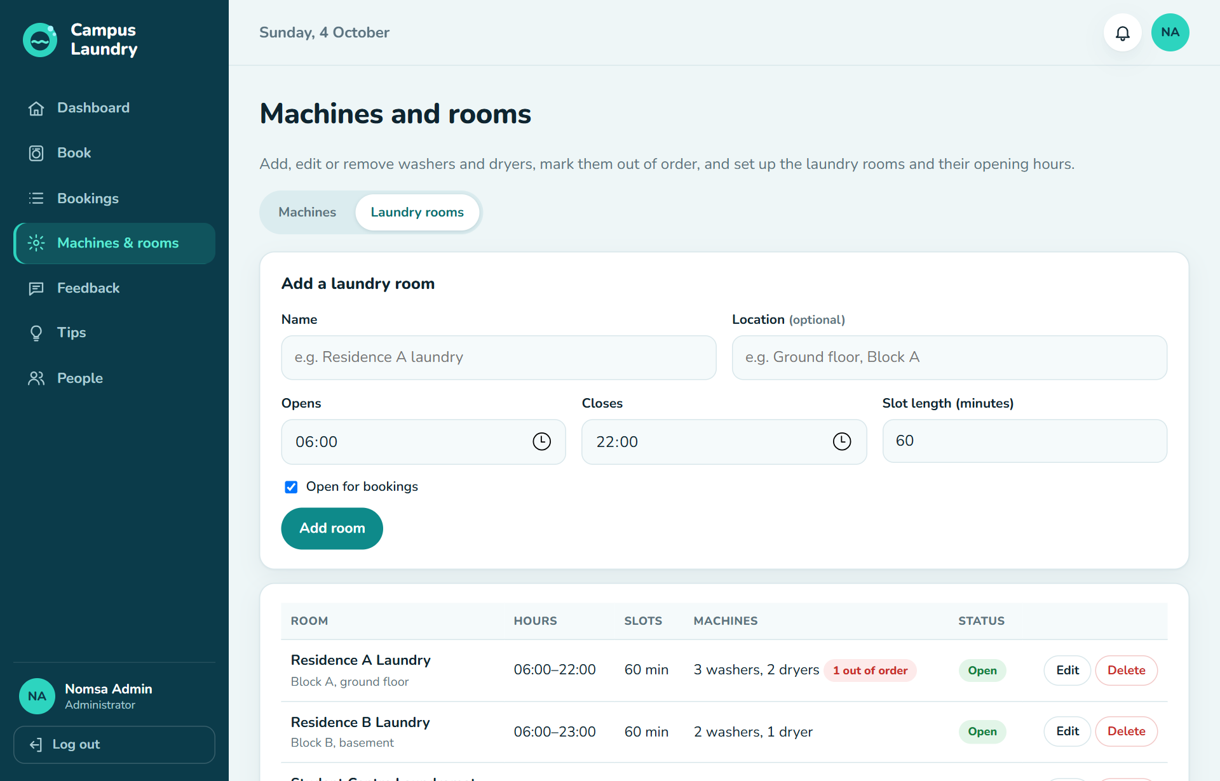
Figure 1: Machines & rooms → Laundry rooms: opening hours and slot length
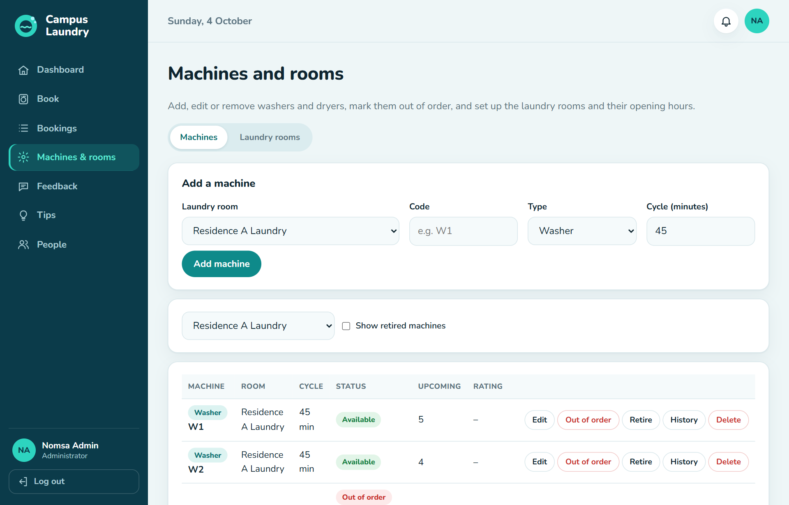
Figure 2: Machines: add washers and dryers; mark them out of order or retire them

Part B · Student guide

5. Getting started

5.1 Register
- Open the system and click Register.
- Enter your full name, student number (8–10 digits), email and a password of at least 8 characters.
- Choose your laundry room (it opens first when you book) and, if you like, your phone number.
- Click Create account. You are logged in and taken to My laundry.
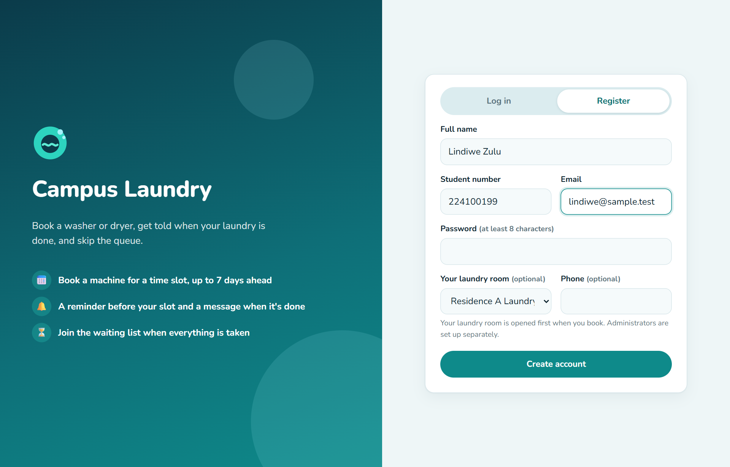
Figure 3: Registering as a student

5.2 Log in
Log in with your email or your student number and your password. Forgot your password? Ask the laundry administrator: they can give you a temporary password, and you then choose a new one.
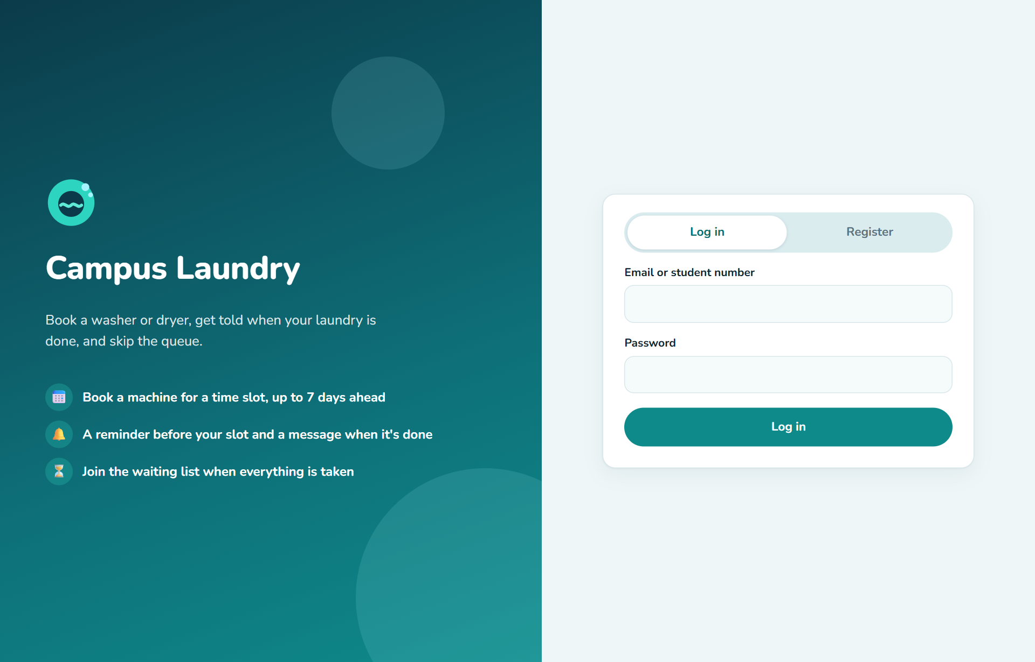
Figure 4: Log in

5.3 The menu and the bell
The menu is on the left of the screen. On a phone it is a bar along the bottom of the screen with short names (Mine, Book, Tips, Feedback). The bar at the top shows today's date, the bell and your initials.
Menu | What it is for
My laundry | Your bookings: start the cycle, mark it collected, cancel or reschedule; your waiting list; your history
Book a machine | Find a free washer or dryer and book it
Laundry tips | Advice on sorting, detergents, fabrics and machine care
Feedback | Rate the service, comment, or report a problem
Bell (top right) | Your notifications; the red number shows how many are unread
Your initials (top right) or your name (bottom of the menu) | Your profile: details, laundry room, phone, password
Log out (bottom of the menu; the arrow icon at the top right on a phone) | Log out

5.4 Your profile
Click your initials at the top right (or your name at the bottom of the menu) to change your name, email, laundry room or phone, change your password, or delete your account. Your student number cannot be changed.
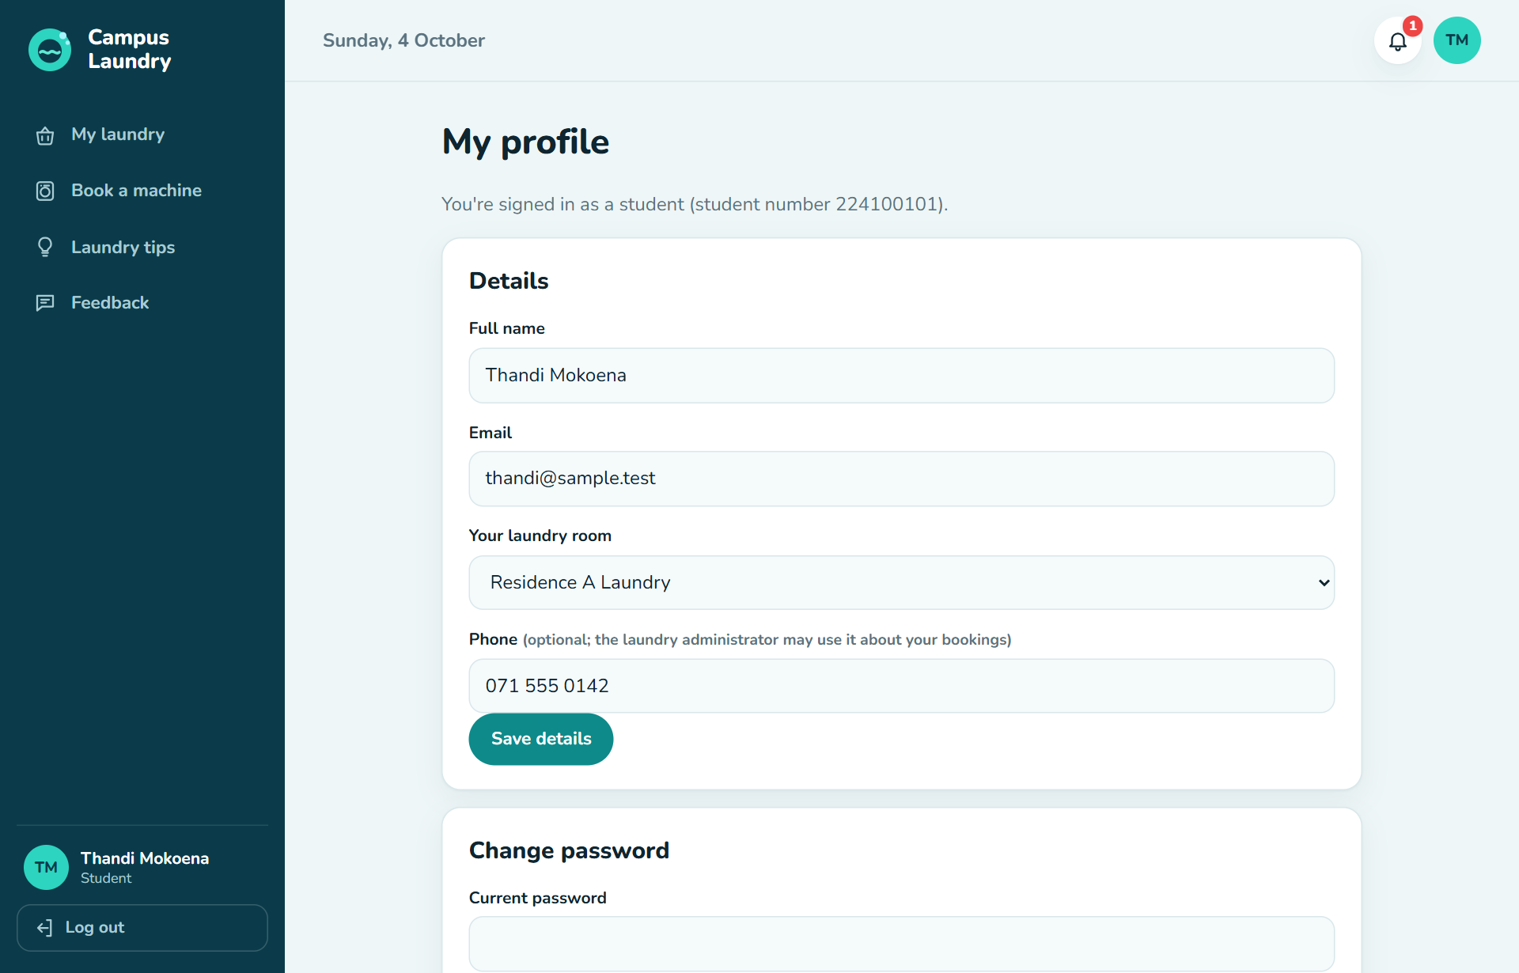
Figure 5: My profile

6. Booking a machine
- Click Book a machine.
- Choose the laundry room at the top right, and the day (today or up to 7 days ahead).
- The grid shows every machine (rows) and every time slot (columns). Scroll sideways to see later slots.
- Click a green Book slot. A bar appears at the bottom with the machine, day and time.
- Click Confirm booking. You are taken to My laundry with your new booking.
In the grid | Means
Book (green) | Free: click to book
Yours (blue) | Your booking
Taken (grey) | Another student booked it
Out (red stripes) | The machine is out of order; the reason is shown under the machine
Empty | The slot has passed
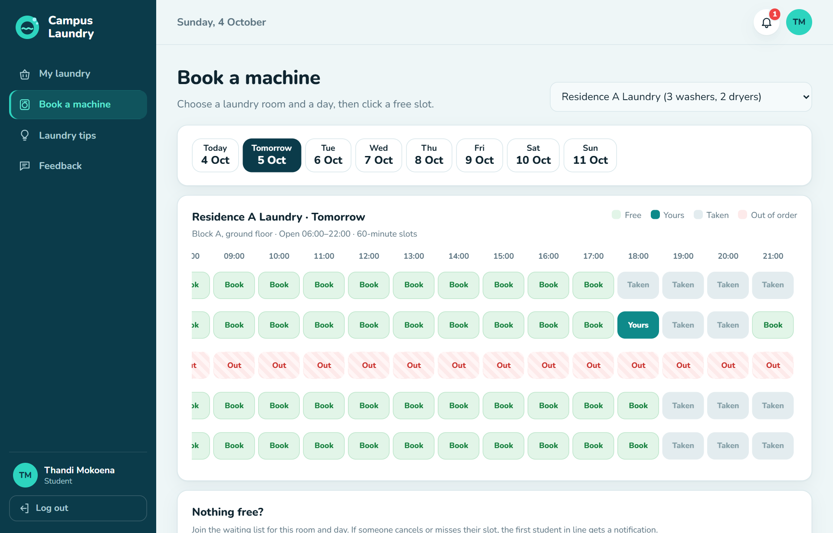
Figure 6: The booking grid: free, taken and out-of-order slots
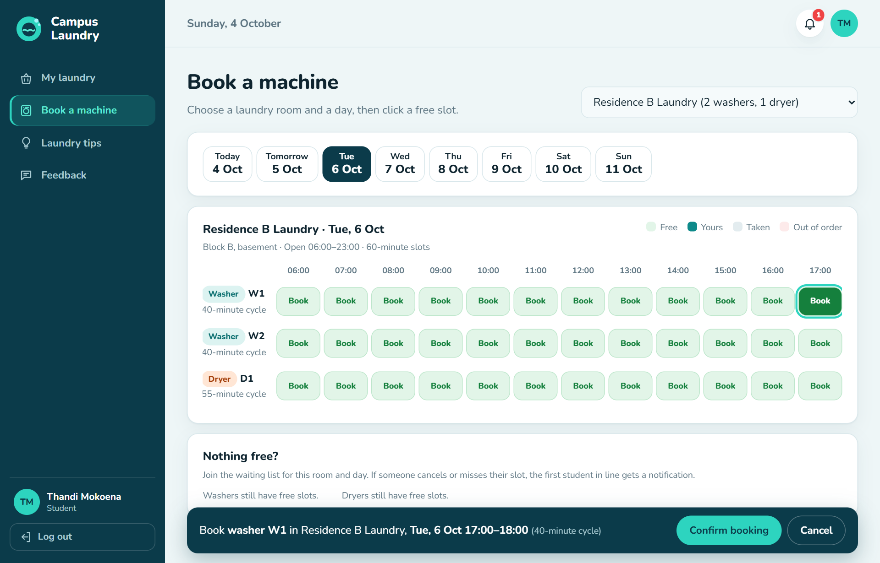
Figure 7: Confirming a booking

6.1 Booking rules
- You can have at most 3 open bookings at a time.
- You can't book two machines for the same time.
- If someone books the same slot a moment before you, you'll see "Sorry, someone has just booked that slot". Choose another one.

6.2 Reschedule or cancel
On My laundry, click Reschedule to pick a new slot in the grid (then Move booking), or Cancel to free the slot for someone else. Both are possible until your slot starts.

7. Doing your laundry
- Go to the laundry room in time for your slot and load the machine.
- Open My laundry and tap ▶ Start cycle. You can do this from 5 minutes before your slot until 15 minutes after it starts.
- A progress bar shows how much time is left.
- When the cycle is done you get a notification. Take your laundry out promptly.
- Tap ✓ Collected. The machine is now free, and the next student booked on it is told.
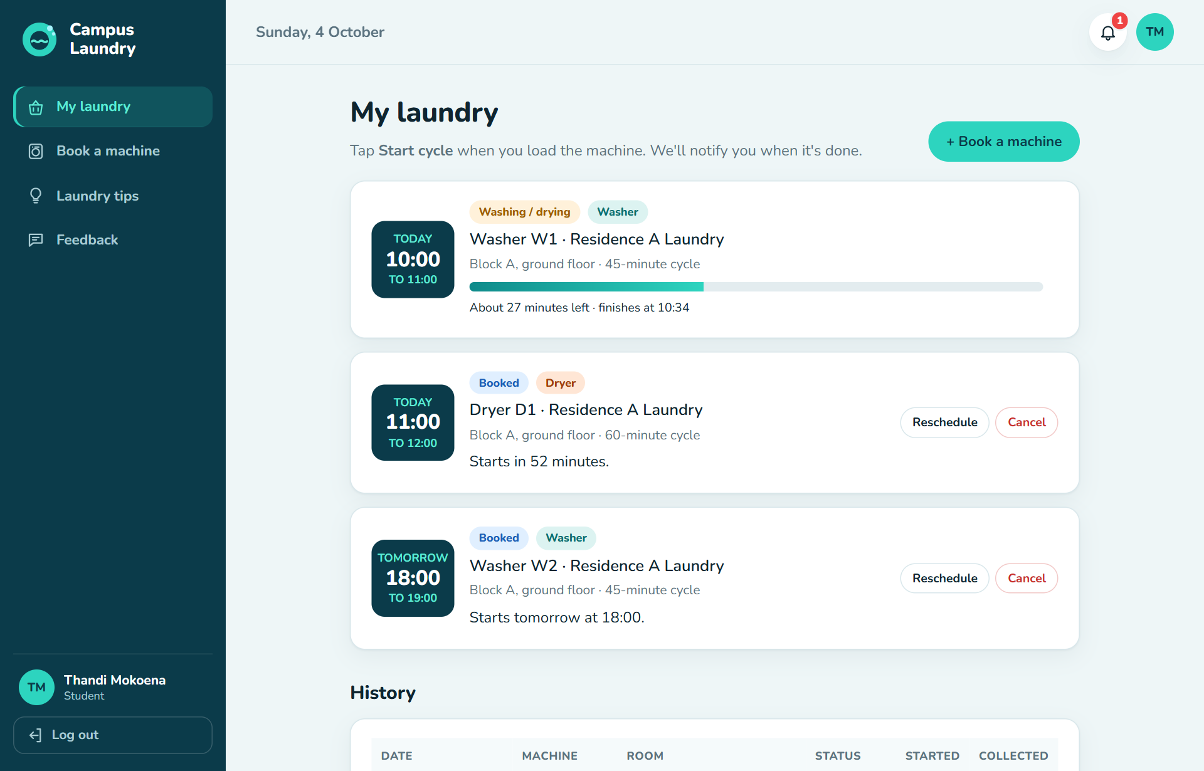
Figure 8: My laundry: a cycle running, a booking ready to start, and an upcoming booking
Important: Not started within 15 minutes? The booking is marked as Missed and the machine is released. Missed bookings show up in your history and in the administrator's reports.

8. The waiting list
When every washer (or dryer) in a room is booked for a day, the Book a machine page shows Join the waiting list for a washer / dryer. If someone cancels or misses their slot, the first student in line gets a notification and can book it. Your waiting-list places are listed on My laundry, with how many students are ahead of you. Booking a machine of that type removes you from the list automatically.
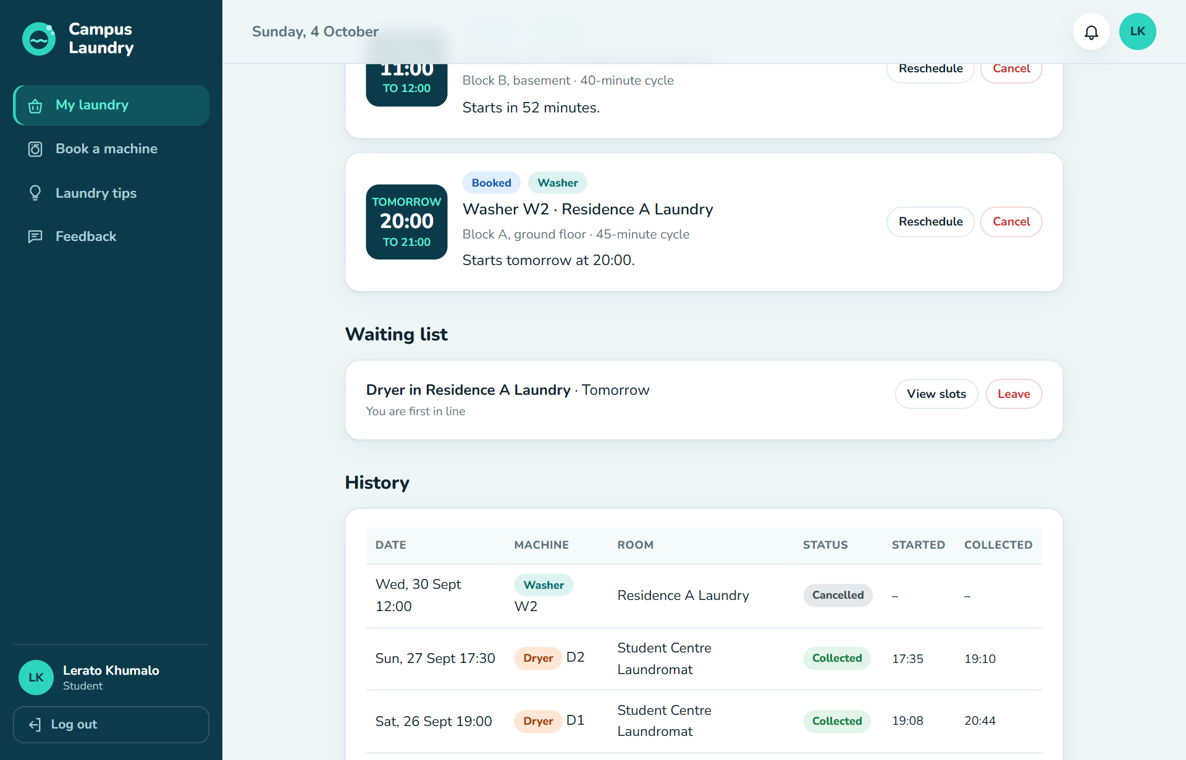
Figure 9: My laundry: on the waiting list for a dryer

9. Notifications
Click the bell to see your notifications. Open takes you to the right page; Mark read or Mark all as read clear the red number.
Notification | When
⏰ Reminder | 30 minutes before your slot
✅ Laundry done | When your cycle has finished
🟢 Machine free | The machine you booked later today is free now, or a machine became free for your waiting list
⚠️ Booking cancelled | The administrator cancelled your booking, for example because the machine is out of order
⌛ Missed | You did not start the cycle within 15 minutes
💬 Feedback reply | The administrator answered your feedback
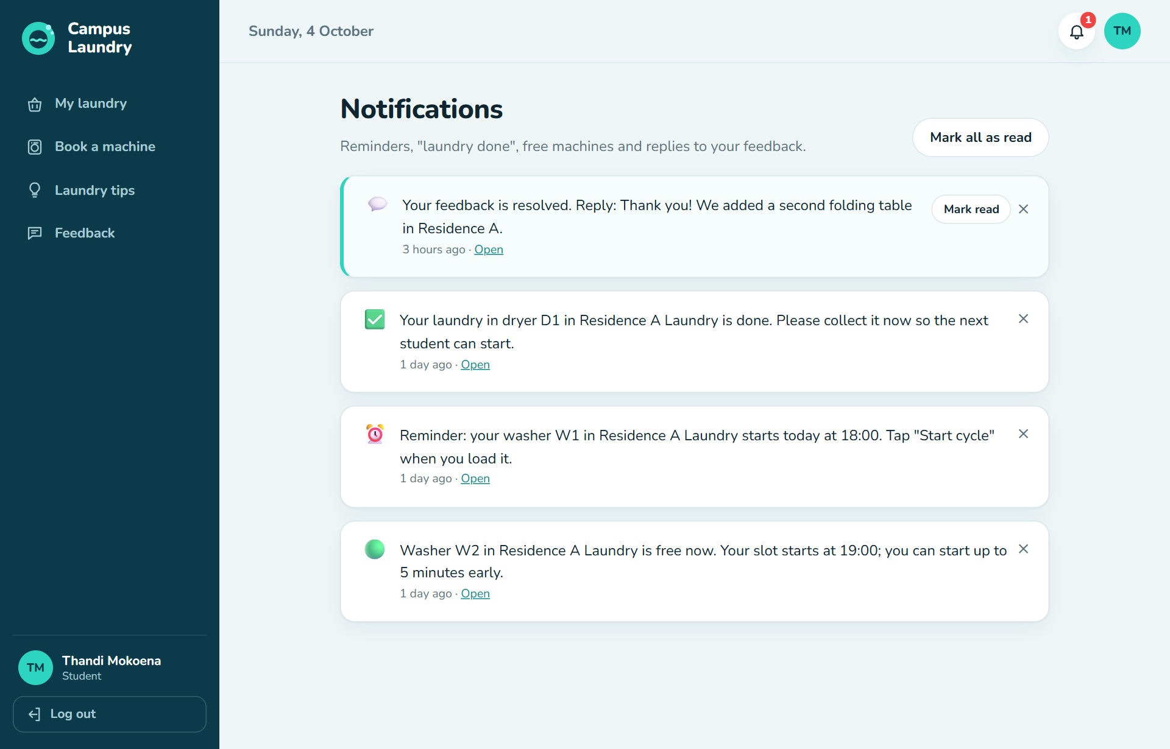
Figure 10: Notifications

10. Laundry tips
Laundry tips gives advice on sorting clothes, choosing detergents, fabric types and machine care. Click a category to see only those tips.
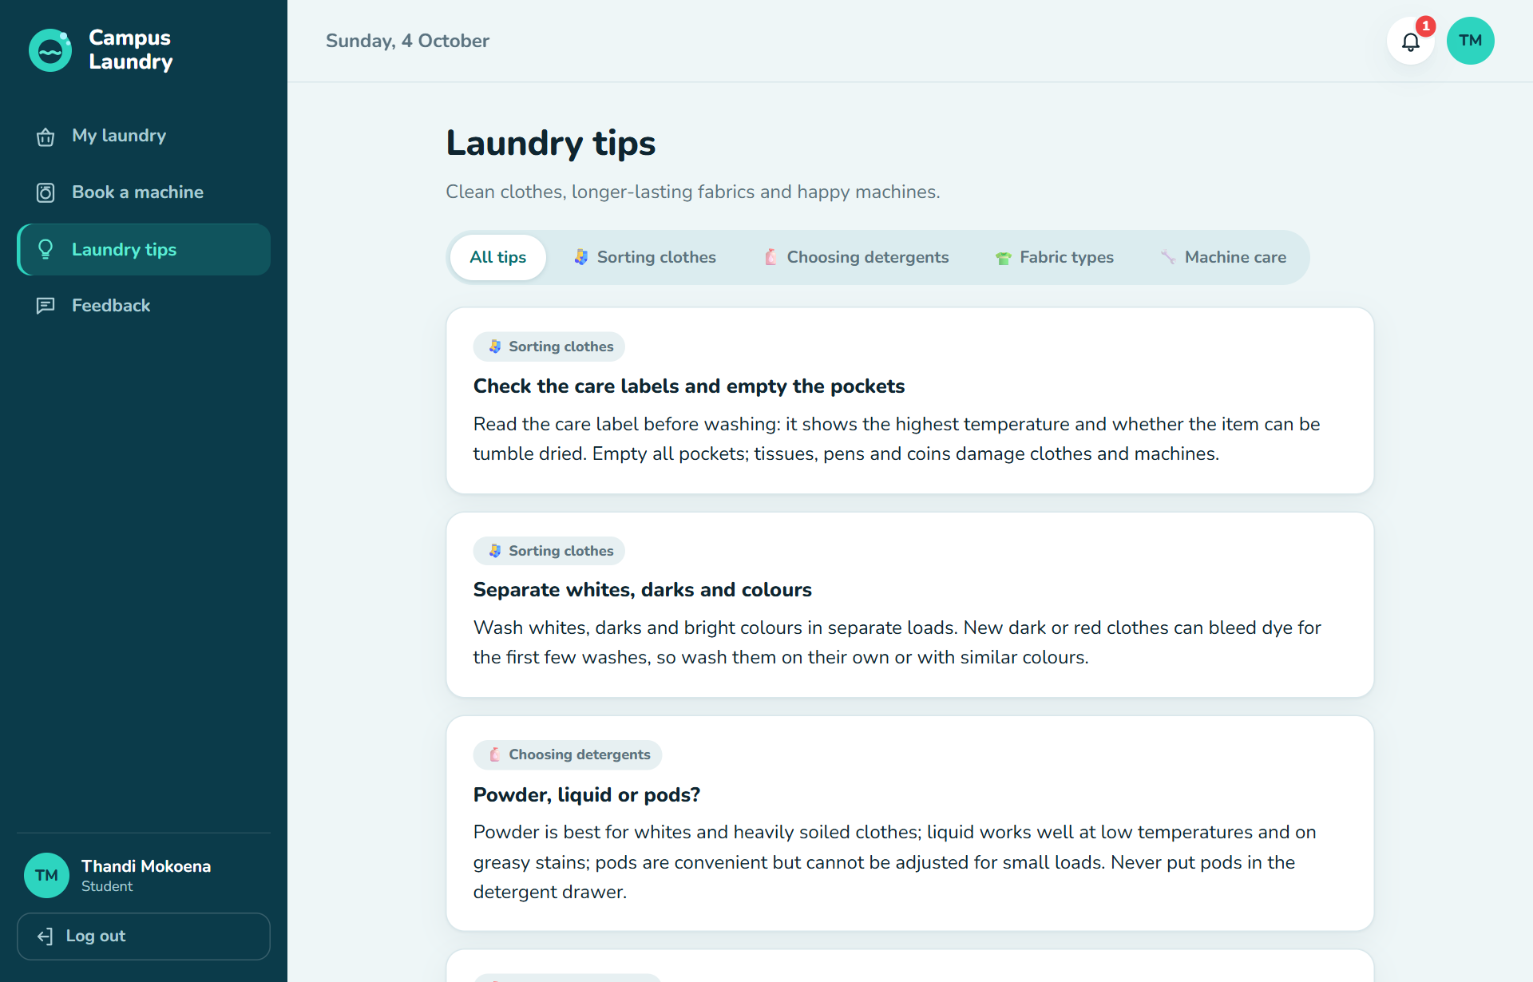
Figure 11: Laundry tips

11. Feedback
- Click Feedback and choose Rate, Comment or Report an issue.
- Choose the laundry room and, if it is about one machine, the machine.
- For a rating, click 1 to 5 stars. Add a comment (required for comments and issues).
- Click Send feedback. Your feedback and the administrator's replies appear under My feedback, and you get a notification when they reply.
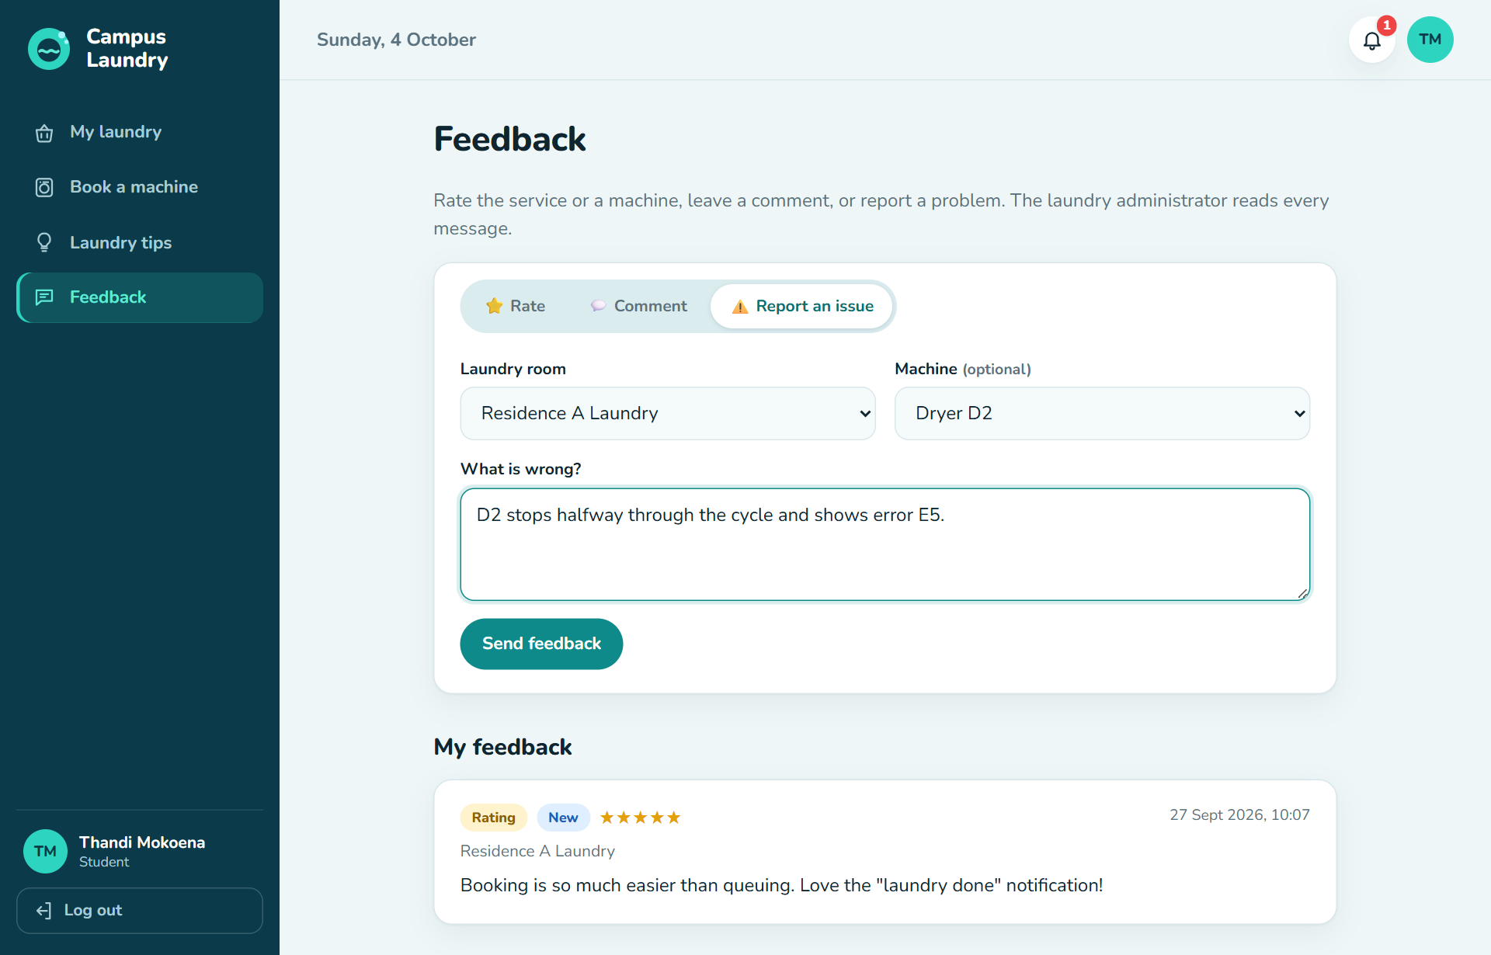
Figure 12: Reporting an issue with a machine

Part C · Administrator guide

12. Dashboard
The Dashboard opens when you log in. Right now shows today's bookings, machines running, loads waiting to be collected, machines out of order, open issues and students on waiting lists. The Usage report (last 7, 30 or 90 days) shows bookings, loads washed, cancellations, the no-show rate and the average rating, with bookings per day, the busiest hours, use per machine and per room.
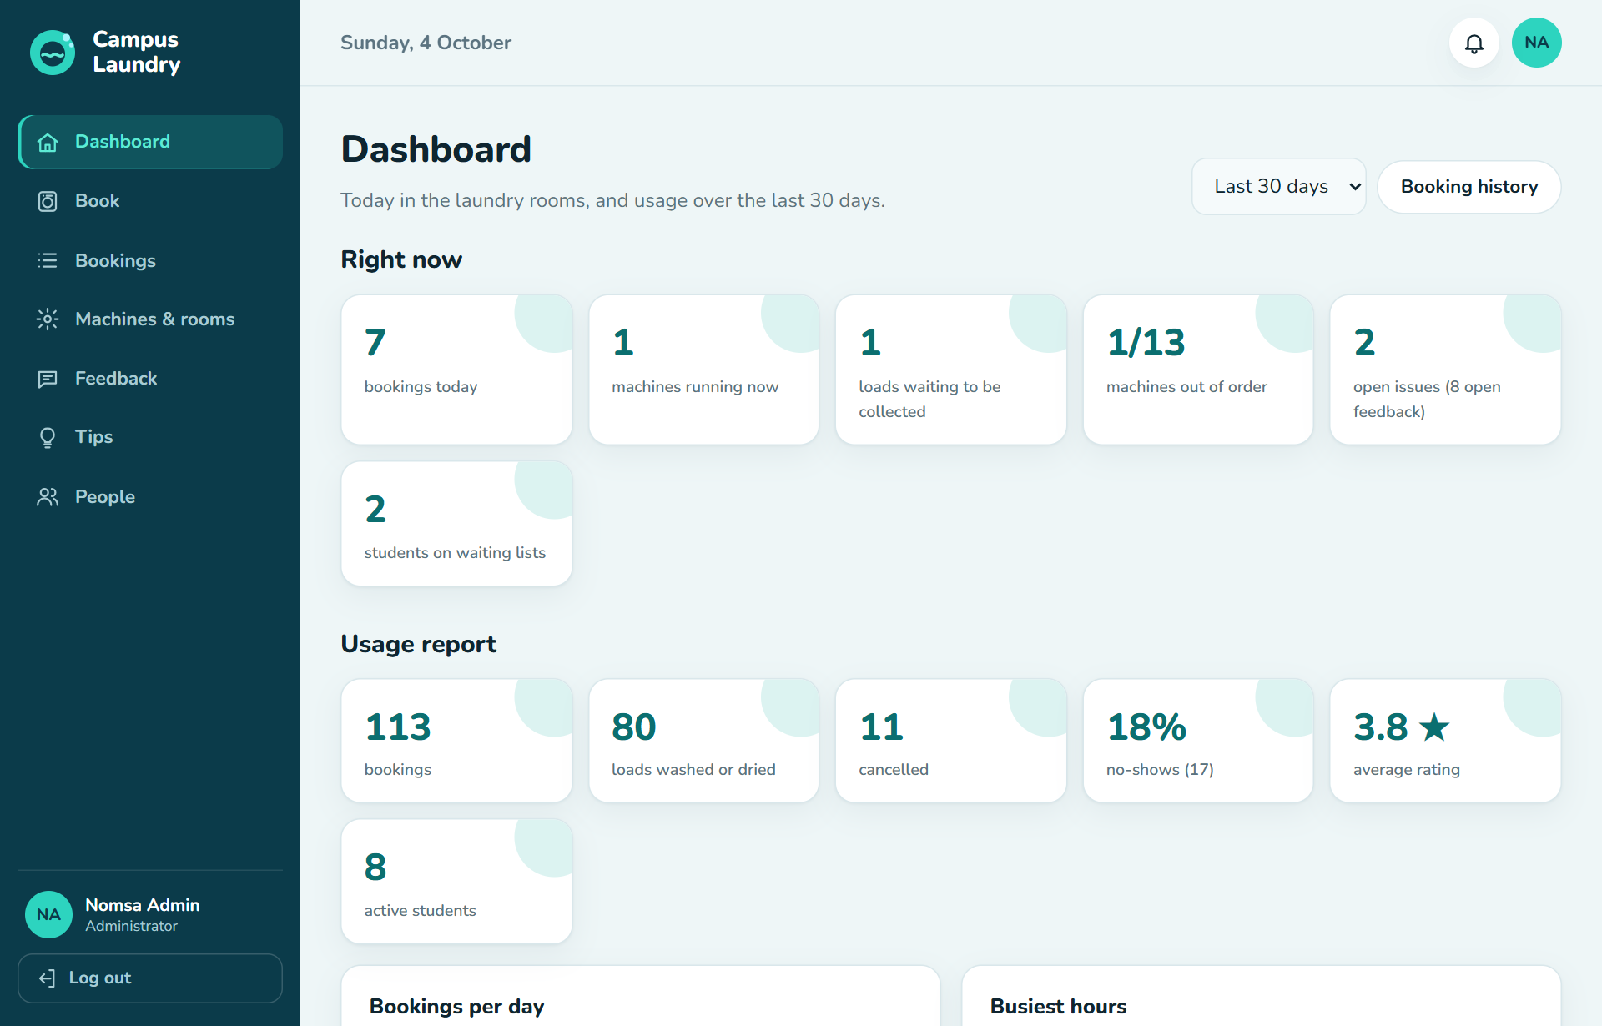
Figure 13: Dashboard and usage report

13. Machines and rooms
Task | How
Add a machine | Machines & rooms → fill in room, code, type and cycle time → Add machine
Edit a machine | Edit in its row; change the details → Save changes
Out of order | Out of order → type the reason. The machine can't be booked; its upcoming bookings are cancelled and those students are notified with the reason.
Repaired | Back in service. The History button lists every past outage.
Remove a machine | Delete works only for a machine that was never booked. Otherwise use Retire: it disappears from the booking grid but its history stays (its upcoming bookings are cancelled).
Rooms | Laundry rooms tab: add or edit rooms and opening hours. Opening hours and slot length can only change when the room has no upcoming bookings. Untick Open for bookings to close a room. A room with machines can't be deleted.

14. Feedback and issues
Feedback lists open feedback first (issues before ratings and comments). For each one you can write a reply, set the status (New, Being looked at, Resolved, Closed) and Save; the student is notified. Closing (dismissing) feedback needs a reply explaining why. For an issue about a machine, Mark machine out of order takes it out of service in one step.
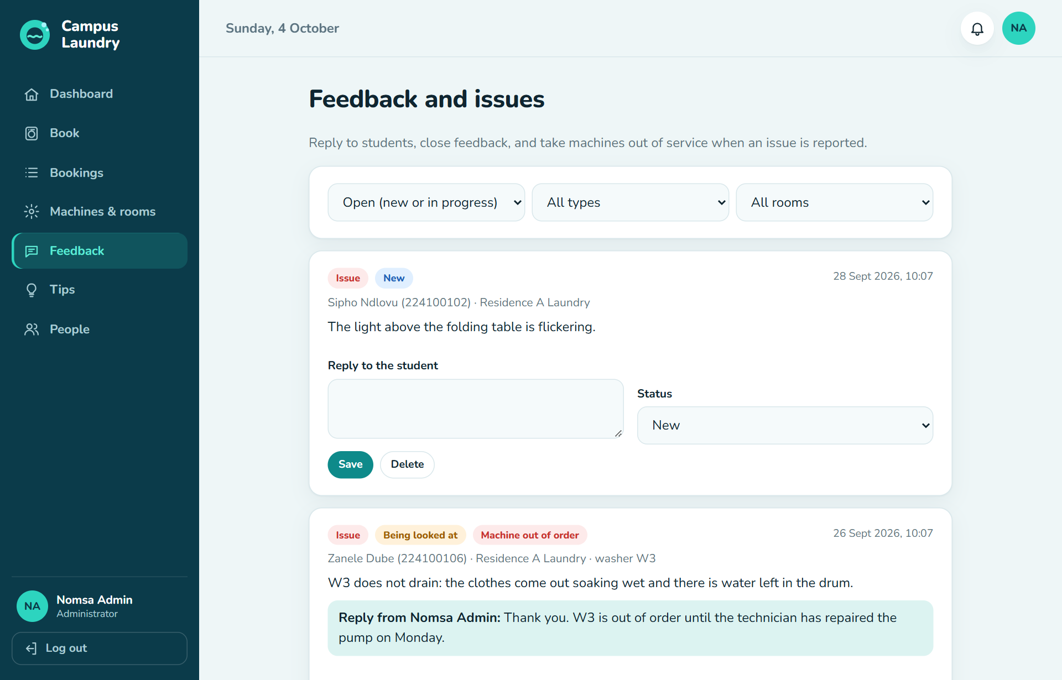
Figure 14: Feedback and issues

15. Booking history
Bookings lists every booking in every room. Filter by student (name, student number or email), dates, room and status. You can Cancel an upcoming booking; the student is notified.
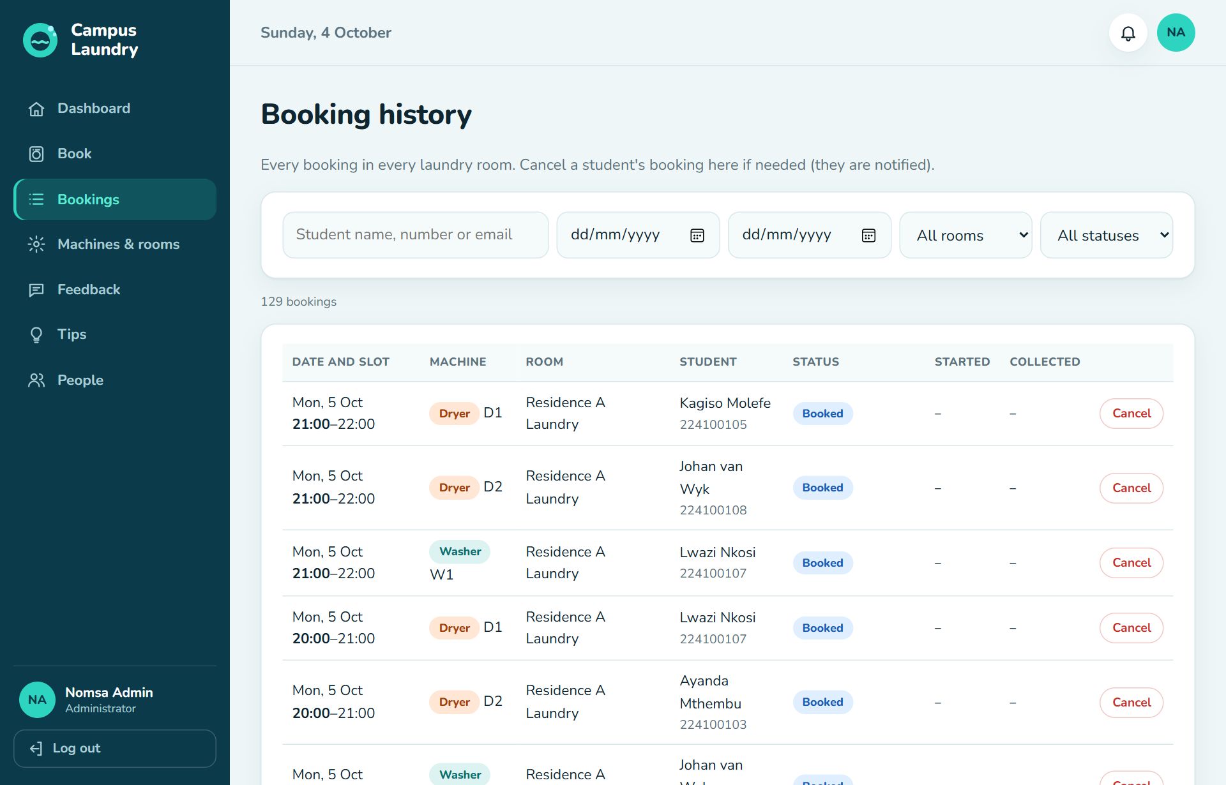
Figure 15: Booking history

16. People
- Search by name, email or student number.
- Change a role to Admin to make another administrator.
- Deactivate someone who should no longer use the system: they can't log in and their upcoming bookings are cancelled; their history stays. Reactivate reverses it.
- Reset password shows a temporary password once; they choose a new one when they log in.
- Delete removes the account; their past bookings and feedback stay in the reports as "former student".
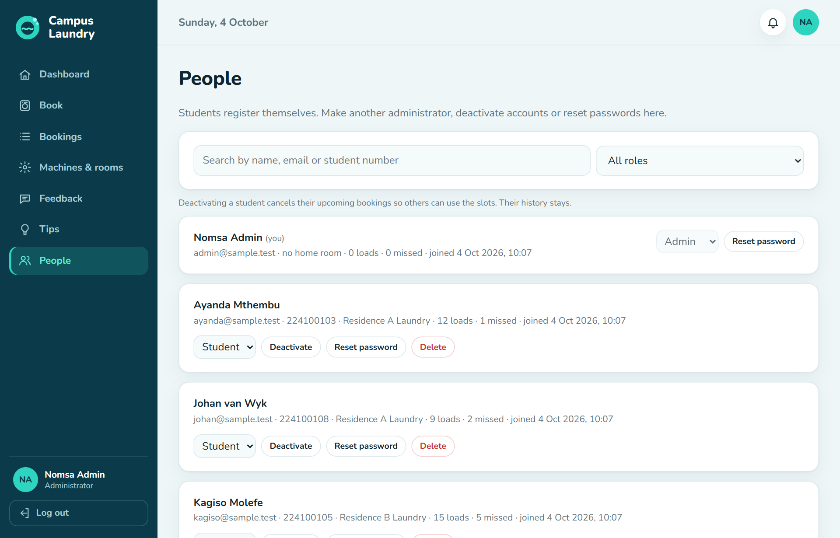
Figure 16: People

17. Laundry tips (administrator)
On Tips, click + New tip, choose the category, write a title and the tip, and Save tip. Untick Published to keep it as a draft that students can't see. Edit and Delete are on each tip.
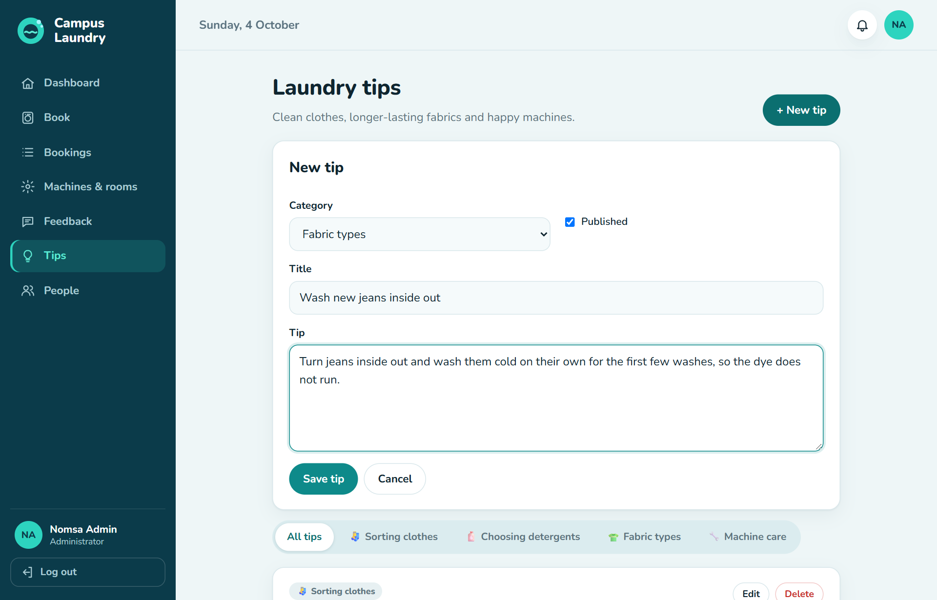
Figure 17: Adding a laundry tip

18. Everyday use

18.1 Starting and stopping
- MySQL starts automatically with Windows.
- Start the system: open a terminal in the project folder and run npm start.
- Stop it: press Ctrl + C in that terminal, or close the window. While it is stopped, no reminders or "laundry done" notifications are sent; they catch up when it starts again.

18.2 Using it from phones
- On the computer running the system, run ipconfig and note the IPv4 Address, e.g. 192.168.1.25.
- The first time it starts, Windows may ask whether to allow Node.js through the firewall. Allow it on Private networks.
- On phones on the same Wi-Fi, open http://192.168.1.25:3003 (use your own address). The pages are designed for phone screens.
Important: The system uses plain http, which is fine on a trusted local network. Do not put it directly on the internet without setting up https.

18.3 Backing up
Back up regularly. Open Command Prompt, go to the project folder and run (it asks for the MySQL root password):
cd /d "C:\CampusLaundry\laundry"
"C:\Program Files\MySQL\MySQL Server 8.4\bin\mysqldump.exe" -u root -p --databases campus_laundry --result-file=laundry-backup.sql

18.4 Demonstration data
For a presentation you can fill the system with fictional data: three laundry rooms, students with @sample.test emails and two weeks of bookings. It needs the full npm install and the system running:
npm run sample:seed
Log in as admin@sample.test or a student such as thandi@sample.test; the password is in tools/sample-data.js. Remove all of it again afterwards (only the sample data is deleted):
npm run sample:clean

19. Moving existing data to another computer
- On the old computer, make a backup as in Section 18.3 and copy laundry-backup.sql to the new computer.
- On the new computer, complete installation steps 1–6, but skip steps 7 and 8.
- Put laundry-backup.sql in the project folder, open Command Prompt there and import it:
"C:\Program Files\MySQL\MySQL Server 8.4\bin\mysql.exe" -u root -p < laundry-backup.sql
- Run npm run db:setup (it applies any newer updates).
- Start with npm start and log in with the existing accounts.

20. Troubleshooting
Problem | Likely cause | What to do
"npm is not recognized" | The terminal was opened before Node.js was installed | Close all terminals (and VS Code) and open a new one.
"Cannot reach the database" or ECONNREFUSED | MySQL is not running | Services → MySQL84 → Start. Set its startup type to Automatic.
db:setup: "ER_ACCESS_DENIED_ERROR" | Wrong DB_PASSWORD in .env | Put the correct MySQL root password in .env.
npm start: "EADDRINUSE :::3003" | Another program is using port 3003 | Close it, or set another PORT in .env and open that address.
The only administrator forgot their password | Nobody else can reset it in the app | Run npm run admin:reset-password -- admin@email and use the temporary password shown.
A student forgot their password |  | Administrator: People → Reset password.
"This account has been deactivated" | The administrator deactivated it | Administrator: People → Reactivate.
No rooms to book | No laundry rooms or machines yet, or the room is closed | Administrator: Machines & rooms (Section 4).
"You can have at most 3 open bookings" | The limit per student | Finish (Collected) or cancel a booking first.
"Start cycle" button missing | Too early, or more than 15 minutes into the slot | It appears 5 minutes before the slot; after 15 minutes the booking is released.
"The previous cycle is still running" | The student before you started late | Wait until it finishes, then start.
No reminders or "done" notifications | The server was stopped | Keep npm start running; notifications catch up when it restarts.
Changes to .env have no effect | The server reads .env only when it starts | Stop (Ctrl + C) and run npm start again.

Appendix A: Command reference
Command | What it does
npm install --omit=dev | Installs the packages the system needs
npm run db:setup | Creates the database or brings it up to date. Never deletes data.
npm run admin:create -- "Name" email | Creates an administrator (or promotes an existing account) with a temporary password
npm run admin:reset-password -- email | Gives anyone a temporary password
npm start | Starts the system at http://localhost:3003 (stop with Ctrl + C)
npm run db:check | Checks the database structure and 43 integrity rules (leaves no data)
npm run test:api | 84 end-to-end tests while the system is running (leaves no data)
npm test | Every test suite, including browser and load tests (needs the full npm install)
npm run sample:seed / sample:clean | Adds / removes fictional demonstration data
npm run db:reset | Deletes the whole database and creates an empty one

Appendix B: macOS and Linux
Step | Windows | macOS / Linux
Install Node.js | Installer or winget | Installer from https://nodejs.org (macOS), or your package manager
Install MySQL 8.4 | MSI installer + MySQL Configurator | DMG installer from dev.mysql.com (macOS), or your package manager
Copy the settings file | copy .env.example .env | cp .env.example .env
Edit the settings file | notepad .env | nano .env (or any text editor)
All the npm commands are the same on every system. The browser tests and document tools use Microsoft Edge and Word, so they run on Windows.

